Tables
Table 1: Model outputs (log-transformed) of the fixed (cave length) and smooth terms (elevation) in GAM for the best-fit model for species richness. where * : < 0.05, ** : < 0.01, *** : <0.001
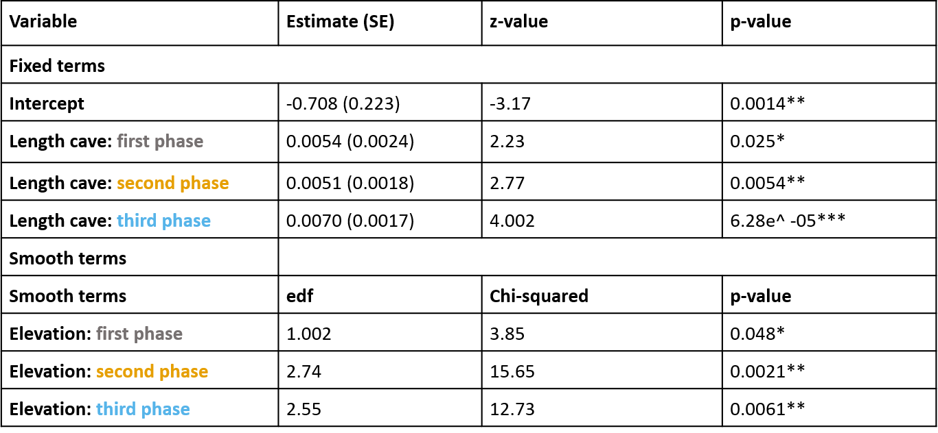
Table 2: Model summary of effects of covariates on presence/absence of three most widely distributed species H. armiger, R. affinis and R. macrotis. All the Beta coefficients and their standard error are in logit scale.
