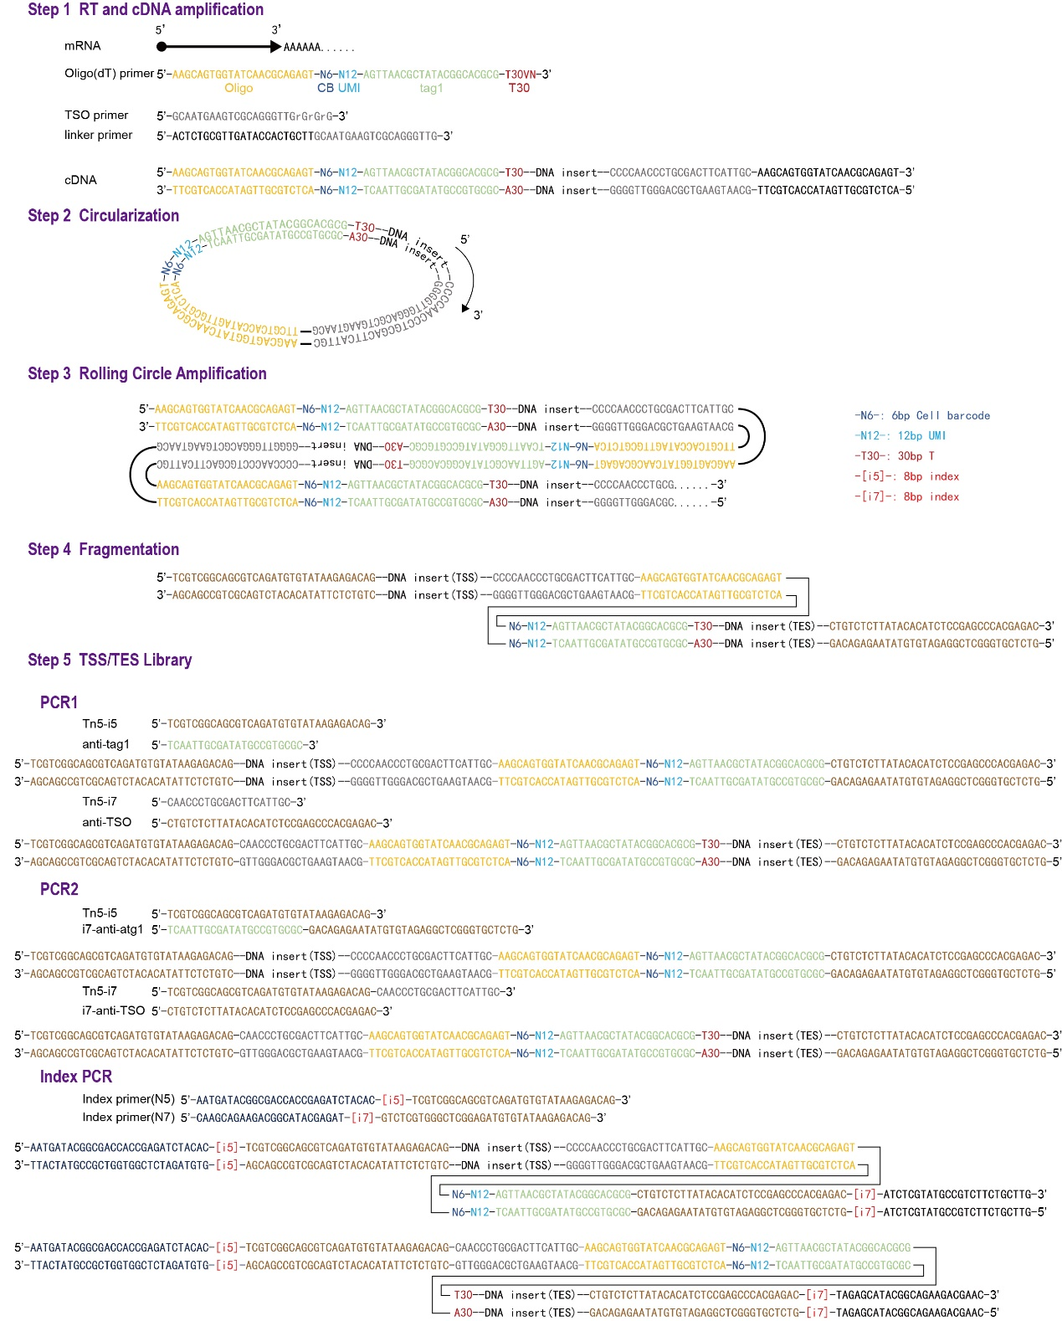
Extended Data Fig. 1
Molecular structure of DNA oligos and the chemistry for the workflow.

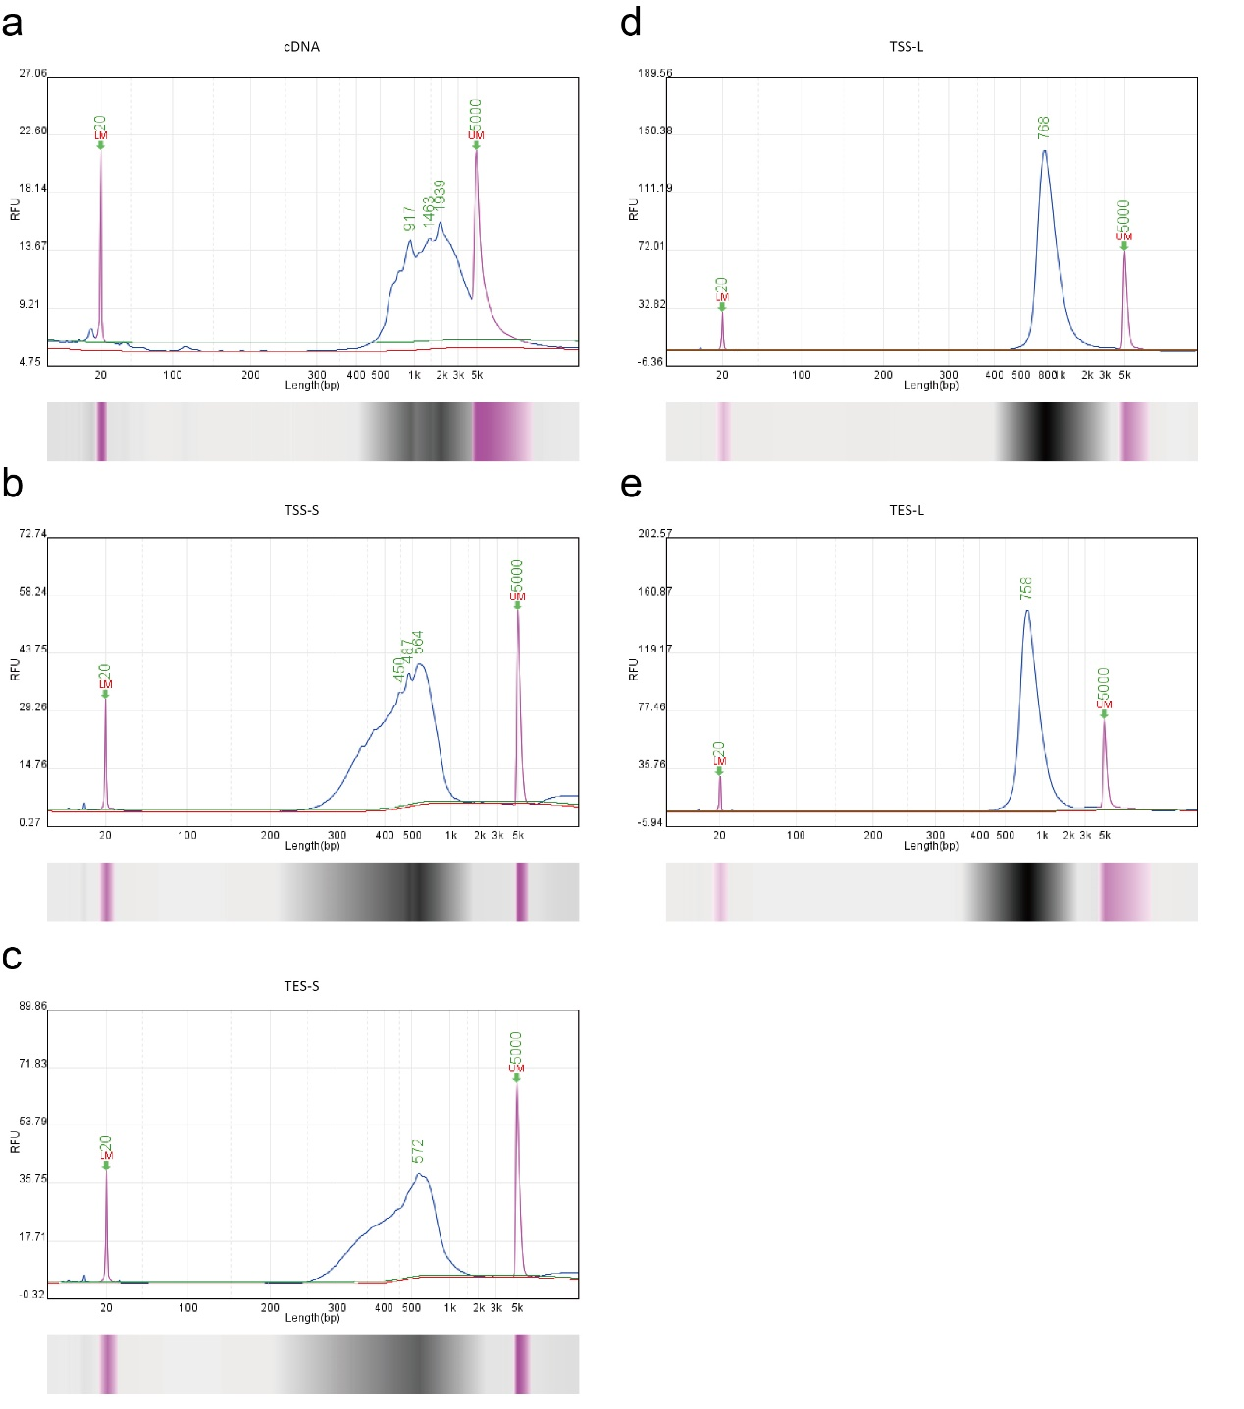
Extended Data Fig. 2
a, cDNA fragment size distribution on the Bioanalyser platform (Qsep100). b-e, Visualization of scRCAT-seq2 library fragment size distribution on the Bioanalyser platform. b, Short fragments of TSS library. c, Short fragments of TES library. d, Long fragments of TSS library. e, Long fragments of TES library.

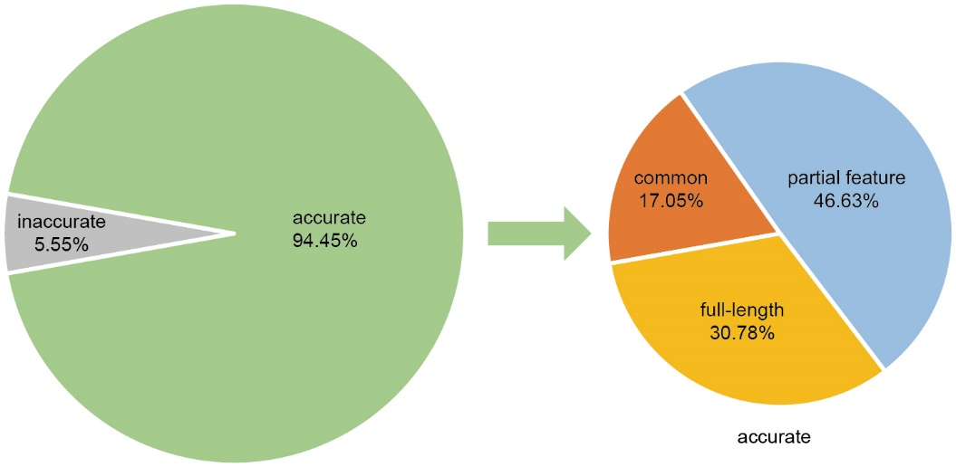
Extended Data Fig. 3
UMI counts of scRCAT-seq2 reads mapping to the reference genome (green), including reads mapping completely to the reference genome (yellow), reads partially mapping to features of specific isoforms (blue), and reads mapping to multiple isoforms (orange).
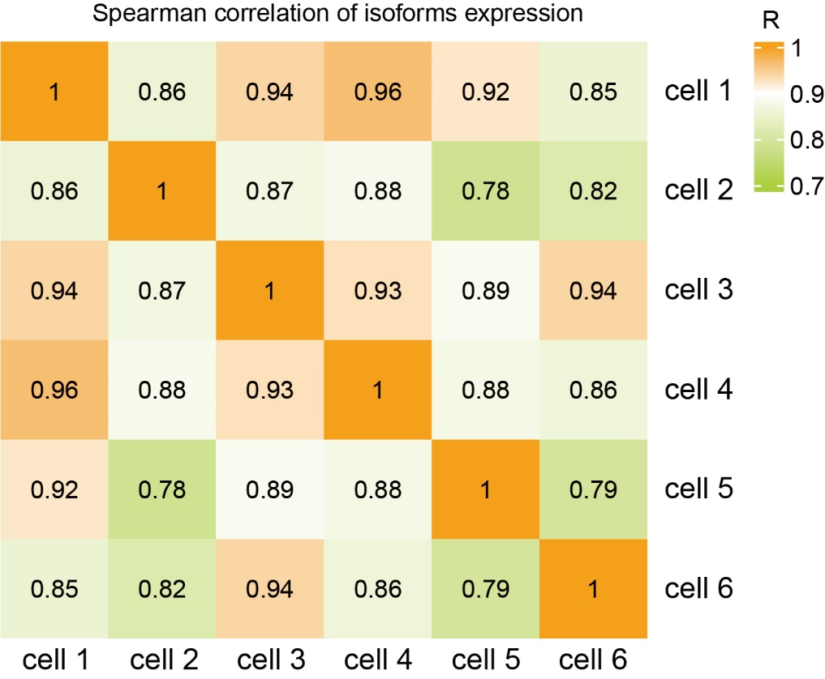
Extended Data Fig. 4
Correlation plots showing Spearman correlation values of SIRV-set 3 among multiple samples, p-value < 0.05.

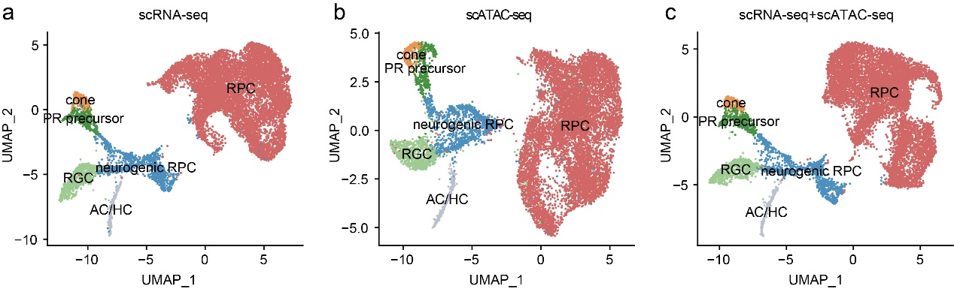
Extended Data Fig. 5
a, Cell clustering of human retinal organoids with the scRNA-seq data. b, Cell clustering of human retinal organoid by using scATAC-seq. c, Cell clustering of human retinal organoid by using scATAC-seq and scRNA-seq.
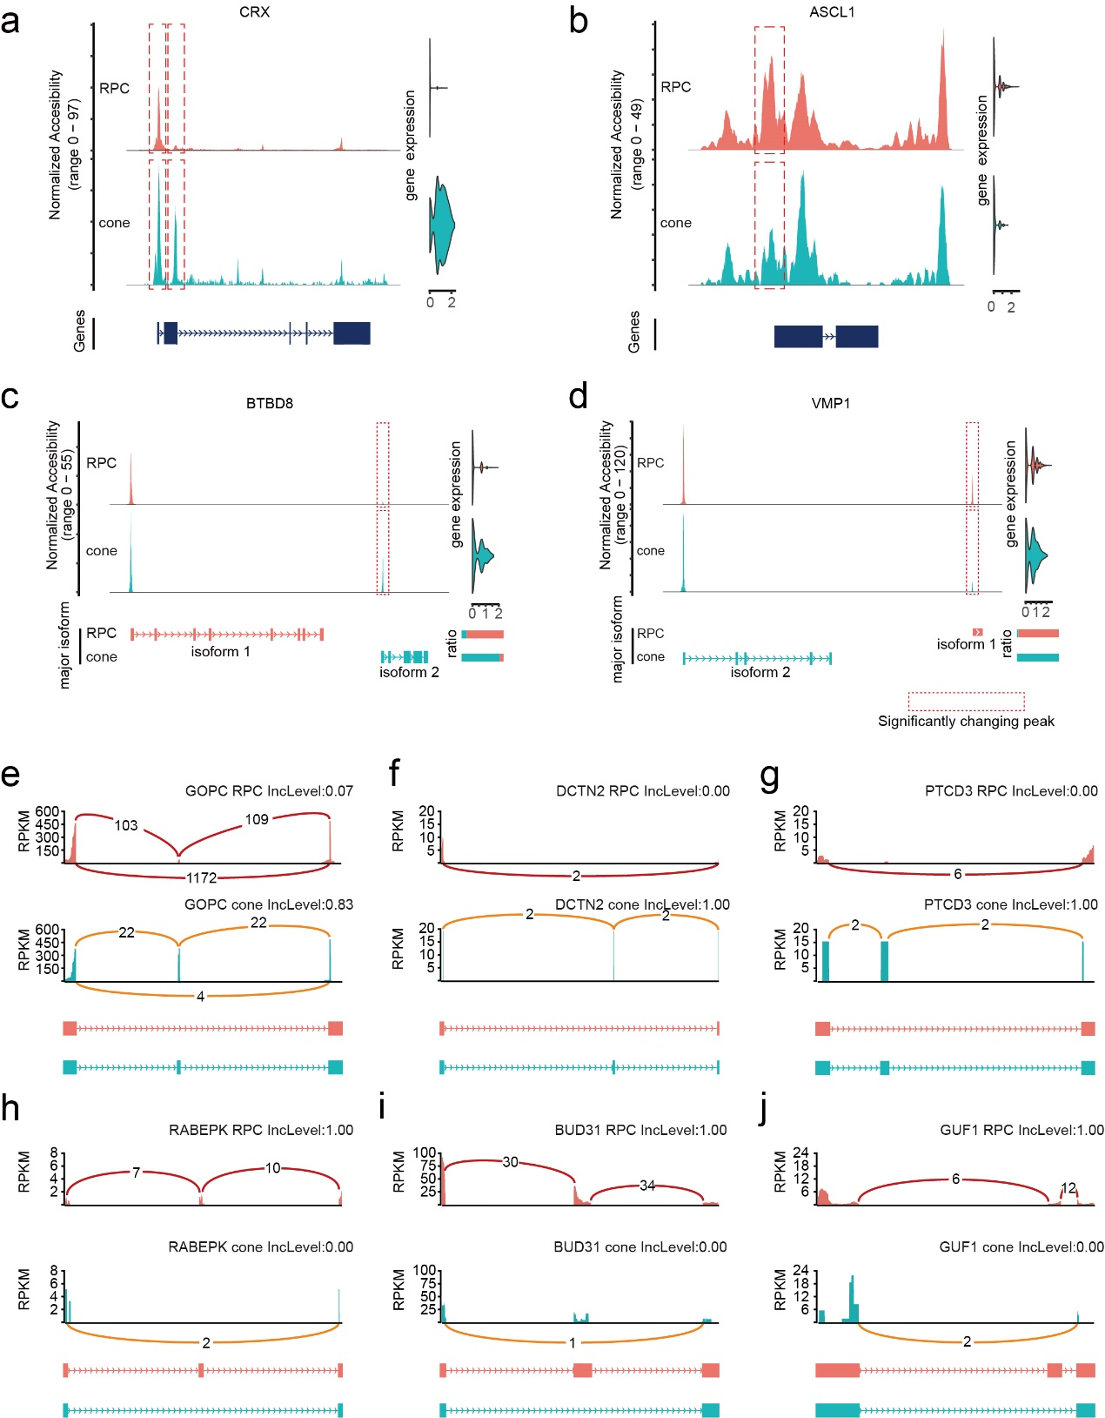
Extended Data Fig. 6
a,b, Genes with concordant changes in gene expression and chromatin accessibility during RPC-cone development. c,d, Major transcript changes in TSS choices during RPC-cone development. e-j, The locus alteration of the genes GOPC (e), DCTN2 (f), PTCD3(g), RABEPK (h), BUD31 (i), and GUF1 (j) undergoing SE.

