Supplementary data

Table S1. Genomes representative to viuB alleles found in Dhaka, Bangladesh used to construct the phylogenetic tree and DDH analysis
Name of the isolate | viuB type | Phylogeny | Country of Origin | Accession number
EDC_690 | 6 | LB | Bangladesh | WUWI00000000
Vc_229135 | 6 | LB | Spain | SRR7062498
EDC_716 | 7 | LB | Bangladesh | WYBY00000000
EDC_717 | 7 | LB | Bangladesh | WYBZ00000000
Vc_2016V_1091 | 5 | LB | Unknown | GCA_003312065.1
Vc_PNUSAV000170 | 5 | LB | USA | SRR6456907
Vc_236140 | 10 | Non-PG | India | SRR7062513
Vc_229143 | 10 | Non-PG | India | SRR7062619
Vc_YB2H11 | 39 | Non-PG | USA | GCA_003349365.1
Vc_YB1A01 | 39 | Non-PG | USA | GCA_001402185.1
Vc_EDC_800 | 45 | Non-PG | Bangladesh | WYCA00000000
Vc_EDC_688 | 45 | Non-PG | Bangladesh | WYCS00000000
Vc_BD21 | 32 | Non-PG | Bangladesh | GCA_003348245.1
Vc_BD23 | 32 | Non-PG | Bangladesh | GCA_003348215.1
Vc_L11 | 51 | Non-PG | Sweden | GCA_001718105.1
Vc_NHCC-008D | 65 | Non-PG | Bangladesh | GCA_000348425.2
Vc_493492 | 65 | Non-PG | Thailand | SRR7062586
Vc_EDC_754 | 73 | El Tor | Bangladesh | WYCF00000000
Vc_EDC_755 | 73 | El Tor | Bangladesh | WYCE00000000
Vc_BD04 | 25 | Non-PG | Bangladesh | GCA_003348485.1
Vc_BD34 | 25 | Non-PG | Bangladesh | GCA_003348055.1
LB denotes long branch

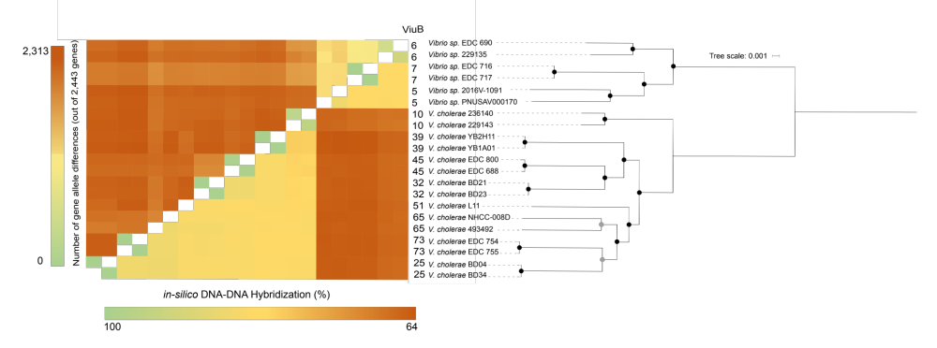

Fig. S1. Genomic and phylogenetic distinction between strains carrying the viuB-05, viuB-06 and viuB-07 alleles and those carrying other alleles. At most two representative strains for each viuB allele were chosen. All genomes were aligned using Mugsy v1r2.3 with default parameters. A maximum likelihood phylogenetic tree was reconstructed using RAxML v8.2.11 based on this alignment under the GTR GAMMA model. Branch support was evaluated with 100 bootstrap replicates and is indicated as black (≥95%) and grey (≥50%) circles. Allelic differences based on the V. cholerae cgMLST scheme shown on the left of the matrix and in-silico DNA-DNA Hybridization values on the right. Self-comparisons are ignored. viuB-73 is exclusively associated with the pandemic generating lineage, which includes the El Tor biotype responsible for the current cholera pandemic. Strains carrying the viuB-05, viuB-06 and viuB-07 alleles were clearly distinct from the rest of the V. cholerae isolates, as they form a clear monophyletic clade by themselves. cgMLST allelic differences and in-silico DDH data also showed a clear boundary between isolates carrying these viuB alleles and isolates carrying other alleles. viuB-79 is not included in this analysis as no genomes with this allele were available.

Table S2: Month wise isolation data of V. cholerae O1 and V. cholerae non-O1/O139 in Dhaka. Identity of the isolates were confirmed by conventional PCR for V. cholerae and serogroup O1

Month | Site | V. cholerae O1 | V. cholerae non-O1/O139
July, 2015 | S1 | - | +
July, 2015 | S2 | - | +
July, 2015 | S3 | - | -
July, 2015 | S4 | - | -
July, 2015 | S5 | + | +
July, 2015 | S6 | + | +
July, 2015 | S7 | - | +
August, 2015 | S1 | - | +
August, 2015 | S2 | - | +
August, 2015 | S3 | - | +
August, 2015 | S4 | - | -
August, 2015 | S5 | - | +
August, 2015 | S6 | - | +
August, 2015 | S7 | - | +
September, 2015 | S1 | - | +
September, 2015 | S2 | - | +
September, 2015 | S3 | - | +
September, 2015 | S4 | - | +
September, 2015 | S5 | - | +
September, 2015 | S6 | - | -
September, 2015 | S7 | - | +
October, 2015 | S1 | + | +
October, 2015 | S2 | - | +
October, 2015 | S3 | - | +
October, 2015 | S4 | - | +
October, 2015 | S5 | + | +
October, 2015 | S6 | + | +
October, 2015 | S7 | - | +
November, 2015 | S1 | - | +
November, 2015 | S2 | - | +
November, 2015 | S3 | - | +
November, 2015 | S4 | - | +
November, 2015 | S5 | - | +
November, 2015 | S6 | - | +
November, 2015 | S7 | + | +
December, 2015 | S1 | - | +
December, 2015 | S2 | - | +
December, 2015 | S3 | - | +
December, 2015 | S4 | - | +
December, 2015 | S5 | - | +
December, 2015 | S6 | - | +
December, 2015 | S7 | - | +
January, 2016 | S1 | - | +
January, 2016 | S2 | - | +
January, 2016 | S3 | - | -
January, 2016 | S4 | - | +
January, 2016 | S5 | - | -
January, 2016 | S6 | - | +
January, 2016 | S7 | - | +
February, 2016 | S1 | - | +
February, 2016 | S2 | - | +
February, 2016 | S3 | - | +
February, 2016 | S4 | - | +
February, 2016 | S5 | - | +
February, 2016 | S6 | - | +
February, 2016 | S7 | - | +
March, 2016 | S1 | - | +
March, 2016 | S2 | - | +
March, 2016 | S3 | - | +
March, 2016 | S4 | - | +
March, 2016 | S5 | - | +
March, 2016 | S6 | + | +
March, 2016 | S7 | - | +

Table S3: Average values of environmental parameters in sampling locations in Dhaka

Site | pH | DO (mg/L) | Con (µs/cm) | TDS (mg/L) | Salinity(ppt) | WT ⁰c | AT ⁰c
Site 1 | 6.86 | 0.95 | 749.94 | 379.77 | 0.34 | 30.18 | 30.86
Site 2 | 7.03 | 2.70 | 639.63 | 289.57 | 0.23 | 30.47 | 31.11
Site 3 | 7.03 | 2.79 | 598.56 | 299.12 | 0.23 | 30.50 | 31.14
Site 4 | 7.03 | 2.78 | 587.28 | 293.6 | 0.23 | 30.56 | 31.20
Site 5 | 7.0 | 2.80 | 559.98 | 279.87 | 0.21 | 30.70 | 31.32
Site 6 | 7.0 | 3.04 | 541.77 | 270.83 | 0.21 | 30.73 | 31.4
Site 7 | 6.91 | 0.90 | 848.11 | 426.25 | 0.35 | 30.79 | 31.41

