Supplemental Figures and tables

Supplemental Figures

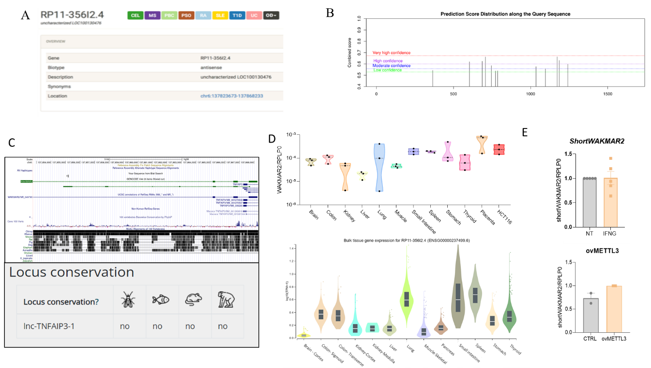
Supplemental Fig. 1. WAKMAR2 is associated with inflammatory disorders, shows tissue-specific expression and presents m6A motifs. (A) WAKMAR2 primary transcript (RP11-356I2.4) is associated with celiac disease (CEL), multiple sclerosis (MS), primary biliary cholangitis (PBS), psoriasis (PSO), rheumatoid arthritis (RA), systemic lupus erythematosus (SLE), type 1 diabetes (T1D), ulcerative colitis (UC) and other disorders (OD). (B) m⁶A predicted peaks for WAKMAR2 by m⁶A predictor SRAMP online tool (C) Interspecies conservation of WAKMAR2 region from UCSC Genome Browser (top) and locus conservation of the lncRNA (WAKMAR2 annotated as lnc-TNFAIP3-1) from LNCipedia database. (D) Relative WAKMAR2 expression in commercial RNA set (top) and RNAseq data from GETx data base (bottom). (E) ShortWAKMAR2 levels quantified by RT-qPCR in HCT-116 cells after 6 hour IFNG treatment. (F) HCT-116 cells were transfected with a METLL3 overexpression or empty vector (CTRL) for 24 hours. shortWAKMAR2 levels were quantified by RT-qPCR. Data are means ± SEM (n≥3).

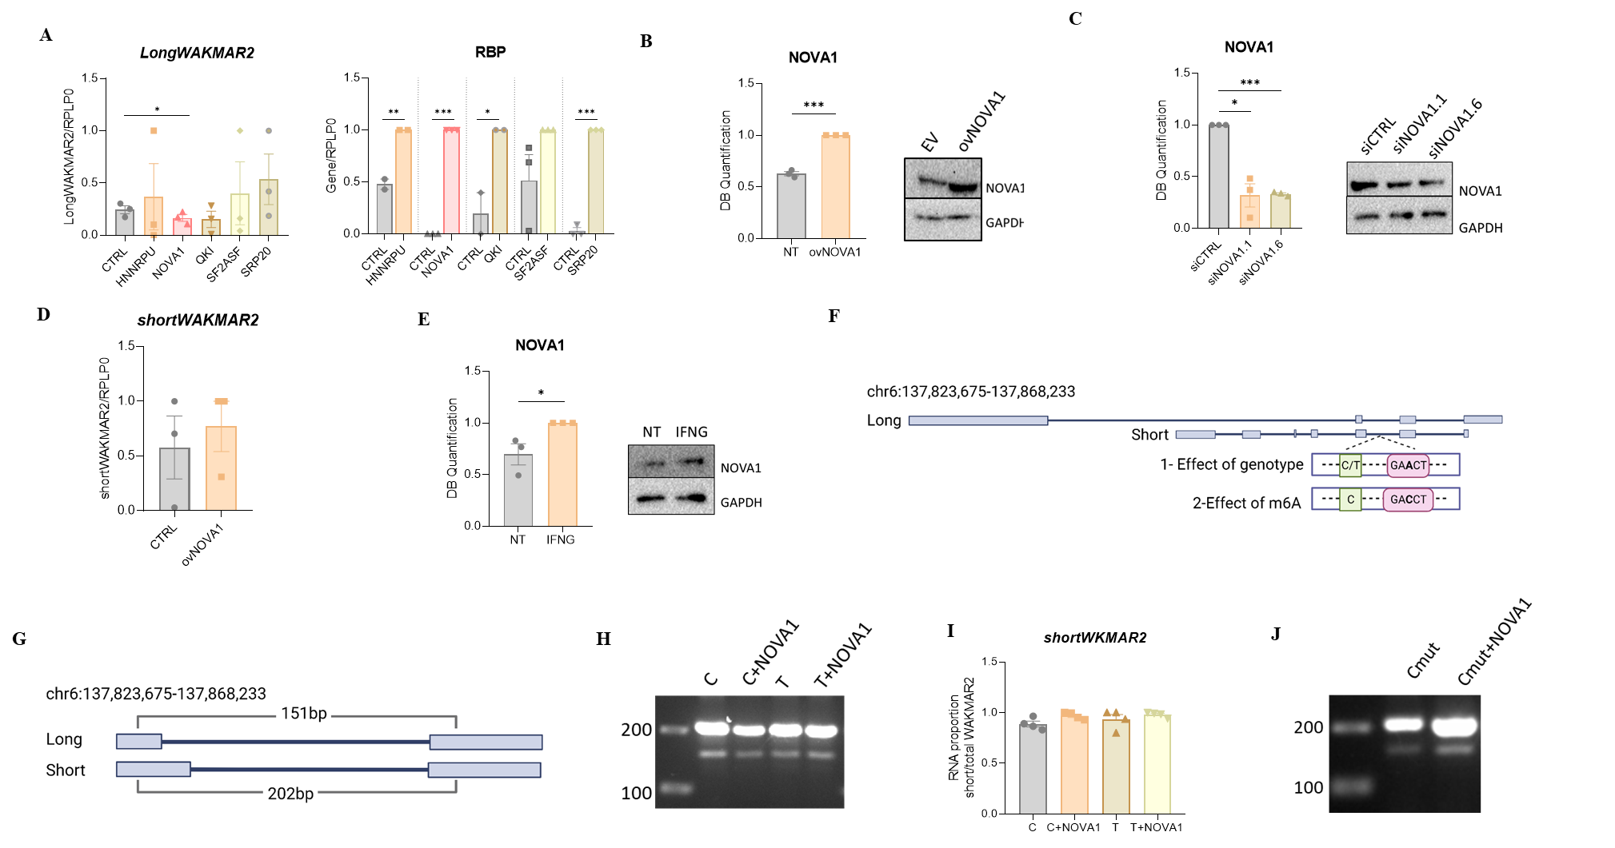
Supplemental Fig. S2. WAKMAR2 splicing is regulated by allele-specific m6A dependent NOVA1 binding. (A) Levels of longWAKMAR2 (left) and WAKMAR2 interacting RBPs (HNNRPU, NOVA1, QKI, SF2ASF, SRP20) (right) after overexpression of these RBPs in HCT-116 cells. (B) Representative Western-Blot (right) and western blot quantification (left) of NOVA1 overexpression in HCT-116 cells. (C) Representative Western-Blot (right) and western blot quantification (left) of NOVA1 silencing in HCT-116 cells. (D) shortWAKMAR2 levels quantified by RT-qPCR in HCT-116 cells transfected with NOVA1 overexpression and an empty vector (CTRL). (E) Representative Western-Blot (right) and quantification (left) of NOVA1 after 6hour IFNG treatment. (F) Graphical representation of the (1) in vitro splicing assay with risk (C) or protective (T) allele and assay (2) after mutated m⁶A motif in the presence of the risk allele. (G) Graphical representation of the PCR amplification depending on the resulting WAKMAR2 isoform after minigene assay. (H) Representative agarose gel showing the amounts of both isoforms before and after NOVA1 overexpression. (I) Relative levels of shortWAKMAR2 after the minigene assay. Levels were quantified from PCR-agarose gel using Fiji software. (J) Representative agarose gel showing the amounts of both isoforms after mutating the m6A motif. Data are means ± SEM (n≥3), *p<0.05, **p<0.01, ***p<0.001 by two-tailed Student’s t-test. Images created with Biorender.

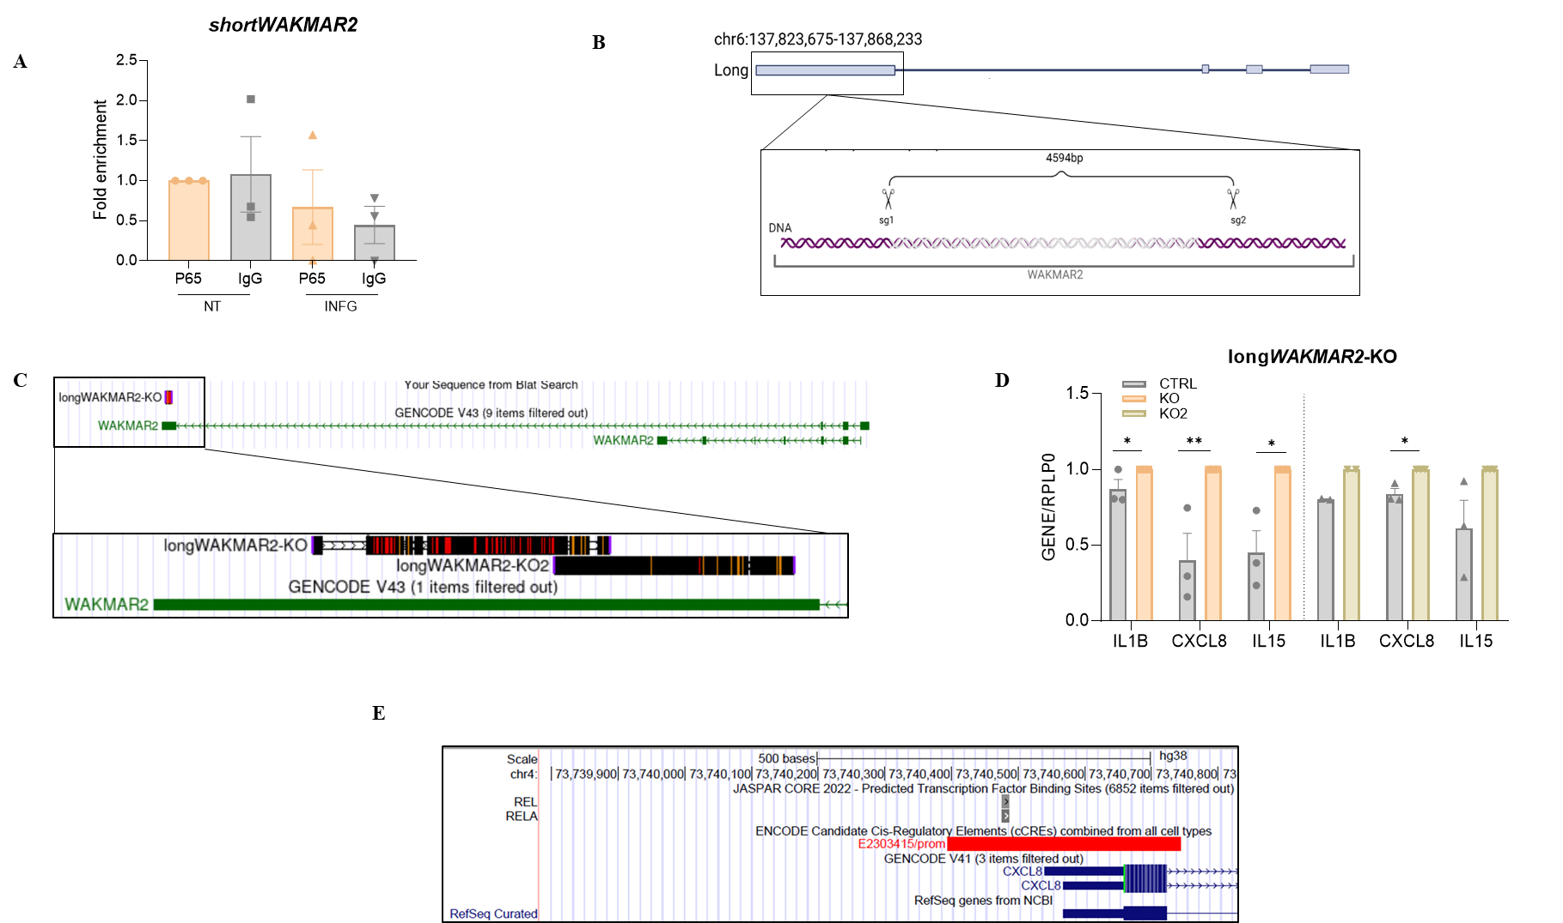
Supplemental Fig. S3. LongWAKMAR2 regulates intestinal inflammation via p65 interaction. (A) HCT-116 cells were stimulated with IFNG for 6 hours and RNA immunoprecipitation was performed using an antibody against p65 or an IgG as a negative control and shortWAKMAR2 levels were quantified by RT-qPCR. Data are means ± SEM (n=3 independent experiments). (B) Graphical representation of CRISPR-KO of longWAKAMR2 deletion in HCT-116. (C) Genomic localization of longWAKMAR2-KO and longWAKMAR2-KO2 deletion sequence. (D) mRNA expression levels of IBD related pro-inflammatory cytokines in HCT-116 longWAKMAR2-KO/KO2 cell lines. Data are means ± SEM (n=3 independent experiments), *p<0.05, **p<0.01 by two-tailed Student’s t-test. (E) Genomic localization of CXCL8 promoter region and predicted RELA (p65) binding to the promoter

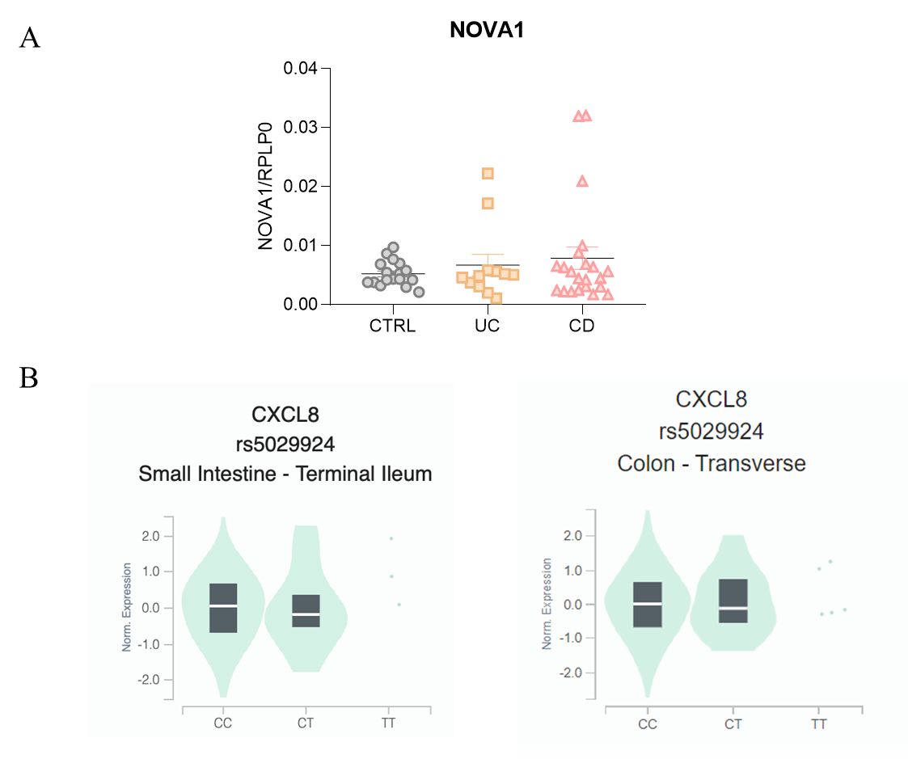
Supplemental Fig. S4. WAKMAR2 and related genes are altered in human samples . (A) Quantification of NOVA1 by RT-qPCR in control (CTRL, n=19), ulcerative colitis (UC. n=12) and Crohn’s disease (Crohn’s, n=23) human samples. Data are means ± SEM. (B) eQTL analysis from GTEx database (https://www.gtexportal.org/home/).

Supplemental Tables
Table S1. In silico analyze of RNA binding proteins of WAKMAR2. The Z-score (standard score) measures the deviation of the hit's WR score from the mean. The mean WR score was calculated using specific background datasets. The P-value represents the probability of obtaining a specific Z-score considering a normal distribution (one-tailed).
 | RBP prediction
 | RNA Binding Protein | Motif | Z-score | P-value
Risk  Allele (C) | HNRNPU | UGUAUUG | 2.328 | 0.00996
Risk  Allele (C) | NOVA1 | YCAY | 2.257 | 0.012
Risk  Allele (C) | QKI | ACUAAY | 1.663 | 0.0482
Risk  Allele (C) | SF2ASF | UGRWGVH | 1.936 | 0.0264
Risk  Allele (C) | SRP20 | WCWWC | 1.886 | 0.0296
Protective Allele (T) | HNRNPU | UGUAUUG | 2.328 | 0.00996
Protective Allele (T) | QKI | ACUAAY | 1.663 | 0.0482
Protective Allele (T) | SF2ASF | UGRWGVH | 1.936 | 0.0264
Protective Allele (T) | SRP20 | WCWWC | 1.886 | 0.0296

Table S3. List of human samples.
Group | Age | Gender (%) |  | Biopsy location (%)
Group | Age±SD | Female | Male | Colorrectum | Ileum | Second Duodenal
Control | 58±13 | 52,63 | 47,36 | 42,105 | 15,789 | 42,105
Ulcerative Colitis | 55±11 | 41,66 | 58,33 | 100,000 | 0,000 | 0,000
Chron's disease | 54±11 | 26,08 | 73,91 | 44,444 | 55,555 | 0,000

Table S3. List and sequence of RT-qPCR primers.
RT-qPCR primers
Gene name | Forward sequence | Reverse sequence
RPLP0 | GCAGCATCTACAACCCTGAAG | CACTGGCAACATTGCGGAC
longWAKMAR2 | GAGCGCAAGGATGATCTTTGAG | AACACAACCTCACGTCACTG
shortWAKMAR2 | GCACAAAAGATGAGCGGTTAC | TGGGATTACAGGAATGCACCAC
WAKMAR2 | TCCATCCGGTTCTAGTTTAGCC | TGTCTTACTGCCCTCTAAGCAC
METTL3 | GGAGATAGAGAGCCTTCTGAACC | TCGAGAGCGAAATTTTTCAAC
NOVA1 | TACTGAGCGAGTGTGCTTGAT | GTCTGGGGTTGTAGAATGCTG
Minigene WAKMAR2 | AGTGGCAGGTATGAACGTGG | GCATGAGACGTAGGTCCCAG
CXCL8 | ACTGAGAGTGATTGAGAGTGGAC | AACCCTCTGCACCCAGTTTTC
CXCL8 promoter | TGGGCCATCAGTTGCAAATC | GTGCTCCGGTGGCTTTTTATATC
HNNRPU | ATTCAAAATGGGGCTCAAGGTAT | GTGTCAGGACTATTTGGACCAG
QKI | CTGATGCTGTGGGACCTATTG | GTTGTTTGGCTGTAAGTCCTCT
SF2ASF | TGTTCTACAAATACGGCGCTATC | CTCGAACTCAACGAAGGCGA
SRP20 | TGGCAACAAGACGGAATTGGA | CAAAGCCGGGTGGGTTTCTA
IL1B | TTCGACACATGGGATAACGAGG | TTTTTGCTGTGAGTCCCGGAG
CXCL10 | GTGGCATTCAAGGAGTACCTC | TGATGGCCTTCATTCTGGATT
IL15 | TTGGGAACCATAGATTTGTGCAG | AGAGAAAGCACTTCATTGCTGTT
longWAKMAR2 KO-sg1 | CAGTTTTAACCAGATAACAG | CTGTTATCTGGTTAAAACTG
longWAKMAR2 KO-sg2 | AGACCCAAAGGGATCAGGCG | CGCCTGATCCCTTTGGGTCT

Table S4. List of antibodies uses for western-blot, dot-blot and immunoprecipitation assays.
Antibodies
Protein name | Size | Source | Product reference
m6A | - | Rabbit | Abcam, #284130
METTL3 | 64 | Rabbit | Abcam, #195352
GAPDH | 37 | Mouse | Santa Cruz Biotechnologies, #sc-47724
NOVA1 | 52 | Goat | Thermo Fisher, # PA5-18895
HSP90 | 90 | Rabbit | Cell Signaling, #4874
RELA/NF-κB p65 | 65 | Mouse | Santa Cruz Biotechnologies, #sc-8008

