A comparison of coffee effects on vigilance and attention in pilots across simple and complex lab environments

Supplemental materials

Blink characteristics
Blink rates and blink duration variability confirmed a gradual increase in sleepiness as the experiment progressed. Moreover, a significant Session x Treatment order interaction for blink duration variability indicated that participants were sleepier during the second session, but only in the regular-first group. Blink rates show a similar pattern, but the Session x Treatment Order interaction was not significant (p=.27).
Table S1. Result summary of repeated-measures ANOVAs of blink duration variability and blink rate: F-statistics, significance levels (*p<.05; **p<.01; ***p<.001) and effect sizes (η²_{G}) (p-values < 0.05 in bold).
 | ALL |  | Regular-first |  |  | Decaf-first
 | F | η²_{G} | F | η²_{G} |  | F |  | η²_{G}
Standard deviation blink duration
Time | 41.6*** | .24 | 35.9*** | .31 |  | 13.9*** |  |  | .182
Session | 5.51* | .02 | 28.5*** | .13 |  | .676
Treatment Order | 1.29
Time x Session | .850 |  | .548 |  |  | .341
Time x Treatment Order | .584
Session x Treatment Order | 13.5*** | .04
Time x Session x Treatment Order | .021
Mean blink rate
Time | 61.1*** | .24 | 38.1*** | .27 |  | 23.9*** |  |  | .22
Session | 2.42 |  | 1.94 |  |  | .365
Treatment Order | .376
Time x Session | 2.43 |  | 2.0 |  |  | .543
Time x Treatment Order | 1.87
Session x Treatment Order | 1.26
Time x Session x Treatment Order | .486

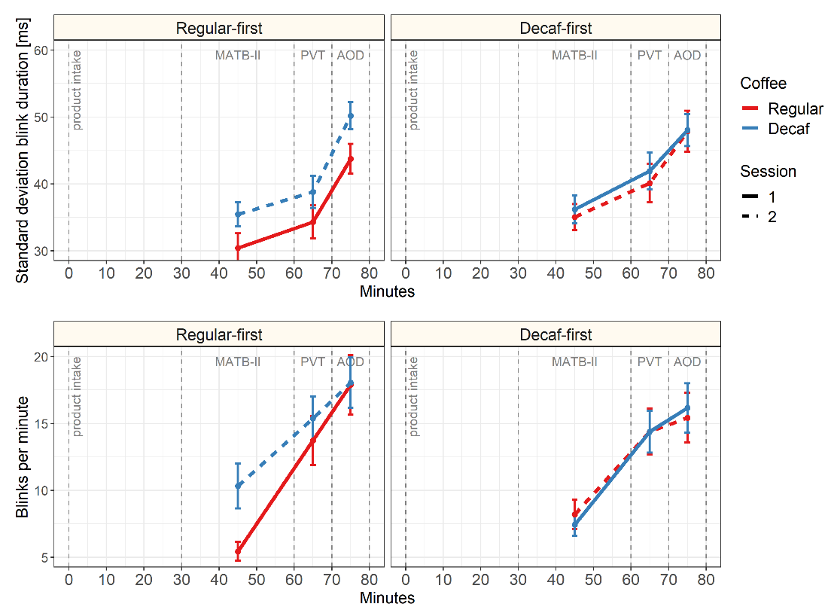
FigS1 Blink duration variability (top panel) and blink rate (bottom) over time in regular coffee session (dark grey lines) and decaf coffee session (light grey lines) for the Regular-first (left) and the Decaf-first group (right). Solid lines reflect session 1, dashed lines session 2. Error bars show ±SEM

