SUPPLEMENTARY MATERIALS

Table S1. Statistical models to determine the effect of host depletion treatment on %host DNA content. Effect size, 95% confidence interval (95% CI), and p-value derived using a linear mixed effect model with outcome as % host DNA, each treatment (binary compared to no treatment) as fixed effect and subject as random effect using r package lmer::lmer( Host DNA % ~ treatment + (1|subject_id) ) [36]. Stratified analyses were conducted for each sample type as an interaction term of sample type and treatment was significant (p-value < 0.001). The baseline of categorical variable is untreated, and statistical significances were noted with *: p-value < 0.05 and ***: p-value < 0.001.
 | BAL |  |  | Nasal swab |  |  | Sputum
 | Effect size (95% CI) | p-value |  | Effect size (95% CI) | p-value |  | Effect size (95% CI) | p-value
(Intercept) | 99.6 (89.4, 109.9) | <0.001 | *** | 95.2 (80.9, 109.6) | <0.001 | *** | 99.0 (89.8, 108.2) | <0.001 | ***
lyPMA | -3.1 (-15.7, 9.5) | 0.657 |  | -27.7 (-49.0, -6.3) | 0.026 | * | -3.8 (-15.4, 7.8) | 0.558
Benzonase | -1.1 (-13.8, 11.5) | 0.870 |  | -20.0 (-41.4, 1.5) | 0.099 |  | -6.3 (-17.9, 5.4) | 0.339
HostZERO | -18.3 (-30.9, -5.6) | 0.016 | * | -73.6 (-94.9, -52.1) | <0.001 | *** | -45.5 (-57.1, -33.8) | <0.001 | ***
MolYsis | -17.7 (-30.3, -5.1) | 0.019 | * | -50.6 (-72.0, -29.3) | <0.001 | *** | -69.6 (-81.3, -58.0) | <0.001 | ***
QIAamp | -6.3 (-18.9, 6.3) | 0.376 |  | -75.4 (-96.9, -54.0) | <0.001 | *** | -18.7 (-30.3, -7.1) | 0.008 | **

Table S2. Statistical models to determine the effect of host depletion treatment on final non-human reads. Changes on final reads stratified by sample type tested with linear mixed effect models using lmer(log₁₀(Final reads) ~ Treatment + (1|Subject id)). Stratified analyses were conducted for each sample type as an interaction term of sample type and treatment was significant at an ANOVA test (p-value < 0.001) using a model, lmer(log₁₀(Final reads) ~ sample type + treatment + sample type * treatment + (1|subject_id) ). Effect size with adjusted 95% confidence intervals and p-value were listed. The unit of final read is reads x 10⁶. *: p-value < 0.05, **: p-value < 0.01 and ***: p-value < 0.001.
 | BAL |  |  | Nasal swab |  |  | Sputum
 | Effect size (95% CI) | p-value |  | Effect size (95% CI) | p-value |  | Effect size (95% CI) | p-value
(Intercept) | -0.5 (-1.0, 0.0) | 0.050 |  | 0.5 ( 0.2, 0.8) | 0.004 | ** | -0.2 (-0.4, 0.0) | 0.120
lyPMA | 0.4 (-0.2, 0.9) | 0.247 |  | -0.5 (-1.0, -0.1) | 0.040 | * | 0.5 ( 0.3, 0.8) | 0.001 | **
Benzonase | 0.8 ( 0.2, 1.4) | 0.012 | * | 0.1 (-0.3, 0.6) | 0.571 |  | 0.8 ( 0.6, 1.1) | <0.001 | ***
HostZERO | 1.0 ( 0.4, 1.5) | 0.004 | ** | 0.9 ( 0.4, 1.3) | 0.002 | ** | 1.7 (1.4, 1.9) | <0.001 | ***
MolYsis | 1.0 ( 0.5, 1.6) | 0.002 | ** | 0.2 (-0.2, 0.7) | 0.407 |  | 2.0 (1.7, 2.2) | <0.001 | ***
QIAamp | 1.0 ( 0.5, 1.6) | 0.002 | ** | 1.1 ( 0.6, 1.5) | <0.001 | *** | 1.4 (1.1, 1.7) | <0.001 | ***

Table S3. Statistical models to determine the effect of host depletion treatment on taxonomic species richness. Effect size, standard error (SE) and p-value of a statistical test for species richness using linear mixed effect model stratified by sample type (species richness ~ treatment + (1|subject id)). Stratified analyses were conducted for each sample type as an interaction term of sample type and treatment was significant at an ANOVA test (p-value < 0.001) using a model, lmer(species richness ~ sample type + treatment + sample type * treatment + (1|subject id)). Statistical significances were noted with *: p-value < 0.05, **: p-value < 0.01, and ***: p-value < 0.001.

 | BAL |  |  | Nasal swab |  |  | Sputum
 | Effect size (95% CI) | p-value |  | Effect size (95% CI) | p-value |  | Effect size (95% CI) | p-value
(Intercept) | 5.0 (-6.7, 16.7) | 0.438 |  | 10.1 (7.5, 12.7) | <0.001 | *** | 15.8 (-4.8, 36.4) | 0.168
lyPMA | 1.8 (-10.3, 13.8) | 0.796 |  | -4.5 (-8.9, -0.1) | 0.068 |  | 36.8 (18.9, 54.7) | 0.001 | **
Benzonase | 5.2 (-6.3, 16.8) | 0.425 |  | -0.1 (-4.5, 4.3) | 0.969 |  | 65.8 (47.9, 83.7) | <0.001 | ***
HostZERO | 8.4 (-3.1, 20.0) | 0.204 |  | 10.3 (5.9, 14.7) | <0.001 | *** | 101.8 (83.9, 119.7) | <0.001 | ***
MolYsis | 18.4 (6.9, 30.0) | 0.010 | ** | 6.3 (1.9, 10.7) | 0.013 | * | 111.4 (93.5, 129.3) | <0.001 | ***
QIAamp | 9.0 (-2.5, 20.6) | 0.175 |  | 7.5 (3.1, 11.9) | 0.004 | ** | 84.2 (66.3, 102.1) | <0.001 | ***

Table S4. Mediation analysis. The analysis employed treatment as the exposure, log₁₀(final non-human reads) as mediator, observed species richness or predicted functional richness as outcome, and also adjusted for sample type in both exposer-mediator and mediator-outcome models, using mixed effect models accounting for random effect by subjects. Statistical significance noted with *: p-value < 0.05, **: p-value < 0.01, and ***: p-value < 0.001.

 | Outcome | Treatment | Indirect est. | Indirect p-value | Direct est. | Direct p-value | Total est. | Total p-value | Proportion mediated est. | Proportion mediated  p-value
Species  richness |  | lyPMA | 1.072 | 0.759 | 11.871 | 0.027* | 12.943 | 0.042* | 0.075 | 0.731
 |  | Benzonase | 11.236 | 0.024* | 11.922 | 0.167 | 23.158 | 0.004** | 0.472 | 0.028*
 |  | HostZERO | 28.569 | 0.002** | 10.444 | 0.407 | 39.013 | <0.001*** | 0.728 | 0.002**
 |  | MolYsis | 25.868 | <0.001*** | 18.709 | 0.040* | 44.577 | <0.001*** | 0.575 | <0.001***
 |  | QIAamp | 20.592 | 0.046* | 11.229 | 0.376 | 31.821 | <0.001*** | 0.645 | 0.046*
 | Functional  richness | lyPMA | 6.6 | 0.543 | 47.393 | 0.006 | 53.993 | 0.009** | 0.108 | 0.537
 | Functional  richness | Benzonase | 35.324 | 0.006** | 35.651 | 0.045 | 70.975 | <0.001*** | 0.492 | 0.006**
 | Functional  richness | HostZERO | 52.768 | 0.003** | 61.922 | 0.006 | 114.691 | <0.001*** | 0.457 | 0.003**
 | Functional  richness | MolYsis | 51.946 | <0.001*** | 65.712 | 0.003 | 117.658 | <0.001*** | 0.434 | <0.001***
 | Functional  richness | QIAamp | 76.921 | <0.001*** | 28.917 | 0.294 | 105.838 | <0.001*** | 0.725 | <0.001***

Table S5. Effect of host depletion on relative abundance of gram-negative bacteria. Note that the mock community preserved in DNA/RNA protect (Zymo D6300) which contains a mild detergent while BAL, nasal swab, and sputum samples had no preservatives added. Statistical testing performed using a linear mixed effect model. lmer(%gram negative ~ sample type + treatment + sample type * treatment + (1|subject id)). Stratified analyses were conducted for each sample type as an interaction term of sample type and treatment was significant at an ANOVA test (p-value < 0.001). Statistical significances were noted with ***: p-value < 0.001.

 | Mock |  |  | BAL |  |  | Nasal swab |  |  | Sputum
 | Effect size (95% CI) | p-value |  | Effect size (95% CI) | p-value |  | Effect size (95% CI) | p-value |  | Effect size (95% CI) | p-value
(Intercept) | 51.1 (46.7, 55.5) | < 0.001 | *** | 32.8 (-5.1, 70.7) | 0.125 |  | 0.8 (-2.4, 4.1) | 0.635 |  | 61.6 (51.8, 71.5) | < 0.001 | ***
lyPMA | -23.5 (-30.1, -17.0) | < 0.001 | *** | 6.4 (-21.2, 34.1) | 0.677 |  | 19.4 (14.1, 24.6) | < 0.001 | *** | -40.9 (-52.6, -29.1) | < 0.001 | ***
Benzonase | -51.1 (-57.6, -44.5) | < 0.001 | *** | 15.3 (-12.3, 43.0) | 0.324 |  | 1.9 (-3.4, 7.5) | 0.514 |  | -52.5 (-64.2, -40.7) | < 0.001 | ***
HostZERO | -51.1 (-57.7, -44.6) | < 0.001 | *** | 8.6 (-19.0, 36.3) | 0.577 |  | 0.0 (-5.3, 5.6) | 0.993 |  | -59.9 (-71.6, -48.1) | < 0.001 | ***
MolYsis | -50.6 (-57.2, -44.1) | < 0.001 | *** | 3.4 (-24.3, 31.0) | 0.826 |  | 2.3 (-3.0, 7.6) | 0.432 |  | -59.9 (-71.6, -48.1) | < 0.001 | ***
QIAamp | -51.1 (-57.6, -44.5) | < 0.001 | *** | 7.3 (-20.4, 35.0) | 0.635 |  | 0.1 (-5.4, 5.5) | 0.963 |  | -60.6 (-72.3, -48.8) | < 0.001 | ***

Table S6. Effect of host depletion treatment on microbial community structure assessed with PERMANOVA. Degree of freedom, effect size (residual, R²) and p-value of permutational ANOVA for Morisita-Horn (MH) dissimilarity with treatment group and strata term (MH-dissimilarity of species composition ~ lyPMA + Benzonase + HostZERO + MolYsis + QIAamp, strata = subject id), stratified by sample type as interaction term of model (MH-dissimilarity of species composition ~ sample type * treatment + subject, strata = subject id) was significant (p-value < 0.001). Statistical significances were noted with ***: p-value < 0.001.
 | BAL |  |  | Nasal swab |  |  | Sputum
 | R² | p-value |  | R² | p-value |  | R² | p-value
lyPMA | 0.006 | 0.302 |  | 0.058 | 0.004 | ** | 0.011 | 0.354
Benzonase | 0.001 | 0.945 |  | 0.031 | 0.254 |  | 0.003 | 0.661
HostZERO | 0.006 | 0.435 |  | 0.029 | 0.471 |  | 0.025 | 0.122
MolYsis | 0.007 | 0.403 |  | -0.005 | 0.975 |  | 0.055 | 0.023 | *
QIAamp | 0.014 | 0.039 | * | 0.053 | 0.030 | * | 0.144 | <0.001 | ***
Residual | 0.966 | - |  | 0.835 | - |  | 0.762 | -
Total | 1.000 | - |  | 1.000 | - |  | 1.000 | -

Table S7. Effect of host depletion treatment on paired Morisita-Horn dissimilarity between treated and untreated samples from the same participant. Effect size, standard error (SE) and p-value of a statistical test for Morisita-Horn dissimilarity from untreated to each treated within subject, stratified by sample type. Stratified analyses were conducted for each sample type as an interaction term of sample type x treatment was significant (p-value < 0.001) using a model, ANOVA(distance within subject by treatment ~ sample type + treatment + sample type * treatment). The test was conducted with a linear mixed effect model lmer(Paired M-H dissimilarity ~ treatment + (1|subject)). Effect size of 0 indicates no dissimilarity, while effect size of 1 indicates complete dissimilarity. Statistical significances were noted with *: p-value < 0.05, **: p-value < 0.01 and ***: p-value < 0.001.
 | BAL |  |  | Nasal swab |  |  | Sputum
 | Effect size (95% CI) | p-value |  | Effect size (95% CI) | p-value |  | Effect size (95% CI) | p-value
Untreated | 0.0 (-0.2, 0.2) | 1.000 |  | 0.0 (-0.1, 0.1) | 1.000 |  | 0.0 (-0.3, 0.3) | 1.000
lyPMA | 0.3 (0.1, 0.6) | 0.029 | * | 0.2 (0.1, 0.3) | 0.013 | * | 0.3 (0.1, 0.6) | 0.006 | **
Benzonase | 0.1 (-0.1, 0.3) | 0.440 |  | 0.2 (0.0, 0.3) | 0.022 | * | 0.5 (0.3, 0.7) | 0.000 | ***
HostZERO | 0.3 (0.0, 0.5) | 0.060 |  | 0.0 (-0.1, 0.2) | 0.460 |  | 0.6 (0.4, 0.8) | 0.000 | ***
MolYsis | 0.2 (0.0, 0.4) | 0.150 |  | 0.2 (0.1, 0.3) | 0.002 | ** | 0.6 (0.4, 0.8) | 0.000 | ***
QIAamp | 0.3 (0.0, 0.5) | 0.082 |  | 0.1 (0.0, 0.3) | 0.050 |  | 0.6 (0.4, 0.8) | 0.000 | ***

Table S8. List of differentially abundant taxa identified using linear mixed effect model (feature ~ sample type + lyPMA + Benzonase + HostZero + MolYsis + QIAamp + (1|subject id)) after centered log ration normalization. Only significant changes (|change of centered log-ratio|≥ 4 or q-value ≤ 0.1) depicted.

Taxa | Fixed effect | Change estimate of CLR transformed count | q-value
Actinomyces graevenitzii | Sample type | 6.348 | 0.000
Actinomyces odontolyticus | Sample type | 4.810 | 0.023
Actinomyces oris | Sample type | 6.431 | 0.000
Actinomyces sp. HMSC035G02 | Sample type | 4.653 | 0.000
Actinomyces sp. ICM47 | Sample type | 4.832 | 0.000
Corynebacterium accolens | Sample type | 13.471 | 0.000
Corynebacterium atypicum | Sample type | 4.963 | 0.000
Rothia dentocariosa | Sample type | 7.048 | 0.000
Rothia mucilaginosa | Sample type | 6.192 | 0.010
Cutibacterium acnes | Sample type | 12.358 | 0.000
Cutibacterium granulosum | Sample type | 6.082 | 0.005
Prevotella oris | Sample type | -4.478 | 0.032
Gemella sanguinis | Sample type | 6.933 | 0.000
Staphylococcus epidermidis | Sample type | 8.345 | 0.000
Dolosigranulum pigrum | Sample type | 7.626 | 0.030
Granulicatella elegans | Sample type | 4.678 | 0.000
Streptococcus australis | Sample type | 5.144 | 0.000
Streptococcus gordonii | Sample type | 4.994 | 0.000
Streptococcus infantis | Sample type | 6.457 | 0.000
Streptococcus mitis | Sample type | 4.856 | 0.034
Streptococcus parasanguinis | Sample type | 7.562 | 0.000
Streptococcus salivarius | Sample type | 7.307 | 0.000
Streptococcus sanguinis | Sample type | 5.021 | 0.001
Streptococcus sp. F0442 | Sample type | 4.818 | 0.000
Finegoldia magna | Sample type | -4.712 | 0.018
Cupriavidus sp. | Sample type | -7.565 | 0.000
Sutterella parvirubra | lyPMA | 4.478 | 0.000
Sutterella parvirubra | HostZERO | 4.048 | 0.000
Pseudomonas aeruginosa | Sample type | 7.500 | 0.000
Candida albicans | Sample type | -5.990 | 0.013
Candida dubliniensis | Sample type | -6.395 | 0.010
Malassezia restricta | Sample type | 4.803 | 0.043
Alloprevotella tannerae | Sample type | -5.883 | 0.008
Prevotella sp. oral taxon 306 | Sample type | -4.575 | 0.025
Prevotella veroralis | Sample type | -4.982 | 0.017
Lactobacillus fermentum | Sample type | -5.182 | 0.029
Staphylococcus haemolyticus | Sample type | -5.489 | 0.028
Candida orthopsilosis | Sample type | -4.995 | 0.026

Table S9. Effect of host depletion on predicted microbial functional richness. Effect size, standard error (SE) and p-value of a statistical test for functional richness with an interaction term using linear mixed effect model (functional richness ~ treatment + (1|subject_id)). Stratified analyses were conducted for each sample type as an interaction term of sample type and treatment was significant (p-value < 0.001). Statistical significance noted with **: p-value < 0.01 and ***: p-value < 0.001.
 | BAL |  |  | Nasal swab |  |  | Sputum
 | Effect size (95% CI) | p-value |  | Effect size (95% CI) | p-value |  | Effect size (95% CI) | p-value
(Intercept) | 21.6 (-51.7, 94.9) | 0.549 |  | 137.1 (118.4, 155.8) | <0.001 | *** | 169.8 (125.1, 214.5) | <0.001 | ***
lyPMA | 58.6 (-45.1, 162.3) | 0.255 |  | 9.1 (-23.2, 41.4) | 0.569 |  | 79.8 (16.5, 143.1) | 0.016 | *
Benzonase | 126.4 (22.7, 230.1) | 0.019 | * | 22.5 (-9.8, 54.8) | 0.165 |  | 85.8 (22.5, 149.1) | 0.010 | **
HostZERO | 164.6 (60.9, 268.3) | 0.003 | ** | 66.3 (34.0, 98.6) | <0.001 | *** | 137.0 (73.7, 200.3) | <0.001 | ***
MolYsis | 190.0 (86.3, 293.7) | 0.001 | ** | 53.5 (21.2, 85.8) | 0.002 | ** | 141.8 (78.5, 205.1) | <0.001 | ***
QIAamp | 130.2 (26.5, 233.9) | 0.016 | * | 65.7 (33.4, 98.0) | <0.001 | *** | 115.6 (52.3, 178.9) | 0.001 | ***

Table S10. Potential contaminants and their prevalence across all samples (N = 113) and within negative controls (N = 31). The contaminants were identified using decontam [23] combined method (Fisher’s exact test result of prevalence and frequency method results), using 16S qPCR bacterial DNA concentration as total bacterial load at prevalence threshold of 0.1. The analyses were stratified by sample types.
Sample type | Taxa | Prevalence (all)  N = 93 | Prevalence (negative controls)  N = 31
BAL | Cupriavidus sp. | 82 (88.17%) | 25 (80.65%)
 | Cutibacterium acnes | 53 (56.99%) | 31 (100%)
 | Sutterella parvirubra | 48 (51.61%) | 1 (3.23%)
Nasal swab | Cupriavidus sp. | 82 (88.17%) | 25 (80.65%)
 | Sutterella parvirubra | 48 (51.61%) | 1 (3.23%)
Sputum | Collinsella intestinalis | 30 (32.26%) | 0 (0%)
 | Cupriavidus sp. | 82 (88.17%) | 25 (80.65%)
 | Cutibacterium acnes | 53 (56.99%) | 31 (100%)
 | Leptotrichia sp. oral taxon 212 | 4 (4.3%) | 0 (0%)
 | Rothia aeria | 16 (17.2%) | 0 (0%)
 | Streptococcus infantis | 27 (29.03%) | 0 (0%)

Table S11. Sensitivity analysis where potential contaminants were removed from dataset prior to statistical modelling for species richness. Effect size (95% confidence interval) and p-value of decontaminated species richness using decontam [23] (decontaminated data 1) and tinyvamp [24] (decontaminated data 2). The change was tested using a model lmer(species richness~ treatment + (1|subject id)). Statistical significances were noted with *: p-value < 0.05, **: p-value < 0.01, and ***: p-value < 0.001.

 | Decontaminated data 1 |  |  |  |  |  |  |  |  | Decontaminated data 2
 | BAL |  |  | Nasal swab |  |  | Sputum |  |  | BAL |  |  | Nasal swab |  |  | Sputum
 | Effect size  (95% CI) | p-value |  | Effect size  (95% CI) | p-value |  | Effect size  (95% CI) | p-value |  | Effect size  (95% CI) | p-value |  | Effect size  (95% CI) | p-value |  | Effect size  (95% CI) | p-value
(Intercept) | 3.4 (-6.6, 13.4) | 0.520 |  | 8.1 (5.6, 10.6) | <0.001 | *** | 14.2 (-4.0, 32.4) | 0.159 |  | 3.6 (-5.2, 12.4) | 0.436 |  | 6.3 (4.9, 7.7) | <0.001 | *** | 8.0 (-2.0, 18.0) | 0.152
lyPMA | 0.2 (-9.3, 9.7) | 0.968 |  | -5.4 (-9.5, -1.2) | 0.017 | * | 31.6 (14.8, 48.4) | 0.001 | ** | 1.0 (-8.3, 10.3) | 0.835 |  | -1.5 (-3.9, 0.9) | 0.235 |  | 14.8 (5.5, 24.1) | 0.005 | **
Benzonase | 5.0 (-4.5, 14.5) | 0.315 |  | -0.6 (-4.7, 3.5) | 0.780 |  | 57.8 (41.0, 74.6) | <0.001 | *** | 4.0 (-4.9, 12.9) | 0.392 |  | 0.1 (-2.3, 2.5) | 0.937 |  | 26.2 (16.9, 35.5) | <0.001 | ***
HostZERO | 7.0 (-2.5, 16.5) | 0.164 |  | 8.0 (3.9, 12.1) | 0.001 | ** | 88.4 (71.6, 105.2) | <0.001 | *** | 6.0 (-2.9, 14.9) | 0.204 |  | 6.3 (3.9, 8.7) | <0.001 | *** | 45.2 (35.9, 54.5) | <0.001 | ***
MolYsis | 16.0 (6.5, 25.5) | 0.004 | ** | 4.6 (0.4, 8.7) | 0.040 | * | 96.8 (80.0, 113.6) | <0.001 | *** | 12.0 (3.1, 20.9) | 0.017 | * | 3.1 (0.7, 5.5) | 0.019 | * | 51.8 (42.5, 61.1) | <0.001 | ***
QIAamp | 7.8 (-1.7, 17.3) | 0.123 |  | 6.4 (2.3, 10.5) | 0.005 | ** | 73.8 (57.0, 90.6) | <0.001 | *** | 6.2 (-2.7, 15.1) | 0.190 |  | 6.3 (3.9, 8.7) | <0.001 | *** | 35.2 (25.9, 44.5) | <0.001 | ***

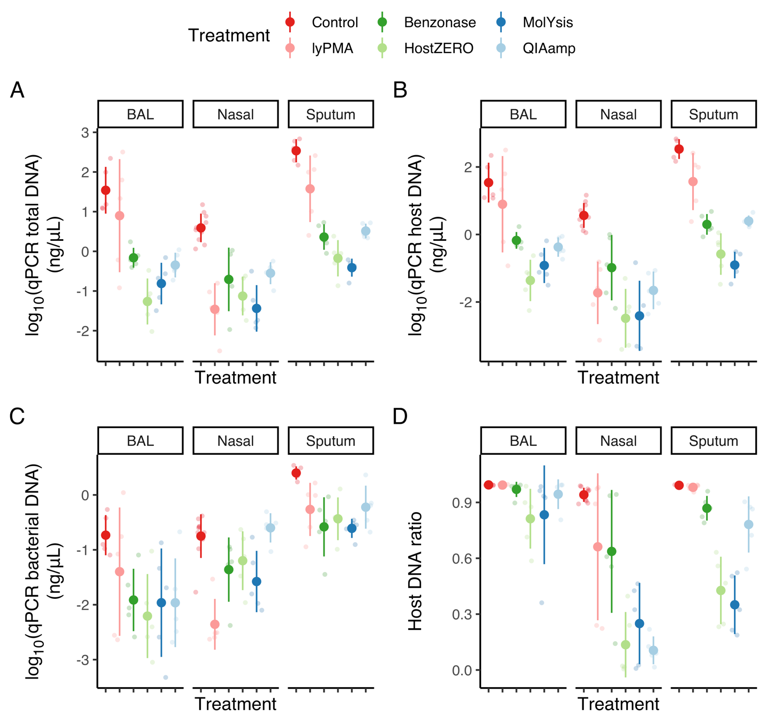

Fig. S1. Host depletion effects measured by qPCR in mean values ± SD. (A) total DNA (16S bacterial DNA + human LINE-1), (B) human DNA, (C) bacterial DNA, and (D) proportion of host DNA.

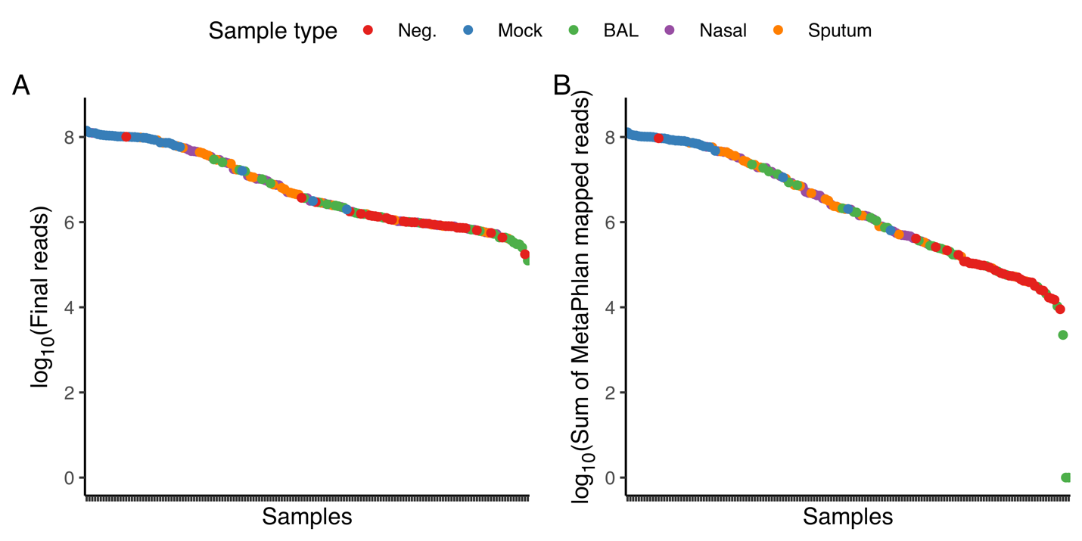

Fig. S2. (A) final reads after removing low quality reads and host-mapped reads and (B) sum of MetaPhlAn mapped reads by sample type.

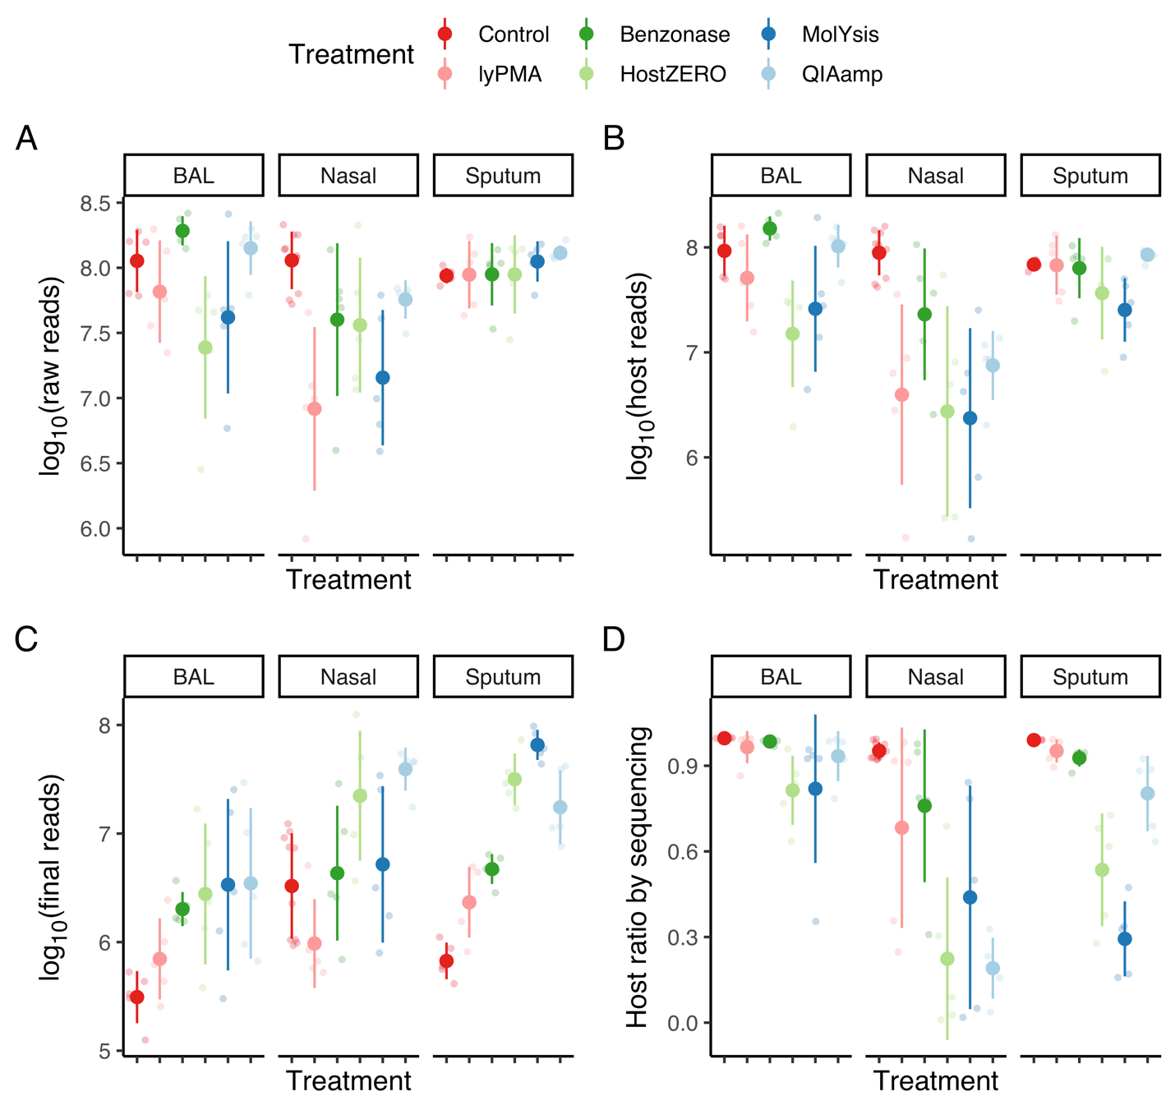 Fig. S3. Host depletion effects measured by shotgun metagenomic sequencing in mean values ± SD. (A) Raw DNA reads, (B) host mapped reads by bowtie2, (C) final reads of microbes, and (D) proportion of host mapped among total mapped reads.

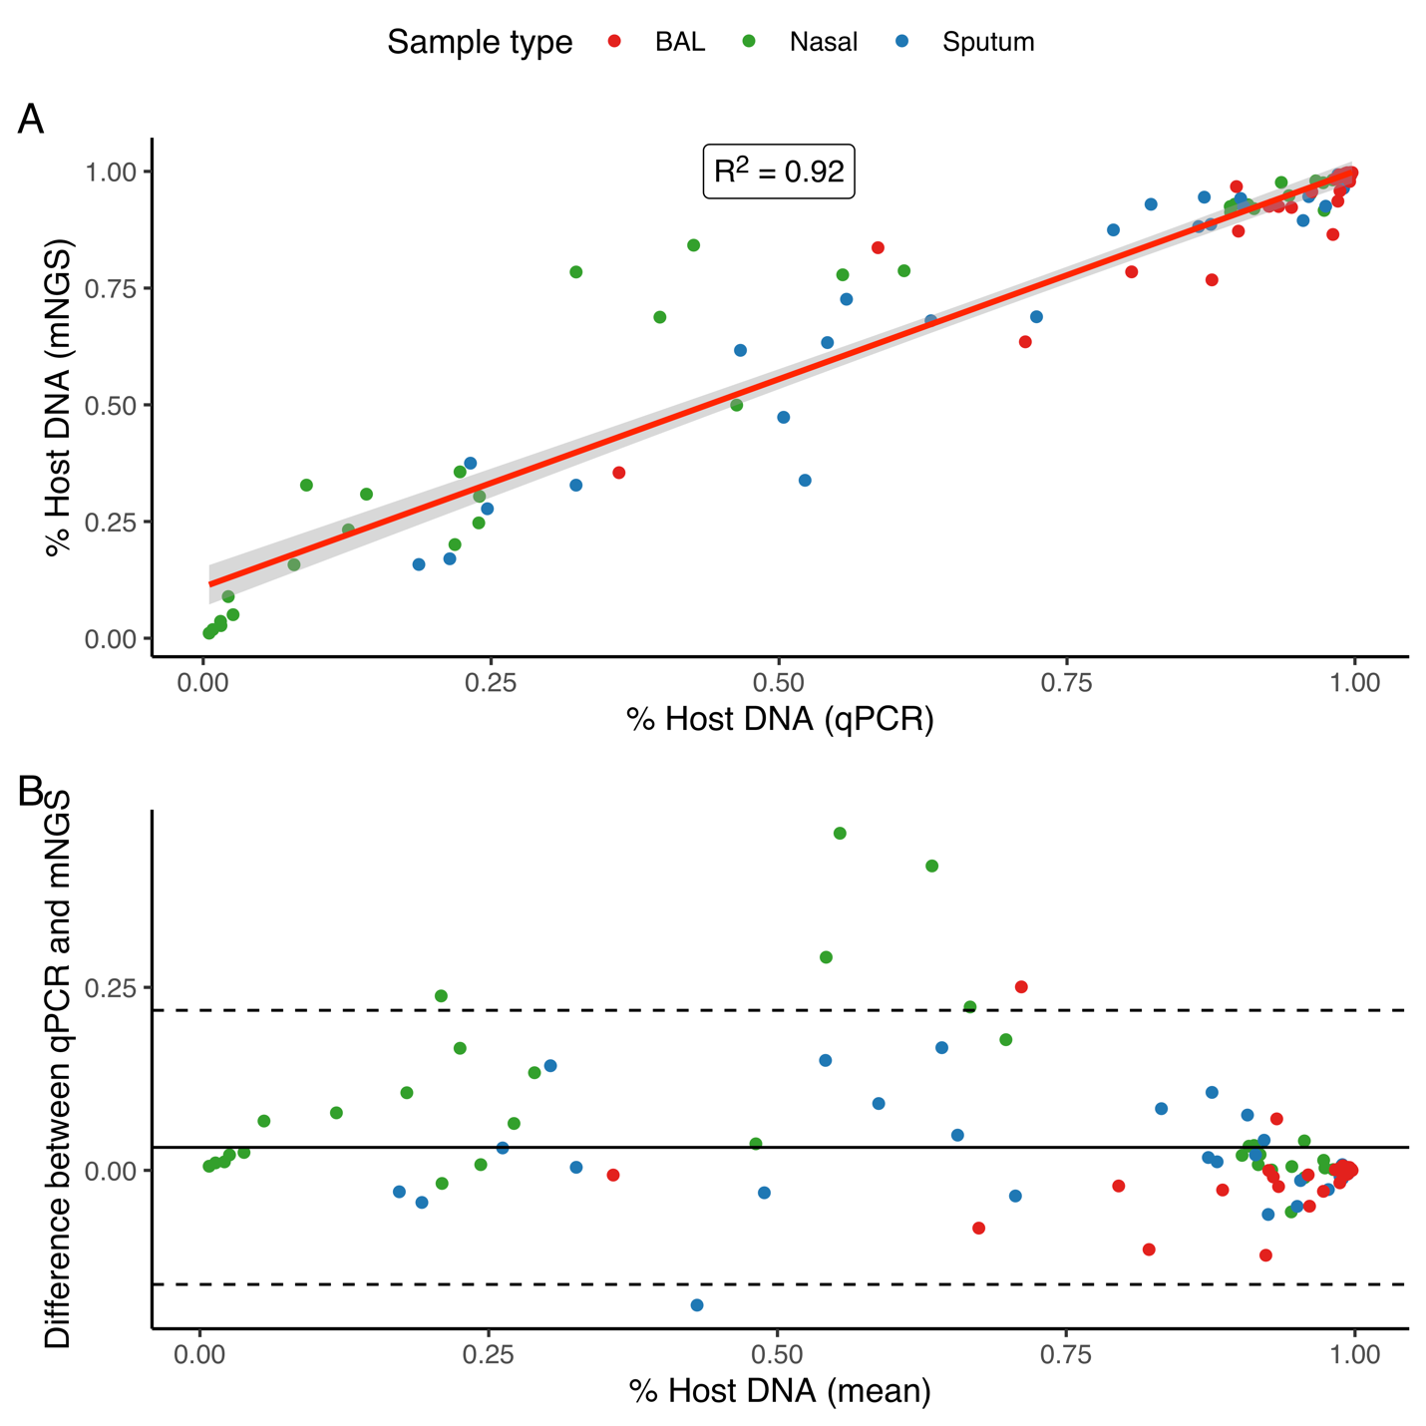

Fig. S4. Proportion host DNA estimated by mNGS and qPCR. (A) Correlation plot and (B) Bland-Altman plot between host DNA proportion measured with qPCR and shotgun metagenomic sequencing.

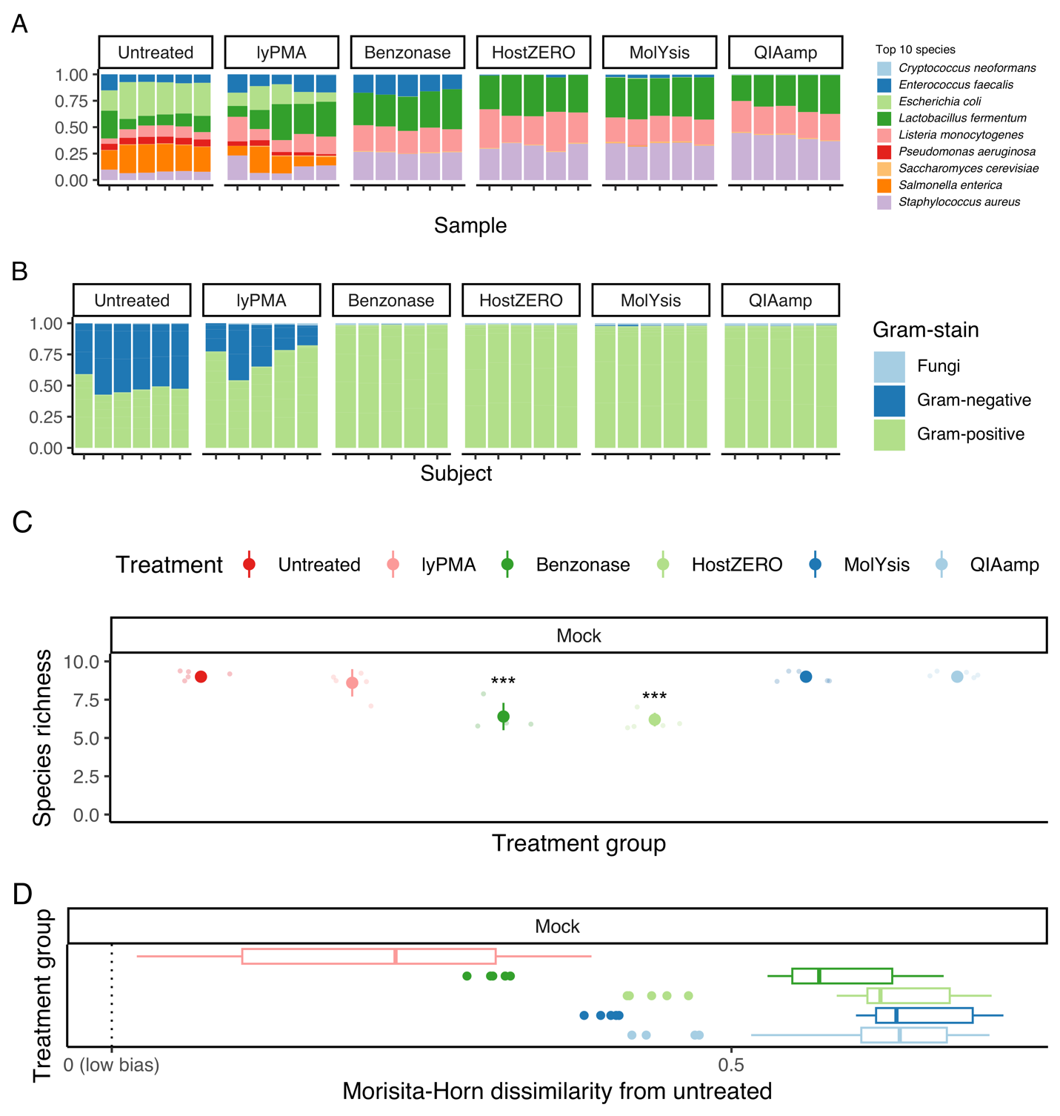Fig. S5. Effect of host depletion treatment on mock community preserved in DNA/RNA Shield (Zymod D6300). (A) Bar plot of expected taxa in mock community at species level, (B) gram-stain proportion, (C) species richness in mean values ± SD, (C) Boxplot of Morisita-Horn dissimilarity after treatment from untreated. Species not included in the Zymo D6300 were filtered for the analysis as some genera were assigned as multiple species and resulted in higher species richness.
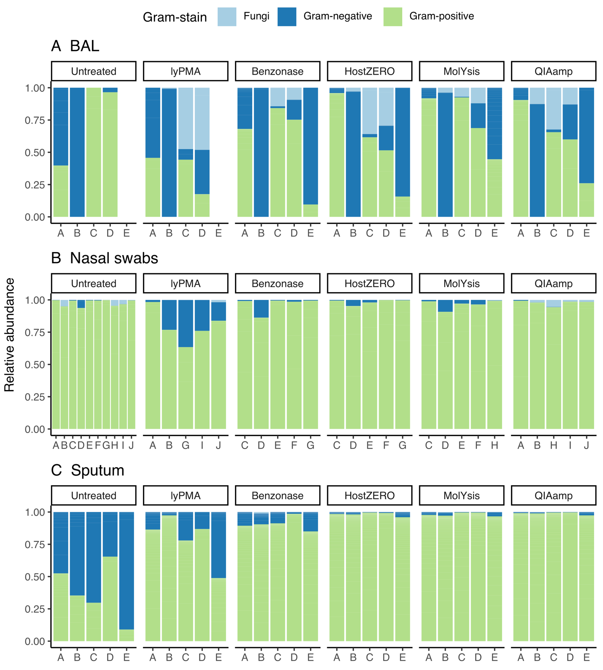 Fig. S6. Effect of host depletion on %gram negative bacteria in treated and untreated samples. Bar plot annotated with gram-stain information of (A) BAL, (B) nasal swabs, and (C) sputum after each treatment.

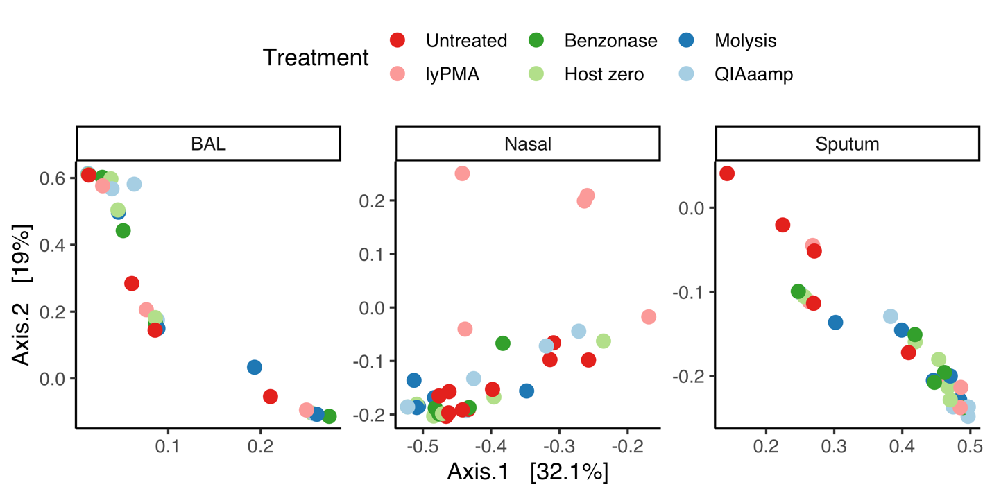

Fig. S7. Principal coordinate analysis plot based on Morisita-Horn dissimilarity of taxonomic sequencing results stratified by sample type.

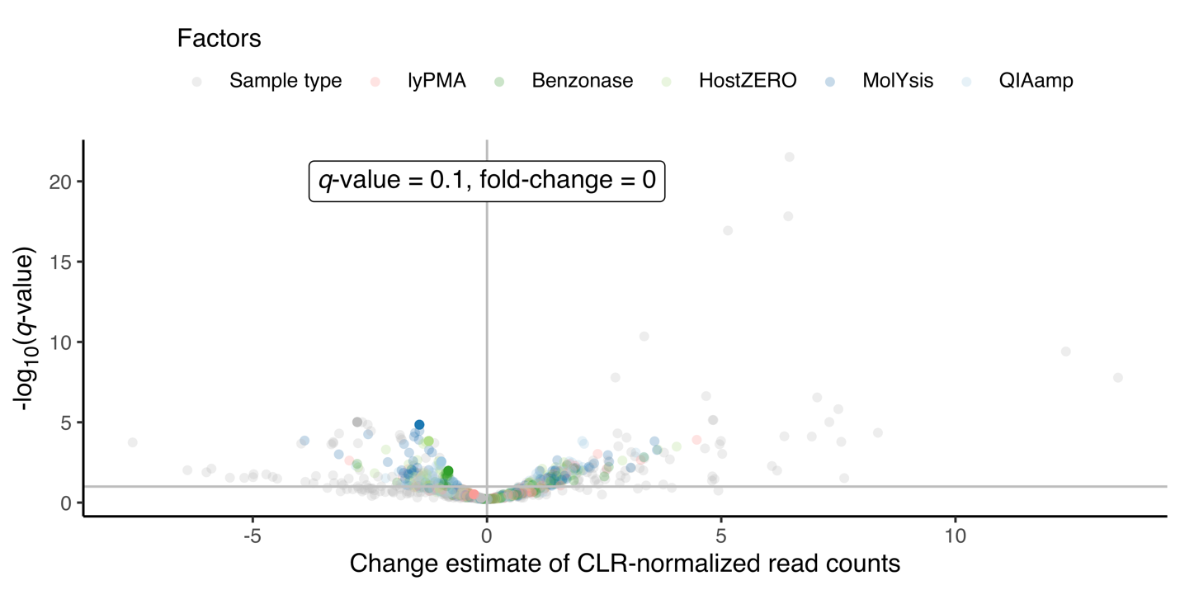

Fig. S8. Volcano plot of differential abundance of microbes by sample type and treatment. Most differentially abundant taxa were associated with sample type. The analysis was conducted with linear mixed effect model (feature~ sample type + lyPMA + Benzonase + HostZERO + MolYsis + QIAamp, random effect = subject id) after centered-log ratio normalization.

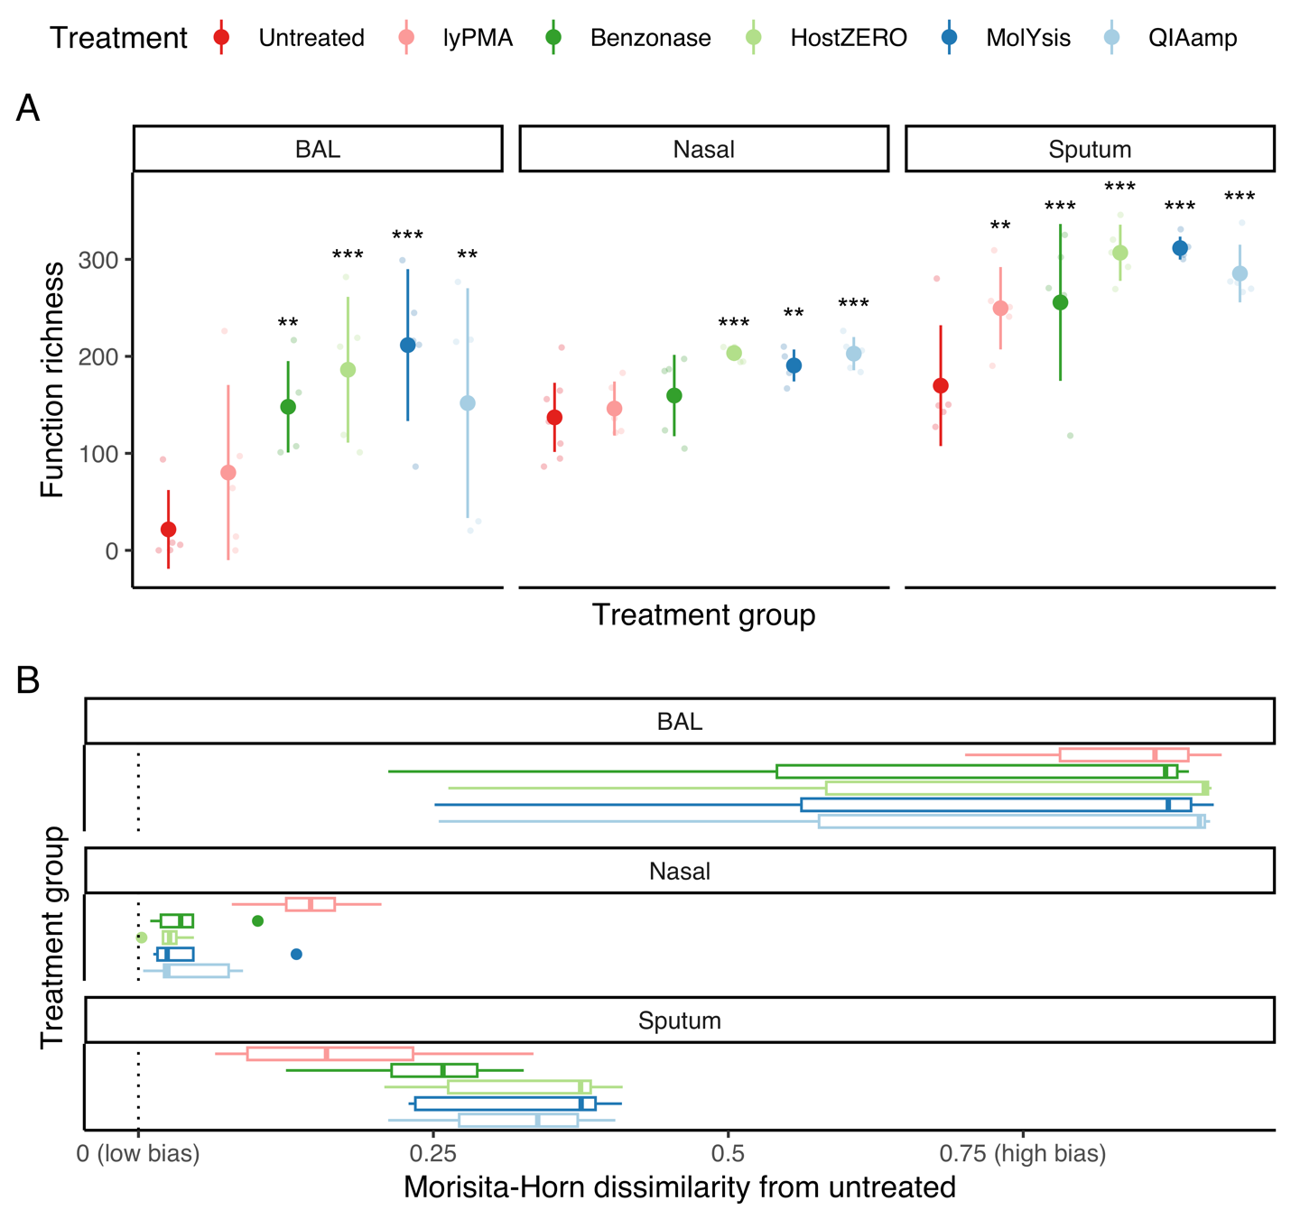

Fig. S9. Alpha and beta diversity by sample type and treatment method of predicted microbial community function. (A) Predicted microbial functional richness for untreated and treated samples in mean values ± SD, with statistical significance from linear mixed effect models stratified by sample type. (B) Boxplot of paired Morisita-Horn distance between untreated and treated samples.

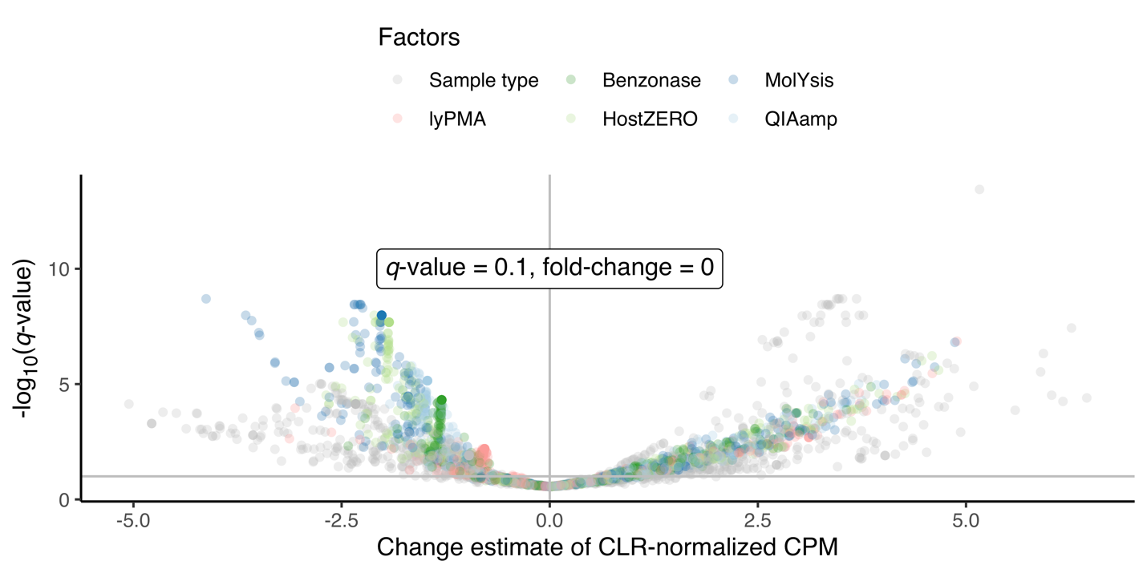

Fig. S10. Volcano plot of differential abundance of predicted microbial function by sample type and treatment. The analysis was conducted with linear mixed effect model (feature~ sample type + lyPMA + Benzonase + HostZERO + MolYsis + QIAamp, random effect = subject id) after centered-log ratio (CLR) normalization of copies per million (CPM) values.

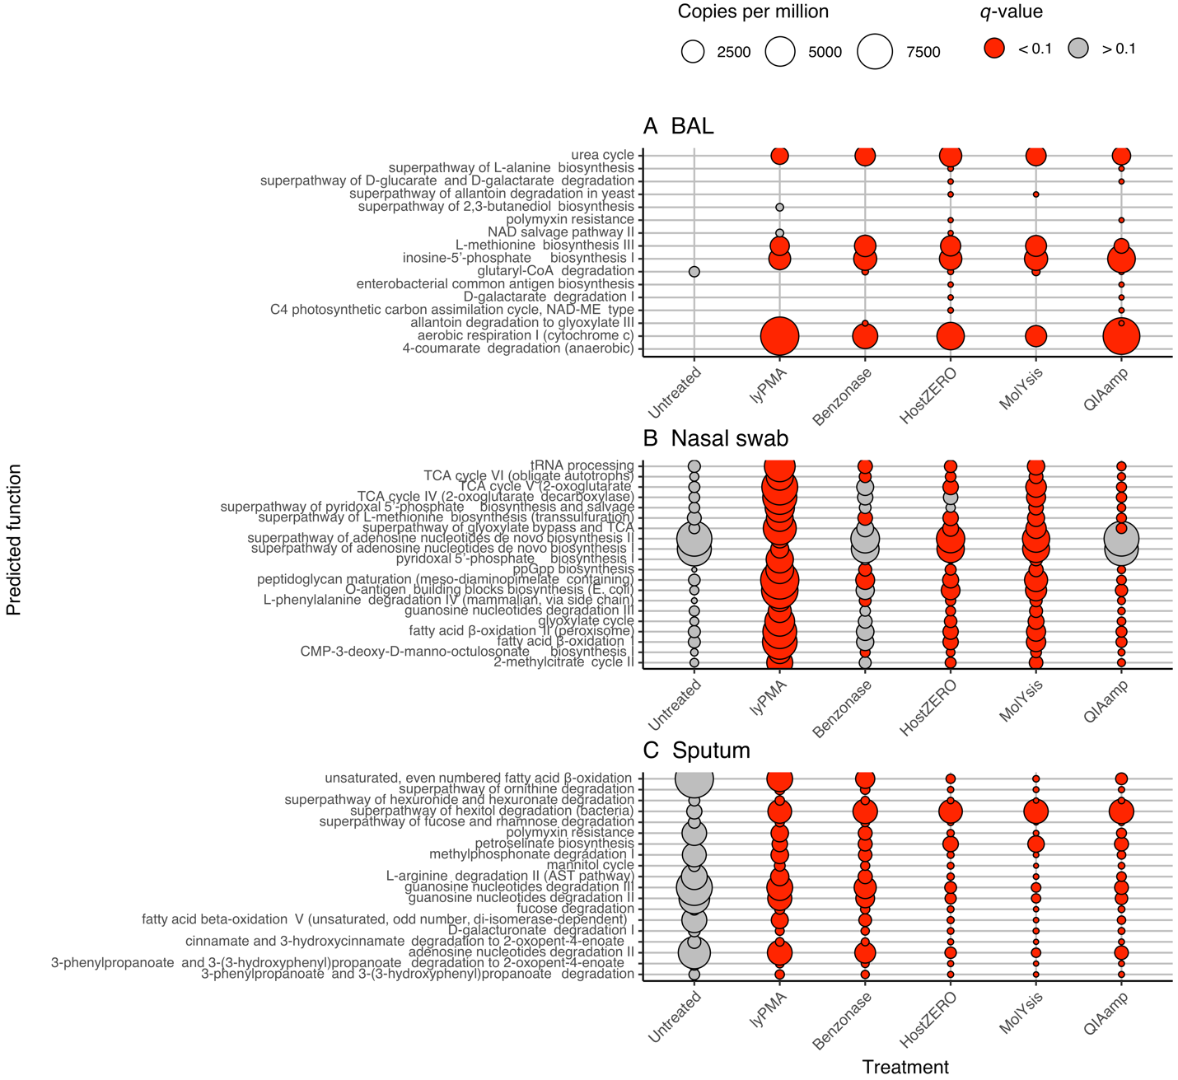

Fig. S11. Mean copies per million of top 20 significant function identified by differential abundance analysis using linear mixed effect model (feature ~ lyPMA + Benzonase + HostZero + MolYsis + QIAamp + (1|subject id)) after centered log ration normalization. Analyses were stratified by sample type. (A) Bronchoalveolar lavage, (B) Nasal swabs, and (C) Sputum. Statistical significances were noted at the level of q-value < 0.1.

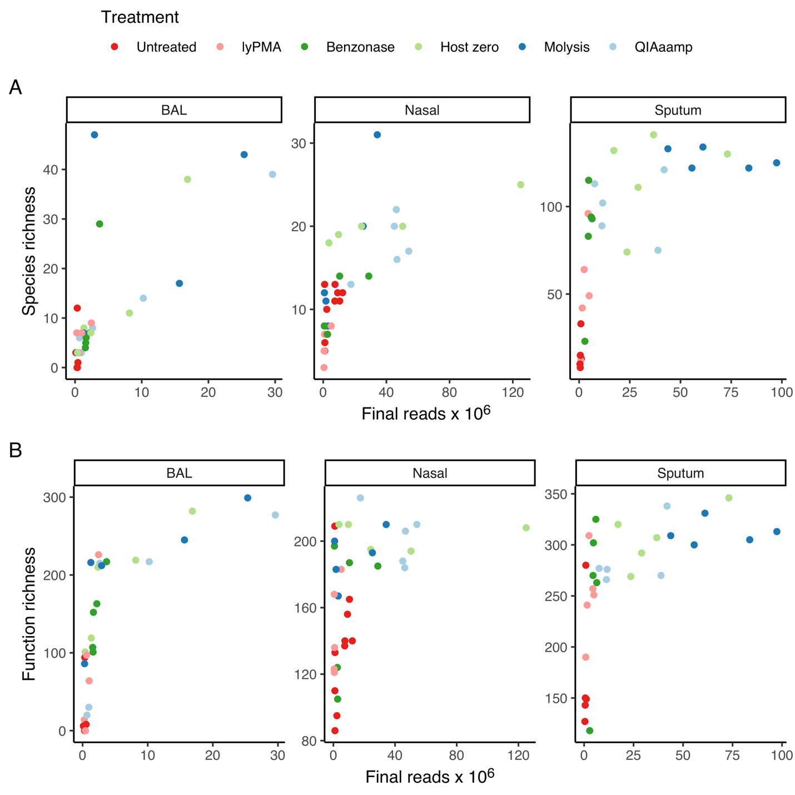

Fig. S12. Rarefaction curve for (A) species richness and (B) functional richness stratified by sample type, after removing possible contaminant-taxa identified by decontam [23] and low prevalent taxa.

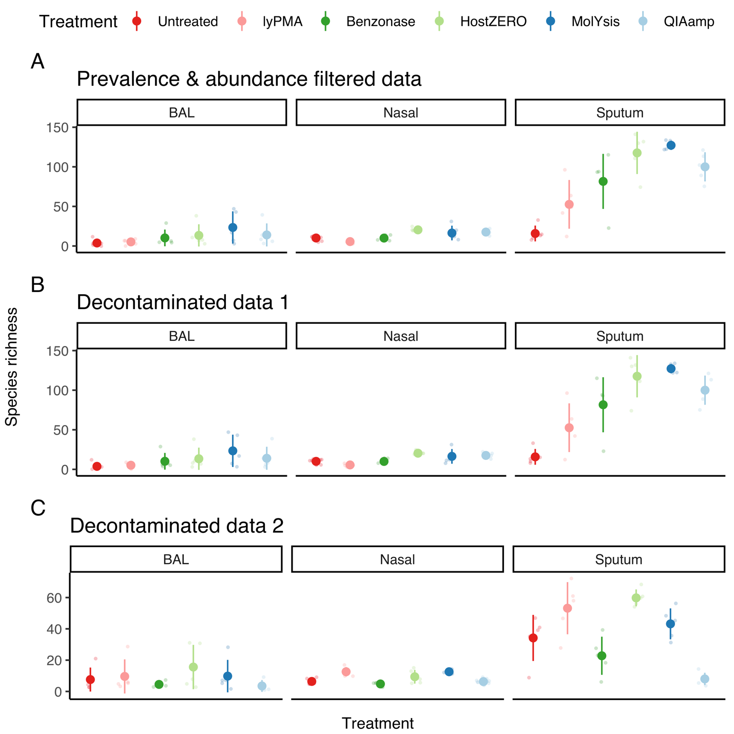

Fig. S13. Effect of prevalence filtering and removal of potential contaminants on taxonomic species richness. Species richness of (A) raw data after prevalence filtering, (B) decontaminated species richness with decontam [23], and (C) decontaminated data using tinyvamp [24].

