Approval Department of health science research ethics committee
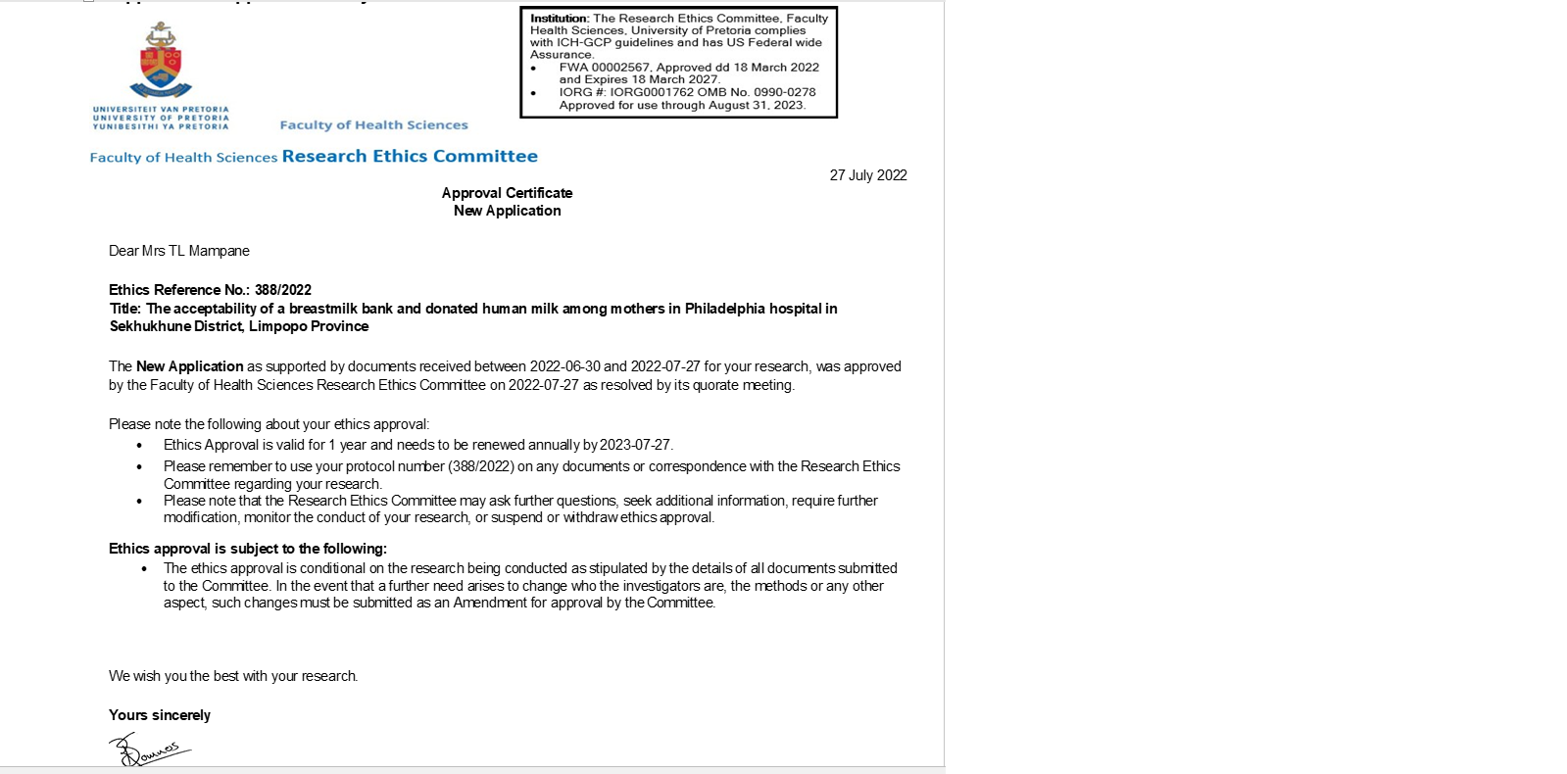

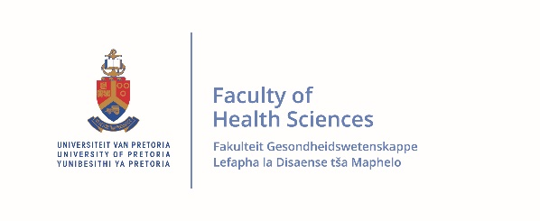
Appendix 2: Participant’s information and informed consent
Study title: | The acceptability of a Breastmilk bank and Donated Human  Milk among mothers in Philadelphia Hospital  in Sekhukhune District, Limpopo Province
Principal investigator: | TL ( TL Mampane
Supervisor: | Prof L Wolvaardt
Institution: | School of Health Systems and Public Health  Faculty of Health Sciences, University of Pretoria

DAYTIME AND AFTER-HOURS TELEPHONE NUMBER(S):
Daytime number/s: 0829068749
Afterhours number: 0829068749
DATE AND TIME OF INFORMED CONSENT DISCUSSION:
 |  |  |  | :
Date | Month | Year |  | Time
Dear Prospective Participant
Dear Mr. / Mrs. .....................................................................................

1) INTRODUCTION
You are invited to volunteer for a research study. I am doing research for a master’s in public health degree purpose at the University of Pretoria. The information in this document is to help you to decide if you would like to participate. Before you agree to take part in this study you should fully understand what is involved. If you have any questions, which are not fully explained in this document, do not hesitate to ask the researcher. You should not agree to take part unless you are completely happy about all the procedures involved.

2) THE NATURE AND PURPOSE OF THIS STUDY
This study will determine the reasons for low donation and uptake of
donated human milk among mothers in Philadelphia Hospital.

3. POSSIBLE RISKS AND DISCOMFORTS INVOLVED
There are no risks associated with the study.

4. POSSIBLE BENEFITS OF THIS STUDY
Although you may not benefit directly. The findings of the study will guide the Department of Health in Limpopo and the South African Breast Milk Reserve (SABR) on the type of intervention needed to encourage and educate mothers about the importance of breastmilk banks and donating milk.

5. COMPENSATION
You will not be paid to take part in the study.

6. YOUR RIGHTS AS A RESEARCH PARTICIPANT
Your participation in this study is voluntary. You will be allowed to exercise the choice to participate in the study or not to participate and may withdraw from the study once started without any negative consequences. You have the option to opt out if you don’t feel comfortable answering specific questions during the interview session.

7. ETHICS APPROVAL
This Protocol was submitted to the Faculty of Health Sciences Research Ethics Committee, University of Pretoria, telephone numbers 012 356 3084 / 012 356 3085 and written approval has been granted by that committee (Approval number: 388/2022).
8) INFORMATION
If you have any questions concerning this study, you should contact:
Mrs. TL Mampane Tel :015 633 2300 or cell: 0829068749

9) CONFIDENTIALITY

All information obtained during this study will be regarded as confidential. Each participant that is taking part will be provided with an alphanumeric coded number e.g. A001. This will ensure the confidentiality of the information collected. Only the researcher will be able to identify you as a participant. Results will be published or presented in such a fashion that participants remain unidentifiable. The hard copies of all your records will be kept in a locked facility at the Faculty of Health Sciences, University of Pretoria.

10) INFORMED CONSENT TO PARTICIPATE IN THIS STUDY AND AUDIOTAPE RECORDING TO BE USED IN THE INTERVIEW
- I confirm that the person requesting my consent to take part in this study has told me about the nature and process, the audiotape recording, any risks or discomforts, and the benefits of the study.
- I have also received, read, and understood the above-written information about
the study.
- I have had adequate time to ask questions and I have no objections to
participate in this study.
- I am aware that the information obtained in the study, including personal details, and the audiotape record will be anonymously processed, and presented in the reporting of results.
- I understand that I will not be penalized in any way should I wish to discontinue the study and that withdrawal will not affect my further treatments.
- I am participating willingly.
- I have received a signed copy of this informed consent agreement.
_______________________________ ________________________
Participant’s name (Please print) Date
_________________________________ ________________________
Participant’s signature Date
__________________________________ ________________________
Researcher’s name (Please print) Date
__________________________________ ________________________
Researcher’s signature

