Extended methodology

Morphology recognition criteria
The selected grid size of each delta is large enough to encompass its subaqueous extent when possible – in the case of wide shallow shelves, grids are extended to encompass a large portion of the shelf but not necessarily up to the shelf edge (e.g., Red Delta). We run a standard workflow on each grid through our developed code to compute surface attributes – such as gradient and curvature –, further allowing the distinction of morphologies and deltaic sub-environments. It is worthy to note that the gradient surfaces are absolute and are inclusive of depositional features (bars) and incisions (channels), which in reality simultaneously occur in each deltaic sub-environment.

Qualitative assessment
Qualitative assessments begin with computing surface attributes – particularly spatial gradients – to visually amplify and identify shallow-marine morphologies (Fig. 4). Since spatial gradients are controlled by the specified grid resolution, any changes to the grid resolution and its resulting grid cell size would result in changes to the computed gradients as illustrated in Fig. 5. In our analyses, the minimum grid resolution of 15 arc-seconds translates to an approximate 450-meter grid cell size that we set as the finest scale to capture quantitative results from. In addition, we upscale the resolution to a 1-kilometer grid cell size that smooths out gradient variations. This allows us to visually filter artifacts – such as merging lines of separate grids – and capture the overall basin morphology trends. Deltas with prominent artifacts, no visible morphologic/gradient distinctions under the provided resolution or are on extremely narrow shelves are only qualitatively assessed when possible (e.g., Yangtze, Rufiji, and Krishna-Godavari Deltas, respectively – Appendix A).

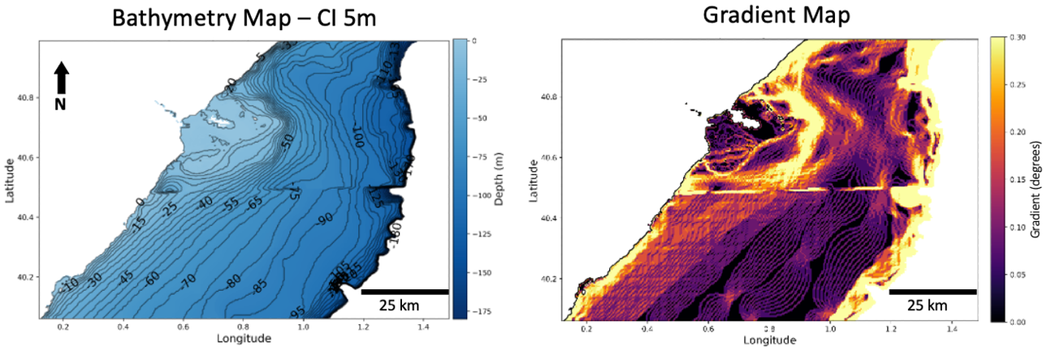

Fig. 4. Ebro Delta’s bathymetry grid with 5m contour interval (left) and gradient map computed at 450-meter resolution (right).
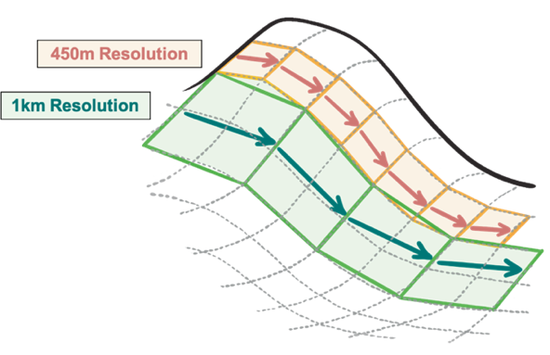
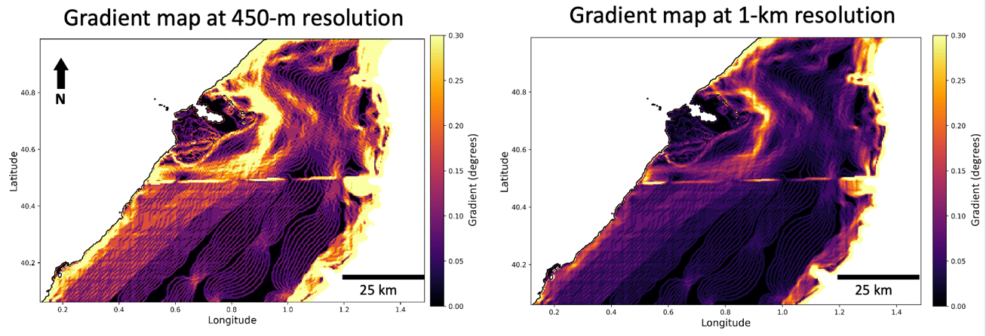

Fig. 5. Gradient surfaces as a result of grid resolution variations. Top: schematic displaying gradient variations between 450-meter (minimum) and 1-kilometer (upscale) grid cell sizes. The 450-meter grid cell size will allow finer gradient calculations, while the 1-kilometer grid cell size smooths out variations in gradient values. Bottom: Comparison of Ebro Delta’s gradient maps as a result of different grid resolutions: 450 meters (minimum) to the left and 1 kilometer (upscaled) to the right, both set to the same color bar cutoff (0.3 gradient cutoff).

Quantitative assessment
To quantitatively assess the different sub-environments in each delta, we manually select polygons defining delta sub-environments across the delta. Even though each delta has its unique dominant oceanographic energy regime and basin configuration, the polygon selection criteria consistently apply to all deltas and is based on the observable gradient breaks. From the shoreline to the decrease of the gradient basinward is the shoreline clinoform (sometimes referred to as the subaerial clinoform), from that boundary basinward to where the relative low gradients consistently turn higher is defined the subaqueous platform, and from the basinward limit of the platform to where larger gradients decrease again on the shelf is defined the subaqueous clinoform (Fig. 6 and Fig. 7). We laterally extend these polygons up to the merging points, where distinction of sub-environments is difficult.
Quantitative results are retrieved and further cleaned before compiling final results. Data abnormalities and outliers must be removed to preserve the integrity of the study. The z-score outlier removal method compares the datapoint to the mean, of which we apply a conservative threshold to remove datapoints that are higher than 3 times the standard deviation. This is particularly powerful for removing artifacts that can strongly skew the data.
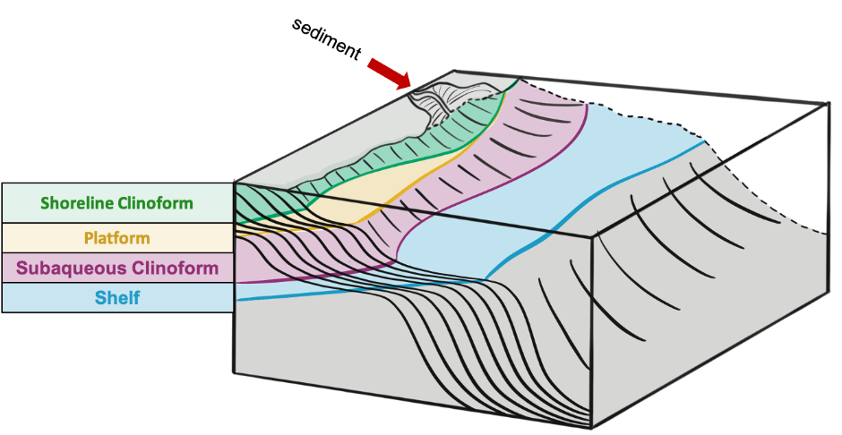

Fig. 6. Schematic demonstrating the polygon selection criteria of sub-environments for quantitative results.
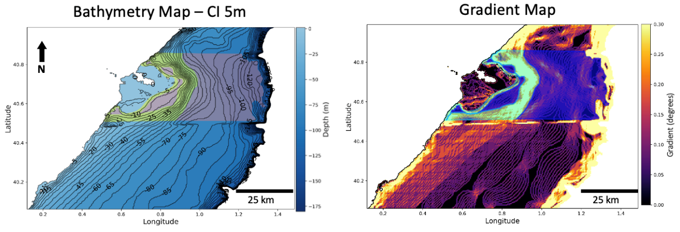

Fig. 7. Ebro Delta’s bathymetry grid (left) and gradient map (right) overlain by the sub-environment interpretation based on gradient breaks. Yellow polygons represent the shoreline and subaqueous clinoforms and darker polygons represent the platform and shelf.

