Supplemental material

Meewis et al. (2021) Post-traumatic trigeminal neuropathy: correlation between objective and subjective assessments and a prediction model for neurosensory recovery

Table S1. Medical Research Council Scale for sensory recovery

Figure S1. Sunderland Clinical classification system (Miloro Modification)

Table S2. EuroQol 5-Dimension Scale (EQ5D)

Table S3. General Anxiety Disorder – 7 Questionnaire (GAD-7)

Table S4. Patient Health Questionnaire – 9 (PHQ-9)

Table S5. Patient Health Questionnaire – 15 (PHQ-15)

Table S6. Brief Pain Inventory (BPI)

Table S7. Neuropathic pain Questionnaire (DN-4-interview)

Table S8. Patient characteristics table

Figure S2. Distribution of cases by Mechanism

Figure S3. Distribution of PTN cases by MRCS-score at baseline vs at final follow-up moment

Figure S4. Distribution of PTN cases by Sunderland Clinical classification score at baseline vs at final follow-up moment

Figure S5. Distribution of PTN cases by sensory phenotype at baseline vs at final follow-up

Figure S6: Evolution of subjective functioning in PTN

Table S9. Criteria for near to complete neurosensory recovery in PTN

Table S1. Medical Research Council Scale for sensory recovery.

Table S1
Medical Research Council Scale for sensory recovery*
S0: Absence of sensibility in the autonomous area of the nerve
S1: Recovery of deep cutaneous pain and tactile sensibility
S1+: Recovery of superficial pain sensibility
S2: Recovery of some degree of superficial cutaneous pain and tactile sensibility
S2+: As in S2, but with overresponse
S3: Return of pain and tactile sensibility with disappearance of overresponse, s2PD>15mm, m2PD>7mm
S3+: Return of sensibility as in S3 with some recovery of 2-point discrimination, s2PD: 7-15mm, m2PD: 4-7mm
S4: Complete recovery, s2PD: 2-6mm, m2PD: 2-3mm
* Birch R, Bonney G, Wynn-Parry CB. Surgical Disorders of the Peripheral Nerves. Philadelphia: Surg. 1992;30(6):387-389.

Figure S1. Sunderland Clinical classification system (Miloro Modification)
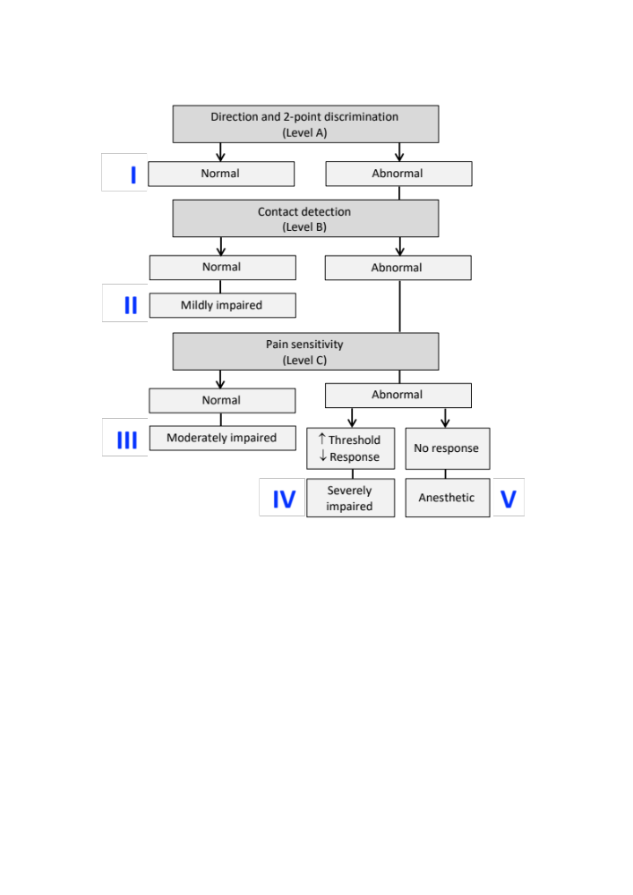

Table S2
EuroQol 5 Dimension Scale (EQ5D)
Indicate for each group in the list below what best suits your health TODAY.
- MOBILITY
I have no problems in walking about
I have slight problems in walking about
I have moderate problems in walking about
I have serious problems in walking about
I am unable to walk about
- SELF-CARE
I have no problems washing or dressing myself
I have slight problems washing or dressing myself
I have moderate problems washing or dressing myself
I have severe problems washing or dressing myself
I am unable to wash or dress myself
- USUAL ACTIVITIES (e.g. work, study, housework, family or leisure activities)
I have no problems doing my usual activities
I have slight problems doing my usual activities
I have moderate problems doing my usual activities
I have severe problems doing my usual activities
I am unable to do my usual activities
- PAIN/ DISCOMFORT
I have no pain or discomfort
I have slight pain or discomfort
I have moderate pain or discomfort
I have severe pain or discomfort
I have extreme pain or discomfort
- ANXIETY/ DEPRESSION
I am not anxious or depressed
I am slightly anxious or depressed
I am moderately anxious or depressed
I am severely anxious or depressed
I am extremely anxious or depressed
- HEALTH-SCALE: We would like you to indicate on this scale how good or bad your own health is today. This scale runs from 0 to 100. 100 Stands for the best imaginable health state. 0 stands for the worst imaginable health state.
0 10 20 30 40 50 60 70 80 90 100
I----------I----------I----------I----------I----------I----------I----------I----------I----------I----------I

Table S3
General Anxiety Disorder – 7 Questionnaire (GAD-7)
Over the last 2 weeks, how often have you been bothered by the following problems? |  |  |  |  |  |  |  | Not at all |  | Several days | More than half the days | Nearly every day
1. Feeling nervous, anxious or on edge |  |  |  |  |  |  |  | 0 |  | 1 | 2 | 3
2. Not being able to stop or control worrying |  |  |  |  |  |  |  | 0 |  | 1 | 2 | 3
3. Worrying too much about different things |  |  |  |  |  |  |  | 0 |  | 1 | 2 | 3
4. Trouble relaxing |  |  |  |  |  |  |  | 0 |  | 1 | 2 | 3
5. Being so restless that it is hard to sit still |  |  |  |  |  |  |  | 0 |  | 1 | 2 | 3
6. Becoming easily annoyed or irritable |  |  |  |  |  |  |  | 0 |  | 1 | 2 | 3
7. Feeling afraid as if something awful might happen |  |  |  |  |  |  |  | 0 |  | 1 | 2 | 3
Add the score for each column |  |  |  |  | Total Score | -----
Scale | Severity
0-4 | None
5-9 | Mild
10-14 | Moderate
15-21 | Severe

Table S4
Patient Health Questionnaire – 9 (PHQ-9)
Over the last 2 weeks, how often have you been bothered by any of the following problems? |  |  |  |  |  |  | Not at all |  | Several days | More than half the days | Nearly every day
1. Little interest or pleasure in doing things |  |  |  |  |  |  | 0 |  | 1 | 2 | 3
2. Feeling down, depressed, or hopeless |  |  |  |  |  |  | 0 |  | 1 | 2 | 3
3. Trouble falling or staying asleep, or sleeping to much |  |  |  |  |  |  | 0 |  | 1 | 2 | 3
4. Feeling tired or having little energy |  |  |  |  |  |  | 0 |  | 1 | 2 | 3
5. Poor appetite or overeating |  |  |  |  |  |  | 0 |  | 1 | 2 | 3
6. Feeling bad about yourself – or that you are a failure or have let your family down |  |  |  |  |  |  | 0 |  | 1 | 2 | 3
7. Trouble concentrating on things, such as reading the newspaper or watching television |  |  |  |  |  |  | 0 |  | 1 | 2 | 3
8. Moving or speaking so slowly that other people could have noticed. Or the opposite – being so fidgety or restless that you have been moving around a lot more than usual |  |  |  |  |  |  | 0 |  | 1 | 2 | 3
9. Thoughts that you would be better off dead, or of hurting yourself |  |  |  |  |  |  | 0 |  | 1 | 2 | 3
Add the score for each column |  |  | Total Score |  |  | -----
Scale | Severity
0-4 | No depression
5-9 | Mild depression
10-14 | Moderate depression
15-19 | Moderately severe depression
20-27 | Severe depression

Table S5
Patient Health Questionnaire – 15 (PHQ-15)
During the past 4 weeks, how much have you been bothered by any of the following problems? |  |  |  |  |  | Not bothered at all |  | Bothered a little | Bothered a lot
1. Stomach pain |  |  |  |  |  | 0 |  | 1 | 2
2. Back pain |  |  |  |  |  | 0 |  | 1 | 2
3. Pain in your arms, legs or joints (knees, hips, etc.) |  |  |  |  |  | 0 |  | 1 | 2
4. Women Only: Menstrual cramps or other problems with your period |  |  |  |  |  | 0 |  | 1 | 2
5. Headaches |  |  |  |  |  | 0 |  | 1 | 2
6. Chest pain |  |  |  |  |  | 0 |  | 1 | 2
7. Dizziness |  |  |  |  |  | 0 |  | 1 | 2
8. Fainting spells |  |  |  |  |  | 0 |  | 1 | 2
9. Feeling your heart pound or race |  |  |  |  |  | 0 |  | 1 | 2
10. Shortness of breath |  |  |  |  |  | 0 |  | 1 | 2
11. Pain or problems during sexual intercourse |  |  |  |  |  | 0 |  | 1 | 2
12. Constipation, loose bowels or diarrhea |  |  |  |  |  | 0 |  | 1 | 2
13. Nausea, gas or indigestion |  |  |  |  |  | 0 |  | 1 | 2
14. Feeling tired or having low energy |  |  |  |  |  | 0 |  | 1 | 2
15. Trouble sleeping |  |  |  |  |  | 0 |  | 1 | 2
Add the score for each column |  |  | Total Score |  | -----
Scale | Somatic symptom Severity
0-4 | No
5-9 | Low
10-14 | Medium
15-30 | High

Table S6
Brief Pain Inventory (BPI)
- Throughout our lives, most of us have had pain from time to time (such as minor headaches, sprains, and toothaches). Have you had pain other than these everyday kinds of pain today?
 |  |  |  |  | Yes |  |  | No
- Where on / in your body do you have the most pain?
- Please rate your pain by circling the one number that best describes your pain as its worst in the past 24 hours
 |  | No pain |  | 0 1 2 3 4 5 6 7 8 9 10 |  |  |  |  |  |  | Pain as bad as you can imagine
- Please rate your pain by circling the one number that best describes your pain as its least in the past 24 hours
 |  | No pain |  | 0 1 2 3 4 5 6 7 8 9 10 |  |  |  |  |  |  | Pain as bad as you can imagine
- Please rate your pain by circling the one number that best describes your pain on the average.
 |  | No pain |  | 0 1 2 3 4 5 6 7 8 9 10 |  |  |  |  |  |  | Pain as bad as you can imagine
- Please rate your pain by circling the one number that tells how much pain you have right now.
 |  | No pain |  | 0 1 2 3 4 5 6 7 8 9 10 |  |  |  |  |  |  | Pain as bad as you can imagine
- What treatments or medications are you receiving for your pain?
- In the last 24 hours, how much relief have pain treatments or medications provided? Please circle the one percentage that most shows how much relief you have received.
 |  | No Relief |  | 0 10 20 30 40 50 60 70 80 90 100 |  |  |  |  |  |  |  | Complete Relief
- Circle the one number that describes how, during the past 24 hours, pain has interfered with your:
 |  | - General Activities
 | Does not interfere |  |  | 0 1 2 3 4 5 6 7 8 9 10 |  |  |  |  |  |  | Completely interferes
 |  | - Mood
 | Does not interfere |  |  | 0 1 2 3 4 5 6 7 8 9 10 |  |  |  |  |  |  | Completely interferes
 |  | - Walking Ability
 | Does not interfere |  |  | 0 1 2 3 4 5 6 7 8 9 10 |  |  |  |  |  |  | Completely interferes
 |  | - Normal work (includes both work outside the home and housework)
 | Does not interfere |  |  | 0 1 2 3 4 5 6 7 8 9 10 |  |  |  |  |  |  | Completely interferes
 |  | - Social interaction
 | Does not interfere |  |  | 0 1 2 3 4 5 6 7 8 9 10 |  |  |  |  |  |  | Completely interferes
 |  | - Joy in life
 | Does not interfere |  |  | 0 1 2 3 4 5 6 7 8 9 10 |  |  |  |  |  |  | Completely interferes

Table S7
Neuropathic pain = Douleur neuropathique-4 questionnaire (DN4-interview)
Question 1: Does your pain have one or more of the following characteristics?
 |  | Yes | No
- Burning |  | 1 | 0
- Painful cold |  | 1 | 0
- Electric shocks |  | 1 | 0
Question 2: Is the pain associated with one or more of the following symptoms in the same area?
 |  | Yes | No
- Tingling |  | 1 | 0
- Pins and needles |  | 1 | 0
- Numbness |  | 1 | 0
- Itching |  | 1 | 0
A score of 3/7 supports the diagnosis of neuropathic pain.

Table S8
Patient characteristics table
Total |  |  |  | n |  |  |  |  | 36
Age |  |  |  | Years (SD, range) |  |  |  |  | 42 (12.5, 23-68)
Gender |  |  |  | 23 female |  |  |  |  | 13 male
Time since injury |  |  |  | Days (SD, range) |  |  |  |  | 210 (289, 3-1073)
Follow-up period |  |  |  |  |  |  |  |  | 566 (218, 149-865)
 |  |  |  |  |  |  |  |  | n (%)
Mechanism of injury |  |  | Third molar removal |  |  |  |  |  | 17 (47)
 |  |  | Implant placement |  |  |  |  |  | 4 (11)
 |  |  | Facial trauma |  |  |  |  |  | 4 (11)
 |  |  | Local anesthesia |  |  |  |  |  | 3 (8)
 |  |  | Non-wisdom tooth extraction |  |  |  |  |  | 2 (6)
 |  |  | Endodontic treatment |  |  |  |  |  | 2 (6)
 |  |  | Other |  |  |  |  |  | 5 (14)
Site of injury |  |  | Inferior alveolar nerve |  |  |  |  |  | 23 (64)
 |  |  | Lingual nerve |  |  |  |  |  | 10 (28)
 |  |  | Maxillary nerve |  |  |  |  |  | 7 (19)
 |  |  | Ophthalmic nerve |  |  |  |  |  | 1 (3)
 |  |  | Right-sided PTN |  |  |  |  |  | 19 (53)
 |  |  | Left-sided PTN |  |  |  |  |  | 17(47)
QST |  |  | Total |  |  |  |  |  | 5 (14)
Surgical reintervention |  |  | Total |  |  |  |  |  | 7 (19)
 |  |  | Buccal fat wrapping |  |  |  |  |  | 5 (14)
 |  |  | Microsurgical repair |  |  |  |  |  | 2 (6)
 |  |  | Decompression |  |  |  |  |  | 2 (6)
 |  |  | Neuroma excision |  |  |  |  |  | 2 (6)
 |  |  | Foreign body removal |  |  |  |  |  | 1 (3)
MRN |  |  | Total |  |  |  |  |  | 7 (19)
 |  |  | Lead to change of policy |  |  |  |  |  | 5 (71)
 |  |  | Lead to surgical reintervention |  |  |  |  |  | 3 (43)
Reported symptoms |  |  | Numbness |  |  |  |  |  | 31 (86)
 |  |  | Pain |  |  |  |  |  | 16 (44)
 |  |  | Stinging pain |  |  |  |  |  | 11 (31)
 |  |  | Nagging |  |  |  |  |  | 10 (28)
 |  |  | Burning |  |  |  |  |  | 10 (28)
 |  |  | Sensitive |  |  |  |  |  | 10 (28)
 |  |  | Swollen |  |  |  |  |  | 10 (28)
 |  |  | Stinging |  |  |  |  |  | 7 (19)
 |  |  | Pulling |  |  |  |  |  | 7 (19)
 |  |  | Electrical |  |  |  |  |  | 6 (17)
 |  |  | Tickling |  |  |  |  |  | 6 (17)
Neurosensory assessment |  |  |  |  |  |  |  |  | Baseline | Final follow-up
Percentage of affected dermatome |  |  |  |  |  |  | % (SD) |  | 91 (21) | 40 (46)
Two-point discrimination |  |  |  |  |  |  | mm (SD) |  | 14 (7) | 8 (5)
Stimulus localization |  |  |  |  |  |  | /5 (SD) |  | 3 (1) | 4 (2)
Directional discrimination |  |  |  |  |  |  | /10 (SD) |  | 6 (3) | 9 (3)
Brush stroke allodynia |  |  |  |  |  |  | n (%) |  | 11 (31) | 5 (14)
MRCS |  |  | S0 |  |  |  | n (%) |  | 5 (14) | 0 (0)
 |  |  | S1 |  |  |  |  |  | 0 (0) | 0 (0)
 |  |  | S2 |  |  |  |  |  | 1 (3) | 0 (0)
 |  |  | S2+ |  |  |  |  |  | 10 (28) | 5 (14)
 |  |  | S3 |  |  |  |  |  | 8 (22) | 1 (3)
 |  |  | S3+ |  |  |  |  |  | 11 (31) | 7 (19)
 |  |  | S4 |  |  |  |  |  | 1 (3) | 23 (64)
Sunderland |  |  | V |  |  |  | n (%) |  | 5 (14) | 0 (0)
 |  |  | IV |  |  |  |  |  | 11 (31) | 6 (17)
 |  |  | III |  |  |  |  |  | 5 (14) | 2 (6)
 |  |  | II |  |  |  |  |  | 5 (14) | 3 (8)
 |  |  | I |  |  |  |  |  | 10 (28) | 25 (69)
Sensory phenotype |  |  | Loss of function |  |  | L0 | n (%) |  | 4 (11) | 24 (67)
 |  |  |  |  |  | L1 |  |  | 1 (3) | 2 (6)
 |  |  |  |  |  | L2 |  |  | 9 (25) | 2 (6)
 |  |  |  |  |  | L3 |  |  | 22 (61) | 8 (22)
 |  |  | Gain of function |  |  | G0 | n (%) |  | 19 (53) | 28 (78)
 |  |  |  |  |  | G1 |  |  | 1 (3) | 2 (6)
 |  |  |  |  |  | G2 |  |  | 5 (14) | 3 (8)
 |  |  |  |  |  | G3 |  |  | 11 (31) | 3 (8)
Pain  (pain-VAS) |  |  |  |  |  |  | /100 (SD) |  | 20 (26) | 13 (25)
Quality of life  (EQ5D) |  |  | Mobility |  |  |  | → ≥ 3/5, % |  | 1 (3) | 1 (3)
 |  |  | Selfcare |  |  |  |  |  | 0 (0) | 0 (0)
 |  |  | Daily activities |  |  |  |  |  | 3 (8) | 0 (0)
 |  |  | Discomfort |  |  |  |  |  | 5 (14) | 3 (8)
 |  |  | Anxiety |  |  |  |  |  | 1 (3) | 0 (0)
 |  |  | VAS Quality of Life |  |  |  | /100 (SD) |  | 59 (18) | 72 (22)
Anxiety  (GAD-7) |  |  | Severe |  |  |  | n (%) |  | 7 (11) | 3 (8%)
 |  |  | Moderate |  |  |  |  |  | 1 (3) | 2 (5)
 |  |  | Mild |  |  |  |  |  | 15 (42) | 8 (22)
Depression  (PHQ-9) |  |  | Severe |  |  |  | n (%) |  | 2 (6) | 4 (11)
 |  |  | Moderately severe |  |  |  |  |  | 2 (6) | 3 (8)
 |  |  | Moderate |  |  |  |  |  | 5 (14) | 1 (3)
 |  |  | Mild |  |  |  |  |  | 15 (42) | 8 (22)
Somatic severity of symptoms  (PHQ-15) |  |  | High |  |  |  | n (%) |  | 4 (11) | 2 (6)
 |  |  | Medium |  |  |  |  |  | 11 (31) | 7 (19)
 |  |  | Low |  |  |  |  |  | 8 (22) | 9 (25)
Neuropathic pain  (DN4) |  |  |  |  |  |  | → ≥ 3/7, % |  | 18 (50) | 10 (28)
BPI | Pain severity |  |  |  | Worst pain in past 24h |  | → ≥ 3/10, % |  | 22 (61) | 11 (31)
BPI |  |  |  |  | Least pain in past 24h |  |  |  | 12 (33) | 7 (19)
BPI |  |  |  |  | Average pain |  |  |  | 21 (58) | 9 (25)
BPI |  |  |  |  | Pain now |  |  |  | 17 (47) | 7 (19)
BPI | Pain medication |  |  |  |  |  |  |  | Number of prescriptions
BPI |  |  |  |  | Corticosteroids |  |  |  | 27
BPI |  |  |  |  | Vitamin B IM |  |  |  | 26
BPI |  |  |  |  | Vitamin B per os |  |  |  | 28
BPI |  |  |  |  | Acetaminophen |  |  |  | 6
BPI |  |  |  |  | Ibuprofen |  |  |  | 21
BPI |  |  |  |  | Amitriptyline |  |  |  | 4
BPI |  |  |  |  | Baclofen |  |  |  | 1
BPI |  |  |  |  | Pregabalin |  |  |  | 4
BPI |  |  |  |  | Oxcarbazepine |  |  |  | 1
BPI |  |  |  |  | Carbamazepine |  |  |  | 2
BPI |  |  |  |  | Duloxetine |  |  |  | 1
BPI |  |  |  |  | other |  |  |  | 2
BPI |  |  |  |  | Percentage of relief provided in past 24h (SD) |  |  |  | 41 (40) | 28 (41)
BPI | Pain interference |  |  |  | General activities |  |  | → ≥ 3/10, % | 17 (47) | 7 (19)
BPI |  |  |  |  | Mood |  |  | → ≥ 3/10, % | 15 (42) | 9 (25)
BPI |  |  |  |  | Walking ability |  |  | → ≥ 3/10, % | 8 (19) | 2 (6)
BPI |  |  |  |  | Normal Tasks |  |  | → ≥ 3/10, % | 14 (39) | 9 (25)
BPI |  |  |  |  | Social interaction |  |  | → ≥ 3/10, % | 12 (33) | 5 (14)
BPI |  |  |  |  | Joy in life |  |  | → ≥ 3/10, % | 15 (42) | 8 (22)
Subjective score (SD) |  |  |  |  |  |  |  |  | 8 (4) | 10 (5)
QST = quantitative sensory tests; MRN = magnetic resonance imaging; MRCS = Medical research council scale for sensory recovery; EQ5D = EuroQol five-dimension scale; GAD-7 = General Anxiety Disorder questionnaire; PHQ-9 & PHQ-15 = Public Health questionnaire 9 and 15; DN4 = Douleur Neuropathique 4 questionnaire

Figure S2. Distribution of PTN cases by mechanism of injury.

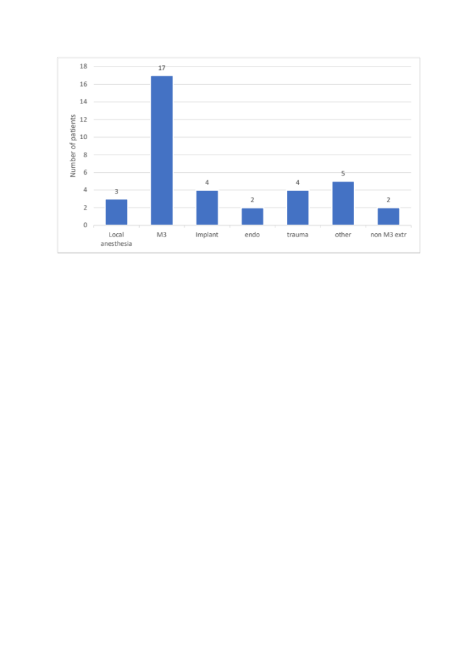

Figure S3. Distribution of PTN cases by MRCS-score at baseline vs. at final follow-up moment.

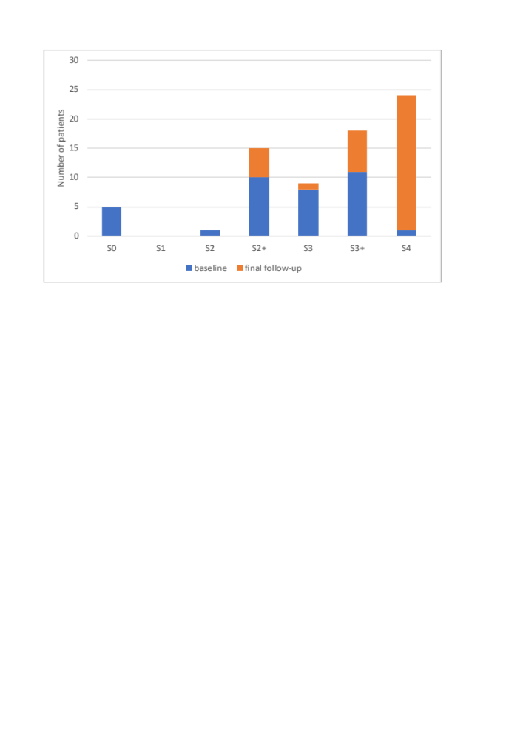
Figure S3: MRCS-score at baseline vs. at final follow-up moment. S0 = Absence of sensibility in the autonomous area of the nerve. S1 = Recovery of deep cutaneous pain and tactile sensibility. S1+ = Recovery of superficial pain sensibility. S2 = Recovery of some degree of superficial cutaneous pain and tactile sensibility. S2+ = as in S2, but with overresponse. S3 = Return of pain and tactile sensibility with disappearance of overresponse, s2PD>15mm, m2PD>7mm. S3+ = Return of sensibility as in S3 with some recovery of two-point discrimination, s2PD: 7-15mm, m2PD: 4-7mm. S4 = complete recovery, s2PD: 2-6mm, m2PD: 2-3mm.

Figure S4. Distribution of PTN cases by Sunderland Clinical classification score at baseline vs. at final follow-up moment.

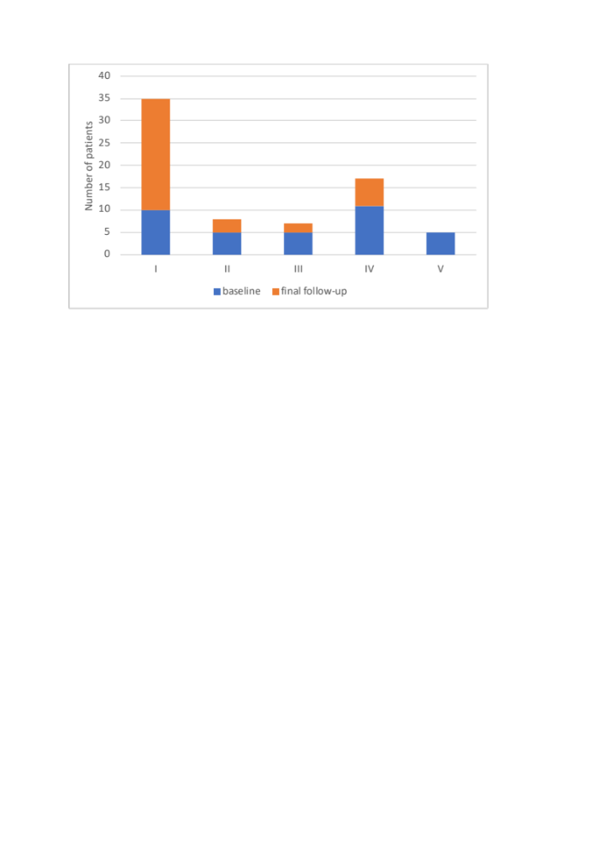

Figure S4. Sunderland Clinical classification score at baseline vs. at final follow-up moment. Scoring system was applied as illustrated in figure S1.

Figure S5. Distribution of PTN cases by sensory phenotype at baseline vs at final follow-up.

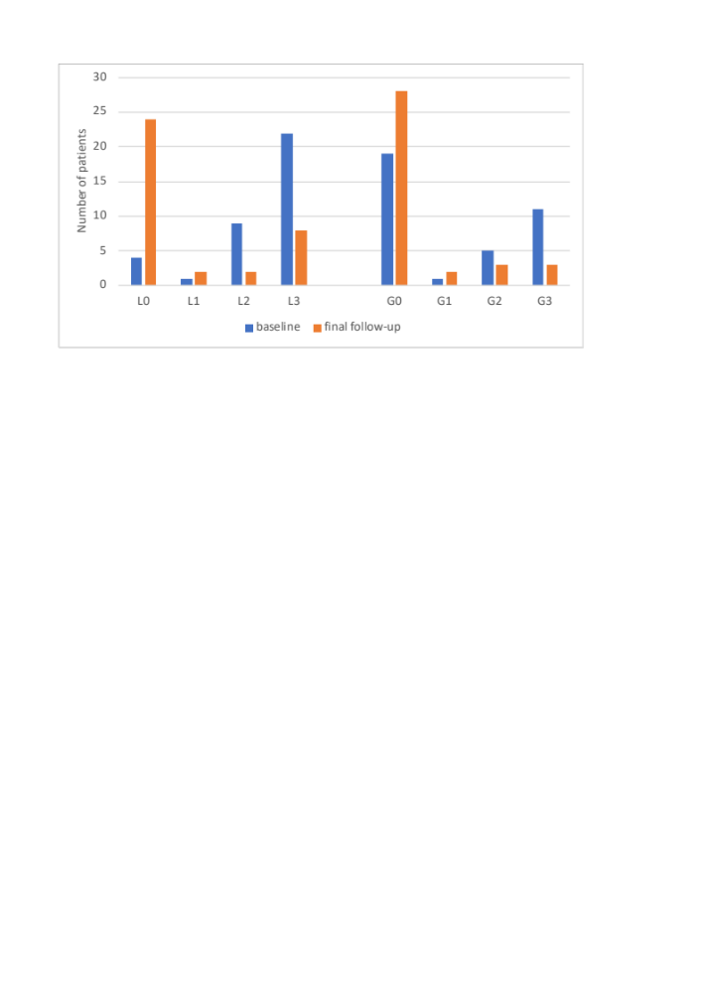
Figure S5. Distribution of PTN cases by sensory phenotype at baseline vs at final follow-up moment. A code for sensory phenotype was assigned to each individual. All codes consist of a letter L (Loss of function or sensory deficit) and a letter G (Gain of function or hyperesthesia), followed by number 0 (none), 1 (thermal), 2 (mechanical) or 3 (mixed). For example, L3G0 stands for a patient with mixed sensory loss and no mechanical or thermal hyperesthesia.

Figure S6: Evolution of subjective functioning in PTN.

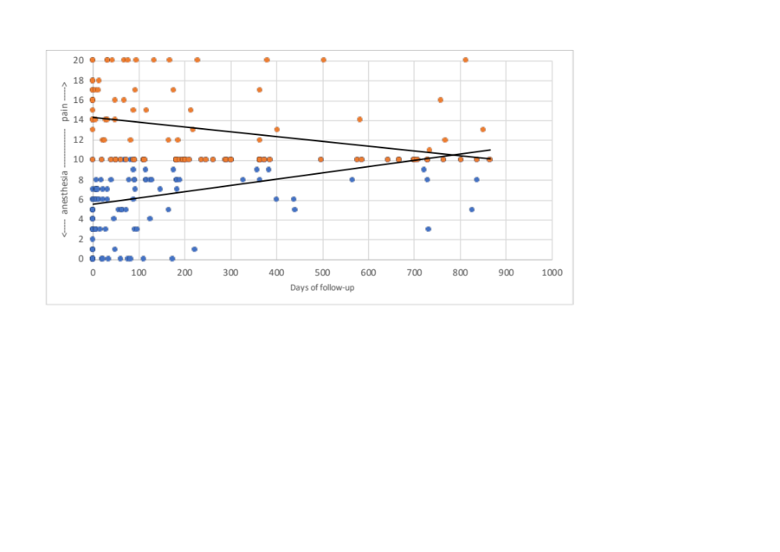
Figure S6: Evolution of subjective functioning in PTN. Patients were asked to score their current subjective function, ranging from 0 (complete anesthesia) to 20 (20 for the worst pain imaginable). A score of 10 would mean a normal function and no deficit. This figure shows trends for both positive and negative symptoms evolve in the same direction towards self-perceived normal functioning. A small group of outliers fail to return to this undisrupted status.

Table S3. Criteria for near to complete neurosensory recovery

Table S3
Post-traumatic trigeminal neuropathy: Criteria* to define near to complete neurosensory recovery
Variable |  | Criterium
% affected dermatome |  | ≤ 10%
VAS |  | ≤ 10/100
Directional discrimination |  | ≥ 9/10
Brush stroke allodynia |  | 0
Stimulus localization |  | ≥ 4/5
Two-point discrimination |  | ≤ 3mm
(affected - control side)
Sensory phenotype Loss of function |  | 0
Sensory phenotype Gain of function |  | 0
MRCS |  | S3+ or S4
Sunderland |  | I or II
*All criteria must be checked in order to qualify for a status of near to complete recovery

