Supplementary Material

Temporal trends and shifts of 24 notifiable infectious diseases in China before and during the COVID-19 epidemic

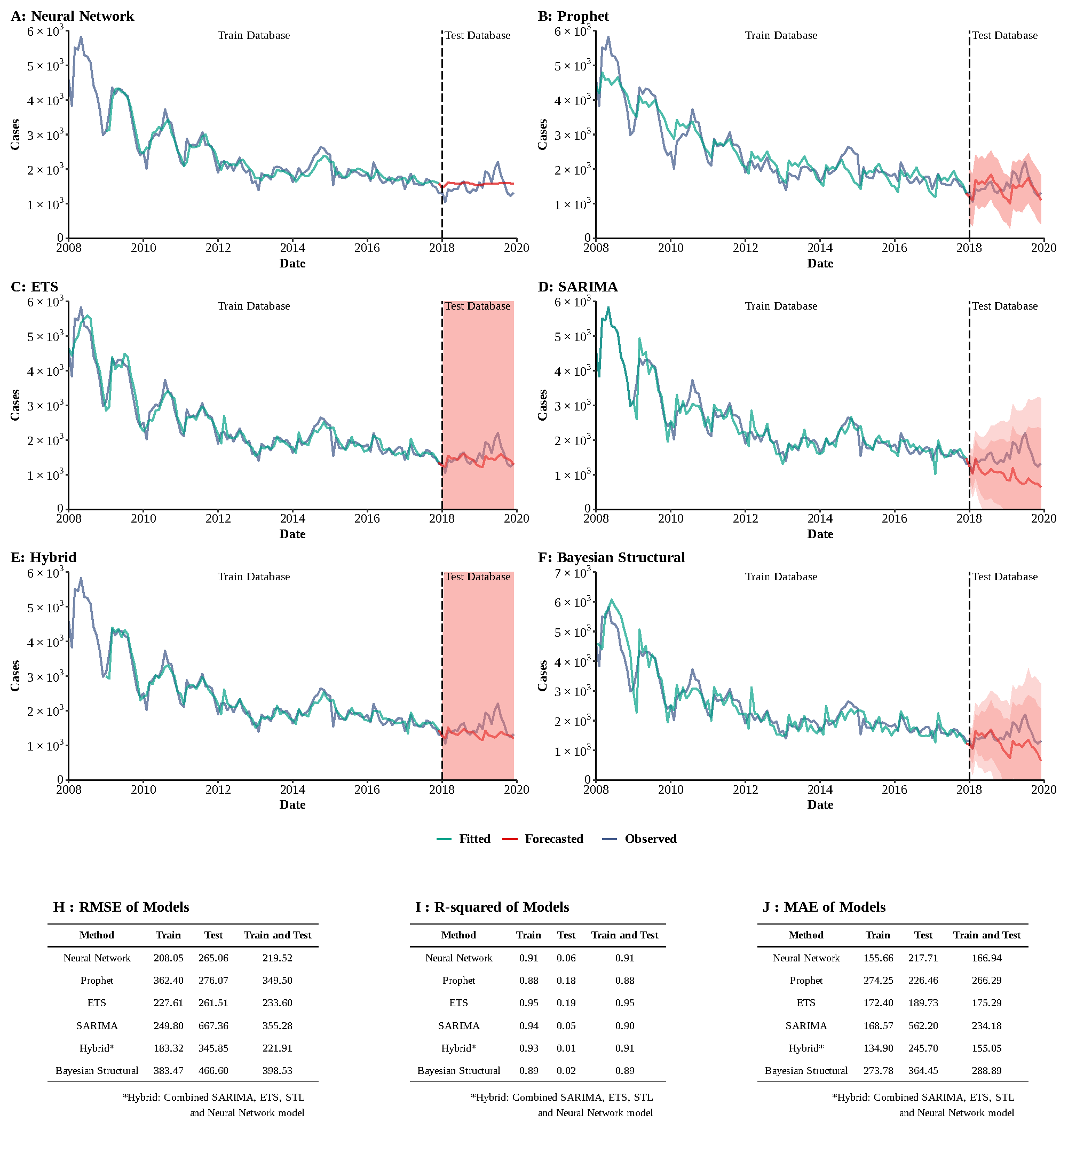
Supplementary Figure 1
Training and comparing variant time series models for HAV. (A) Neural Network model; (B) ETS model; (C) ARIMA model; (D) SEARIMA model; (E) Hybrid models combining SARIMA, ETS, STL, and neural network model; (F) Bayesian structural model; (G) RMSE of variant models; (H) R-squared of variant models; (J) MAE of variant models.

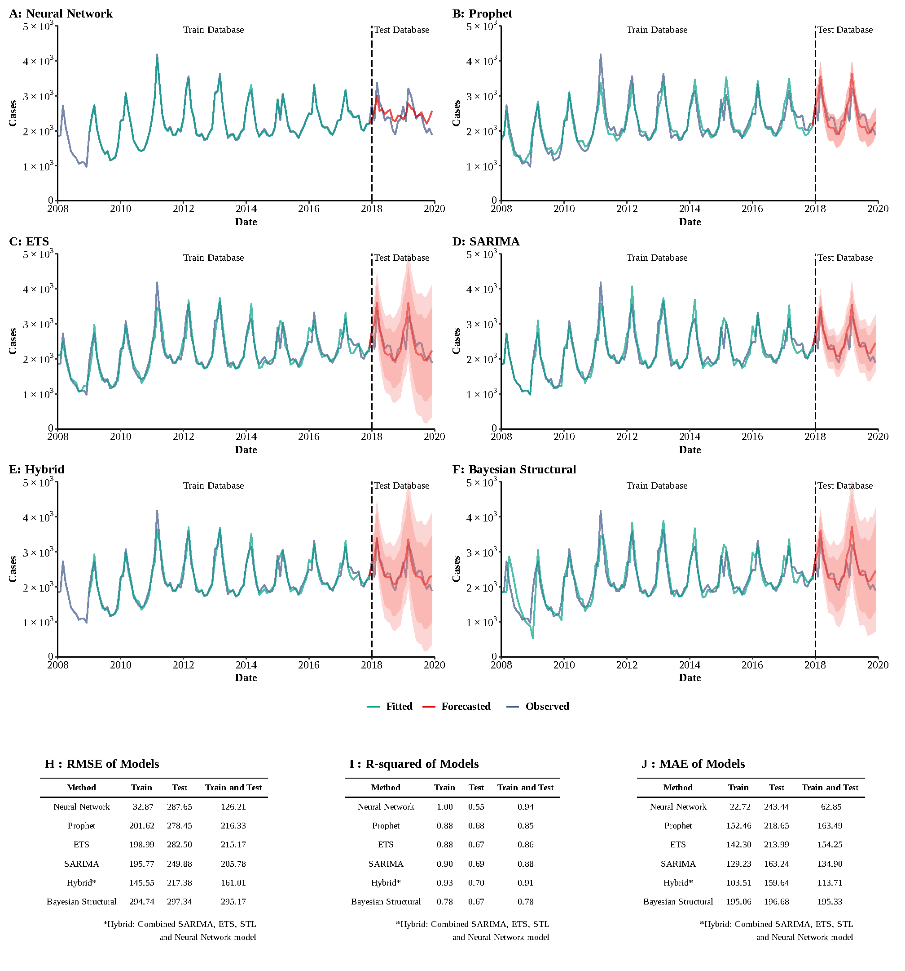
Supplementary Figure 2
Training and comparing variant time series models for HEV. (A) Neural Network model; (B) ETS model; (C) ARIMA model; (D) SEARIMA model; (E) Hybrid models combining SARIMA, ETS, STL, and neural network model; (F) Bayesian structural model; (G) RMSE of variant models; (H) R-squared of variant models; (J) MAE of variant models.

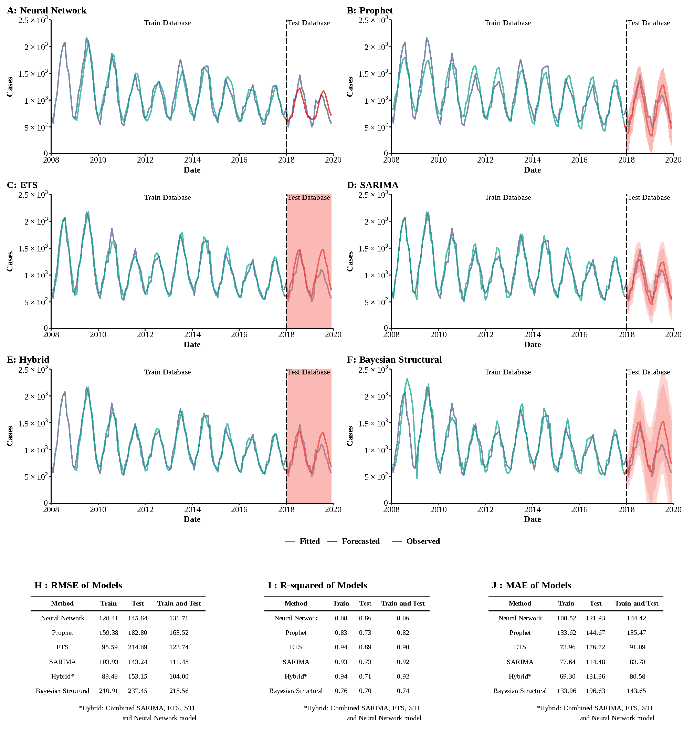
Supplementary Figure 3
Training and comparing variant time series models for typhoid and paratyphoid fever. (A) Neural Network model; (B) ETS model; (C) ARIMA model; (D) SEARIMA model; (E) Hybrid models combining SARIMA, ETS, STL, and neural network model; (F) Bayesian structural model; (G) RMSE of variant models; (H) R-squared of variant models; (J) MAE of variant models.
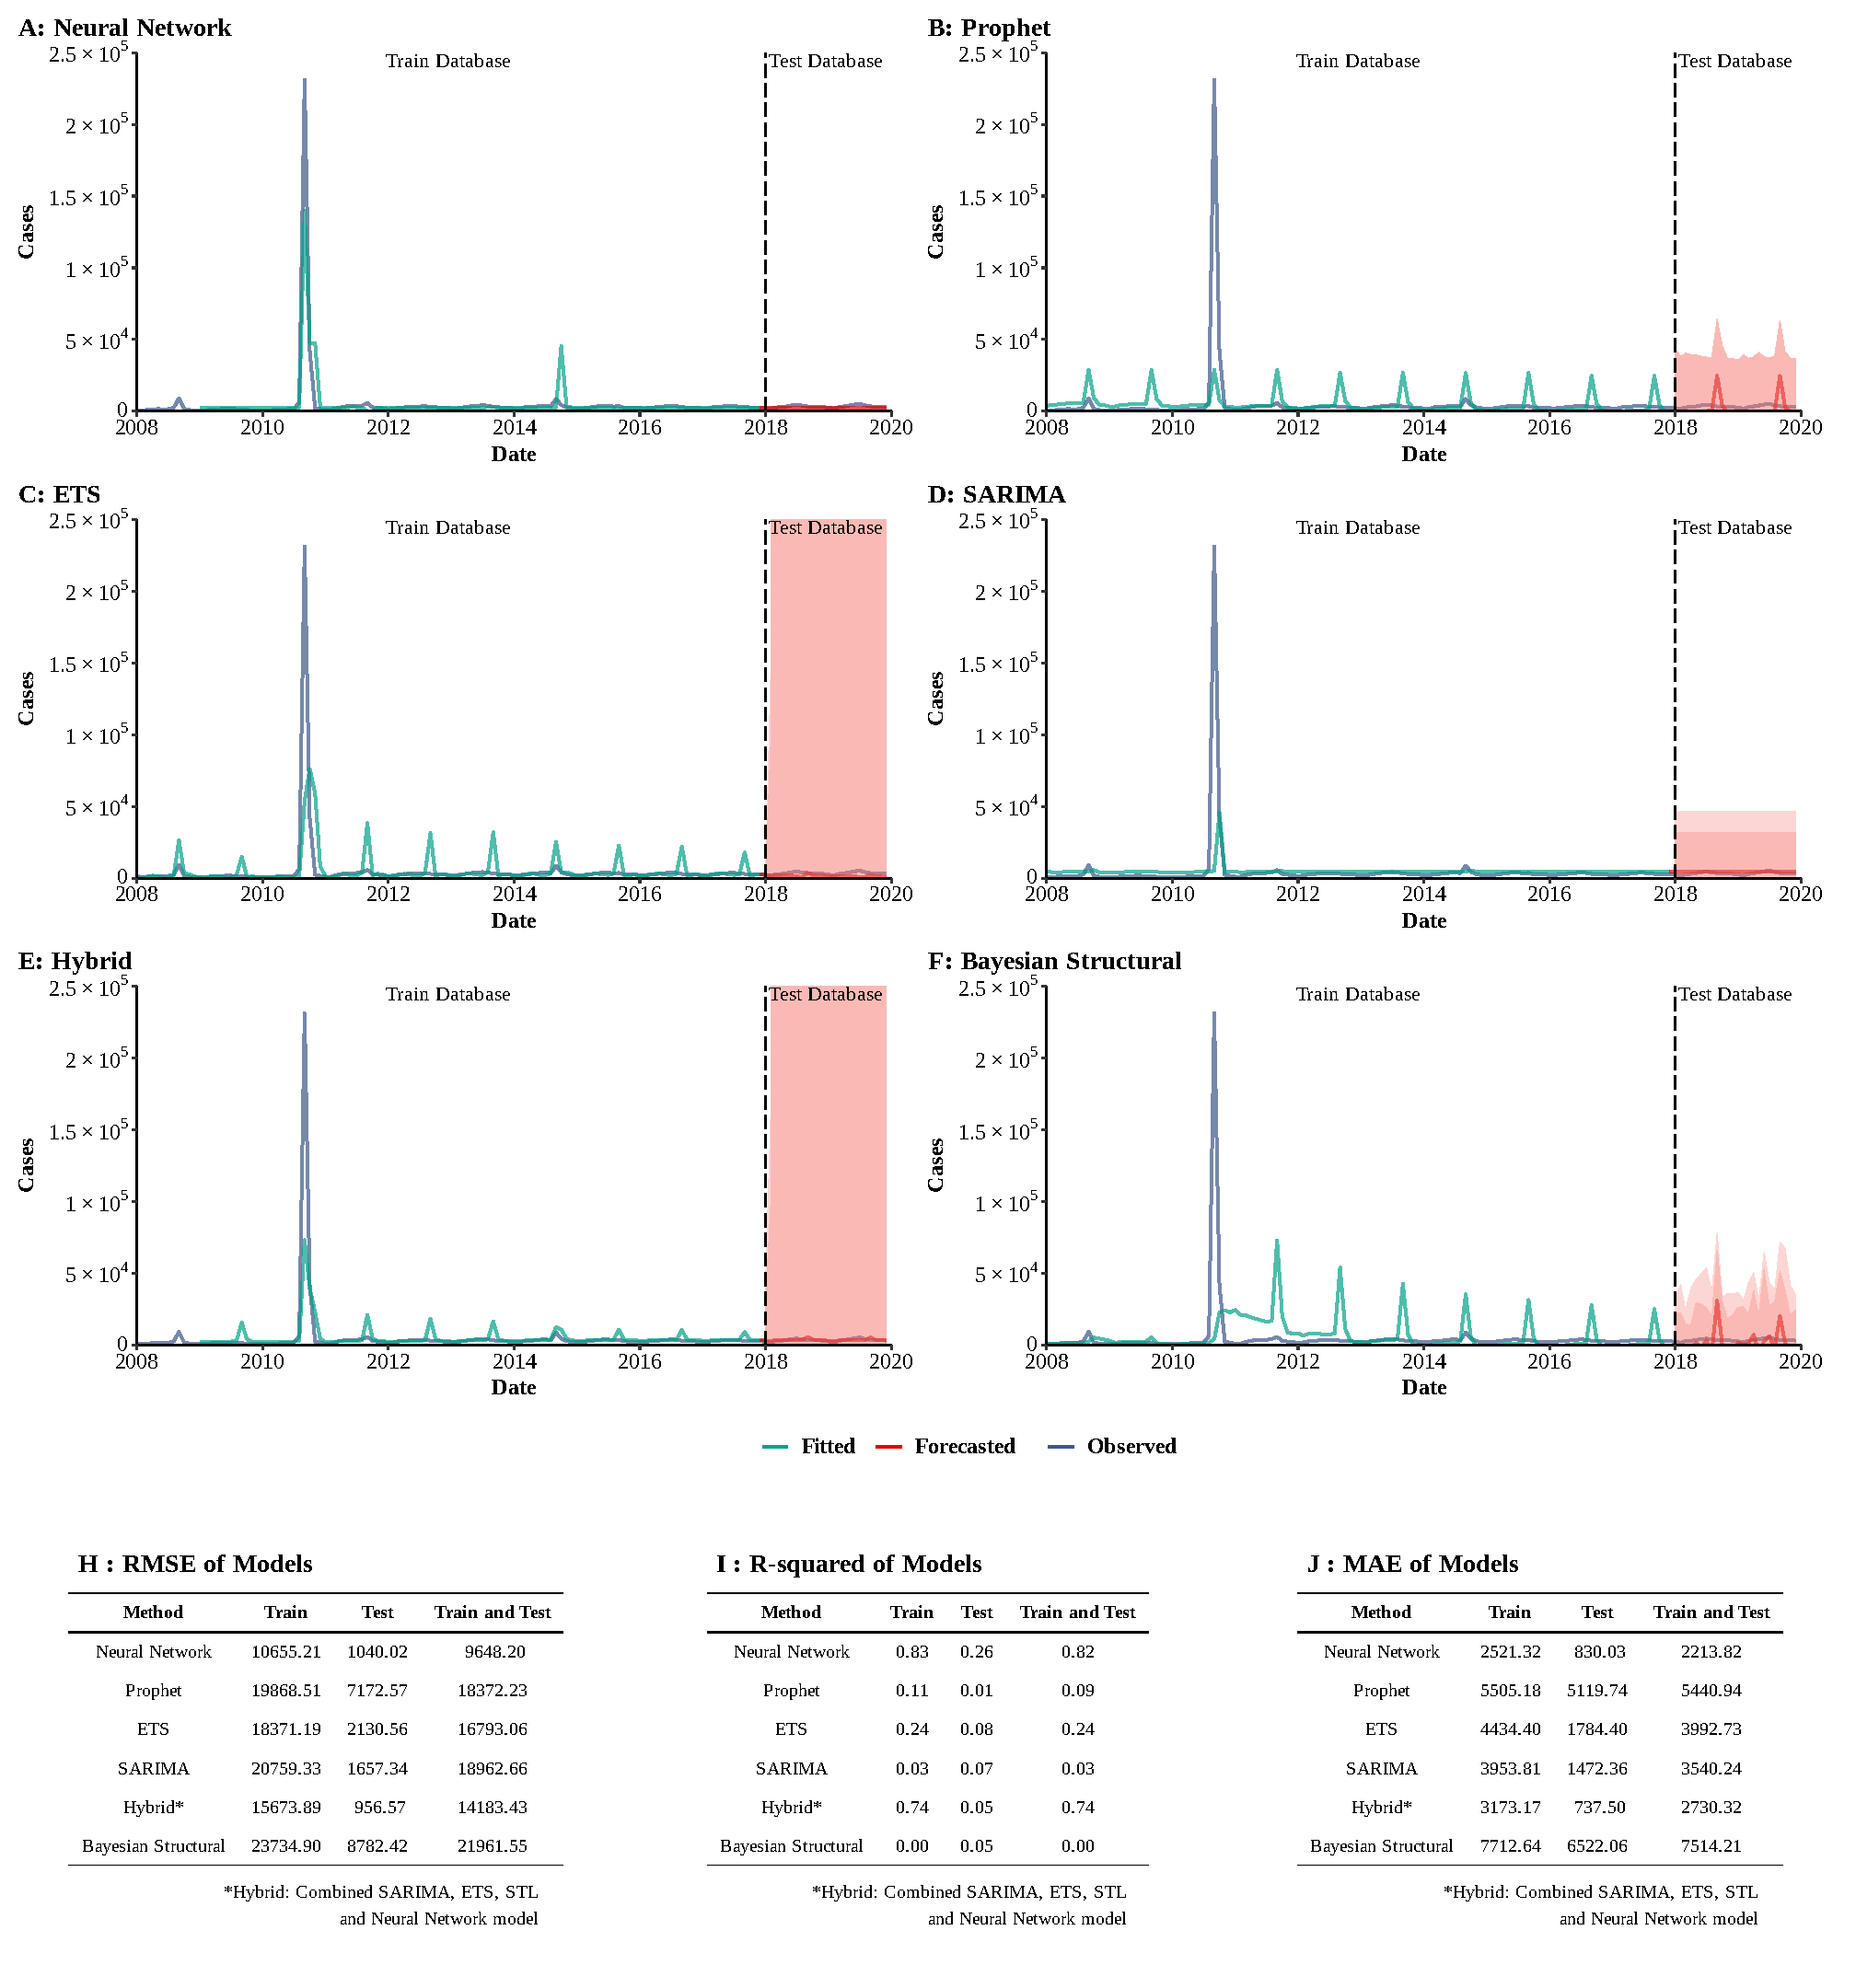
Supplementary Figure 4
Training and comparing variant time series models for AHC. (A) Neural Network model; (B) ETS model; (C) ARIMA model; (D) SEARIMA model; (E) Hybrid models combining SARIMA, ETS, STL, and neural network model; (F) Bayesian structural model; (G) RMSE of variant models; (H) R-squared of variant models; (J) MAE of variant models.
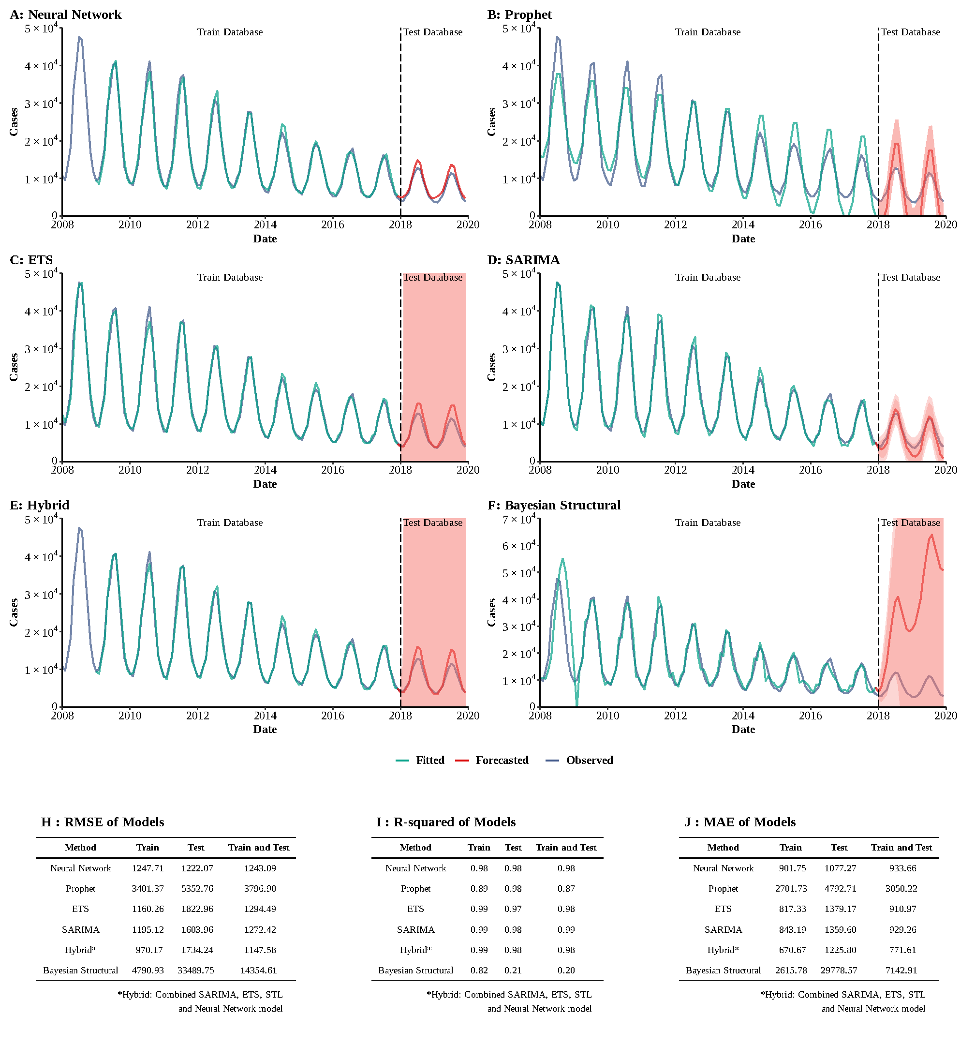
Supplementary Figure 5
Training and comparing variant time series models for dysentery. (A) Neural Network model; (B) ETS model; (C) ARIMA model; (D) SEARIMA model; (E) Hybrid models combining SARIMA, ETS, STL, and neural network model; (F) Bayesian structural model; (G) RMSE of variant models; (H) R-squared of variant models; (J) MAE of variant models.

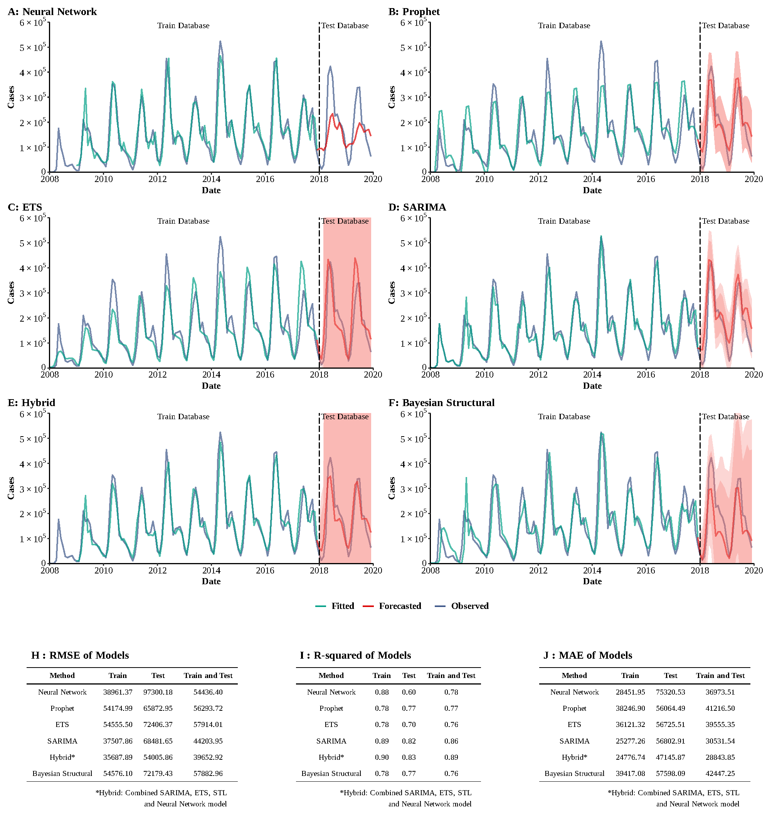
Supplementary Figure 6
Training and comparing variant time series models for HFMD. (A) Neural Network model; (B) ETS model; (C) ARIMA model; (D) SEARIMA model; (E) Hybrid models combining SARIMA, ETS, STL, and neural network model; (F) Bayesian structural model; (G) RMSE of variant models; (H) R-squared of variant models; (J) MAE of variant models.
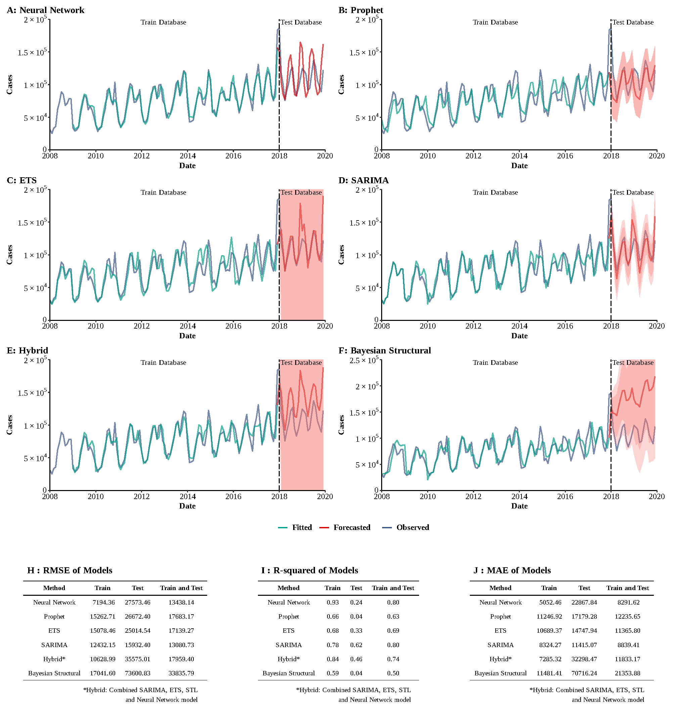
Supplementary Figure 7
Training and comparing variant time series models for other infectious diarrhea. (A) Neural Network model; (B) ETS model; (C) ARIMA model; (D) SEARIMA model; (E) Hybrid models combining SARIMA, ETS, STL, and neural network model; (F) Bayesian structural model; (G) RMSE of variant models; (H) R-squared of variant models; (J) MAE of variant models.

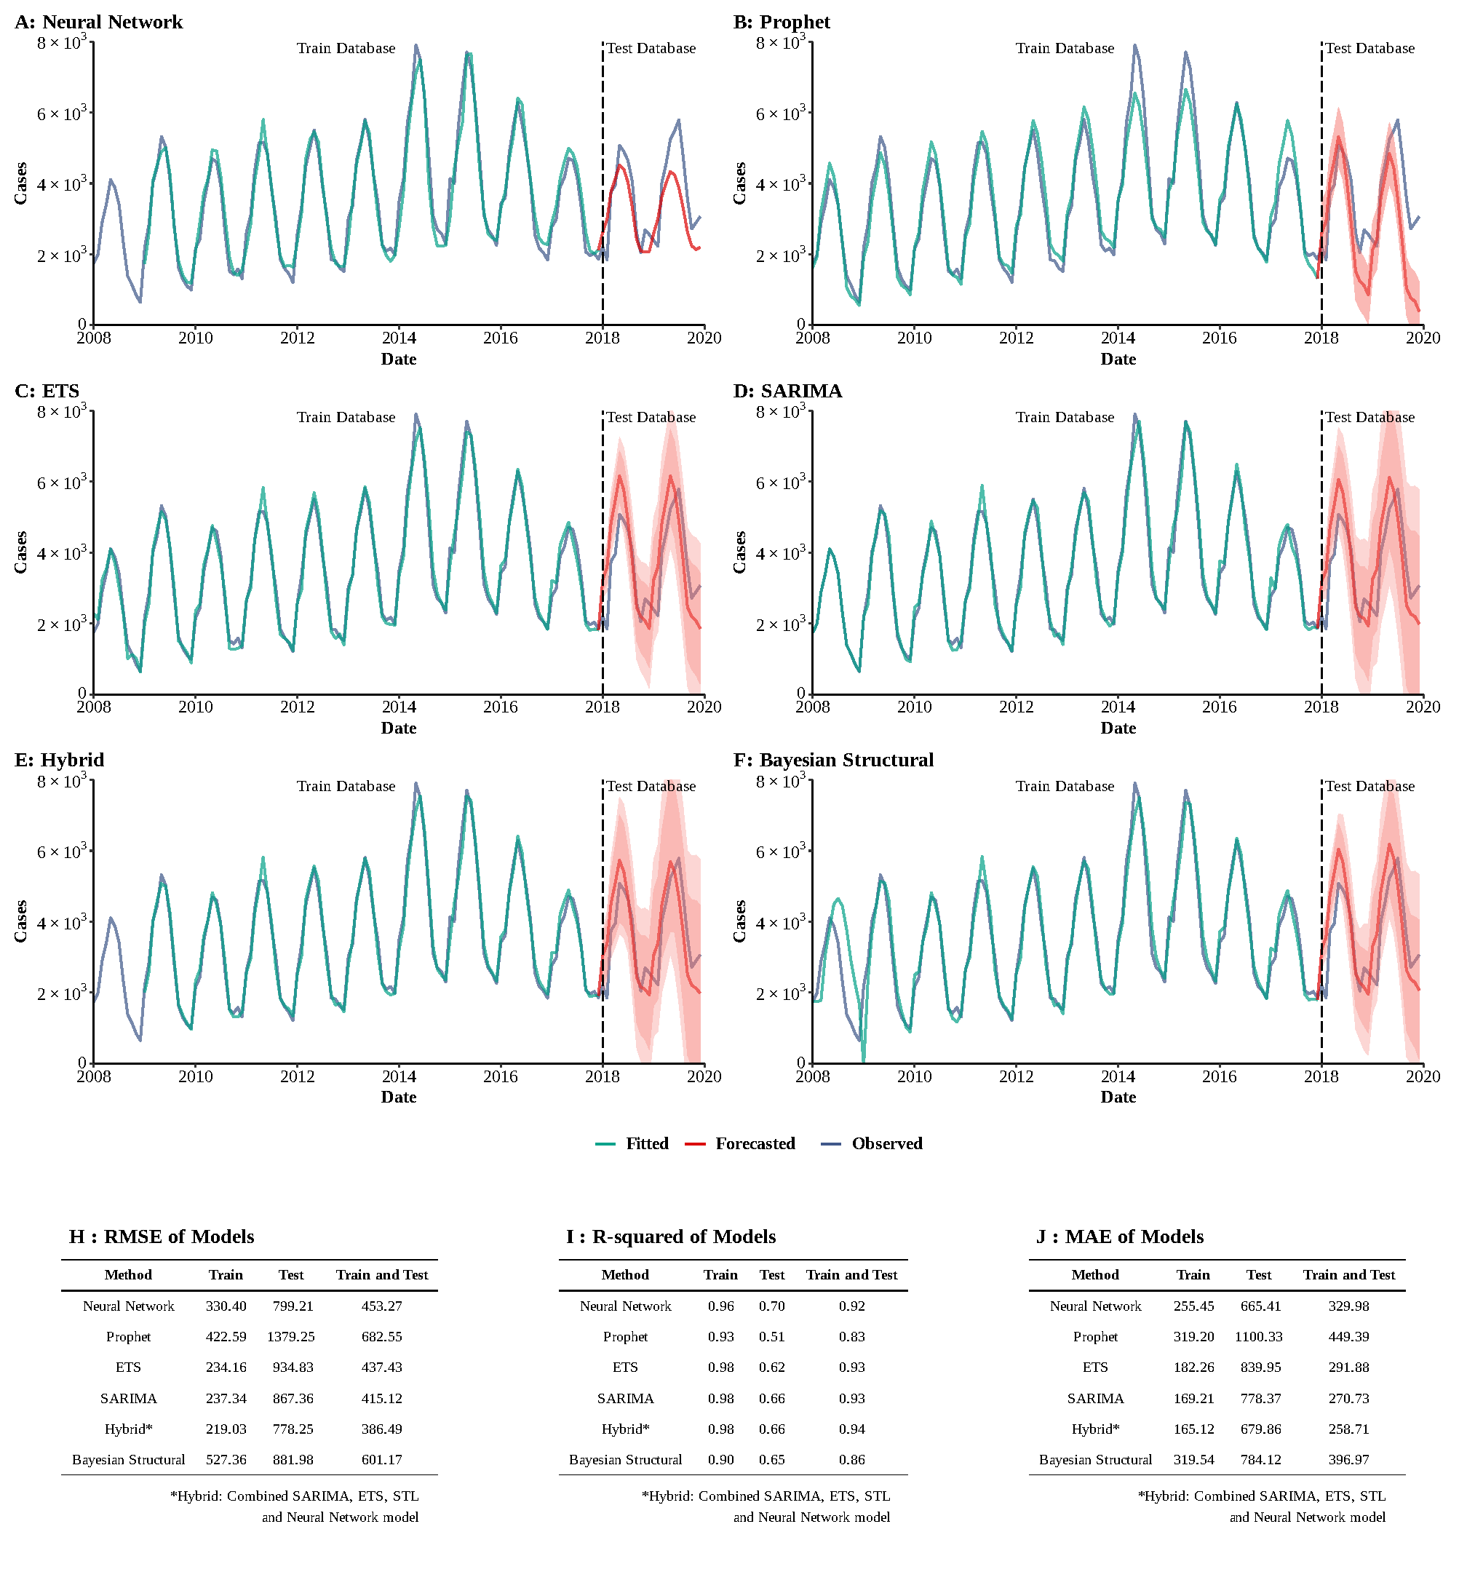Supplementary Figure 8
Training and comparing variant time series models for brucellosis. (A) Neural Network model; (B) ETS model; (C) ARIMA model; (D) SEARIMA model; (E) Hybrid models combining SARIMA, ETS, STL, and neural network model; (F) Bayesian structural model; (G) RMSE of variant models; (H) R-squared of variant models; (J) MAE of variant models.

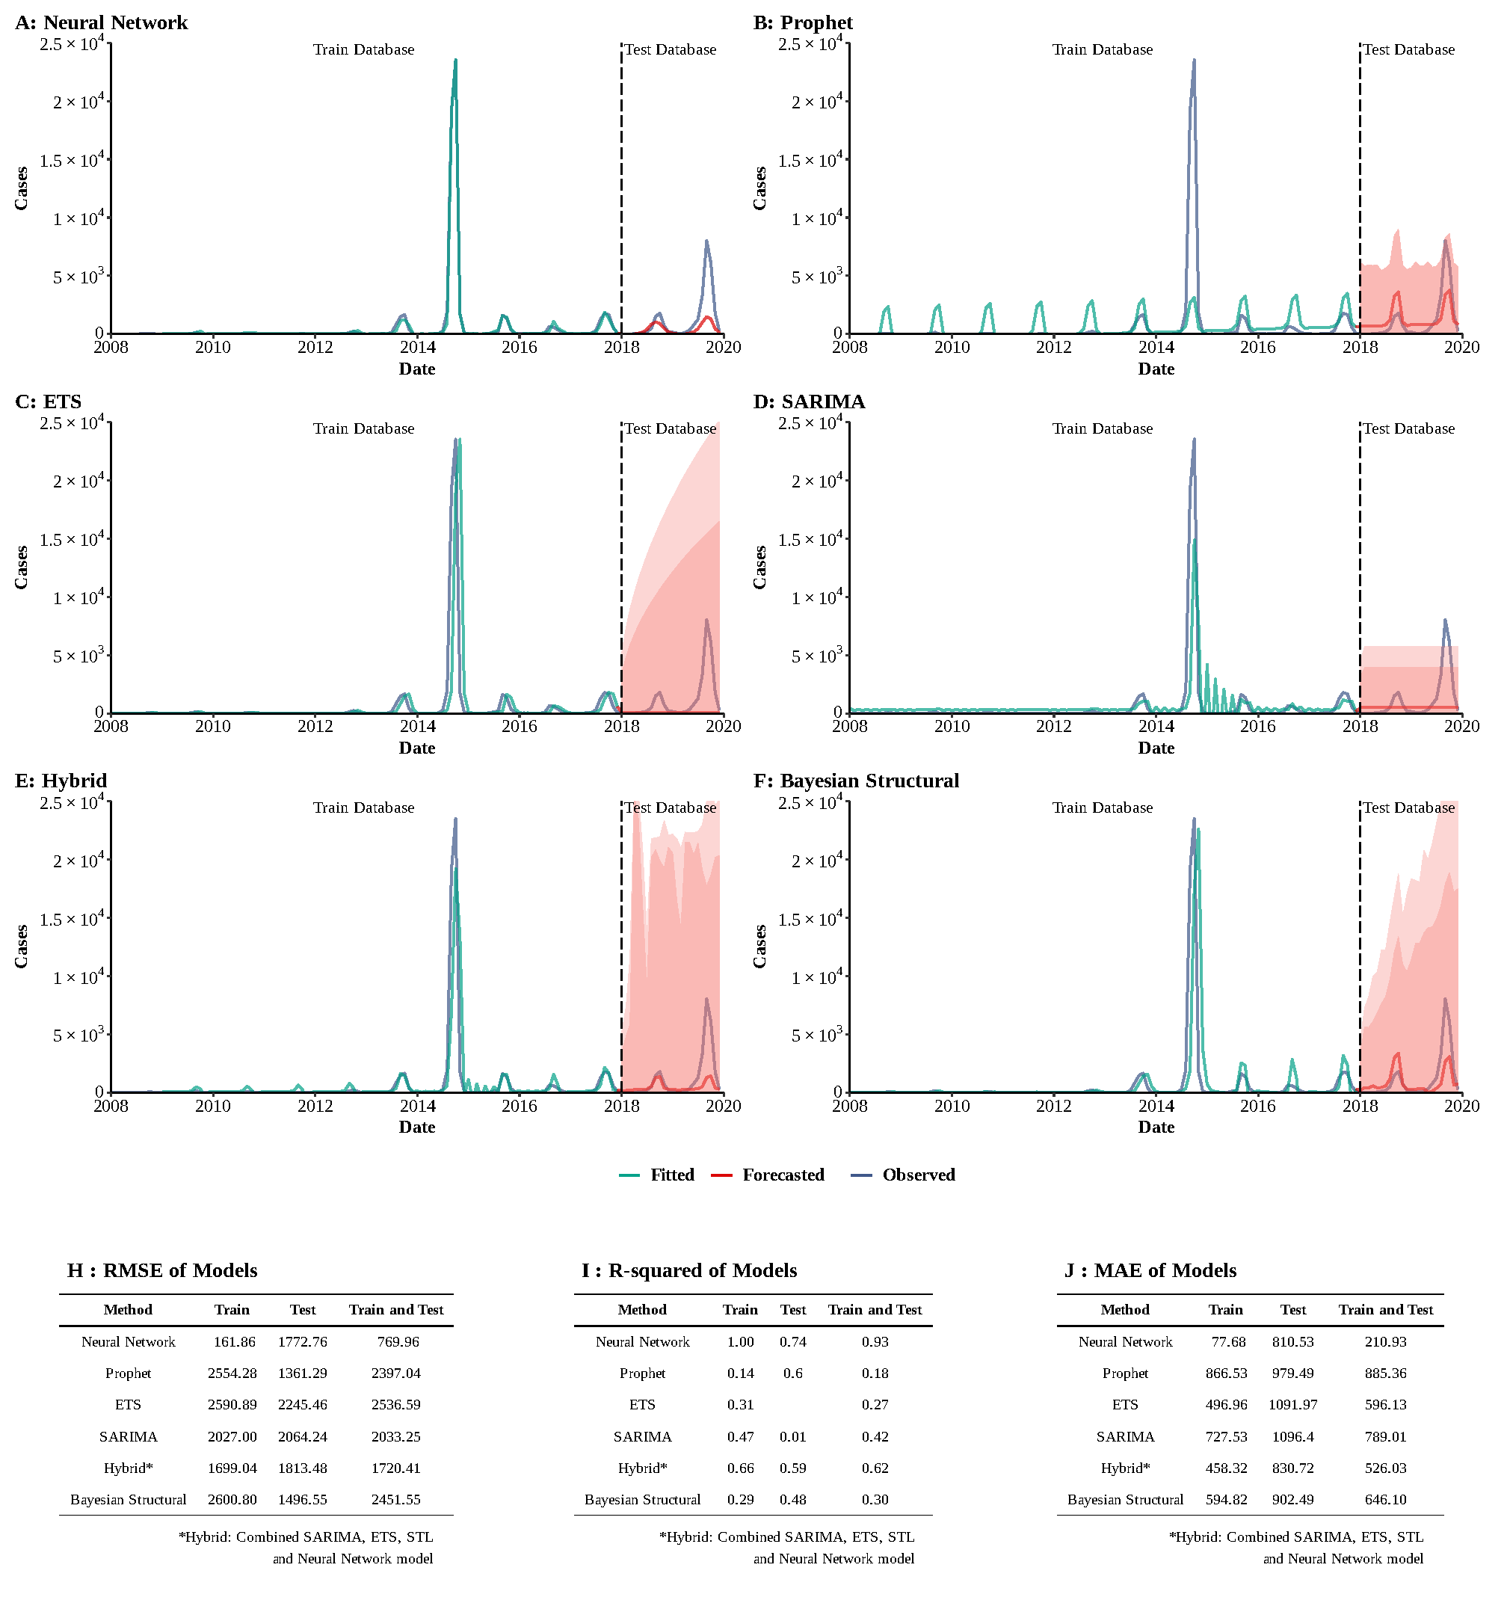
Supplementary Figure 9
Training and comparing variant time series models for dengue fever. (A) Neural Network model; (B) ETS model; (C) ARIMA model; (D) SEARIMA model; (E) Hybrid models combining SARIMA, ETS, STL, and neural network model; (F) Bayesian structural model; (G) RMSE of variant models; (H) R-squared of variant models; (J) MAE of variant models.
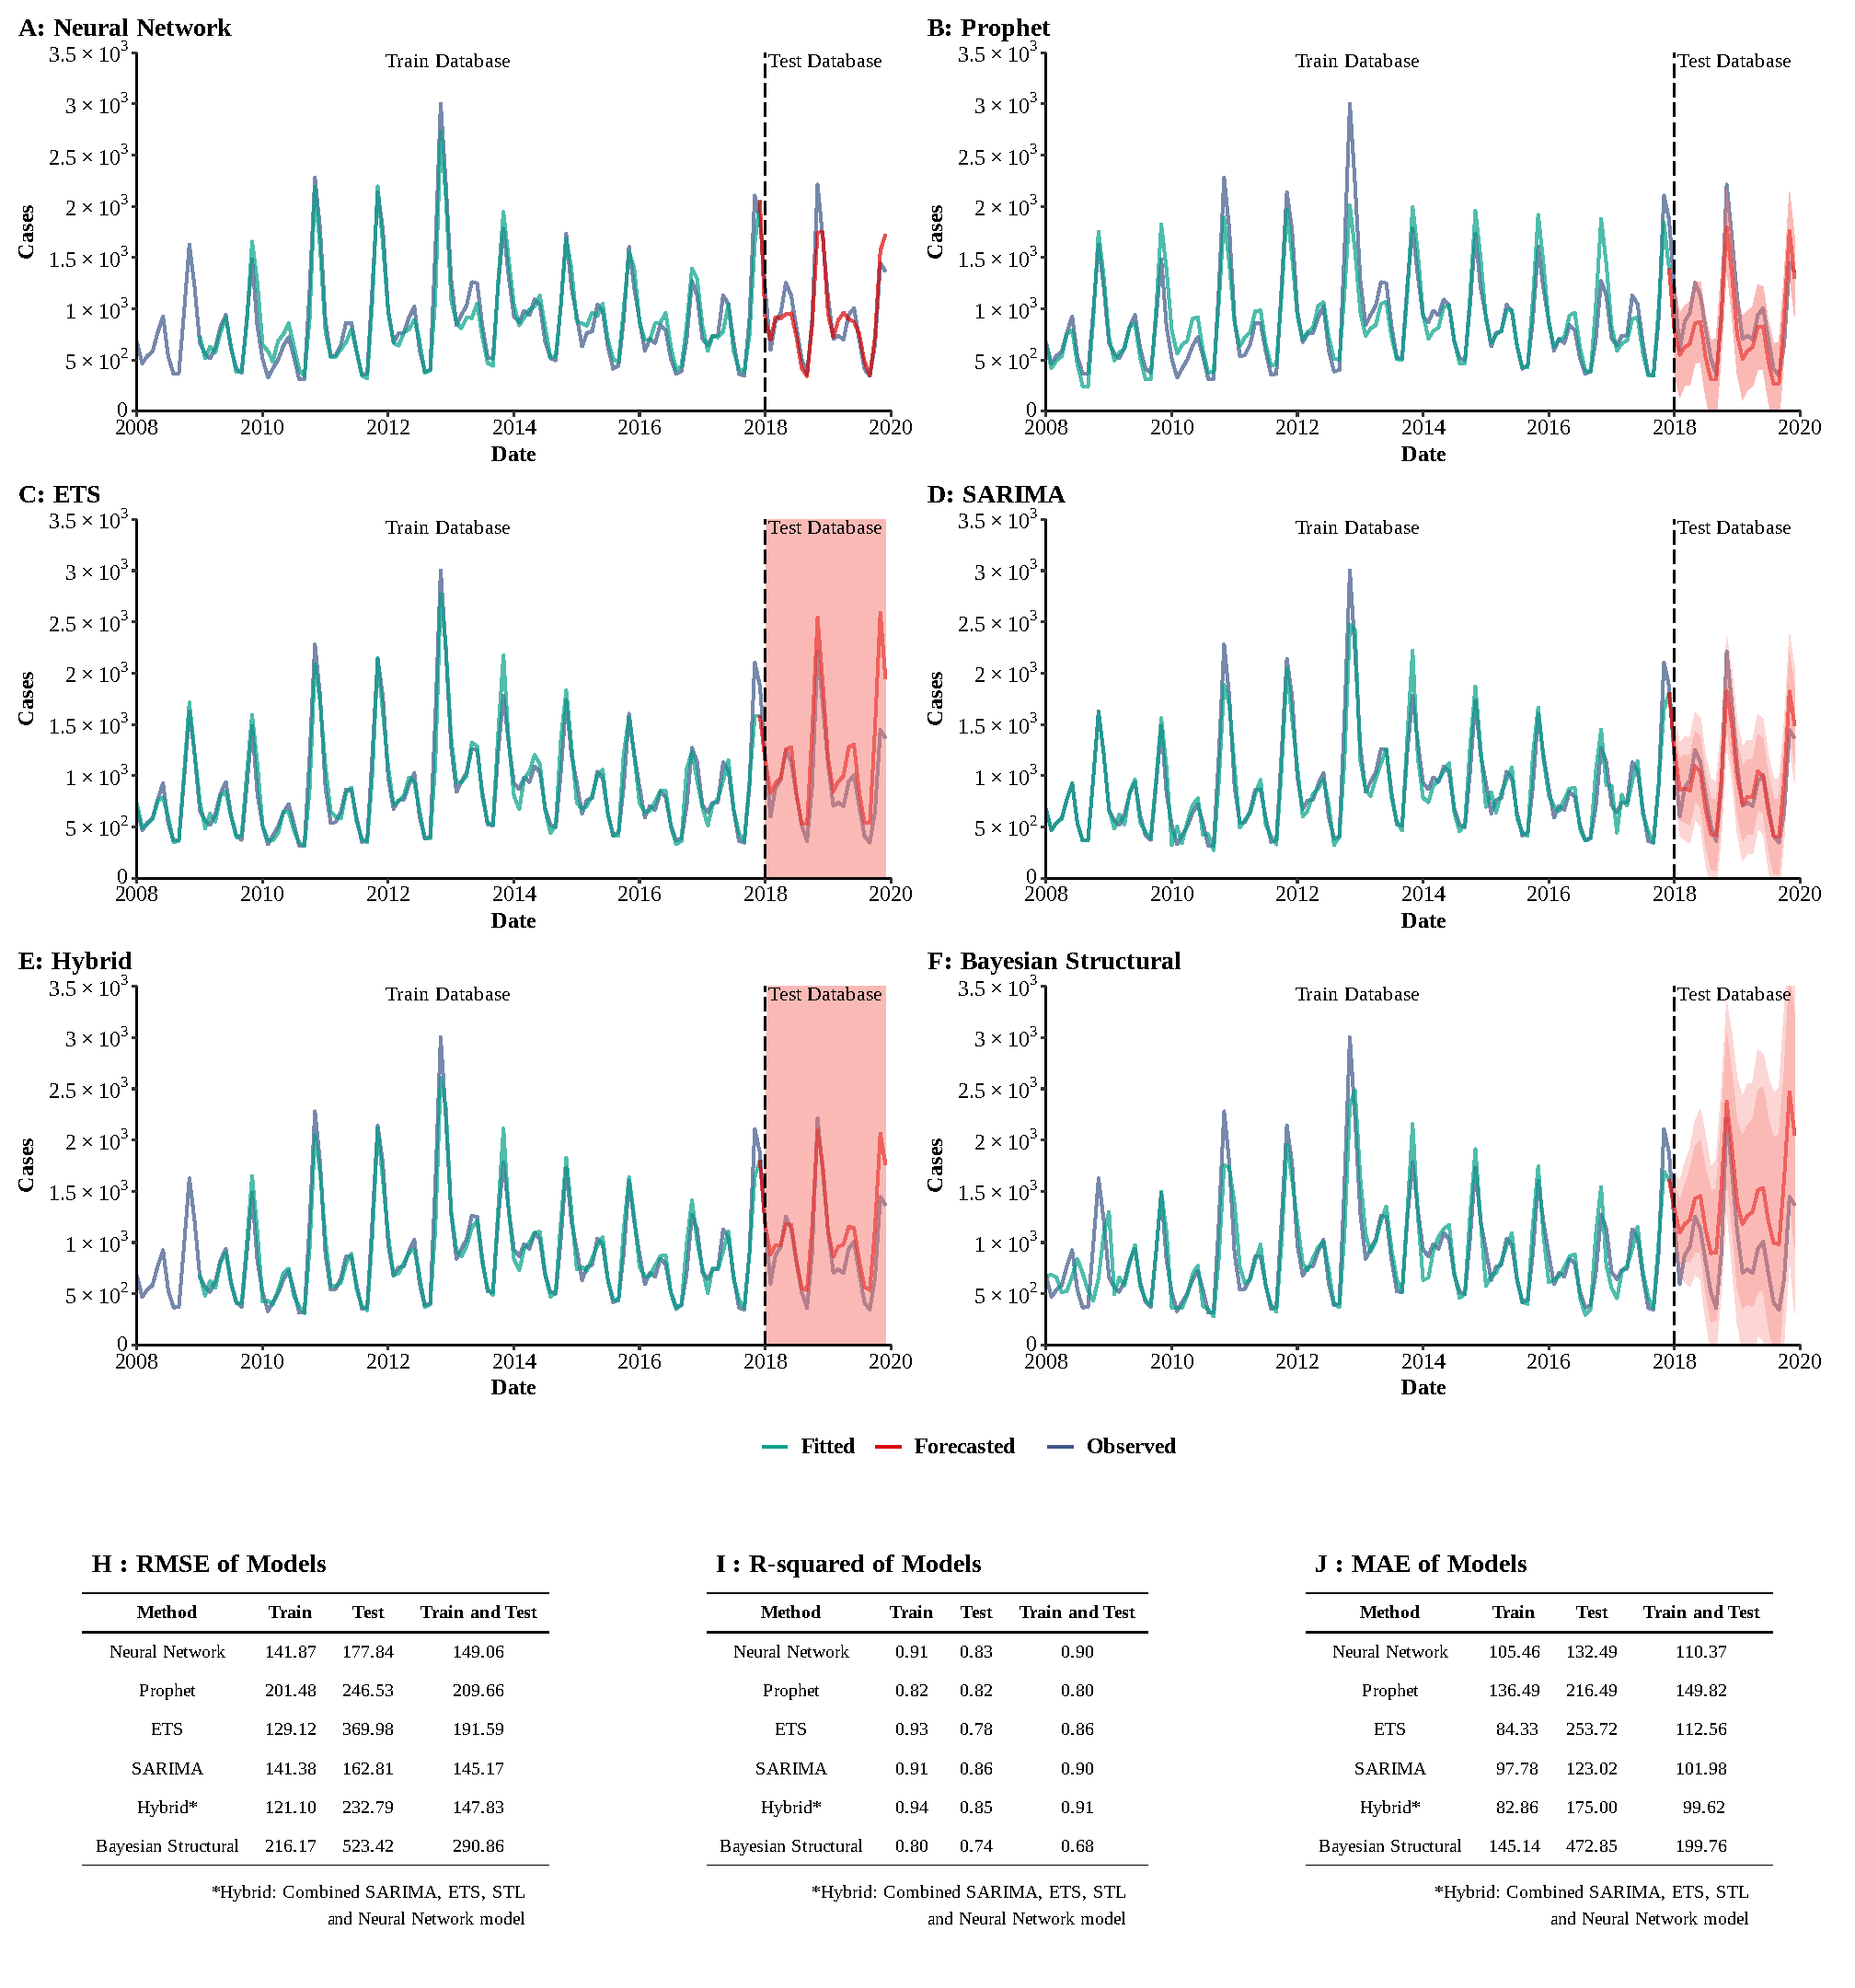
Supplementary Figure 10
Training and comparing variant time series models for HFRS. (A) Neural Network model; (B) ETS model; (C) ARIMA model; (D) SEARIMA model; (E) Hybrid models combining SARIMA, ETS, STL, and neural network model; (F) Bayesian structural model; (G) RMSE of variant models; (H) R-squared of variant models; (J) MAE of variant models.
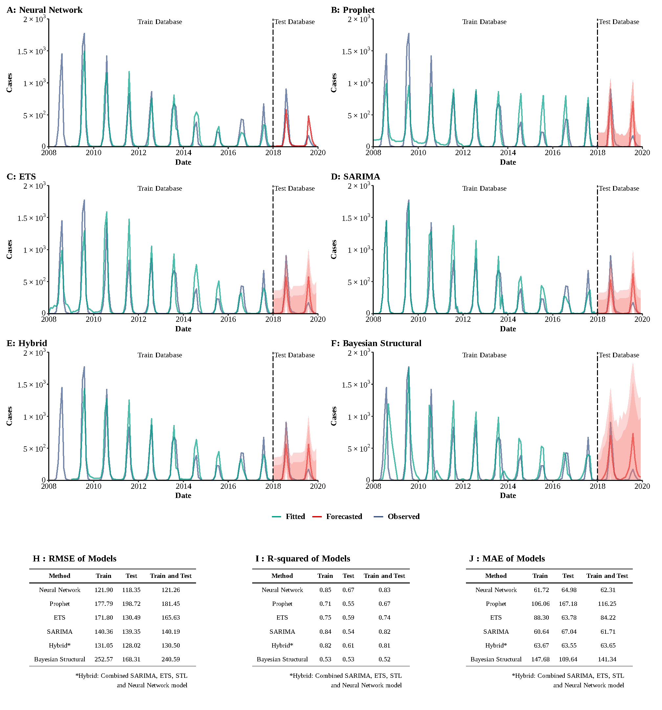
Supplementary Figure 11
Training and comparing variant time series models for Japanese encephalitis. (A) Neural Network model; (B) ETS model; (C) ARIMA model; (D) SEARIMA model; (E) Hybrid models combining SARIMA, ETS, STL, and neural network model; (F) Bayesian structural model; (G) RMSE of variant models; (H) R-squared of variant models; (J) MAE of variant models.

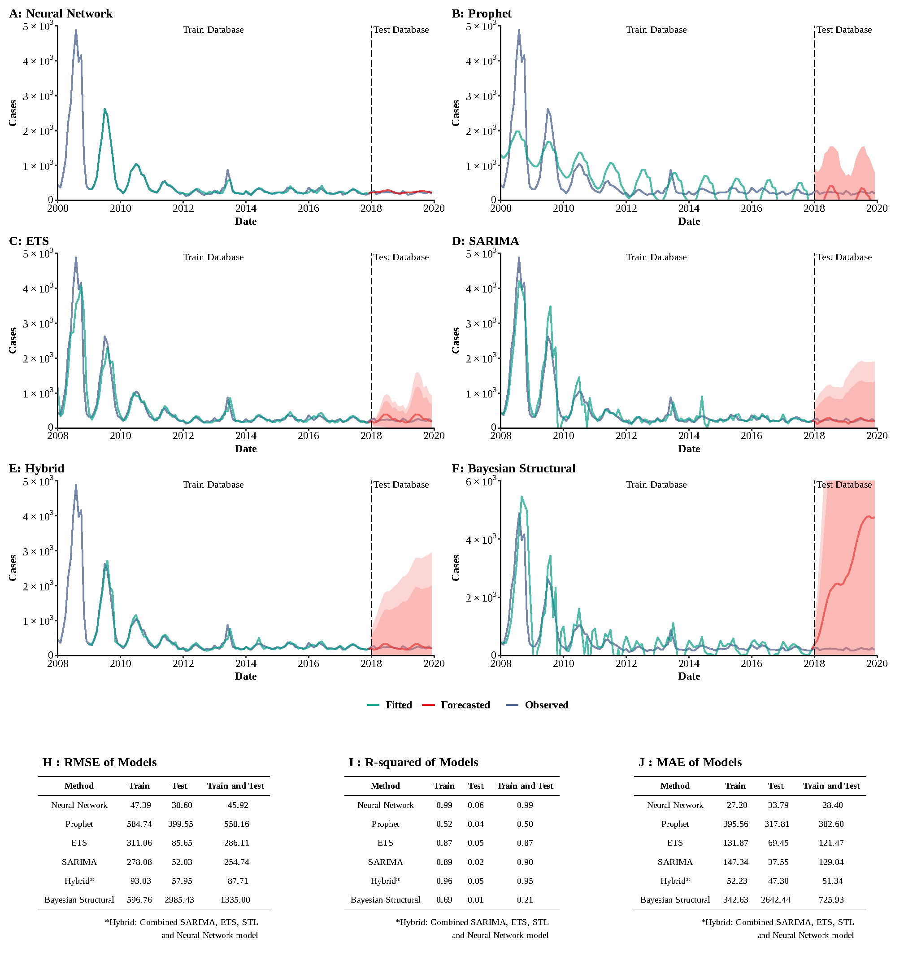Supplementary Figure 12
Training and comparing variant time series models for malaria. (A) Neural Network model; (B) ETS model; (C) ARIMA model; (D) SEARIMA model; (E) Hybrid models combining SARIMA, ETS, STL, and neural network model; (F) Bayesian structural model; (G) RMSE of variant models; (H) R-squared of variant models; (J) MAE of variant models.
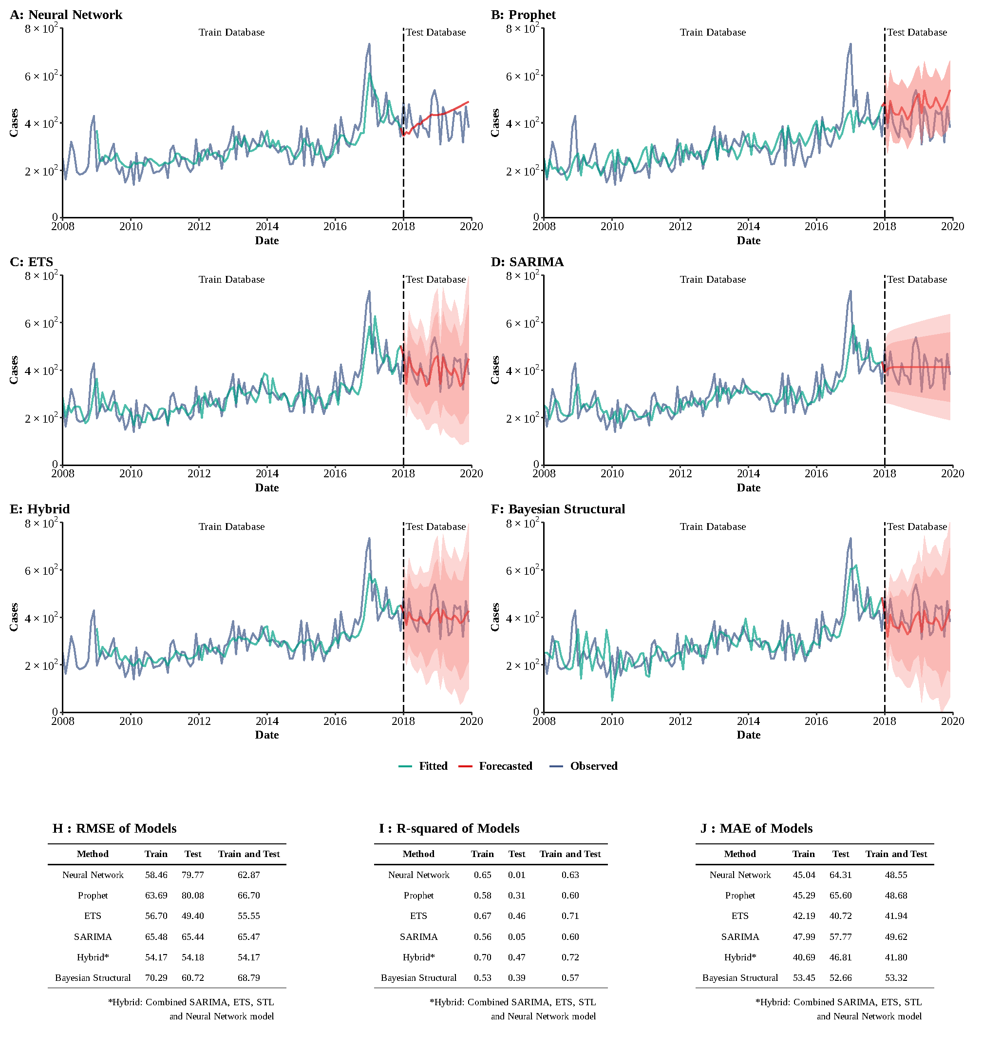
Supplementary Figure 13
Training and comparing variant time series models for hydatidosis. (A) Neural Network model; (B) ETS model; (C) ARIMA model; (D) SEARIMA model; (E) Hybrid models combining SARIMA, ETS, STL, and neural network model; (F) Bayesian structural model; (G) RMSE of variant models; (H) R-squared of variant models; (J) MAE of variant models.

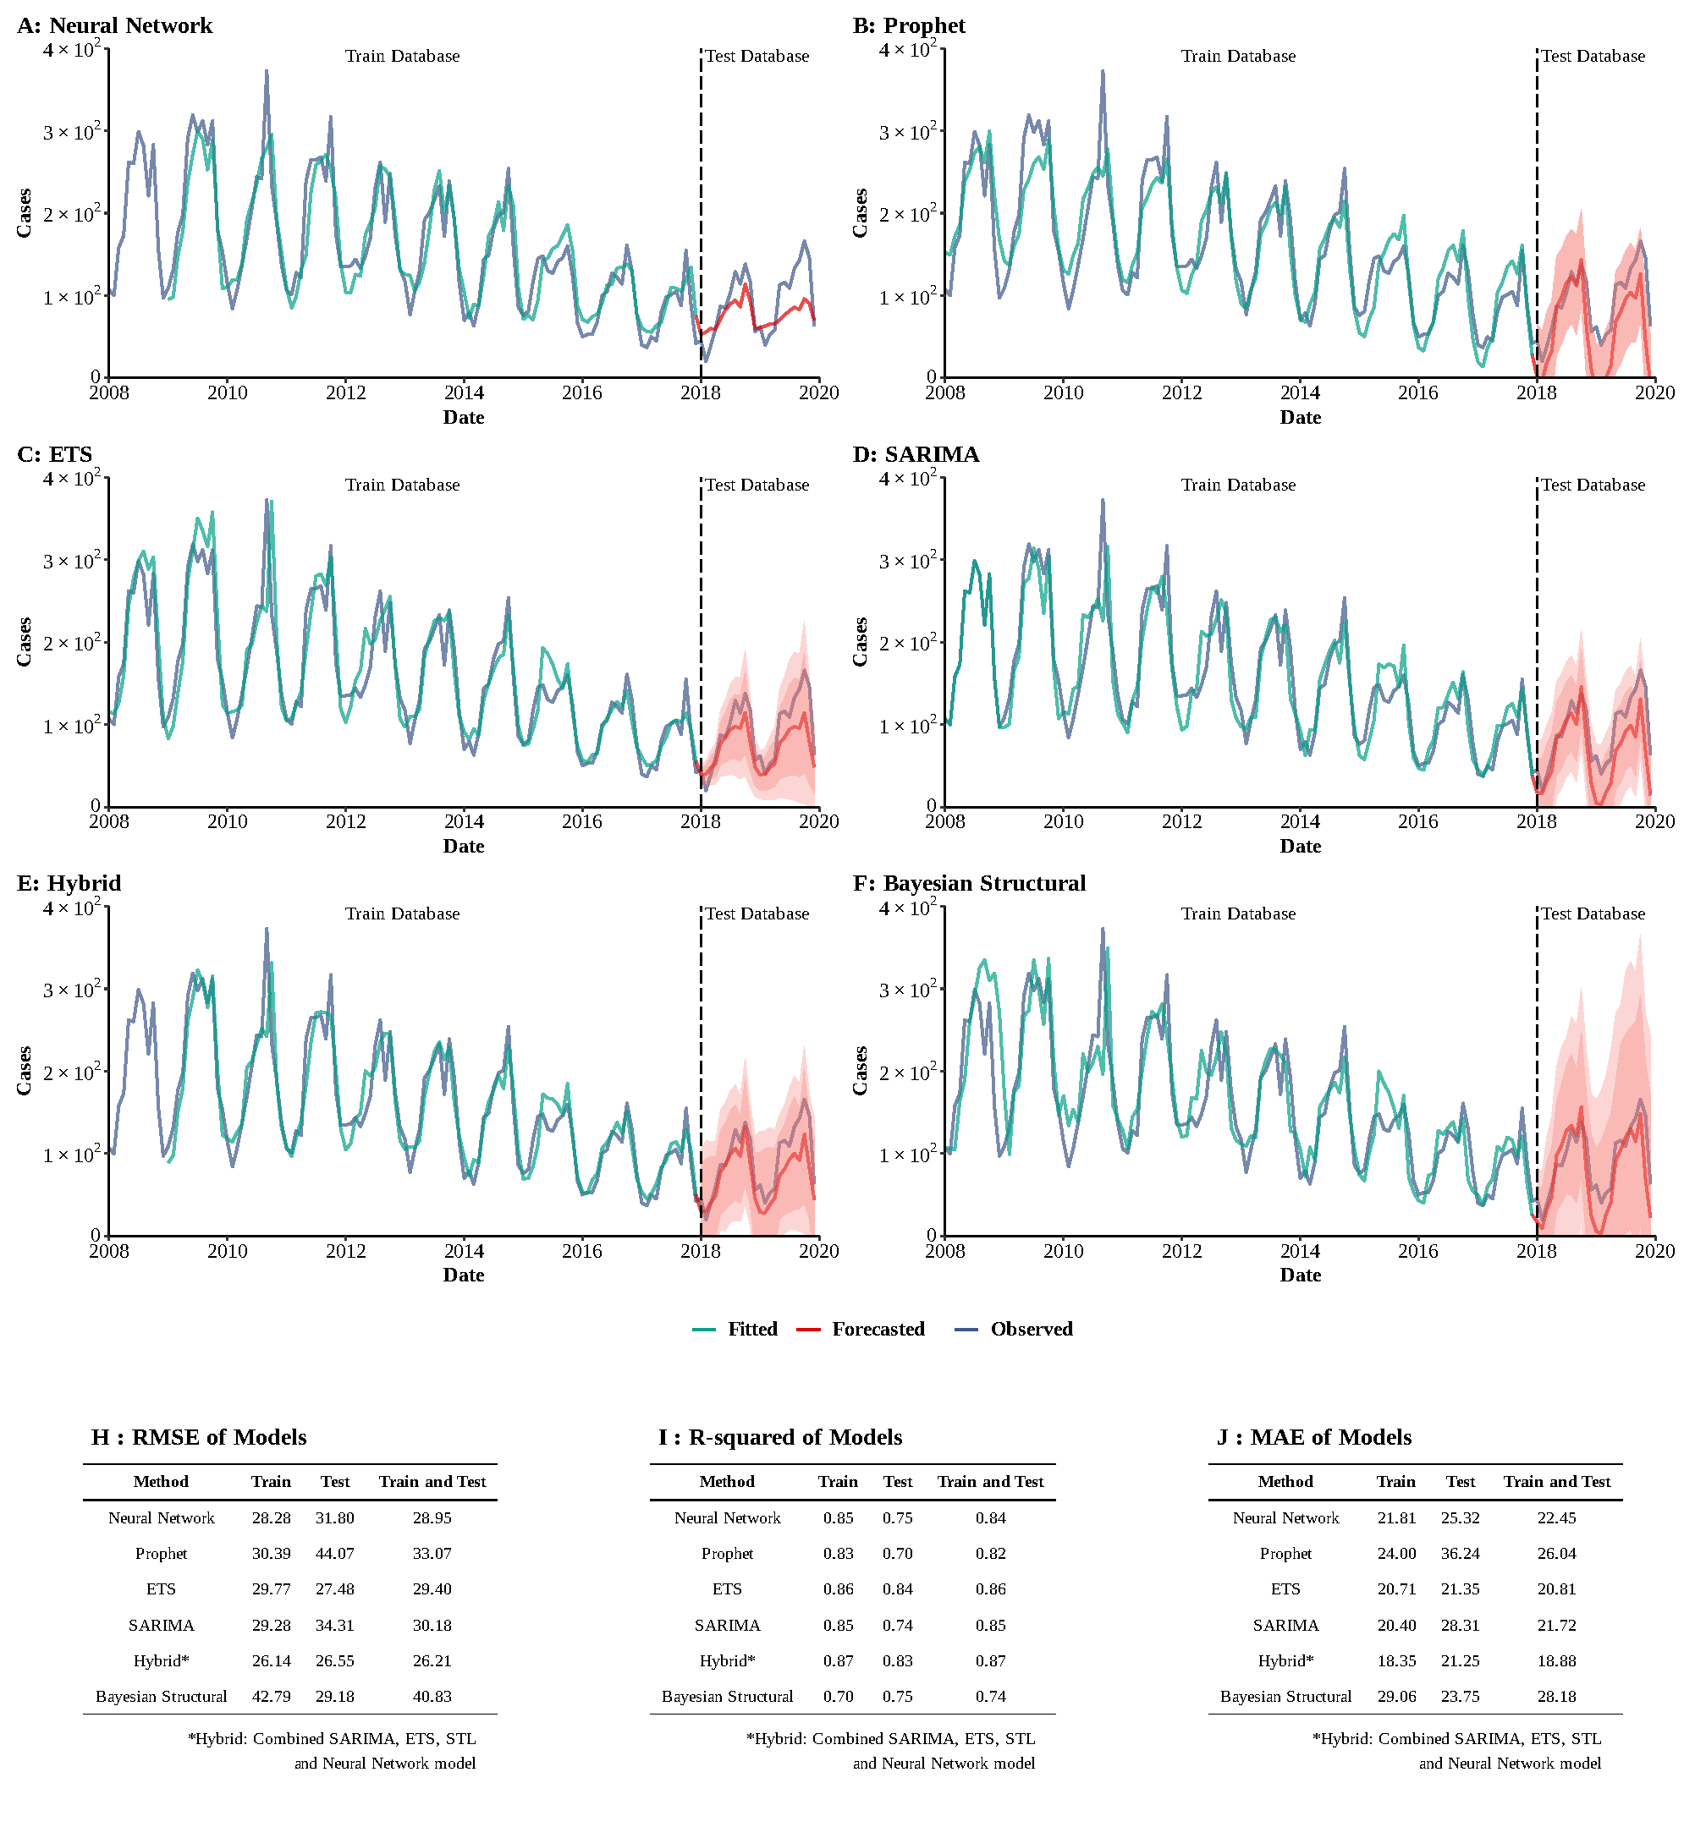Supplementary Figure 14
Training and comparing variant time series models for typhus. (A) Neural Network model; (B) ETS model; (C) ARIMA model; (D) SEARIMA model; (E) Hybrid models combining SARIMA, ETS, STL, and neural network model; (F) Bayesian structural model; (G) RMSE of variant models; (H) R-squared of variant models; (J) MAE of variant models.
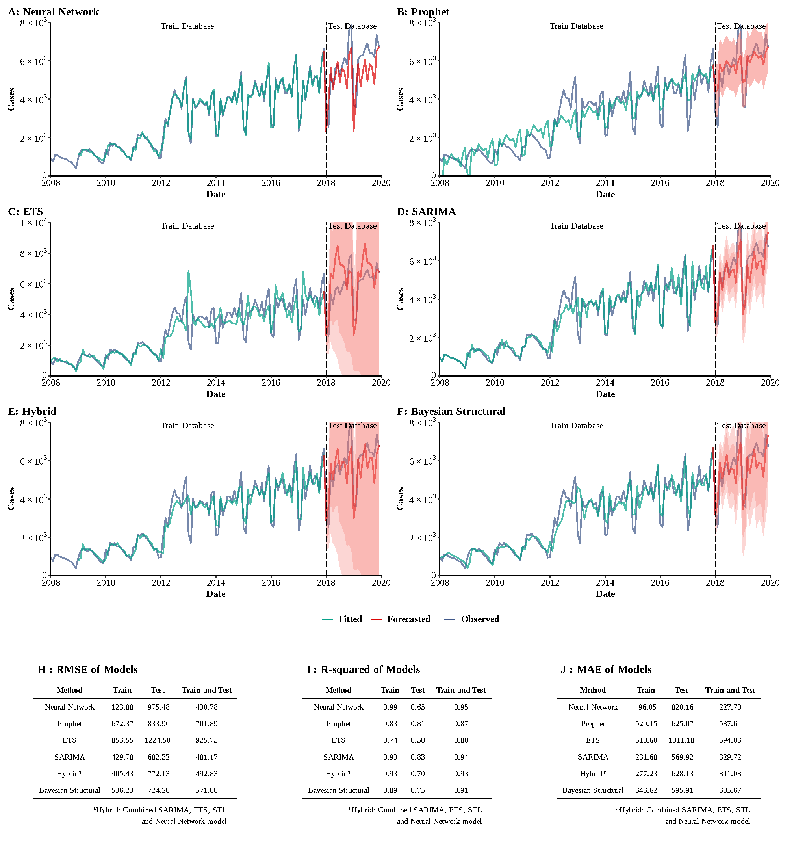
Supplementary Figure 15
Training and comparing variant time series models for AIDS. (A) Neural Network model; (B) ETS model; (C) ARIMA model; (D) SEARIMA model; (E) Hybrid models combining SARIMA, ETS, STL, and neural network model; (F) Bayesian structural model; (G) RMSE of variant models; (H) R-squared of variant models; (J) MAE of variant models.
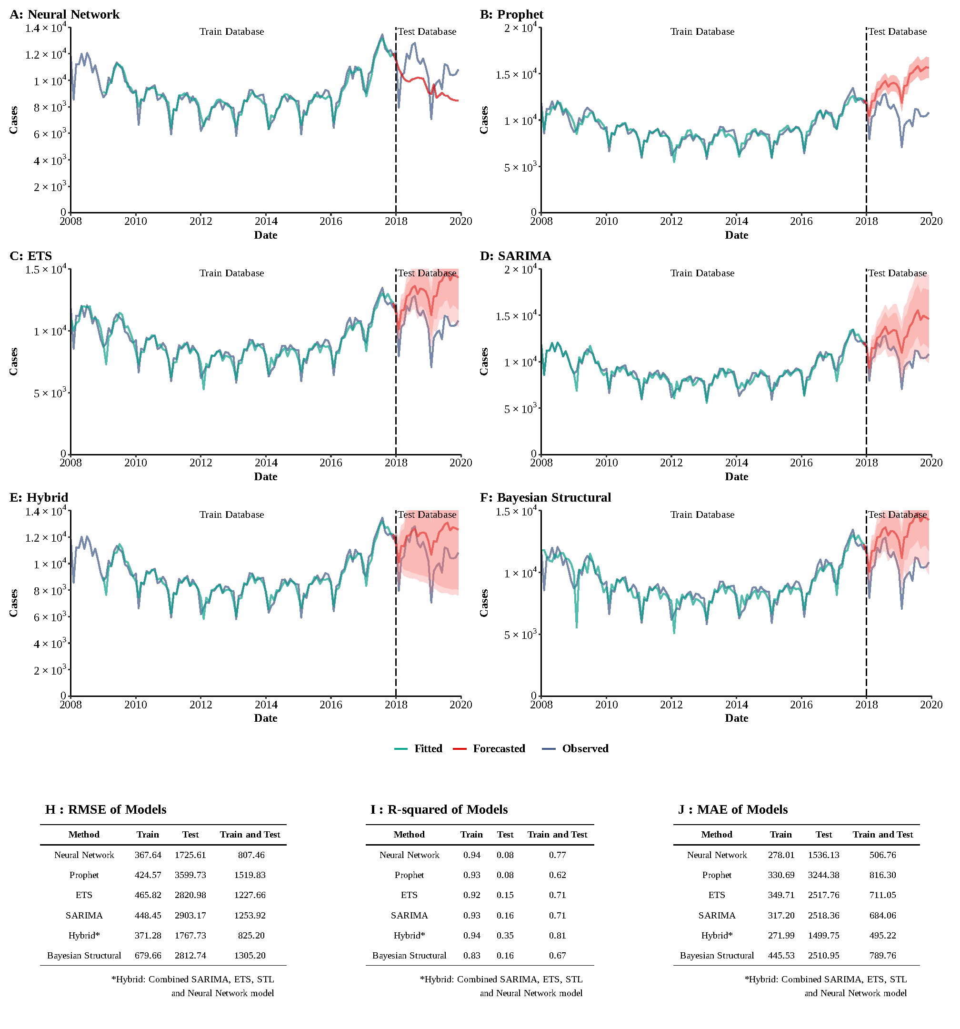
Supplementary Figure 16
Training and comparing variant time series models for gonorrhea. (A) Neural Network model; (B) ETS model; (C) ARIMA model; (D) SEARIMA model; (E) Hybrid models combining SARIMA, ETS, STL, and neural network model; (F) Bayesian structural model; (G) RMSE of variant models; (H) R-squared of variant models; (J) MAE of variant models.
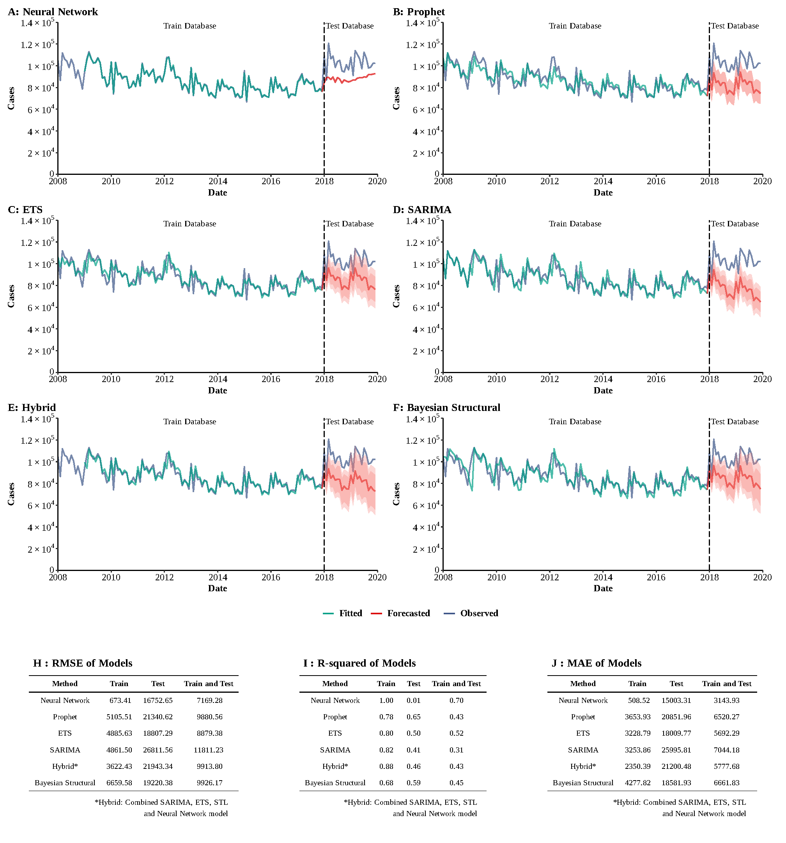
Supplementary Figure 17
Training and comparing variant time series models for HBV. (A) Neural Network model; (B) ETS model; (C) ARIMA model; (D) SEARIMA model; (E) Hybrid models combining SARIMA, ETS, STL, and neural network model; (F) Bayesian structural model; (G) RMSE of variant models; (H) R-squared of variant models; (J) MAE of variant models.
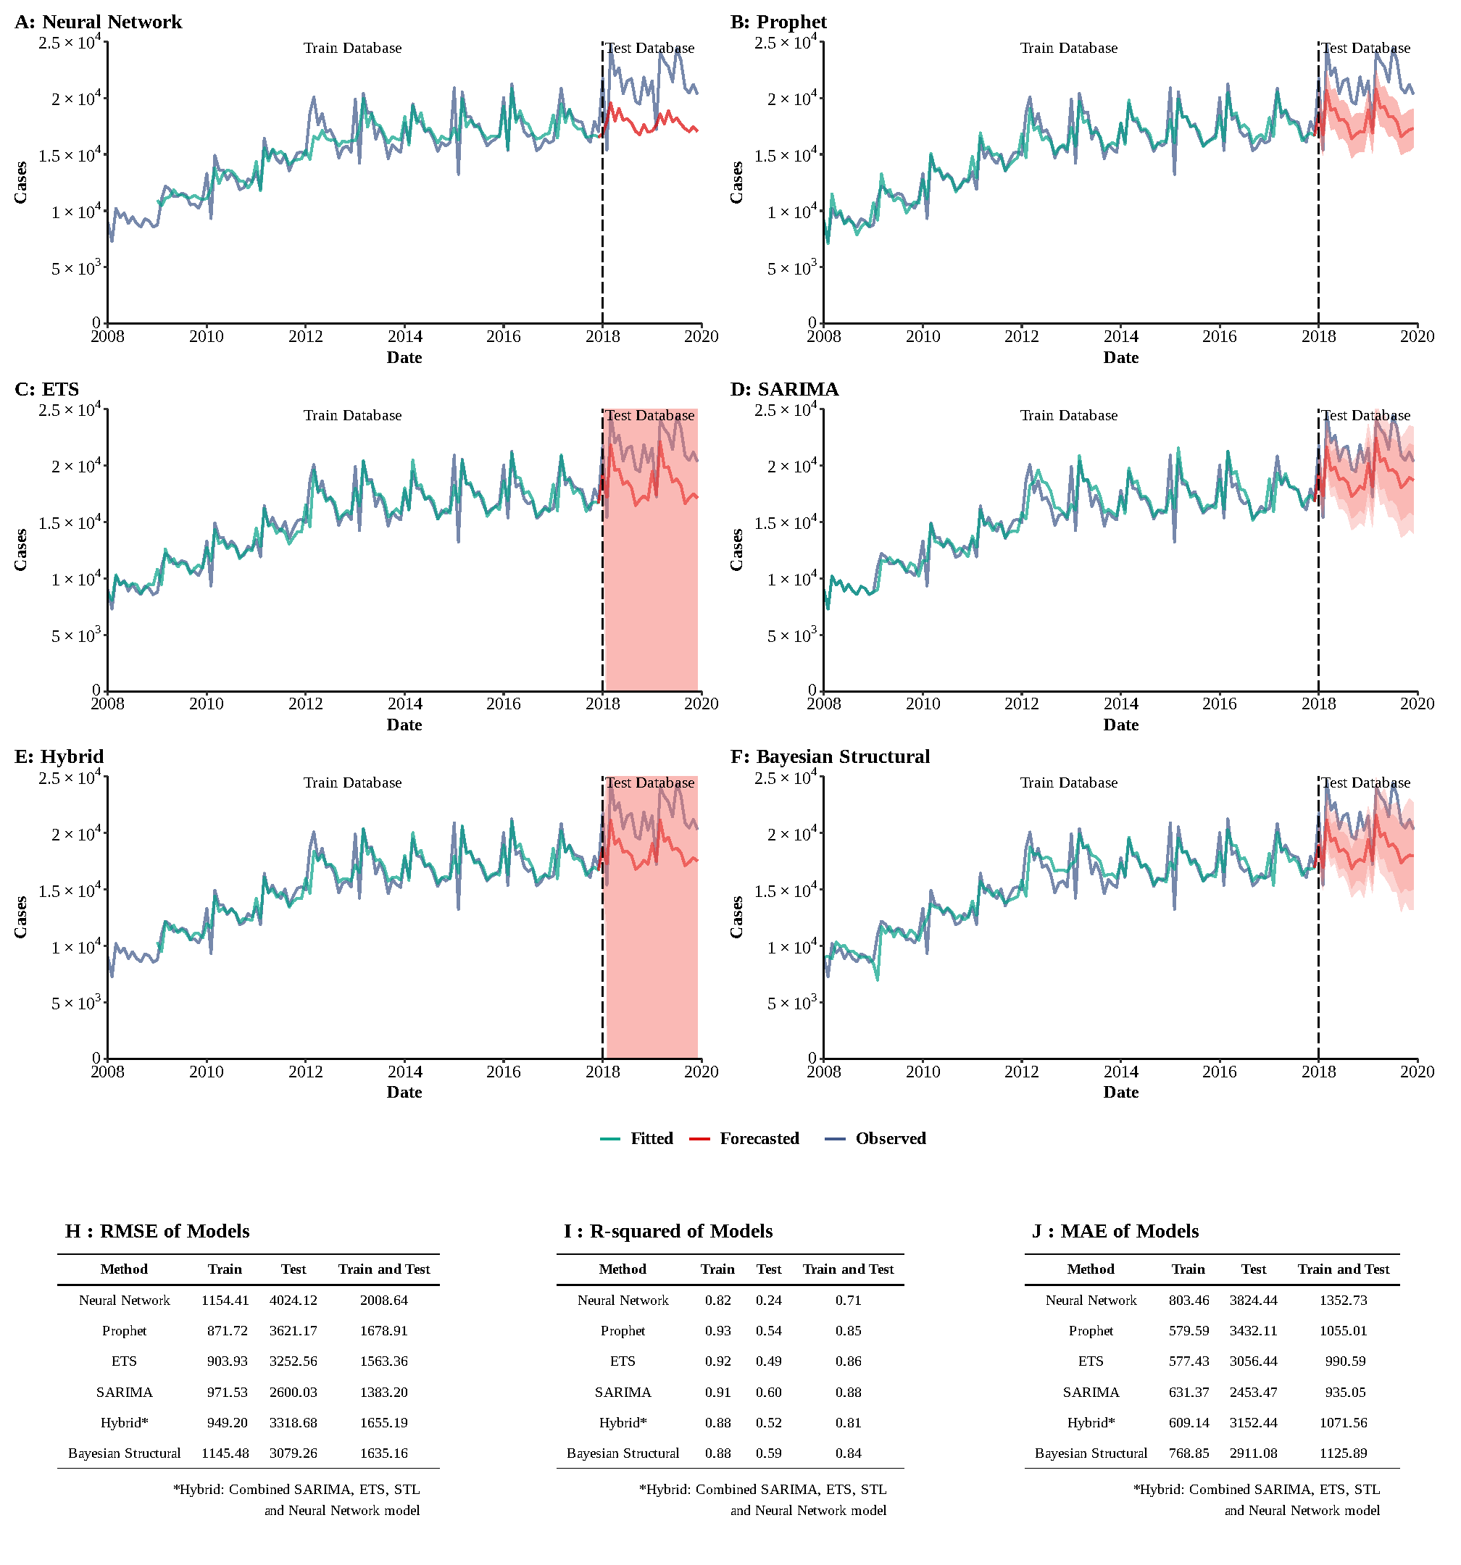
Supplementary Figure 18
Training and comparing variant time series models for HCV. (A) Neural Network model; (B) ETS model; (C) ARIMA model; (D) SEARIMA model; (E) Hybrid models combining SARIMA, ETS, STL, and neural network model; (F) Bayesian structural model; (G) RMSE of variant models; (H) R-squared of variant models; (J) MAE of variant models.

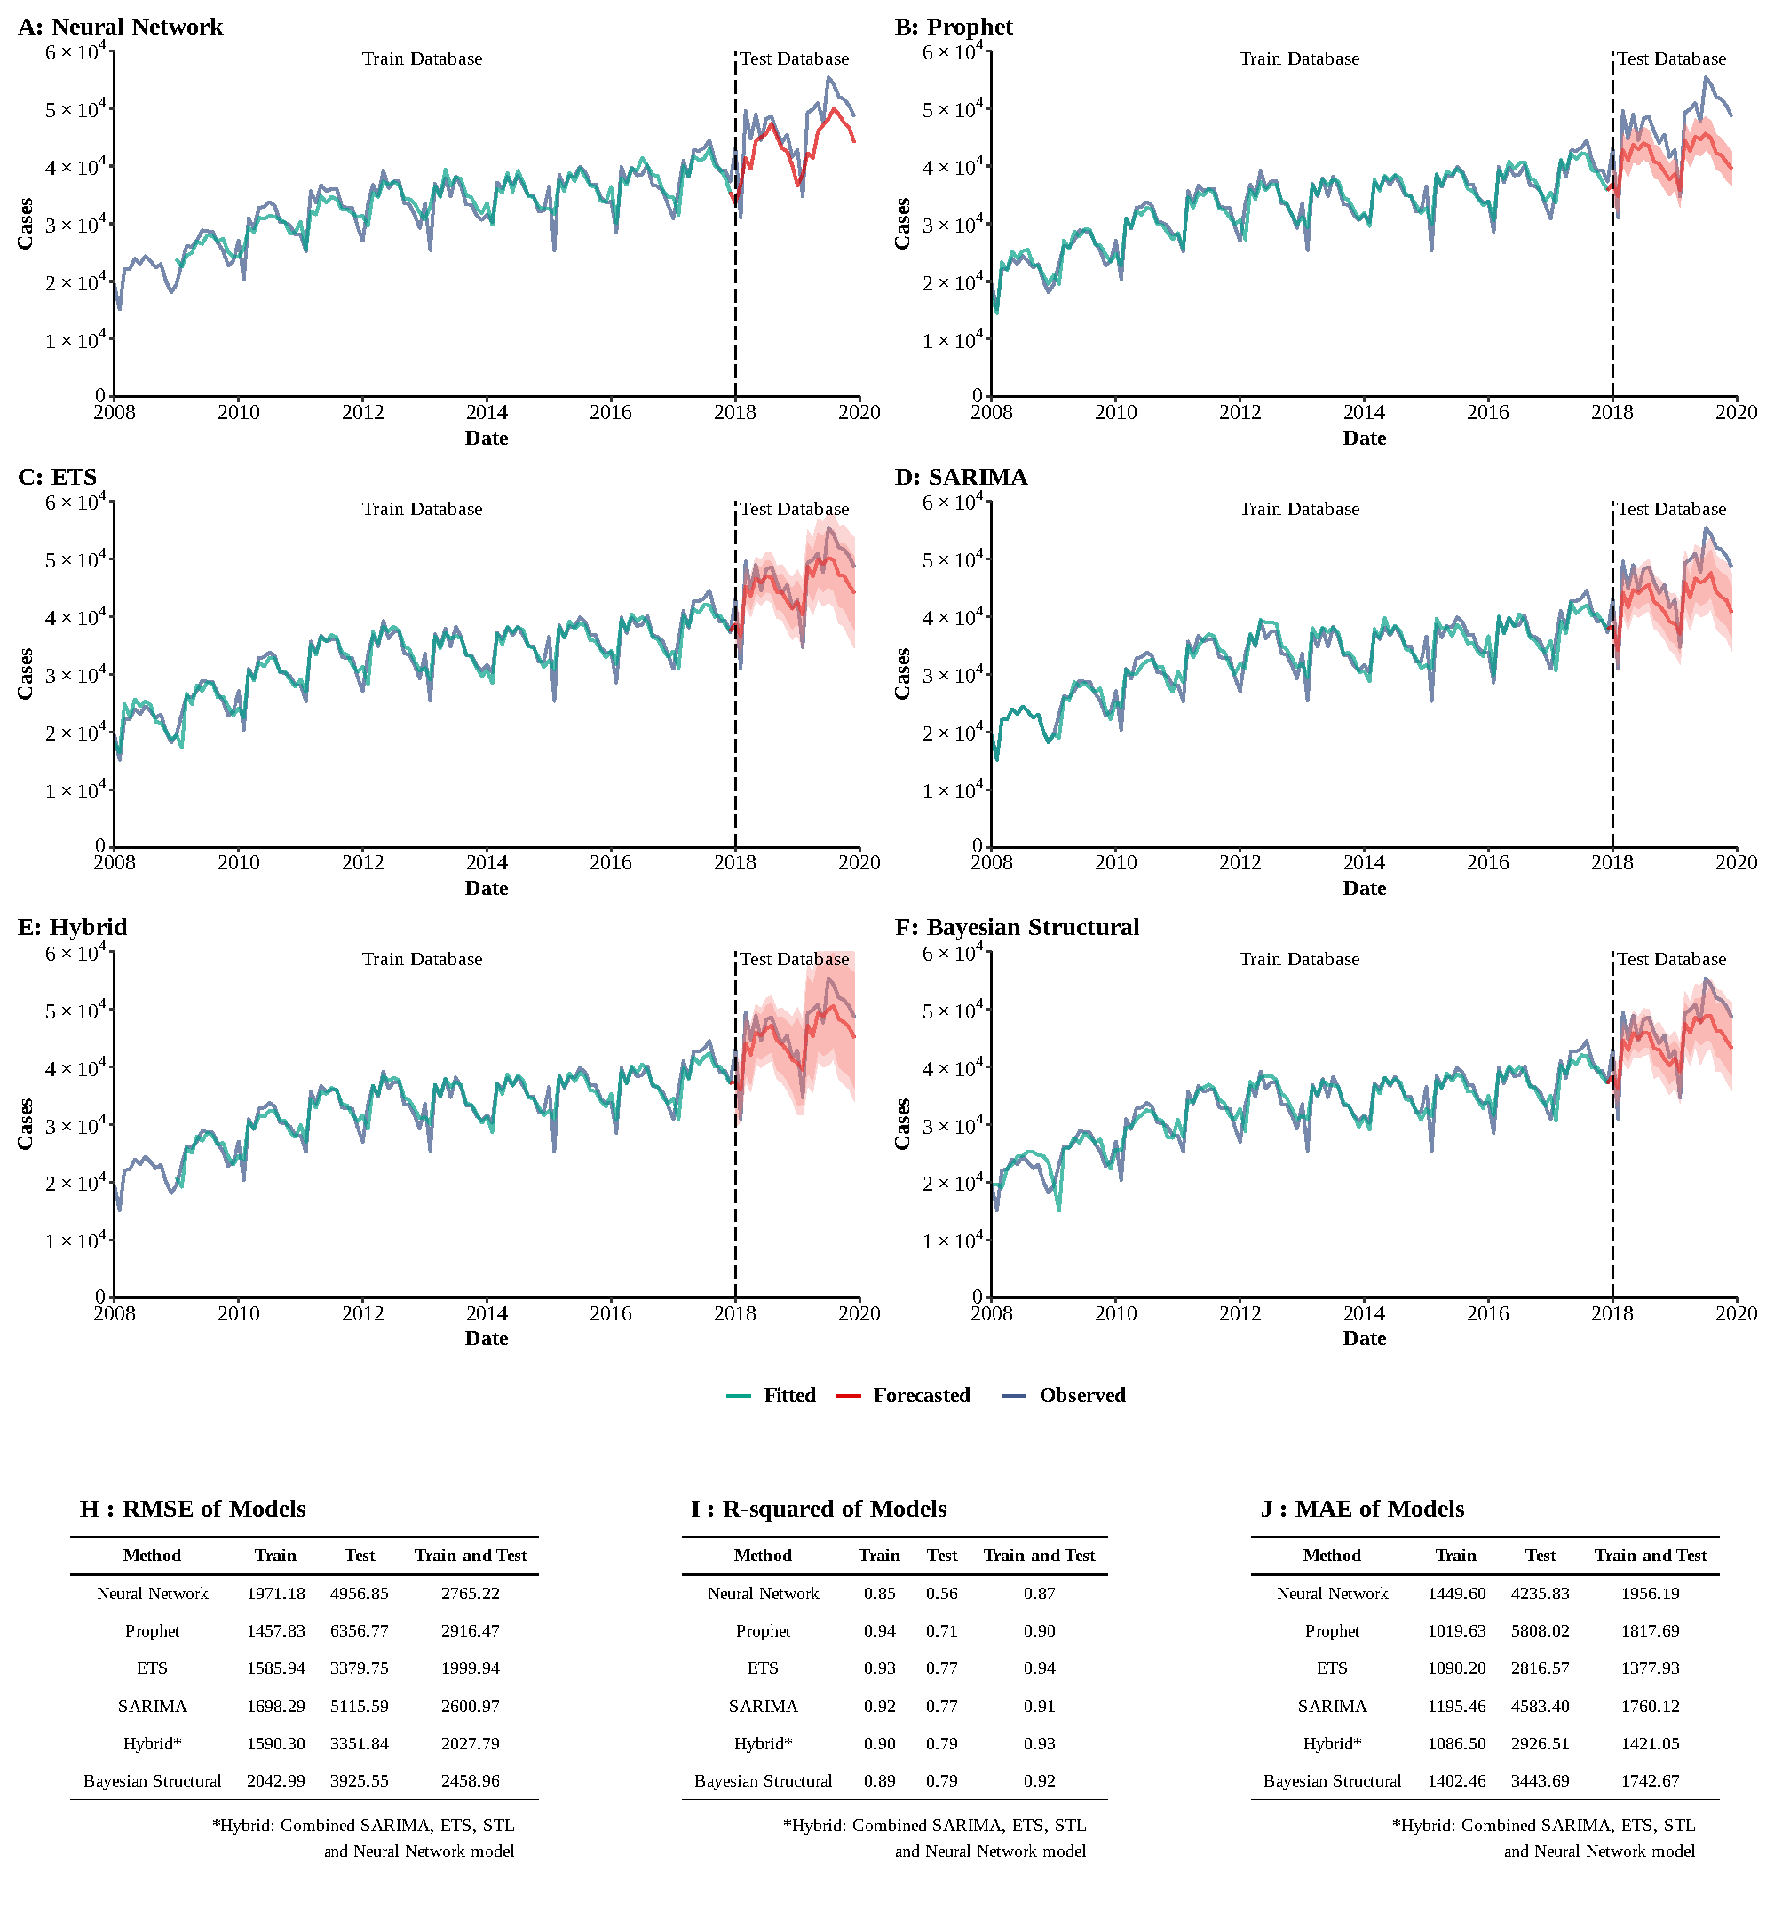Supplementary Figure 19
Training and comparing variant time series models for syphilis. (A) Neural Network model; (B) ETS model; (C) ARIMA model; (D) SEARIMA model; (E) Hybrid models combining SARIMA, ETS, STL, and neural network model; (F) Bayesian structural model; (G) RMSE of variant models; (H) R-squared of variant models; (J) MAE of variant models.

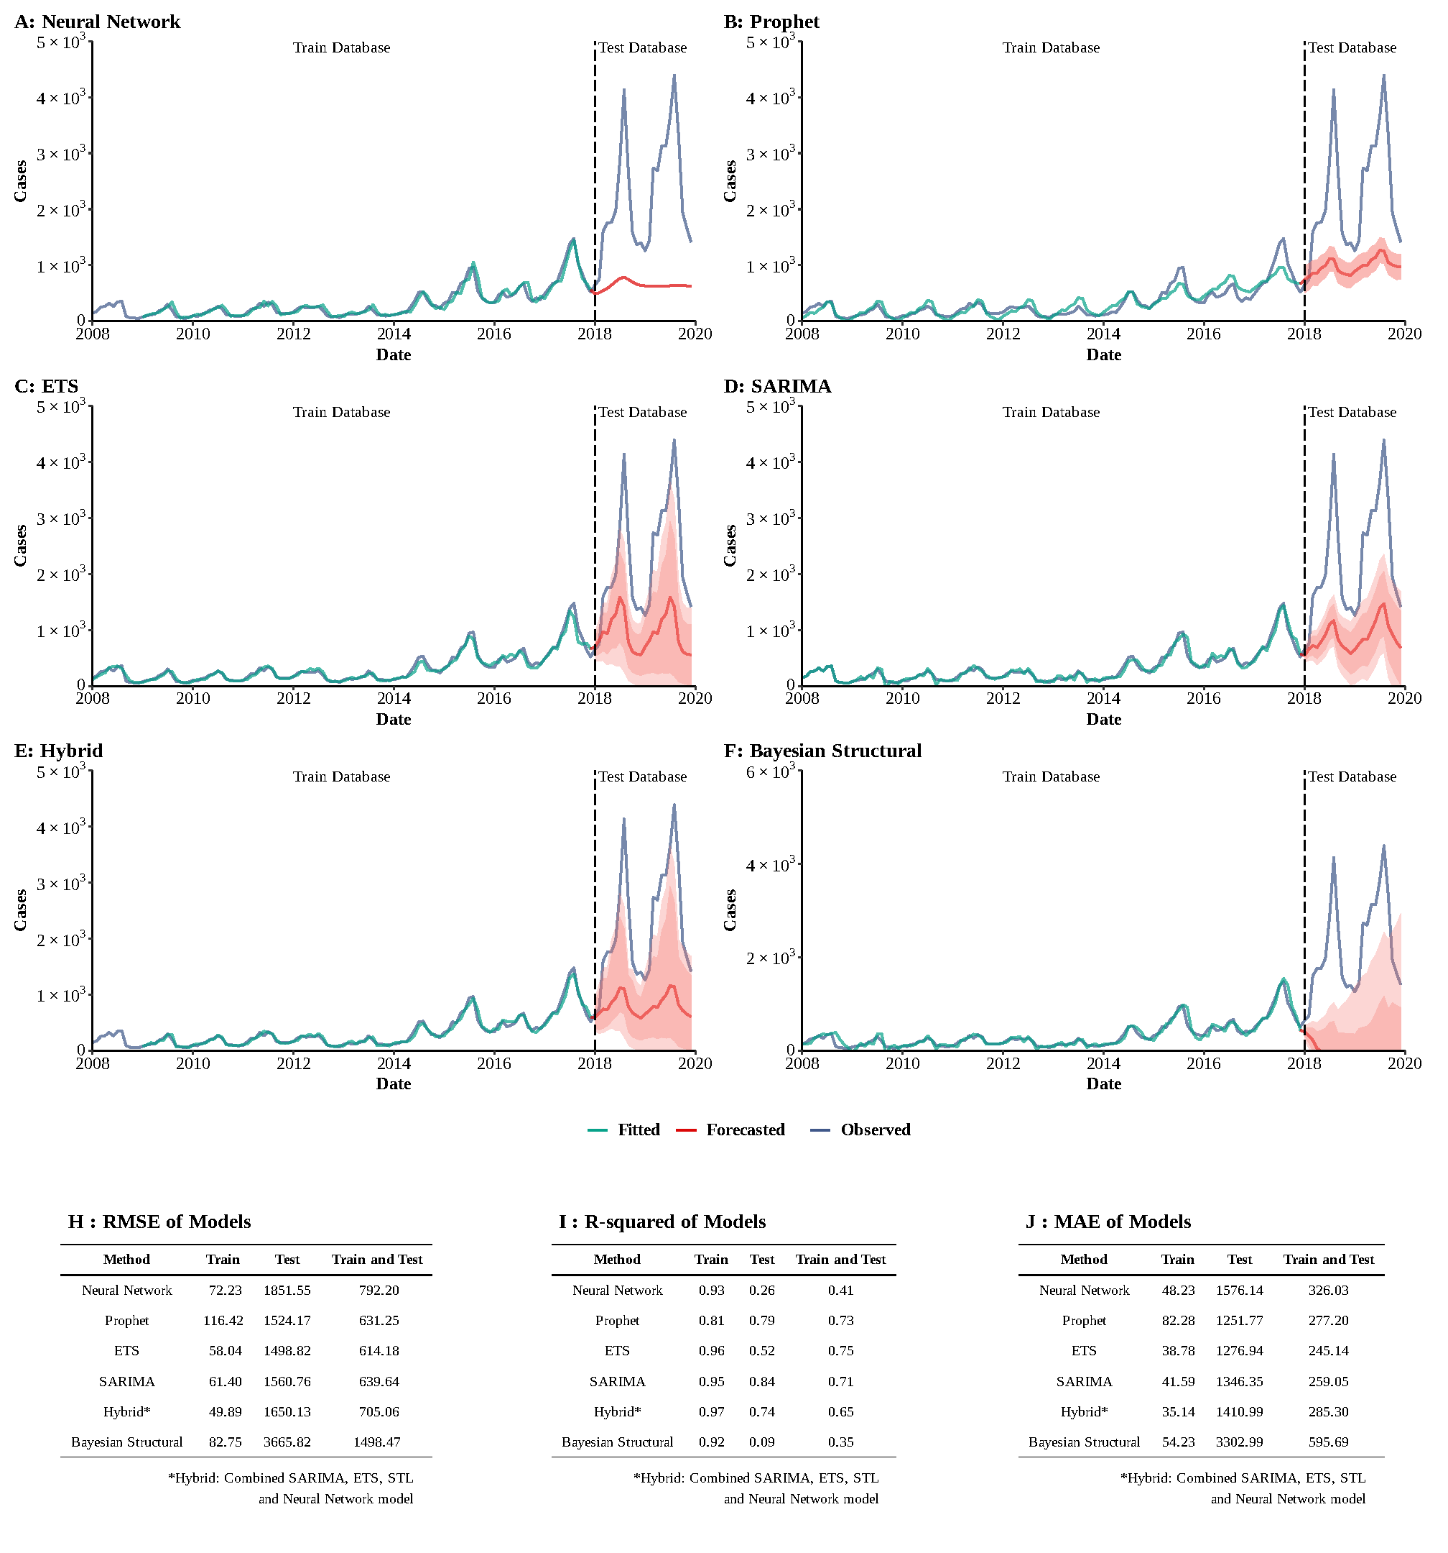
Supplementary Figure 20
Training and comparing variant time series models for pertussis. (A) Neural Network model; (B) ETS model; (C) ARIMA model; (D) SEARIMA model; (E) Hybrid models combining SARIMA, ETS, STL, and neural network model; (F) Bayesian structural model; (G) RMSE of variant models; (H) R-squared of variant models; (J) MAE of variant models.

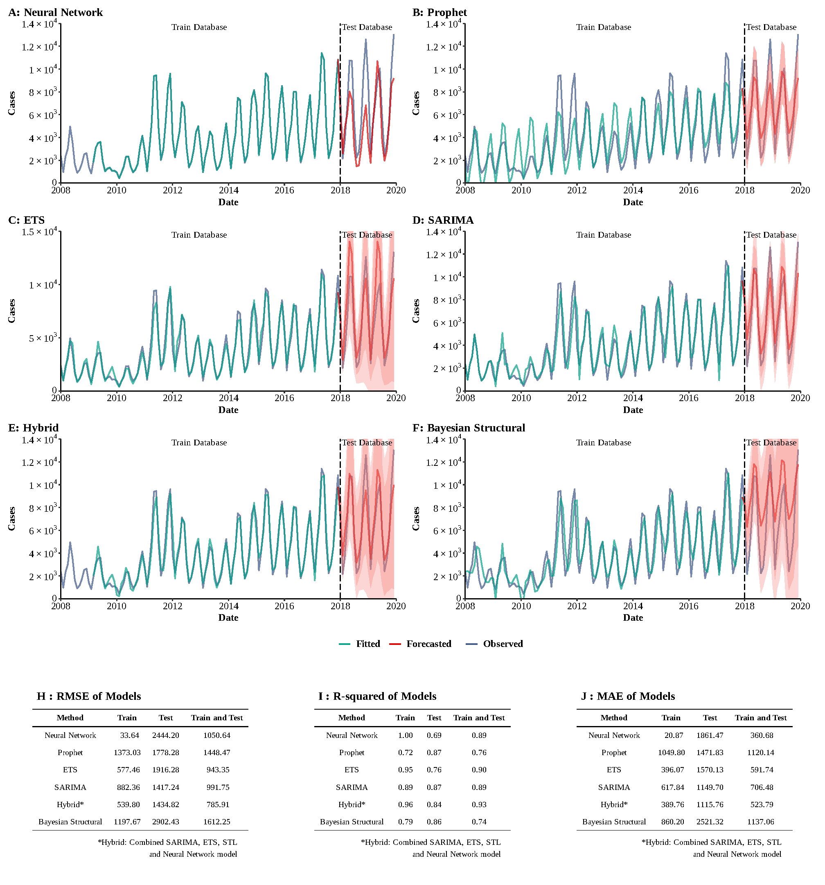Supplementary Figure 21
Training and comparing variant time series models for scarlet fever. (A) Neural Network model; (B) ETS model; (C) ARIMA model; (D) SEARIMA model; (E) Hybrid models combining SARIMA, ETS, STL, and neural network model; (F) Bayesian structural model; (G) RMSE of variant models; (H) R-squared of variant models; (J) MAE of variant models.

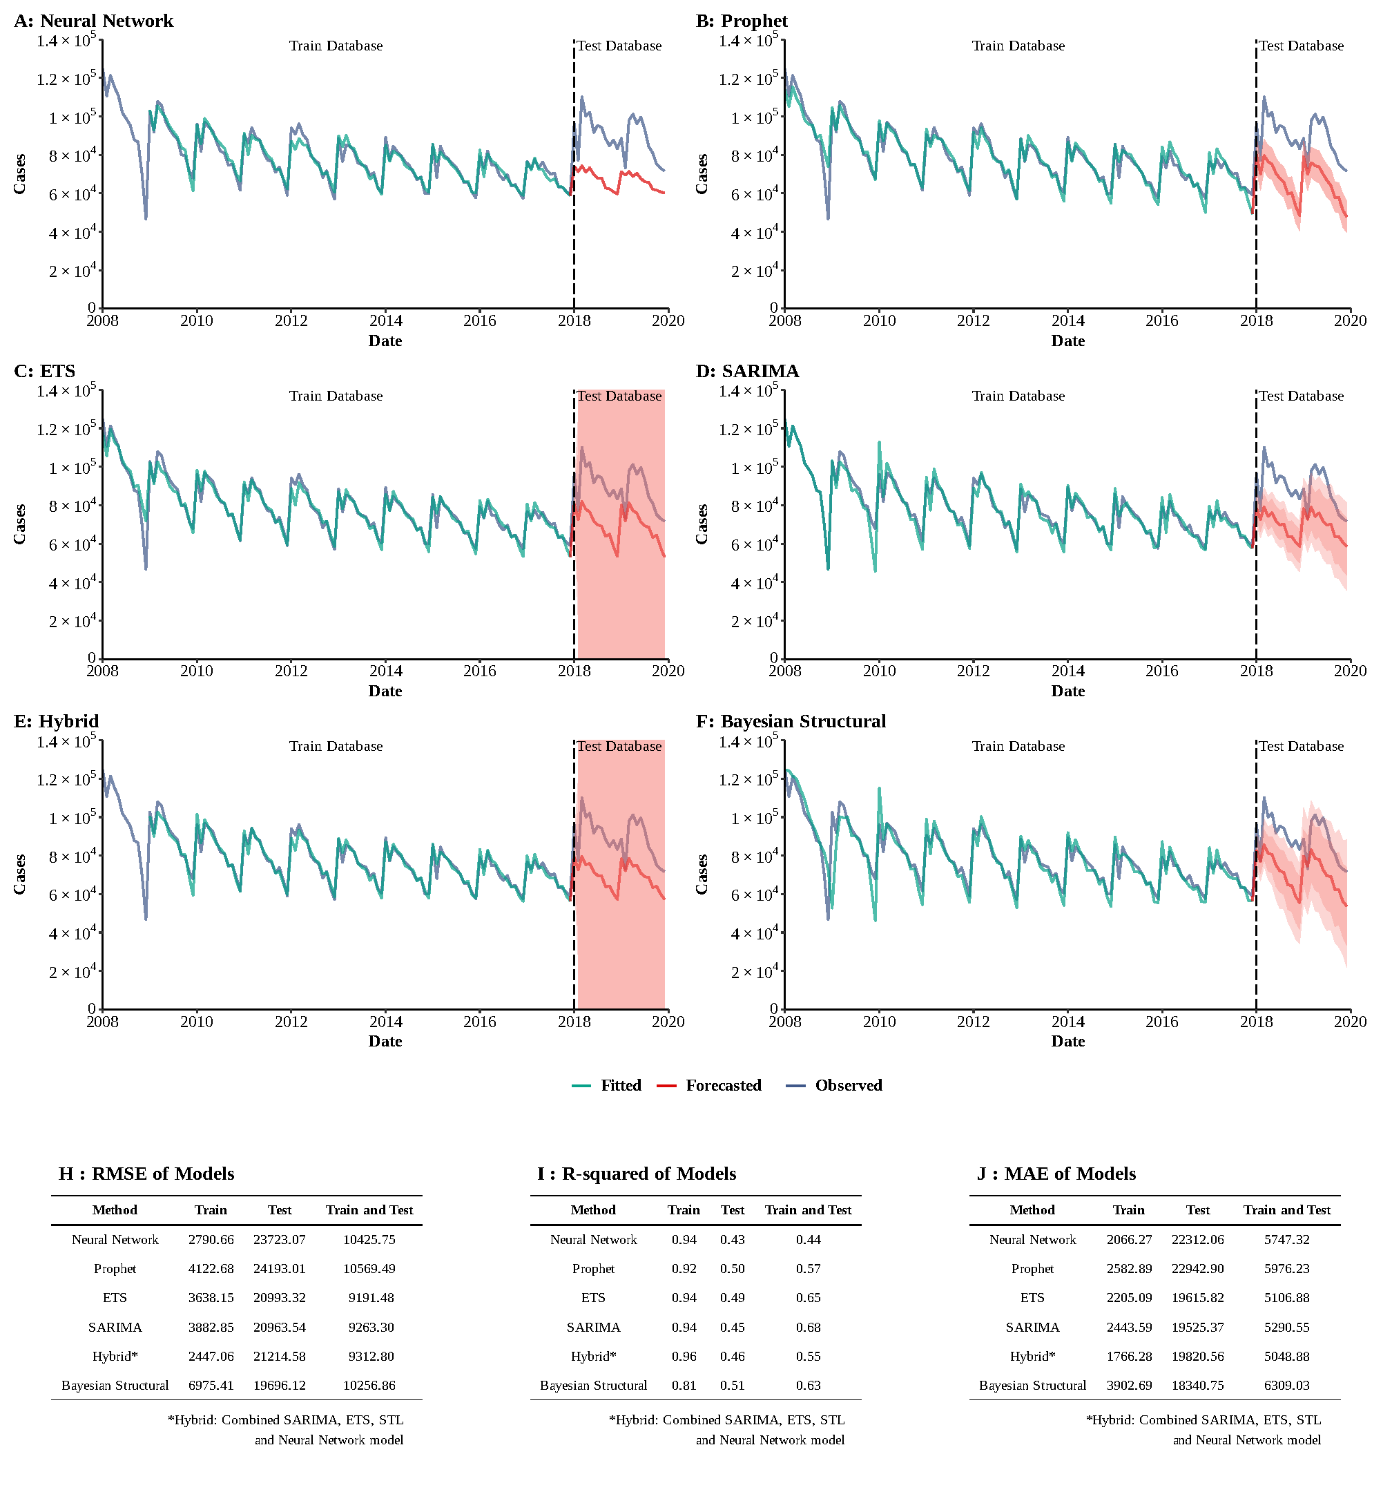Supplementary Figure 22
Training and comparing variant time series models for tuberculosis. (A) Neural Network model; (B) ETS model; (C) ARIMA model; (D) SEARIMA model; (E) Hybrid models combining SARIMA, ETS, STL, and neural network model; (F) Bayesian structural model; (G) RMSE of variant models; (H) R-squared of variant models; (J) MAE of variant models.

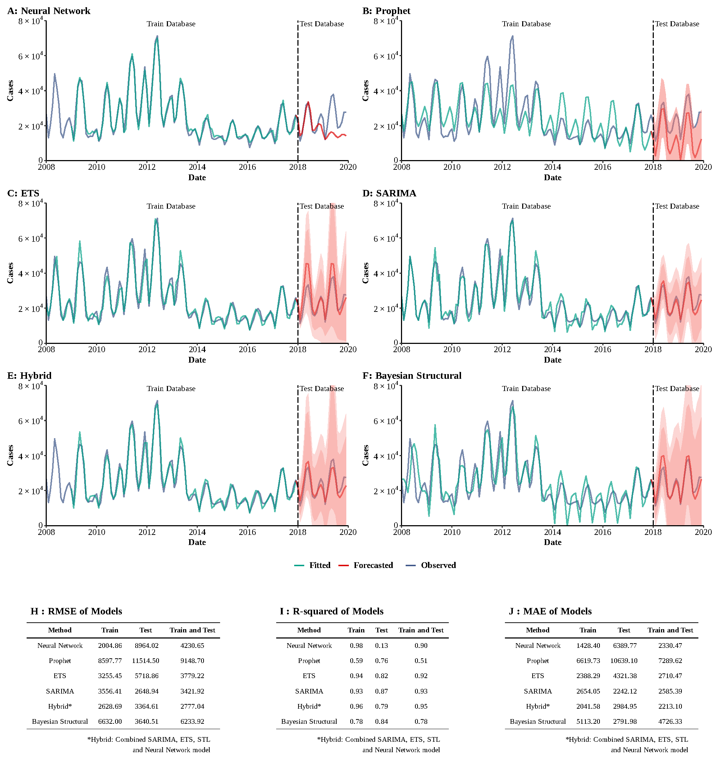Supplementary Figure 23
Training and comparing variant time series models for mumps. (A) Neural Network model; (B) ETS model; (C) ARIMA model; (D) SEARIMA model; (E) Hybrid models combining SARIMA, ETS, STL, and neural network model; (F) Bayesian structural model; (G) RMSE of variant models; (H) R-squared of variant models; (J) MAE of variant models.
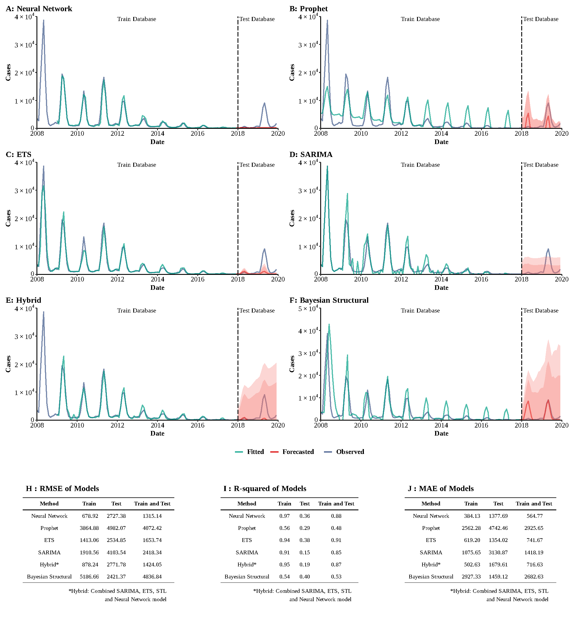Supplementary Figure 24
Training and comparing variant time series models for rubella. (A) Neural Network model; (B) ETS model; (C) ARIMA model; (D) SEARIMA model; (E) Hybrid models combining SARIMA, ETS, STL, and neural network model; (F) Bayesian structural model; (G) RMSE of variant models; (H) R-squared of variant models; (J) MAE of variant models.

