Table S1. Generalized linear mixed models of average hourly movement distances of American white pelicans. Symbol ∆AIC is difference in Akaike information criterion between a model and the most parsimonious model. Models include year as a covariate instead of Christmas Bird Count.
Model | df | ∆AIC
(sin + cos) * ssn * g + ssn * g * yr + hfp | 51 | 0.00
(sin + cos) * ssn * g + ssn * g * yr + ssn * hfp | 54 | 1.08
(sin + cos) * ssn * g + ssn * g * yr | 50 | 8.87
(sin + cos) * ssn * g + ssn * yr + hfp | 47 | 10.67
(sin + cos) * ssn * g + g * yr + ssn * yr + hfp | 48 | 12.70
(sin + cos) * ssn * g + yr + hfp | 44 | 28.22
(sin + cos) * ssn * g + g * yr + hfp | 45 | 29.82
(sin + cos) * ssn * g + hfp | 43 | 36.54
(sin + cos) * (g + ssn) + ssn * g * yr + hfp | 39 | 55.21
(sin + cos) * ssn + ssn * g * yr + hfp | 35 | 71.52
(sin + cos) * g + ssn * g * yr + hfp | 27 | 792.61
(sin + cos) + ssn * g * yr + hfp | 23 | 800.14
(sin + cos): Circadian hours with Fourier transformation of sine and cosine function
ssn: Season (i.e., breeding and wintering seasons and spring and autumn migration)
g: Wintering population group (the Northern or Southern Gulf of Mexico)
yr: Year from 2002 to 2012
hfp: Human footprint index within seasonal home ranges of pelicans
All the models with interactions include main effects.
Table S2. Generalized linear mixed models of maximum hourly movement distances of American white pelicans. Symbol ∆AIC is the difference in Akaike information criterion between a model and the most parsimonious model. Models include year as a covariate instead of Christmas Bird Count.
Model | df | ∆AIC
(sin + cos) * ssn * g + ssn * g * yr | 50 | 0.00
(sin + cos) * ssn * g + ssn * g * yr + hfp | 51 | 1.40
(sin + cos) * ssn * g + ssn * g * yr + ssn * hfp | 54 | 1.75
(sin + cos) * ssn * g + g * yr | 44 | 13.41
(sin + cos) * ssn * g + g * yr + ssn * yr | 47 | 13.42
(sin + cos) * ssn * g + ssn * yr | 46 | 13.94
(sin + cos) * ssn * g + yr | 43 | 14.80
(sin + cos) * (g + ssn) + ssn * g * yr | 38 | 18.95
(sin + cos) * ssn + ssn * g * yr | 34 | 33.82
(sin + cos) * ssn * g | 42 | 66.50
(sin + cos) * g + ssn * g * yr | 26 | 328.67
(sin + cos) + ssn * g * yr | 22 | 336.18
(sin + cos): Circadian hours with Fourier transformation of sine and cosine function
ssn: Season (i.e., breeding and wintering seasons and spring and autumn migration)
g: Wintering population group (the Northern or Southern Gulf of Mexico)
yr: Year from 2002 to 2012
hfp: Human footprint index within seasonal home ranges of pelicans
All the models with interactions include main effects.
Table S3. Linear mixed models of seasonal home ranges of American white pelicans. Symbol ∆AIC is difference in Akaike information criterion between a model and the most parsimonious model. Models include year as a covariate instead of Christmas Bird Count.
Model | df | ∆AIC
ssn * g + g * yr + hfp | 13 | 0.00
ssn * g + yr + hfp | 12 | 1.71
ssn * g + g * yr + ssn * yr + hfp | 16 | 2.51
ssn * g + ssn * yr + hfp | 15 | 4.88
ssn * g * yr + ssn * hfp | 22 | 7.36
ssn * g * yr + hfp | 19 | 7.95
ssn * g + hfp | 11 | 9.05
ssn * g | 10 | 32.82
ssn * g * yr | 18 | 37.16
ssn + g * yr + hfp | 10 | 46.04
g * yr + ssn * yr + hfp | 13 | 48.81
ssn + g | 7 | 74.26
ssn: Season (i.e., breeding and wintering seasons and spring and autumn migration)
g: Wintering population group (the Northern or Southern Gulf of Mexico)
yr: Year from 2002 to 2012
hfp: Human footprint index within seasonal home ranges of pelicans
All the models with interactions include main effects.
Figure S1. Estimated annual pelican population counts per survey site by Christmas Bird Counts (CBC) from 1974 to 2017 in the Northern and Southern Gulf of Mexico (GOM) (left panels). The calculation of the estimated CBC was conducted separately using generalized additive models (See the methods of the text; 4243 vs. 126 observations at Northern and Southern GOMs, respectively). Right panel indicates the location of CBC survey. A horizontal line in the right panel separates the survey sites between Northern and Southern GOMs.
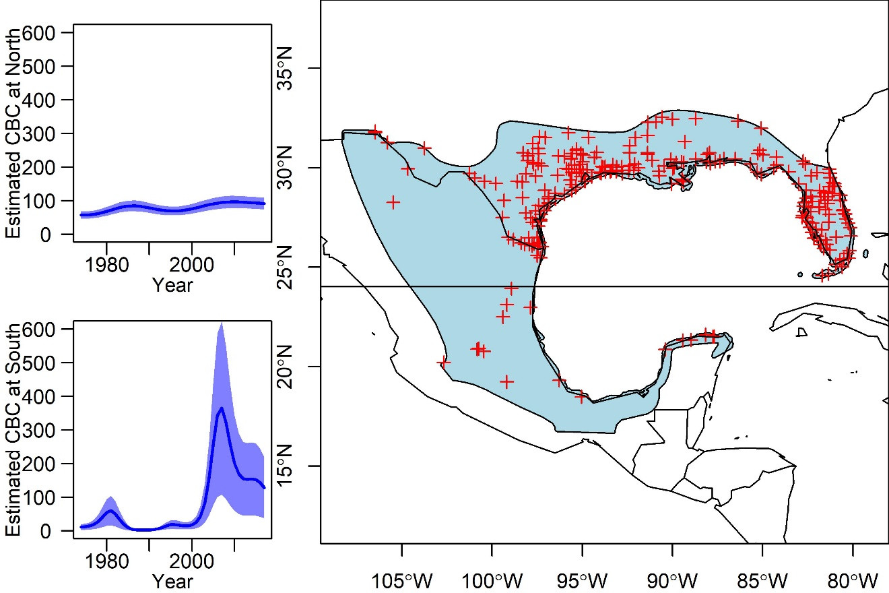
Figure S2. Relationships between year and estimated Christmas Bird Counts per survey site.

Figure S3. Hourly movement distances of American white pelicans from 2002 to 2012. Blue and red colors represent wintering populations at the Northern and Southern Gulf of Mexico, respectively. Panels show a) breeding, b) wintering, c) spring migration, and d) autumn migration. Polygons represent 95% confidence intervals of the lines.
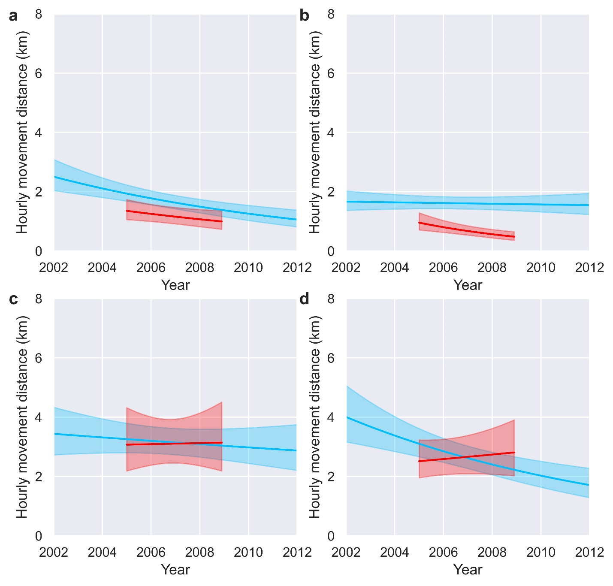
Figure S4. Maximum hourly movement distances of American white pelicans from 2002 to 2012. Blue and red colors represent wintering populations at the Northern and Southern Gulf of Mexico, respectively. Panels show a) breeding, b) wintering, c) spring migration, and d) autumn migration. Polygons represent 95% confidence intervals of the lines.
