Supplementary Information

Horizontal lithium electrodeposition on atomically polarized monolayer hexagonal boron nitride
Seung-Hyeok Kim^{1,†}, Minsu Kim^{2,†}, Imanuel Kristanto³, Won-Yeong Kim¹, Kun Ryu⁴, Hong-I Kim¹, Kyung Yeol Ma², Cheol Heo¹, Hyeongjoon Kim², Sang Kyu Kwak^{3,}*, Ying Shirley Meng^{4,5,*}, Hyeon Suk Shin^{2,}* & Sang-Young Lee^{1,6,}*

¹Department of Chemical and Biomolecular Engineering, Yonsei University, 50 Yonsei-ro, Seodaemun-gu, Seoul 120-749, Republic of Korea
²Department of Chemistry, Ulsan National Institute of Science and Technology (UNIST), Ulsan 44919, Republic of Korea
³Department of Chemical and Biological Engineering, Korea University, 145 Anam-ro, Seongbuk-gu, Seoul 02841, Republic of Korea
⁴Pritzker School of Molecular Engineering, The University of Chicago, Chicago, IL, USA
⁵Argonne Collaborative Center for Energy Storage Science (ACCESS), Argonne National Laboratory, Lemont, IL, USA

⁶Lead Contact
†These authors contributed equally

*Correspondence: syleek@yonsei.ac.kr, shin@unist.ac.kr, shirleymeng@uchicago.edu, skkwak@unist.ac.kr

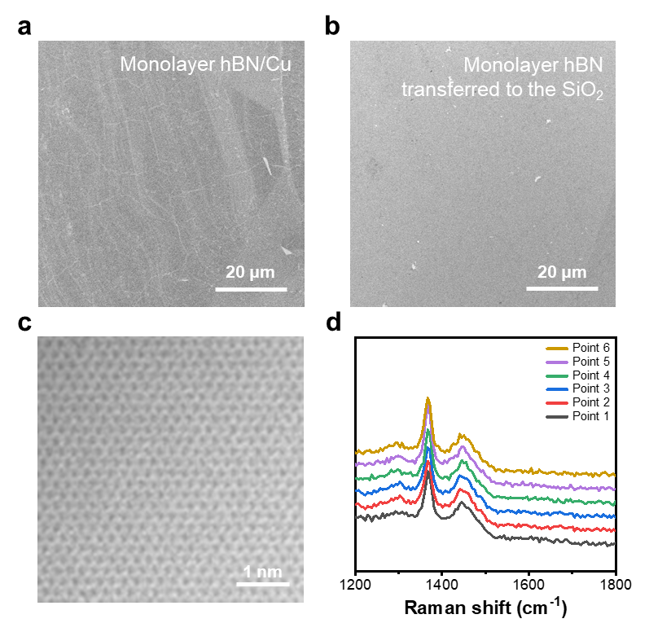
Supplementary Fig. 1 | Scanning electron microscopy (SEM) images of the monolayer hexagonal boron nitride (hBN) on a, Cu foil and b, transferred to the SiO₂ (300 nm)/Si substrate. c, Atomic-resolution transmission electron microscopy (TEM) image of the monolayer hBN. d, Raman spectrum of the monolayer hBN transferred to the SiO₂ (300 nm)/Si substrate at multiple points showing the uniformity of hBN thickness.

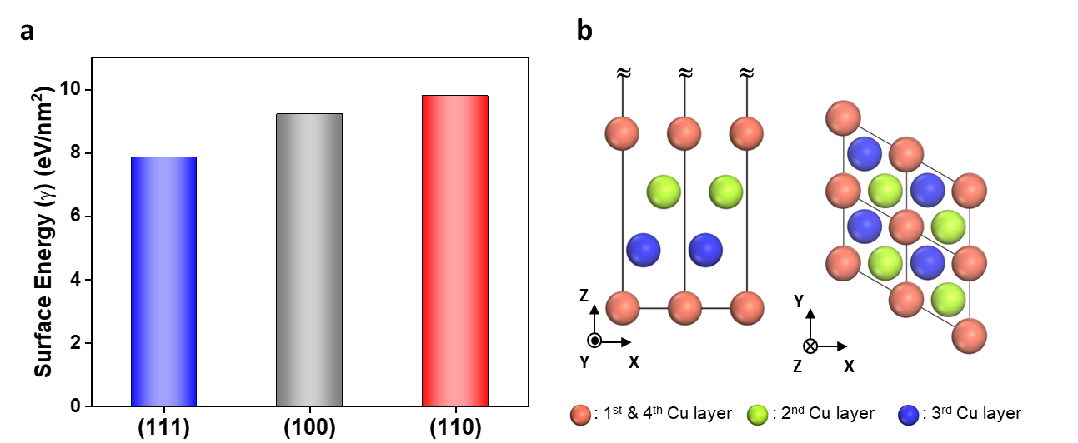
Supplementary Fig. 2 | a, Surface energies of the Cu slab models. b, Optimized Cu(111) surface shown as a 2 × 2 supercell. Atoms are colored based on their layer order; first and last layer: orange, second layer: green, third layer: light blue.

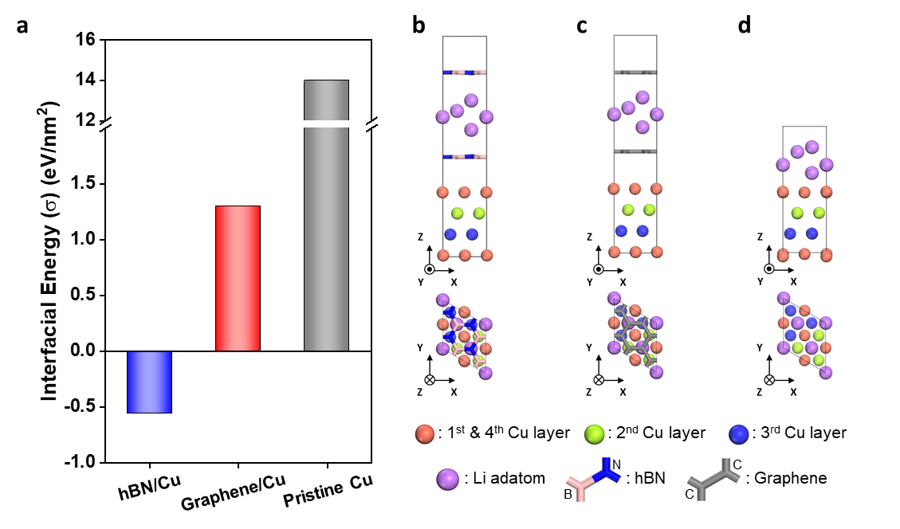
Supplementary Fig. 3 | a, Average interfacial energies (σ) of the monolayer hBN/Cu, monolayer graphene/Cu and pristine Cu. The snapshots of the representative optimized interfacial systems of Li(111) on b, hBN/Cu, c, graphene/Cu and d, pristine Cu. The interfacial systems are modeled periodically in all axes to depict the uniform thin-layer Li surface deposition. The monolayer hBN and monolayer graphene are represented with stick style, whereas other atoms are represented with spheres. Atoms are colored based on the element: C atom: gray, N atom: blue, B atom: light pink, Li adatom: lavender, Cu atom: orange (to distinguish the Cu stacking configuration, the Cu atoms in the second and third layers are colored in light green and dark blue, respectively). In the interfacial energy calculation, a periodically flat interface was assumed. The negative interfacial energy implies that the formed interface is thermodynamically stable. However, the positive interfacial energy implies that the formed interface is thermodynamically unstable, resulting in Li dendrites.

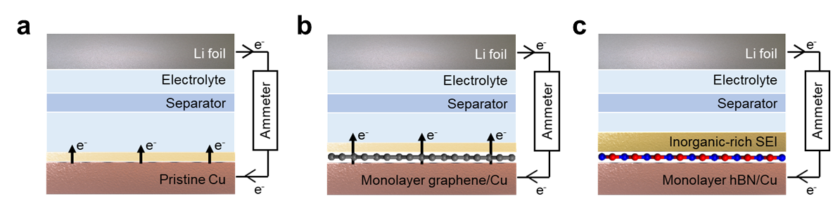
Supplementary Fig. 4 | Schematic representation of the asymmetric galvanic cells (substrates||Li metal) with an externally connected ammeter and the solid electrolyte interphase (SEI) layers formed on a, pristine Cu, b, monolayer graphene/Cu and c. monolayer hBN/Cu.

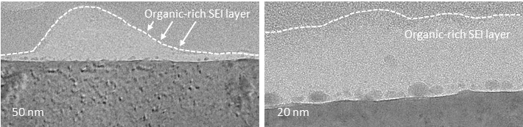
Supplementary Fig. 5 | Cross-sectional TEM images of the SEI layer formed on the pristine Cu.

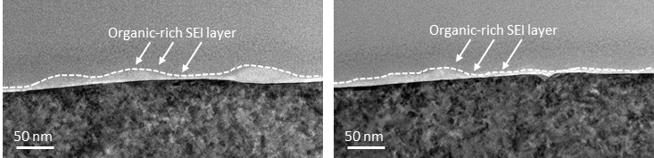
Supplementary Fig. 6 | Cross-sectional TEM images of the SEI layer formed on the monolayer graphene/Cu.

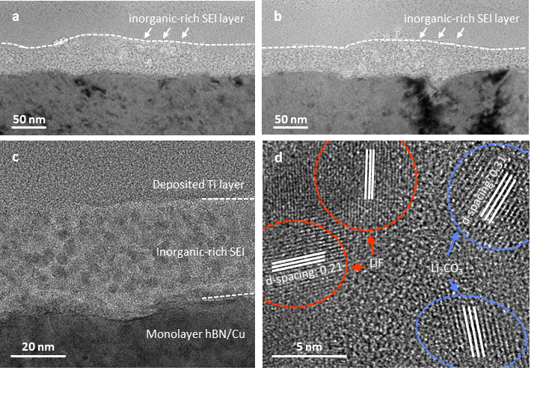
Supplementary Fig. 7 | a-c, Cross-sectional TEM images of the SEI layer formed on the monolayer hBN/Cu at various positions. d, Magnified TEM image showing (c) LiF (d-spacing: 0.21 nm) and Li₂CO₃ (d-spacing: 0.31 nm) crystals in the SEI layer.

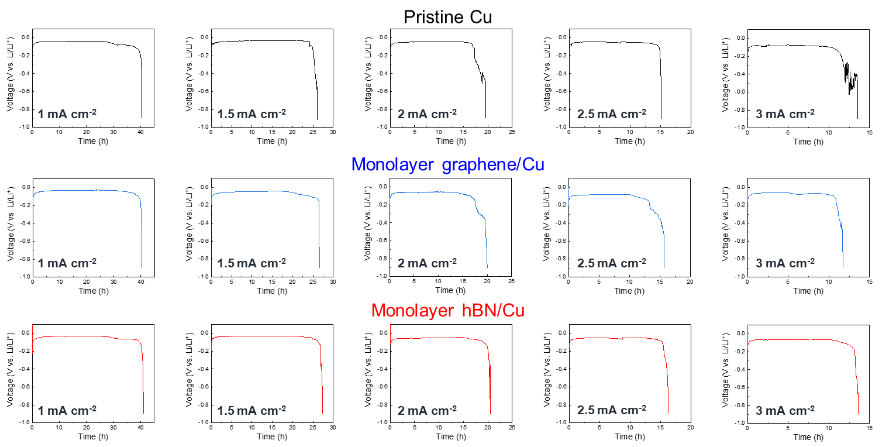
Supplementary Fig. 8 | Voltage-time profiles of the asymmetric cells (substrates||Li metal). Asymmetric cells were charged at different current densities to the point of failure. The slope k was calculated using equation (1) and (2)¹⁵.
Q_{total} = Q_{deposit} + Q_{loss} (1)
Q_{loss} = Q_{ir} + k·j (2)
Herein, 200-μm Li foils were used, corresponding to Q_{total} = 41.2248 mAh cm⁻². The time in which the cell failed is denoted as t_{dis}. Q_{deposit} is the product of current density j and t_{dis}.

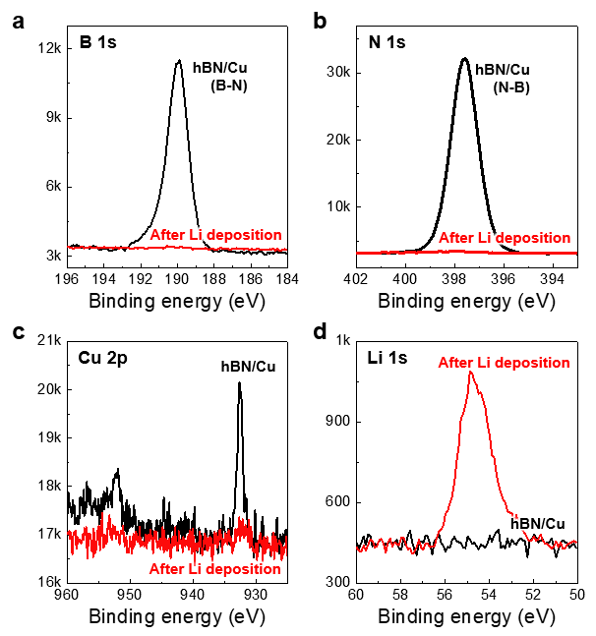
Supplementary Fig. 9 | Change in the X-ray photoelectron spectroscopy (XPS) profiles before and after the deposition of Li on the monolayer hBN/Cu: a, B 1s b, N 1s, c, Cu 2p and d, Li 1s. After the Li metal deposition, the intensity of peaks corresponding to the B–N bonds and Cu decreased. However, the peak assigned to Li increased after Li deposition. This indicates that the monolayer hBN/Cu was almost completely covered by the uniform and dense Li deposition.

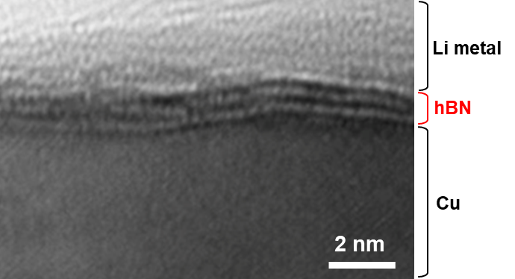
Supplementary Fig. 10 | Cross-section TEM image obtained after the Li deposition on the tri-layer hBN/Cu at an areal capacity of 0.1 mAh cm⁻². Image shows the uniform deposition of Li on the hBN. Note that we used the tri-layer hBN/Cu because it was difficult to distinguish Cu and the deposited Li metal when the monolayer hBN was used.

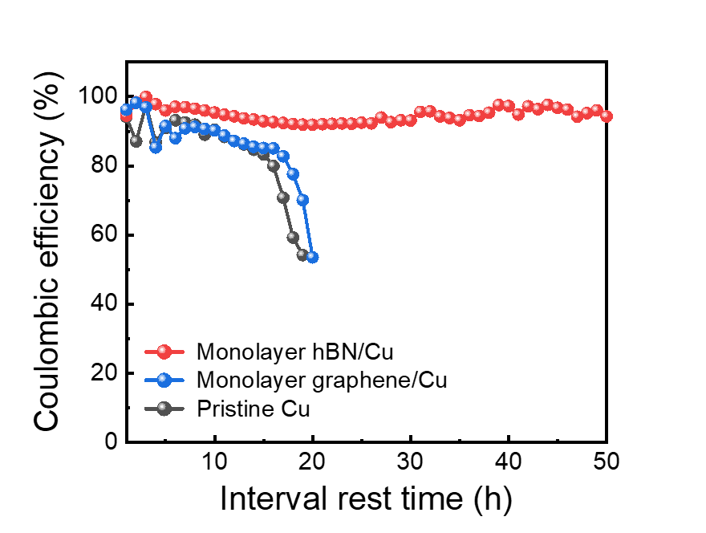
Supplementary Fig. 11 | Coulombic efficiencies of the monolayer hBN/Cu, monolayer graphene/Cu and pristine Cu at a current density of 5 mA cm⁻² and an areal capacity of 5 mAh cm⁻².

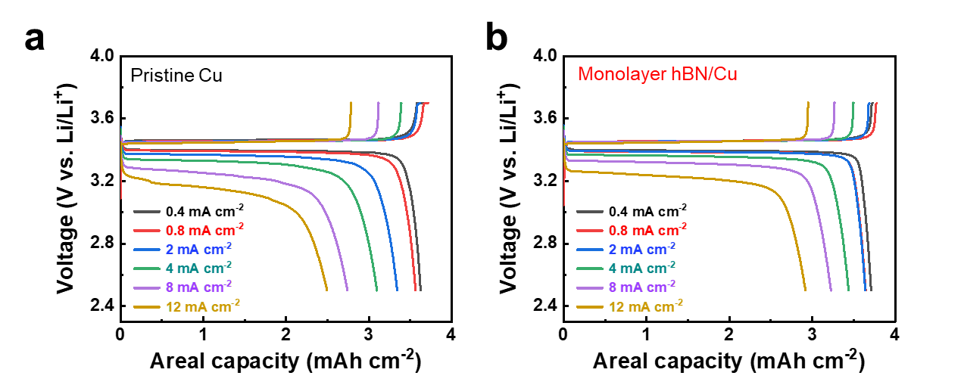
Supplementary Fig. 12 | Charge/discharge rate capabilities of the Li metal full cells (N/P ratio = 1) with a, the pristine Cu and b, the monolayer hBN/Cu, in which the discharge current density was varied from 0.4 to 12 mA cm⁻² at a fixed charge current density of 0.4 mA cm⁻².

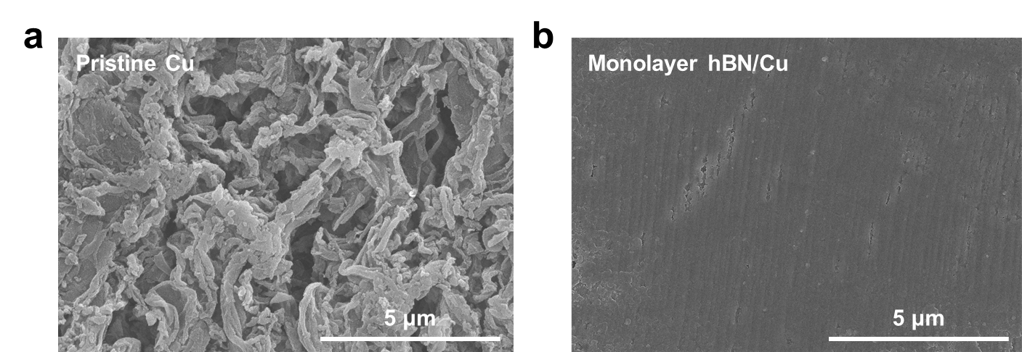
Supplementary Fig. 13 | Surface SEM images of a, pristine Cu and b, monolayer hBN/Cu after the cycling test in anode-free full cells.

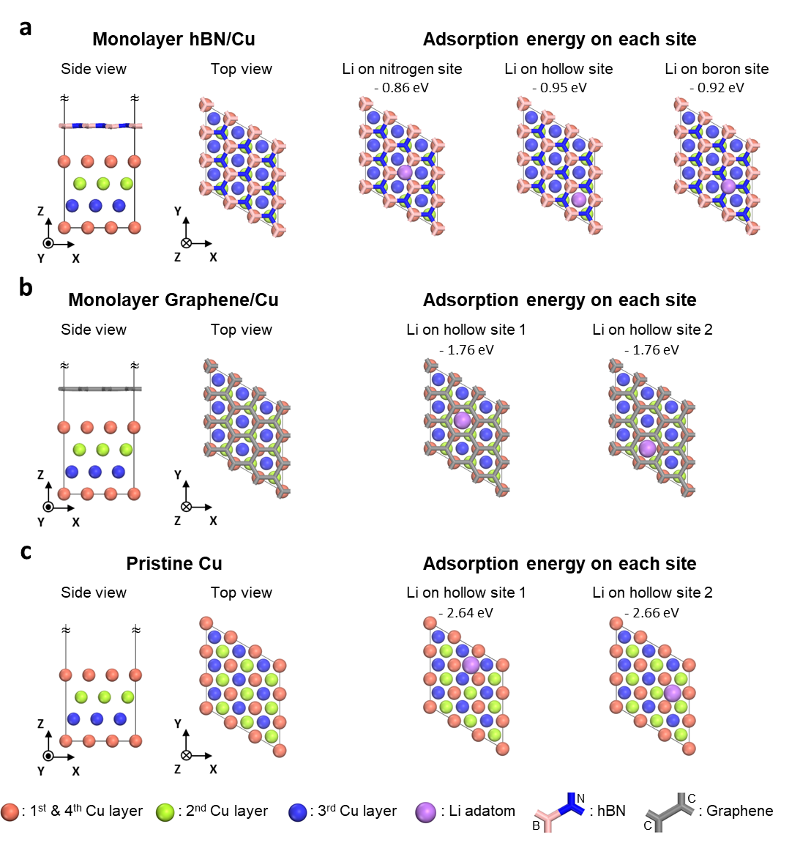
Supplementary Fig. 14 | Slab model (left) and possible Li adsorption sites (right) on a, monolayer hBN/Cu, b, monolayer graphene/Cu and c, pristine Cu(111) surfaces. Various sites were optimized to obtain the stable adsorption sites, and the monolayer hBN and graphene are shown in a stick shape, whereas other atoms are indicated with spheres. The atoms are colored according to their element, with C atom in gray, N atom in blue, B atom in light pink and Li adatom in lavender, whereas Cu atoms are colored based on their layer order, with the first and last layer in orange, the second layer in light green and the third layer in dark blue. The adsorption energy values for each site are also provided.

Supplementary Table 1 | Comparison between the performance metrics of the anode-free full cell fabricated in this study with those of previously reported anode-free full cells.
Concept | Thickness (Coating layer on Cu) | Cathode material | Electrolyte | Areal capacity  [mAh cm⁻²] | Discharge current density  [mA cm⁻²] | Cycle number  (capacity retention) | Average coulombic efficiency  [%] | Reference
Monolayer hBN | 0.6 nm | LFP | 1 M LiTFSI DOL/DME + 2 wt% LiNO₃ | 3 | 0.8 | 50  (84%) | 99.65 | This  study
PEO film | 200 nm | LFP | 1 M LiTFSI DOL/DME + 2 wt% LiNO₃ | 0.7 | 0.14 | 100  (52%) | 99.35 | 30
Multilayer graphene | 1.7 nm | LFP | 1 M LiTFSI DOL/DME + 2 wt% LiNO₃ | 1.8 | 0.2 | 100  (61%) | 99.51 | 31
Tin plating | - | Ni_{0.85}Co_{0.1}Al_{0.05} | 1 M LiPF₆ FEC/EMC | 1 | 0.5 | 80  (~0%) | 97.16 | 32
SiO_{x} | 10 um | LFP | 4 M LiFSI DME | 2.6 | 0.9 | 100  (53%) | 99.37 | 33
Graphene oxide | 1.2 um | NCM111 | 1 M LiPF₆ EC/DEC + 5% FEC | 1.8 | 0.2 | 50  (48%) | 98.54 | 34
Ag@PDA-GO | 9.6 um | NCM111 | 1 M LiPF₆ EC/DEC + 5% FEC | 2.2 | 0.5 | 50  (65%) | 99.14 | 35
Mesoporous silica | 30 nm | LFP | 4 M LiFSI DME | 2 | 0.2 | 100  (46%) | 99.22 | 36
B-PVDF fiber | 1 um | NCM111 | 1 M LiPF₆ EC/DEC | 2 | 0.2 | 30  (61%) | 98.37 | 37
* Average coulombic efficiency = Capacity retention^{(1/cycle number)}

