Direct observation of space charge layers at oxide grain boundaries

Satoko Toyama¹, Takehito Seki^{1, 2*}, Bin Feng^{1,3*}, Yuichi Ikuhara^{1,3,4}, Naoya Shibata^{1,4,5*}

¹Institute of Engineering Innovation, School of Engineering, University of Tokyo, 2-11-16, Yayoi, Bunkyo, Tokyo 113-0032, Japan.
²PRESTO, Japan Science and Technology Agency, Kawaguchi, 332-0012, Japan.
³Next Generation Zirconia Social Cooperation Program, Institute of Engineering Innovation, School of Engineering, University of Tokyo, 2-11-16, Yayoi, Bunkyo, Tokyo 113-0032, Japan.
⁴Nanostructures Research Laboratory, Japan Fine Ceramics Center, 2-4-1, Mutsuno, Atsuta, Aichi, 456-8587, Japan.
⁵Quantum-Phase Electronics Center (QPEC), The University of Tokyo, Hongo 7-3-1, Bunkyo-ku, Tokyo 113-8656, Japan.

*Corresponding authors: shibata@sigma.t.u-tokyo.ac.jp, seki@sigma.t.u-tokyo.ac.jp, feng@sigma.t.u-tokyo.ac.jp

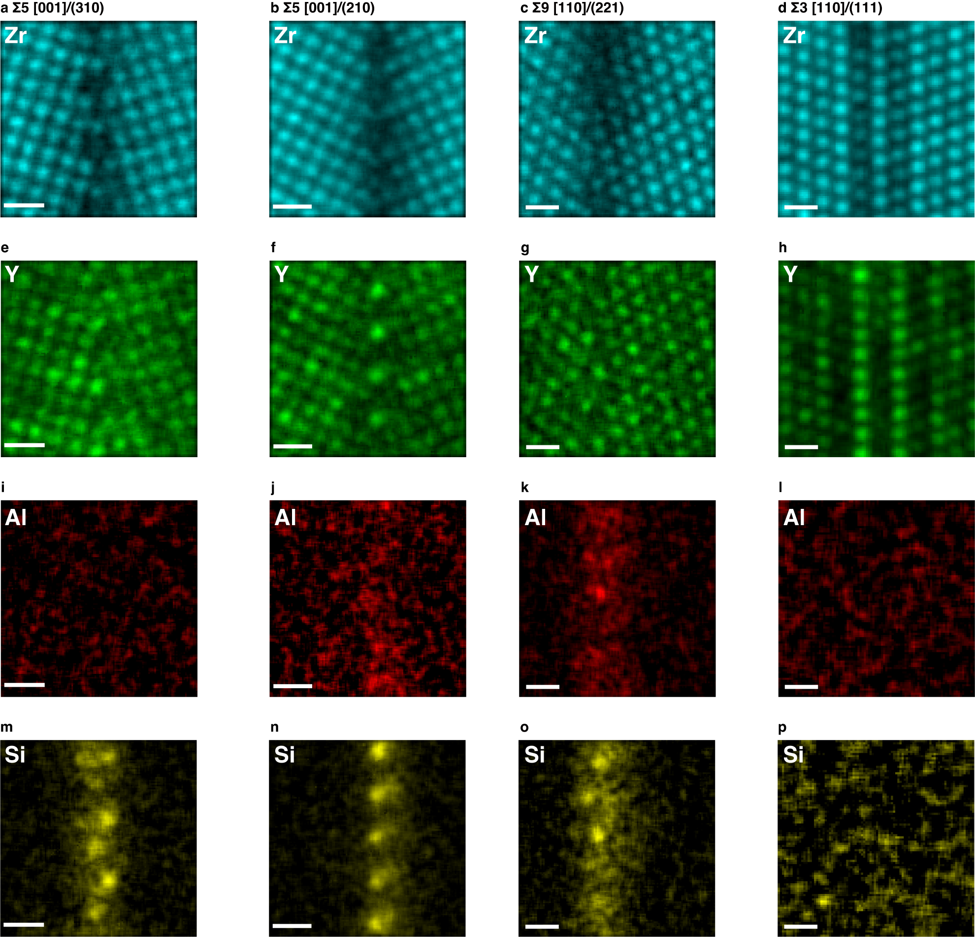

Supplementary Fig. S1 Elemental maps of the YSZ GBs obtained by STEM-EDS. The scale bars represent 0.5 nm.

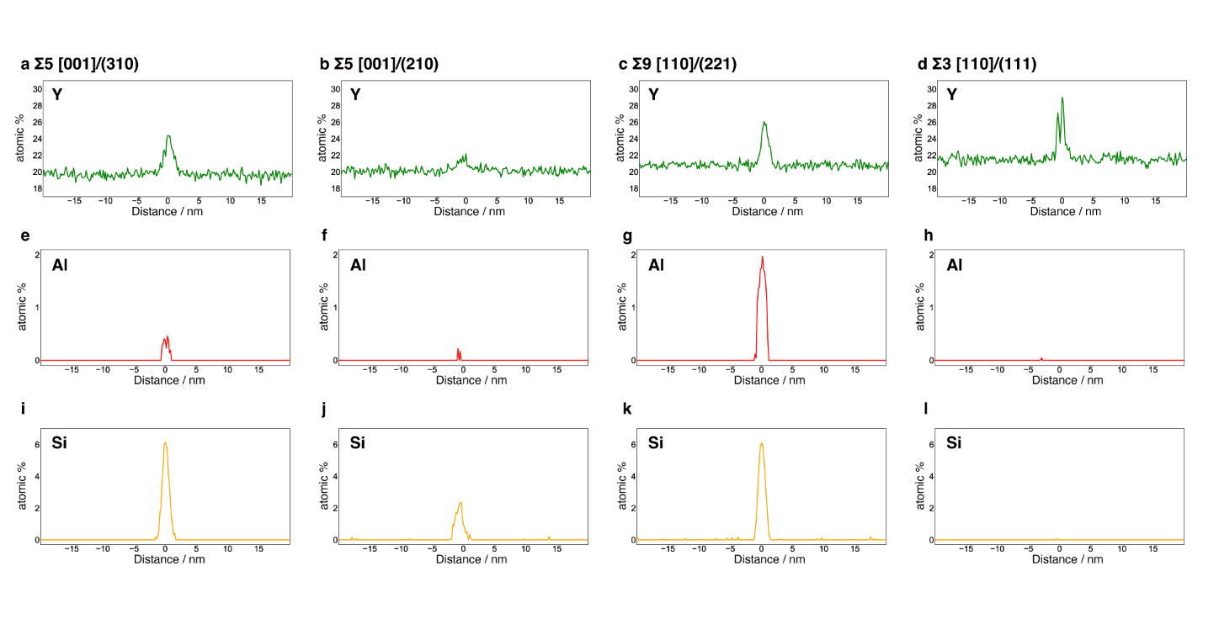
Supplementary Fig. S2 Line profiles of Y, Al and Si concentration across the $\text{∑5}\left[\text{001}\right]\text{/(310)}$, $\text{∑5}\left[\text{001}\right]\text{/(210)}$, $\text{∑9}\left[\text{110}\right]\text{/(221)}$ and, $\text{∑3}\left[\text{110}\right]\text{/(111)}$ GBs. The vertical axis is plotted by cation percentage.

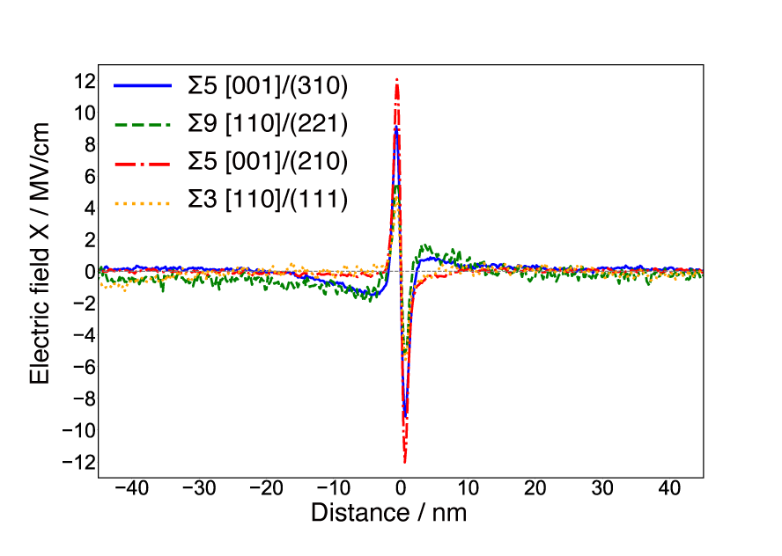
Supplementary Fig. S3 The horizontal-component electric field line profiles of four YSZ GBs. The range of the profiles is changed from Fig. 5 so that all plots are visible.

