360-Degree Virtual Reality Video to Teach Neonatal Resuscitation: An Exploratory Development Study.
Supplemental Materials
Tachejian Sevag, MD^{1,2}, Moussa Ahmed*, MD, MMEd^{3,4,5}
Affiliations:
¹Department of Pediatrics, Division of Pediatric Emergency Medicine, The Hospital for Sick Children, Toronto, Ontario, Canada.
²Department of Pediatrics, Division of General Pediatrics, CHU Sainte-Justine, Montreal, Quebec, Canada.
³Department of Pediatrics, Division of Neonatology, CHU Sainte-Justine, Montreal, Quebec, Canada.
⁴CHU Sainte-Justine Research Center, Montreal, Quebec, Canada.
⁵Centre for applied health sciences education (CPASS), Faculty of Medicine, Université de Montréal, Montreal, Quebec, Canada.

Corresponding author:
Ahmed Moussa
Department of Pediatrics, University of Montreal
CHU Sainte-Justine
3175 Chemin Cote Sainte-Catherine
Montreal (QC), H3T 1C5.
Tel: 514-345-4931
Email: ahmed.moussa@umontreal.ca
https://orcid.org/0000-0002-2556-6970

Figures
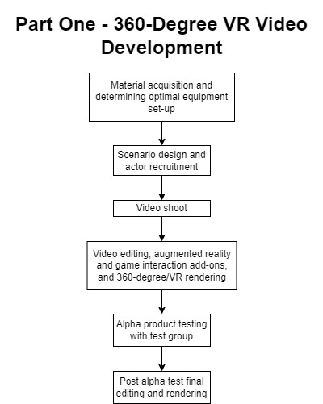
Supplementary Figure S1A. Study design flow chart, part one.

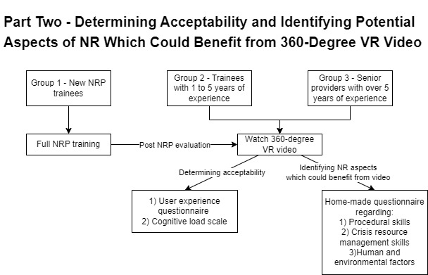
Supplementary Figure S1B. Study design flow chart, part two.

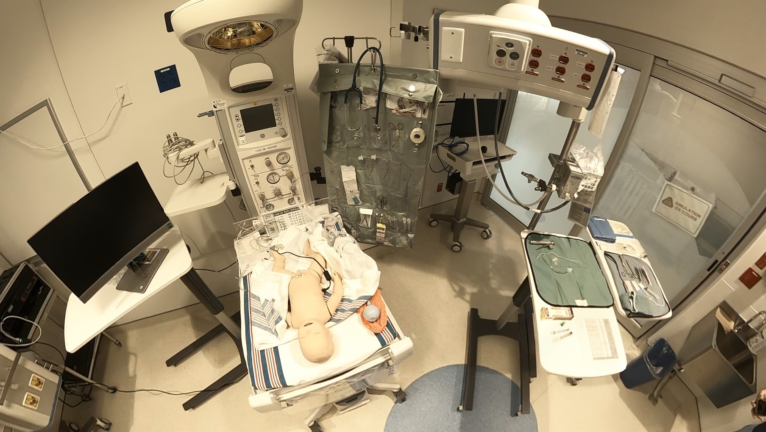
Supplementary Figure S2. A 360-degree point of view from the camera.
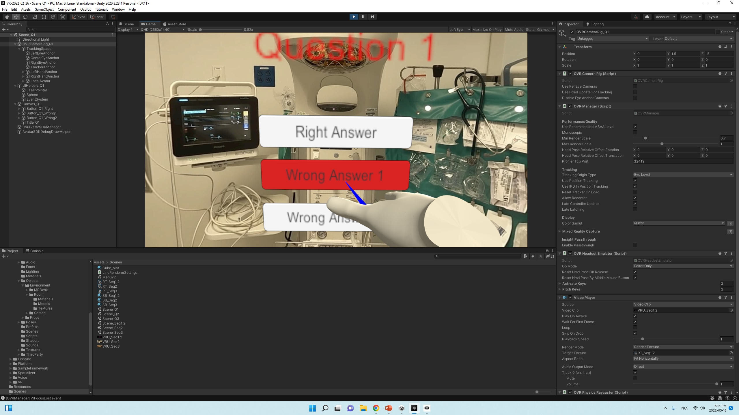
Supplementary Figure S3. Testing the game interactions/questions using Unity Editor.

Table
User Experience Subscale | Original Cronbach’s Alpha | Study Cronbach’s Alpha
Presence | 0.755 | 0.931
Engagement | 0.759 | 0.845
Immersion | 0.767 | 0.887
Flow | 0.826 | 0.838
Emotion | 0.718 | 0.898
Skill | 0.820 | 0.853
Experience Consequence | 0.908 | 0.883
Technology Adoption | 0.781 | 0.916
Judgment | 0.804 | 0.588

Supplementary Table S1 – Cronbach’s alpha comparison between our study and the original study.

Questionnaires
Q1) Demographic questionnaire
- Healthcare provider role
- Years of NRP experience
  - New trainee
  - 1 to 5 years of experience
  - Over 5 years of experience
- Previous experience with virtual reality
  - Yes
  - No
Q2) User experience questionnaire
User Experience Questionnaire, adapted from Tcha-Tokey et al.
All items are on a 10-point Likert scale, except open ended questions and differential scale items.
Strikethrough and bold words represent our adaptations.
Item # | Item | Subscale
1 | My interactions with the virtual environment seemed natural | Presence
2 | The visual aspects of the virtual environment incited me to get involved | Engagement
3 | The devices (gamepad or keyboard) which controlled my movement in the virtual environment seemed natural | Presence
4 | I was able to actively survey the virtual environment using vision | Presence
5 | The sense of moving looking around inside the virtual environment was compelling | Engagement
6 | I was able to examine objects closely | Presence
7 | I could examine objects from multiple viewpoints | Presence
8 | I was involved in the virtual environment experience | Engagement
9 | I felt proficient in moving and interacting with the virtual environment at the end of the experience | Presence
10 | I could concentrate on the assigned tasks rather than on the devices (gamepad or keyboard) | Presence
11 | I correctly identified sounds produced by the virtual environment | Presence
12 | I correctly localized sounds produced by the virtual environment | Presence
13 | I felt stimulated by the virtual environment | Immersion
14 | I became so involved in the virtual environment that I was not aware of things happening around me | Immersion
15 | I became so involved in the virtual environment that it felt as if I was inside the game rather than manipulating a gamepad and watching a screen | Immersion
16 | I felt physically fit/well in the virtual environment | Immersion
17 | I became so involved in the virtual environment that I lost all track of time | Immersion
18 | I felt I could perfectly control my actions | Flow
19 | At each step, I knew what to do | Flow
20 | I felt I controlled the situation | Flow
21 | Time seemed to flow differently than usual | Flow
22 | Time seemed to speed up | Flow
23 | I was losing the sense of time | Flow
24 | I was not worried about what other people would think of me | Flow
25 | I felt I was experiencing an exciting moment | Flow
26 | This experience was giving me a great sense of well-being | Flow
27 | When I mention the experience in the virtual environment, I feel emotions I would like to share | Flow
28 | I enjoyed being in this virtual environment | Emotion
29 | It was so exciting that I could stay in the virtual environment for hours | Emotion
30 | I enjoyed the experience so much that I feel energized | Emotion
31 | I did not feel felt nervous in the virtual environment | Emotion
32 | I did not feel felt like distracting myself in order to reduce my anxiety | Emotion
33 | I found my mind wandering while I was in the virtual environment | Emotion
34 | The interaction devices (Oculus headset, gamepad and/or keyboard) did not bored me to death | Emotion
35 | When my actions were going well, it gave me a rush | Emotion
36 | While using the interaction devices (Oculus headset, gamepad and/or keyboard), I did not feel felt like time was dragging | Emotion
37 | I enjoyed the challenge of learning the virtual reality interaction devices (Oculus headset, gamepad and/or keyboard) | Emotion
38 | I enjoyed dealing with the interaction devices (Oculus headset, gamepad and/or keyboard) | Emotion
39 | I felt confident selecting objects in the virtual environment | Skill
40 | I felt confident moving the cross-hair hands around the virtual environment | Skill
41 | I felt confident using the gamepad and/or keyboard to move look around the virtual environment | Skill
42 | I feel confident understanding the terms/words relating to the interaction devices (Oculus headset, gamepad and/or keyboard) | Skill
43 | I feel confident learning advanced skills within a specific virtual reality software using the Oculus headset | Skill
44 | I feel confident describing the functions the interaction devices (Oculus headset, gamepad and/or keyboard, joystick, etc.) of a virtual reality environment | Skill
45 | Personally, I would say the virtual environment is impractical/practical | Judgement
46 | Personally, I would say the virtual environment is confusing/clear | Judgement
47 | Personally, I would say the virtual environment is unruly/manageable | Judgement
48 | I found that this virtual environment was lame/exciting | Judgement
49 | I found this virtual environment amateurish/professional | Judgement
50 | I found this virtual environment gaudy/classy | Judgement
51 | I found this virtual environment unpresentable/presentable | Judgement
52 | I found that this virtual environment is ugly/beautiful | Judgement
53 | I found that this virtual environment is unlikeable/likeable | Judgement
54 | I suffered from fatigue during my interaction with the virtual environment | Experience consequence
55 | I suffered from headache during my interaction with the virtual environment | Experience consequence
56 | I suffered from eyestrain during my interaction with the virtual environment | Experience consequence
57 | I felt an increase of my salivation during my interaction with the virtual environment | Experience consequence
58 | I suffered from nausea during my interaction with the virtual environment | Experience consequence
59 | I suffered from fullness of the head during my interaction with the virtual environment | Experience consequence
60 | I suffered from dizziness with eye open during my interaction with the virtual environment | Experience consequence
61 | I suffered from vertigo during my interaction with the virtual environment | Experience consequence
62 | If I use the same virtual environment again, my interaction with the environment would be clear and understandable for me | Technology adoption
63 | It would be easy for me to become skillful at using the virtual environment | Technology adoption
64 | Learning to operate the virtual environment would be easy for me | Technology adoption
65 | Using the interaction devices (Oculus headset, gamepad and/or keyboard) is a bad good idea | Technology adoption
66 | The interaction devices (Oculus headset, gamepad and/or keyboard) would make work more interesting | Technology adoption
67 | I would like to work with the interaction devices (Oculus headset, gamepad and/or keyboard) | Technology adoption
68 | I have the resources necessary to use the interaction devices (Oculus headset, gamepad and/or keyboard) | Technology adoption
69 | In your opinion, what were the positive points about your experience? | N/A
70 | In your opinion, what were the negative points about your experience? | N/A
71 | Do you have suggestions to improve this virtual reality environment? | N/A

Q3) Paas cognitive load scale
- During the self-directed learning period with the textbook, I invested: (only for group 1)
- During the in-person simulation, I invested: (only for group 1)
- During the immersion in and interaction with the 360-degree video of a neonatal resuscitation, I invested:

- Very, very low mental effort
- Very low mental effort
- Low mental effort
- Rather low mental effort
- Neither low nor high mental effort
- Rather high mental effort
- High mental effort
- Very high mental effort
- Very, very high mental effort

Q4) Home-made questionnaire for the identification of aspects of neonatal resuscitation which could benefit from the incorporation of 360-degree VR videos in the NRP training program.
Evaluate features of procedural skills, crisis resource management skills, and human factors
All questions are on a 5-point Likert scale (1: strongly disagree and 5: strongly agree)
After having experienced the immersive 360-degree video, I believe that it can help in teaching technical abilities, as in to correctly:
- Evaluate if a neonate needs resuscitation and initiate the first steps.
- Position the airways.
- Suction and clear the airways.
- Position a mask in order to administer CPAP or PPV.
- Ensure adequate ventilation and perform the corrective steps for PPV (MR SOPA).
- Perform endotracheal intubation.
- Perform chest compressions, coordinated with ventilation.
- Administer ET or IV epinephrine.
After having experienced the immersive 360-degree video, I believe it can help in correctly:
- Positioning myself according to my role and the other members.
- Positioning myself regarding the equipment I may need to use.
- Identifying the different equipment and material in a resuscitation room.
- Choosing the equipment needed to complete the initial steps.
- Choosing the equipment needed to ventilate.
- Choosing the equipment needed to intubate.
After having experienced the immersive 360-degree video, I believe it can help in teaching the following skills:
- Anticipating and planning.
- Knowing the environment.
- Designating leadership.
- Distributing the workload.
- Establishing role clarity.
- Using all available information.
- Allocating attention wisely.
- Calling for help early.
- Mobilizing resources.
- Using cognitive aids.
- Communicating effectively.
After having experienced the immersive 360-degree video, I believe it:
- Can be a strong adjunct in teaching neonatal resuscitation.

