Descriptive statistics stratified by sex, site and location
Comparative analyses were done using t-test, and χ2 test to compare the distribution of covariates according to sex, location (urban/rural), and site (Bangalore, Hyderabad, Nagpur, and Lucknow). The distribution of the cardiometabolic risk factors were statistically different across gender, site, and location. Supplementary Table 1 summarizes the distribution of the risk factors between males, and females. VAI, BAI along with BMI, and hip girth were statistically higher among females while the other parameters including dietary intake was higher in males. Nagpur exhibited lowest levels of cardiometabolic risk factors, highest dietary intakes, and physical activity (Supplementary Table 2). However, it is noteworthy that the mean age for participants from Nagpur is 29 years, that is different from other sites between the range 43.57-44.82 years. The mean values of all the variables were almost similar between Lucknow, and Hyderabad at comparable mean ages (Supplementary Table 2). Supplementary Table 3 describes the distribution of the characteristics between rural, and urban participants.
The obesity-related indices namely BMI, Waist girth, WHR %BF were found to be statistically correlated at (p-value<0.001) with VAI, and BAI (Figure 2). VAI was positively correlated with BMI (0.23), WC (0.26), WHR (0.13), %BF (0.26), and BAI (0.22). BAI was inversely correlated with WHR (-0.20). BAI was most strongly correlated with BMI (0.76), and %BF (0.75). BAI was also positively correlated with WC (0.38) better that VAI.

Correlation between VAI, BAI, and other obesity-related indices
The correlation matrix between VAI, BAI, and other obesity-related indices is illustrated in Figure 2. VAI was positively correlated with all the other indices and strongest with %BF (percent body fat) (r = 0.26). Correlation coefficient between Waist-Hip-Ratio (WHR) and VAI was 0.13 which was least. However, the range of coefficient for other indices namely Body Mass Index (BMI), Waist circumference (WC) and BAI (Figure 2).
Similarly, BAI was also positively correlated with all the indices except WHR. Strong correlation was observed between BAI and BMI (r = 0.76) and BAI and %BF (r = 0.75) (Figure 2).

The distribution of the phenotype across genotypes
The distribution of VAI on logarithmic scale stratified by the number of risk alleles is presented in Figure 3, and Figure 4. The genotypic distribution also depicts that the median VAI for homozygous mutant genotype of rs6659428 (-/-) is comparatively lower than the homozygous wild type (+/+), and heterozygous (+/-), whereas the median VAI for rs7611535 (-/-) is higher as compared to (+/+), and (+/-).
The distribution of BAI stratified by the number of risk alleles of the variant is presented in Figure 5. The median value of BAI being slightly higher for (-/-) as compared to other 2 genotypes, also supports the results.

Interaction Analyses of the identified SNVs
Gene-environment/lifestyle interaction with physical activity, fat intake, energy intake, migrant status (migrant, rural, and urban), and location (rural/urban) was also explored for the variants that were found to be associated with VAI, or BAI in MLM (S.Table 4) . The continuous interaction terms were categorised based on respective median values by convention, and inferences were drawn at significance level of 0.05. The interaction term was included with the fixed effect term (within-sib effect) of the Fulker association model for these exploratory analyses.
rs6659428 showed marginal interaction with location for VAI (ꞵ= 0.26, SE = 0.13, p-value=0.047). This implied the effect of rs6659428 on VAI increased by 0.26 SD among rural as compared to urban participants with every unit increase in the major (risk allele) (Supplementary Table 4). On the other hand, the effect of rs73300702 on BAI exhibited 0.29 SD reduction in more physically active group (ꞵ= -0.29, SE = 0.14, p-value=0.034). The categories for physical activity had total METS/day ranging from 26.15 – 38.45, and 38.46 - 67.51 (Supplementary Table 4). None of the three identified for VAI, and BAI showed interaction with dietary factors, and migrant status.

Supplementary Figures and Tables

Figure 1: Sampling strategy for the present work

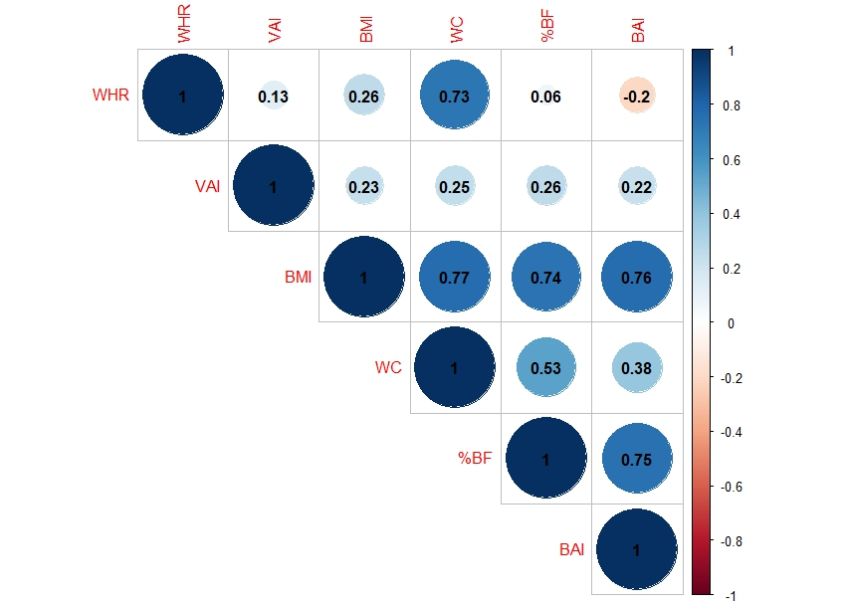
Figure 2: Correlation matrix of important obesity-related indices (Body Mass Index (BMI), Waist Circumference (WC), Waist-Hip-Ratio (WHR), %Bodyfat (%BF)) with VAI, and BAI

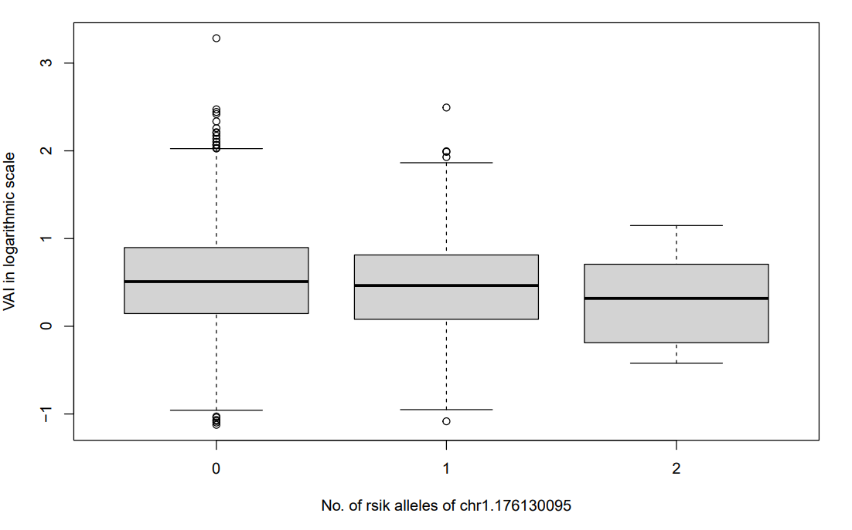
rs6659428
Figure 3: Boxplot of the distribution of Visceral Adiposity Index in logarithmic scale for homozygous for wild alleles, heterozygous, and homozygous for mutant alleles of rs6659428 at LOC400796 | SEC16B

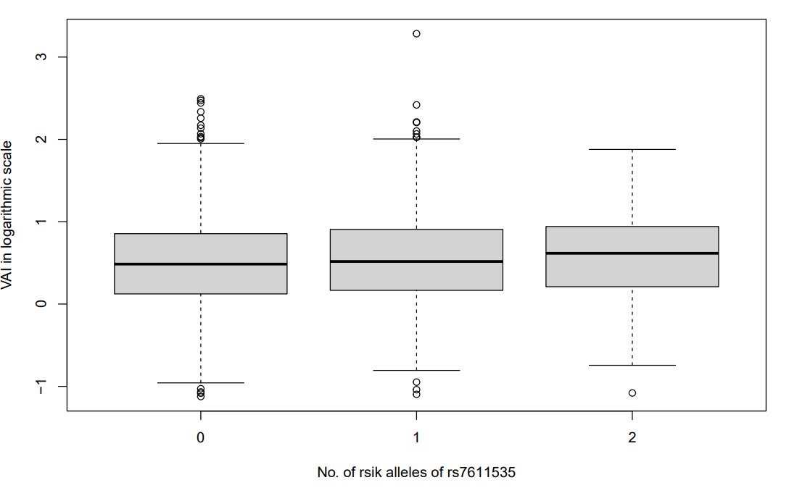
Figure 4: Boxplot of the distribution of Visceral Adiposity Index in logarithmic scale for homozygous for wild alleles, heterozygous, and homozygous for mutant alleles of rs7611535 at DRD3 | LOC645180
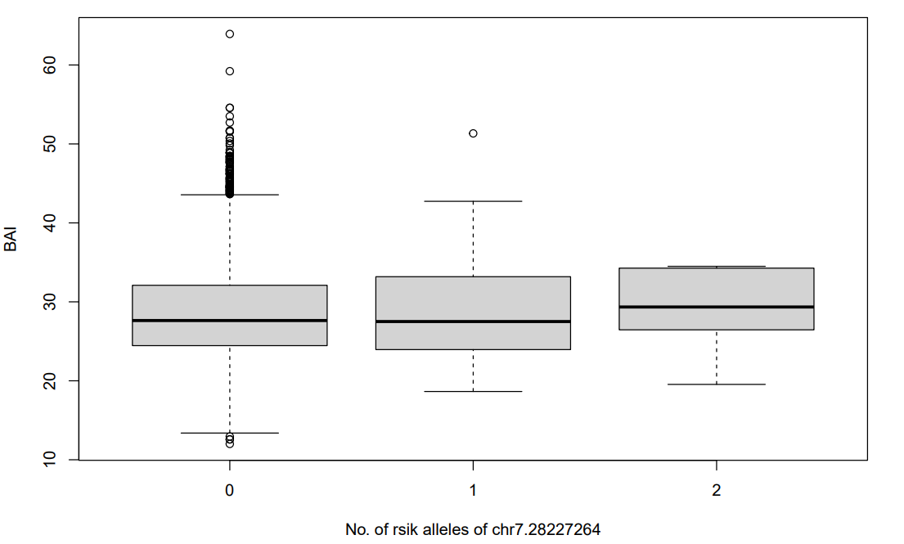
rs73300702
Figure 5: Boxplot of the distribution of Body Adiposity Index for homozygous for wild alleles, heterozygous, and homozygous for mutant alleles of rs73300702 at JAZF1-AS1

Supplementary Table 1: Characteristics of Indian Migration Study participants stratified by gender
Characteristic | Male (N = 2,649) |  |  |  |  | Female (N = 1,881) | p-value¹
Age (Years) ª | 41.54 (10.64) |  |  |  |  | 39.77 (9.88) | <0.001
Site ^{b} |  |  |  |  |  |  | <0.001
Lucknow | 837 (32%) |  |  |  |  | 511 (27%)
Nagpur | 670 (25%) |  |  |  |  | 378 (20%)
Hyderabad | 713 (27%) |  |  |  |  | 667 (35%)
Bangalore | 429 (16%) |  |  |  |  | 325 (17%)
Location ^{b} |  |  |  |  |  |  | <0.001
Urban | 1,509 (57%) |  |  |  |  | 1,311 (70%)
Rural | 1,140 (43%) |  |  |  |  | 570 (30%)
Migrant Group ^{b} |  |  |  |  |  |  | <0.001
Non-Migrant | 1,922 (73%) |  |  |  |  | 1,222 (65%)
Migrant (Ever) | 727 (27%) |  |  |  |  | 659 (35%)
Migrant Status ^{b} |  |  |  |  |  |  | <0.001
Rural | 952 (39%) |  |  |  |  | 423 (25%)
Migrant | 725 (30%) |  |  |  |  | 650 (38%)
Urban | 755 (31%) |  |  |  |  | 653 (38%)
Standing Height (cm) ª | 165.60 (6.51) |  |  |  |  | 152.86 (5.63) | <0.001
Body Weight (kg) ª | 63.34 (11.63) |  |  |  |  | 57.37 (12.08) | <0.001
Circumference ª
Waist Circumference (cm) | 84.50 (11.35) |  |  |  |  | 78.55 (11.01) | <0.001
Hip Circumference (cm) | 92.62 (7.92) |  |  |  |  | 96.35 (10.64) | <0.001
Body Mass Index (BMI) ª | 23.06 (3.84) |  |  |  |  | 24.54 (4.94) | <0.001
Total Cholesterol (mmol/l) ª |  |  | 4.68 (1.11) |  |  | 4.77 (1.14) | 0.007
LDL-C (mmol/l) ª |  |  | 2.84 (0.97) |  |  | 2.94 (1.00) | 0.001
HDL-C (mmol/l) ª |  |  | 1.16 (0.24) |  |  | 1.20 (0.25) | <0.001
Triglycerides (mmol/l) ª | 1.50 (0.83) |  |  |  |  | 1.40 (0.69) | <0.001
Visceral Adiposity Index (VAI) ª | 1.77 (1.18) |  |  |  |  | 2.18 (1.23) | <0.001
Body Adiposity Index (BAI) ª | 25.53 (3.90) |  |  |  |  | 33.07 (6.00) | <0.001
Percent Body fat (%BF) | 23.86 (7.27) |  |  |  |  | 31.32 (7.44) | <0.001
Average daily energy intake (kcal/day) ª | 3,116.48 (1,048.03) |  |  |  |  | 2,553.90 (828.38) | <0.001
Average daily carbohydrate intake (g/day) ª |  | 488.43 (162.86) |  |  | 400.66 (126.17) |  | <0.001
Average daily fat intake (g/day) ª | 88.76 (38.29) |  |  |  |  | 74.34 (31.00) | <0.001
Total Physical Activity per day (MET h/day) ª |  |  |  | 39.72 (4.98) |  | 37.84 (4.00) | <0.001
LDL-C – Low density lipoprotein-cholesterol; HDL-C – High density lipoprotein-cholesterol
ª All-continuous variables are reported as Mean (SD), and ^{b} categorical as n (%)
The measures are adjusted for clustering; there are missing values for variables except age, gender, site, and location
¹ test of comparison (t-test, and χ2 test depending upon variable) between groups, p<0.05 signifies the groups are different for the variable

Supplementary Table 2: Characteristics of Indian Migration Study participants stratified by site (4 different cities)
Characteristic | Lucknow  (N = 1,348) | Nagpur  (N = 1,048) | Hyderabad  (N = 1,380) | Bangalore  (N = 754) | p-value¹
Age (Years) ª | 43.92 (8.58) | 29.53 (6.41) | 44.82 (8.99) | 43.57 (8.82) | <0.001
Gender ^{b} |  |  |  |  | <0.001
Male | 837 (62%) | 670 (64%) | 713 (52%) | 429 (57%)
Female | 511 (38%) | 378 (36%) | 667 (48%) | 325 (43%)
Location ^{b} |  |  |  |  | <0.001
Urban | 935 (69%) | 607 (58%) | 746 (54%) | 532 (71%)
Rural | 413 (31%) | 441 (42%) | 634 (46%) | 222 (29%)
Migrant Group ^{b} |  |  |  |  | 0.029
Non-Migrant | 953 (71%) | 735 (70%) | 916 (66%) | 540 (72%)
Migrant (Ever) | 395 (29%) | 313 (30%) | 464 (34%) | 214 (28%)
Migrant Status ^{b} |  |  |  |  | <0.001
Rural | 395 (30%) | 305 (34%) | 461 (38%) | 214 (29%)
Migrant | 395 (30%) | 305 (34%) | 461 (38%) | 214 (29%)
Urban | 536 (40%) | 276 (31%) | 282 (23%) | 314 (42%)
Standing Height (cm) ª | 160.29 (8.82) | 161.38 (8.45) | 159.14 (8.74) | 160.98 (9.09) | <0.001
Body Weight (kg) ª | 62.29 (12.16) | 54.57 (10.27) | 62.62 (12.08) | 63.83 (11.83) | <0.001
Circumference ª
Waist Circumference (cm) | 84.69 (11.90) | 74.98 (9.08) | 84.36 (11.04) | 82.82 (11.15) | <0.001
Hip Circumference (cm) | 95.11 (8.28) | 88.23 (7.37) | 97.16 (9.77) | 95.29 (9.05) | <0.001
Body Mass Index (BMI) ª | 24.21 (4.17) | 20.91 (3.34) | 24.73 (4.51) | 24.65 (4.21) | <0.001
Total Cholesterol (mmol/l) a | 4.78 (1.11) | 4.43 (1.10) | 4.80 (1.15) | 4.86 (1.08) | <0.001
LDL-C (mmol/l) ª | 2.86 (0.97) | 2.69 (0.96) | 2.96 (1.03) | 3.05 (0.94) | <0.001
HDL-C (mmol/l) ª | 1.24 (0.24) | 1.15 (0.25) | 1.15 (0.24) | 1.14 (0.25) | <0.001
Triglycerides (mmol/l) ª | 1.48 (0.78) | 1.30 (0.64) | 1.53 (0.77) | 1.50 (0.92) | <0.001
Visceral Adiposity Index (VAI) ª | 1.86 (1.11) | 1.68 (0.94) | 2.17 (1.27) | 2.03 (1.52) | <0.001
Body Adiposity Index (BAI) ª | 29.09 (5.40) | 25.22 (4.61) | 30.70 (6.65) | 28.96 (6.25) | <0.001
Percent Body fat (%BF) | 28.18 (7.16) | 19.28 (6.84) | 30.56 (7.02) | 28.86 (6.79) | <0.001
Average daily energy intake (kcal/day) ª | 2,857.39 (925.75) | 3,338.11 (1,026.36) | 2,504.03 (897.09) | 2,989.11 (1,001.31) | <0.001
Average daily carbohydrate intake (g/day) ª | 441.14 (143.75) | 526.58 (155.24) | 394.50 (138.11) | 472.89 (156.27) | <0.001
Average daily fat intake (g/day) ª | 81.03 (30.30) | 97.07 (39.82) | 72.19 (33.80) | 85.40 (37.66) | <0.001
Total Physical Activity per day (MET h/day) ª | 38.86 (4.07) | 40.44 (5.20) | 38.02 (4.71) | 38.70 (4.47) | <0.001
LDL-C – Low density lipoprotein-cholesterol; HDL-C – High density lipoprotein-cholesterol
ª All-continuous variables are reported as Mean (SD), and ^{b} categorical as n (%)
The measures are adjusted for clustering; there are missing values for variables except age, gender, site, and location
¹ test of comparison (Analysis of Variance (ANOVA), and χ2 test depending upon variable) between groups, p<0.05 signifies the groups are different for the variable

Supplementary Table 3: Characteristics of Indian Migration Study participants stratified by location (rural/urban)
Characteristic | Urban (N = 2,820) | Rural (N = 1,710) | p-value¹
Age (Years) ª | 41.46 (9.49) | 39.72 (11.58) | <0.001
Gender ^{b} |  |  | <0.001
Male | 1,509 (54%) | 1,140 (67%)
Female | 1,311 (46%) | 570 (33%)
Site ^{b} |  |  | <0.001
Lucknow | 935 (33%) | 413 (24%)
Nagpur | 607 (22%) | 441 (26%)
Hyderabad | 746 (26%) | 634 (37%)
Bangalore | 532 (19%) | 222 (13%)
Migrant Group ^{b} |  |  | <0.001
Non-Migrant | 1,445 (51%) | 1,699 (99%)
Migrant (Ever) | 1,375 (49%) | 11 (0.6%)
Migrant Status ^{b} |  |  | <0.001
Rural | 38 (1.4%) | 1,337 (99%)
Migrant | 1,375 (49%) | 0 (0%)
Urban | 1,394 (50%) | 14 (1.0%)
Standing Height (cm) ª | 159.81 (8.86) | 161.13 (8.63) | <0.001
Body Weight (kg) ª | 63.23 (12.04) | 56.96 (11.37) | <0.001
Circumference ª
Waist Circumference (cm) | 84.17 (11.26) | 78.50 (11.26) | <0.001
Hip Circumference (cm) | 96.18 (9.12) | 90.87 (8.71) | <0.001
Body Mass Index (BMI) ª | 24.74 (4.25) | 21.92 (4.03) | <0.001
Total Cholesterol (mmol/l) a | 4.79 (1.12) | 4.60 (1.13) | <0.001
LDL-C (mmol/l) ª | 2.94 (0.98) | 2.79 (1.00) | <0.001
HDL-C (mmol/l) ª | 1.18 (0.25) | 1.17 (0.24) | 0.400
Triglycerides (mmol/l) ª | 1.49 (0.81) | 1.40 (0.71) | <0.001
Visceral Adiposity Index (VAI) ª | 2.02 (1.28) | 1.81 (1.10) | <0.001
Body Adiposity Index (BAI) ª | 29.87 (6.08) | 26.66 (5.68) | <0.001
Percent Body fat (%BF) | 28.99 (7.47) | 23.61 (8.27) | <0.001
Average daily energy intake (kcal/day) ª | 3,001.56 (950.38) | 2,687.15 (1,053.09) | <0.001
Average daily carbohydrate intake (g/day) ª | 466.15 (143.34) | 428.62 (169.70) | <0.001
Average daily fat intake (g/day) ª | 88.00 (35.33) | 74.15 (35.83) | <0.001
Total Physical Activity per day (MET h/day) ª | 38.02 (3.91) | 40.48 (5.43) | <0.001
LDL-C – Low density lipoprotein-cholesterol; HDL-C – High density lipoprotein-cholesterol
ª All-continuous variables are reported as Mean (SD), and ^{b} categorical as n (%)
The measures are adjusted for clustering; there are missing values for variables except age, gender, site, and location
¹ test of comparison (t-test, and χ2 test depending upon variable) between groups, p<0.05 signifies the groups are different for the variable

Supplementary Table 4: Gene-Environment/Lifestyle Interaction Analyses for the three genetic variants related to VAI, and BAI
Variant (Loci) | Interaction Term | Model 1 |  |  | Model 2
 |  | ꞵ | SE | p-value | ꞵ | SE | p-value
VAI
rs6659428 (LOC400796 | SEC16B) | PA | 0.11 | 0.12 | 0.351 | 0.11 | 0.12 | 0.372
 | Migrant | 0.06 | 0.10 | 0.557 | 0.05 | 0.10 | 0.601
 | Location | 0.26 | 0.13 | 0.056 | 0.27 | 0.13 | 0.047*
 | Fat | 0.15 | 0.12 | 0.228 | 0.16 | 0.12 | 0.188
 | Energy | 0.05 | 0.12 | 0.698 | 0.04 | 0.12 | 0.737
rs7611535 (DRD3 | LOC645180) | PA | 0.03 | 0.09 | 0.752 | 0.03 | 0.09 | 0.757
 | Migrant | -0.04 | 0.07 | 0.605 | -0.03 | 0.07 | 0.660
 | Location | 0.10 | 0.09 | 0.298 | 0.11 | 0.10 | 0.264
 | Fat | -0.01 | 0.08 | 0.943 | 0.00 | 0.09 | 0.982
 | Energy | -0.02 | 0.09 | 0.794 | -0.01 | 0.09 | 0.865
BAI
rs73300702 (JAZF1-AS1) | PA | -0.29 | 0.14 | 0.035* | -0.29 | 0.14 | 0.034*
 | Migrant | -0.09 | 0.11 | 0.395 | -0.08 | 0.11 | 0.488
 | Location | 0.21 | 0.15 | 0.163 | 0.19 | 0.15 | 0.195
 | Fat | 0.06 | 0.13 | 0.630 | 0.08 | 0.13 | 0.563
 | Energy | -0.10 | 0.14 | 0.469 | -0.10 | 0.14 | 0.470
VAI – Visceral Adiposity Index, and BAI – Body Adiposity Index
Model 1 – Adjusted for age, sex, site, location, and BMI
Model 2 - Adjusted for age, sex, site, location, BMI, Total METS/day, daily energy intake, daily fat intake, and daily carbohydrate intake
Level of significance - 4.10×10⁻⁷, Level of suggestive significance – 8.21×10⁻⁶
# - Risk allele is the minor allele

