Supporting Information
Identification of Cu-N₂ sites for Zn-air batteries in harsh electrolytes: from computer virtual screening to practical application

Chenxi Xu,^{1,=} Kaiqi Li,^{2,=} Haihui Zhou,¹* Subash Sharma,³ Jincan Zhang,³ Boyang Mao,³ Hao Zhang,⁴ Bingcheng Luo,⁵ Yi Gong,⁶ Kai Yang,⁶ Jianan Wang,⁷ Kai Xi,⁷ Chaopeng Fu,⁸ Yunlong Zhao,⁹ Guoliang Chai,¹⁰ Guanjie He,² Ivan Parkin,²* Huanxin Li,^{1,2,3,4}*

¹ State Key Laboratory for Chemo/Biosensing and Chemometrics, College of Chemistry and Chemical Engineering, Hunan University, Changsha, Hunan, 410082, China
² Christopher Ingold Laboratory, Department of Chemistry, University College London, London WC1H 0AJ, United Kingdom
³ Department of Engineering, University of Cambridge, 9 JJ Thomson Avenue, Cambridge, CB3 0FA, United Kingdom
⁴ Department of Chemistry, Physical & Theoretical Chemistry Laboratory, University of Oxford, South Parks Road, Oxford, OX1 3QZ, United Kingdom
⁵ College of Science, China Agricultural University, Beijing, 100083 P. R. China
⁶ Advanced Technology Institute, University of Surrey, Guildford, Surrey GU2 7XH, United Kingdom
⁷ Department of Environmental Science and Engineering, School of Energy and Power Engineering, Xi’an Jiaotong University, 28 Xianning West Road, Xi’an 710049, China
⁸ School of Materials Science and Engineering, Shanghai Jiao Tong University, Shanghai, 200240, China
⁹ Dyson School of Design Engineering, Imperial College London, London SW7 2BX, United Kingdom
¹⁰ State Key Laboratory of Structural Chemistry, Fujian Institute of Research on the Structure of Matter, Chinese Academy of Sciences (CAS), Fuzhou, Fujian, 350002 P.R. China
⁼ These authors contributed equally

List of content:
- Supplementary Notes
- Supplementary Figures
- Supplementary Table
- Supplementary References

- Supplementary Notes
1.1 Simulation details
The standard protocol for computer VS was proposed to predict effective oxygen reduction electrocatalysis for Zn-air batteries. The input dataset was generated as following workflow.
A. The promitive M-N_{x}-C (x=2, 3, 4, 5) was built with Materials Studio software, and then we performed 100 stochastic surface walking steps running with the following neural network potential input setting, which yielded 100+ structures. This setting allows the structure to change from initial M-N_{x}-C structure but the obtained structures could have high energy.
B. The as-obtained M-N_{x}-C structures were initially checked to ensure the bond lengths of C-C, C-N and CMN are within rational range. The data of the atom spatial coordinates from VESTA were collected to calculate the bond lengths.
C. The LAMMPS Molecular Dynamics Simulator was used to confirm the stability of input rational structures at both room temperature @300 K and high temperature @3300 K within 50 fs.
D. The last step is to carry out DFT calculations on the selected structures to verify the catalytic activities by evaluating their adsorption energies for intermediates, e.g. *O2, *OOH, *O, and *OH in oxygen-related catalysts, to determine the “Volcano plots” and filter out promising candidates.
1.2 Computational simulations
The density functional theory (DFT) calculations were executed using the Vienna Ab initio Simulation Package (VASP). The generalized gradient approximation (GGA) method, specifically the Perdew, Burke, and Ernzerhof (PBE) formulation, was employed to describe the exchange-correlation functional component of the Hamiltonian. The DFT+U formalism was applied to compute free energies and electron–ion interactions, utilizing the GGA-PBE functional with a U–J value of 3.0 eV for Fe. Electron–ion interactions were modeled using projected augmented wave potentials, and a plane-wave cutoff energy of 500 eV was employed. The model structures underwent full optimization, and a 5 × 5 × 1 grid was utilized for k-point sampling, with convergence thresholds set at 10⁻⁶ eV for energy and 0.05 eV Å⁻¹ for force. A vacuum distance exceeding 10 Å was implemented to eliminate interactions between successive slabs. Additional details can be found in Tables S3-S5.
Molecular dynamics (MD) simulations were performed using the large-scale atomic/molecular massively parallel simulator.^{S1, S2}. The ReaxFF force field and NVT ensemble with a Nosé-Hoover thermostat at temperatures of 300, 500, 1000, 1500 and 2000 K were employed.^{S3} The NVT-MD simulation comprised 10,000 steps with a time step of 1.0 fs, resulting in a total simulation time of 100 ps (Figure S16).
S1. Plimpton, S. Fast Parallel Algorithms for Short-Range Molecular Dynamics. Journal of Computational Physics 117, 1-19, doi:10.1006/jcph.1995.1039 (1995).
S2. Thompson, A. P. et al. LAMMPS - a flexible simulation tool for particle-based materials modeling at the atomic, meso, and continuum scales. Computer Physics Communications 271, 108171, doi:https://doi.org/10.1016/j.cpc.2021.108171 (2022). S3. Aktulga, H. M., Fogarty, J. C., Pandit, S. A. & Grama, A. Y. Parallel reactive molecular dynamics: Numerical methods and algorithmic techniques. Parallel Computing 38, 245-259, doi:https://doi.org/10.1016/j.parco.2011.08.005 (2012).

1.3 Material synthesis strategy
We adopted a facile in–situ self–template induced strategy to fabricate densely unsaturated Cu–N₂ sites decorated hollow nitrogen–doped octahedron carbon (Cu–N₂@HNOC), in which the valence state of Cu is close to +1 in linear type Cu–N₂ sites. Firstly, CuO octahedrons were served as sacrificial template and pyrrole monomer was dispersed around them. Then, acid solution was added drop by drop and the released Cu²⁺ ions as oxidant initiate the polymerization of pyrrole monomer on the surface of CuO octahedrons. And the Cu²⁺ ions will be continually reduced into Cu⁺ and subsequently captured by polypyrrole until the CuO octahedrons were completely dissolved. Finally, the obtained Cu–containing hollow octahedrons polypyrrole was pyrolyzed to acquire the targeted sample of Cu–N₂@HNOC. The low valence state Cu⁺ and tends to form low coordination compounds, and results in unsaturated Cu–N₂ sites. In addition, it is notably that our adopted in–situ polymerization rationally designing is available to avoid the adverse impact of template removal and overuse of reducing agents. Obviously, it is an innovative and green synthetic approach to high–efficiency Cu–based electrocatalysts.
1.4 Material characterizations
Morphologies and microstructure was observed by scanning electron microscopy (SEM, Hitachi S–4800), transmission electron microscopy (TEM, Thermo scientific (3.2)) Microstructure and defect nature was measured by X–ray diffraction (Bruker D8 advanced powder X–ray diffractometer) and raman spectroscopy (Renishaw invia-reflex). The specific surface area and pore size distributions were tested by BET analyzer (Micromeritics, ASAP 2020 HD). The chemical composition was manifested by X–ray photoelectron spectroscopy (XPS, ESCALAB250). The content of Cu was evaluated by inductively coupled plasma mass spectrometry (ICP-MS). Thermogravimetric analyzer (TGA, STA449-C) was employed to reflect mass loss process.
1.5 ORR catalytic performance
All the electrochemical measurement was experimented by CHI 660D electrochemical workstation in three–electrode cell. Herein, a rotating disk electrode (RDE), graphic rod and Ag/AgCl electrode was used as working, counter and reference electrodes respectively. All the potentials can be converted to RHE potential according to the following equation: E (RHE) = E (Ag/AgCl) + 0.059 pH + 0.197. The electron transfer numbers (n) at various potential were determined by the Koutecky–Levich equation: $\frac{1}{J}=\frac{1}{J_{k}}+\frac{1}{0.62nFC_{0}D_{0}^{2/3}ν^{1/6}ω^{1/2}}$, where J and J_{k} represents current density and kinetic diffusion–limiting current density respectively. n signifies the electron transfer number, F is the Faraday constant, C₀ is the saturated concentration of oxygen, D₀ is the diffusion coefficient of oxygen in the bulk solution, ν is the kinematic viscosity and ω is the angular speed of the disk. For the rotating ring–disk electrode (RRDE) test, the electrode was prepared as same as that for RDE. Peroxide yield (HO^{2–} %) and transferred electron number (n) was calculated by the equations as follows: HO^{2–} %$=200\frac{{Ir}/N}{Id+{Ir}/N}$ n=$\frac{4×Id}{Id+{Ir}/N}$. Herein, I_{d} and I_{r} correspond to the current of disk and ring respectively. N is current collection efficiency of Pt ring. In our work the value of N is 0.37.
1.6 Tests of Zn–air batteries
The home–made liquid Zn–air batteries (ZABs) consist of air cathode, anode and electrolyte. Air cathode was prepared by loading catalyst ink on carbon cloth with a mass loading of ~1 mg/cm². Polished Zn foil was employed as anode. 6 M KOH solutions with 0.2 M zinc acetate was utilized as electrolyte. All the electrochemical tests were carried out under ambient condition on a CHI 660E electrochemical workstation and LAND–CT2011A battery testing system. All the solid–state ZABs were also assembled by anode, cathode and gel electrolyte. Specifically, the carbon cloth with catalyst and Zn plate were putted on the two sides of the gel polymer, and then pressed together by roll–pressing under the assistant of nickel foam.

- Supplementary Figures
Figure S1. The XRD patterns (a) of different samples and Raman spectrum (b) of CuO octahedron.
Note: (a) The curve in black can be assigned to the dominant peaks of CuO (PDF#89–5899).
(b) There are three strong peaks centered at 295 cm⁻¹, 342 cm⁻¹and 628 cm⁻¹ in the Raman spectrum, which corresponds to the A_{g}, B_{1g}, and B_{2g} characteristic modes of CuO with monoclinic crystal symmetry ^{[1,2]}
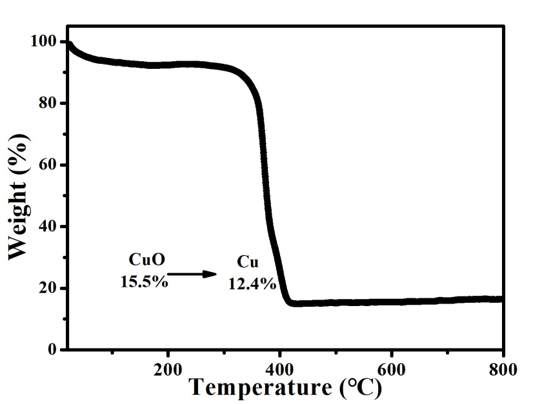
Figure S2. The TGA result of Cu-N₂@HNOC
Note: The TGA test was conducted under O₂ flow. With the temperature increasing, carbon skeleton was gradually decomposed and Cu species can be oxidized into CuO, so the content of Cu can be deduced to be 12.4 % according to the mass of CuO.
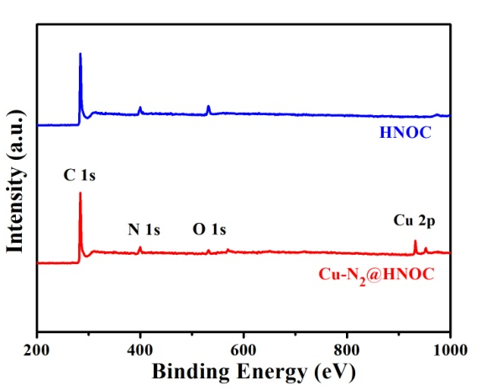
Figure S3. The XPS survey spectra of the as-prepared samples

Figure S4. The high-resolution XPS spectra of N 1s (a) and Cu 2p (b) for Cu–N₂@HNOC

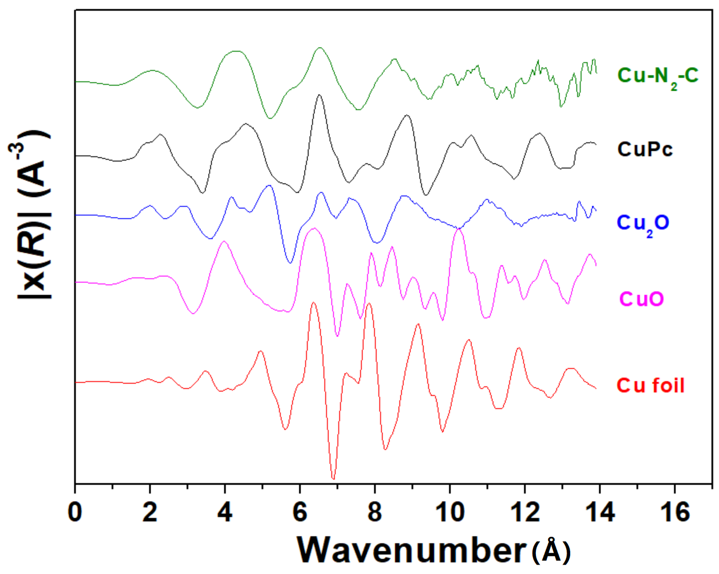
Figure S5. k-space EXAFS spectra of Cu foil, CuO, Cu₂O, CuPc and Cu–N₂@HNOC samples.
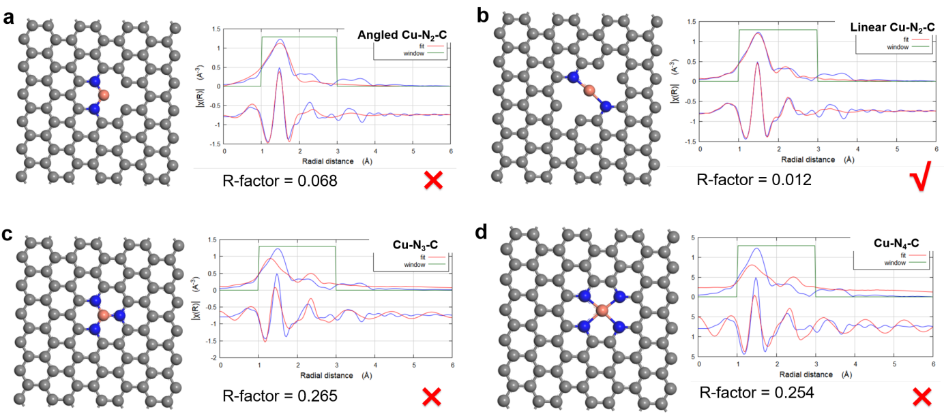
Figure S6. The R-space EXAFS spectra fitting of Cu–N₂@HNOC with angled Cu-N₂-C, linear Cu-N₂-C, Cu-N₃-C and Cu-N₄-C models.

Figure S7. (a) N₂ adsorption/desorption isotherm for Cu-N₂@HNOC; (b) XRD patterns and (c) Raman spectra for Cu-N₂@HNOC and HNOC.

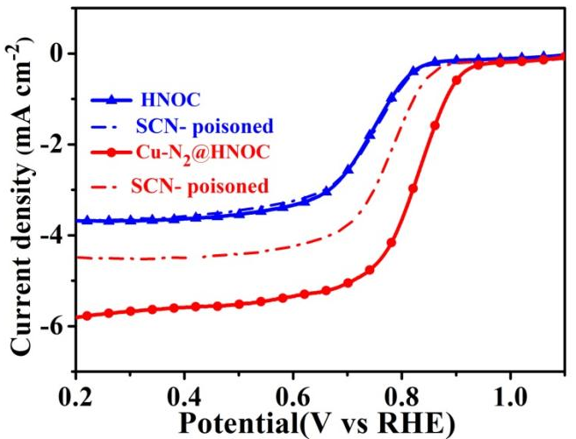
Figure S8. Effect of SCN⁻ poisoning on the catalytic activity of Cu-N₂@HNOC and HNOC
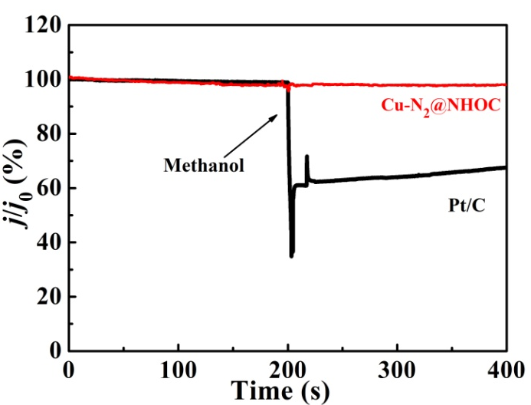
Figure S9. Chronoamperometric response with the addition of methanol (lower panel) on Cu-N₂@HNOC and 20 % Pt/C catalysts

Figure S10. The galvanostatic discharge curves of a Cu–N₂@HNOC driven Zn–air battery at a current density of 5 mA/cm².

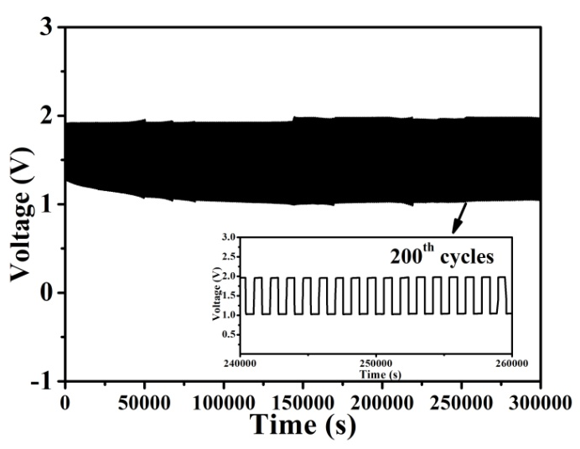
Figure S11. Long-term stability tests of the Zn-air batteries at a current density of 5 mA/cm²

Figure S12. The ionic conductivity of CD-PVA and pure PVA within 18 hours
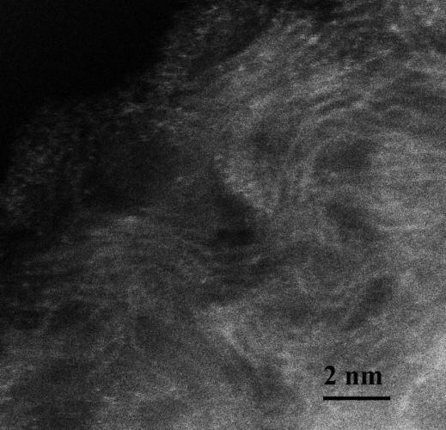
Figure S13. HADDF-STEM image of Cu–N₂@HNOC after heat-treatment at 2000K
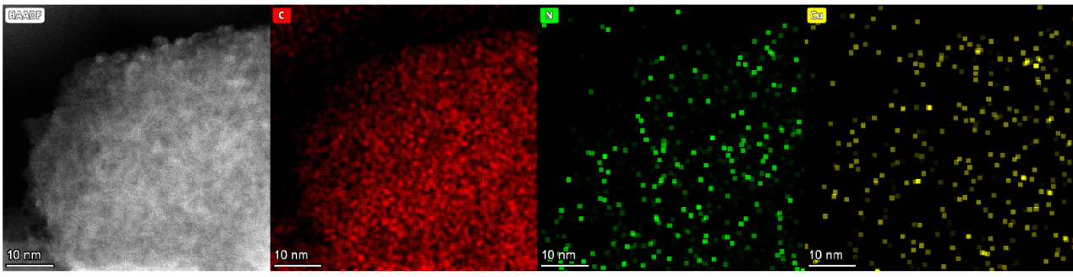
Figure S14. Elemental mapping images of Cu–N₂@HNOC after heat-treatment at 2000K
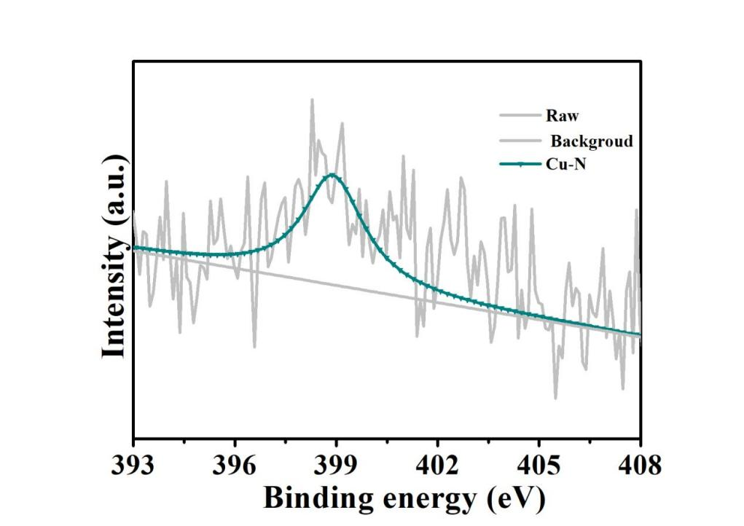
Figure S15. Cu 2p high resolution XPS spectrum of Cu–N₂@HNOC after heat-treatment at 2000 K
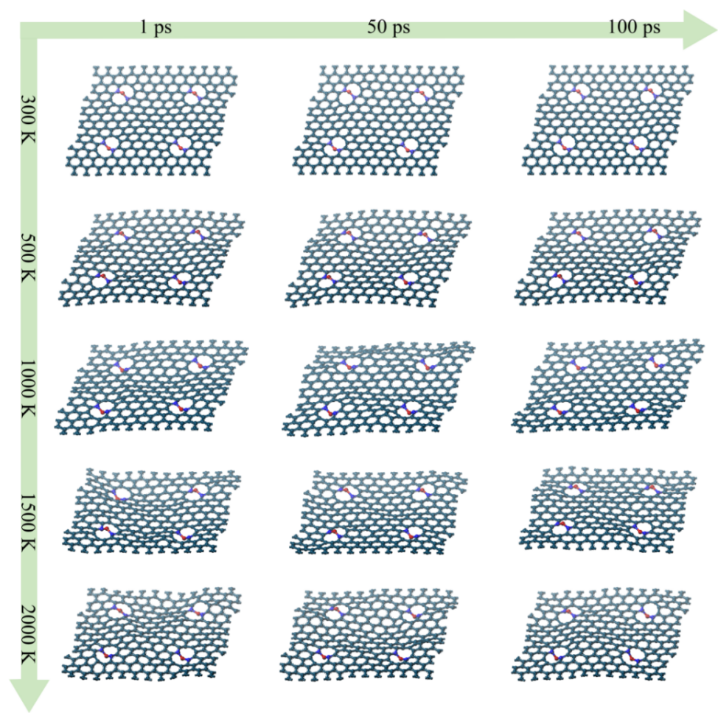
Figure S16. The MD simulations of Cu-N₂-C models at 300, 500, 1000, 1500 and 2000K in 100 ps with a time step of 1.0 fs
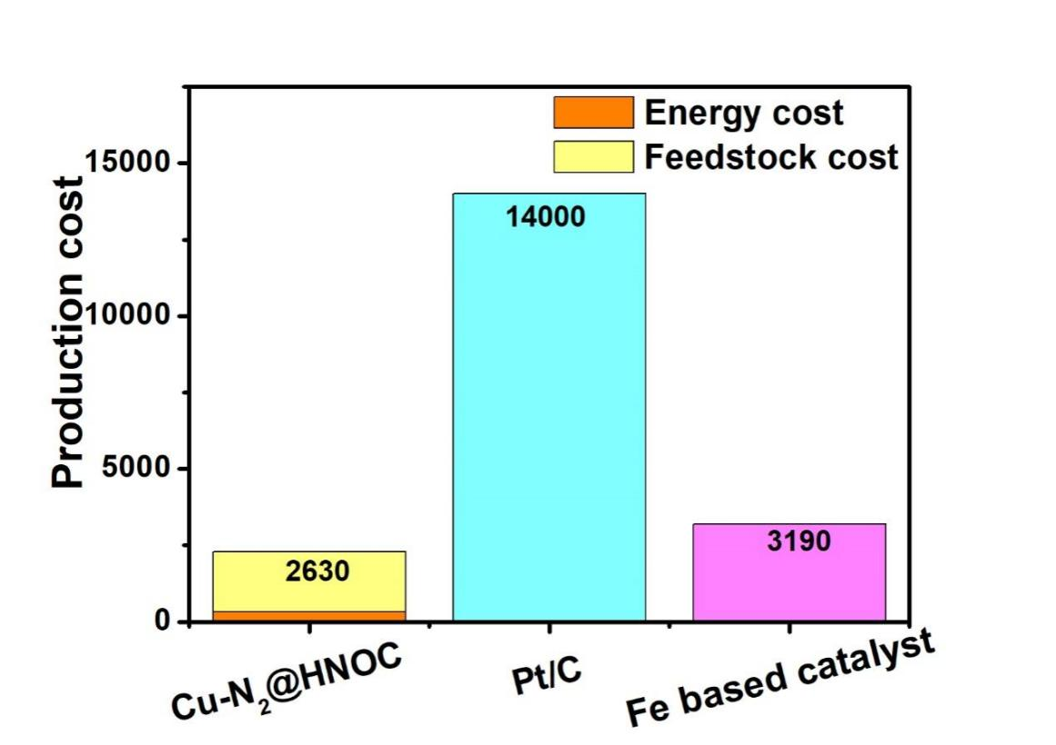
Figure S17. Comparison of cost considerations for different catalysts
- Supplementary Table
Table S1. The content of different nitrogen configuration in different catalysts
 | Pyridinic-N | Cu-N | Pyrrollic-N | Graphite-N | Oxideized-N
Cu-N₂@HNOC | 26.7% | 25.7% | 26.6% | 14.6% | 6.4%
HNOC | 29.9% | - | 34.8% | 22.2% | 13.1%

Table S2. Structural parameters of Cu foil, CuPc and Cu-N₂@HNOC based on fitting results.
Samples | Bonding form | CN | R(Å) | σ² | ΔE⁰ (eV)
Cu foil | Cu-Cu | 12.07±0.16 | 2.547±0.005 | 0.0035 | 1.2
CuPc | Cu-N | 3.96±0.19 | 1.952±0.005 | 0.0053 | 2.9
Cu-N₂@HNOC | Cu-N | 2.11±0.24 | 1.939±0.035 | 0.0066 | -1.6
CN, coordination number; R(Å), distance between absorber and backscatter atoms; σ², the Debye-Waller factor value; ΔE⁰, inner potential correction to account for the difference in the inner potential between the sample and the reference compound.

Table S3. Free energies of O₂ (g), H₂ (g) and H₂O (l)
 | P/bar | T/K | E(DFT)/eV | ▲G/eV | G/eV
O₂ (g) | 1.00 | 298.15 |  |  | -9.91
H₂ (g) | 1.00 | 298.15 | -6.76 | -0.05 | -6.81
H₂O (l) | 0.04 | 298.15 | -14.22 | 0.00 | -14.22

Table S4. Adsorption energy (E_{x}), Free energy of intermediates (G_{x}) on Cu-N₂-C slab
Cu-N₂-C | E | E_{(ZPE)} | E' |  | G/eV | ▲G/eV
slab | -730.97 | 0.00 | -730.97 | O₂ + 2H₂ | -754.49 | 0.00
*OOH | -745.54 | 0.32 | -745.22 | 3/2H₂ | -755.43 | -0.94
*O | -736.55 | 0.28 | -736.27 | H₂O+H₂ | -757.29 | -2.80
*OH | -740.85 | 0.03 | -740.82 | H₂O+1/2H₂ | -758.44 | -3.95
slab | -730.97 | 0.00 | -730.97 | 2H₂O | -759.41 | -4.92

Table S5. Free energy of intermediates (G_{x}) on Cu-N₂-C slab at various potentials U (V)
U (V) | G O₂ (eV) | G*OOH (eV) | G*O (eV) | G*OH (eV) | G H₂O (eV)
1.23 | 0 | -0.06 | -0.34 | -0.26 | 0
0.83 | 0 | -0.46 | -1.14 | -1.46 | -1.6
0 | 0 | -1.29 | -2.8 | -3.95 | -4.92

Table S6. Summary of cost estimation categories
Operation cost
Contribution to cost | Estimation cost | Consideration
Cost of precursor | ~1150 €/kg | Laboratory chemical suppliers  (www.sigmaaldrich.cn)
Energy required | ~330 €/kg | 0.1 €/kWh  (European Energy Portal)
Yield of products | 50%
Production cost of products | ~2630 €/kg | Evaluation of the cost largely depends on guesses and application of rules of thumbs

Table S7. Comparison of cost considerations for different catalysts
Catalyst | Cost estimation | Reference
Cu-N₂@HNOC | 2630 €/kg | This work
Pt/C | 14000 €/kg | Alfa Aesar
Fe based catalyst | 3400 €/kg | Applied Catalysis B: Environmental, 2017, 205, 24-33

Table S8. Comparison of cost considerations for different catalyst
Consumptions | Energy | Time | Total Cost
Cu-N₂-C by computer VS | 130 € per screen | 2 days per screen | 520 € per screen
Cu-N₂@HNOC by experiment | 330 €/kg | 20 days per sample | 2630 €/kg
Pt/C  by experiment | / | 25 days per sample | 14000 €/kg; Alfa Aesar
Fe based catalyst by experiment | / | 30 days per sample | 3400 €/kg; Applied Catalysis B: Environmental,  2017, 205, 24-33

4. References
[S1] T. Jan, S. Azmat, Q. Mansoor, S. Z. Ilyas, I. Ahmad, H. Khan, M. Ismail, Materials Research Express 2019, 6, 1050a3.
[S2] J. F. Xu, W. Ji, Z. X. Shen, W. S. Li, S. H. Tang, X. R. Ye, D. Z. Jia, X. Q. Xin, Journal of Raman Spectroscopy 1999, 30, 413–415.
[S3] Yang L, Shi L, Wang D, et al. Single-atom cobalt electrocatalysts for foldable solid-state Zn-air battery[J]. Nano Energy, 2018, 50: 691-698.
[S4] Tang C, Wang B, Wang H F, et al. Defect engineering toward atomic Co-Nx-C in hierarchical graphene for rechargeable flexible solid Zn-air batteries[J]. Advanced materials, 2017, 29(37): 1703185.
[S5] Yu M, Wang Z, Hou C, et al. Nitrogen-doped Co₃O₄ mesoporous nanowire arrays as an additive‐free air‐cathode for flexible solid-state zinc-air batteries[J]. Advanced materials, 2017, 29(15): 1602868.
[S6] Li B Q, Zhang S Y, Wang B, et al. A porphyrin covalent organic framework cathode for flexible Zn-air batteries[J]. Energy & Environmental Science, 2018, 11(7): 1723-1729.
[S7] Miao H, Chen B, Li S, et al. All-solid-state flexible zinc-air battery with polyacrylamide alkaline gel electrolyte[J]. Journal of Power Sources, 2020, 450: 227653.
[S8] Fang W, Dai P, Hu H, et al. Fe_{0. 96}S/Co₈FeS₈ nanoparticles co-embedded in porous N, S co doped carbon with enhanced bifunctional electrocatalystic activities for all-solid-state Zn-air batteries[J]. Applied Surface Science, 2020, 505: 144212.
[S9] Tian Y, Xu L, Qian J, et al. Fe₃C/Fe₂O₃ heterostructure embedded in N-doped graphene as a bifunctional catalyst for quasi-solid-state zinc-air batteries[J]. Carbon, 2019, 146: 763-771.
[S10] Liu H, Liu Y, Mehdi S, et al. Surface Phosphorus-induced CoO coupling to monolithic carbon for efficient air electrode of quasi-solid-state Zn-air batteries[J]. Advanced Science, 2021, 8(19): 2101314.
[S11] Zheng X, Cao X, Zeng K, et al. Cotton pad-derived large-area 3D N-doped grapheme-like full carbon cathode with an O-rich functional group for flexible all solid Zn-air batteries[J]. Journal of Materials Chemistry A, 2020, 8(22): 11202-11209.
[S12] Bian J, Cheng X, Meng X, et al. Nitrogen-doped NiCo₂O₄ microsphere as an efficient catalyst for flexible rechargeable zinc-air batteries and self-charging power system[J]. ACS Applied Energy Materials, 2019, 2(3): 2296-2304.
[S13] Zhong Y, Pan Z, Wang X, et al. Hierarchical Co₃O₄ nano-micro arrays featuring superior activity as cathode in a flexible and rechargeable zinc-air battery[J]. Advanced Science, 2019, 6(11): 1802243.
[S14] Zhang J, Fu J, Song X, et al. Laminated cross-linked nanocellulose/graphene oxide electrolyte for flexible rechargeable zinc-air batteries[J]. Advanced Energy Materials, 2016, 6(14): 1600476.
[S15] Sumboja A, Lübke M, Wang Y, et al. All-solid-state, foldable, and rechargeable Zn-air batteries based on manganese oxide grown on grapheme-coated carbon cloth air cathode[J]. Advanced Energy Materials, 2017, 7(20): 1700927.
[S16] Chen Z, Wang Q, Zhang X, et al. N-doped defective carbon with trace Co for efficient rechargeable liquid electrolyte-/all-solid-state Zn-air batteries[J]. Science Bulletin, 2018, 63(9): 548-555.

