Supplementary material
A metabolic modeling approach reveals promising therapeutic targets and antiviral drugs to combat COVID-19
Fernando Santos-Beneit¹, Vytautas Raškevičius², Vytenis A. Skeberdis², Sergio Bordel^{1,2}.
- Institute of Sustainable Processes, Universidad de Valladolid, Spain.
- Institute of Cardiology, Lithuanian University of Health Sciences, Kaunas, Lithuania
* Sergio Bordel. Email: sergio.bordel@uva.es
Fernando Santos-Beneit: https://orcid.org/0000-0001-7986-5557
Sergio Bordel: https://orcid.org/0000-0001-6162-6478

Table S1. Composition of the viral particles used in the model of SARS-CoV-2 infected cells.
Virion components | Number of molecules per virion
Viral RNA | 1
S protein | 90
M protein | 720
N protein | 380
Cholesterol | 1600
Phosphatidylcholine | 10800
Phosphatidylethanolamine | 4000
Phosphatidylinosithol | 2100

Docking results:
In order to quantify the interaction between each target enzyme and its putative inhibitors, the ΔG of binding was calculated after docking. The results are shown in the following table.
Table S2. Target-inhibitor binding affinities predicted by docking.
Gene | Uniprot ID | Ihibitor | CID | affinity (kcal/mo)
FAR2 | Q96K12 | Lonafarnib | 148195 | -10.9
FAR2 | Q96K12 | Tipifarnib | 159324 | -9.5
ALG8 | Q9BVK9 | Castanospermine | 54445 | -5.5
CYB5R3 | P00387 | Propylthiouracil (PTU) | 657298 | -5.4
CYB5R3 | P00387 | ZINC39395747 | - | -7.5
CYB5R3 | P00387 | ZINC05626394 | - | -6.5
ACSL3 | O95573 | Triacsin C | 9576787 | -6.1
SLC27A2 | O14975 | Diclofenac | 3033 | -7.2
ZDHHC5 | Q9C0B5 | 2-bromopalmitate | 82145 | -4.6

The most negative values of ΔG correspond to the inhibitors of FAR2, Lonafarnib and Tipifarnib, which bind in the same region as NADPH with equal or higher affinity (see the main figure).
Propyltyouracil is a drug already approved against hyperthyroidism, thus it can be particularly interesting for further research. However, the experimental compounds ZINC39395747 and ZINC05626394 have a stronger binding to their substrate CYB5R3. Figure 1 shows the docking results for these three compounds.

List of proposed drugs:

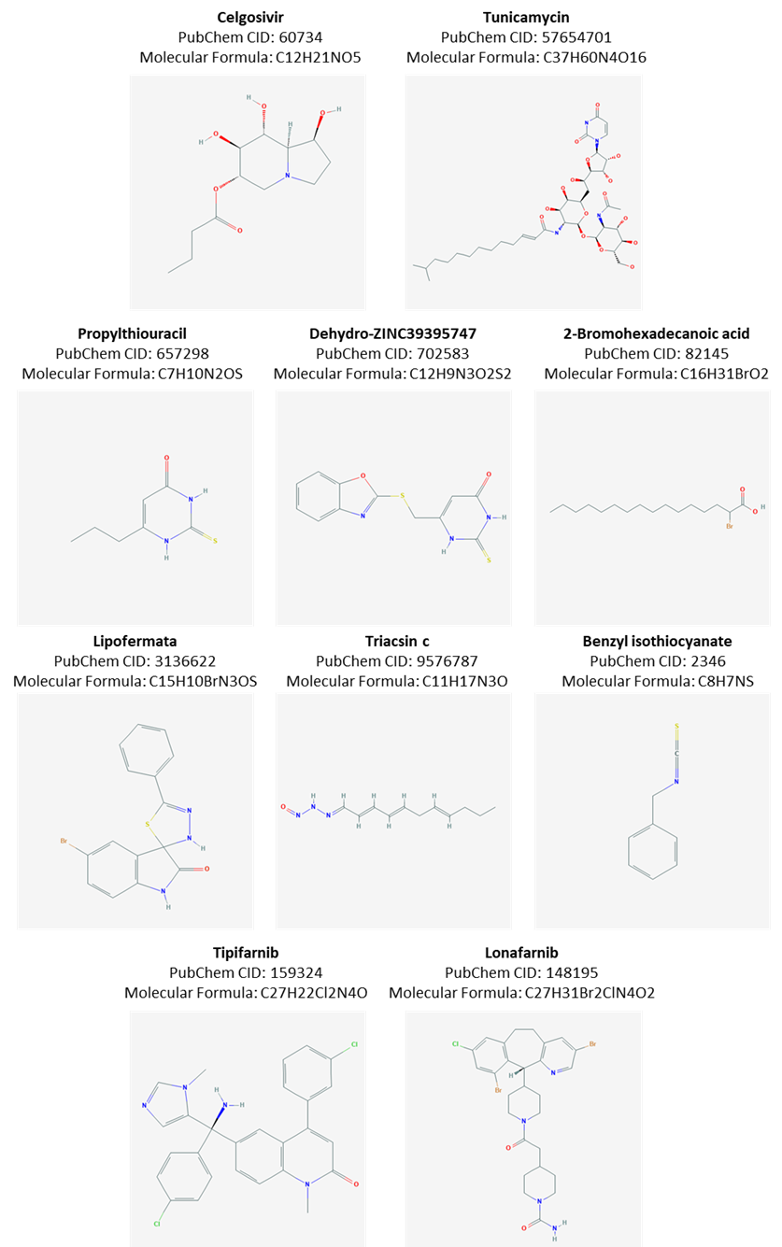
Figure S1. Structures and indentifiers of each of the putative inhibitors identified.

