Supplementary Information for

Accumulation of Airborne Microplastics on Forest Canopy Leaves: Insights from Trichomes and Epicuticular Waxes

Natsu Sunaga ª, Yasuhiro Niida ^{b}, Hiroshi Okochi ^{c}, Akane Miyazaki ^{a,＊}

ª Graduate School of Chemical and Biological Sciences, Japan Women's University
^{b} PerkinElmer Japan G.K.
^{c} Graduate School of Creative Science and Engineering, Waseda University

----------------------------------------------------
＊Corresponding author. Akane Miyazaki
Japan Women’s University
2-8-1 Mejirodai, Bunkyo-ku, Tokyo 112-8681, Japan
E-mail address: miyazakia@fc.jwu.ac.jp

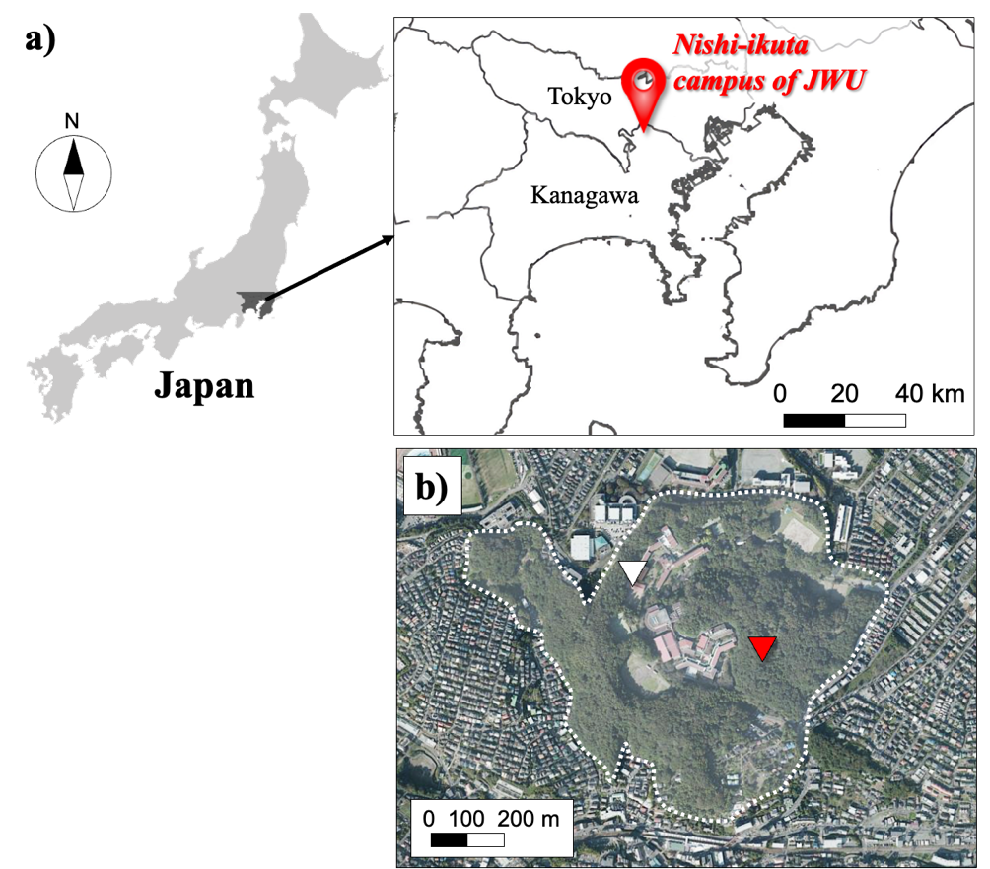

Fig. S1. The sampling site in this study. (a) Location of Nishi-Ikuta campus, Japan Women’s University. (b) Panoramic view of Nishi-Ikuta campus. The red triangle indicates konara oak trees from which throughfall and leaf samples were collected. The white triangle indicates the rooftop of the building where precipitation was collected.
(The map is from the website of the Geospatial information authority of Japan, available at https://www.gsi.go.jp/tizu-kutyu.html.)

Sampling campaign and system

- Precipitation and throughfall
Precipitation and throughfall of the konara oak trees were collected every month from 28th October 2021 to 7th April of 2022. This period corresponds to the dormancy season of the oak, with leaf shedding typically commencing in November. However, leaves persist on the branches until late December; therefore, the period from October to late December was categorized as the leaf-attached period and the period from early January to early April was categorized as the leaf-detached period. Please refer to Table S1 for details of precipitation and throughfall samples.
Throughfall samples were sampled under the oak trees located in the center of the forest and precipitation samples were sampled at the rooftop of the building where the precipitation collected (Fig. S1 (b)). This rooftop is higher than the forest canopy and approximately 400 m from the sampling point of throughfall; therefore, precipitation could not be affected by the canopy.
Precipitation and throughfall were collected by an in-house built rainwater sampler (Fig. S2). Rainwater was collected through an upper funnel into a filter holder, where a 1.0 µm polytetrafluoroethylene (PTFE) filter (Millipore, USA) was placed. AMPs in rainwater were collected on the filter.

Table S1. Details for precipitation and throughfall samples.

Forest canopy condition | Sampling period  (Days) | Samples | The amount of rainfall collected  (mm)
Leaf-attached period | 2021/10/28~2021/11/18  (21 d) | Precipitation | 2.7
Leaf-attached period | 2021/10/28~2021/11/18  (21 d) | Throughfall | 1.0
Leaf-attached period | 2021/11/18~2021/12/06  (18 d) | Precipitation | 6.0
Leaf-attached period | 2021/11/18~2021/12/06  (18 d) | Throughfall | 2.8
Leaf-attached period | 2021/12/06~2021/12/21  (15 d) | Precipitation | 2.6
Leaf-attached period | 2021/12/06~2021/12/21  (15 d) | Throughfall | 1.4
Leaf-detached period | 2021/12/21~2022/01/13  (23 d) | Precipitation | 1.4
Leaf-detached period | 2021/12/21~2022/01/13  (23 d) | Throughfall | 0.8
Leaf-detached period | 2022/01/13~2022/02/21  (39 d) | Precipitation | 2.9
Leaf-detached period | 2022/01/13~2022/02/21  (39 d) | Throughfall | 1.7
Leaf-detached period | 2022/02/21~2022/03/30  (37 d) | Precipitation | 2.5
Leaf-detached period | 2022/02/21~2022/03/30  (37 d) | Throughfall | 1.0
Leaf-detached period | 2022/03/30~2022/04/07  (8 d) | Precipitation | 1.0
Leaf-detached period | 2022/03/30~2022/04/07  (8 d) | Throughfall | 0.5

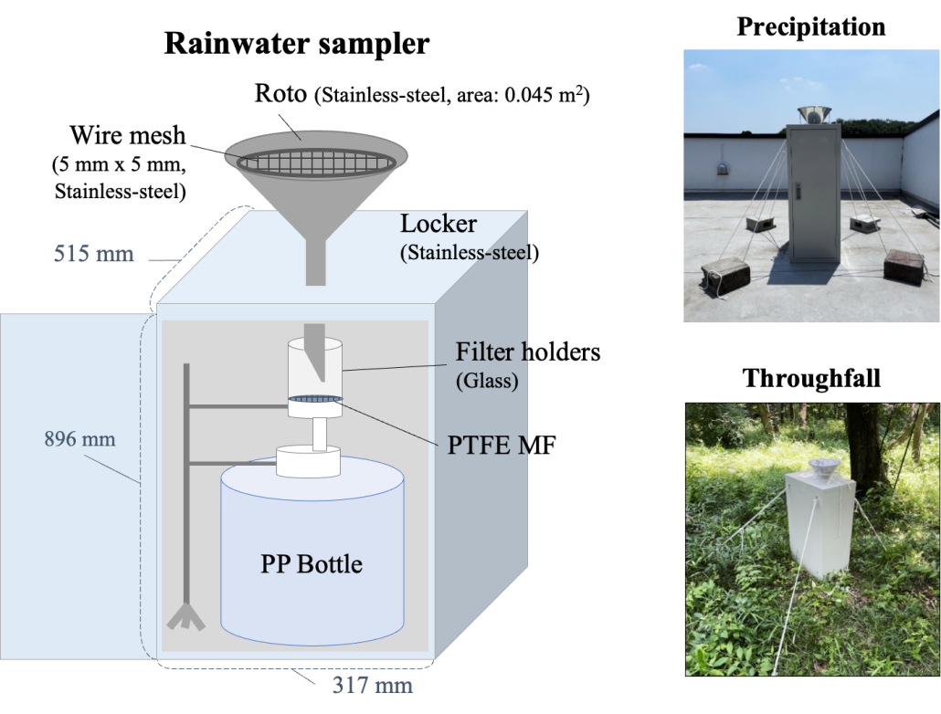
Fig. S2. In-house built rainwater sampler.

- Konara oak leaves
Fresh leaves were taken from the same oak tree as throughfall samples (Fig. S1 (b)). Sampling was performed on the 21st June and the 9th August of 2022. In both cases, it had not rained more than 3 days prior to sampling. Leaves were collected at a height of approximately 5 m above the ground level using high branch secateurs, which can hold and cut a branch. The leaves were then wrapped with aluminum foil and transported to the laboratory. The leaves were stored in a refrigerator (5°C) until analysis.

Measurement of leaf surface area
The leaves were spread on clean aluminum foil and a ruler was set together with the leaves. Photographs were taken from above the leaves and the leaf area was calculated from these photographs using ImageJ software (version 1.53k) (Abramoff et al. 2004).

Sequential washing of leaves
The detailed procedure for the three-step sequential washing process (Fig. S3) is given here.

- Rinsing with Milli-Q water
For the first washing step, rinsing with Milli-Q water was performed following the procedure described by Liu et al. (2020). The leaves were held inside the top of a 500 mL glass beaker with metal tweezers and washed individually. Milli-Q water was poured from a polytetrafluoroethylene (PTFE) washing bottle. Each leaf was rinsed thoroughly from all directions with 40 to 50 mL of water and the solution was accumulated for a sample set of leaves. The aluminum foil used to wrap the leaves was also rinsed. The solutions in the beakers were designated as AMP suspension (i).

- Ultrasonication in Milli-Q water
After rinsing with Milli-Q water, one of the leaves was kept for SEM observation and the other 11 leaves were collected in a glass jar with a lid. 200 mL of Milli-Q water was then added to soak the leaves, and the jar was sonicated (28 kHz;US-3R ultrasonic cleaner, AS ONE Co., Japan) for 30 min. After sonication, the leaves in the jar were removed and rinsed with water. The remaining solution was designated as AMP suspension (ii).

- Extraction with KOH solution
After sonication, one of the leaves were kept for SEM observation and the other 10 leaves were processed with potassium hydroxide (KOH) aqueous solution following the method described by Foekema et al. (2013). The leaves were kept in a glass jar and 150 mL of 10% KOH aqueous solution was added to soak the leaves. The bottles were kept at room temperature for 14 days with occasional stirring, and the leaves were then rinsed with water and removed. The solution obtained was designated as AMP suspension (iii). One of the leaves was removed and rinsed thoroughly in Milli-Q water and kept for SEM observation.

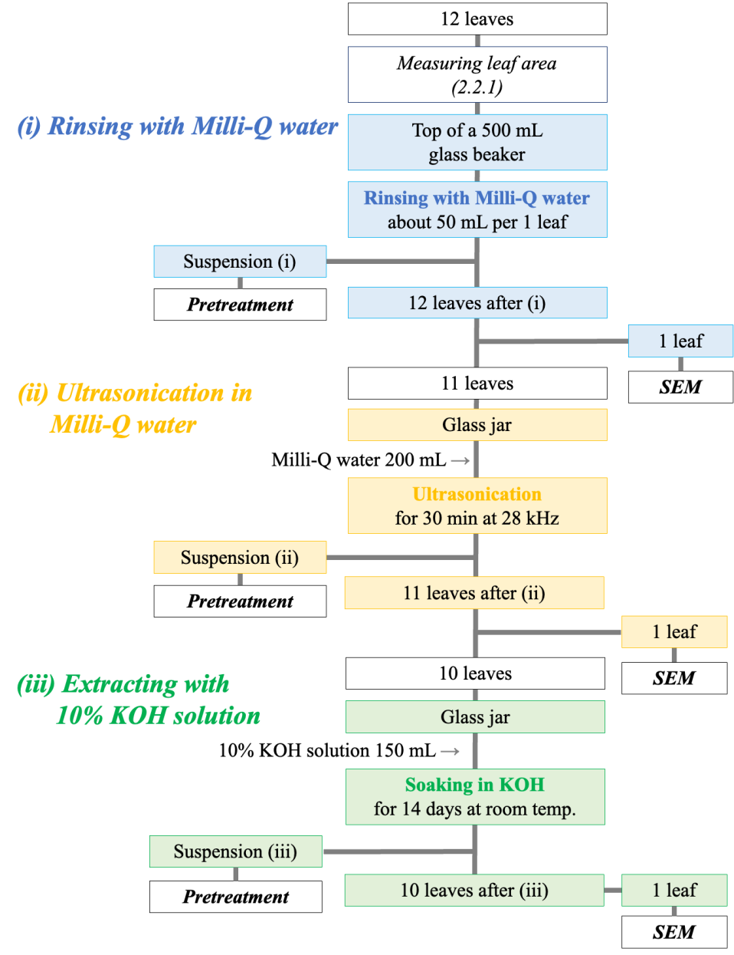
Fig. S3. Sequential washing process: (i) rinsing with Milli-Q water, (ii) ultrasonication in Milli-Q water, and (iii) extraction with 10% KOH solution.

Pretreatment for AMP extraction

- Organic matter removal
Digestion of organic matter in suspensions (i) and (ii) was first performed using hydrogen peroxide. The suspensions were filtered through 0.45 µm polytetrafluoroethylene (PTFE) filters (Millipore, USA) to collect suspended matter. The filters were then set in 50-mL glass centrifuge tubes and soaked with 30 mL of 30% hydrogen peroxide solution. The tubes were shaken at 500 rpm for 1 h to re-suspend the particles on the filters into the solution. The filters were then removed from the tubes, and the solutions in the tubes were stood for 1 day at room temperature. For suspension (iii), the extraction described here was insufficient, because it contained a larger amount of organic matter such as leaf debris. Therefore, the sample was treated with Fenton’s reagent, a mixture of 30 mL of 30% hydrogen peroxide solution and 0.08 g of iron (II) sulfate heptahydrate. Iron (II) sulfate heptahydrate dissolved in a small amount of Milli-Q water was added to the centrifuge tube containing the filter from suspension (iii). The Fenton reaction is highly exothermic; therefore, the centrifuge tube was kept in an ice bath and 30 mL of hydrogen peroxide was added drop by drop to prevent the sample from being exposed to high temperature. The tubes were held in the ice bath for 1 day, after which the tubes were shaken at 500 rpm for 1 h and the filters removed.

- Density separation
After the removal of organic matter, minerals were separated by density gradient centrifugation using sodium iodine solution (Wang et al. 2023). The solutions obtained after the decomposition of organic matter were filtered through 0.45 µm PTFE filters. These filters were then soaked in 30 mL of 5.3 M sodium iodide solution (1.5 g/cm³) in the centrifuge tubes and shaken at 500 rpm for 2 h to re-suspend the particles on the filters into the solutions. 20 mL of 5.3 M sodium iodide solution was added after removal of the filters from the tubes. The tubes were centrifuged at 1,500 rpm for 1 h and then stood for another 1 h. 25 mL of the supernatant solution was then filtered through 0.20 µm alumina filters (Whatman, UK). After these procedures, AMPs in the original suspensions (i) to (iii) were separated and concentrated on the alumina filters.

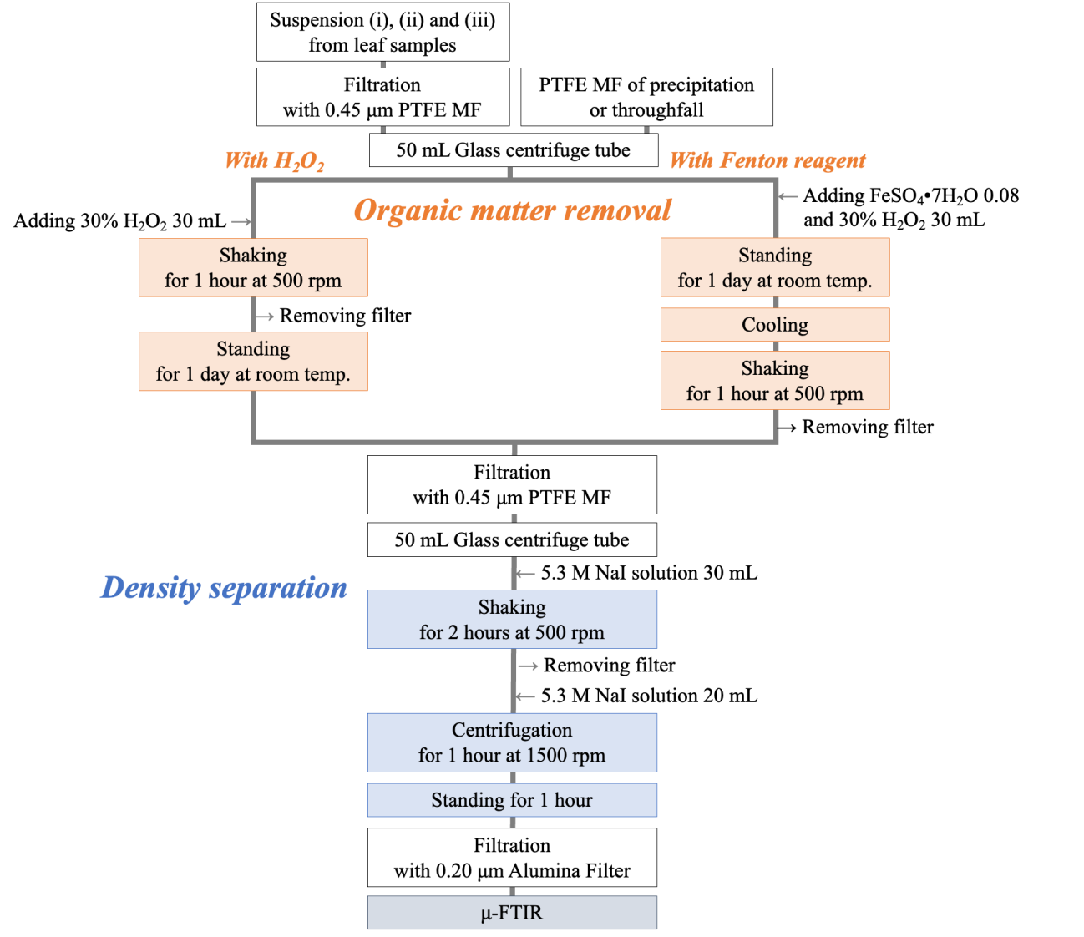

PTFE MF: PTFE hydrophilic membrane filter
Organic matter removal with H₂O₂: Suspensions (i) and (ii) contained little organic matter; therefore, decomposition was achieved using only hydrogen peroxide.
Organic matter removal with Fenton’s reagent: Precipitation, throughfall sample, and suspension (iii) contained abundant organic matter; therefore, decomposition was achieved using Fenton’s reagent.

Fig. S4. Pretreatment process for the extraction of AMPs: (i) organic matter removal and (ii) density separation.

Identification of AMPs: Micro‐Fourier transform infrared spectroscopy
Identification and counting of AMPs on the leaves were performed using attenuated total reflection imaging with a micro-Fourier transform infrared spectroscope (μ-FTIR ATR imaging; Spectrum3/Spotlight 400; PerkinElmer, Waltham, MA). A 1.2-mm diameter germanium crystal was applied for ATR imaging. On the alumina filter prepared by the procedure described in 2.3, four areas of 750×750 μm were selected systematically without overlapping. The μ-FTIR parameters were as follows: wavenumber resolution: 8 cm⁻¹; number of scans: 1; wavenumber range: 4,000 to 695 cm⁻¹; pixel size: 1.56 μm. The scanned areas corresponded to 17.9% and 1.1% of the total filter area for the leaf and precipitation samples, respectively. The detected AMPs were converted to the number of AMPs on the leaves and the deposition flux according to the equations shown in 2.4. based on these percentages. The germanium crystal for ATR imaging was in direct contact with the AMPs on the filters during the measurement. The lower limit of detection was calculated from the standard deviation of the absorbance data screened from blank imaging data and was determined by a factor of five standard deviations (Tokunaga et al. 2023; Wang et al. 2023).
Chemical composition analysis of the AMPs was conducted for the data acquired. All spectra obtained for the scanned area were compared using the Spectrum 10.7.2 software (PerkinElmer, Walthum, MA), which includes over 5000 types of standard reference spectra. The spectra were evaluated by a hit quality index (HQI), which is the degree of matching between a sample spectrum and a reference spectrum (Tanabe and Saeki 1975). Identification of each spectrum was evaluated by a matching score (70% or more) and followed by visual confirmation of polymer-derived absorption peaks and further confirmation by an expert from PerkinElmer Japan.

SEM observation of leaf surfaces
The samples for SEM observation were prepared by cutting 10×10 mm sections from the leaf samples. The sections were attached to an aluminum sample stage with carbon tape. Carbon conductive coating was not performed due to the high carbon content of the leaves (Ensikat et al. 2010). To minimize degradation of the leaf sample, SEM micrographs were acquired using back-scattered electrons (BSE) under a low vacuum (LV) mode at 40× to 1,000×.

Quality control
The following measures were taken to minimize potential contamination. Either glass or stainless-steel utensils were used for the experiments. These utensils were all washed with Milli-Q water before use. Reagents, i.e., hydrogen peroxide solution, iron (II) sulfate solution, and sodium iodide solution, were preliminarily filtered through a 0.45-µm PTFE filter. The experimenters wore cotton lab coats, gloves, and face masks. All laboratory operations were performed inside a clean bench with a germicidal lamp (CT-600UVAX, AS ONE Co., Japan), which was surrounded by vinyl and acrylic curtains. The µ-FTIR instruments were similarly shielded. Although plastics were used in these curtains, a blank test confirmed that there was no contamination.
The Mann-Whitney U test was used to test if the data of AMPs and SEM images acquired in this study showed any predominant differences. Statistically significant and highly significant differences are indicated by ** = P < 0.001, and * = P < 0.05, respectively.

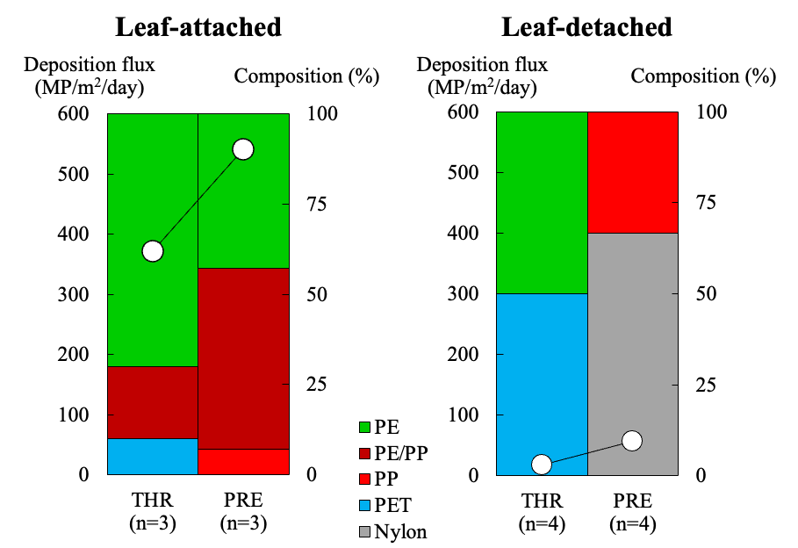
PRE: Precipitation, THR: throughfall

Fig. S5. Deposition flux and polymer composition of precipitation and throughfall in the leaf-attached and leaf-detached periods.
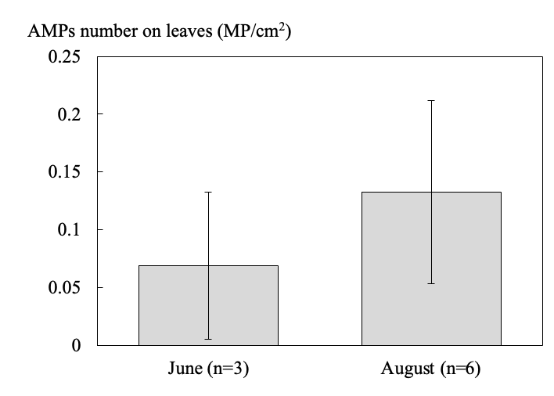

Fig. S6. Total AMPs numbers on leaves taken in June and August of 2022. Means and standard deviations from sextuplicate experiments are shown.

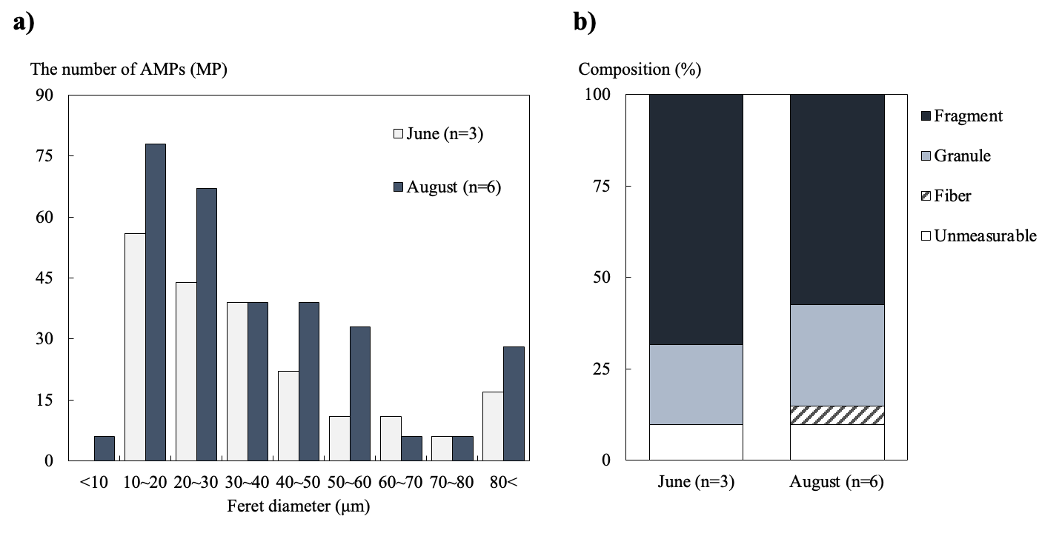

Fig. S7. Characteristics of AMPs detected from konara oak leaves taken in June and August of 2022. (a) Feret diameter composition of AMPs. (b) Shape composition of AMPs.
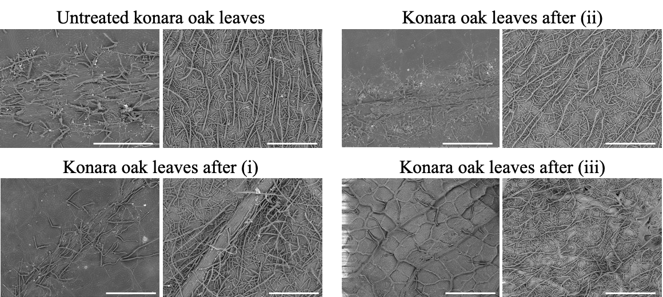

Fig. S8. Representative SEM images of konara oak leaves (100×). Images of a leaf surface taken in June of 2022 are shown as an example. The left and right parts of the images shows the adaxial and abaxial side of leaves, respectively. Scale bar = 100 μm.

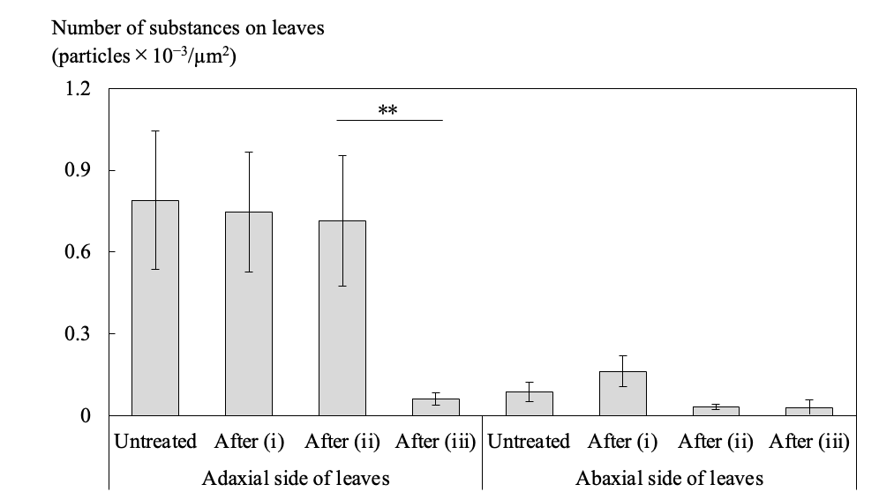

Fig. S9. Changes in the number of MPs per 1 µm² of leaves (×10⁻³) in SEM images at each step of the sequential washing process. Three areas (90×90 μm to 300×300 μm depending on magnification) were randomly selected in each of two SEM images at each step. Means and standard deviations are shown. **: P < 0.01, Mann-Whitney U test.

References

Abrámoff MD, Magalhães PJ, Ram SJ (2004) Image Processing with ImageJ. Biophotonics Int 7:36−42

Ensikat HJ, Ditsche-Kuru P, Barthlott W (2010) Scanning electron microscopy of plant surfaces: simple but sophisticated methods for preparation and examination. In: Mendez-Vliess A, Diaz J (ed) Microscopy: Science, Technology, Applications and Education, Formatex Research Center, Badajoz, Spain, pp 248−255

Foekema EM, Gruijter CD, Mergia MT, Franeker JAV, Murk ATJ, Koelmans AA (2013) Plastic in North Sea Fish. Environ Sci Technol 47:8818−8824. https://doi.org/10.1021/es400931b

Liu K, Wang X, Song Z, Wei N, Li D (2020) Terrestrial plants as a potential temporary sink of atmospheric microplastics during transport. Sci of the Total Environ 742:140523. https://doi.org/10.1016/j.scitotenv.2020.140523

Tanabe K, Saёki S (1975) Computer Retrieval of Infrared Spectra by a Correlation Coefficient Method. Analytical Chemistry 47:118−122. https://doi.org/10.1021/ac60351a041

Tokunaga Y, Okochi H, Tani Y, Niida Y, Tachibana T, Saigawa K, Katayama K, Moriguchi S, Kato T, Hayama S (2023) Airborne microplastics detected in the lungs of wild birds in Japan. Chemosphere 321: 180032. https://doi.org/10.1016/j.chemosphere.2023.138032

Wang Y, Okochi H, Tani Y, Hayami H, Minami Y, Kastumi N, Takeuchi M, Sorimachi A, Fujii Y, Kajino M, Adachi K, Ishihara Y, Iwamoto Y, Niida Y (2023) Airborne hydrophilic microplastics in cloud water at high altitudes and their role in cloud formation. Environ Chem Lett 21:3055−3062. https://doi.org/10.1007/s10311-023-01626-x

