A.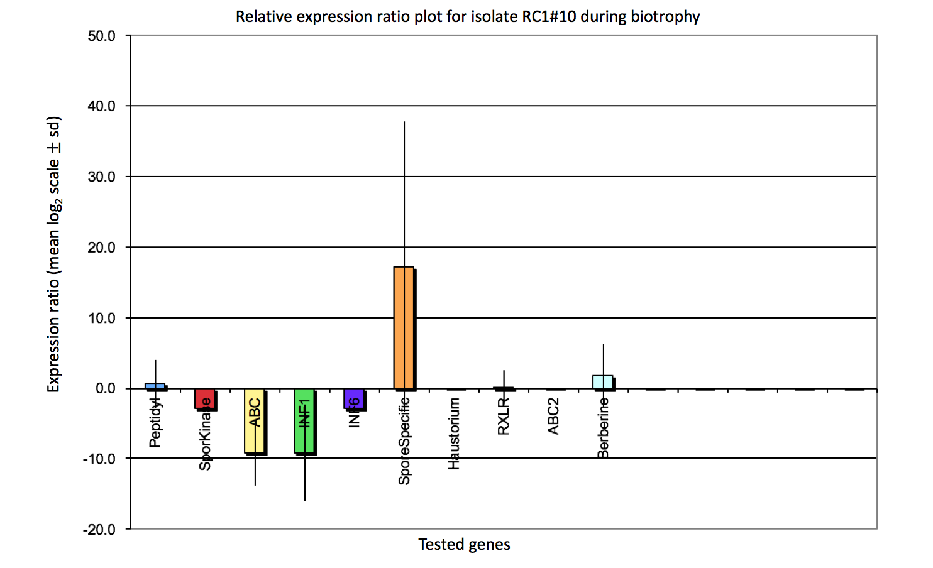

B.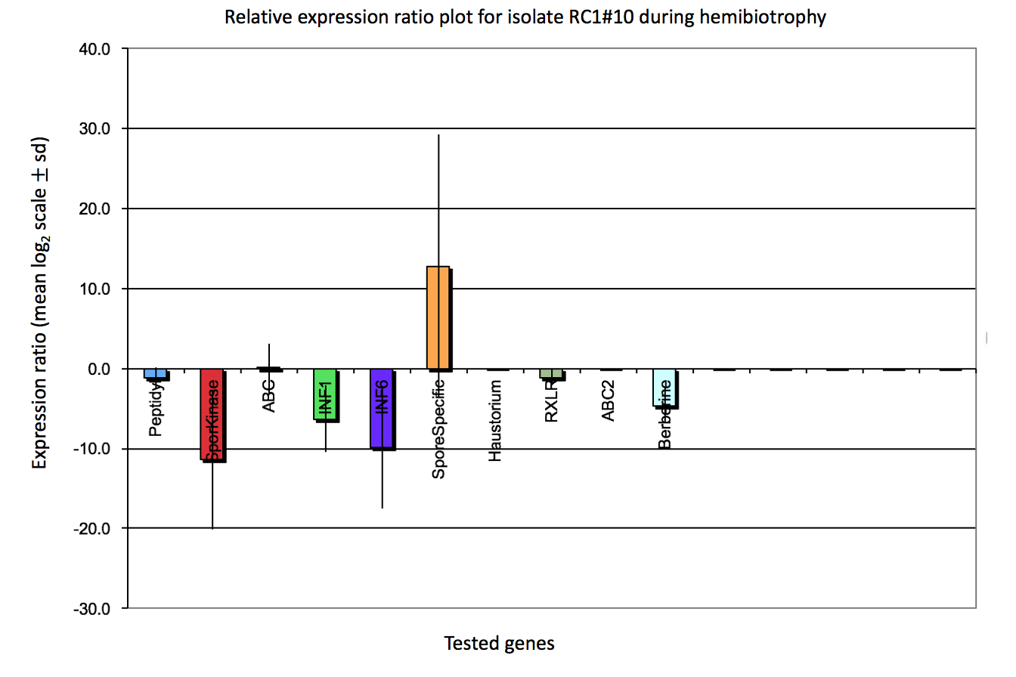
C.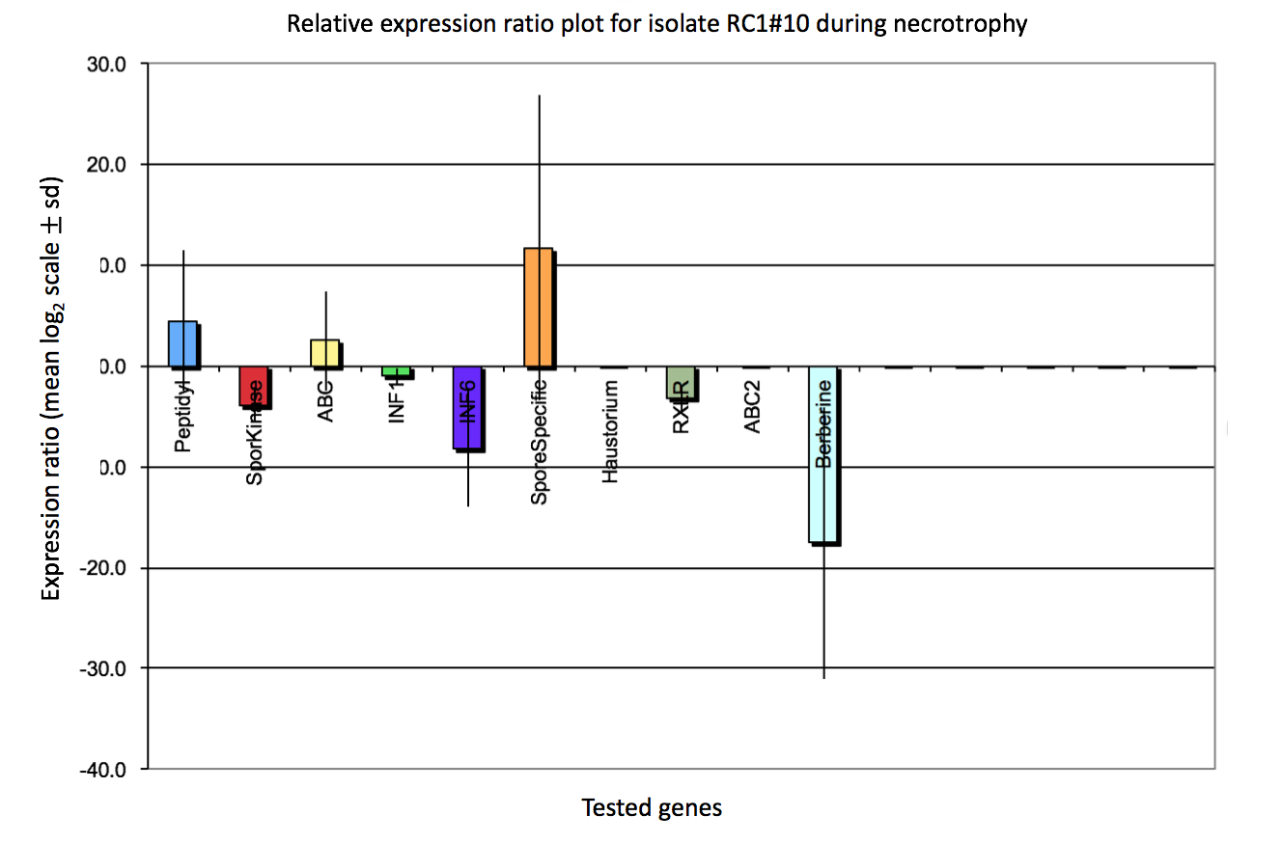

Figure A2. Specific levels of up or down regulation of the evaluated genes using qRT-PCR. A) Relative expression ratio plot for isolate RC1#10 during biotrophy. Genes shown are: Peptidyl: Peptidyl-prolyl cis-trans isomerase (PITG_03856), SporKinase: Sporangia induced phosphatidyl inositol kinase (PITG_20221), ABC#1: ATP-binding Cassette (ABC) Superfamily (PITG_04289), INF1: Elicitin (INF1) (PITG_12551), INF6: Elicitin-like INF6 (PITG_12556), SporeSpecific: Nuclear LIM factor interactor-interacting protein spore-specific form (PITG_11241), Haustorium: Haustorium-specific membrane protein (PITG_00375), RXLR: Avr2 family secreted RxLR effector peptide protein (PITG_22870), ABC#2: ATP-binding Cassette (ABC) Superfamily (PITG_13576) and Berberine: Berberine-like protein (PITG_02930). B) Relative expression ratio plot for isolate RC1#10 during hemibiotrophy, same genes shown. C) Relative expression ratio plot for isolate RC1#10 during necrotrophy, same genes shown.

