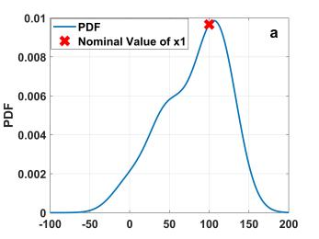 | 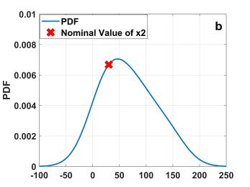 | 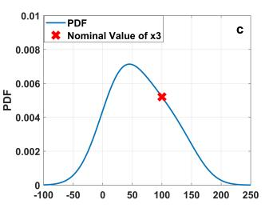
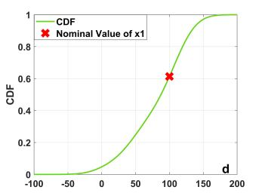 | 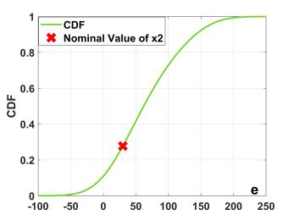 | 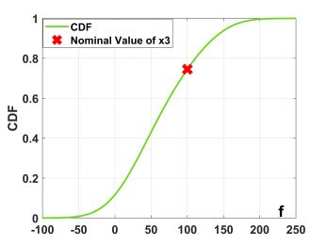
Extended Data Fig.1|PDF, CDF and nominal value in Step1.We use the Gaussian Kernel Function to construct the kernel function of design variables. The curves in a-c represent the probability density functions of design variables x1 to x3, respectively. The curves in d-f represent the Cumulative Distribution Function of design variables x1 to x3, respectively. The symbol “X” in a-f indicates the specific position of the nominal value on the probability density function and cumulative distribution function.

