A.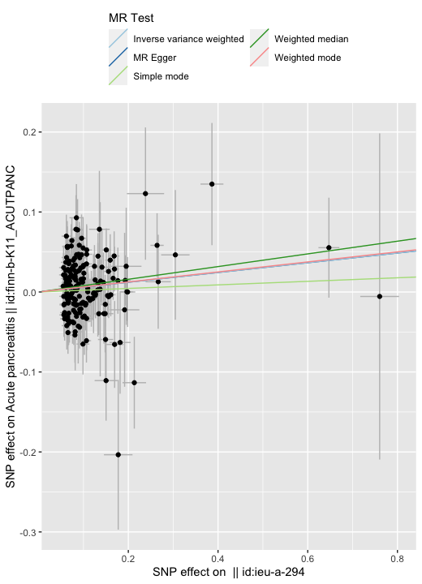B.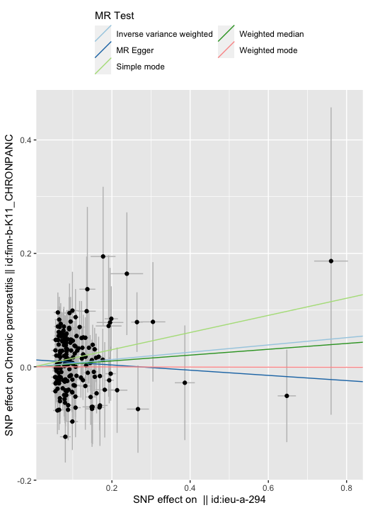
C.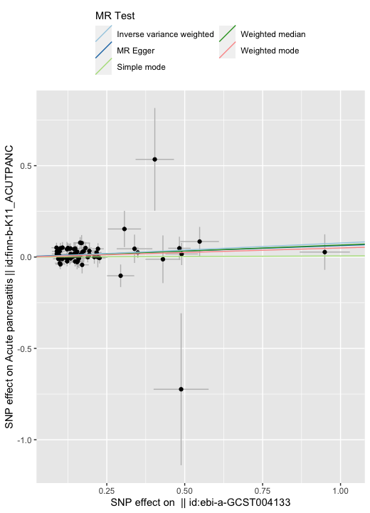D.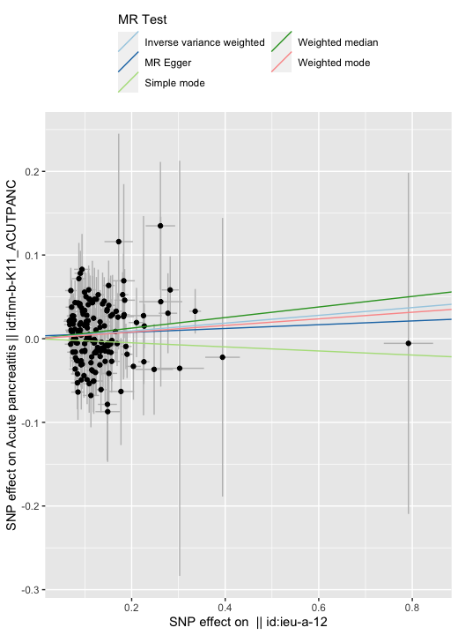
E. 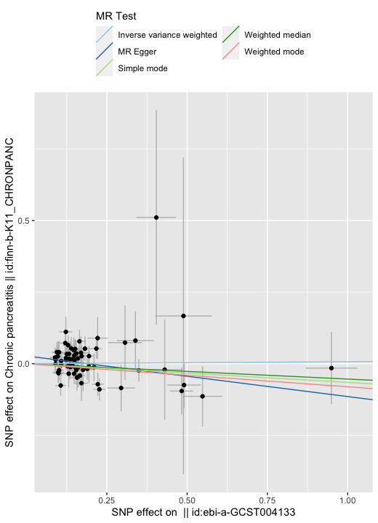F.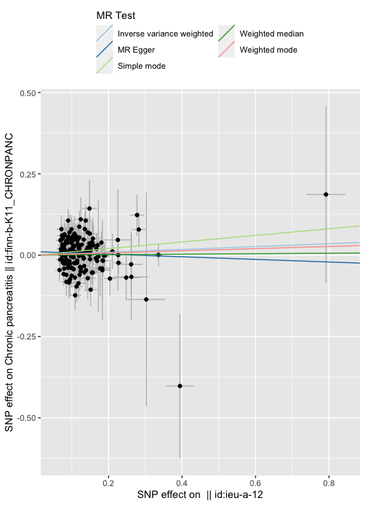
Supplementary Fig 1: Scatter plots of the relationship between genetically predicted IBD on pancreatitis. (A) IBD on AP; (B) IBD on CP; (C) UC on AP; (D) UC on CP; (E) CD on AP; (F) CD on CP; Abbreviations: IBD, Inflammatory bowel disease; UC, Ulcerative colitis; CD, Crohn's disease; AP, Acute pancreatitis; CP, Chronic pancreatitis.

A.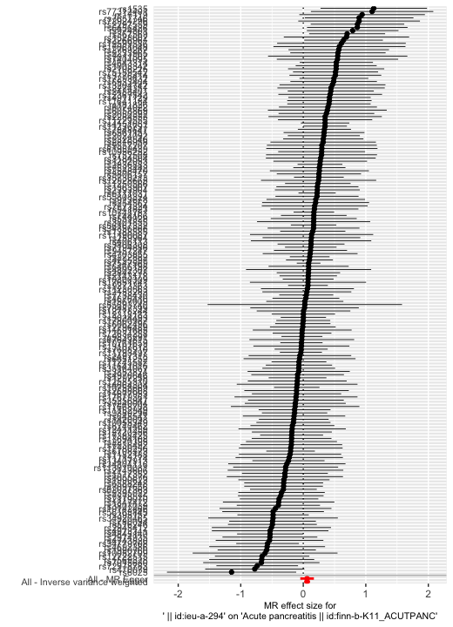B.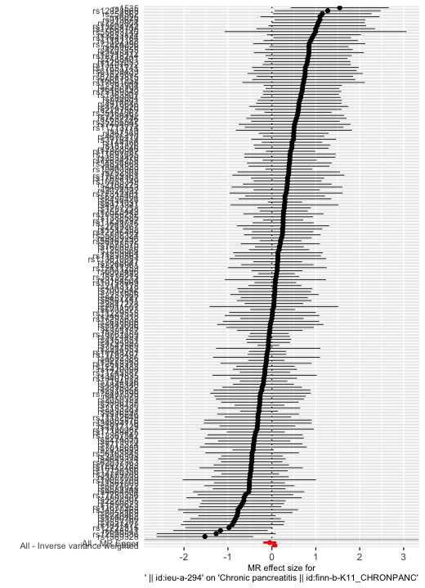
C.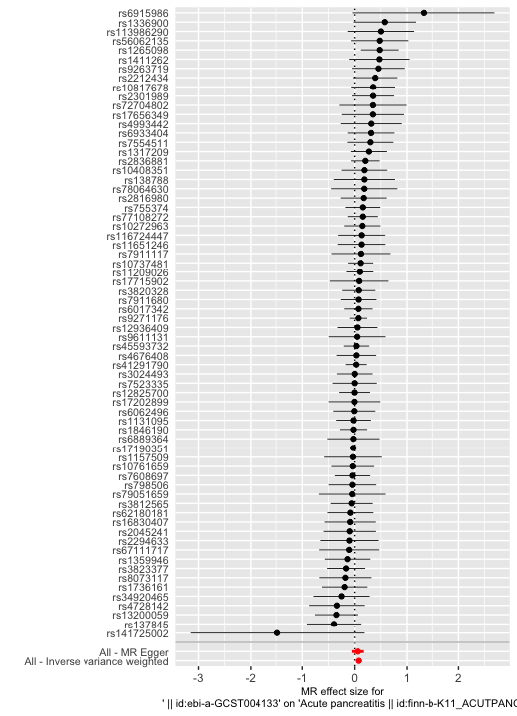D.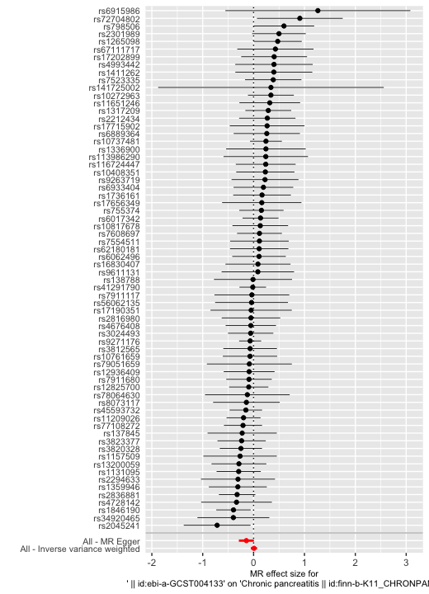
E.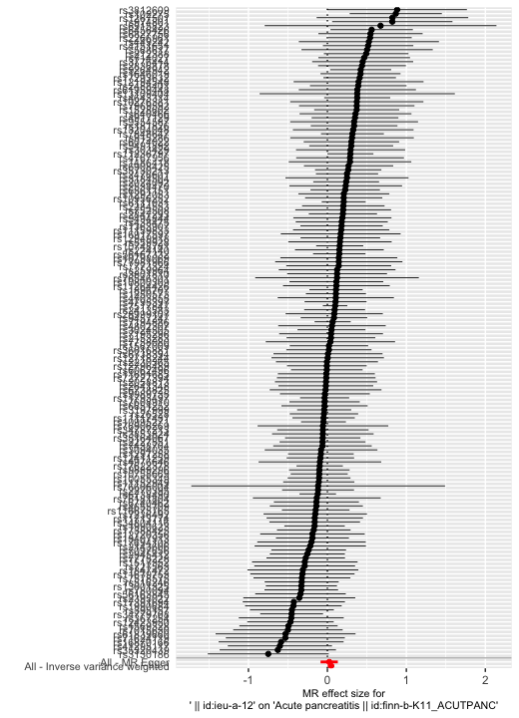F.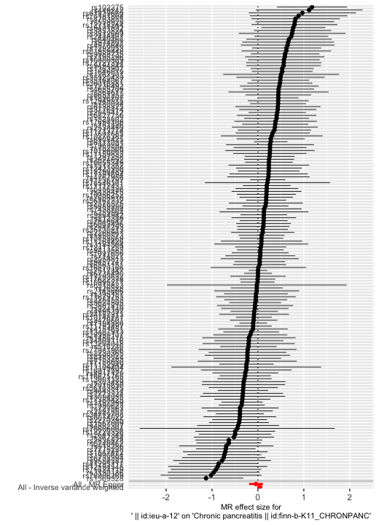
Supplementary Fig 2: Forest plot of the MR analysis. (A) IBD on AP; (B) IBD on CP; (C) UC on AP; (D) UC on CP; (E) CD on AP; (F) CD on CP; Abbreviations: IBD, Inflammatory bowel disease; UC, Ulcerative colitis; CD, Crohn's disease; AP, Acute pancreatitis; CP, Chronic pancreatitis.

A.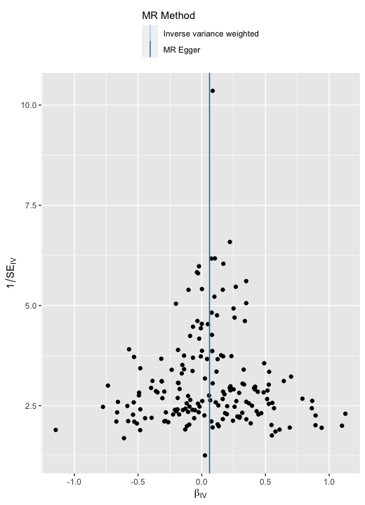B.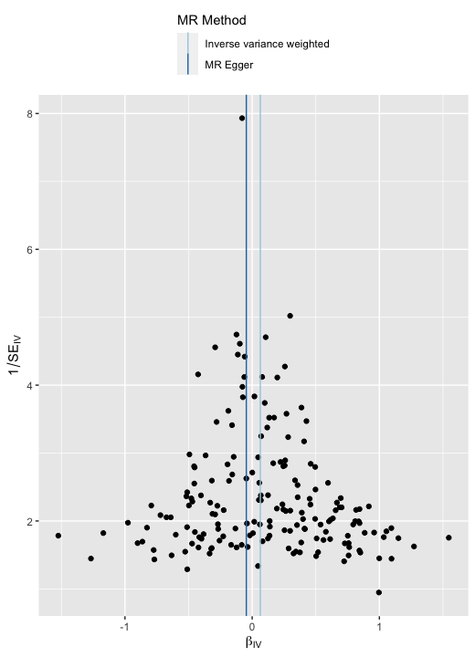
C.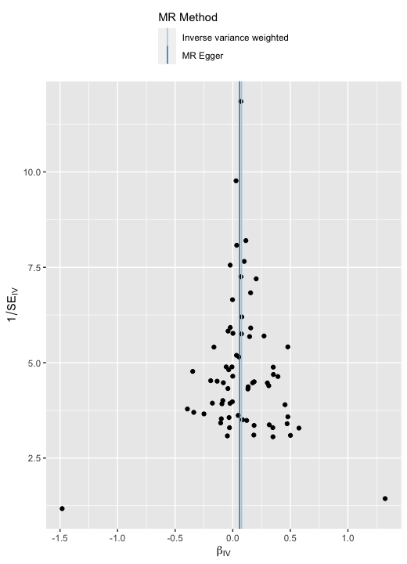D.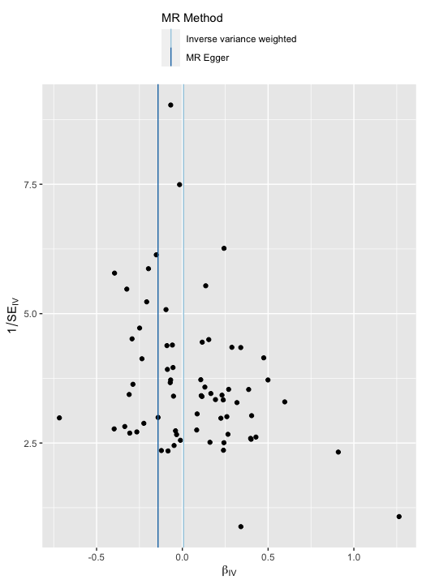
E.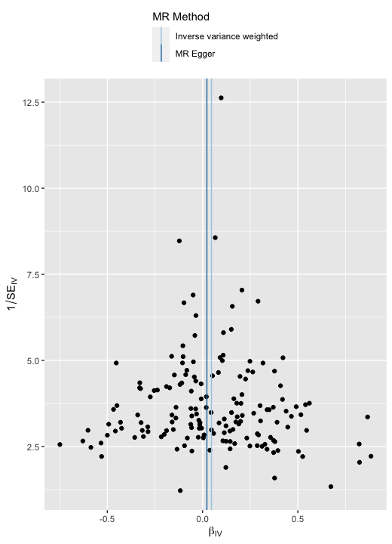F.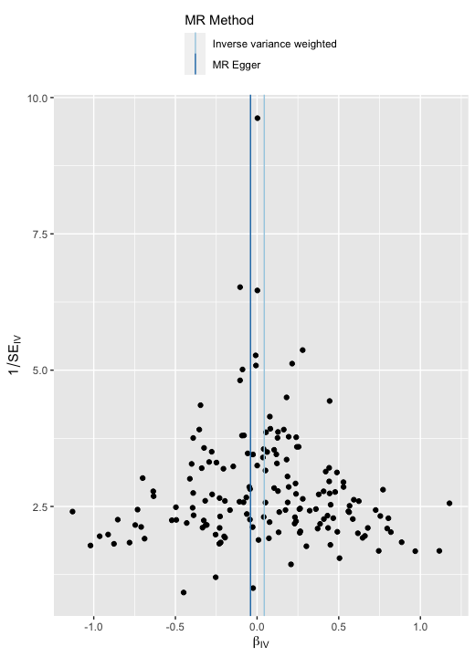
Supplementary Fig 3: Funnel plot of the MR analysis. (A) IBD on AP; (B) IBD on CP; (C) UC on AP; (D) UC on CP; (E) CD on AP; (F) CD on CP; Abbreviations: IBD, Inflammatory bowel disease; UC, Ulcerative colitis; CD, Crohn's disease; AP, Acute pancreatitis; CP, Chronic pancreatitis.

A.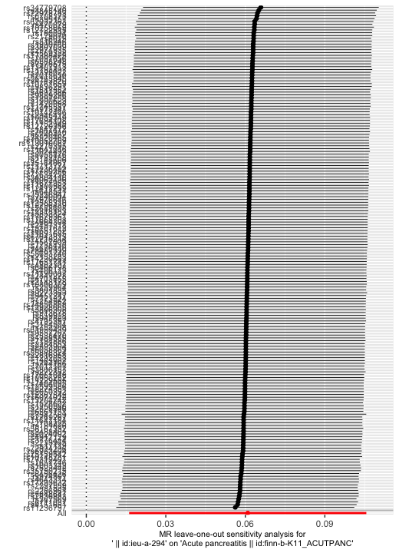B.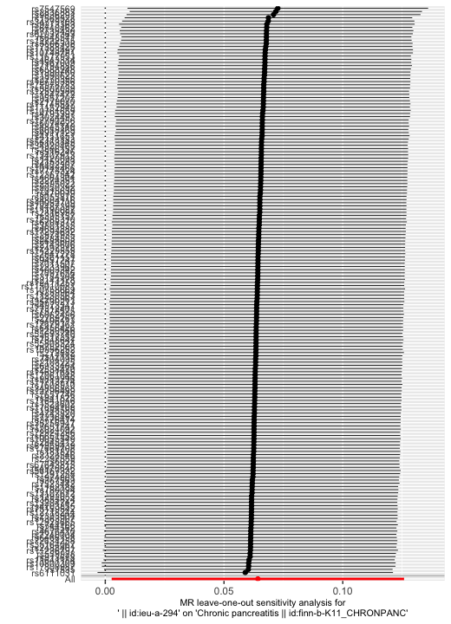
C.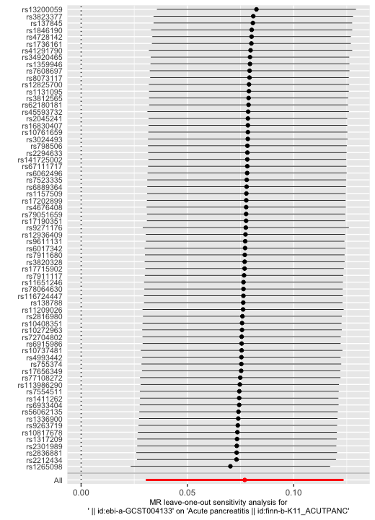D.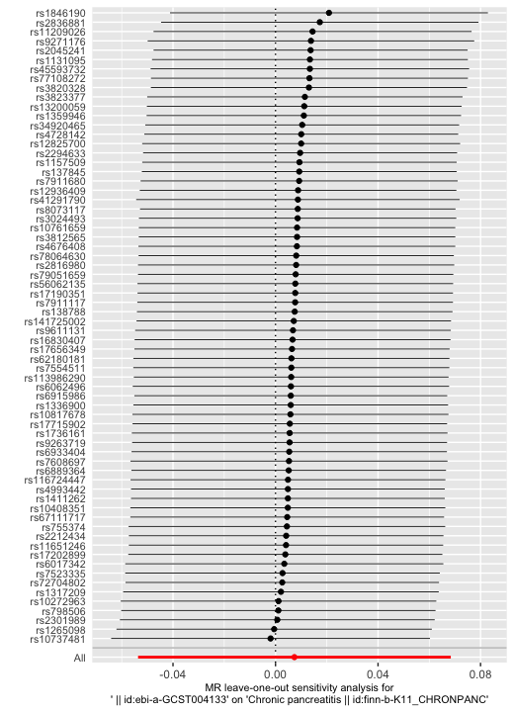
E.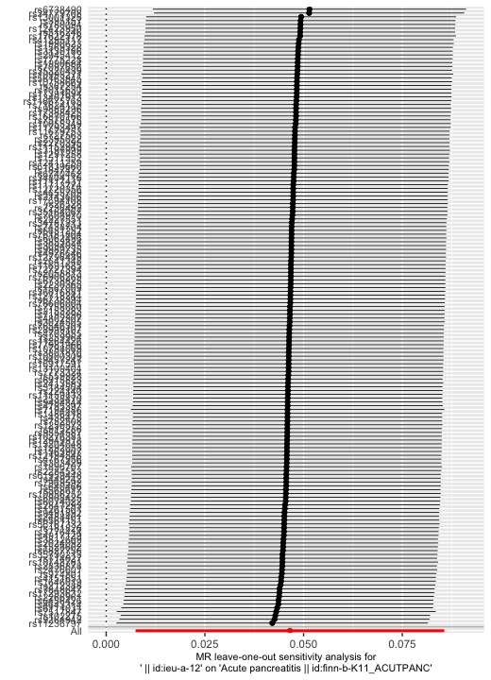F.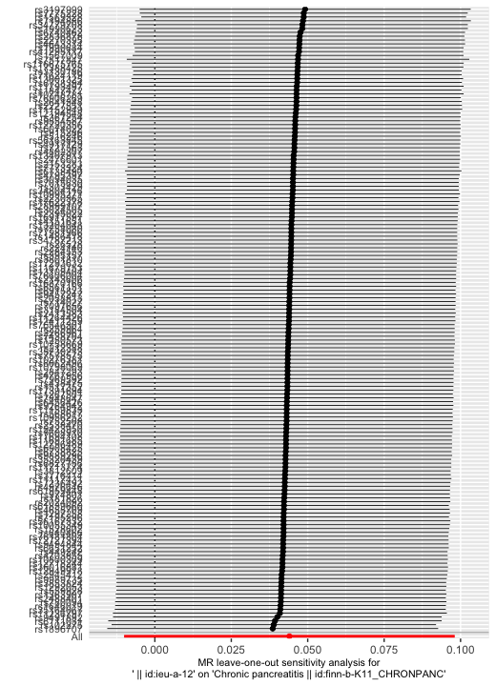
Supplementary Fig 4: Leave-one-out sensitivity test of the MR analysis. (A) IBD on AP; (B) IBD on CP; (C) UC on AP; (D) UC on CP; (E) CD on AP; (F) CD on CP; Abbreviations: IBD, Inflammatory bowel disease; UC, Ulcerative colitis; CD, Crohn's disease; AP, Acute pancreatitis; CP, Chronic pancreatitis

