Increased extinction probability and altered physiological characteristics in carbamate tolerant Daphnia magna
- Supplementary Information-

Makoto Ishimota, Mebuki Kodama, Naruto Tomiyama, Kazutoshi Ohyama
The Institute of Environmental Toxicology, 4321, Uchimoriya-machi, Joso-shi, Ibaraki, Japan

Address correspondence to:
Makoto Ishimota, Laboratory of Residue Analysis II, Chemistry Division, The Institute of Environmental Toxicology, 4321, Uchimoriya-machi, Joso-shi, Ibaraki 303-0043, Japan.

Tel.: +81 297 27 4514, Fax.: +81 297 27 4517,
E-mail address: mota-4024will@hotmail.co.jp
ORCID: 0000-0003-4686-024
Supplementary Information
1. Materials and methods
1.1. Lipid content in algae
Analytical methods for determining lipid content were obtained from Folch et al. (1957). After original algal cultures were prepared for each species in triplicate, they were centrifuged at 4000 rpm for 5 min at 20 °C, and the supernatant was removed. The residue was dried at 60 °C for 24 h, and a 1 g of the sample was transferred to 200 mL eggplant flask. Subsequently, 20 mL chloroform/methanol (2:1, v/v) was added and incubated for 10 min. The samples were then transferred to eggplant flasks and homogenized. After the sample was filtered by the Qualitative circular filter paper (No. 5 C, Toyo Roshi Kaisha, Ltd., Tokyo), the filtrates were concentrated by rotary-evaporation in a water bath at <40 °C. After the residue was dissolved in 40 mL chloroform, the sample was filtered again. The filtrates were transferred to weighed eggplant flasks. We concentrated by rotary-evaporation in a water bath at <40 °C and dried the residue at 105 °C for 30 minutes. The dried samples were weighed after cooling in a desiccator, and the algal weight was estimated from the difference between the weight of the flasks with and without dried samples. The lipid content was calculated as the amounts of algae that one Daphnid fed (µg/one feeding (5 × 10⁴ cells/mL)).

1.2. Feeding rates
We conducted the feeding experiments using the neonates from F25 at 0, 3.8, 7.5, and 15 µg/L treated groups. One neonate (< 24 h old) was cultured in a 10 mL glass container containing 10 mL of medium without any pollutant and ten replicates were prepared for each concentration group. The test conditions, such as water temperature, followed standard conditions (see the section Culture methods for test cladocerans). To avoid algal growth during the test period, the experiments were performed under dark conditions. We performed this experiment under different food conditions, namely green algae (C. vulgaris) and cyanobacteria (Synechococcus leopoliensis). The algal cell density was set at 5 × 10⁵ cells/mL/day. After culturing the neonates for 24 h with each alga, we measured the algal cell density using flow cytometry (Guava EasyCyte Mini, Millipore, USA) at the beginning and end of the test (after 24 h of exposure). The feeding rate (Fr) of each neonate was calculated using the following equation:

$$Fr (\%)=\left(\frac{\left(Ct0-Ct24\right)×100}{Ct0}\right)-\left(\frac{\left(Cb0-Cb24\right)×100}{Cb0}\right)$$

where Fr is the feeding rate, Ct and Cb are the algal densities (cells/mL) in each test and blank groups, respectively. The number "0" shows the time at the beginning of pirimicarb exposure and “24” represents 24 h (exposure time). Finally, mean feeding rate was calculated.

1.3. Reproduction and survival in the life cycle test
To confirm the significant difference in life cycle parameters (reproduction (total number of neonates from the parents), survival rate of parents) between concentration groups in the life cycle test, we performed data comparison following Tukey's HSD methods (see Section 1.4).

1.4. Analytical methods
The R software was used for the analysis (R Core Team 2020; 2021). Because homogeneity of variance was shown in this test (Fox &Weisberg 2019), we performed Tukey's HSD method in the multcomp package (Hothorn et al. 2022). To analyze the survival rates of parents, a GLM was used to assume a binomial distribution of the data, and then the data were analyzed using Tukey's HSD method in the multcomp package.

2. Results
2.1. Lipid contents in algae
The means and standard deviations of lipid contents in C. vulgaris, and S. leopoliensis were 0.37 ± 0.05 and 0.11 ± 0.02 µg/one feeding, respectively. Therefore, the mean lipid content of C. vulgaris was approximately four times higher than that of S. leopoliensis.

2.2. Feeding rates
For both, the C. vulgaris and S. leopoliensis treatments, the feeding rates in neonates were almost similar to those in each control group, except a decrease of feeding rates from 7.5 µg/L exposure group in the C. vulgaris treatment compared to the control (p<0.05); a decrease of 3.8 µg/L exposure group in the S. leopoliensis treatment compared to the control (p<0.05) (Fig. S1). We did not observe any clear concentration-dependent effects for each treatment.

2.3. Reproduction and survival of parents
In both algal treatments, reproduction (total number of neonates per parent) in Daphnia significantly decreased with pirimicarb continuous exposure (p < 0.05) (Table S1). All parents survived the C. vulgaris treatment during the life cycle experiment. Although the survival rates of the parents decreased with the S. leopoliensis treatment, the difference was not significant. Conversely, reproduction in all concentration groups was significantly decreased compared to that in the control.
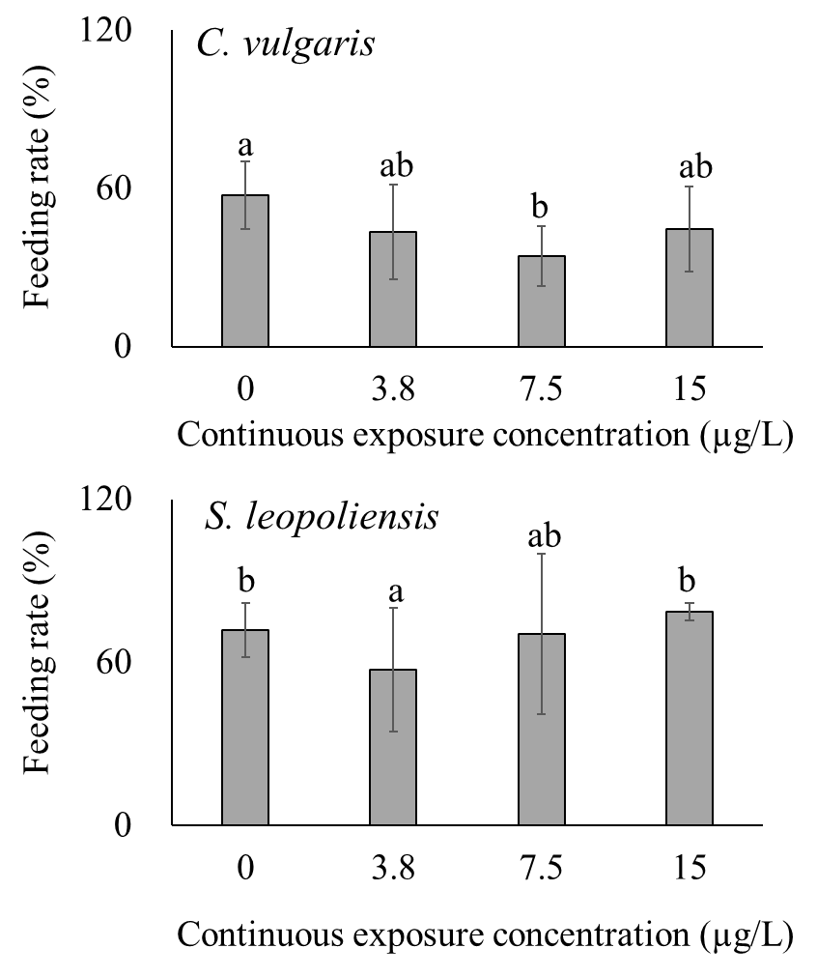
Fig. S1 Feeding rates in each concentration group of neonates (<24 h old). The neonates from continuous exposure groups were cultured without any chemical for 24 h with two foods (a) C. vulgaris and (b) S. leopoliensis The bar graphs with error bars show the mean feeding rates with standard deviations (1 neonate/one vessel, n=12). The same alphabets mean that the groups have no significant difference from each other (p < 0.05).

Table S1. Total number of neonates and survival rates of parents in the life cycle test
Continuous exposure | Total number of neonates | Survival rates of parents
concentration (µg/L) | Mean ± SD*
 | C. vulgaris
0 | 81.3 ± 3.8 ^{a)} | 1.0 ± 0.0^{a)}
3.8 | 78.0 ± 12.5 ^{a)} | 1.0 ± 0.0 ^{a)}
7.5 | 68.3 ± 5.0 ^{ab)} | 1.0 ± 0.0 ^{a)}
15 | 53.3 ± 5.0 ^{b)} | 1.0 ± 0.0 ^{a)}
 | S. leopoliensis
0 | 17.0 ± 0.0 ^{a)} | 1.0 ± 0.0 ^{a)}
3.8 | 5.7 ± 4.0 ^{b)} | 1.0 ± 0.0 ^{a)}
7.5 | 4.3 ± 0.6 ^{b)} | 0.8 ± 0.0 ^{a)}
15 | 4.3 ± 1.5 ^{b)} | 0.5 ± 0.3 ^{a)}
* SD: standard deviation.
The same letters indicate that the groups were not significantly different (p < 0.05).

Reference list
Folch J, Lees M, Sloane Stanley GH (1957) A simple method for the isolation and purification of total lipides from animal tissues. J Biol Chem 226:497-509. https://doi.org/10.1016/S0021-9258(18)64849-5
Fox J, Weisberg S (2019) An R Companion to Applied Regressions, 3rd ed. https://www.john-fox.ca/Companion/index.html
Hothorn T, Bretz F, Westfall P, Heiberger RM, Schuetzenmeister A, Scheibe S (2022) Multcomp: Simultaneous
Inference in General Parametric Models, Accessed 28 June 2023
R Core Team (2020, 2021). R: A language and environment for statistical. Computing, Ver 3.6.1. R Foundation for
Statistical Computing, Vienna, Austria 1:4.1.0. MSOR connections.

