Supplementary Information for
Mercury’s Ring Current: MESSENGER Observations and Test-Particle Simulations
J.-T. Zhao¹, Q.-G. Zong¹*, Chao Yue¹, W.-J. Sun², H. Zhang³, X.-Z. Zhou¹, G. Le⁴, R. Rankin⁵, J. A. Slavin², J. M. Raines², Y. Wei⁶
¹Institute of Space Physics and Applied Technology, Peking University, Beijing, China.
²Department of Climate and Space Sciences and Engineering, University of Michigan, Ann Arbor, Michigan 48109, USA.
³Geophysical Institute, University of Alaska Fairbanks, AK 99775, USA.
⁴ITM Laboratory, Heliophysics Science Division, NASA Goddard Space Flight Center, Greenbelt, Maryland, USA.
⁵Department of Physics, University of Alberta, Edmonton T6G2R3, Canada.
⁶Institute of Geology and Geophysics, Chinese Academy of Sciences.
* Q.-G. Zong.
Email: qgzong@pku.edu.cn

Classification
Earth and environmental sciences/Planetary science/Inner planets;
Earth and environmental sciences/Space physics/Magnetospheric physics;
Keywords
Mercury, Ring current, Magnetic Storm

Figure S1-S4
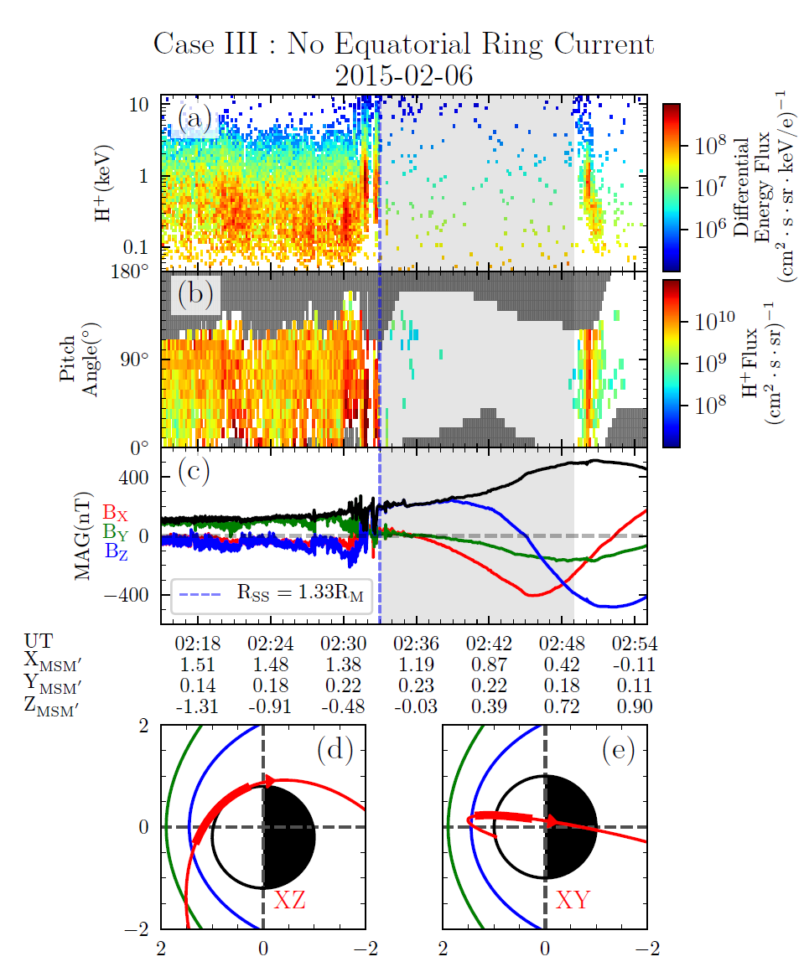
Figure S1. A case without the observation of equatorial ring current proton under strong solar wind forcing. (a) Differential energy spectrum of the proton. (b) Corresponding pitch angle distribution, the uncovered pitch angle bins are noted by grey grids. (c) Magnetic field vectors (red, blue, and green solid lines represent the $B_{x},B_{y} and B_{z}$ components, respectively) and strength (black solid line). (d, e) the trajectory of MESSENGER in XZ, XY planes. The shaded area indicates the time period during which MESSENGER pass through the dayside magnetosphere of Mercury without sensible proton flux enhancement. The corresponding spacecraft locations during this interval are plotted in (d, e) as bold red lines.

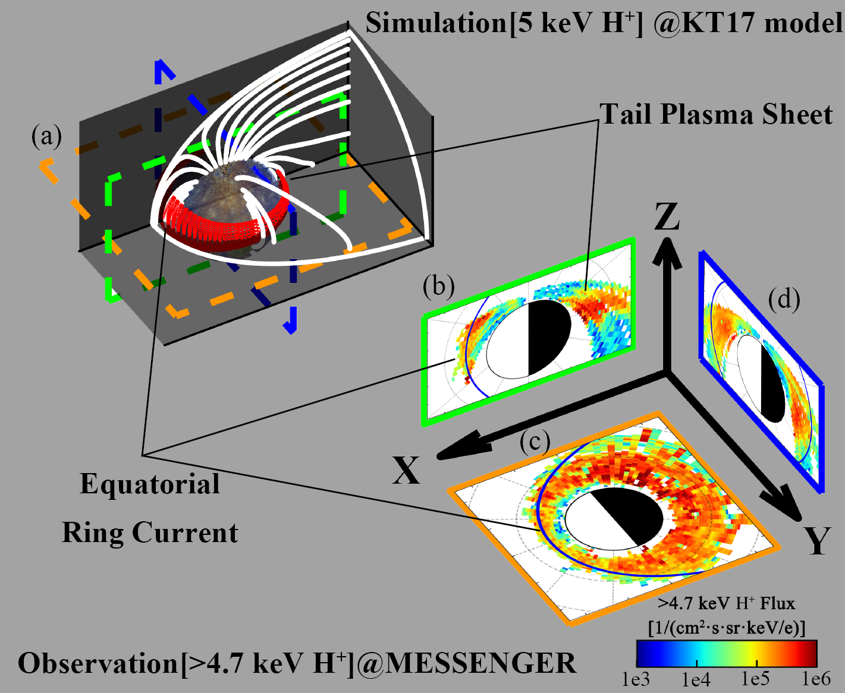
Figure S2. Illustration of Mercury's equatorial ring current. (a) 3D view of the test particle trajectory. (b, c, d) Energetic proton flux distribution in the equatorial (|Z|<0.2${ R}_{M}$), meridian (Local Time: 11 h-13 h & 23 h-01 h), and dawn-dusk planes (Local Time: 5 h-7 h & 17 h-19 h).

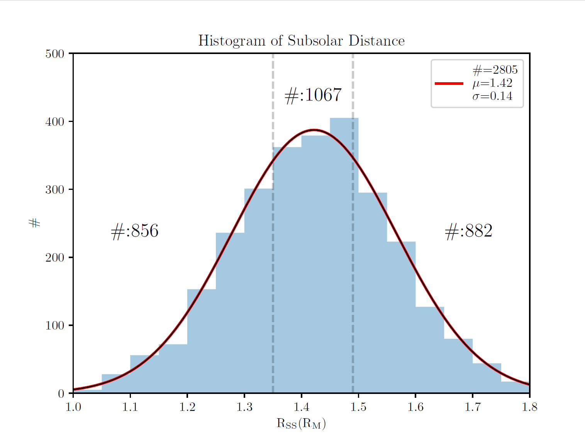
Figure S3. The histogram of subsolar distances with a total number of 2805. The mean and standard derivation is 1.42${ R}_{M}$ and 0.14${ R}_{M}$. Gaussian distribution with the same parameters is denoted as the red solid line. The grey dashed lines indicate the critical values of classification ($i.e. R_{SS}=μ-\frac{σ}{2} and R_{SS}=μ+\frac{σ}{2}$). The event numbers in each group [low ($R_{SS}<1.35)$/medium (${1.35<R}_{SS}<1.49)$/high ($R_{SS}>1.49)$] are noted above the gaussian curve.

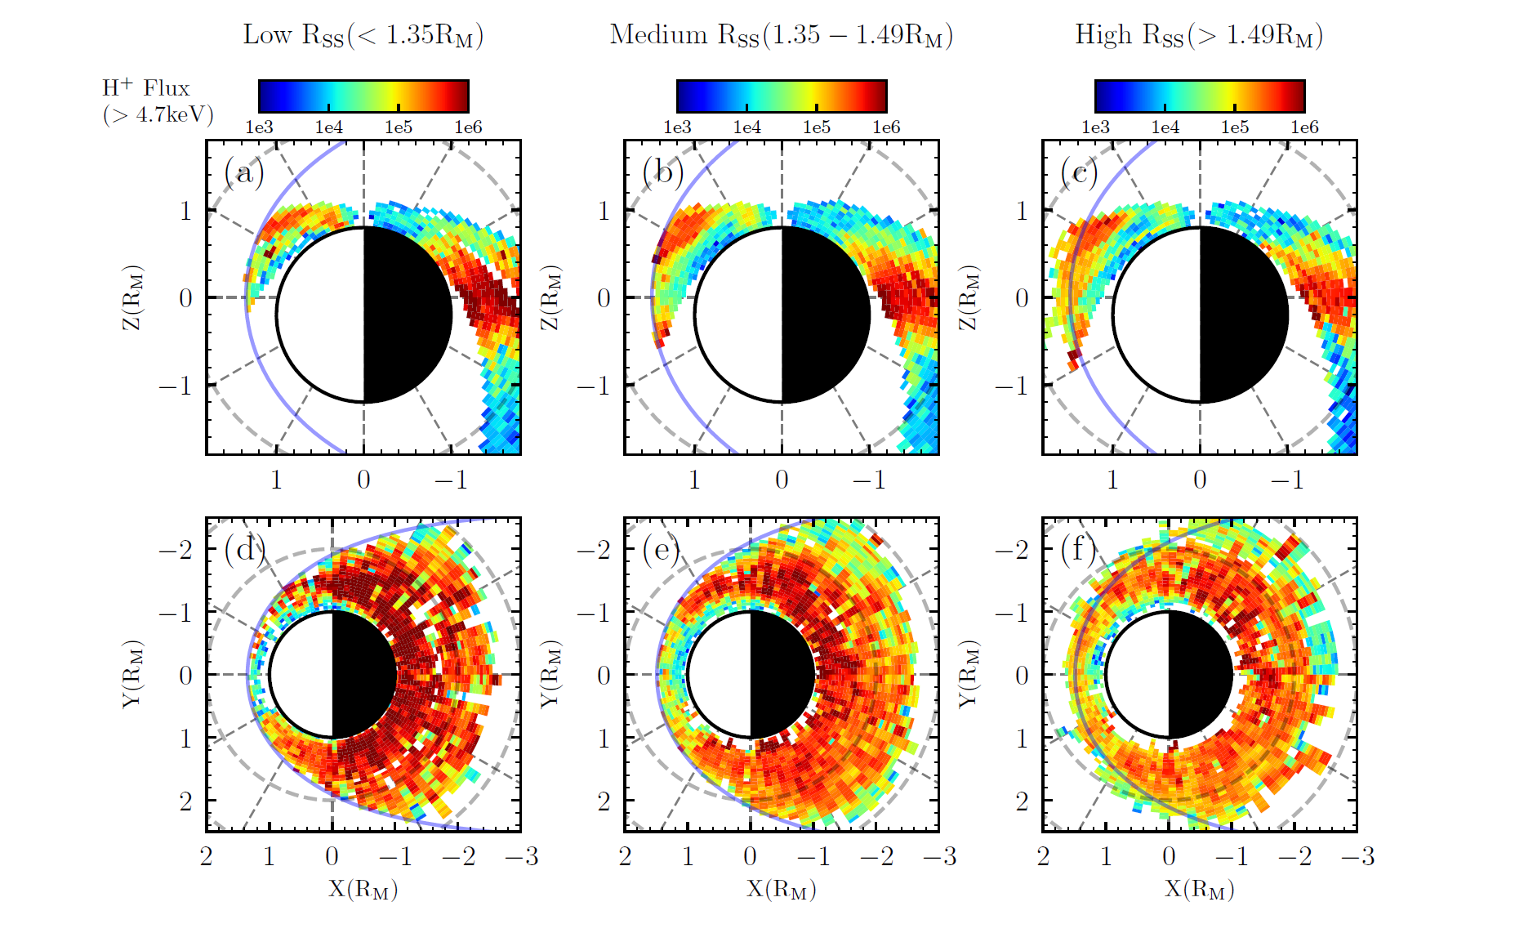
Figure S4. The distribution of energetic protons differential fluxes in units of ${cm}^{-2}⋅s^{-1}⋅sr^{-1}⋅(k{eV/e)}^{-1}$. (a-c) The distribution in the meridian plane, accumulating from 11 to 13 and 23 to 01 local time for dayside and nightside, respectively. (d-e) The distribution in the equatorial plane, accumulating from $-0.2 R_{M}$ to $0.2{ R}_{M}$ in the Z direction.

