Supporting information for
Depth-dependent responses of soil microbial respiration to nitrogen addition in a temperate steppe in Inner Mongolia
Author information:
Zhuhai Branch of State Key Laboratory of Earth Surface Processes and Resource Ecology, Beijing Normal University, Zhuhai, 519087, China
Yun Jiang & Bingwei Zhang
Faculty of Geographical Science, Beijing Normal University, Beijing, 100875, China
Yun Jiang, Xia Xu, Yongmei Huang & Xiuchen Wu
School of Ecology, Sun Yat-sen University, Shenzhen, 518107, China
Weitao Wang
School of National Safety and Emergency Management, Beijing Normal University, Zhuhai, 519087, China
Jiawei Li
Corresponding authors:
Correspondence to Xiuchen Wu (e-mail: xiuchen.wu@bnu.edu.cn) & Bingwei Zhang (e-mail: bwzhang@bnu.edu.cn).

Contents of this file
Text S1
Table S1
Figures S1–S8

Text S1. Determination of soil and root physicochemical properties
We measured soil water holding capacity (WHC) using the ring knife method (Dugan et al. 2010; Zhang et al. 2022). Soil gravimetric water content (SWC) was determined after 48 hr oven-drying at 105°C to a constant weight. Soil pH was measured at a 1:2.5 (weight/volume, w/v) soil-to- deionized water slurry using an automatic pH analyzer (Skalar SP2000-1, Netherlands) (Ryti 1965; Liu et al. 2022). Soil particle size (i.e., clay, silt, and sand content) was determined by the hydrometer method (Ashworth et al. 2007). Soil available phosphorus (AP) was determined by using an ultraviolet spectrophotometer (UV-2550, Shimadzu, Kyoto, Japan). Total C and N contents of soil (soil C and soil N) and root samples (root C and root N) were determined with an elemental analyzer (Vario EL III, Elementar, Germany). The C quality of fine roots (root C:N) and soils (soil C:N) were expressed using the total C divided by total N (Thuille et al. 2015). Moreover, the total amount of micronutrients in the fine root (FRBC and FRBN) were given via root C and root N (i.e., content × biomass) (Jiang et al. 2020). Soil inorganic N (NO₃⁻-N and NH₄⁺-N) were extracted from 1 M KCl solution at a 1:5 (w/v) soil-to- deionized water slurry (Jones and Willett 2006) and further determined by a continuous flow analyzer (Skalar San++ System, Netherlands). Soil total dissolved C (DC), total dissolved N (DN), and total inorganic C (IC) concentrations of the extractions were measured with a multi N/C 3100 analyzer (Analytik Jena, Germany) in the laboratory. The soil total dissolved organic C (DOC) concentration was calculated by subtracting the content of IC from those of DC (Yuan et al. 2023). All of the soil fractions were calculated based on the dry weight of soil.

Table S1 Ranges and mean values (± se) (n = 3) of MR across 15 plots. Different letters denote significant differences of MR between the N treatment at the p < 0.05 level after the Bonferroni correction. MR, soil microbial respiration.
Treatment | MR (μg C g⁻¹ soil d⁻¹)
Treatment | Shallow (0-10 cm) |  | Medium (10-20 cm) |  | Deep (20-40 cm)
Treatment | Mean (± se) | Ranges | Mean (± se) | Ranges | Mean (± se) | Ranges
N0 | 9.32 ± 0.91 a | 7.50~ 10.28 | 5.34 ± 0.27 a | 4.80~ 5.64 | 4.61 ± 0.46 a | 4.10~ 5.54
N2 | 11.57 ± 0.35 a | 10.86~ 11.94 | 7.55 ± 0.83 a | 6.21~ 9.08 | 4.95 ± 0.21 a | 4.71~ 5.36
N5 | 7.54 ± 1.28 a | 5.06~ 9.36 | 6.58 ± 0.85 a | 5.24~ 8.14 | 5.18 ± 0.94 a | 4.02~ 7.05
N10 | 12.02 ± 0.13 a | 11.81~ 12.27 | 6.90 ± 0.48 a | 5.97~ 7.56 | 5.04 ± 1.29 a | 2.74~ 5.19
N25 | 11.30 ± 1.67 a | 8.10~ 13.72 | 5.59 ± 0.32 a | 5.17~ 6.23 | 3.55 ± 0.23 a | 3.30~ 4.01
Total | 10.35 ± 0.60 | 5.05~ 13.72 | 6.39 ± 0.32 | 4.80~ 9.08 | 4.67 ± 0.33 | 2.74~ 7.20

Fig. S1. Relative abundance of the identified C-degrading bacterial (a) and fungal (b) phyla across five N addition levels. In descending order of relative abundance, the six bacterial taxa are: Actinobacteria, Proteobacteria, Acidobacteria, Bacteroidetes, Verrucomicrobia, and Planctomycetes. Similarly, the four fungal taxa are: Ascomycota, Basidiomycota, Glomeromycota, and Mucoromycota. Treatment: N0, N2, N5, N10, and N25 correspond to N additions of 0, 2, 5, 10, and 25 g N m⁻²yr⁻¹, respectively.
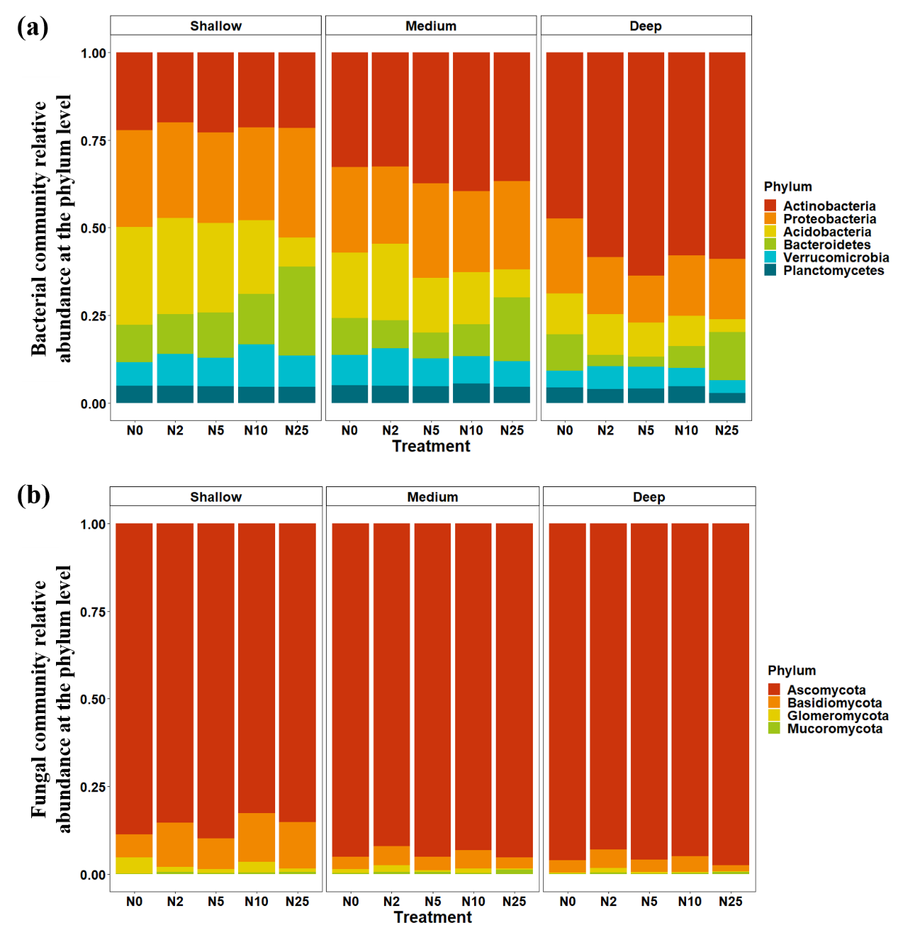

Fig. S2. Linear relationships between MR and the relative abundance of C-degrading bacterial and fungal phyla. Solid lines represent significant (p < 0.05) fitted lines. The shaded areas show the 95% confidence interval for each fit.
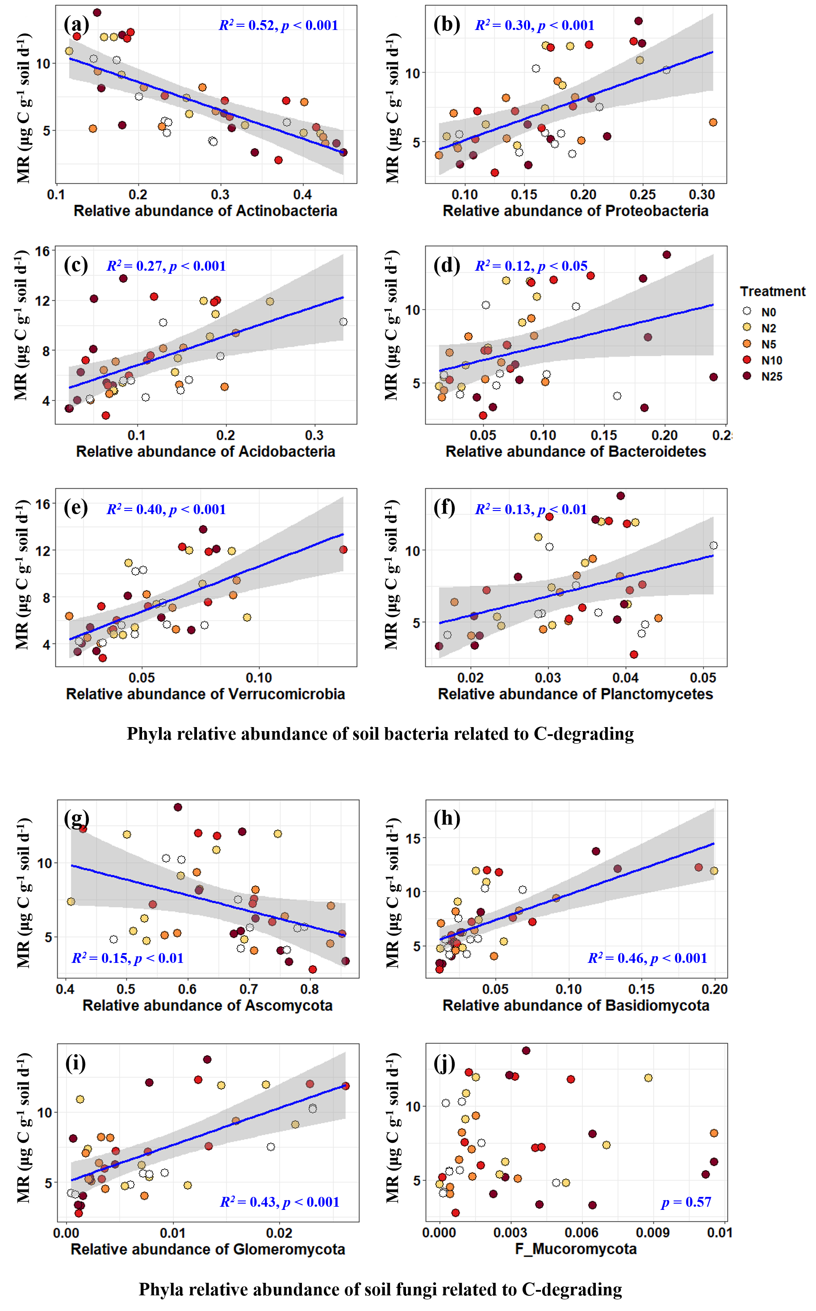

Fig. S3. Results from random forest analysis showing the top 10 important variables driving MR in shallow (a), medium (b) and deep (c) soil layers. Variables’ importance is estimated using the percentage increase in mean square error (%IncMSE).
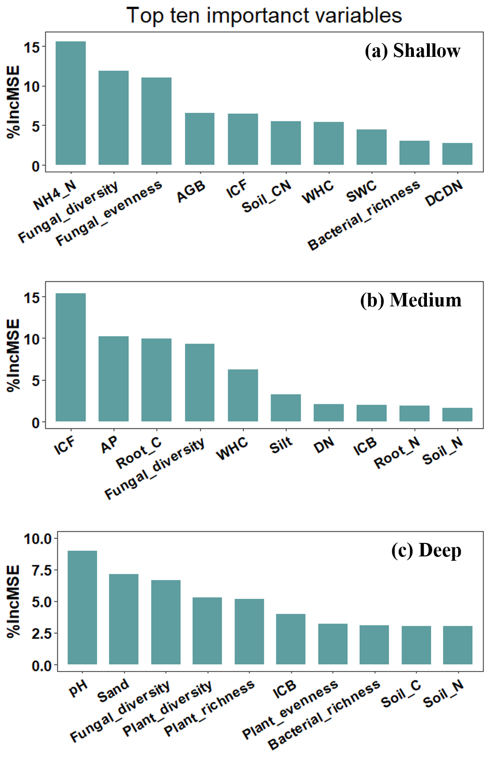

Fig. S4. Pearson correlation plot of the most important ten predictors from random forest analysis for MR in shallow (a), medium (b) and deep (c) soil layers. Red squares indicate positive correlations, while bule squares indicate negative correlations. The square sizes and values in the lower left triangle denote the correlation coefficients.
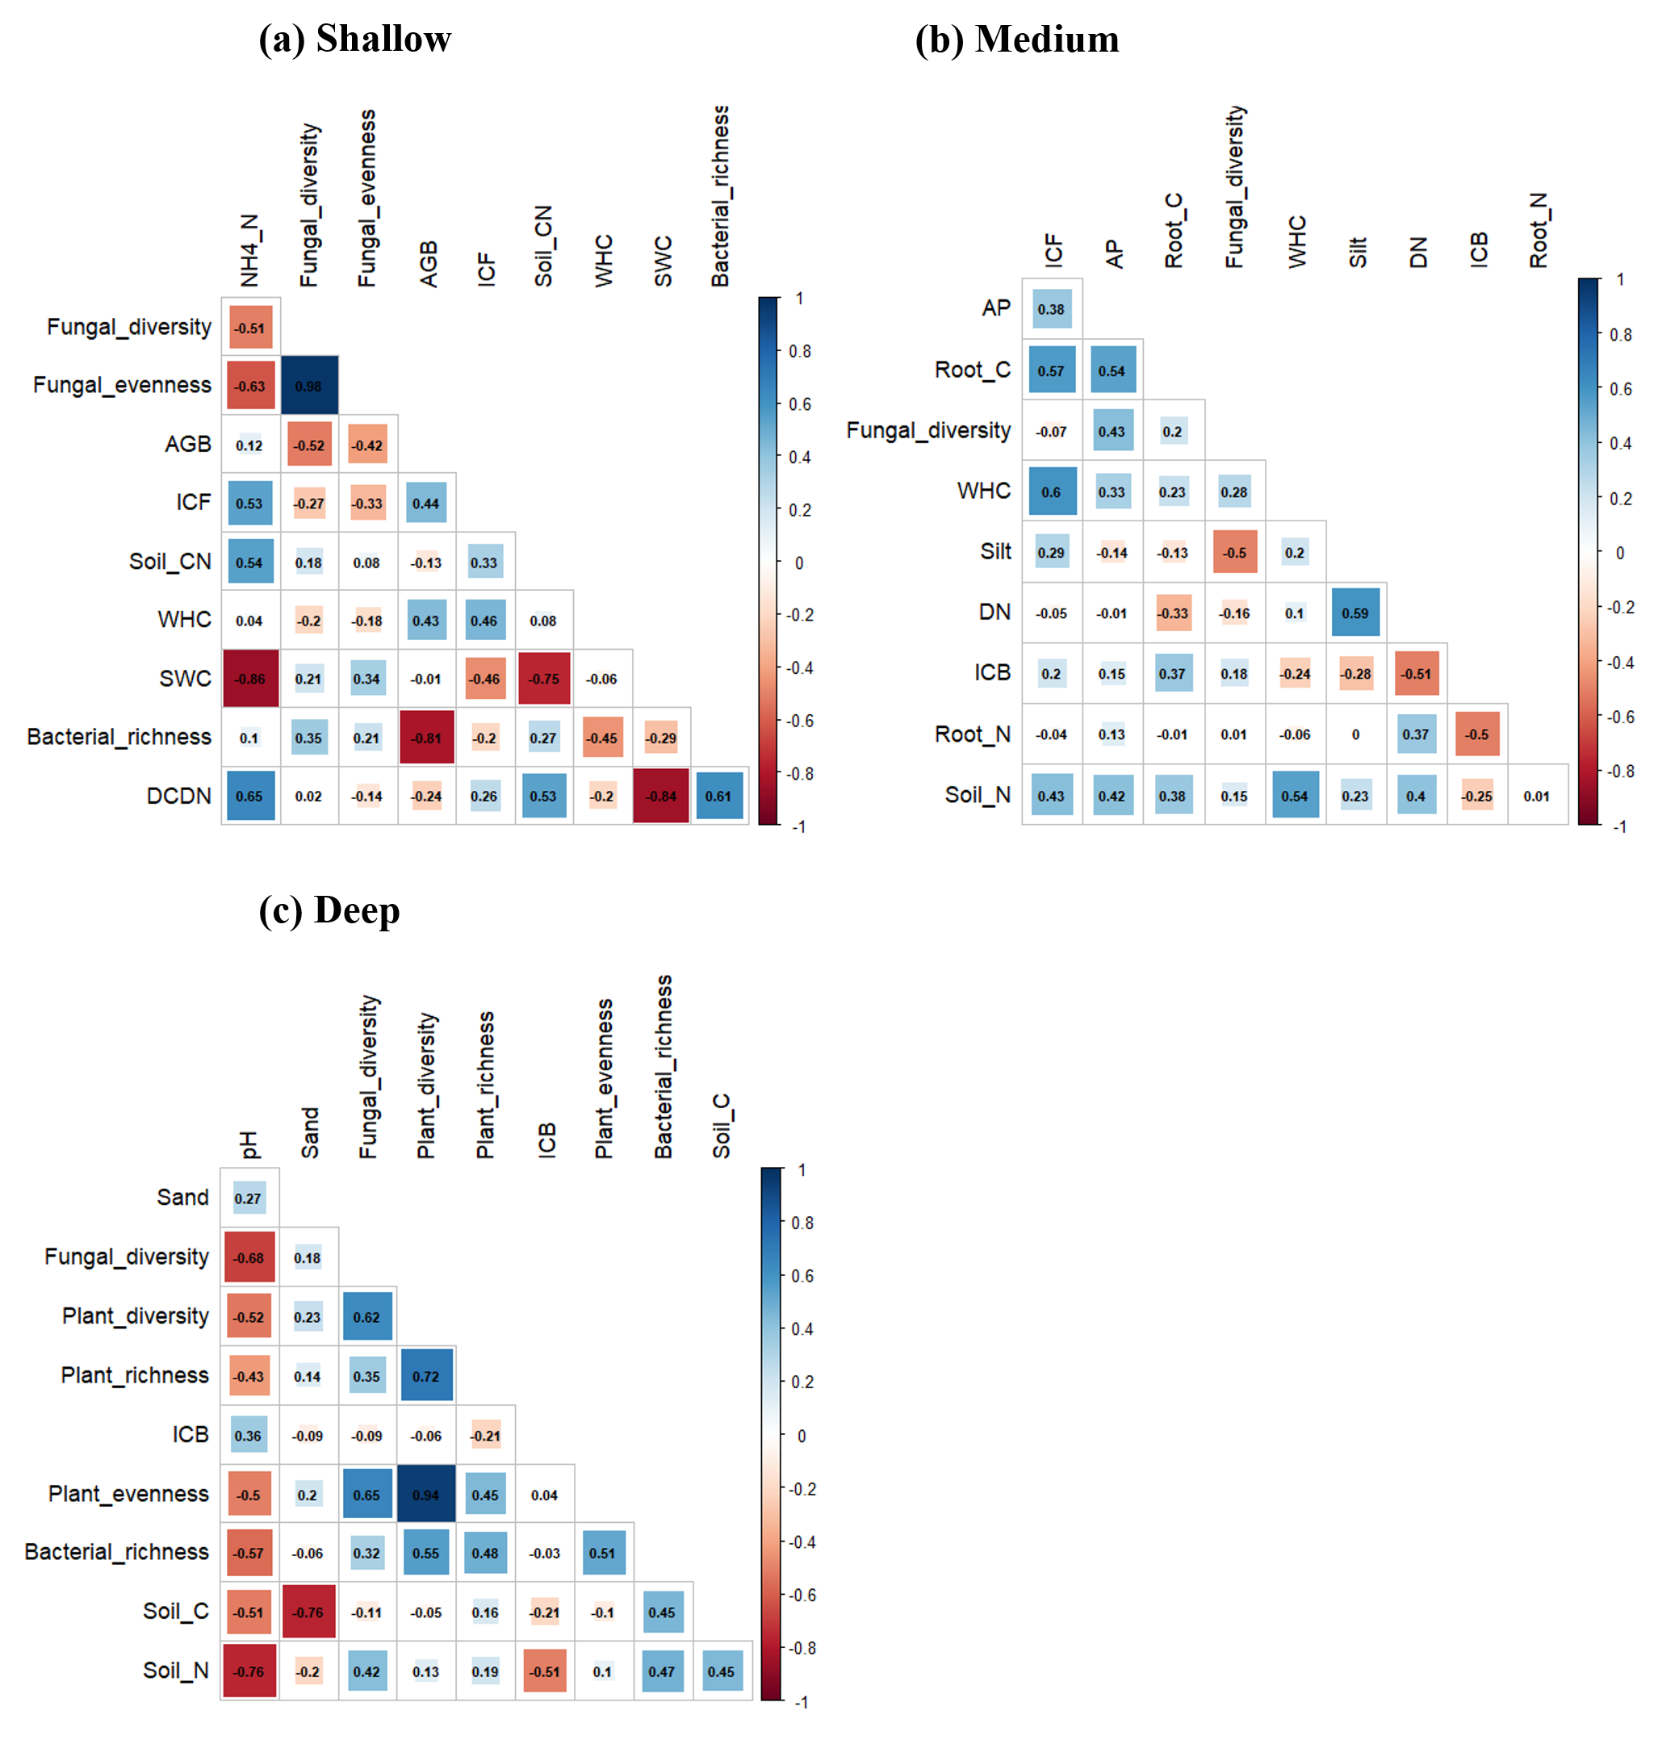

Fig. S5. Principal component analysis (PCA) of soil properties in medium soil layer (a) and the loadings of the first two soil PCA axes (b).
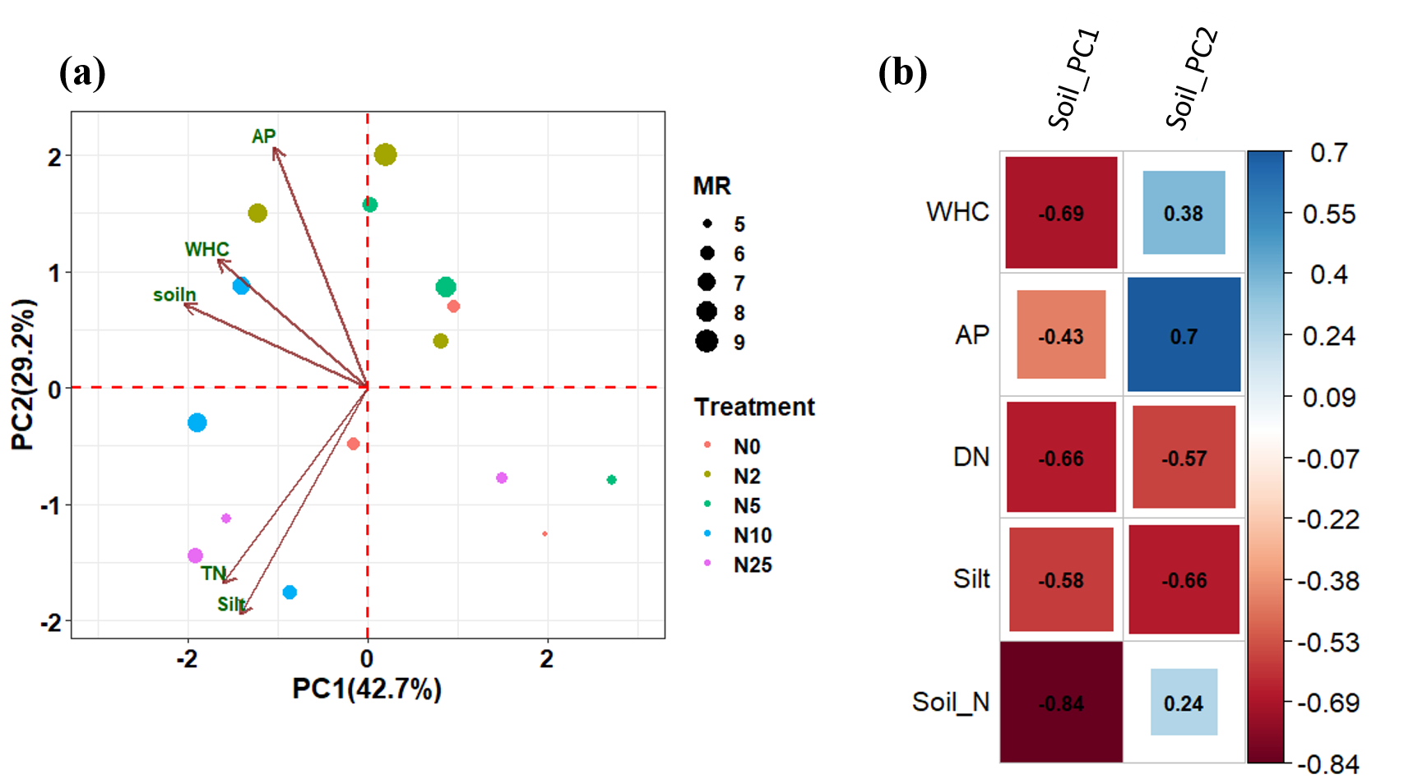

Fig. S6. Violin plot of MR across three soil layers. Pairwise t-tests were used to compare the MR differences among the soil layers with adjusted p-value using the Bonferroni correction highlighted in blue. Significance level: p < 0.01, ***; p < 0.001, ****.
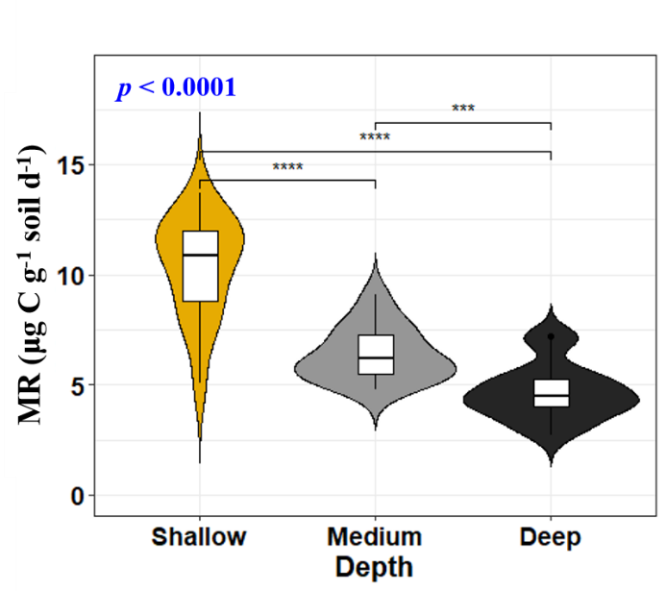

Fig. S7. Linear responses of richness (a), diversity (b) and AGB (c) of above ground plant communities to increasing N addition rates. Solid lines represent significant (p < 0.05) fitted lines. The shaded areas show the 95% confidence interval of the fits.
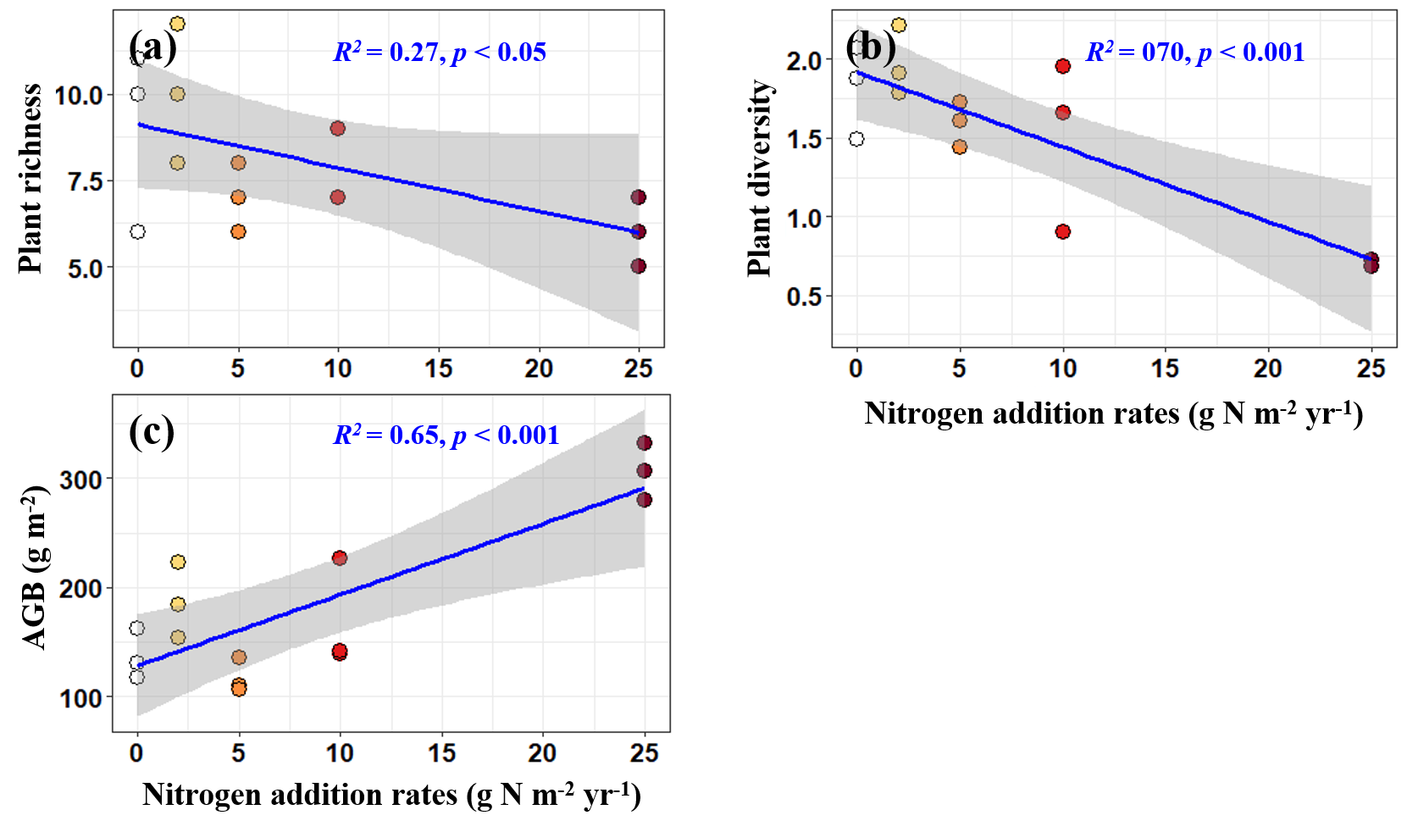

Fig. S8. Linear responses of soil NO₃⁻-N (a) and soil pH (b) to increasing N addition rates across three soil layers. The shaded areas show the 95% confidence interval of the fit. The statistics (both R² and p value) are displayed on the graphs for those fitted lines that are significant.
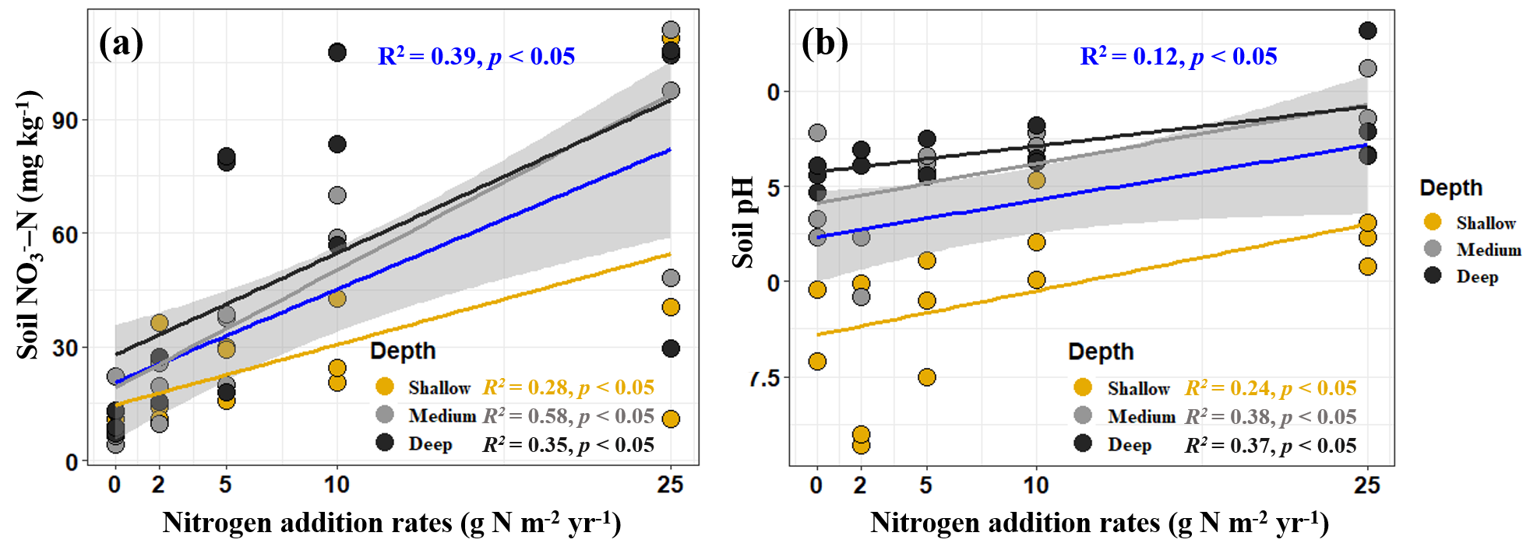

References
Ashworth J, Keyes D, Kirk R, Lessard R (2007) Standard procedure in the hydrometer method for particle size analysis. Commun Soil Sci Plant Anal 32:633-642. https://doi.org/10.1081/css-100103897
Dugan E, Verhoef A, Robinson S, Sohi S (2010) Bio-char from sawdust, maize stover and charcoal: impact on water holding capacities (WHC) of three soils from Ghana. 19th World Congress of Soil Science, Soil Solutions for a Changing World 11:9-12.
Jiang Y, Zhang BW, Wang WW, Li BH, Wu ZR, Chu CJ (2020) Topography and plant community structure contribute to spatial heterogeneity of soil respiration in a subtropical forest. Sci Total Environ 733:139287. https://doi.org/10.1016/j.scitotenv.2020.139287
Jones D, Willett V (2006) Experimental evaluation of methods to quantify dissolved organic nitrogen (DON) and dissolved organic carbon (DOC) in soil. Soil Biol Biochem 38:991-999. https://doi.org/10.1016/j.soilbio.2005.08.012
Liu Y, Ding C, Xu X, Wang K, Li Y, Pan H, Zhang Q, Dumont MG, Di H, Xu J, Li Y (2022) Atmospheric methane oxidation is affected by grassland type and grazing and negatively correlated to total soil respiration in arid and semiarid grasslands in Inner Mongolia. Soil Biol Biochem 173. https://doi.org/10.1016/j.soilbio.2022.108787
Ryti R (1965) On the determination of soil pH. Agricultural and Food Science 37:51–60.
Thuille A, Laufer J, Höhl C, Gleixner G (2015) Carbon quality affects the nitrogen partitioning between plants and soil microorganisms. Soil Biol Biochem 81:266-274. https://doi.org/10.1016/j.soilbio.2014.11.024
Yuan X, Niu D, Guo D, Fu H (2023) Responses of soil carbon and nitrogen mineralization to nitrogen addition in a semiarid grassland: The role of season. Catena 220. https://doi.org/10.1016/j.catena.2022.106719
Zhang B, Jiang Y, Chen D, Wu Z, Li B, Chu C (2022) Highly spatial variation of soil microbial respiration and temperature sensitivity in a subtropical forest. Sci Total Environ 808:152197. https://doi.org/10.1016/j.scitotenv.2021.152197

