Unprecedented Direct Methanol Coupling for Selective Conversion of CO₂ to Ethane at Room Temperature and Ambient Pressure
Supporting Information
Bright Ngozichukwu¹, Chi Ho Lee¹, Denis Johnson¹, James Kasten¹, Joseph Sang-II Kwon^{1*} and Abdoulaye Djire^{1,2*}
¹Artie McFerrin Department of Chemical Engineering, Texas A&M University, College Station, TX 77843, USA
²Department of Materials Science & Engineering, Texas A&M University, College Station, TX 77843, USA
*Corresponding Authors: adjire@tamu.edu, kwonx075@tamu.edu

- Gas flow plate
- Cathode GDE
- Catholyte flow plate
- Polymer electrolyte membrane (PEM)
- Anolyte flow plate
- Anode (Pt mesh)
(1)
(2)
(3)
(4)
(5)
(6)

Figure S1. Schematic of flow cell design. The cathode GDE consists of a Ti₂N paste (95% Ti₂N, 5% Nafion) coated onto a 4 cm² PVDF-infused carbon cloth. PEMs consist of Nafion-117 to enable selective proton diffusion from anode to cathode. The anode GDE is a 4 cm² fine Pt wire mesh.

CO₂ Supply
Pump
Catholyte Tank
Pump
Anolyte Tank
Liquid to NMR
Flow controller
Potentiostat
Gas to GC

Figure S2. Flow diagram of CO₂ reduction setup. Green stream: Supplied CO₂ flows into the gas flow plate and gaseous products. The gaseous products are collected in the catholyte tank and recycled to the cathode chamber of the flow cell to further enhance conversion and are extracted to the GC in batches using a control valve. Orange stream: Catholyte (1M KHCO₃) is pumped through the cathode plate and the catholyte tank. Samples are extracted in batches for NMR analysis (blue stream). Purple stream: Anolyte (1M KHCO₃) is pumped through the anode plate and the anolyte tank.

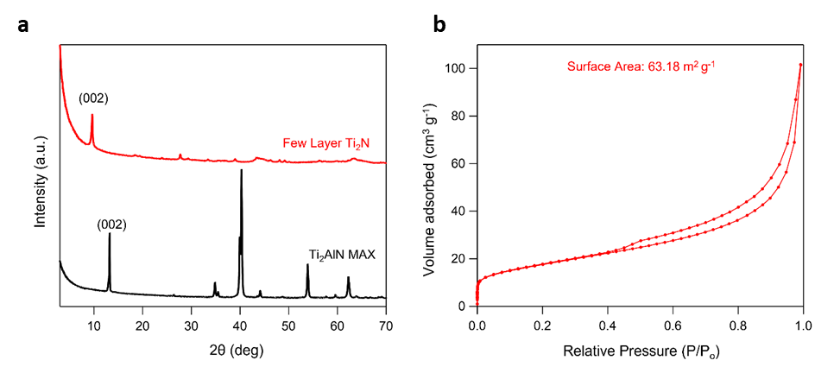
Figure S3. Characterization of Ti₂N. a, X-ray diffraction spectrum of Ti₂AlN MAX precursor (black trace) and delaminated few layer Ti₂N (red trace). Clear shift of the 002 peak to a lower $2θ(°)$ indicating successful etching of the Al³⁺ from the MAX phase b, Low-pressure N₂ physisorption was measured to evaluate the porous properties of Ti₂N. The Brunauer Emmett Teller (BET) surface area was measured to be 63.18 m² g⁻¹.

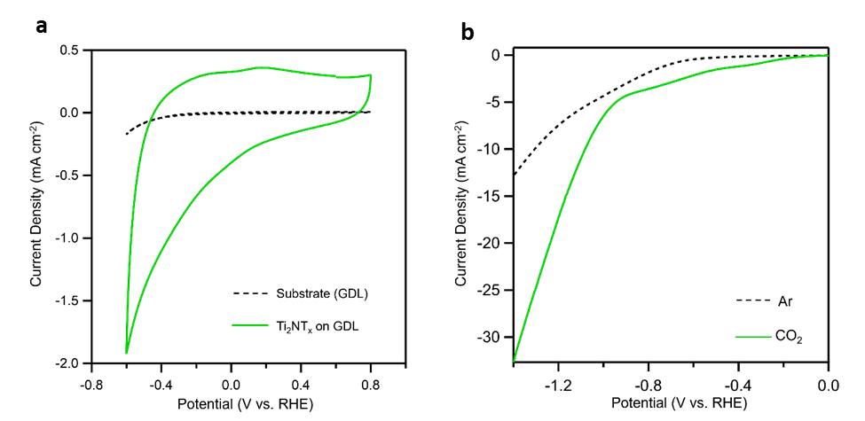
Figure S4. a, Cyclic voltammetry (CV) of uncoated gas diffusion layer electrode (black trace) compared against coated electrode in CO₂-saturated electrolyte (green trace). b, Linear sweep voltammetry of coated gas diffusion electrode in Ar-saturated (black trace) and CO₂-saturated (green) KHCO₃ electrolyte. Cyclic voltammetry and linear sweep voltammetry performed at scan rate of 50 mV/s and 5 mV/s, respectively. CV experiments showed a higher current density for Ti₂N in CO₂-saturated media compared to Ar-saturated electrolyte, revealing its potential for CO₂RR.

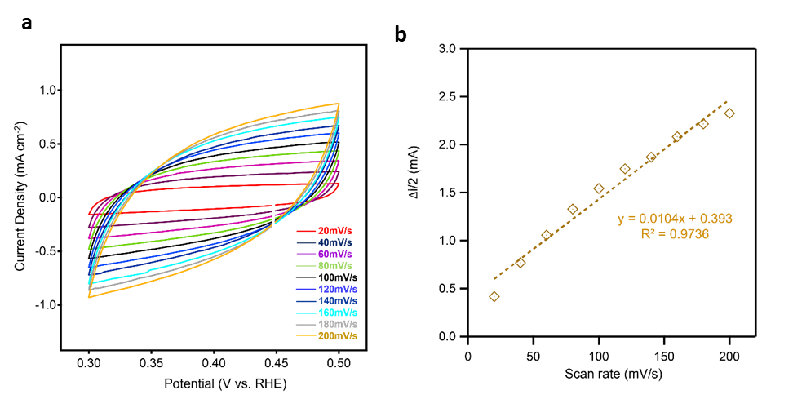
Figure S5. a, Cyclic voltammograms and b, linear calculation curve used for ECSA calculations of the Ti₂NT_{x}-coated electrode in 1 M KHCO₃ saturated with CO₂ at different scan rate. Cyclic voltammograms scans were taken in the non-faradaic region from 0.3 to 0.5 V vs. RHE with 20 mV/s scan rate from 20 to 200 mV/s scan rates when studying the scan rate-dependence of the current.
The Electrochemical surface area (ESCA) is calculated by the following equation:
$$A_{ECSA}=\frac{C_{DL}}{40µF cm^{-2}}$$
Where C_{DL} is the total double layer capacitance represented by the slope of the calculation curve (in Farads) in Figure S5. In aqueous electrolyte, 40 $μ$F cm-2 represents the specific capacitance of a flat surface with a real surface area of 1 cm² for metallic and semiconducting materials. From this, the calculated ECSA of the Ti₂N-coated electrode is 260 cm², significantly higher than the 4 cm² geometric surface area of the electrode. These results justify that Ti₂N contains a greater specific electrochemically active surface compared to flat plate electrodes of comparable geometries.

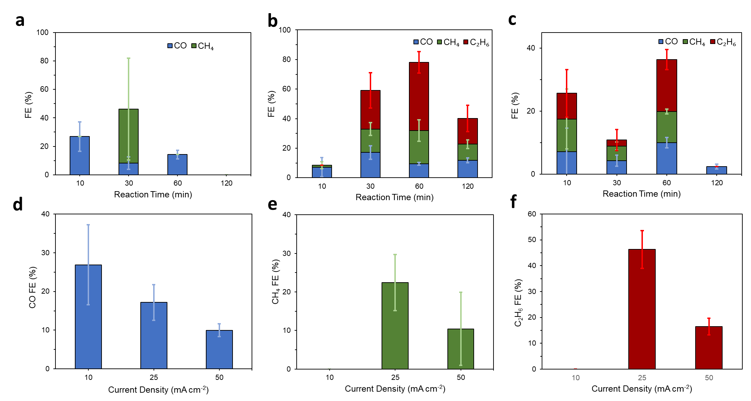
Figure S6. CO₂RR performance of Ti₂N in 1M KHCO₃. a-c) Faradaic efficiencies for gaseous products after applying a, 10 mA cm⁻², b, 25 mA cm⁻², c, 50 mA cm⁻² current densities across time. d-f) Peak Faradaic efficiencies for gaseous products d, CO, e) CH₄, and f) C₂H₆ at various current densities.

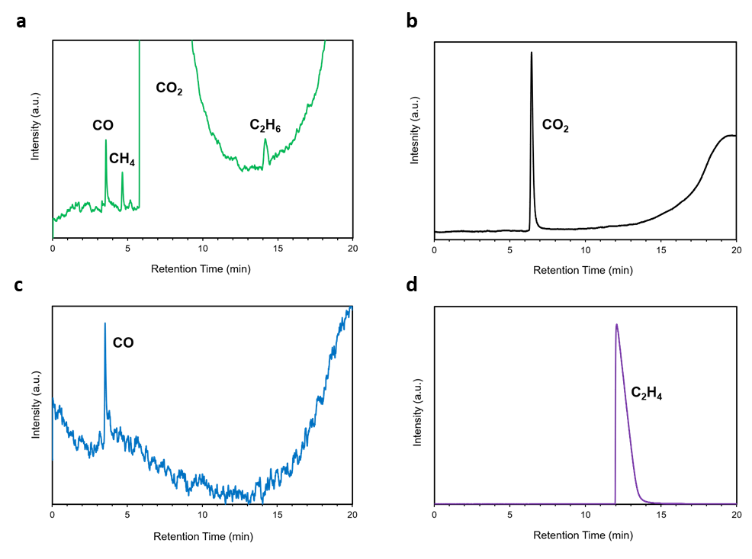
Figure S7. GC spectrum of the CO₂RR gaseous products. FID spectrum for CO₂RR Products using a, Ti₂N as the working electrode with applied current and continuous CO₂ flow, b, blank electrode substrate with applied current and continuous CO₂ flow, c, CO as feedstock, and d, ethylene as feedstock. Sample was obtained after the CO₂ reduction at applied current density of 25 mA cm⁻².

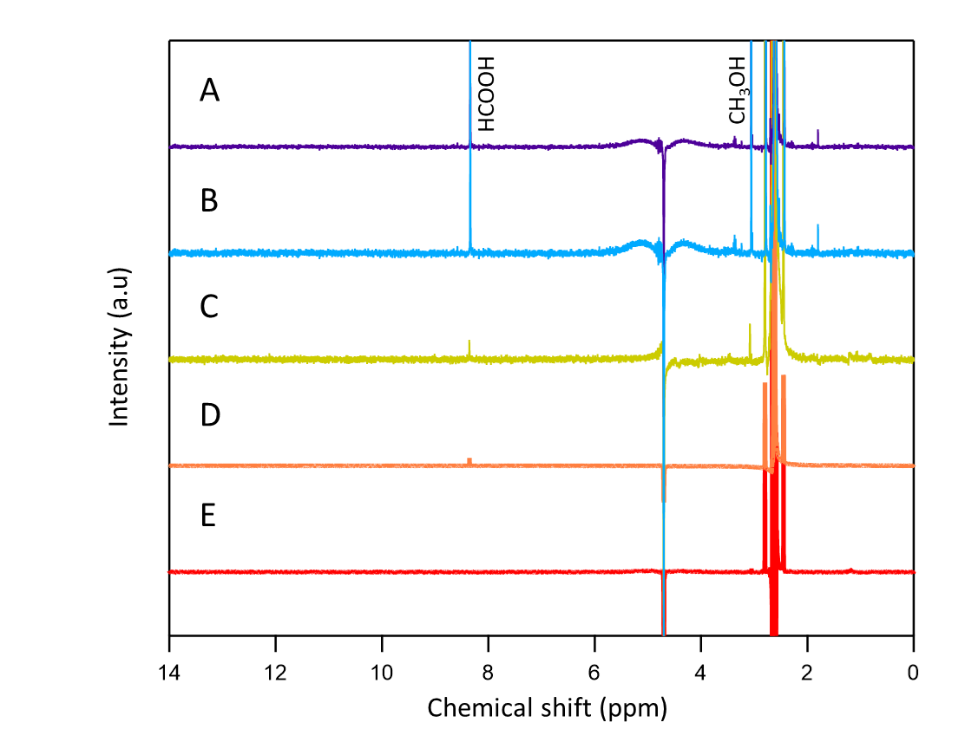
Figure S8. ¹H NMR spectrum of the CO₂RR liquid products. NMR spectrum obtained at current density of a, 50 mAcm⁻² b, 25 mAcm⁻² c, 10 mAcm⁻² d, electrocatalysis done using the substrate without Ti₂N catalyst e, Fresh bicarbonate. The NMR sample were obtained by mixing an aliquot of 0.5 mL of the electrolyte following the electrolysis process with 100 µL of D₂O and 0.03 μL dimethyl sulfoxide (DMSO) which was used as an internal standard. The one-dimensional ¹H spectrum was measured with water suppression using a pre-saturation method.

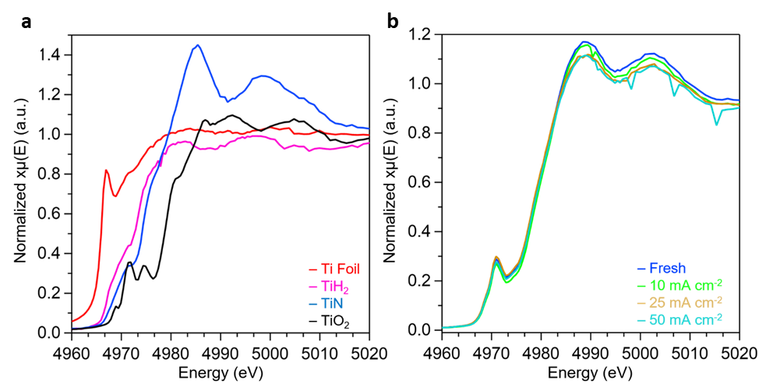
Figure S9. Characterization of Ti₂N spent electrodes. a, XANES region of the XAS spectra for the four reference samples, Ti foil (red), TiH₂ (purple), TiN (blue), and TiO₂ (black), to form the calibration curve used for Ti valence calculations. b, Focus on the XANES portion of the XAS spectra where calibration curve is used for Ti valence calculations. The spent catalysts were collected and dried after having a current density of 10 mA cm⁻² (green), 25 mA cm⁻² (orange), or 50 mA cm⁻² (cyan) applied for 120 minutes.

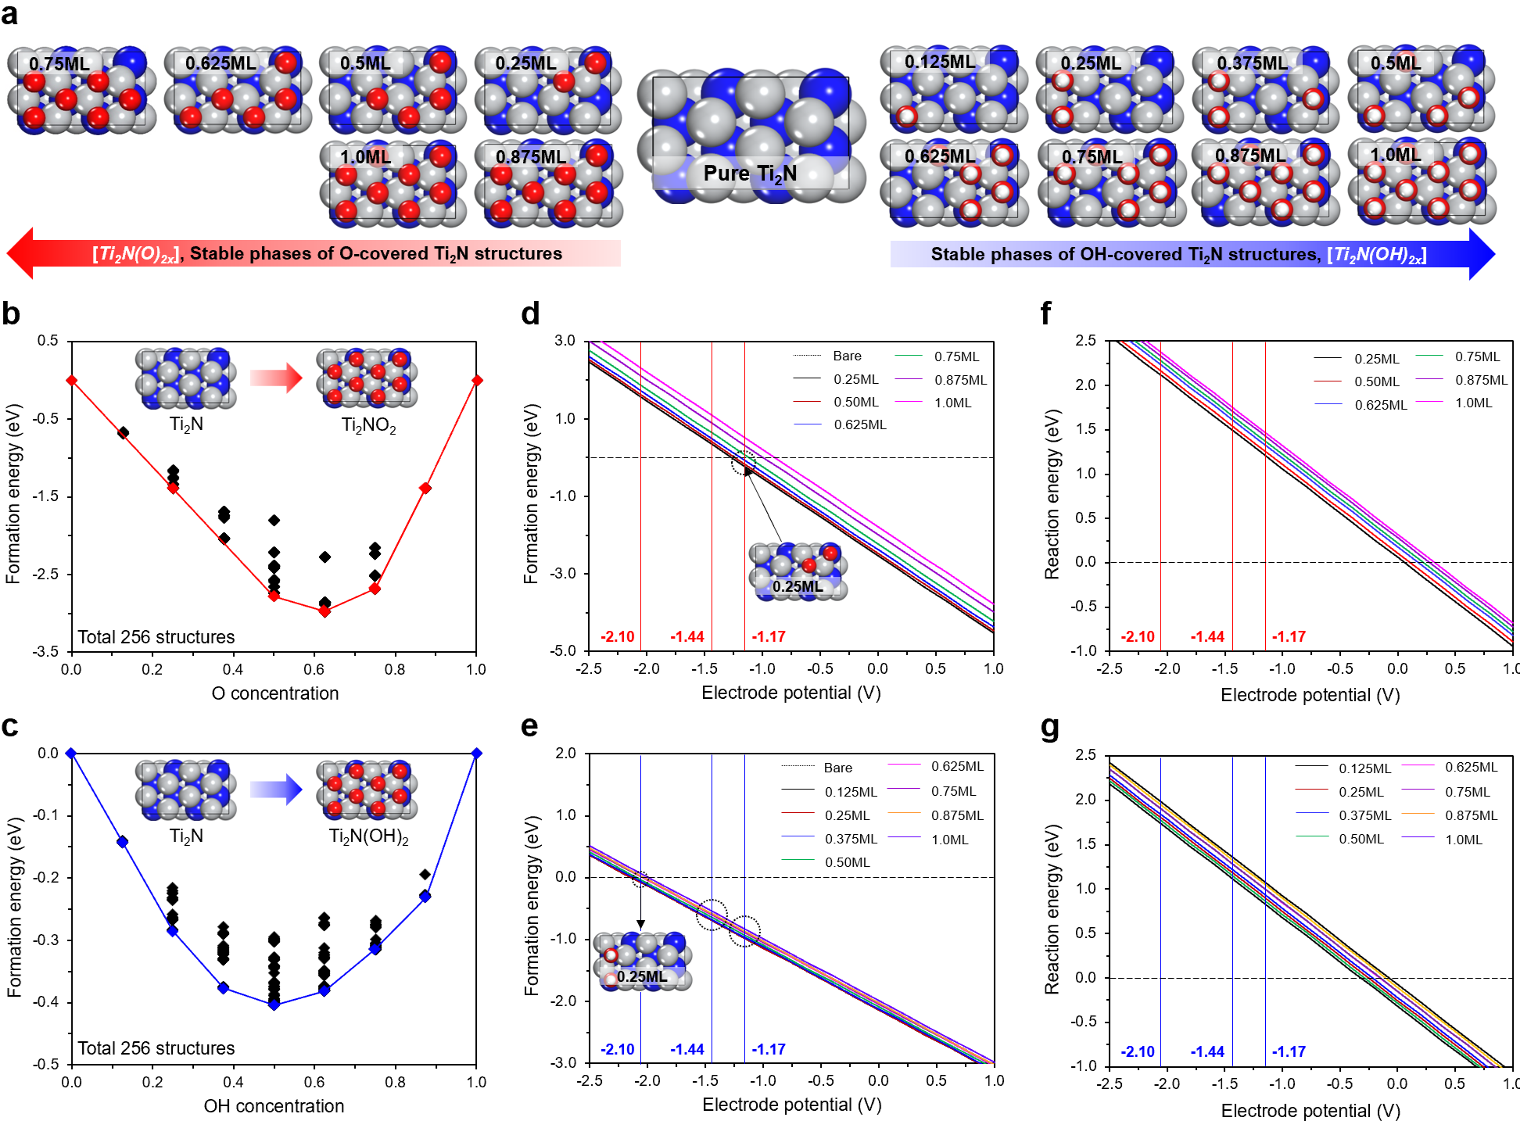
Figure S10. Ti₂N functional group modeling. a, Stable intermediate phases of O- and OH-covered Ti₂N structures. Convex hull diagrams for b, O- and c, OH-covered Ti₂N surfaces indicate the formation energies of different O- and OH-covered surfaces, respectively. Each point represents the E_{f} of ${Ti}_{2}N{[O or OH]}_{2x}$ configurations at a given O or OH concentration. Pourbaix diagrams for formation of d, O- and e, OH-covered Ti₂N surfaces. Reaction energies required for f, OOH transition and g, OHO transition, and the free energies are calculated as $∆G\left(U\right)=∆G\left(0\right)-neU$.

To discern the stable O- and OH-covered structures that could emerge under the water solvent environment (Fig. S10a), we investigated relative formation energies (E_{f}) corresponding to varying concentrations of O and OH, employing the Cluster Approach to Statistical Mechanics (CASM) approach (Fig. S10b and c). Specifically, we constructed convex hull diagram by considering all feasible configurations (total 256 each) of intermediate structures within the O- and OH-covered ranges of 0 ≤ x ≤ 1. Each point represents the E_{f} of ${Ti}_{2}N{[O or OH]}_{2x}$ configurations at a given O or OH concentration, adhering to the formula$E_{f}=E\left(one-phase solid solution\right)-E\left(two-phase composite\right)$ that breaks down to: $E_{f}=E\left({Ti}_{2}N{\left[O or OH\right]}_{2x}\right)-[xE\left({Ti}_{2}N\right)+\left(1-x\right)E\left({Ti}_{2}N{\left[O or OH\right]}_{2}\right)]$. The calculated results explicitly show that ${Ti}_{2}N{\left[O or OH\right]}_{2x}$ structures prefer the one-phase solid solution, as most of the E_{f} values are negative, indicating the higher stabilities of intermediate structures (Fig. S10b and c). From this result, we could identify five and seven stable intermediates of Ti₂NO_{2x} and Ti₂N(OH)_{2x}, respectively, corresponding to differing O (0.25, 0.5, 0.625, 0.75, and 0.875 ML) and OH concentrations (0.125, 0.25, 0.375, 0.5, 0.625, 0.75, and 0.875 ML).
We conducted a comprehensive analysis of variations in surface configurations of Ti₂N, the associated reaction mechanism, and catalytic activity under differing electrode potential conditions. Initially, informed by the experimental observations of predominant functionalization process on the Ti₂N surface (Fig. 1, Fig. S6), our emphasis was on identifying the stable O- and OH-covered structures that could emerge under the water solvent process by examining relative formation energies (E_{f}) corresponding to varying concentrations of O and OH. Specifically, we constructed a convex hull diagram by considering all feasible configurations of intermediate structures (Ti₂NO_{2x} and Ti₂N(OH)_{2x}) within the O- and OH-covered ranges of 0 ≤ x ≤ 1. Our analysis clearly reveals that intermediate structures have higher stabilities rather than the pure and fully covered structures, evidenced by the predominantly negative E_{f} values. Through this calculation, we could identify five and seven stable intermediates of Ti₂NO_{2x} and Ti₂N(OH)_{2x}, respectively, corresponding to differing O (0.25, 0.5, 0.625, 0.75, and 0.875 ML) and OH concentrations (0.125, 0.25, 0.375, 0.5, 0.625, 0.75, and 0.875 ML) (Fig. S10a).
Based on these findings, we delved further into the Pourbaix diagrams of the identified intermediates, with the aim of uncovering which surface configurations could stably exist under different applied potentials. Particularly, we directed our focus towards three distinct electrode potential values (-1.17, -1.44, and -2.10 V), pinpointed in our experiments, and systematically explored the surface configurations that could feasibly maintain stability at these specific potentials. The results (Fig. S10d and e) reveal that for O-covered Ti₂N, the intermediates can exclusively exist at -1.17 V with coverages of 0.25, 0.50, and 0.625 ML, of which the 0.25 ML demonstrates the highest thermodynamic stability. Moreover, at middle and high electrode potentials (-1.44 and -2.10 V, respectively), the preferred configuration undergoes a phase transition from an O-covered to a bare surface configuration. In contrast, for OH-covered Ti₂N, the identified seven intermediates can stably exist at low and middle potentials (-1.17 and -1.44 V), but at high potential (-2.10 V), only a coverage of 0.25 ML is thermodynamically favorable.
Building on these findings, we extended our investigation into the possible transitions between O- and OH-covered surface. This was spurred by the consideration that while the O-covered surface with 0.25 ML could be stable under specific potentials, its stability could be at risk if it can easily transition to OH-covered surfaces due to the proton supply from the solvent. However, our calculations show that under the three distinct potentials, the transition from O-covered to OH-covered surface (Fig. S10f) is not only a significant endothermic reaction but also the reverse reaction (Fig. S10g) exhibits a similar tendency, verifying that both processes are not easily achievable. This supports the stability of the O-covered and OH-covered intermediates as distinct configurations under the experimentally determined potentials. Here, we emphasize that the intricate interaction between the applied potential and surface configuration delivers significant implications, since it can directly impact the catalytic activity and, in principle, can serve as a guide for better understanding selective generation of C₂H₆ product based on reasonable configurations.

Table S1. Reaction free energies for the CO₂ conversion process (CH₃OH adsorption) on favorable active sites of three different Ti₂N surfaces, which can be generated under different electrode potentials (-1.17, -1.44, and -2.10 V). Asterisk (*) denotes adsorbed molecules. Red color indicates the reaction step where the CH₃OH resides on the T_{i2}N surface.
O site on Ti₂N surface  under low potential |  | OH site on Ti₂N surface  under middle potential |  | Bare site on Ti₂N surface  under high potential
$${∆G}_{1}$$  (CO₂*  COOH*) | 0.62 eV | $${∆G}_{1}$$  (CO₂*  HCOOH*) | -0.28 eV | $${∆G}_{1}$$  (CO₂*  OCHO*) | 0.53 eV
$${∆G}_{2}$$  (COOH*  HCOOH*) | -0.37 eV | $${∆G}_{2}$$  (HCOOH*  CHO*) | 0.18 eV | $${∆G}_{2}$$  (OCHO*  OCH₂O*) | -1.27 eV
$${∆G}_{3}$$  (HCOOH*  CHO*) | 0.20 eV | $${∆G}_{3}$$  (CHO*  H₂CO*) | -0.06 eV | $${∆G}_{3}$$  (OCH₂O*  HOCH₂O*) | 1.33 eV
$${∆G}_{4}$$  (CHO*  H₂CO*) | -0.25 eV | $${∆G}_{4}$$  (H₂CO*  CH₂OH*) | 0.61 eV | $${∆G}_{4}$$  (HOCH₂O*  OCH₃OH*) | -1.14 eV
$${∆G}_{5}$$  (H₂CO* CH₂OH*) | 0.77 eV | $${∆G}_{5}$$  (CH₂OH*  CH₃OH*) | -1.33 eV | $${∆G}_{5}$$  (OCH₃OH*  OCH₃*) | 1.39 eV
$${∆G}_{6}$$  (CH₂OH* CH₃OH*) | -1.51 eV | $${∆G}_{6}$$  (CH₃OH*  CH₃*) | 0.73 eV | $${∆G}_{6}$$  (OCH₃*  O*) | -2.49 eV
$${∆G}_{7}$$  (CH₃OH*CH₃*) | 0.88 eV | $${∆G}_{7}$$  (CH₃*  * - H) | -1.68 eV | $${∆G}_{7}$$  (O*  OH*) | 0.49 eV
$${∆G}_{8}$$  (CH₃*  *) | -1.69 eV | $${∆G}_{8}$$  (* - H  *) | 0.52 eV | $${∆G}_{8}$$  (OH*  *) | 2.05 eV

Table S2. Reaction free energies for the CO₂ conversion process (CH₄ and C₂H₆ generation) on favorable active sites of three different Ti2N surfaces, which can be generated under different electrode potentials (-1.17, -1.44, and -2.10 V). Asterisk (*) denotes adsorbed molecules. Red and blue colors indicate the energies required for CH₄ and C₂H₆ generations, respectively.
O site on Ti₂N surface  under low potential |  | OH site on Ti₂N surface  under middle potential |  | Bare site on Ti₂N surface  under high potential
$${∆G}_{1}$$  (CO₂*  HCOOH*) | -0.09 eV | $${∆G}_{1}$$  (CO₂*  HCOOH*) | -0.24 eV | $${∆G}_{1}$$  (CO₂*  HCOOH*) | 0.06 eV
$${∆G}_{2}$$  (HCOOH*  CHO*) | 0.16 eV | $${∆G}_{2}$$  (HCOOH*  CHO*) | 0.11 eV | $${∆G}_{2}$$  (HCOOH*  CHO*) | 0.46 eV
$${∆G}_{3}$$  (COOH*  CHO*) | -0.07 eV | $${∆G}_{3}$$  (COOH*  CHO*) | -0.07 eV | $${∆G}_{3}$$  (COOH*  CHO*) | -0.61 eV
$${∆G}_{4}$$  (CHO*  H₂CO*) | 0.69 eV | $${∆G}_{4}$$  (CHO*  H₂CO*) | 0.35 eV | $${∆G}_{4}$$  (CHO*  H₂CO*) | 0.30 eV
$${∆G}_{5}$$  (CH₂OH*  CH₃OH*) | -1.56 eV | $${∆G}_{5}$$  (CH₂OH*  CH₃OH*) | -1.11 eV | $${∆G}_{5}$$  (CH₂OH*  CH₃OH*) | -0.73 eV
$${∆G}_{6}$$  (CH₃OH* CH₃*) | 0.39 eV | $${∆G}_{6}$$  (CH₃OH*  2H₂O*) | -2.16 eV | $${∆G}_{6}$$  (CH₃OH*  * - 2H) | -1.63 eV
$${∆G}_{7}$$  (CH₃*  * - H) | -1.21 eV | $${∆G}_{7}$$  (2H₂O*  H₂O*) | -0.80 eV | $${∆G}_{7}$$  (* - 2H  * - H) | -1.60 eV
$${∆G}_{8}$$  (* - H  *) | 0.41 eV | $${∆G}_{8}$$  (H₂O*  *) | -0.51 eV | $${∆G}_{8}$$  (* - H  *) | 0.41 eV
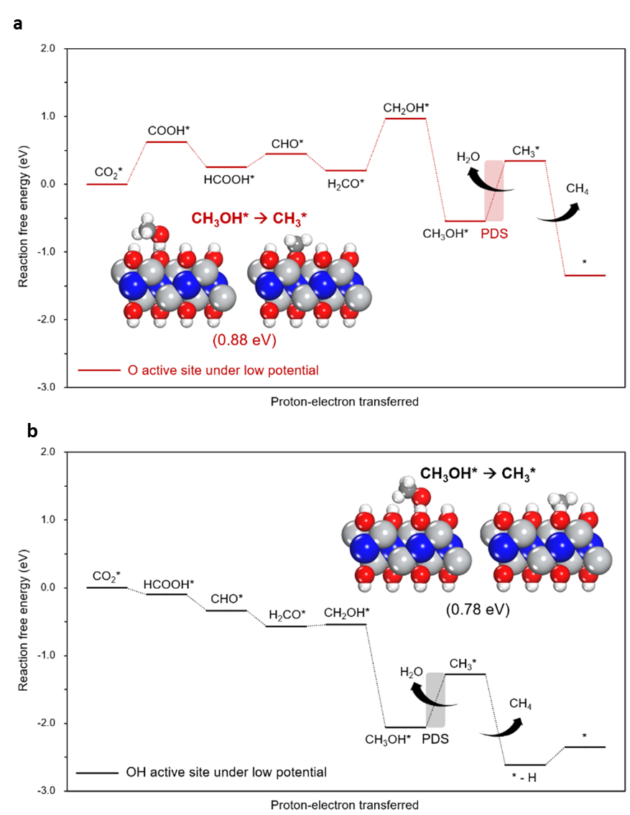
Figure S11. Free energy diagram (FED) for CH₃OH generation on a, O-covered and b, OH-covered active sites of Ti₂N surfaces under low electrode potentials (-1.17 V). The inset figures indicate the reaction for C₂H₆ generations as potential-determining step (PDS).

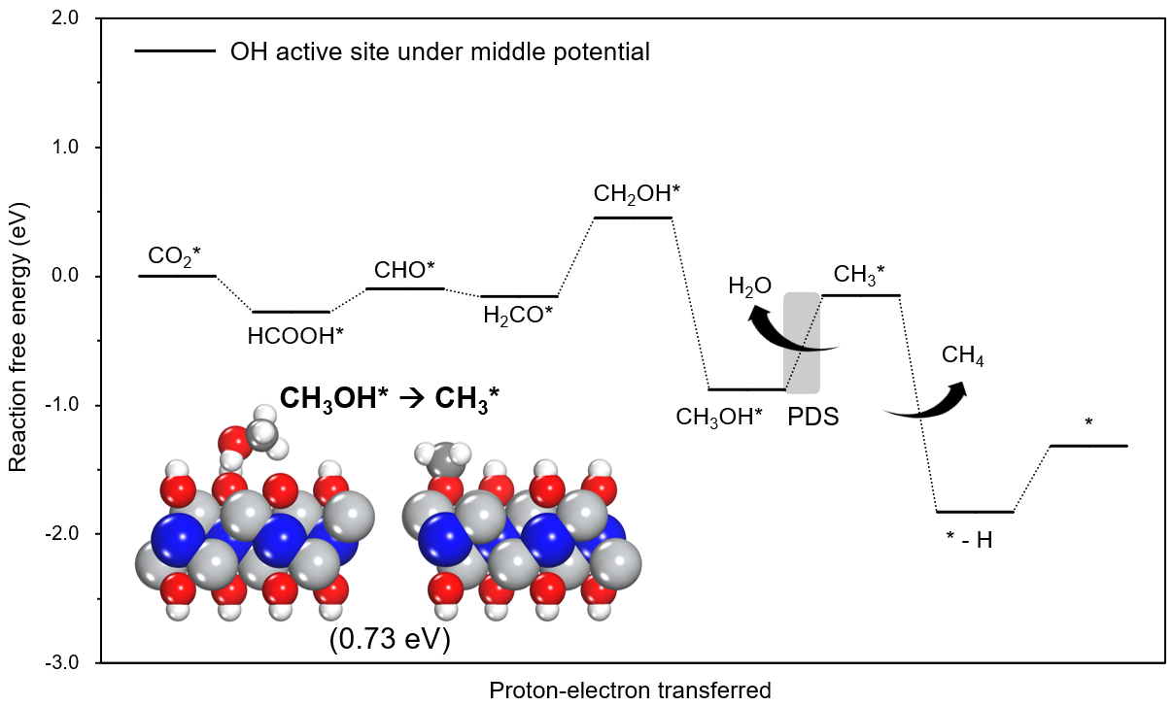
Figure S12. Free energy diagram (FED) for CH₃OH generation on OH-covered active sites of Ti₂N surfaces under middle electrode potentials (-1.44 V). The inset figures indicate the reaction for C₂H₆ generations as potential-determining step (PDS).
.

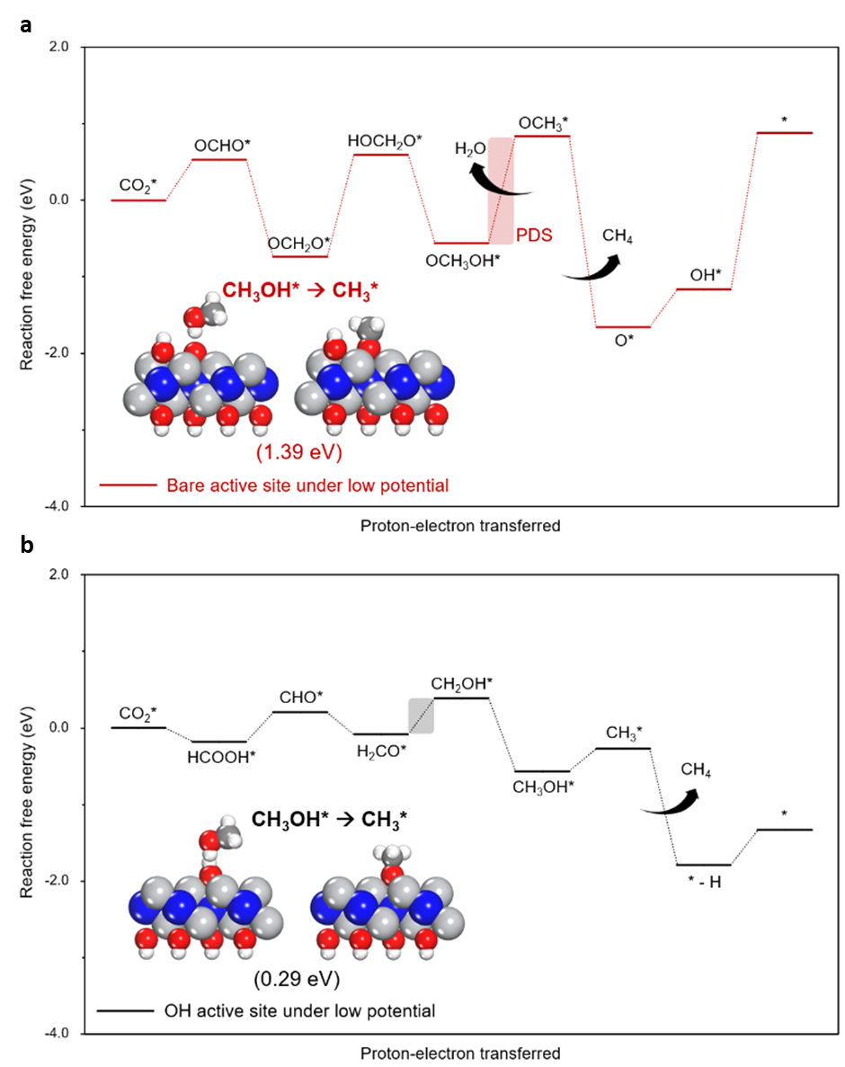
Figure S13. Free energy diagram (FED) for CH₃OH generation on a, Bare- b, OH-covered active sites of Ti₂N surfaces under high electrode potentials (-2.10 V). The inset figures indicate the reaction for C₂H₆ generations as potential-determining step (PDS).

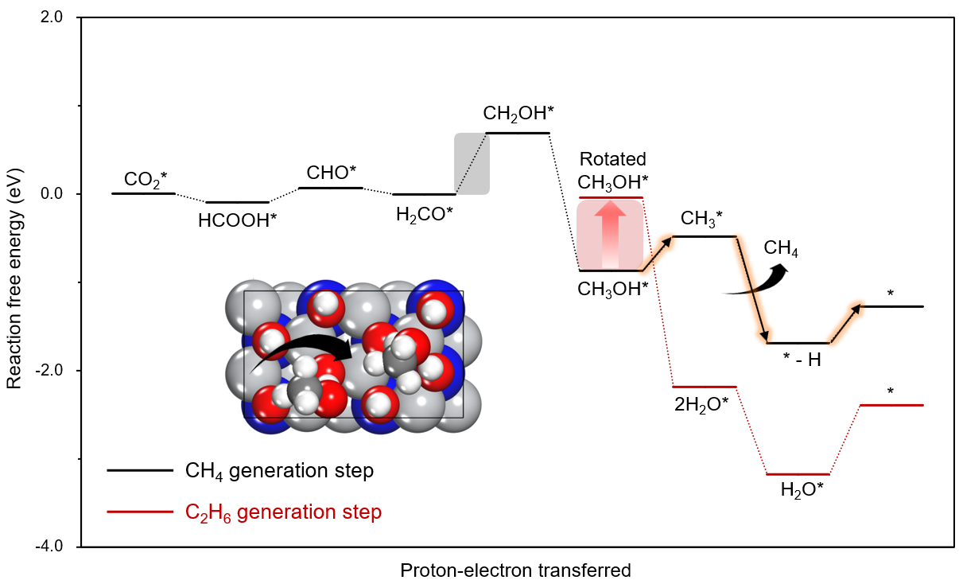
Figure S14. Free energy diagram (FED) for CH₄ and C₂H₆ generation on O-covered active sites of Ti₂N surfaces under low electrode potentials (-1.17 V). The inset figure indicates the rotating process of C₂H₆ required for a significantly high reaction potential.

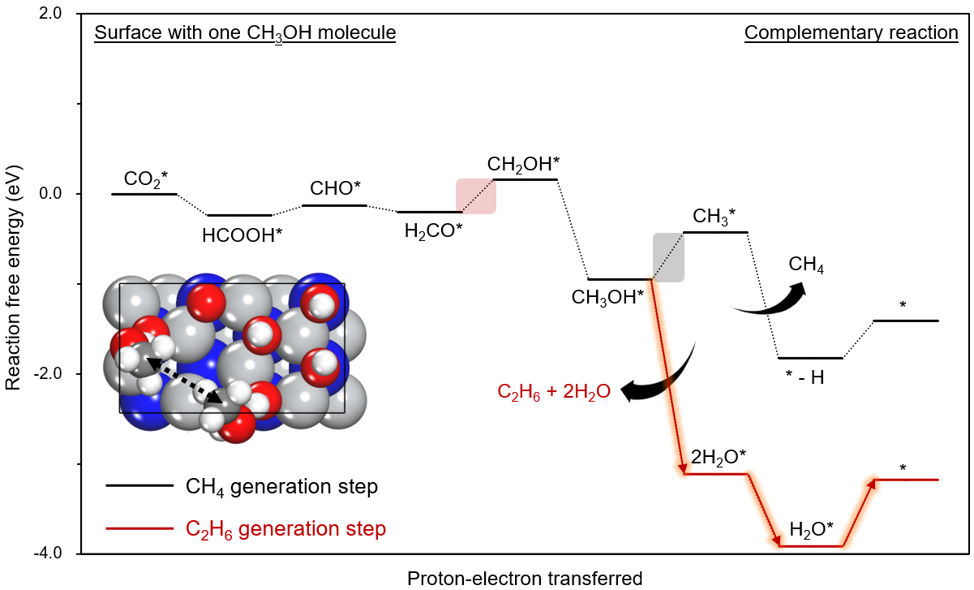
Figure S15. Free energy diagram (FED) for CH₄ and C₂H₆ generation on OH-covered active sites of Ti₂N surfaces under middle electrode potentials (-1.44 V). The inset figure indicates the reaction of C₂H₆ generation based on complementary reaction mechanism.

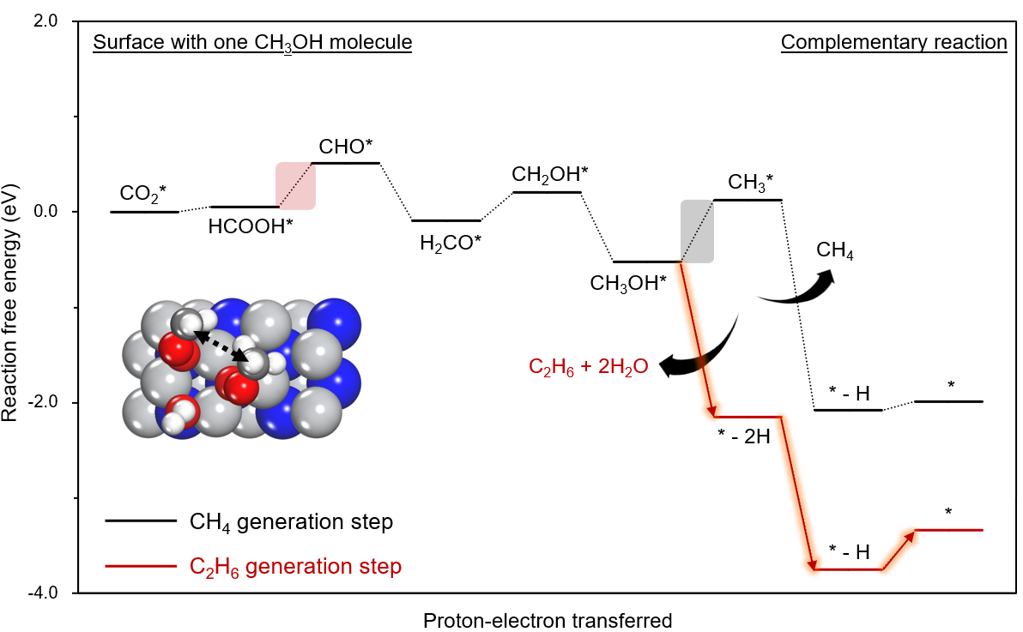
Figure S16. Free energy diagram (FED) for CH₄ and C₂H₆ generation on OH-covered active sites of Ti₂N surfaces under high electrode potentials (-2.10 V). The inset figure indicates the reaction of C₂H₆ generation based on complementary reaction mechanism.

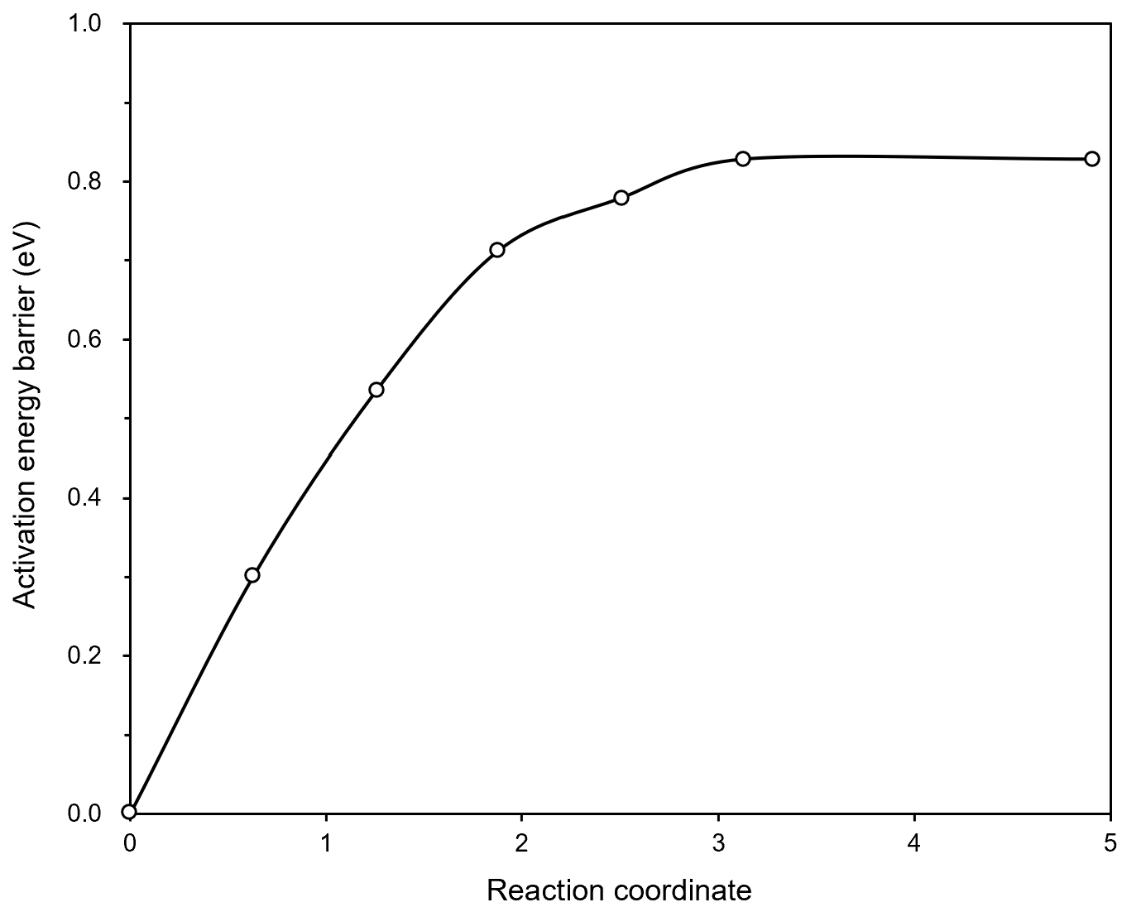
Figure S17. Activation energy barrier required for the rotating process of CH₃OH molecule on the Ti₂N surface under low electrode potential (-1.17 V).

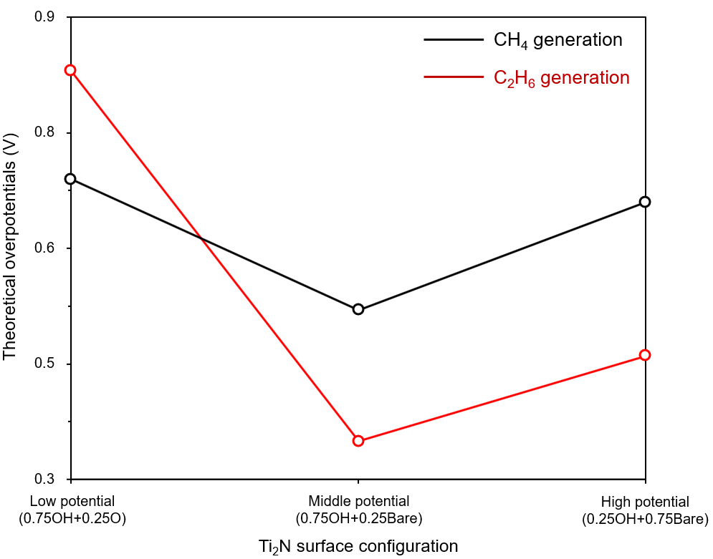
Figure S18. Theoretical overpotential trends required for CH₄ and C₂H₆ generations for different Ti₂N surfaces, which can be generated under different electrode potentials (-1.17, -1.44, and -2.10 V).

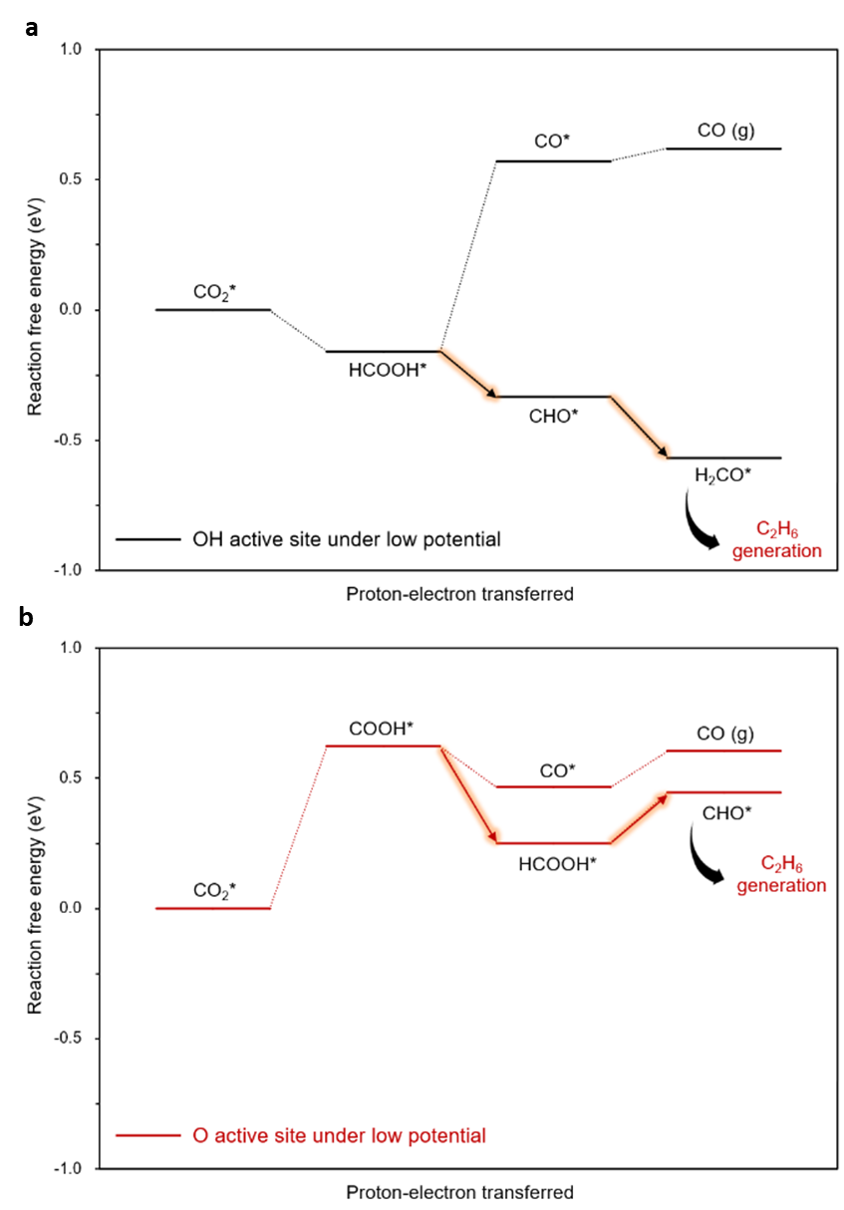
Figure S19. Free energy diagram (FED) for CO and C₂H₆ generation on a, OH- b, O-covered active sites of Ti₂N surfaces under low electrode potentials (-1.17 V).

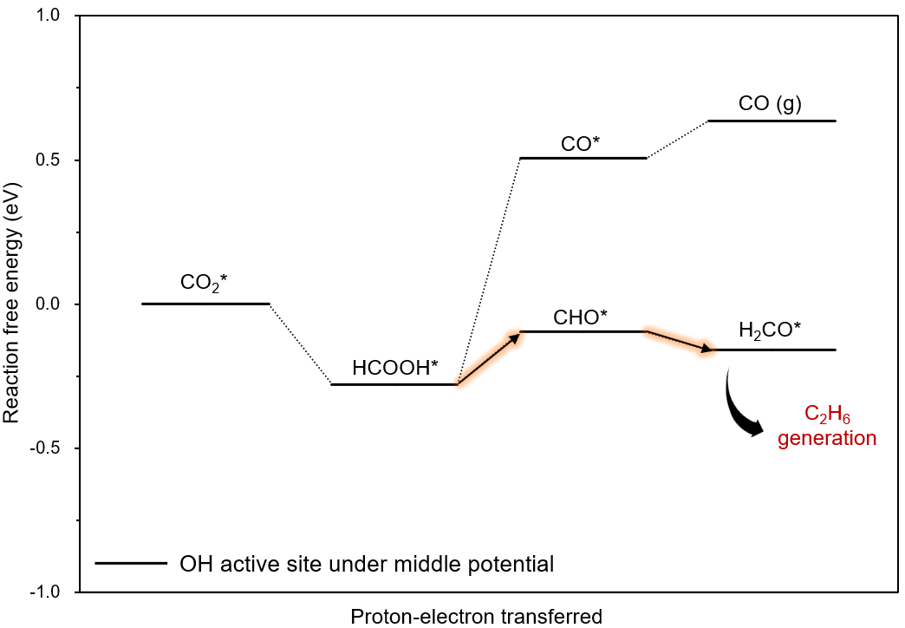
Figure S20. Free energy diagram (FED) for CO and C₂H₆ generation on OH-covered active sites of Ti₂N surfaces under middle electrode potentials (-1.44 V).

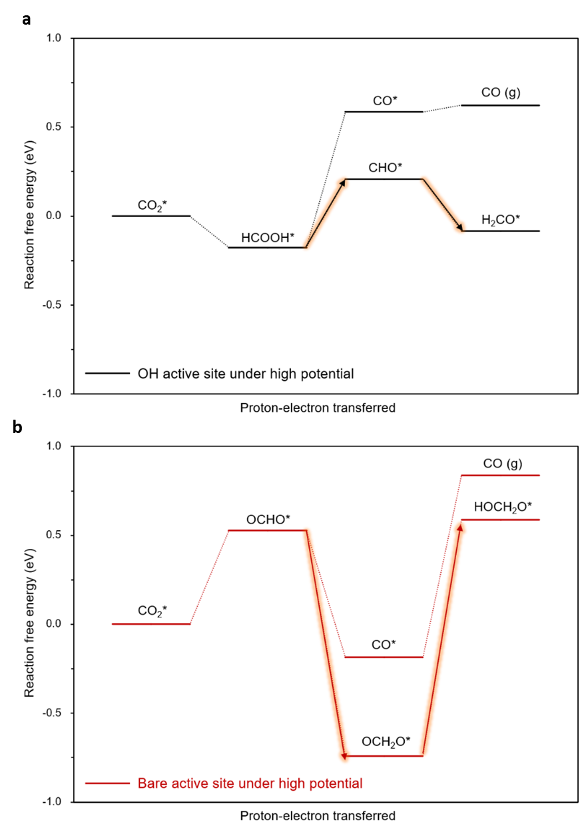
Figure S21. Free energy diagram (FED) for CO and C₂H₆ generation on a, OH- b, Bare-covered active sites of Ti₂N surfaces under high electrode potentials (-2.10 V).

