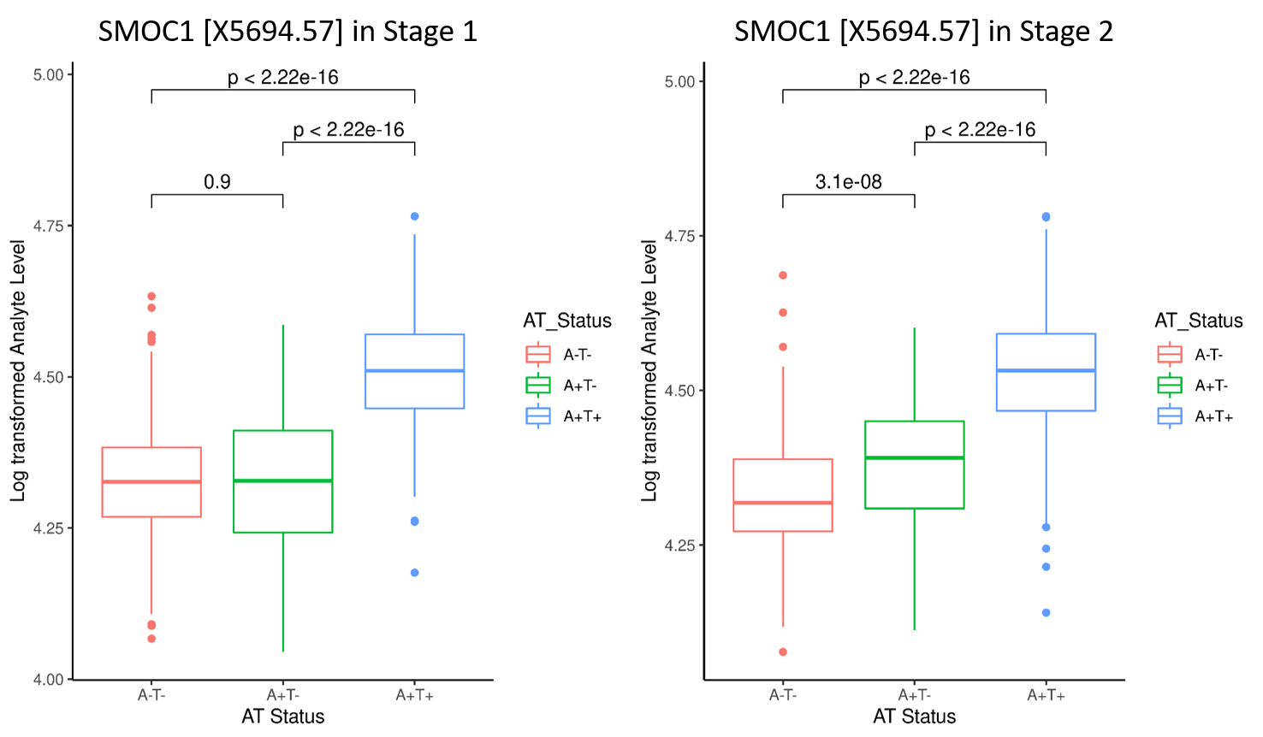
Supplementary Figure 1: Protein expression level across different AT strata. CSF proteomic abundance of an AD-biomarker protein (SMOC1) across different AT groups (A-T-, A+T-, and A+T+) in Stage1 (Knight ADRC and FACE) and Stage2 cohorts (ADNI and Barcelona-1).

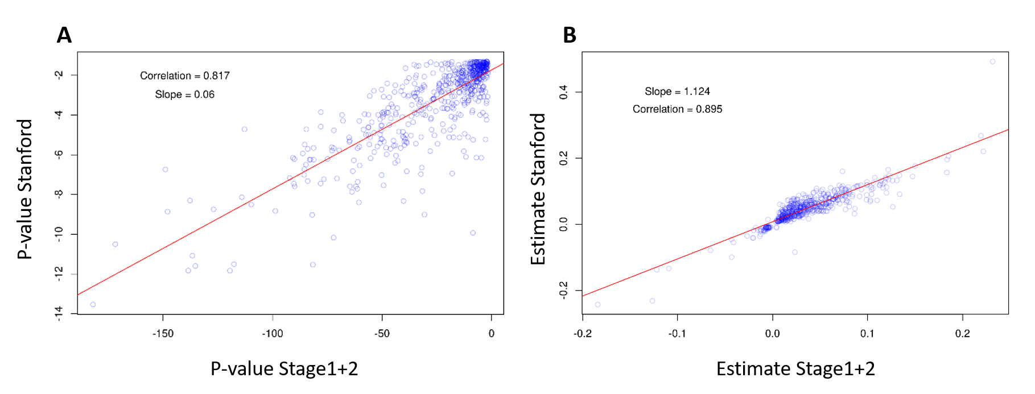
Supplementary Figure 2: Replication in external dataset (Stanford ADRC). Correlation of unadjusted P-values (A) and Estimates (B) for proteins (N=577) that are altered between A-T- and A+T+ individuals in the stage1+2 meta-analysis (P-Bonf < 0.05) and Stanford ADRC cohort (P < 0.05; Stanford). Both estimates and p-values have been transformed to log10 scale.

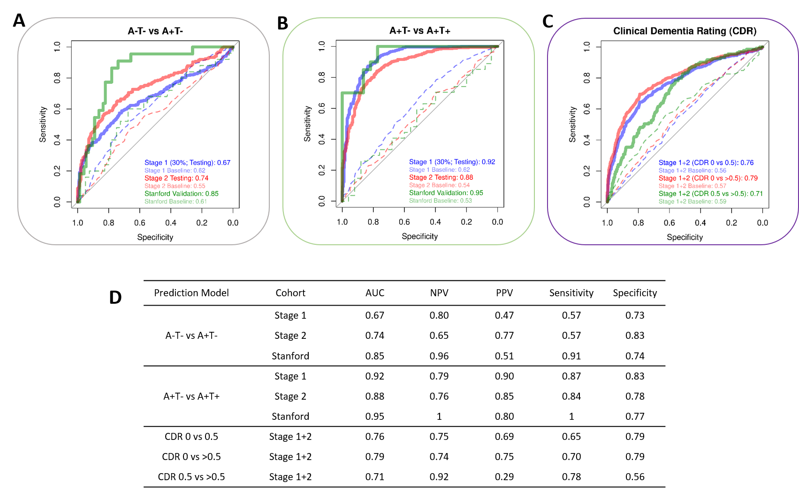
Supplementary Figure 3: Performance of AD prediction model. Performance of 11 analytes AD prediction model in distinguishing healthy controls from A) early-stage (A-T- vs. A+T-), B) late-stage (A+T- vs. A+T+) AD individuals, and at different CDR-scales (CDR 0 vs. 0.5, CDR 0 vs. >0.5, and CDR 0.5 vs. >0.5). D) Different model performance measures (e.g. AUC, NPV, PPV) for the tested prediction models.

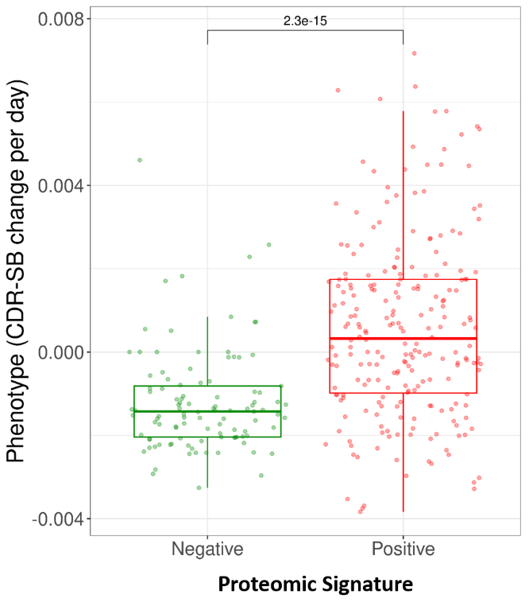
Supplementary Figure 4: Change of CDR-SB across proteomic signature (biomarker) positive and negative individuals. A boxplot showing the difference in the rate of disease progression (CDR-SB) between predicted biomarker–positive and –negative individuals.

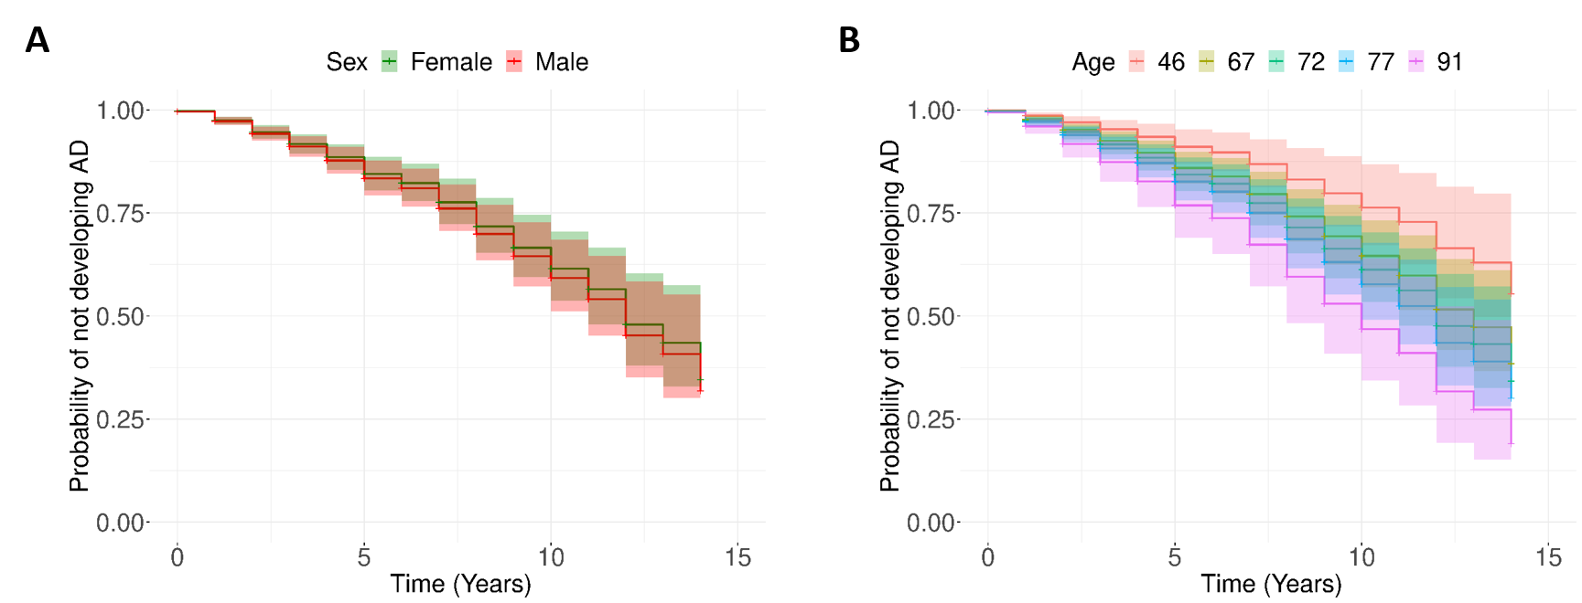
Supplementary Figure 5: Effect of covariates (age and sex) on probability for not developing AD. Cox-Proportional Hazards Model using sex (A) and age (B) as covariates.

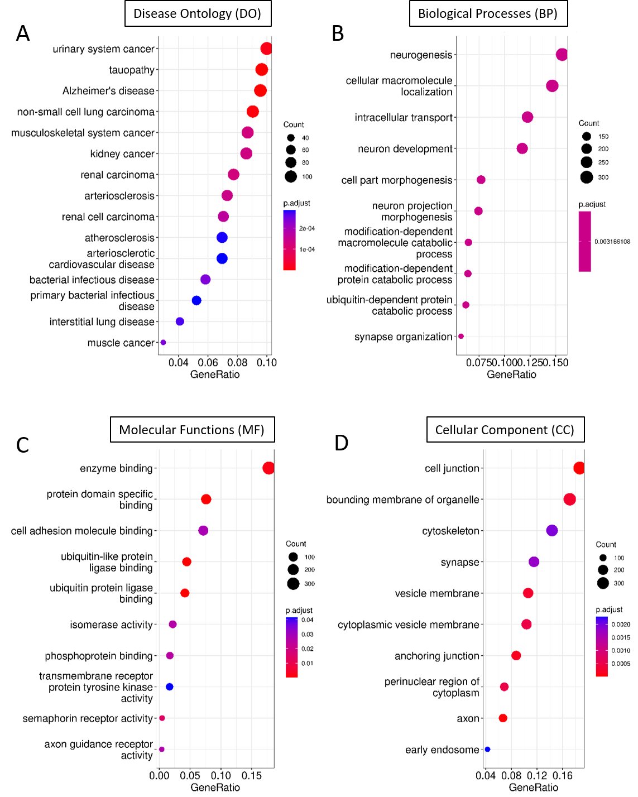
Supplementary Figure 6: Pathway enrichment analysis for differentially expressed proteins. Pathway enrichment analysis for complete set of unique proteins (N=2030) differentially abundant between A+T+ and controls A-T-. A) Disease ontology (DO) enrichment analysis, B) Gene Ontology (GO) Biological processes, C) Molecular functions, D) and cellular components.

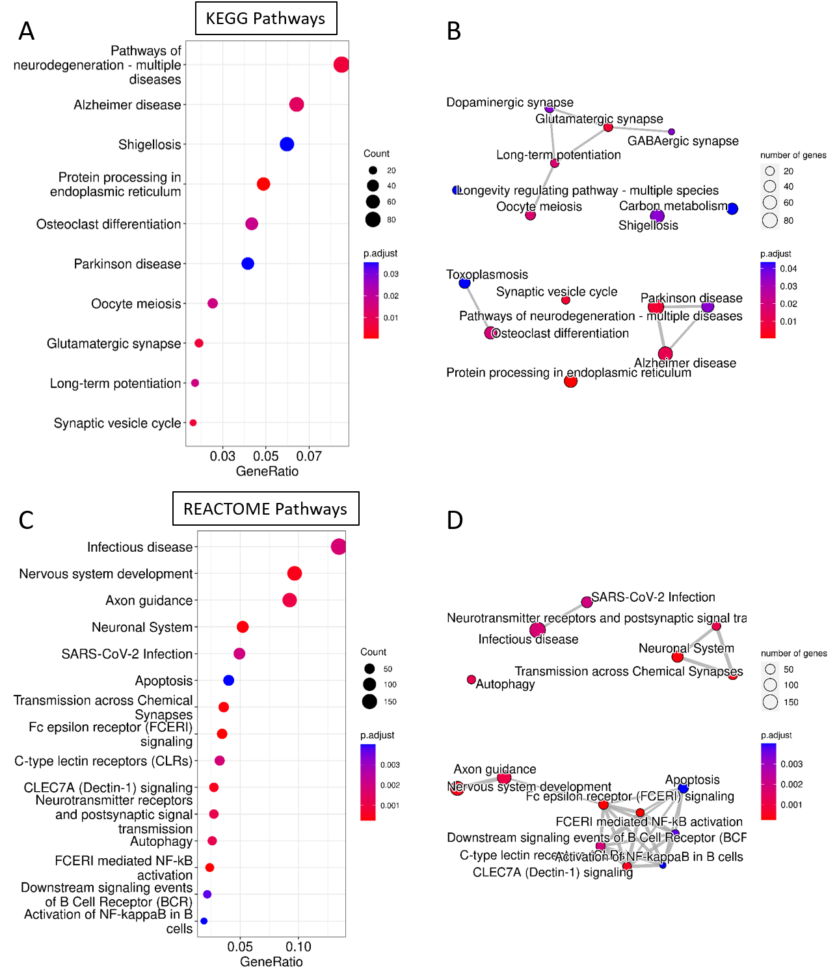
Supplementary Figure 7: Over-representation analysis using KEGG and REACTOME database. Pathway enrichment analysis for complete set of unique proteins (N=2030) differentially abundant between A+T+ and A-T-. A) KEGG pathway enrichment analysis, B) and interactions among those pathways. C) Reactome pathway enrichment analysis, D) and interactions among those pathways.

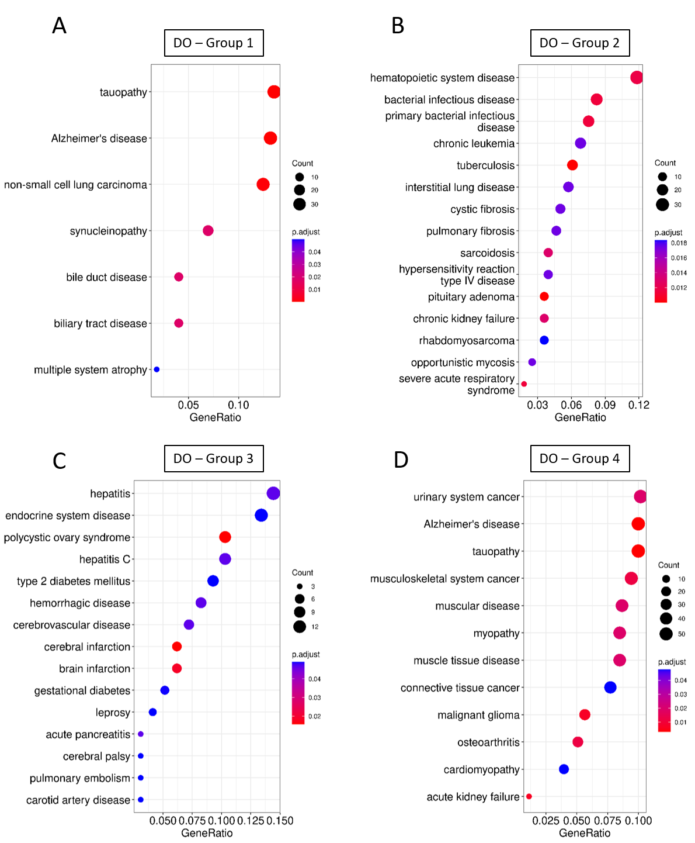
Supplementary Figure 8: Over-representation analysis for disease ontology (DO). DO enrichment analysis individually performed on 4 different groups (Group 1-4) of proteins differentially abundant between A+T+ and A-T-.

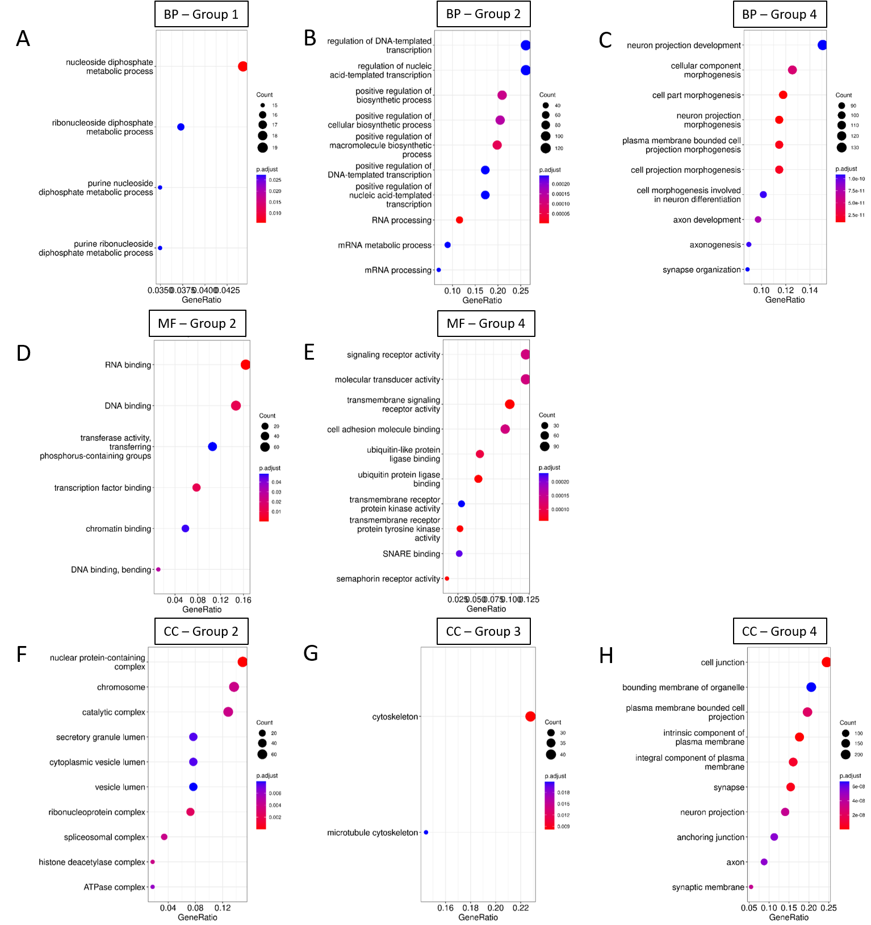
Supplementary Figure 9: Over-representation analysis for Gene Ontology (GO). GO enrichment analysis for biological processes (BP; A,B,C), molecular functions (MF; D,E), and cellular components (CC; F,G,H) individually performed on 4 different groups of proteins differentially abundant between A+T+ and A-T-. Only pathways passing the significance threshold (P-FDR < 0.05) are shown.

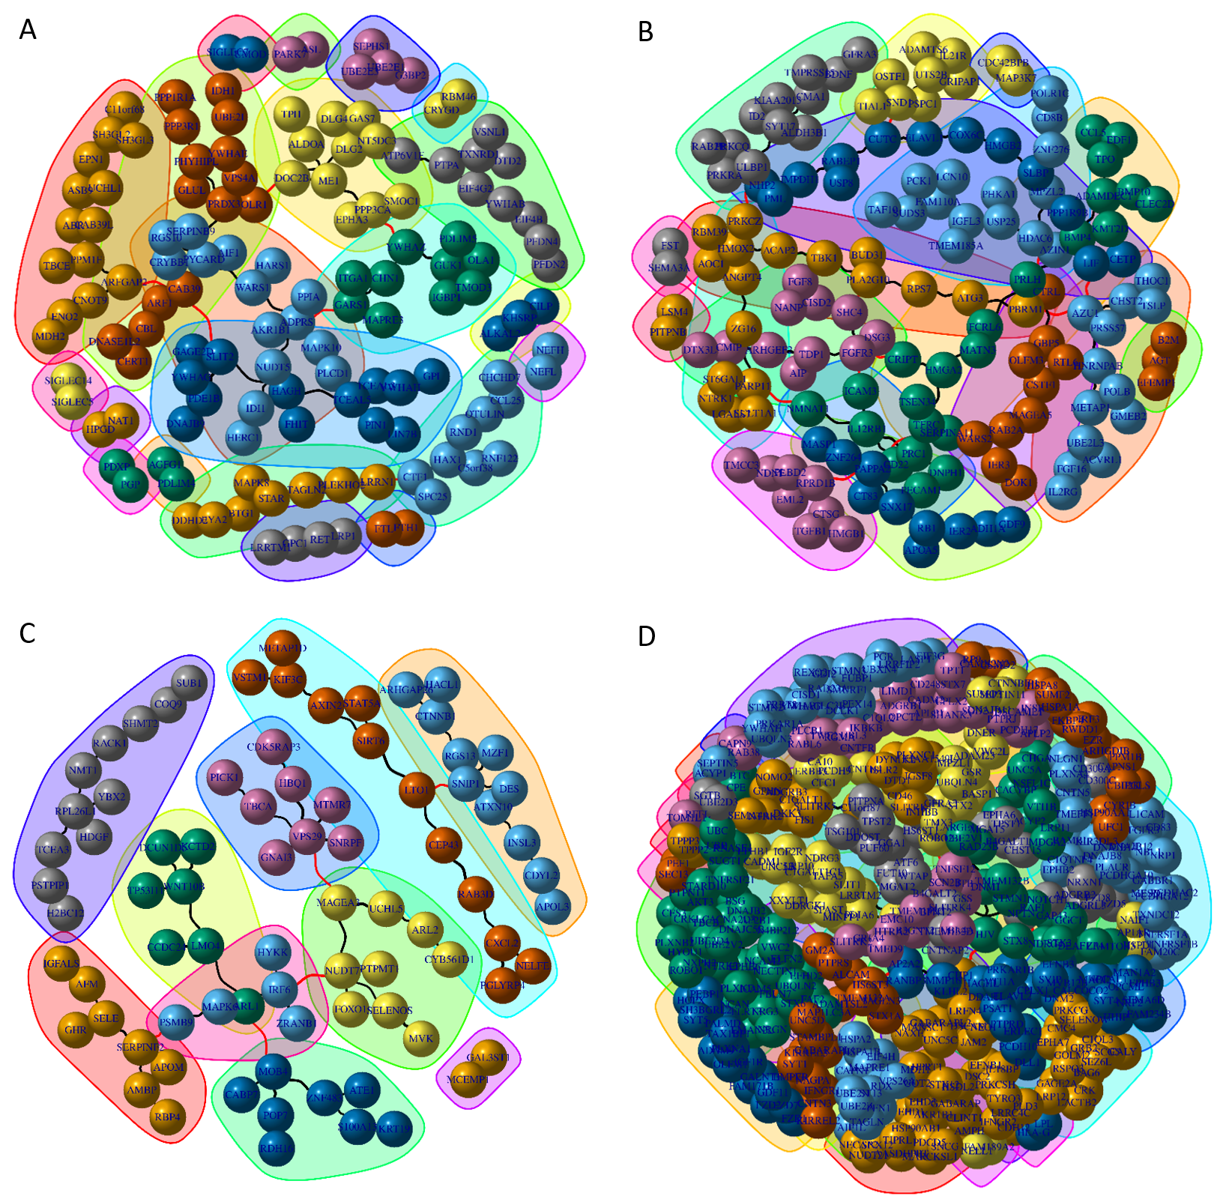
Supplementary Figure 10: Protein co-expression based network community analysis. A network community detection algorithm was used to perform protein co-expression based network analysis, individually for each protein group. Proteins in group 1 contained 17 different communities (A). Group 2 comprised of 17 communities (B) and group 3 had only 10 different communities (C) with a maximum of 12 different proteins (red nodes). Finally, group 4 contained 38 different communities. Only network communities containing highly co-expressed (cor > 0.7) proteins are shown.

