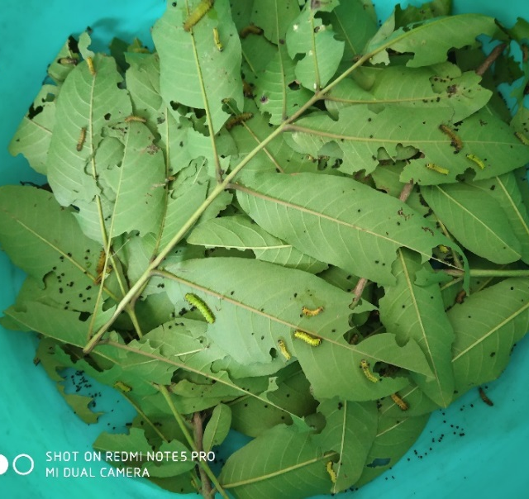
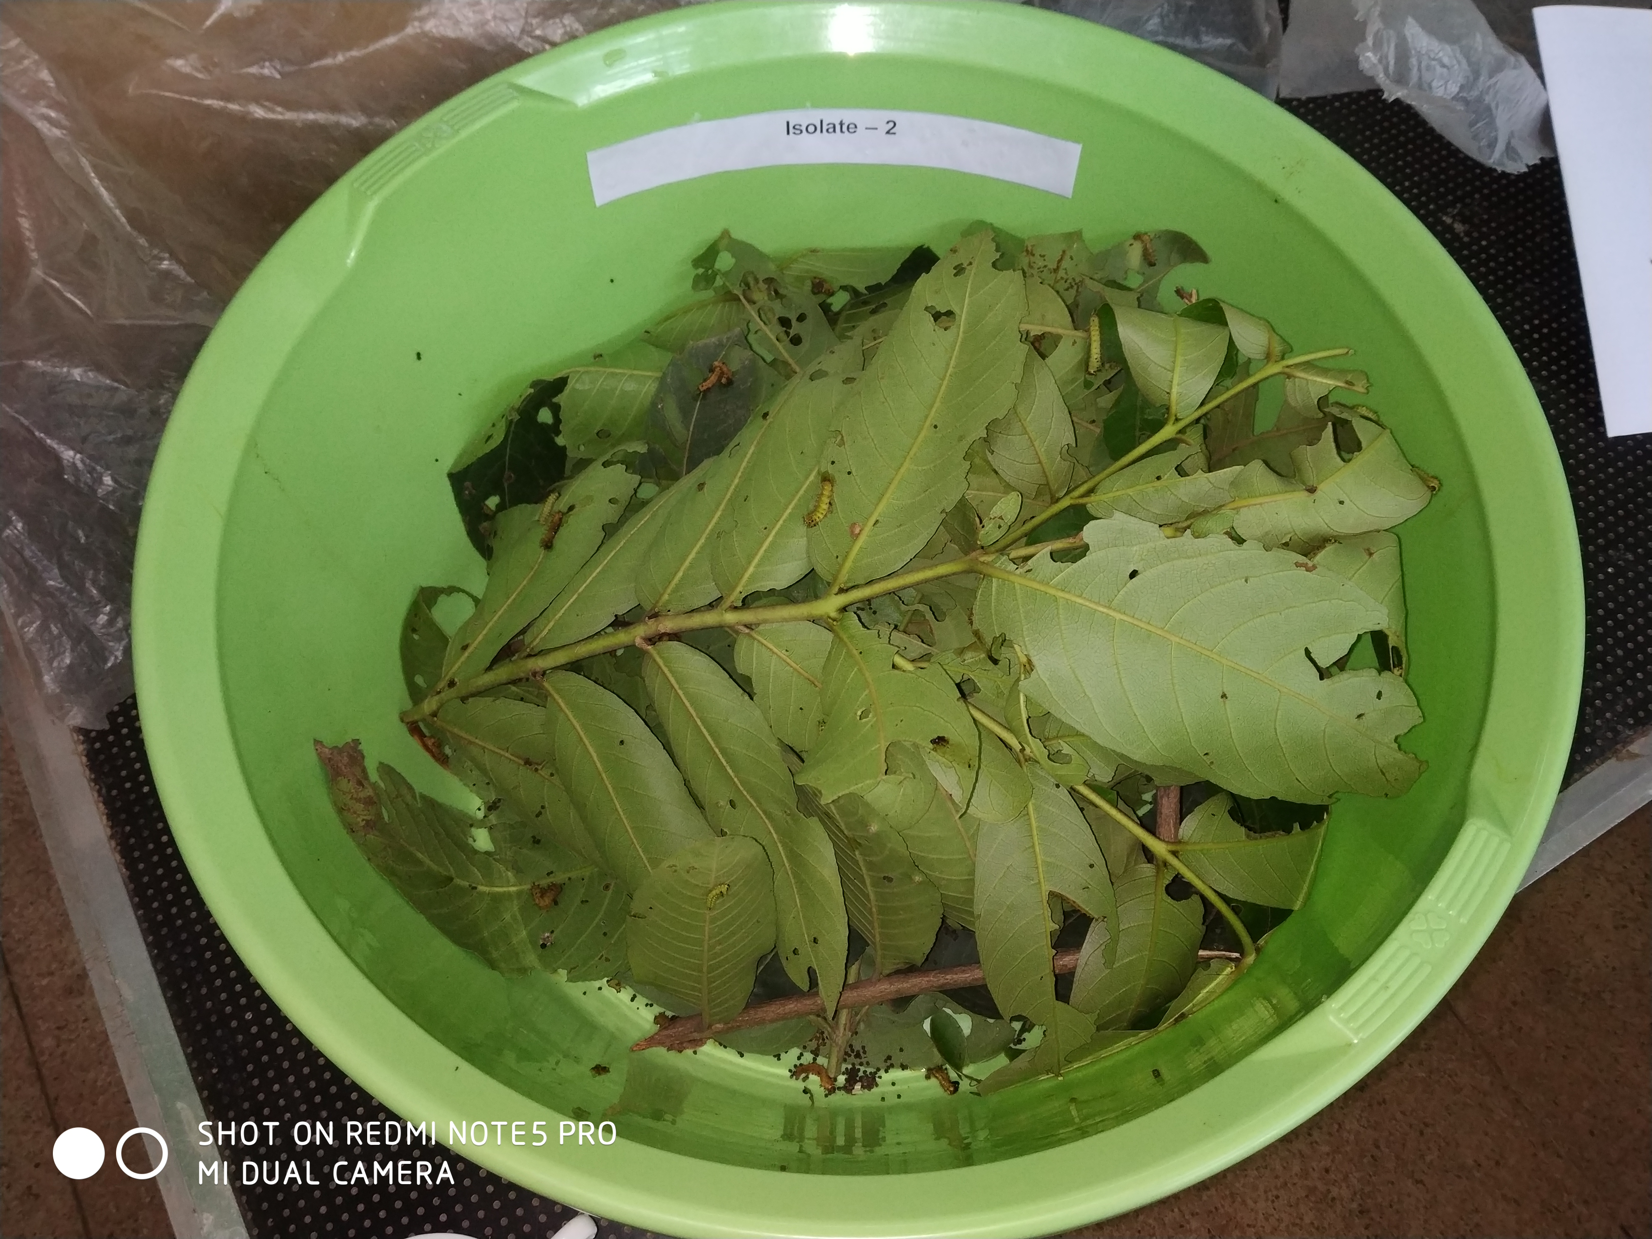
Supplementary figures
(b)
(a)
Fig. S1 Pathogenicity test of SBP-1 strain on second instar tasar silkworm larva. Inoculated larvae were reared in plastic tub (a) silkworm have shown high mortality after 48 hours after inoculation (b).

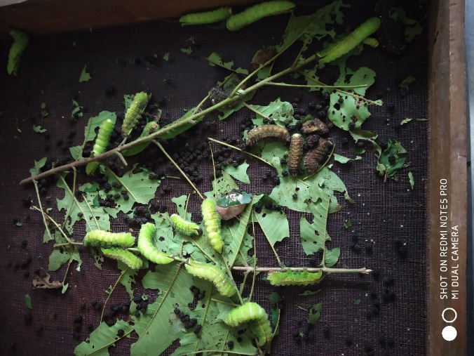
Fig.S2 Pathogenicity test of SBP-1 strain on fourth instar tasar silkworm larva. SBP-1 caused less mortality in fourth instar larvae as compared to second instar.

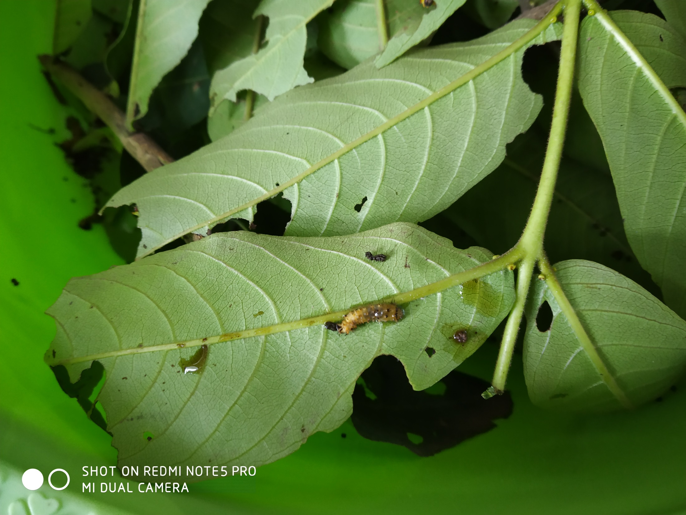
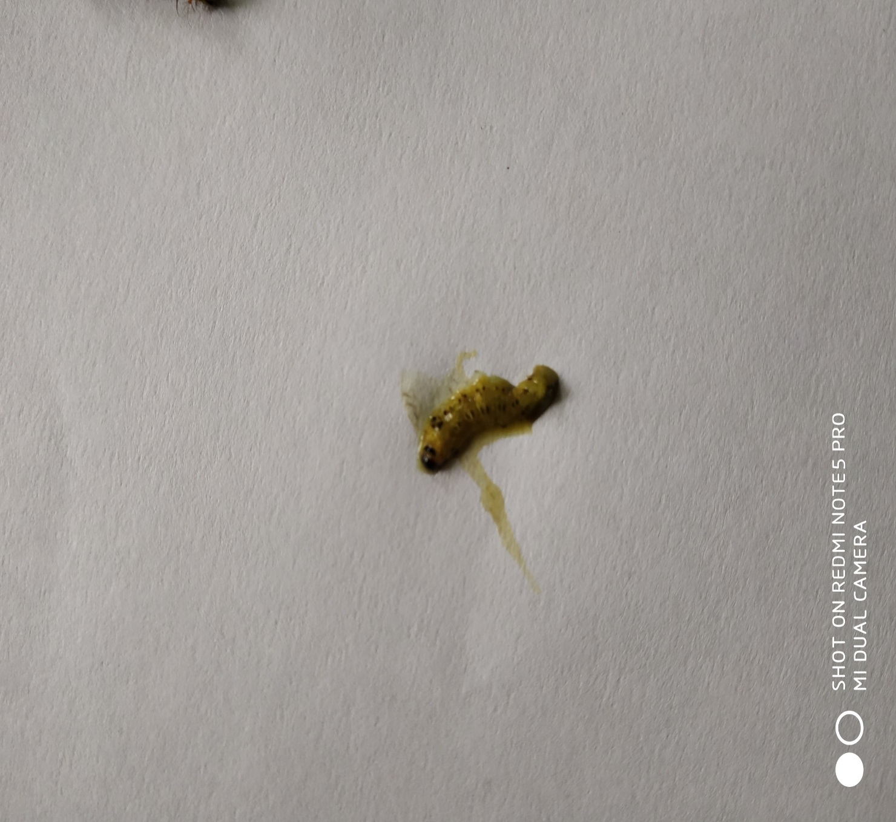
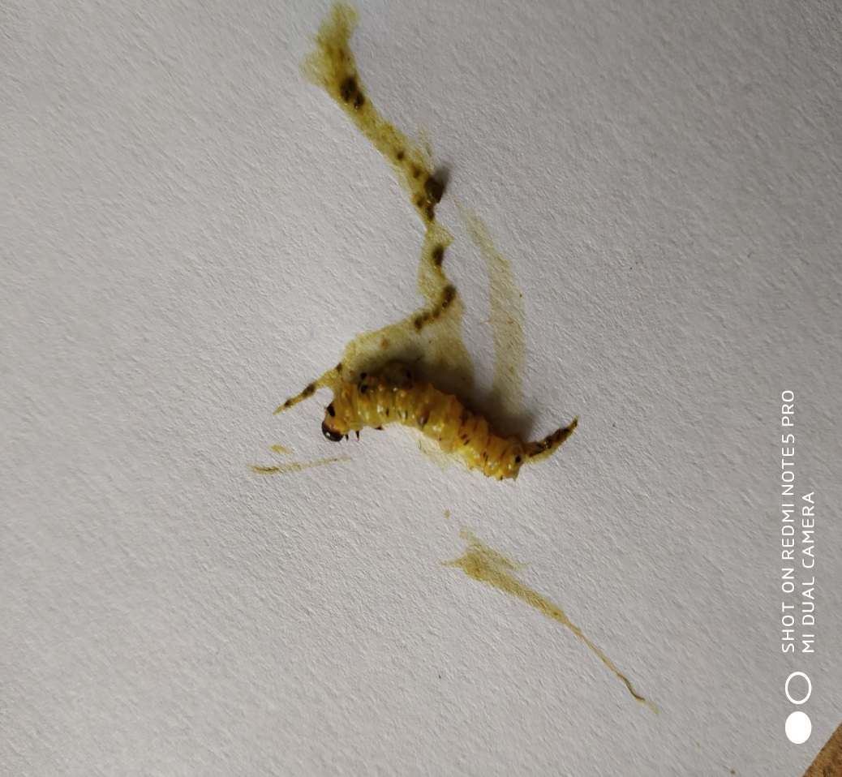
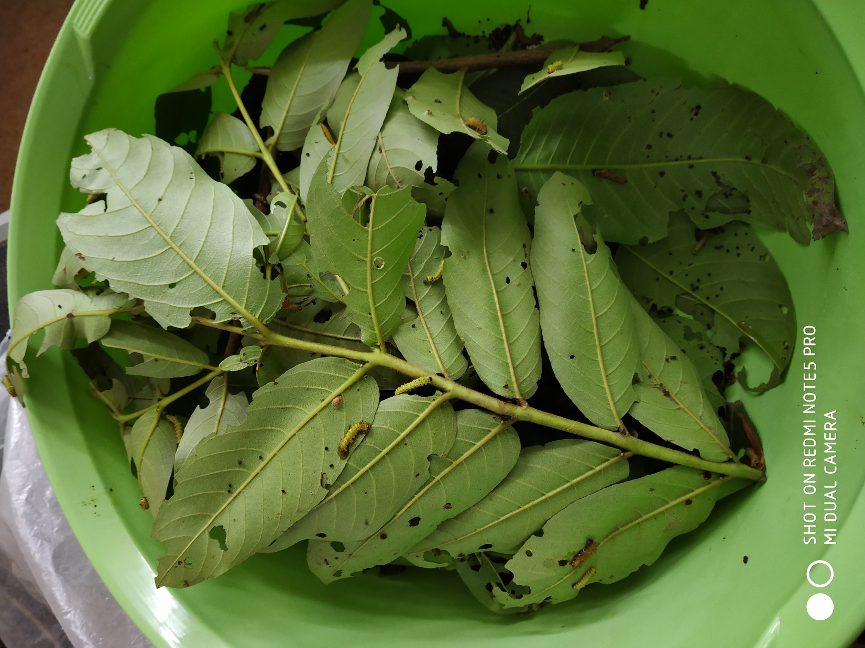
(a)
(b)
(c)
(d)

Fig. S3: Symptoms of second instar tasar silkworm larva infected with bacterial pathogen. 48 h after pathogen inoculation some larvae defecate liquid (a), body becomes shine and soft (b), sometime its body will rupture (c) body content will comes out (d).

