Supplementary Information

Fully 3D Printed Biodegradable, Wireless, and Smart Bioimplants with Voxelated Semiconductor

Ju-Yong Lee^{1,16}, Jooik Jeon^{2,16}, Joo-Hyeon Park¹, Se-Hun Kang¹, Yea-seol Park¹, Min-Sung Chae³, Jieun Han¹, Kyung-Sub Kim¹, Jae-Hwan Lee¹, Sung-Geun Choi¹, Sun-Young Park⁴, Young-Seo Kim¹, Yoon-Nam Kim¹, Seung-Min Lee¹, Myung-Kyun Choi¹, Jun Min Moon¹, Joon-Woo Kim⁵, Seung-Kwon Seol^{6,7}, Jeonghyun Kim⁵, Jahyun Koo^{8,9}, Ju-Young Kim¹⁰, Woo-Byoung Kim¹¹, Kang-Sik Lee³, Jung Keun Hyun^{2,12,13*}, Seung-Kyun Kang^{1,14,15*}

¹Department of Materials Science and Engineering, Seoul National University, Seoul, 08826, Republic of Korea.
²Department of Nanobiomedical Science and BK21 NBM Global Research Center for Regenerative Medicine, Dankook University, Cheonan 31116, Republic of Korea.
³Biomedical Engineering Research Center, Asan Medical Center, Seoul, 05505, Republic of Korea.
⁴Materials Safety Technology Research Division, Korea Atomic Energy Research Institute(KAERI), Daejeon 34057, Republic of Korea
⁵Department of Electronics Convergence Engineering, Kwangwoon University Seoul 01897, Republic of Korea.
⁶Smart 3D Printing Research Team, Korea Electrotechnology Research Institute (KERI), Changwon 51543, Korea
⁷Electrical Functionality Material Engineering, University of Science and Technology (UST), Changwon 51543, Korea
⁸School of Biomedical Engineering, College of Health Science, Korea University, Seoul 02841, Republic of Korea.
⁹Interdisciplinary Program in Precision Public Health, Korea University, Seoul 02841, Republic of Korea.
¹⁰Department of Materials Science and Engineering UNIST (Ulsan National Institute of Science and Technology), Ulsan 44919, Republic of Korea.
¹¹Department of Energy Engineering, Dankook University, Cheonan 31116, Republic of Korea
¹²Department of Rehabilitation Medicine, College of Medicine, Dankook University, Cheonan, 31116, Republic of Korea
¹³Institute of Tissue Regeneration Engineering (ITREN), Dankook University, Cheonan, 31116, Republic of Korea
¹⁴Research Institute of Advanced Materials (RIAM), Seoul National University, Seoul, 08826, Republic of Korea
¹⁵Nano Systems Institute SOFT Foundry, Seoul National University, Seoul, 08826, Republic of Korea
¹⁶These authors contributed equally: Ju-Yong Lee, Jooik Jeon.
e-mail : rhhyun@dankook.ac.kr; kskg7227@snu.ac.kr

Table of Contents

Supplementary Note 1. Mechanism and conductivity enhancement effects of electrochemical sintering.
Supplementary Note 2. Modeling of electrochemical sintering kinetics
Supplementary Note 3. Dielectric nanocomposite inks
Supplementary Note 4. Parameters for 3D-printable inks
Supplementary Note 5. Structure of electroceutical tube
Supplementary Note 6. In vivo histological assessment in functional recovery
Supplementary Note 7. Parameters for 3D-printable inks.
Supplementary Note 8. Design rule for 3D-printable customized bioelectronic devices.
Supplementary Note 9. Structure of tubular shaped wireless nerve stimulator.
Supplementary Note 10. Ferrite effects in wireless electrical stimulator.
Supplementary Note 11. In vivo histological assessment in functional recovery.

Supplementary Figures 1 – 61
Supplementary Table 1, 2
Supplementary Video Legends 1, 2, 3
References

Supplementary Note 1. Mechanism and conductivity enhancement effects of electrochemical sintering.
Room temperature sintering methods on biodegradable metals, especially Zn micro-particles, using acetic acid solution was reported^{1,2}. Native oxide layer is dissolved by acidic solution which generates Zn²⁺ at the Zn/H₂O interface and Zn²⁺ self-reduces on Zn surfaces inducing direct connection between percolated Zn fillers (Supplementary Fig. 2a)^{1,2}. Then, after drying the acid-treated Zn ink, acetate anion(ac) produced a new passivation layer, Zn(ac)₂, with Zn²⁺ from the corrosion reaction of Zn and CH₃COOH^{1,2}. In our study, we conducted a comparative analysis of the morphological changes of Zn-PCL induced by acetic acid treatment before and after treatment using scanning electron microscopy (SEM). Our observations confirmed a distinctive transformation, wherein the particles exhibited agglomeration and direct connections, as shown in Supplementary Fig. 2b. Importantly, this structural alteration was accompanied by a substantial reduction in electrical resistance, providing concrete evidence of the formation of an actual sintered pathway between the Zn particles. Furthermore, through X-ray diffraction (XRD) analysis, we ascertained that the Zn-PCL material treated with acetic acid for 15 minutes exhibited a characteristic peak at 2θ ≈ 11.8, corresponding to the presence of Zn(ac)₂ which is relevant to passivation layer (Supplementary Fig. 2c).
Four types of biodegradable conductive fillers into a fixed PBAT-TG matrix (PBAT : TG = 0.2 g : 0.5 ml) were introduced, optimizing the volume fraction for both extrusion and stacking. These fillers included iron (Fe, 800 nm, 17 vol%), zinc (Zn, <10 μm, 38 vol%), molybdenum (Mo, 800 nm, 14 vol%), and tungsten (W, 5 μm, 24 vol%) in printable paste. Subsequently, we subjected these blends to a 15-minutes acetic acid treatment, as illustrated in Supplementary Fig. 2d. Initially, the conductivity values varied, with Zn (~0.171 S/m) and Fe (0.0617 S/m) exhibiting lower conductivities compared to Mo (21.2 S/m) and W (2270 S/m). However, after treatment, conductivity of Zn significantly increased by approximately 2×10⁵ times (35000 S/m), and Fe's conductivity increased by approximately 4×10⁴ times (2500 S/m). Mo and W also displayed conductivity enhancements, increasing by 60 times (1330 S/m) and approximately 1.1 times (2430 S/m), respectively. The initial conductivity trend, Fe < Zn < Mo < W, appeared to align with the reduction potential values (E⁰(VSHE)), which were -0.76 V (Zn²⁺/Zn), -0.44 V (Fe²⁺/Fe), -0.2 V (Mo³⁺/Mo), and -0.09 V (W⁴⁺/W). This alignment suggests a correlation between metal reactivity and the formation of native oxide layers¹. However, we observed that the impact of acetic acid on enhancing the conductivity of Zn and Fe was significantly greater than that observed for W and Mo. Specifically, the increase in conductivity for Zn was several orders of magnitude larger than that for Fe, Mo, and W, making it suitable for applications involving wiring and coils.

Supplementary Note 2. Modeling of electrochemical sintering kinetics.
It is important to develop a model for electrochemical sintering kinetics to ensure that the sintering solution does not inadvertently reach undesired regions and to predict the sintering duration accurately. The analytical model known as the reactive diffusion model, which is utilized for water permeation kinetics in degradable materials³, was employed to elucidate the kinetics of electrochemical sintering. In this context, it is assumed that the rate-determining step is associated with the diffusion of CH₃COO⁻ ions and H⁺ ions within the printed inks along the thickness direction (z), as depicted in Supplementary Fig. 3. This behavior can be mathematically represented as:
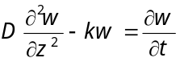
where D represents the diffusivity of CH₃COOH within the porous ink structure (P), k denotes the reaction constant governing the formation of the Zn/Zn²⁺ interface, which results in the consumption of acetic acid through the chelation of Zn²⁺ at the interface, and w represents the concentration of CH₃COOH. The following boundary conditions and initial conditions are used for the diffusion equations. (1) w (z = H₀) = w₀ (Constant acetic acid at top) (2) ∂w/∂z (z = 0) = 0 (No flux of acetic acid at the bottom) (3) w (t = 0) = 0, (0 ≤ z ≤ H₀) (Zero concentration of acetic acid). In this model, for times (t) prior to achieving complete sintering between Zn fillers, the thickness of the non-sintered porous trace (H) decreases approximately linearly with t, as described by the following equation:
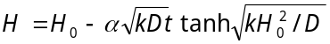
where H₀ represents the initial thickness of the printed trace, M(CH₃COOH) and M(P) are the molar masses of acetic acid and porous P, respectively, w0 is the initial water concentration, n_{P} is the number of CH₃COOH molecules reacting with P, ρ_{P} is the mass density of P, and α is a constant with α=[M(P)/M(CH₃ COOH)]w₀/(n_{P}ρ_{P}). The saturation time for the thickness to reach zero can be approximated as:
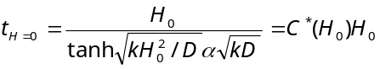
Since, R_{sintered}≪R_{non-sintered}, total resistance of trace at time (t) can be formulated as
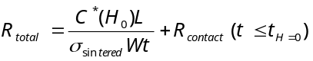
where σ_{sintered} is the conductivity of completely sintered P, L is the length of trace, W is the width of trace, and R_{contact} is the resistance between probe and trace. For the Zn-PCL trace with H₀ = 0.97 mm and L/W = 3.3, it was experimentally confirmed that the time for the resistance to saturate according to the sintering time is 10 min which is t_{H=0}. Therefore, C*(0.97 mm) is obtained, and using the conductivity of Zn-PCL when sintered, the formula R_{total} = 0.2/t + R_{contact} can be a candidate fitting model. When R_{contact} is 0, there is a deviation from the experimental value, but when R_{contact} is 0.15 Ω, it is confirmed that it fits well (Supplementary Fig. 3c). Thus, once all other parameters (D, k, etc.) are acquired, sintering time of arbitrarily shaped Zn-PCL can be modeled using a reactive diffusion model.

Supplementary Note 3. Interpretation of junction in ZnO/conjugated molecules.
For n-type semiconductor, an electron at Fermi level tends to leak out to the vacuum level and induces higher work function at the particle surface (W_{S}) than bulk work function (W_{B}) (Supplementary Fig. 5). In the case of Ws higher than the ionization energy of a conjugated molecule, there is a chance to transfer electron from conjugated molecule to n-type semiconductor. Due to the high surface dipole at n-type semiconductor surface, conjugated molecule have physisorption interaction with it (Supplementary Fig. 5a). When the semiconducting nanoparticle and conjugated molecule get closer, orbitals leak out from interior part of the semiconductor pushes back inside and surface dipole get smaller and at some distance, HOMO level of conjugated molecule pinned to Fermi level of semiconducting nanoparticle (Supplementary Fig. 5b). Then, conjugated molecule’s band gap becomes potential barrier of electron conduction in semiconducting inks. Conductivity enhancement effects of conjugated molecule to ZnO-PCL inks was Brilliant yellow (~32 times) > Indigo (~3 times) > Guanine (~1.1 times) (Fig. 2e) while main direct band gap was Brilliant yellow (~2.66 eV) < Indigo (~3.59 eV) < Guanine (~3.8 eV) (37) from Tauc plot (Supplementary Fig 4c and 4d). Although the minor direct band gap of indigo has 1.67 eV with the quantity of ~4.48 (eV/cm)² at 0.01 g/ml, Brilliant yellow in major band gap (~2.66 eV) has a quantity of 200 (eV/cm)² at 0.001 g/ml which is significantly different.
Also, morphologically ZnO should be condensely packed to get assisted from conjugated molecules referring to previously reported papers⁵, while the reports used high pressure and high temperature. In our case, to densely pack ZnO in room temperature and standard pressure, percolation of ZnO in PCL/TG was investigated but there were no ZnO volume fraction dependency with conductivity of ZnO-PCL (near 10⁻⁵ S/m, Supplementary Fig. 12c). In addition, intrinsic conductivity of a ZnO film with a thickness of approximately 460 nm is known to be around 674 S/m⁶ which can be the maximum of ZnO-PCL inks while our ZnO filler has a diameter of ~500 nm. Therefore, we highly packed ZnO fillers inside the PCL/TG matrix to reduce distance between fillers (ZnO ~35 vol%; PCL ~14 vol%; TG ~52 vol%; conjugated molecule ~small vol%) where the volume fraction of ZnO filler is still in printable range. Interestingly, TG (52 vol%) also assisted ZnO fillers to compactly gather by formation of micelle or microenvironments and conjugated molecules increased inter-granular conductivity by reducing the total potential barrier of the interphase between ZnO fillers (Supplementary Fig. 4a and 4b).
Based on the observation of conjugated molecule effects, we decided to explore p-type semiconductors and utilize boron-doped silicon, known for its degradability. In the case of n-type semiconductors, the surface charge was polarized negatively, inducing the physisorption of conjugated molecules. For p-type semiconductors, we expected surface polarization with a positive charge, leading to both physisorption of conjugated molecules and charge transfer, along with the occurrence of quasi-Fermi pinning. Experimental results showed that it exhibited similar enhancements in orders of magnitude of conductivity by conjugated molecules similar to ZnO (Supplementary Fig. 5).

Supplementary Note 4. Interpretation of junction in ZnO/conjugated molecules/p-type Si.
The presence of conjugated molecules not only enhanced the conductivity of ZnO-PCL or p-type Si inks but also provided Fermi level alignment along other inks. We observed asymmetric I-V curve with rectified currents with heterojunction of p-type Si-PCL ink and ZnO-PCL ink only in presence of conjugated molecules. In the absence of a conjugated molecule, symmetric I-V curve was observed which indicates no formation of a depletion zone (Supplementary Fig. 27c). However, p-type Si / ZnO configuration including a conjugated molecule showed an asymmetric I-V curve having on/off ratio ~33 (-10 V to 10 V) (Supplementary Fig. 27d). Also the diode showed avalanche breakdown at -20 V which confirm the formation of depletion zone between p-type Si-PCL and ZnO-PCL.
In a microscale perspective, in the absence of a conjugated molecule, the interface consists of ZnO / PCL / SiO₂ / p-Si. SiO₂ has a high dielectric constant and a relatively crystalline structure, while the PCL has a relatively low dielectric constant and an amorphous structure, making it difficult to create a PIN junction due to the difficulty in Fermi-alignment by defects or trap sites in the binder polymer (PCL) and the interface between ZnO and SiO₂ (Supplementary Fig. 27a). On the other hand, in the presence of a conjugated molecule, firstly, the HOMO level of the conjugated molecule is pinned to the Fermi level of ZnO fillers. Then, inter/intra-molecular conduction occurs through conjugated molecules, reaching the native oxide layer of the Si filler through a quasi-Fermi-pinning state, and a PIN junction is formed among the aligned Fermi levels (Supplementary Fig. 27b). For voxelated semiconducting inks, agents that assist Fermi-level alignment between fillers is crucial for their performances, and conjugated molecule blending could be an option.

Supplementary Note 5. Interpretation of junctions in ZnO/interfacial layers/metal.
The junctions that occur in this case are defined by the work function of the metal filler and the electronegativity of the semiconducting filler with an interfacial layer with a conjugated molecule or binder. To determine this, the work function of the conductor ink's surface and the electronegativity of the semiconductor ink's surface were measured. The work function of the conductor is measured by the potential difference with the work function of a HOPG tip in a Kelvin probe. Mapping was conducted for a small area, and the average value was obtained. The measured work functions for each conductor surface were 3.83 eV, 3.49 eV, 4.47 eV, and 4.44 eV for Fe, Zn, Mo, and W respectively (Supplementary Fig. 25a).
For the semiconductor, the electronegativity was determined by measuring the work function and the valence band maximum, as well as the direct band gap, using UPS and UV/VIS techniques. As a result, it was found that ZnO had an electronegativity of approximately 4.01 eV (Supplementary Fig. 24e). Based on the difference between the work function of the conductive fillers (Fe, Zn, Mo, W) and the electronegativity of ZnO, it was determined that Fe and Zn would form ohmic junctions, while Mo and W would have Schottky barriers of approximately 0.47 eV and 0.44 eV, respectively (Supplementary Fig. 25a). Subsequently, the performance of four 3D-printed diodes, Zn-PCL / ZnO-PCL / Mo-PBAT, Zn-PCL / ZnO-PCL / W-PBAT, Fe-PBAT / ZnO-PCL / Mo-PBAT, and Fe-PBAT / ZnO-PCL / W-PBAT, were compared. Among them, Zn-PCL / ZnO-PCL / Mo-PBAT exhibited a relatively high on/off ratio (~12) with reproducibility (n = 10) (Supplementary Figs. 25c,d). It was also confirmed that the similar rectification behavior occurred when brilliant yellow was blended with the ZnO-PCL ink (Fig. 1e).
In a microscale situation, there can be three cases to describe the interface inside ZnO-PCL ink with conductive inks (Supplementary Fig. 25b). (1) ZnO / binder / native oxide / metal (2) ZnO / conjugated molecule / native oxide / metal (3) ZnO / conjugated molecule / binder / native oxide / metal. Without conjugated molecule, the native oxide layer and binder become an interfacial layer for electron tunneling between ZnO and metal. With conjugated molecule, for cases (2) and (3), conjugated molecule is placed at metal filler surface within Schottky-Mott rule and indeed increases electrical conductivity through it. For case (2), Fermi alignment occurs between metal filler and ZnO filler and form an apparent Schottky barrier regarding native oxide, conjugated molecule as interfacial layer. For case (3), the apparent Schottky barrier regards native oxide, conjugated molecule, and binder as interfacial layer. In such cases, the apparent Schottky barrier needs to be adjusted, and it might be expressed using the following equation⁷⁻⁹.
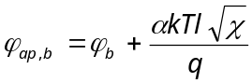
Where Φ_{b} denotes the Schottky Barrier between metal and ZnO, k is Boltzmann constant, T is the temperature in Kelvin, q is the charge of electron, α=[4π(2m*)^(1/2)]/h, h is Planck constant, m* is the effective electron mass. And importantly, l is thickness of interfacial layer which consists of binder or conjugated molecules or native oxide. X signifies the difference between semiconductor electronegativity and the interfacial layer, for case (3) as an example, the summation of the difference between electron negativity of ZnO and LUMO level of conjugated molecule and difference between LUMO level of conjugated molecule and LUMO level of native oxide.

Supplementary Note 6. Interphase power law model in dielectric nanocomposite.
Since the interface of dielectric filler acts as a dielectric properties enhancer, based on the interphase power law model, nanodielectric phenomena can be modeled¹⁰⁻¹³. Considering interphase interaction, shape and orientation of filler, and air voids in predicting the dielectric constant of a composite material is
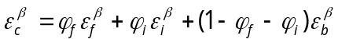 (Equation 1)
Where 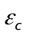, , , 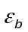 are the dielectric constants of nanocomposite, filler, interphase, and binder, respectively. 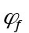 and is the volume fraction of fillers and interphase in the nanocomposite. β is the filler geometrical factor, in this case, 1/3 (spherical). The interphase volume fraction () depends on the filler volume fraction and an interphase volume constant (K) and can be calculated by Equation 2. K is related to filler-binder interaction affected by surface energy at the interface of bulk and surface of materials originates from chemical interaction and physical orientation of particles.
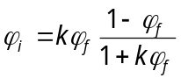 (Equation 2)
Since the air voids in the interphase region in the nanocomposite can be neglected as compared to nanofillers so that the interphase dielectric constant can be assumed to be a function of matrix and filler dielectric constants.
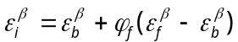 (Equation 3)
Combining Equation 1, 2, 3, with k measured from experimental data (Supplementary Fig. 6b) we can model the dielectric constant of nanocomposite as following:
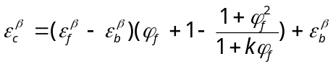 (Equation 4)
By modeling interphase volume fraction and dielectric constant in Si₃N₄-PCL nanocomposite film, we could observe large k (~25) which implies that due to DC capacitance measurement with DMM, estimated interphase volume fraction is maximized at each filler volume fraction resulting 10 times higher than filler volume fraction (Supplementary Fig. 6c). It might be originated from pores or air bubble generated by solvent vaporization, while interphase power law model neglects air gap inside composites¹³. The nanocomposite has dielectric loss as measured in the high frequency range (Supplementary Fig. 13). We verified with 3D-printed Zn-PCL/Si3N4-PCL/Zn-PCL capacitor within 1 – 100 kHz frequency using LCR meter with two different capacitor type, interdigitated (I) and parallel plated (P) (Supplementary Fig. 13a). Structural difference of capacitor affected in low and high frequency range where interdigitated capacitor secure larger capacitance than the parallel capacitor in low and high frequency range (@ 1 kHz, 64.43 pF (I) > 56.62 pF(P), @ 100 kHz, 11.16 pF (I) > 10.62 pF (P)) (Supplementary Figs. 13d, e).

Supplementary Note 7. Parameters for 3D-printable inks.
1). Volume fraction of fillers
The volume fraction of fillers for 3D-printing were optimized in the range of securing electrical conductivity. For conductive inks, volume fraction was optimized over percolation thresholds. For semiconducting inks, volume fraction was maximized to increase percolative networks and mimic condensed situations. For dielectric nanocomposite film, considering the mechanical stability of dielectric nanocomposite film (e.g. Si₃N₄ volume fraction < 7.7 vol%) from previous characterizations. Binder/solvent fraction was optimized to a certain concentration for robust film formation by solvent casting (PCL 0.15 g/ml, PBAT 0.2 g/ml). Supplementary Figs. 7, 8, 9, and 10 shows characterized and printed conductive inks, semiconducting inks, dielectric inks, magnetic, and electrochemical electrode inks in PCL and PBAT matrix with TG. The volume fractions represented by the blue regions were determined to fall within a range suitable for extrusion and stacking using a commercially available bioprinter. The printer's operational parameters were set within a pressure spectrum ranging from 50 to 200 kPa and a velocity spectrum spanning from 1 to 5 mm/s, as depicted in Supplementary Fig. 14. These parameters were employed to precisely deposit optimized inks within the scaffolds, as depicted in Supplementary Figs. 15 and 16.

2). Humectant
Although humectant, in this case TG, helps reduce yield shear stress of inks and improve volume shrinkage after printing, excessive humectant lowers storage modulus after printing which fails stacking for constructing 3D objects. Therefore, appropriate humectant was important, here we set parameters with humectant / solvent ratio based on pre-determined filler/binder, binder/solvent ratio (Supplementary Figs. 11a, b). So continuously, storage modulus of different ratio inks was measured with constant angular frequency 10 rad/s and shear strain 1 %, and the exposed edge region of the disk shape sample between two plates seems to increase modulus by drying time. For Zn-PCL, the weight of Zn was fixed to 7.2 g, and for Mo-PBAT, weight of Mo was fixed to 2.62 g and blended with 1.5 ml humectant/solvent/binder. Then we found after a few minutes, over storage modulus over 10⁴ Pa was possible to stack and the humectant/solvent ratio was about 1:2. Since our dispensing pressure is limited to 200 kPa, we compromise to 1:2 ratios where a lower volume fraction of humectant could provide better stackability while poor extrusion for our printing system. In the case of a humectant/solvent ratio of 1:2, it was observed that under pressures less than 200 kPa, reproducible feature sizes of approximately 400 µm could be achieved. Furthermore, when printing was conducted using a dispenser operating at high pressures ranging from 1000 to 3000 kPa, it was confirmed that feature sizes of less than 100 µm could be consistently achieved without encountering any issues related to clogging (Supplementary Figs. 17 and 18).

3). Particle size
Regarding particle size of fillers (D) in ink for appropriate rheology for printability, a smaller diameter seems to require less amount for appropriate rheology. Specifically, log scale of the filler’s diameter (log D) seems to be proportional to the volume fraction (ρ) needed for printability by observation (Supplementary Fig. 11c, d). In PBAT, PCL matrix TG, the volume fraction of nanoparticle or microparticle ranging from ~0.05 to ~0.4 seems to exhibit 3D-printable inks with appropriate shear yield stress for low pressure (< 200 kPa) commercially available printer (BIOX, Cellink, Inc).

Supplementary Note 8. Design rule for 3D-printable customized bioelectronic devices.
Supplementary Figs. 30 and 32 illustrate the algorithm used for constructing stereographic circuits within customized structures and for creating wirelessly powered electrically stimulating systems in a tubular shape. The algorithm-generated models are subsequently sliced into layers and manipulated, as depicted in Supplementary Fig. 33. During the design and layering process, careful consideration was given to optimizing parameters such as the XY line gap, Z interconnection shape, and Z line gap to align with the specifications of our printing system.
To determine the optimal XY line gap, a line gap test was conducted (Supplementary Fig. 22a), comparing the programmed gap with the actual printed gap in the G-code. This iterative process led to the optimization of the XY line gap to approximately 0.4 mm. Utilizing a higher-pressure printing system capable of delivering around 350 psi (Supplementary Figs. 17 and 18), we achieved varying feature sizes of approximately 72.7 μm, 83.3 μm, 105 μm, 124 μm, and 143 μm for Fe₃O₄-PCL, ZnO-PCL, Si₃N₄-PCL, Mo-PBAT, and Zn-PCL inks, respectively. These results were directly linked to the fine XY line gap.
Regarding Z interconnections, two approaches were explored such as connecting via voxelated dot and connecting through fragments (Supplementary Fig. 22b). While 5-axis printing system could potentially enable diagonal connections, it proved challenging in our setup. Therefore, we adopted fragment stacking for coil construction. This approach introduced two challenges: (1) designing periodic fragments and (2) mitigating structural collapse. To address the issue (1), we employed a simple polygonal square shape (n=4) and systematically designed fragments to increase the number of turns in the stacked square-like coil. To tackle the issue (2), we incorporated one or two layered walls within the squares to prevent inward gathering phenomena. In addition to optimizing the XY line gap, we recognized the importance of configuring an appropriate Z line gap to prevent unintended connections resulting from the slight spread of conductive ink after extrusion. Our investigations indicated that a Z line gap between conductors of approximately 0.8 mm was suitable for this purpose.

Supplementary Note 9. Structure of tubular shaped wireless nerve stimulator.
Supplementary Fig. 31 illustrates the structure of the electroceutical tube. In Supplementary Fig. 31a, we present the nerve interfacing electrodes (constructed from Mo-PBAT) and the inner/outer encapsulation layers (made of PBAT, PCL) of the electroceutical tube. These encapsulation layers can be seamlessly integrated using either dip-coating or direct-printing techniques. Supplementary Fig. 31b showcases the circuit diagram and the 3D circuit design. To enhance the performance of the wireless antenna, we strategically modified the circuit diagram for the inductor and capacitor. Specifically, we optimized the placement of the capacitor by identifying equipotential points to maximize its area, resulting in a tenfold increase in capacitance when located at the bottom of the tube, providing a substantial 163 mm² area compared to the 16.8 mm² area when placed on the side of the tube. The inductor, designed with 10 turns and employing a Fe₃O₄ permeability enhancer at its core, approached an inductance of approximately 1 μH. A Schottky diode was then connected to the wireless antenna, situated above the inductor and wires (Supplementary Fig. 31c), as depicted in Supplementary Fig. 25e.
In cases of long-nerve gap injuries, the presence of a guidance channel is crucial for axons to regrow. Therefore, integrating a guidance channel with a wireless electrical stimulator within an electronic conduit represents an extensive application of the electroceutical tube (Supplementary Fig. 51a). Supplementary Fig. 51b provides an exploded view of the electronic conduit designed for addressing long nerve gap injuries, along with an assembled image. Lastly, Supplementary Fig. 51c details the surgical process as a proof-of-concept for implanting the electronic conduit in cases of long nerve defects, utilizing a straightforward suture technique at the side of the conduits.

Supplementary Note 10. Ferrite effects in wireless electrical stimulator.
The wireless powering system is based on the inductive coupling of the transmittance antenna (TX) and receiving antenna (RX) generating Faraday’s voltage at the receiver antenna. Powering efficiency can be determined as formula below,
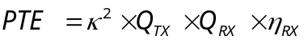
where κ is the coupling coefficient, Q_{TX} is the Q-factor of TX, Q_{RX} is the loaded Q-factor of RX, and η_{RX} is the RX internal efficiency. To improve the power transfer efficiency of adjusting device parameters, Q_{RX} and η_{RX} is described as
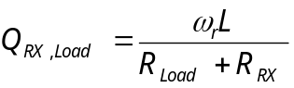,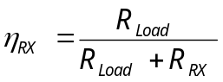
Where ω_{r} is resonant frequency, L is inductance of RX, R_{Load} is loaded resistor in this case nerve, and R_{RX} is resistance of RX. The operational frequency range is limited to 5 - 25 MHz for the high-frequency amplifier used in nerve stimulation. The load characteristics are primarily dictated by the specific animal model under study. Consequently, our focus shifted towards optimizing inductance and resistance as key parameters to enhance system efficiency. For resistance, encapsulation of biodegradable RF antenna was important. For instance, the inductor of the RF antenna exhibited a resistance of approximately 125 Ω after sintering, along with an S₁₁ value of -4.67. However, after being exposed to air without encapsulation for 12 hours, the inductor's resistance surged to 21 kΩ, and the S₁₁ value of the RF antenna dropped to -2.42, indicative of reduced wireless power absorption (see Supplementary Fig. 36). To improve inductance, we incorporated biodegradable magnetic materials such as Fe₃O₄. 3D-printability was optimized for Fe₃O₄-PCL focusing on maximizing F₃O₄ volume fraction (Supplementary Fig. 10). Supplementary Fig. 34 presents the 3D-printed planar wireless stimulator, highlighting the increased inductive output voltage achieved by varying the area of the ferrite material within the core of the coil. When considering Faraday's law in the context of wireless power transfer, two distinct conditions are established in the transmitter (TX) and receiver (RX) stages.
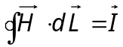 (in TX)
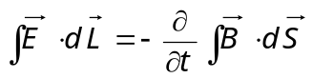 (in RX)
And the relationship between magnetic field intensity (H) and magnetic field (B) is B = μ₀μ_{r}H where μ₀ and μ_{r} are permeability of vacuum and material relative to vacuum at the RX inductor. Thus, biodegradable, high permeability material Fe₃O₄ can provide enhanced inductive coupling.

Supplementary Note 11. In vivo histological assessment in functional recovery.
In this study, various histological evaluations were performed to confirm the effect of therapeutic electrical stimulation on functional recovery. To assess the effects of electrical stimulation, the experiment was divided into three groups: a control group with transection only, an electrical stimulation group using a wireless non-resorbable electrical stimulator (NR) from previous studies, and finally, an electrical stimulation group using a 3D printed bioresorbable stimulator (B3DP).
The study measured the cross-sectional area of the gastrocnemius muscle, the largest muscle responsible for the sciatic nerve, and the tibialis anterior muscle using hematoxylin eosin staining (Supplementary Fig. 44). While no significant difference was observed in the tibialis anterior muscle based on the presence or absence of electrical stimulation, there were statistically significant differences in both muscle mass and fiber cross-sectional area in the gastrocnemius muscle.
To verify the extent of nerve regeneration and investigate the reasons for the successful improvement in functional recovery through electrical stimulation, immune-histochemical staining with TUJ1 was performed. To measure the number of regenerated axons at each location, immune-histochemical staining with TUJ1 antibody was performed. Measurements were conducted at regions -3 mm, -1 mm, 0 mm, +1 mm, and +3 mm from the proximal end (Supplementary Fig. 45). The results showed no significant difference in the number of regenerated TUJ1-positive nerve fibers between the group that underwent electrical stimulation with the B3DP stimulator and the group that underwent electrical stimulation with an NR stimulator, indicating that the damage to the neural model was mild and already regenerated.
In order to confirm the evidence for the observed differences in functional recovery, despite the animal model being a simple transection model and not a long-gap nerve transected model, the distribution and phenotype of immune cells were examined. Immuno-histochemical staining was performed using ED1 antibody to identify macrophage distribution (Supplementary Fig. 46). Staining results for ED1 showed statistically significant differences in the distribution of ED1-positive macrophages among the control group, electrical stimulation with NR stimulator group, and electrical stimulation with B3DP stimulator group (-3 mm: 21.75±7.93 vs 5.75±3.59 vs 5.25±2.99, -1 mm: 75.00±16.39 vs 39.50±16.46 vs 42.50±23.87, 0 mm: 147.00±26.52 vs 106.50±9.54 vs 88.50±32.21, +1 mm: 116.50±9.57 vs 51.25±12.18 vs 45.00±8.60, +3 mm: 22.75±6.65 vs 8.75±3.86 vs 8.50±3.42) (Supplementary Fig. 46). It is suggested that modulating the immune system through electrical stimulation has created a microenvironment for neural regeneration and functional recovery, resulting in improved functional recovery outcomes.

Supplementary Figures
Supplementary Figure 1. Apparatus for ink conductivity measurement sample preparation. (a) Design and image of a stencil mask used for filler + binder + solvent ink. (b) Design and image of a PDMS mold for filler + binder + solvent + humectant ink. (c) The fabrication process of the PDMS mold, involving the creation of wells through UV laser ablation and the use of a punch to establish inlet and outlet ports for the ink.
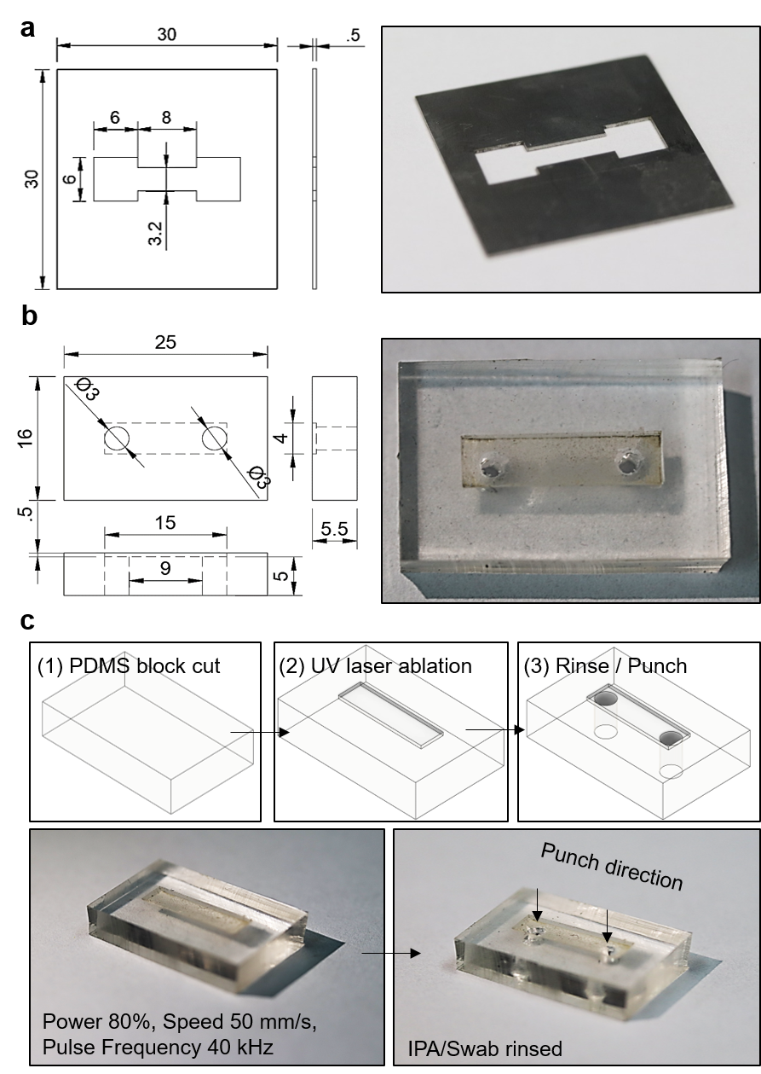

Supplementary Figure 2. SEM, XPS analysis on electrochemical sintering of Zn-PCL inks and conductivity enhancement effects on Zn, Mo, Fe, W inks. (a) Illustration depicting the mechanism of electrochemical sintering of Zn-PCL ink at room temperature. (b) SEM images of Zn-PCL ink, before and after exposure to a 10% acetic acid solution for 15 minutes. (c) X-ray diffraction patterns of Zn-PCL ink after treatment with a 10% acetic acid solution for 15 minutes. The inset displays the X-ray diffraction measurement setup. (D) Changes in conductivity after 15-minutes treatment with a 10% acetic acid solution for 3D printable Zn, Fe, Mo, W in PBAT/TG matrix.
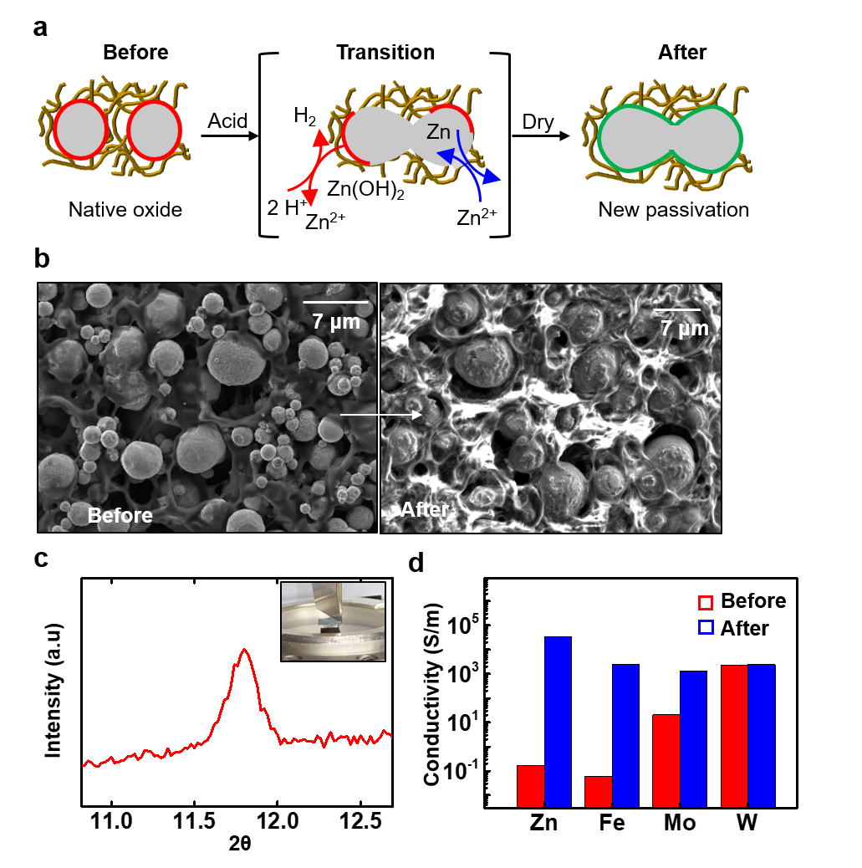

Supplementary Figure 3. Kinetic modeling of the electrochemical sintering process in Zn-PCL ink. (a) Cross-sectional view illustrating the electrochemical sintering process within the printed Zn-PCL trace. (b) Top view indicating the location of resistance measurement probes on the Zn-PCL trace. (c) Fitting of the reactive diffusion model to the sintering behavior of the Zn-PCL trace, with fitting equation expressed as R = 0.2/t + R_{contact}.
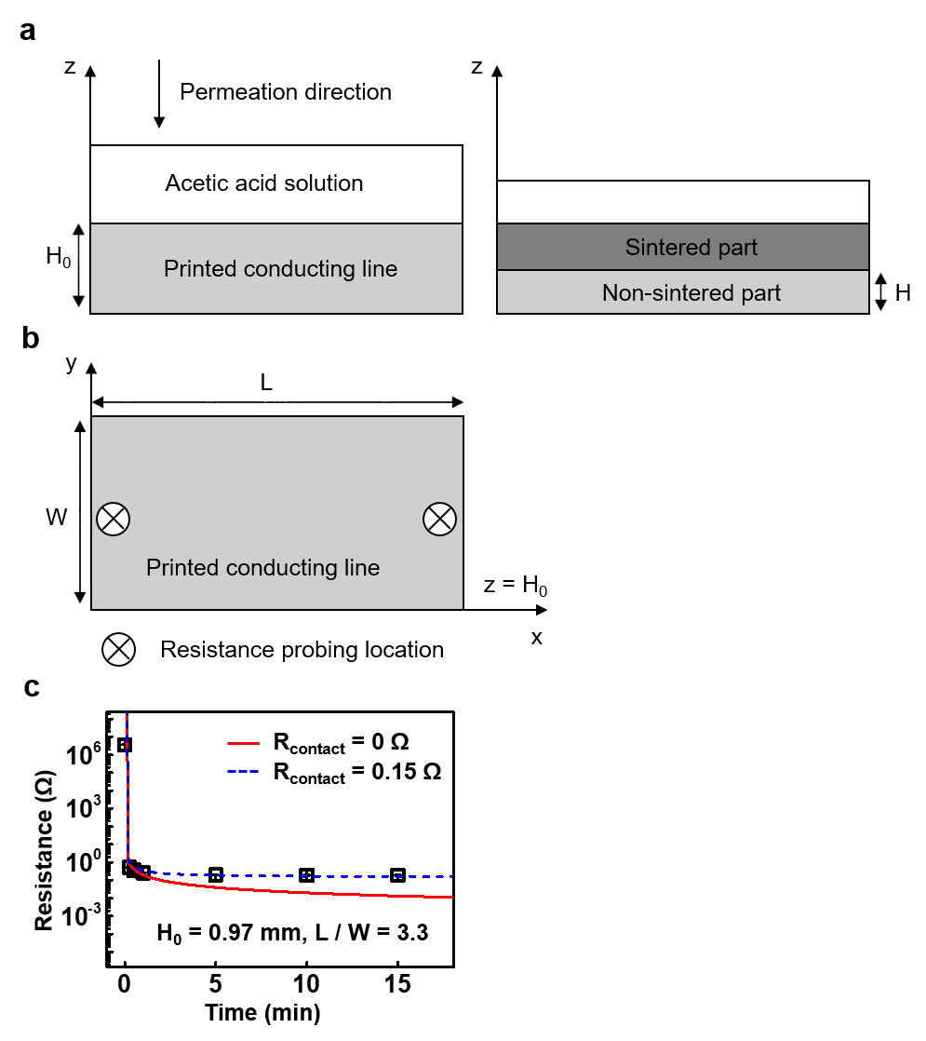

Supplementary Figure 4. Morphology and band gap analysis of conjugated molecules in ZnO-PCL ink. (a) EDS images of ZnO-PCL ink containing TG. (b) Illustration depicting the presence of conjugated molecules blended with ZnO-PCL and TG. Tauc plots for (c) PCL, (d) Brilliant yellow, and (e) Indigo.
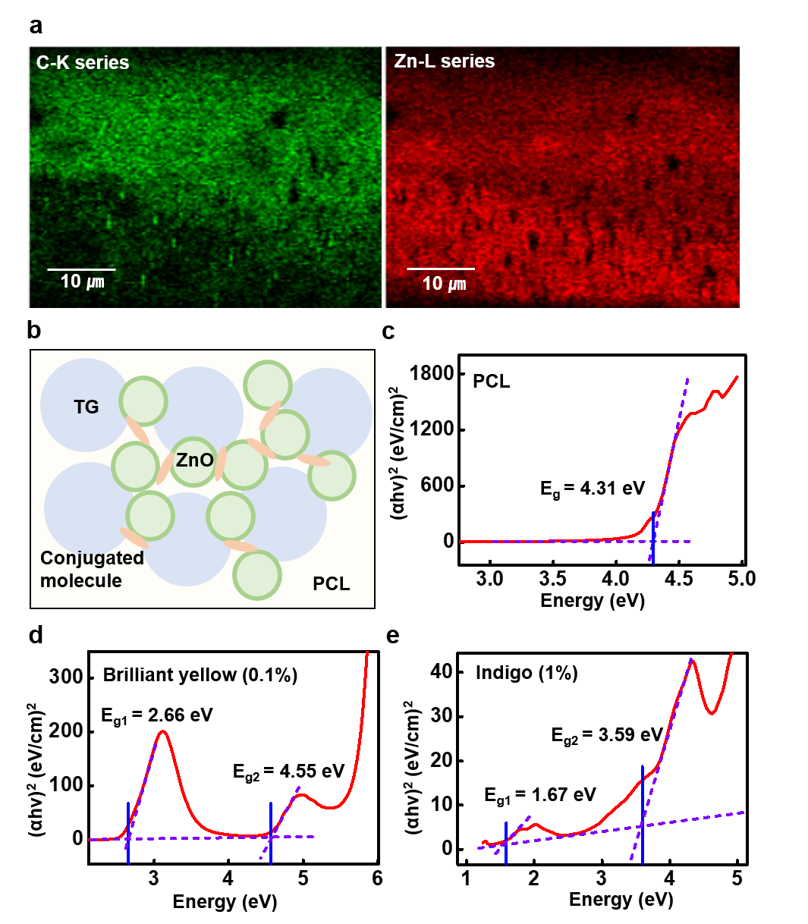

Supplementary Figure 5. Description of Fermi-level pinning of conjugated molecules with ZnO and its effects within p type Si-PCL. Illustration and energy diagram representing the situation (a) before physisorption interaction and (b) after Fermi pinning via charge transfer between ZnO and conjugated molecule (CM). (c) Changes in conductivity of p-type Si-PCL ink by the volume fraction of conjugated molecules (Brilliant yellow, Indigo).
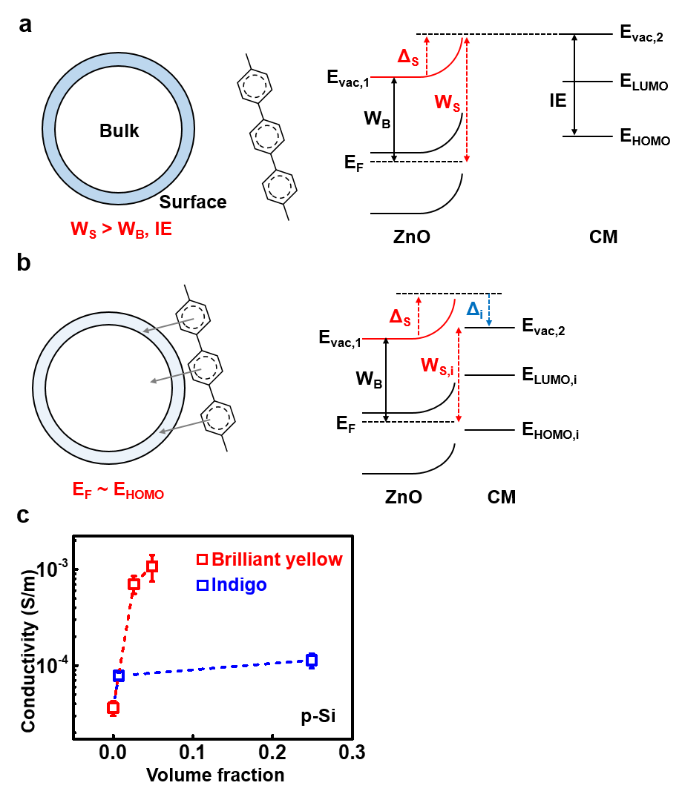

Supplementary Figure 6. Nanodielectric properties measurement sample preparation and modeling (Si₃N₄-PCL, MgO-PCL). (a) Series of images depicting the fabrication process of the biodegradable thin-film parallel plated capacitor. (b) Interphase power law model for Pt/Si₃N₄-PCL/Pt, with fitting expressed as y = (0.42481495579*(x+1-(1+x^2)/(1+k*x))+1.53261886479)^3, with various k values. (c) Estimation of interphase volume fraction and interphase dielectric constant in the Si₃N₄-PCL composite. (d) Interphase power law model for fully degradable Mg/MgO-PCL/Mg, with line fitting expressed as y = (0.60735609634*(x+1-(1+x^2)/(1+80*x))+1.53261886479)^3, with various k values. (e) Estimation of interphase volume fraction and interphase dielectric constant in the MgO-PCL composite.
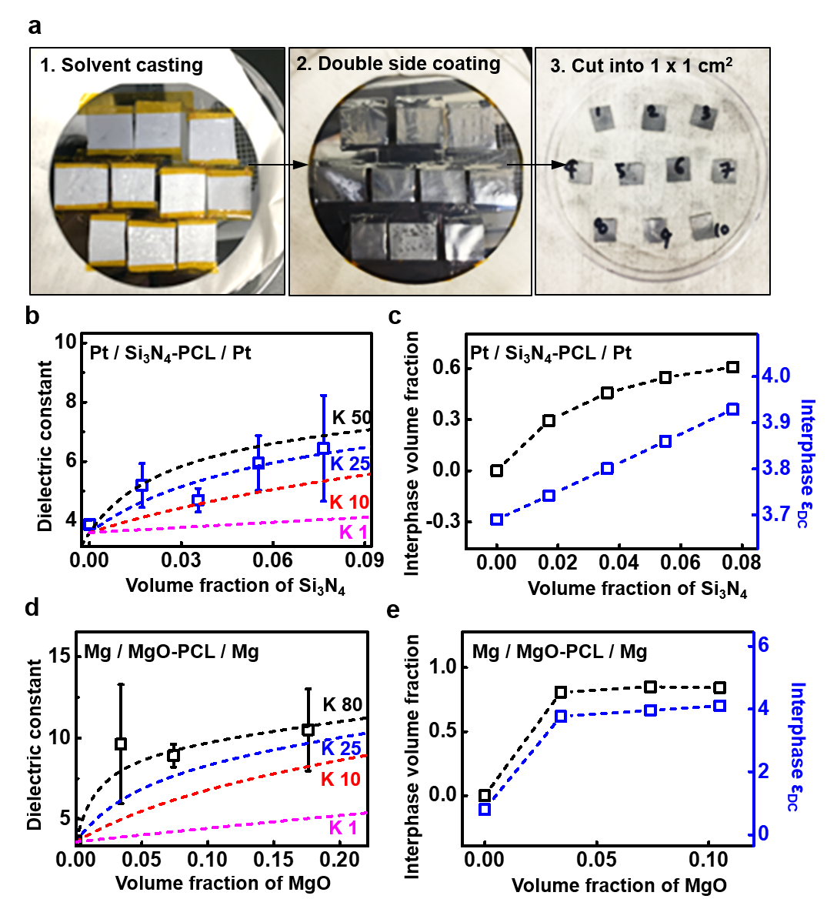

Supplementary Figure 7. Rheological properties of conductive inks (Zn-PCL, Zn-PBAT, Mo-PBAT) with different volume fractions of fillers. Viscosity changes by shear rate for (a) Zn-PBAT, (c) Zn-PCL, and (e) Mo-PBAT. Shear modulus changes by shear stress for (b) Zn-PBAT, (d) Zn-PCL, and (f) Mo-PBAT.
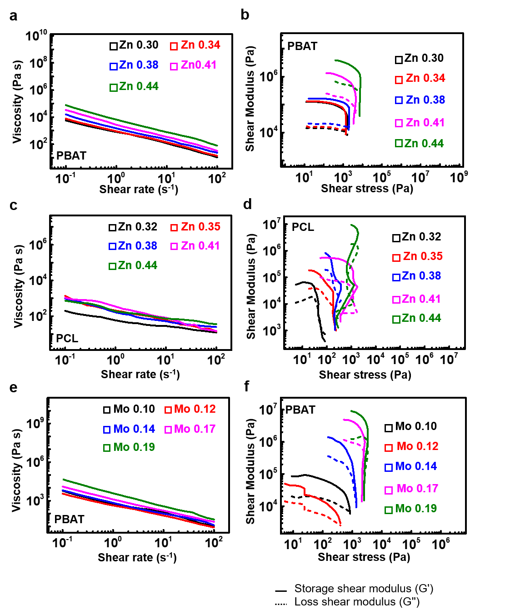

Supplementary Figure 8. Rheological properties of semiconducting inks (ZnO-PCL, ZnO-PBAT) with different volume fractions of fillers. Viscosity changes by shear rate for (a) ZnO-PCL, (c) ZnO-PBAT, and (e) ZnO_{BY2%}-PCL. Shear modulus changes by shear stress for (b) ZnO-PCL, (d) ZnO-PBAT, and (f) ZnO_{BY2%}-PCL.
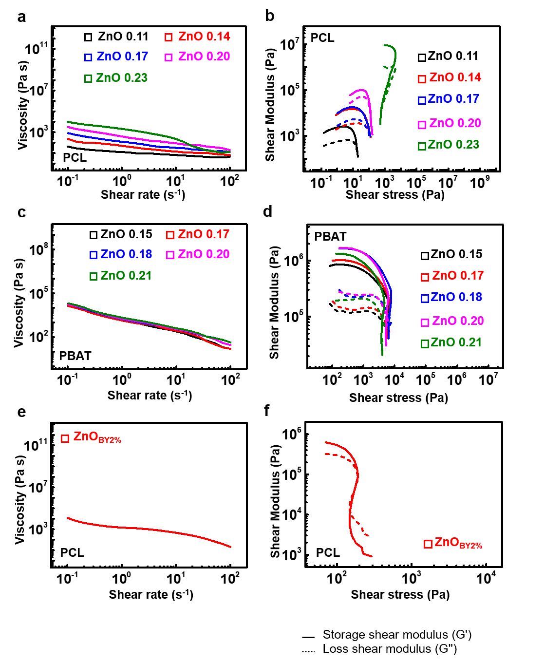

Supplementary Figure 9. Rheological properties of semiconducting inks (p-type Si-PCL, ZnO_{Al}-PCL, ZnO_{Al}-PBAT) with different volume fractions of fillers. Viscosity changes by shear rate for (a) p-type Si-PCL, (c) ZnO_{Al}-PCL, and (e) ZnO_{Al}-PBAT. Shear modulus changes by shear stress for (b) p-type Si-PCL, (d) ZnO_{Al}-PCL, and (f) ZnO_{Al}-PBAT.
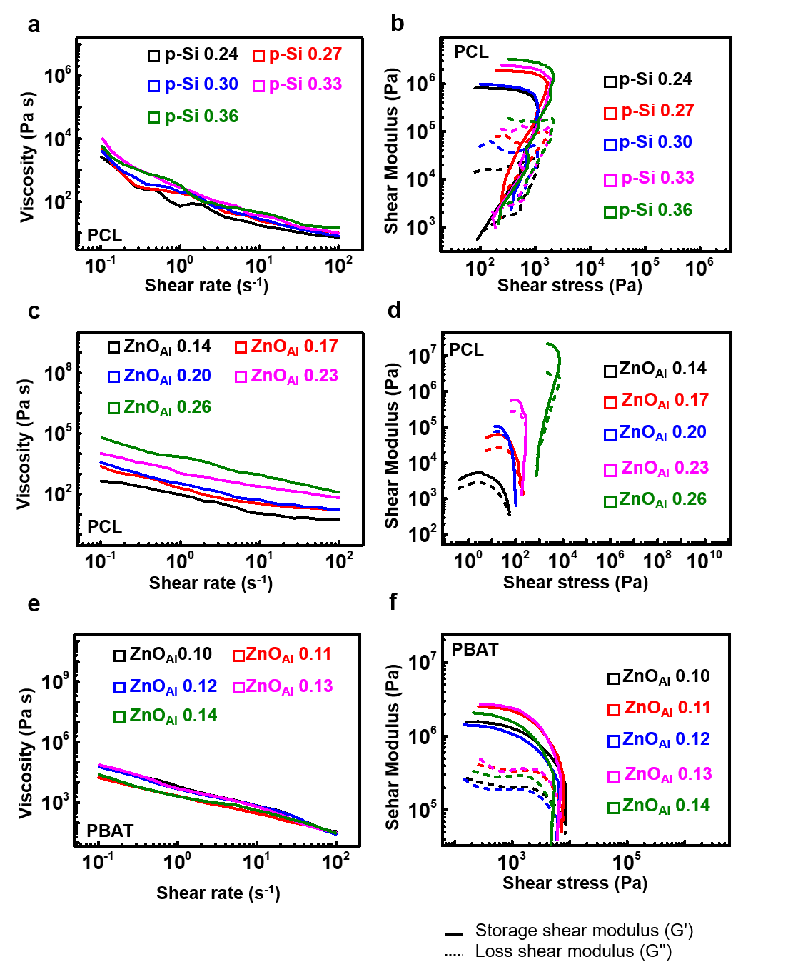

Supplementary Figure 10. Rheological properties of dielectric inks (Si₃N₄-PCL, SiO₂-MgO-PCL), magnetic (Fe₃O₄-PCL) and electrochemical inks (MoO₃-PCL) with different volume fractions of fillers. Viscosity changes by shear rate for (a) Si₃N₄-PCL, (c) SiO₂-MgO-PCL, and (e) MoO₃ microparticle (MP)-PCL, MoO₃ nanoparticle (NP)-PCL, and Fe₃O₄-PCL. Shear modulus changes by shear stress for (b) Si₃N₄-PCL, (d) SiO₂-MgO-PCL, and (f) MoO₃ MP-PCL, MoO₃ NP-PCL, and Fe₃O₄-PCL.
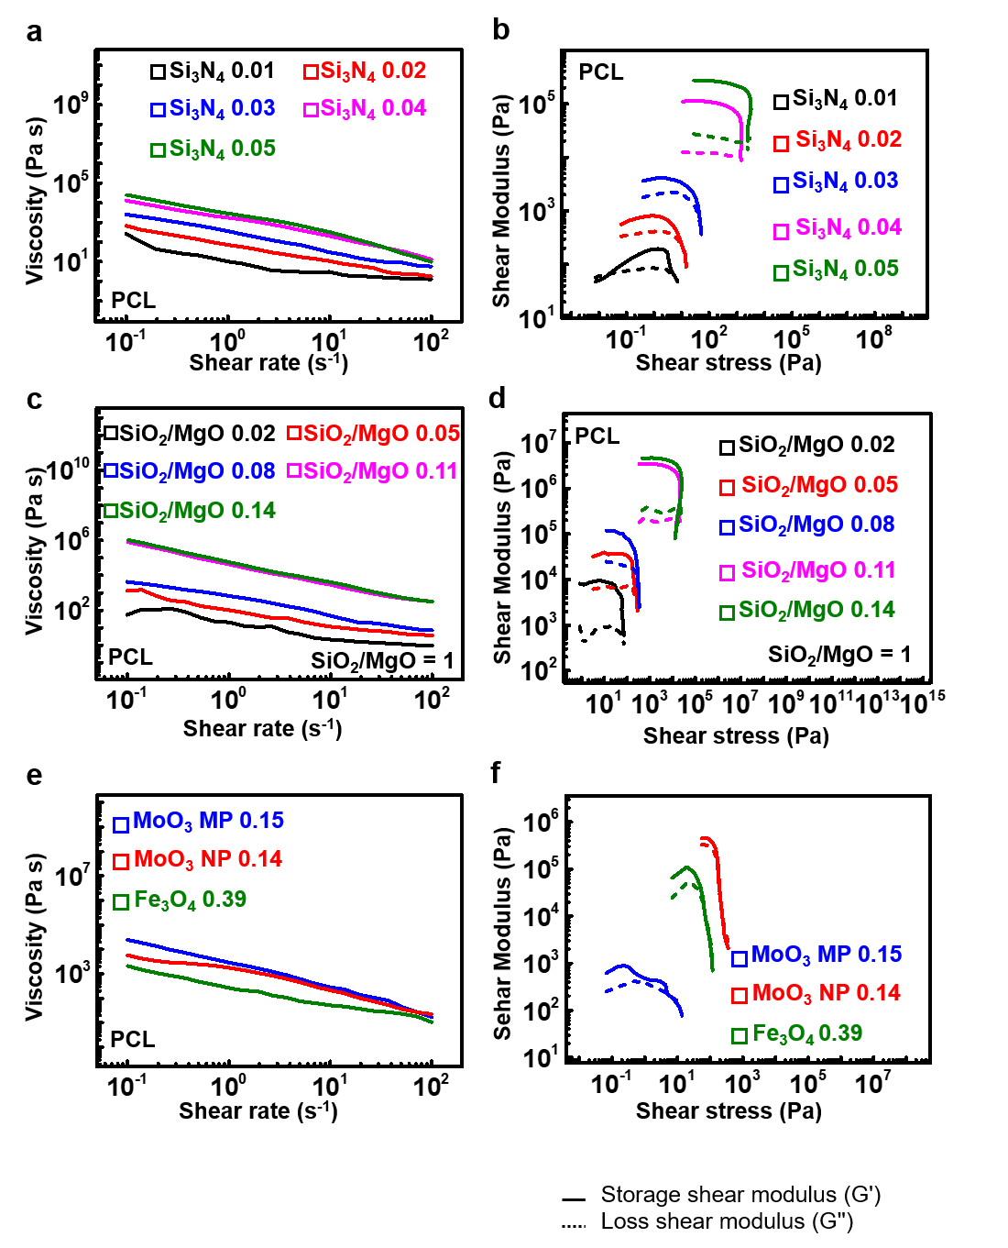
Supplementary Figure 11. Printability optimization by humectant/solvent ratio and particle sizes. Changes in storage modulus over drying time at an angular frequency of 10 rad/s and a shear strain of 1% with different solvent-to-TG ratios for (a) Various ratios of TG : PCL/THF blended with 7.2 g Zn and (b) Various ratios of TG : PBAT/CF blended with 2.62 g Mo. The total volume of humectant, binder, and solvent was approximately 1.5 ml. Volume fraction optimization for 3D printing with different fillers and particle sizes in different matrices for (c) TG : PCL/THF = 1:2 and (d) TG : PBAT/CF = 1:2, where PCL/THF = 0.15 g/ml and PBAT/CF = 0.2 g/ml.
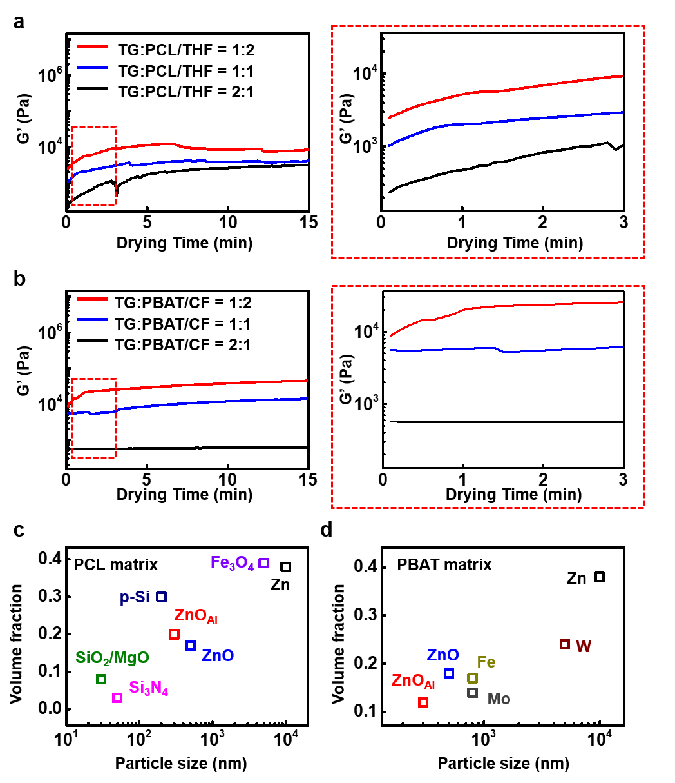

Supplementary Figure 12. Conductivity changes by volume fraction of conductive fillers (Zn, Mo) and semiconducting fillers (ZnO) in PCL-TG or PBAT-TG matrices. (a) Conductivity changes by Zn volume fraction in PBAT (black) and PCL (red) after a 15-minute treatment with acetic acid. (b) Conductivity changes by Mo volume fraction in PBAT (black), PCL (blue), and PCL after a 15-minute treatment with acetic acid (red). (c) Conductivity changes by ZnO volume fraction in PBAT (black) and PCL (red). Data represent averages with standard deviations.
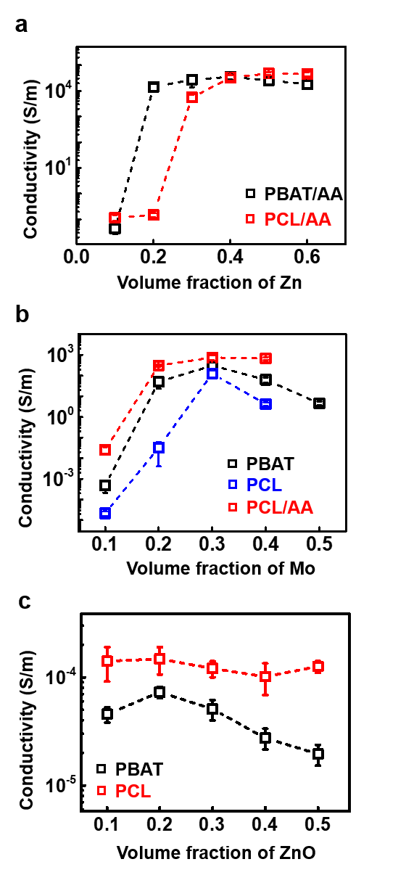

Supplementary Figure 13. Capacitance changes of 3D printed capacitor (Zn-PCL/Si₃N₄-PCL/Zn-PCL) by frequency. (a) Design of an interdigitated capacitor and parallel plated capacitor. (b) Image of a 3D printed interdigitated capacitor. (c) AC capacitance changes by frequencies ranging from 1 kHz to 100 kHz, comparing the two types of capacitors. Detailed views for (d) the low-frequency range (1 kHz to 1.8 kHz) and (e) the high-frequency range (85 kHz to 100 kHz).
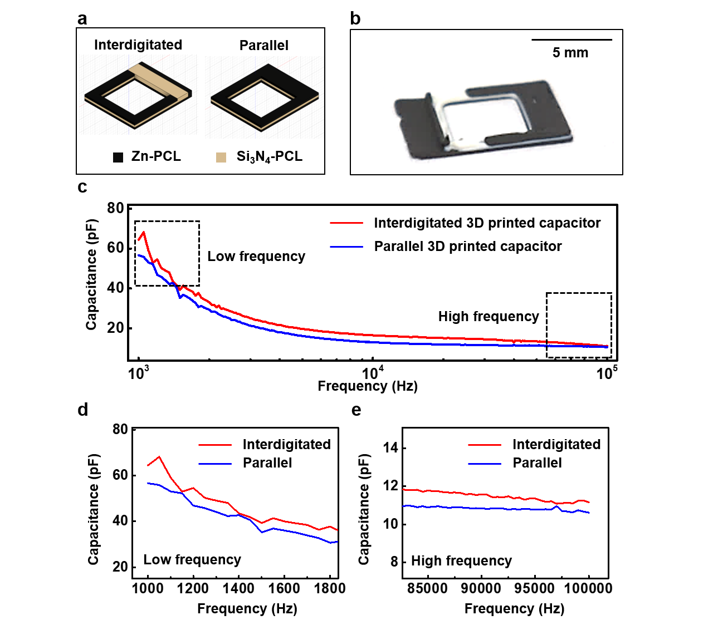

Supplementary Figure 14. Printer parameters for 3D printing and extrusion/stacking morphology. (a) Illustration of parameters influencing feature size. (b) Various feature sizes of printed Zn-PCL using a 22GA needle under speed and pressure control at room temperature on a glass substrate. (c) Images of Zn-PCL ink printed using a 27GA conical nozzle, showing 2-layer stacking (left) and discrete wavy lines (right).
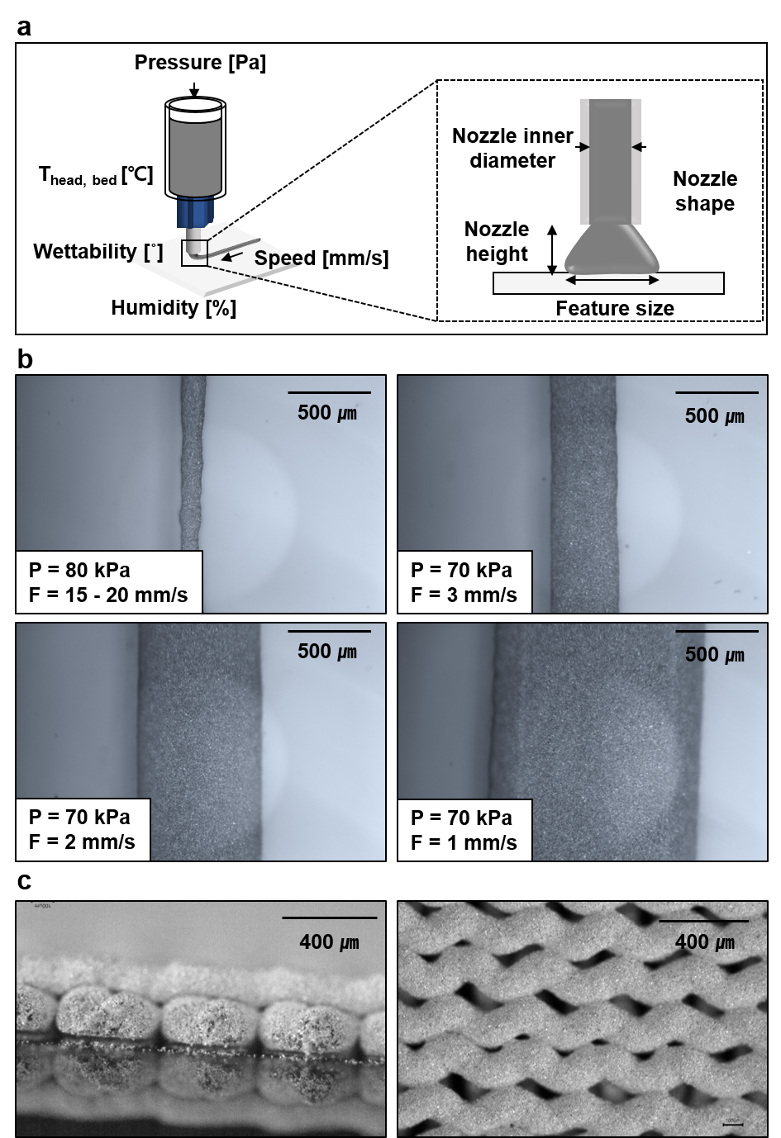
Supplementary Figure 15. 3D printed scaffolds with conductive inks (Zn-PCL, Mo-PBAT) and semiconducting inks (ZnO-PCL, ZnO_{Al}-PCL, p-type Si-PCL). (a) Zn-PCL (b) Mo-PBAT (c) ZnO-PCL (d) ZnO_{Al}-PCL (e) p-type Si-PCL.
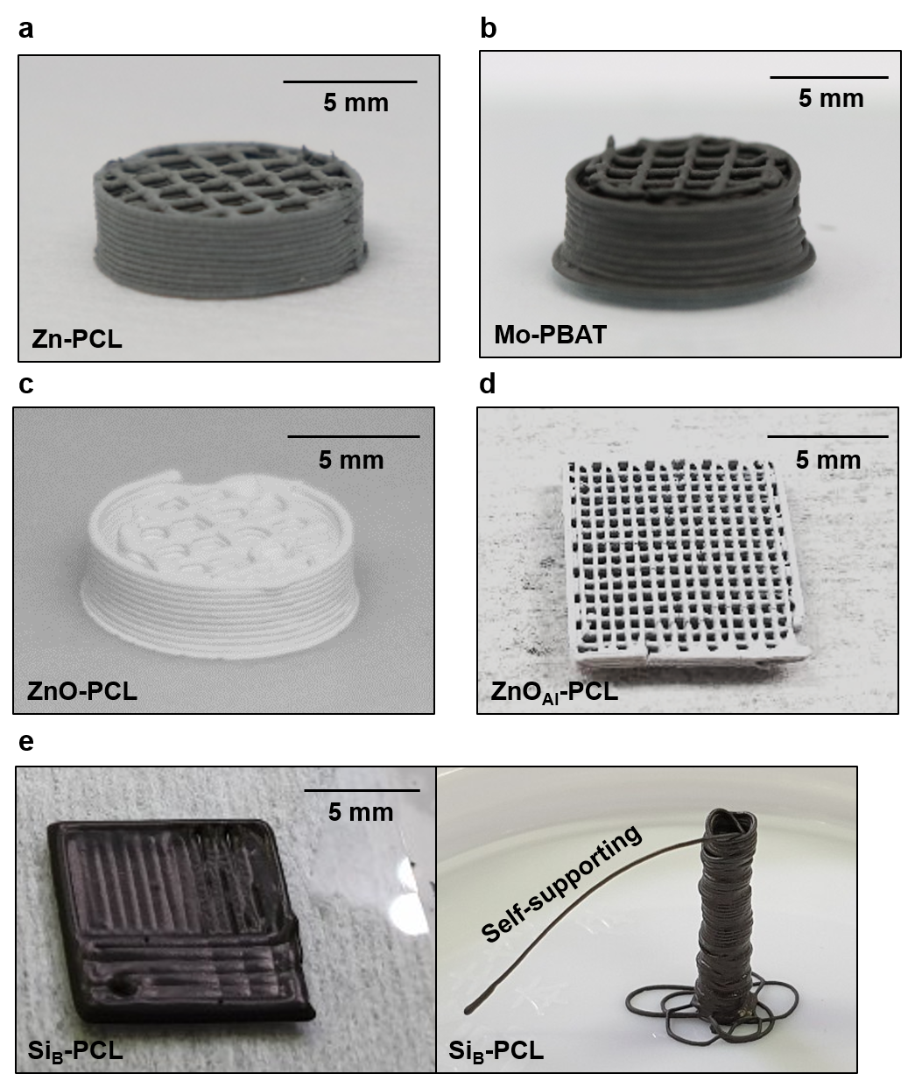

Supplementary Figure 16. 3D printed scaffolds with dielectric inks (Si₃N₄-PCL, SiO₂-MgO-PCL), structural frame materials (solvent-casted PCL, pellet-fused PBAT), and magnetic inks (Fe₃O₄-PCL). (a) Si₃N₄-PCL (b) SiO₂-MgO-PCL (c) solvent-casted PCL (d) pellet fused PBAT (e) Fe₃O₄-PCL.
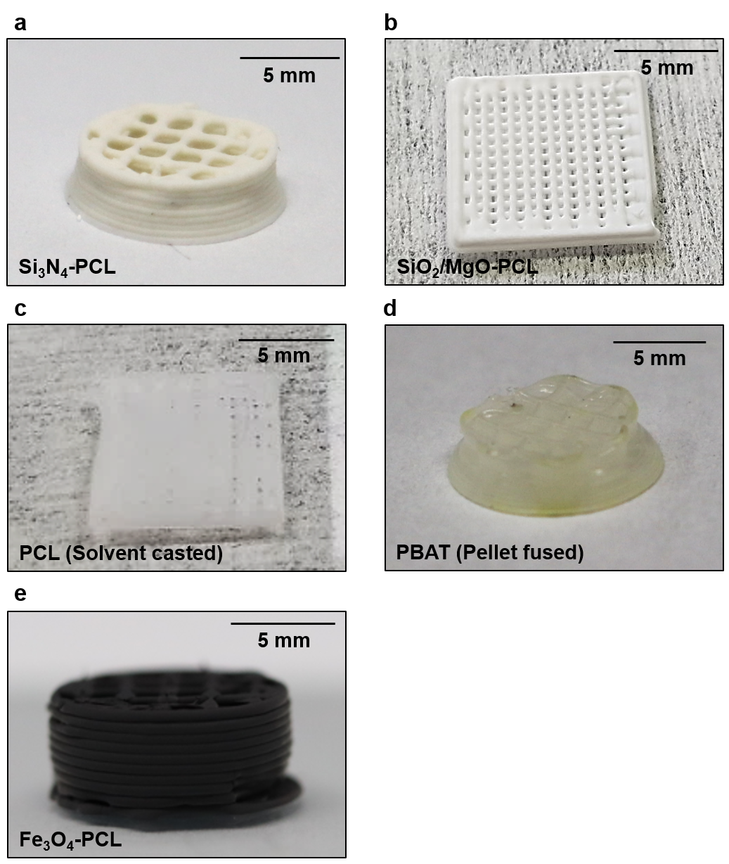

Supplementary Figure 17. Feature size of Zn-PCL, Mo-PBAT, ZnO-PCL, Si₃N₄-PCL, and Fe₃O₄-PCL inks with higher dispensing pressure system. (a) Table detailing feature size, pressure, and nozzle inner diameter for the inks. (b) Images of extrusion printing of Zn-PCL and ZnO-PCL using high pressure. (c) Printed line width by printing speed for Zn-PCL, Si₃N₄-PCL, Mo-PBAT, Fe₃O₄-PCL, ZnO-PCL inks, and (d) Images of Zn-PCL and ZnO-PCL line width by various printing speed.
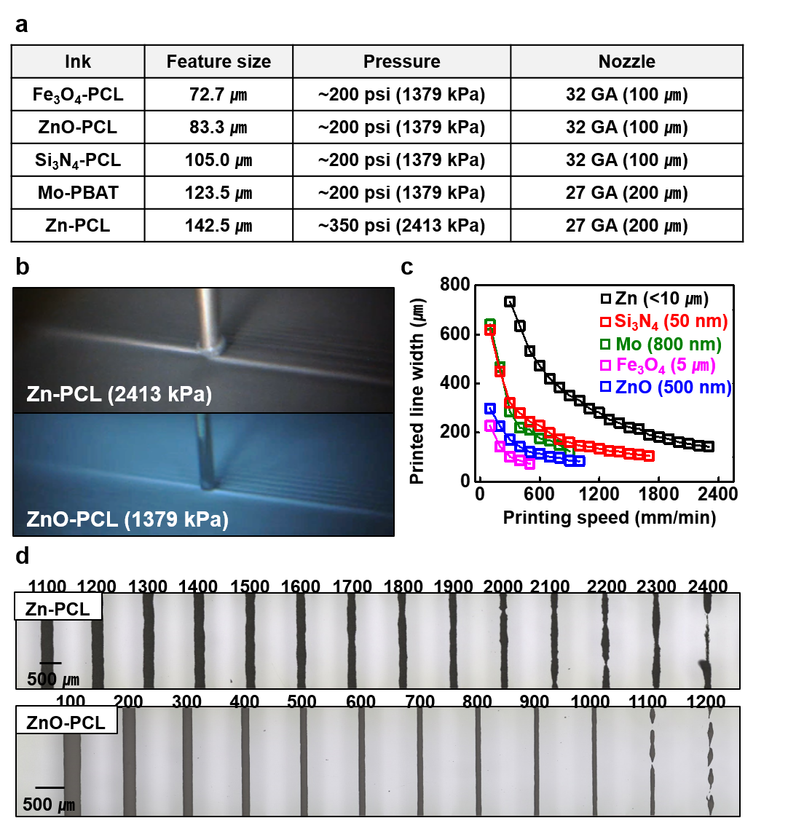

Supplementary Figure 18. Characterization of printed Zn-PCL and Mo-PBAT resistors in high pressures. Images of resistor, dispensing pressure, printing speed, feature size and resistance of Zn-PCL (Left) and Mo-PBAT (Right).

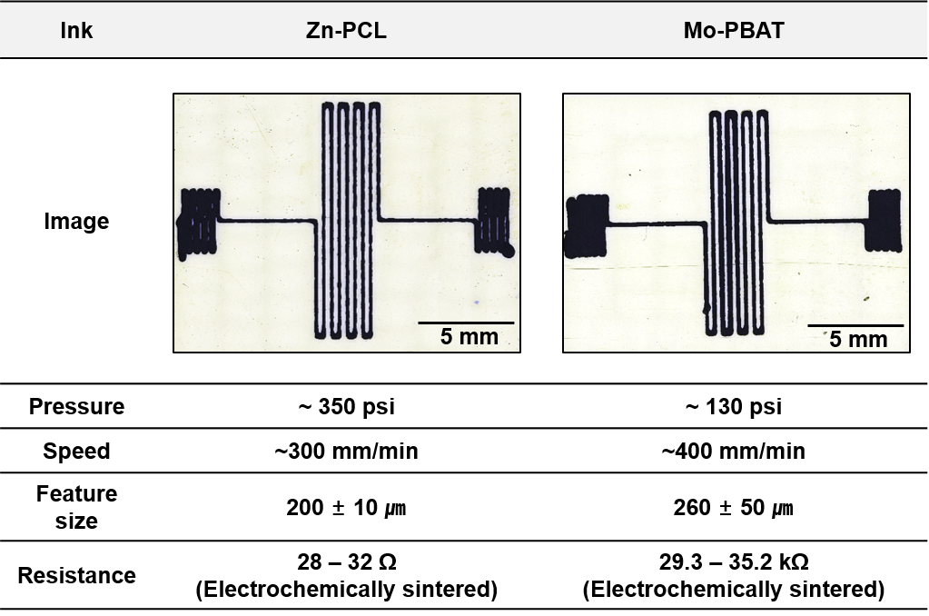

Supplementary Figure 19. Process of 3D printable encapsulation inks and evaluation setup. Images of 3D printed (a) PBAT (b) PBAT-CWAX layer on a glass substrate with a highly concentrated polymer solution on a cooled bed (~4 °C). The blend consisted of 20 wt% CWAX and 80 wt% PBAT in PBAT-CWAX. (c) Images of encapsulation layer printing on a sintered printed resistor (Zn-PCL) (Left). Sequential images visualizing G-code for the first and second encapsulation layers (Right). (d) Schematics and images of the encapsulant performance measurement setup. Resistance of the Zn resistor beneath the encapsulation layer was measured in PBS at 37 °C over time, with doubling of resistance time serving as a performance standard.
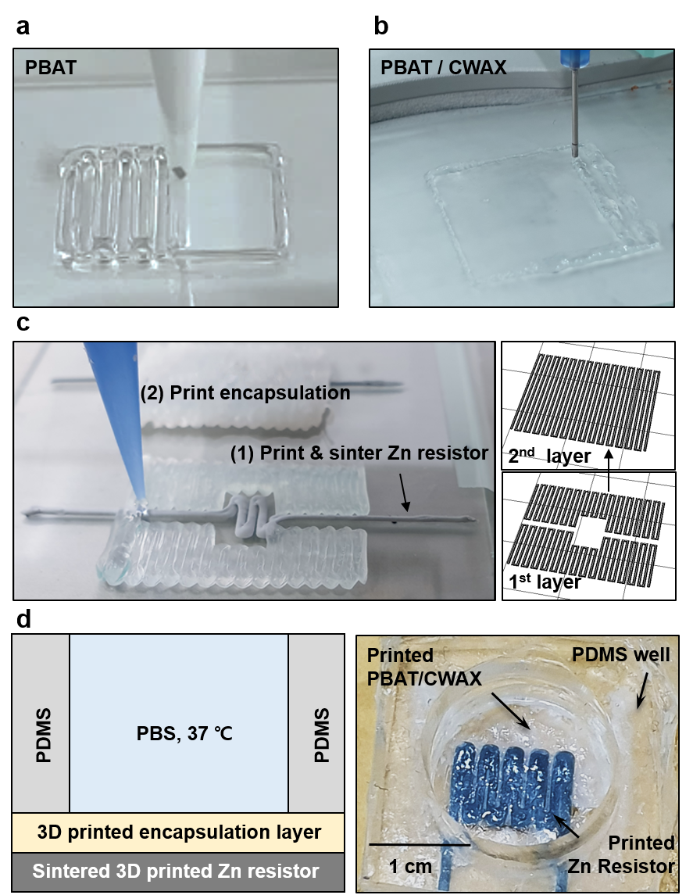

Supplementary Figure 20. Series of SEM images for surface on 3D printed Zn-PCL and ZnO-PBAT inks immersed in PBS, 37 ℃. (a) Sintered Zn-PCL, (b) Non-sintered Zn-PCL and (c) ZnO-PBAT traces with various immersion time.
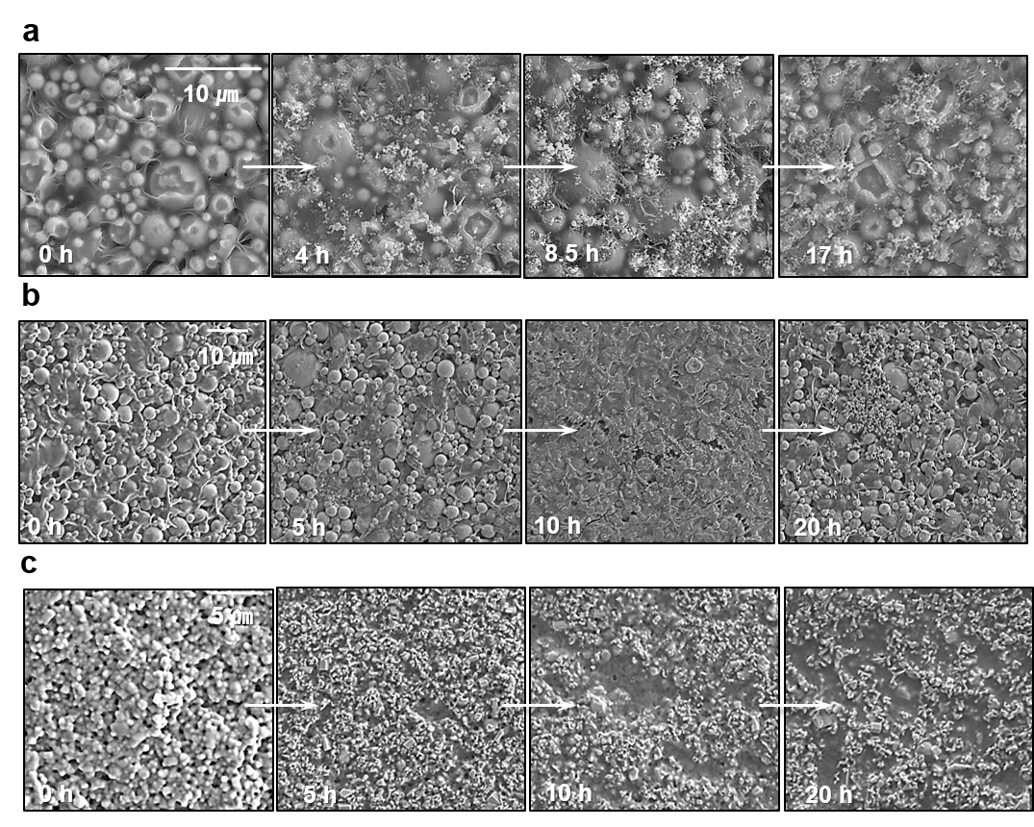

Supplementary Figure 21. Mechanical properties of 3D printed Zn-PCL, Mo-PBAT, ZnO-PCL, Si₃N₄-PCL, SiO₂-MgO-PCL and Fe₃O₄ inks. Uniaxial tensile tests were conducted on 3D printed inks with samples oriented in parallel and perpendicular directions relative to the printed direction. (a) Illustration depicting the parallel and perpendicular directions of the samples. Stress-strain curves for (b) Zn-PCL and Mo-PBAT, (c) ZnO-PCL, (d) Si₃N₄-PCL and SiO₂/MgO-PCL, (e) Fe₃O₄-PCL.
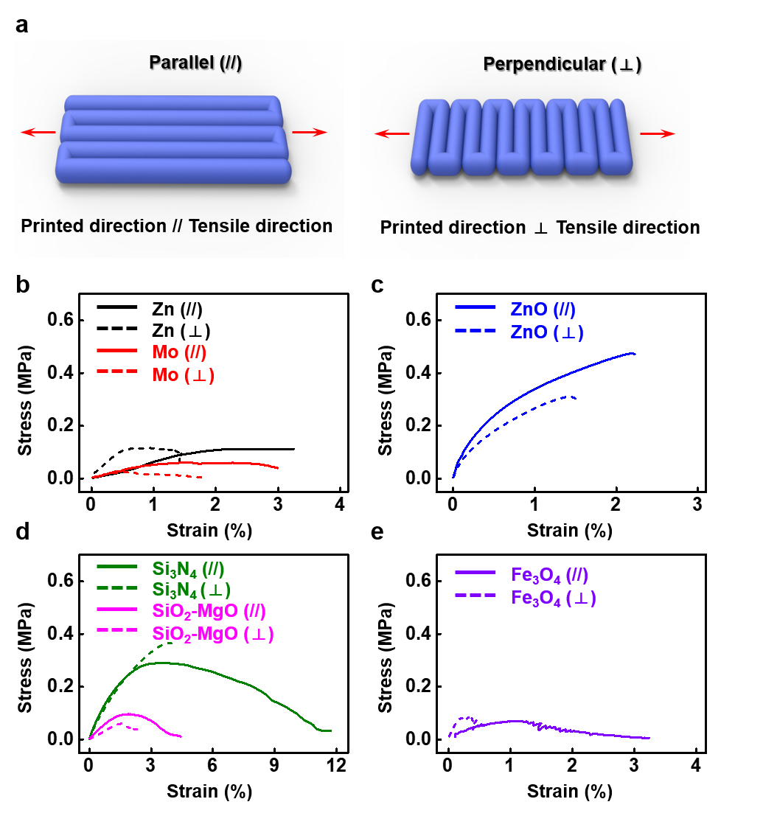

Supplementary Figure 22. Design parameters for printing structural electronics. (a) Image of a printed Zn-PCL sample used for XY line gap testing, comparing programmed gap with a printed gap. (b) Visualization of G-code for two types of Z-axis interconnections: one voxel or one fragment. (c) Images showcasing different Z-line gap configurations for square-like stacked inductors.
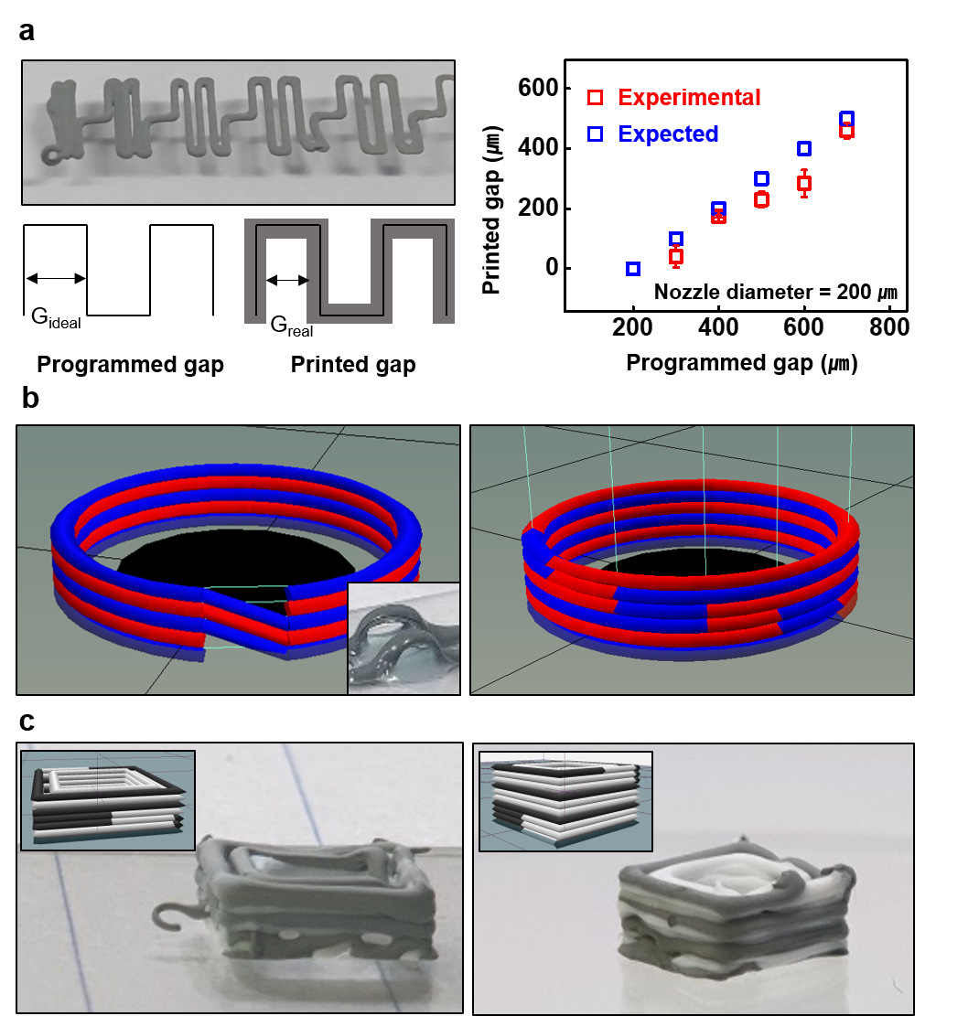

Supplementary Figure 23. 3D printed biodegradable passive components (resistor, capacitor, inductor). (a) Zn-PCL-based resistor. (b) Zn-PCL / SiO2-MgO-PCL / Zn-PCL capacitor. (c) Zn-PCL based inductor.
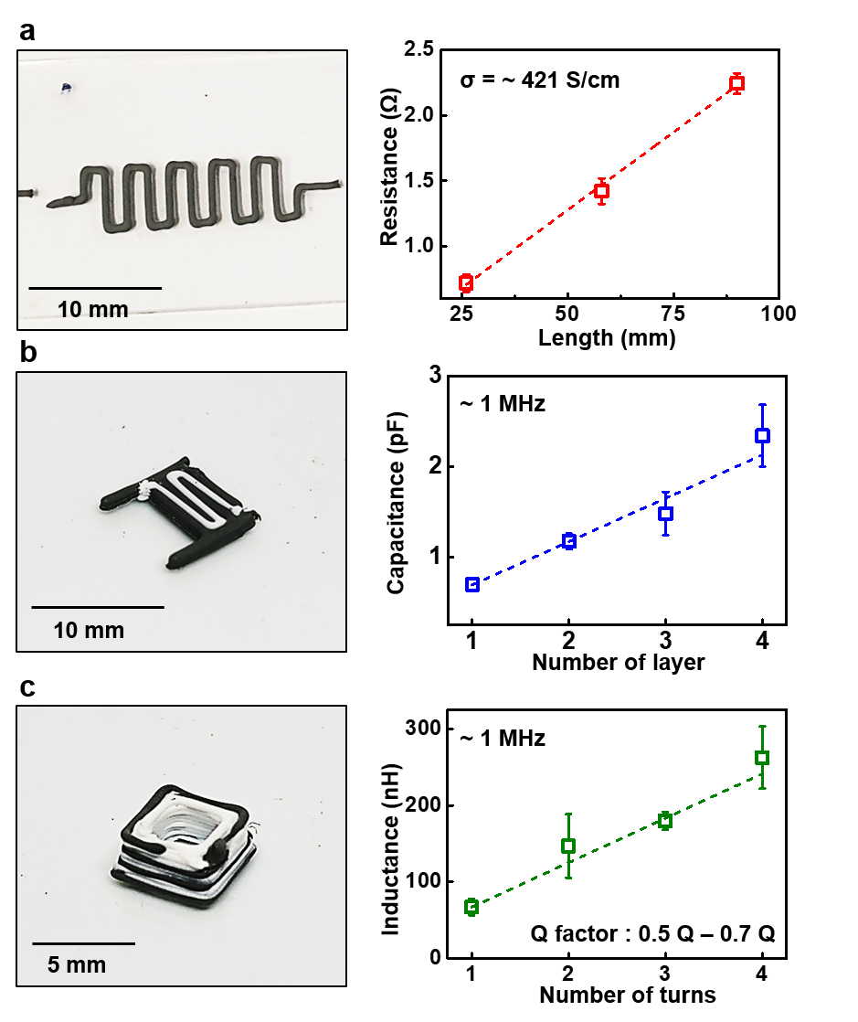

Supplementary Figure 24. UPS, UV-VIS analysis of ZnO. (a) UPS data for a ZnO filler-based pellet with a bias of -15 V, (b) Work function, (c) Valence band maximum of ZnO and (d) Direct band gap obtained from Tauc plot of ZnO filler. (e) Energy state of ZnO filler.
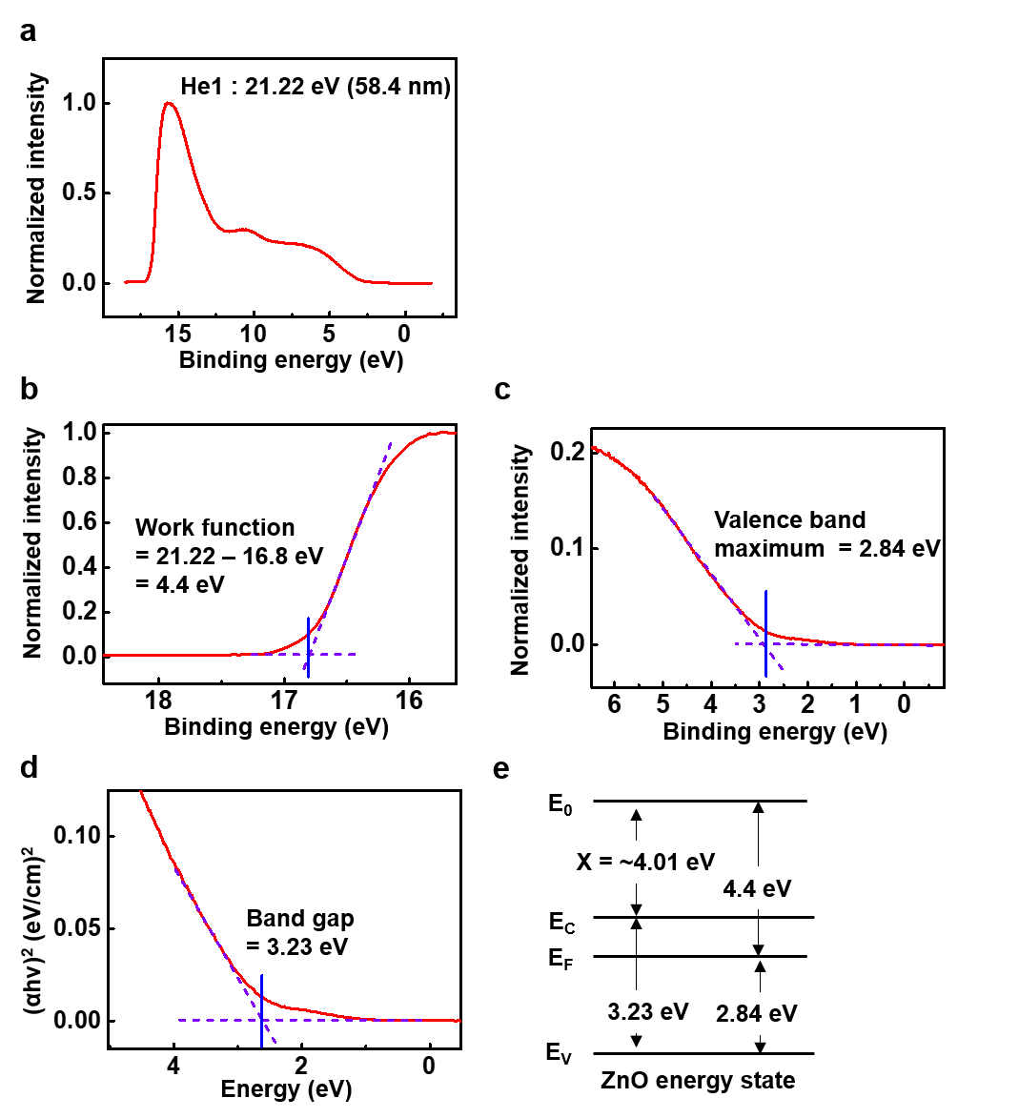

Supplementary Figure 25. Energy band diagrams of Fe, Zn, Mo, W, ZnO and performance of 3D printed biodegradable Schottky diode. (a) Energy band diagram of Fe, Zn, Mo, W, and ZnO obtained from KP, UPS, and UV-VIS. (b) Band diagram for metal - interfacial layer - ZnO. (c) I-V curve of Zn-PCL / ZnO-PCL / Mo-PBAT and Zn-PCL / ZnO-PCL / W-PBAT. (d) On/off ratio of Zn-PCL / ZnO-PCL / Mo-PBAT and Zn-PCL / ZnO-PCL / W-PBAT (n=10). (e) Image of 3D printed Schottky diode Zn-PCL / ZnO_{BY}-PCL / Mo-PBAT.
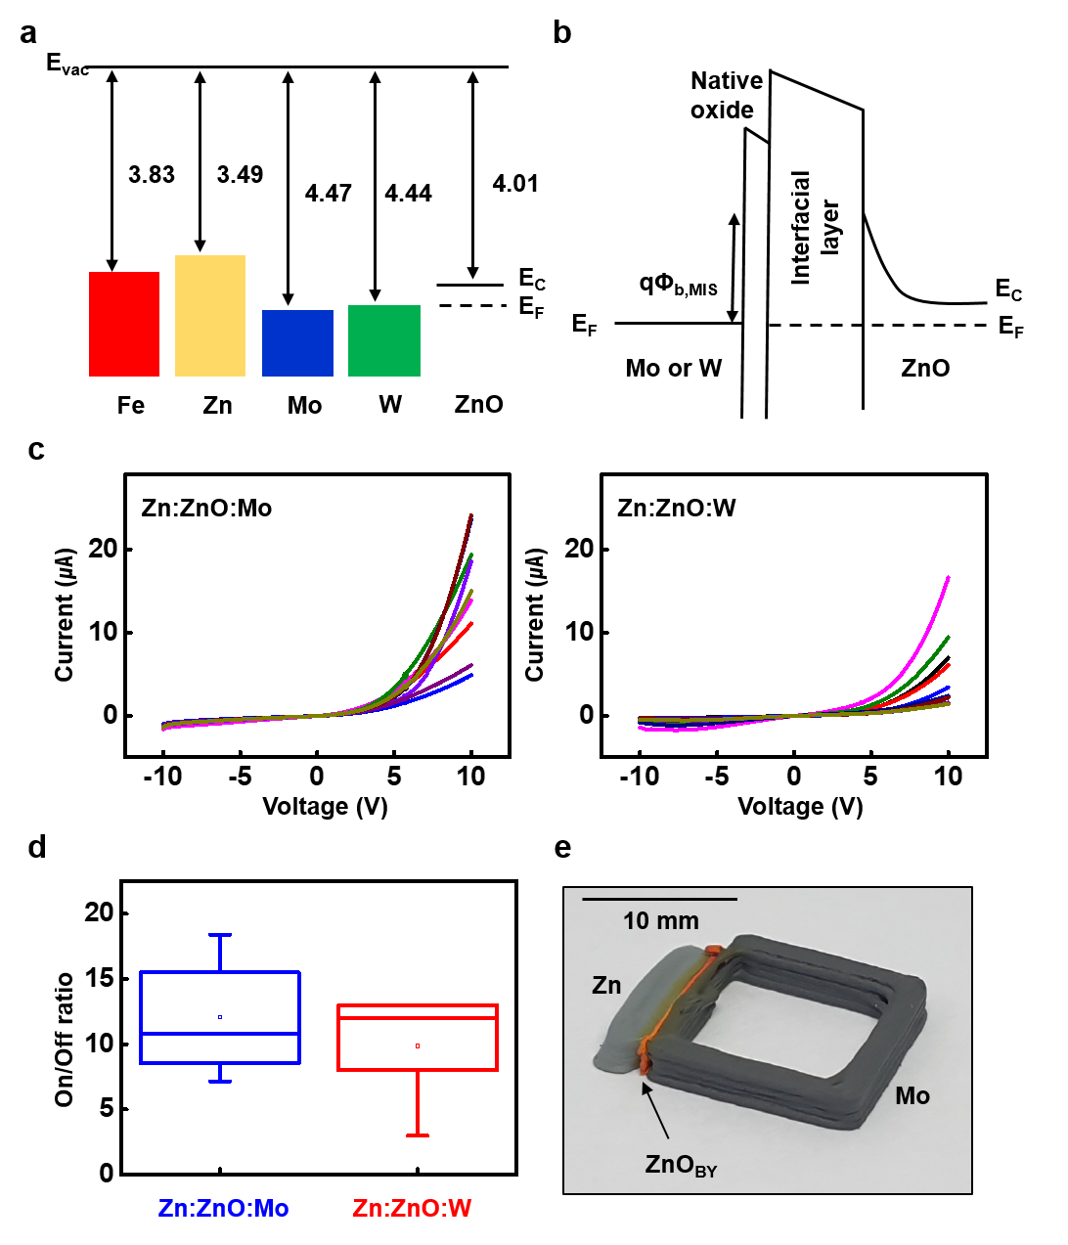
Supplementary Figure 26. Rectification with printed Zn-PCL / ZnO_{BY}-PCL / Mo-PBAT Schottky diode in ~MHz frequency. (a) Output voltage of direct connection to function generator transmitting a 32 MHz, 3Vpp continuous wave. (b) Output voltage of wirelessly powered 3D-printed stimulator generating monophasic continuous wave with Zn-PCL / ZnO_{BY}-PCL / Mo-PBAT Schottky diode (External wave, 10 MHz, RF amplified 200 mVpp).

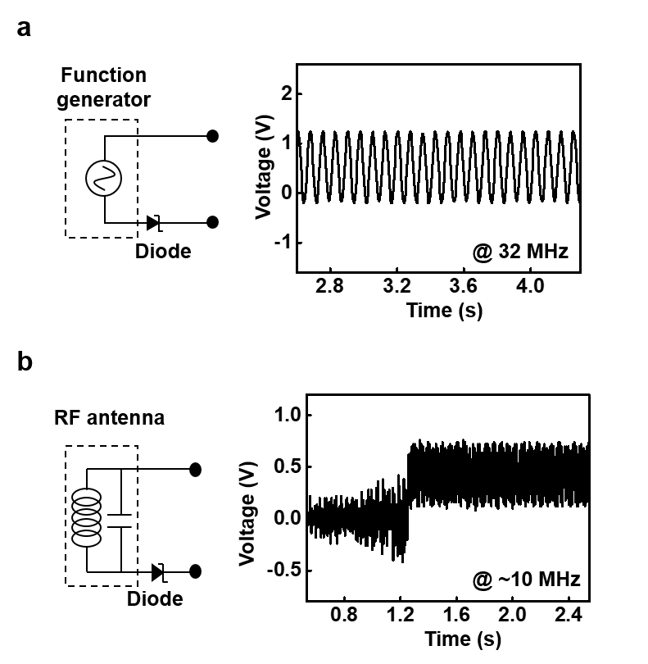

Supplementary Figure 27. Interpretation of Fermi-level alignment with conjugated molecule and demonstrated PN diode and NPN transistor. Illustration and energy band diagram of ZnO and p-Si fillers (a) without conjugated molecule (CM) and (b) with CM. I-V curve of p-type Si-PCL / ZnO-PCL configuration (c) without CM and (d) with CM. Here CM is guanine(G). Inset image is printed p-type Si_{G}-PCL / ZnO_{G}-PCL, with a scale bar of 5 mm. (e) Transfer curve of ZnO_{G}-PCL / p-type Si_{G}-PCL / ZnO_{G}-PCL transistor.
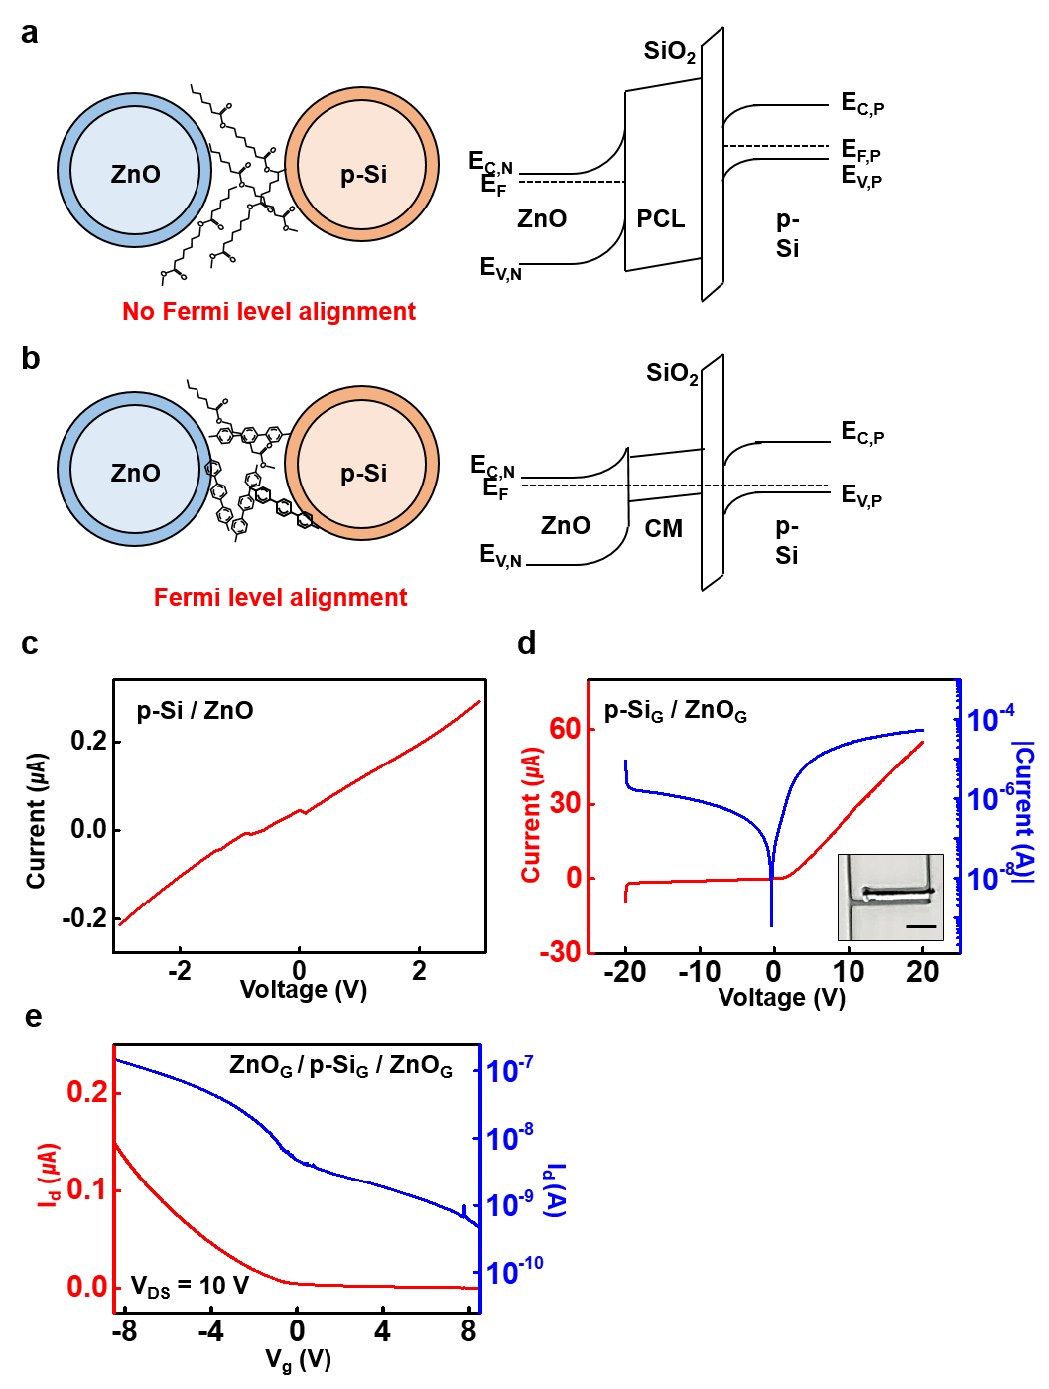
Supplementary Figure 28. 3D-printable biodegradable solid-state-electrolyte-gated field effect transistor. Solid electrolyte is printed with NaCl 1 mM in 2 wt% agarose gel. (a) Schematic illustration of a side-gated transistor structure. (b) 3D-printed solid-state-electrolyte in mono-layered fractal structure (Top) and multi-layered fractal structure (Bottom). (c) Transfer curve of the electrolyte-gated transistor. (d) Performance of electrolyte-gated transistor. Saturation mobility was determined as following¹⁴: 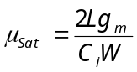. Where 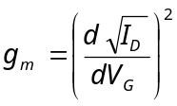is the transconductance; W and L is the width and length of the channel; C_{i} is the capacitance of the dielectric layer¹⁵ (NaCl 1 mM, C_{i} ~ 6 μF/cm²).
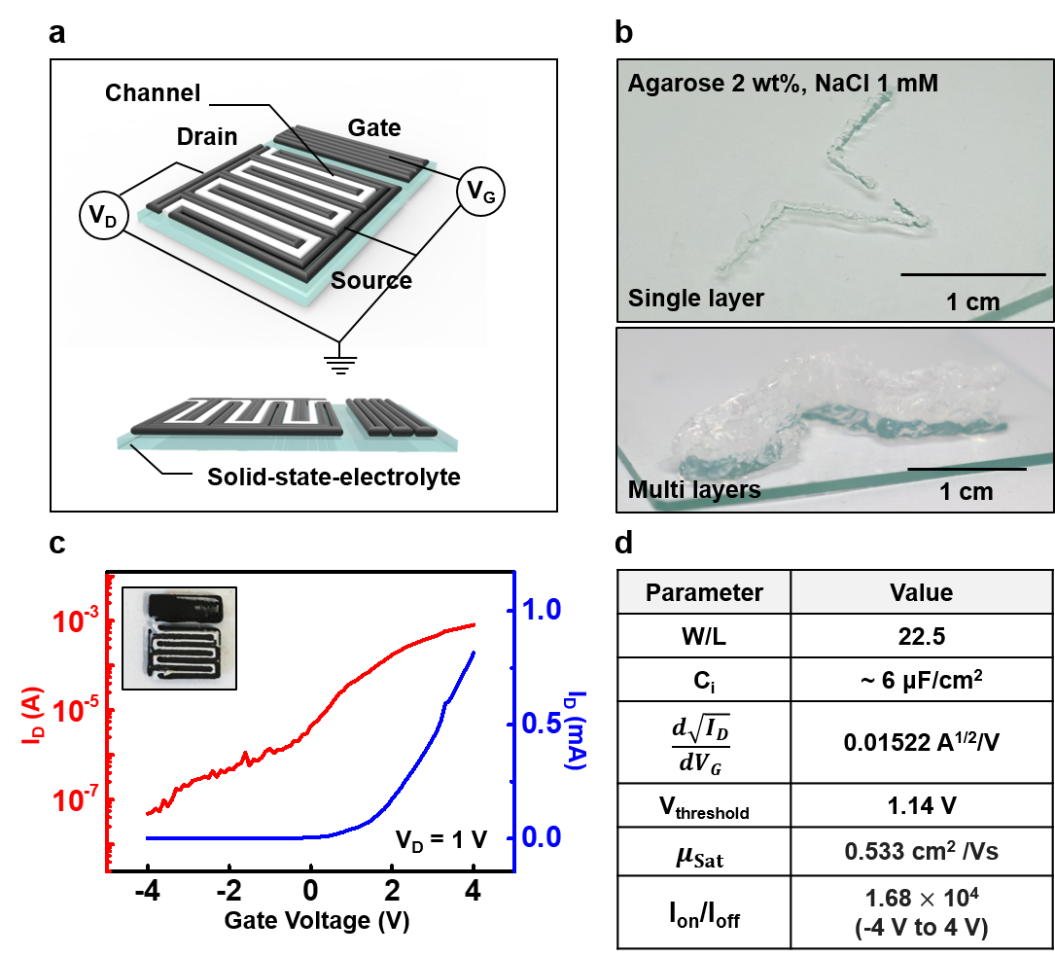

Supplementary Figure 29. Operation of LED chip and NFC chip via printed Zn-PCL as wire and antenna. (a) Illustration of electronic component integration via printed biodegradable printed circuit board (PCB) and wireless antenna. (b) Image showing the operation of μLED via Zn-PCL wires connected to a Digital Multi-meter (voltage = 1.7 V). (c) Image of a printed planar Zn-PCL inductor integrated with NFC tag (Ntag213) and SMD capacitor (30 pF). (d) RF behavior comparison between a smartphone and a printed inductor with NFC chip and SMD chip.
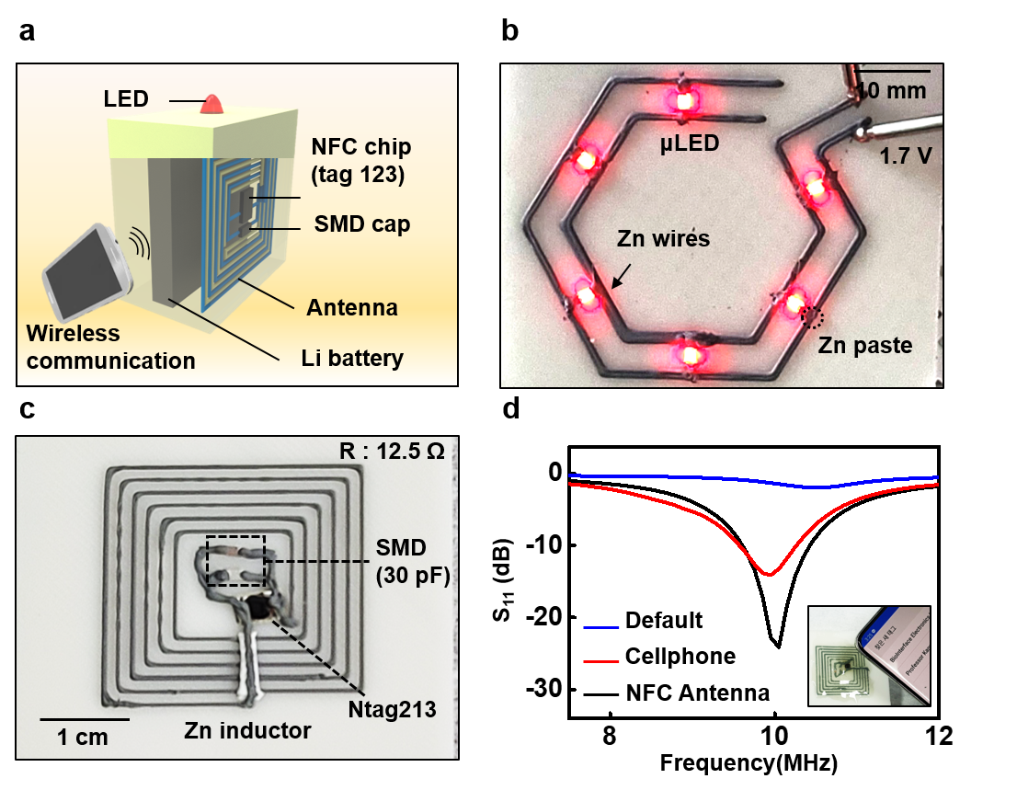

Supplementary Figure 30. Design algorithm of 3D-printable stereographic integrated circuits in customized structure.
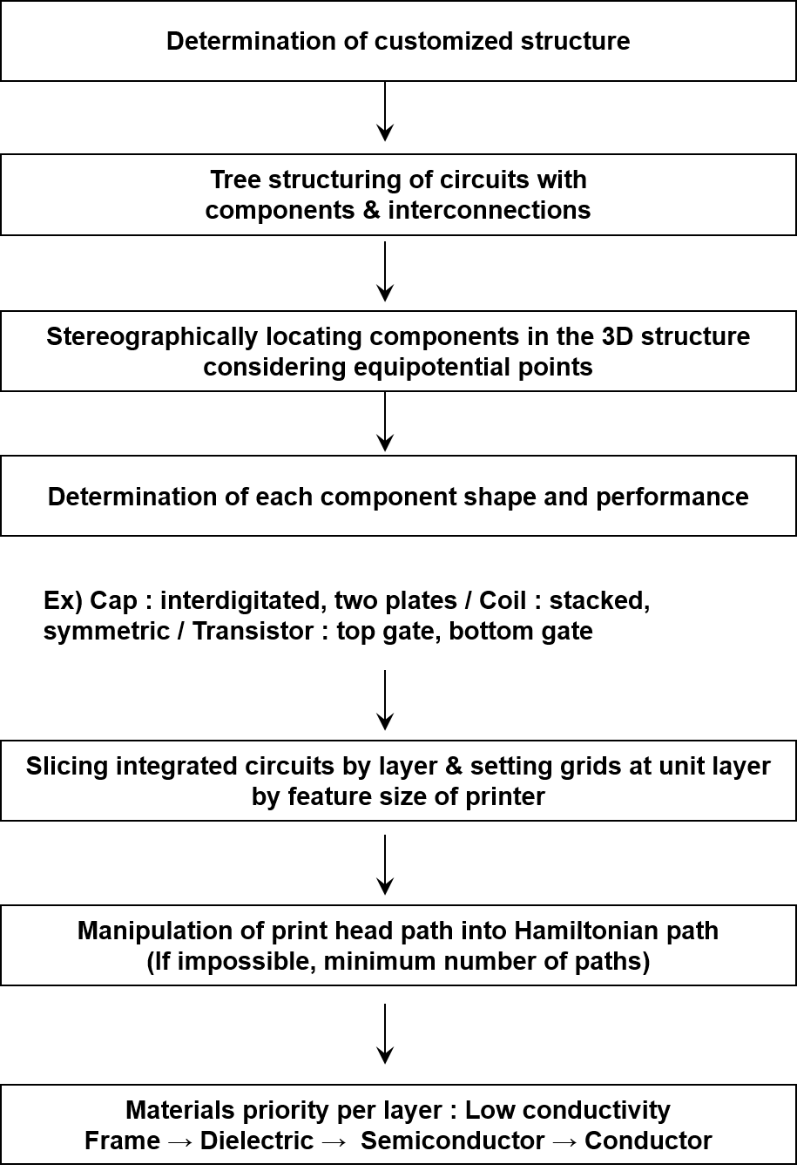

Supplementary Figure 31. Structure of 3D printed wireless biodegradable electroceutical tube. (a) Tissue-interfacing parts: inner encapsulation and electrodes, outer encapsulation. (b) Circuit diagram of the 3D structural wireless neuro-stimulator. (c) Internal view for integration with diodes, inductor, and wire in hollow structure
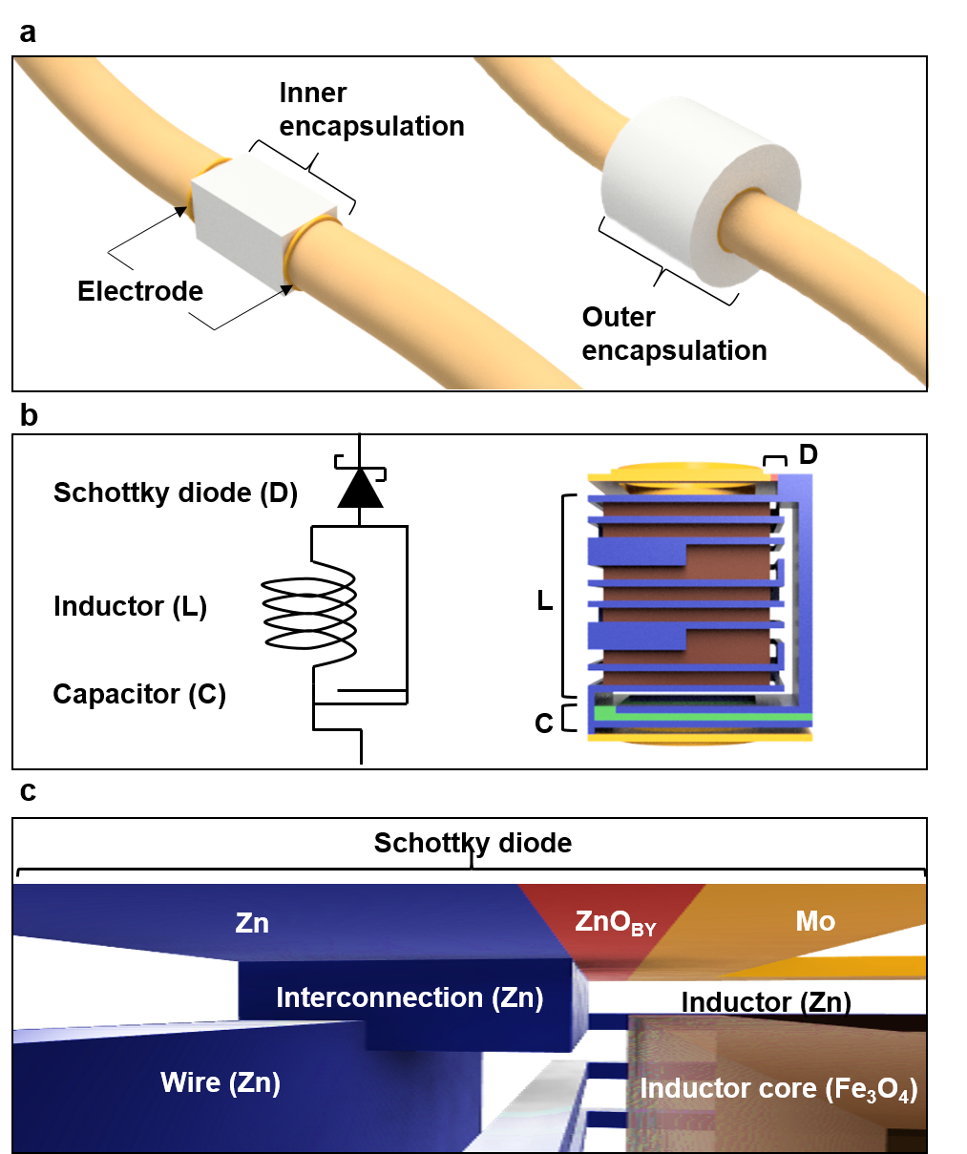

Supplementary Figure 32. Design algorithm of the electroceutical tube with various nerve sizes.
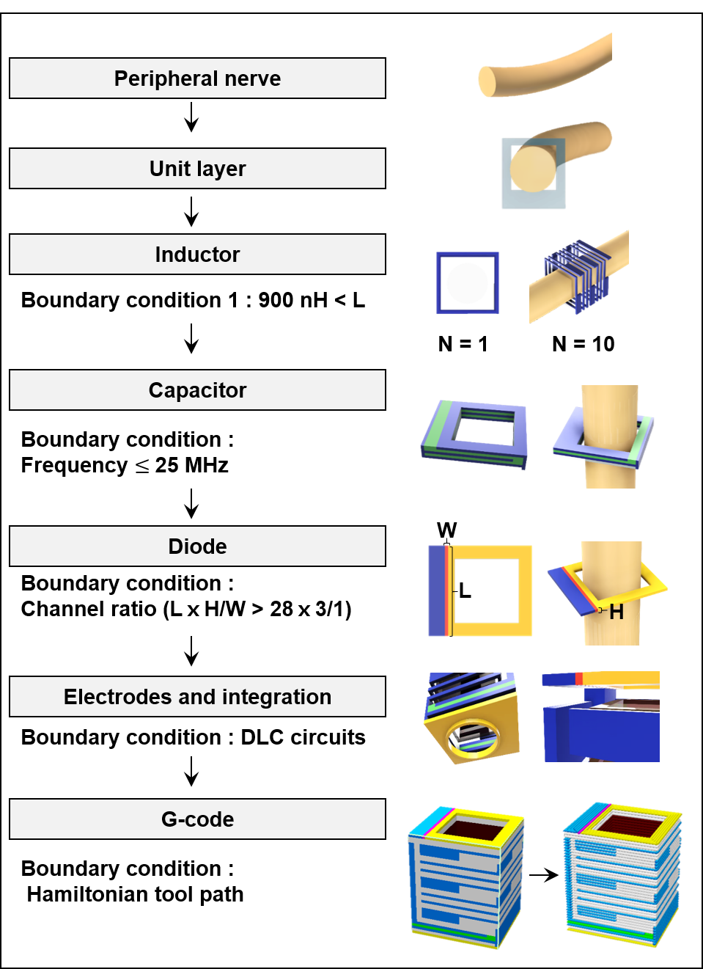

Supplementary Figure 33. Visualized printing tool path per layer of the electroceutical tube. The different colored materials for each layer are as followed: Blue (Zn-PCL), Yellow (Mo-PBAT), Pink (ZnO_{BY}-PCL), Green (Si₃N₄-PCL), White (PBAT), and Dark red (Fe₃O₄-PCL).
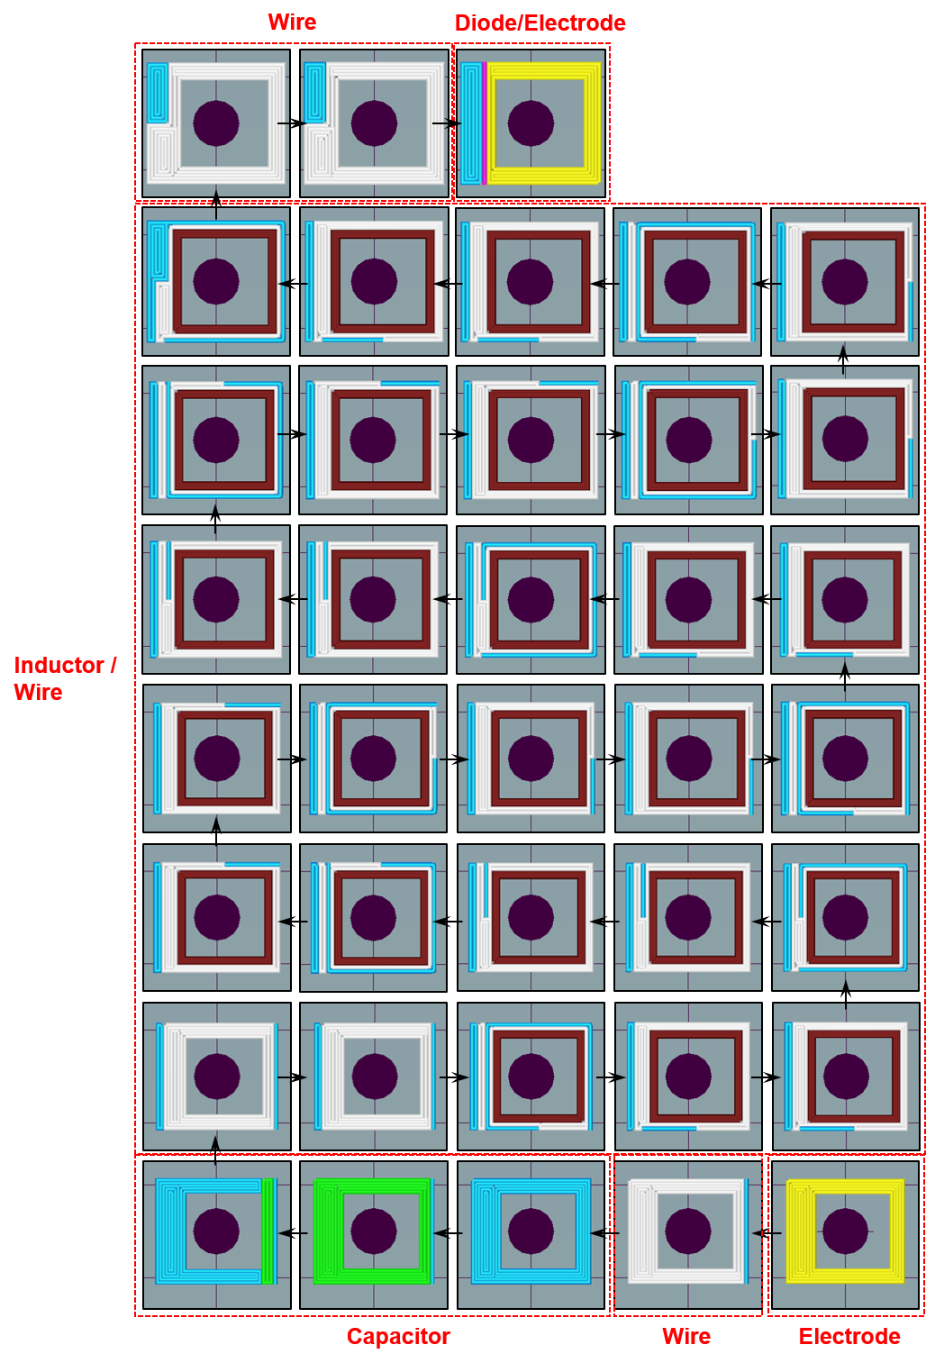

Supplementary Figure 34. Ferrite effects in 3D printed biodegradable wireless powering system. (a) 3D printed 2D planar stimulator on PLA substrate. (b) Output voltage of the 2D stimulator as influenced by the area difference of Fe₃O₄-PCL. (c) Top view of Fe₃O₄-PCL embedded in a 3D stacked inductor. (d) X-ray image of embedded Fe₃O₄-PCL in a 3D stacked inductor. Inset is image of outer surface of the inductor (e) Wireless operation of an LED with a 3D printed stacked inductor containing Fe₃O₄-PCL, with a RF amplified 39.2 MHz, 460 mVpp transmission wave.
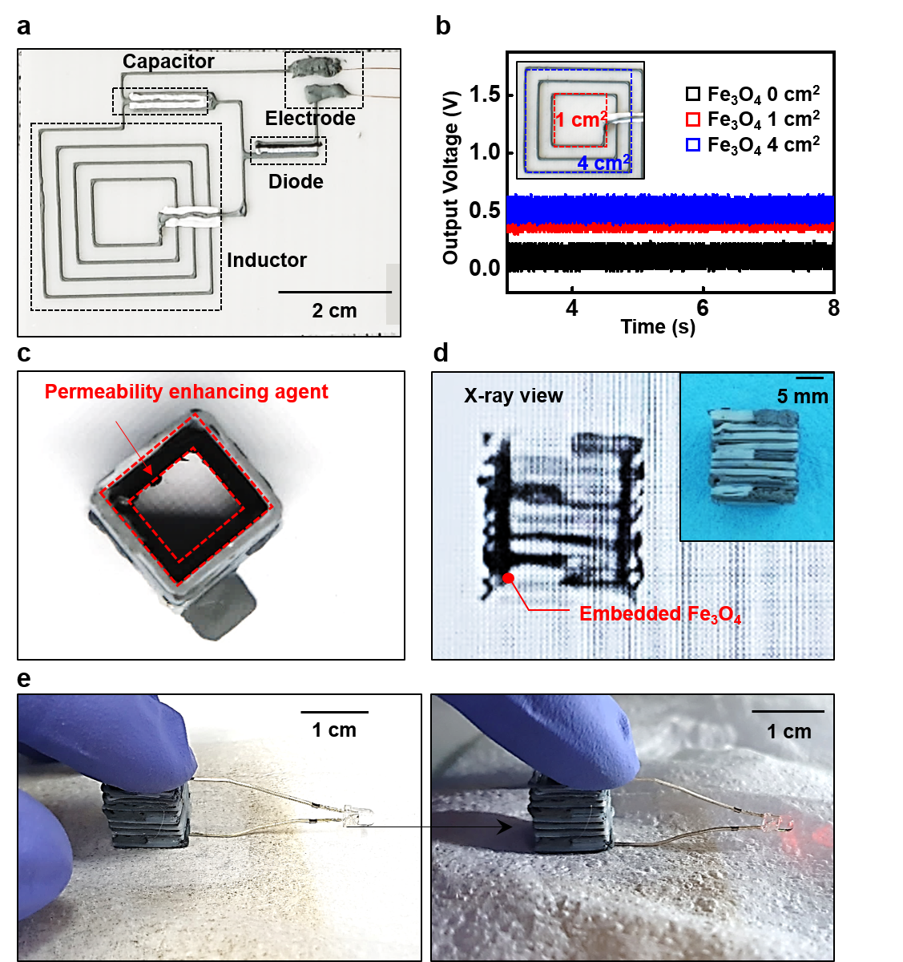

Supplementary Figure 35. Components and conditions of the wireless powering system for 3D-printed biodegradable wireless stimulator. Electrical properties of the RF powering system of a 3D-printed biodegradable electrical stimulator, both inside and outside the animal body.

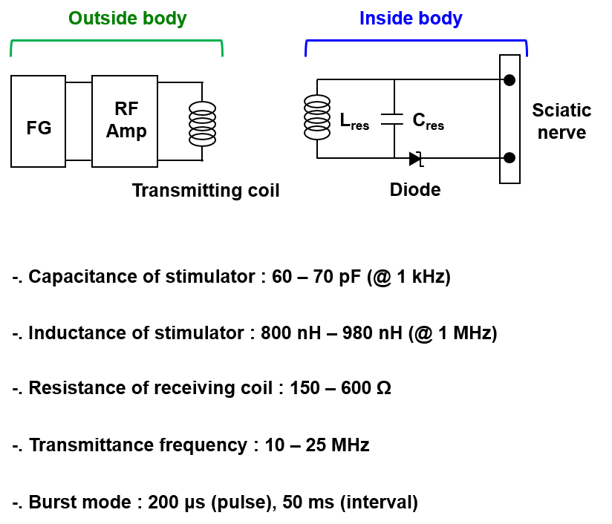

Supplementary Figure 36. Oxidation effects in return loss (S₁₁) of non-encapsulated 3D-printed biodegradable wireless stimulator. (a) S₁₁ variation of a non-encapsulated 3D-printed stimulator right after sintered case. (b) S₁₁ variation after 12 hours of incubation in ambient conditions.

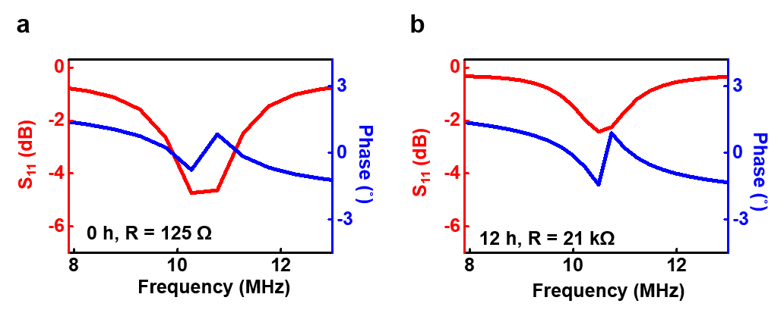

Supplementary Figure 37. In vivo operation of a 3D printed biodegradable wireless stimulator in a rat model. (a) Image of a Mo wire-interconnected stimulator (ID 8.8 mm) with dip-coated PBAT encapsulation. (b) Surgical implantation process of the wired stimulator in the dorsal subcutaneous region of an SD rat. (c) Threshold voltage for electrical stimulation on a 14-week-old male rat using a non-degradable Cu-PI-based wireless stimulator. (d) CMAP response to electrical stimulation with the wireless stimulator.
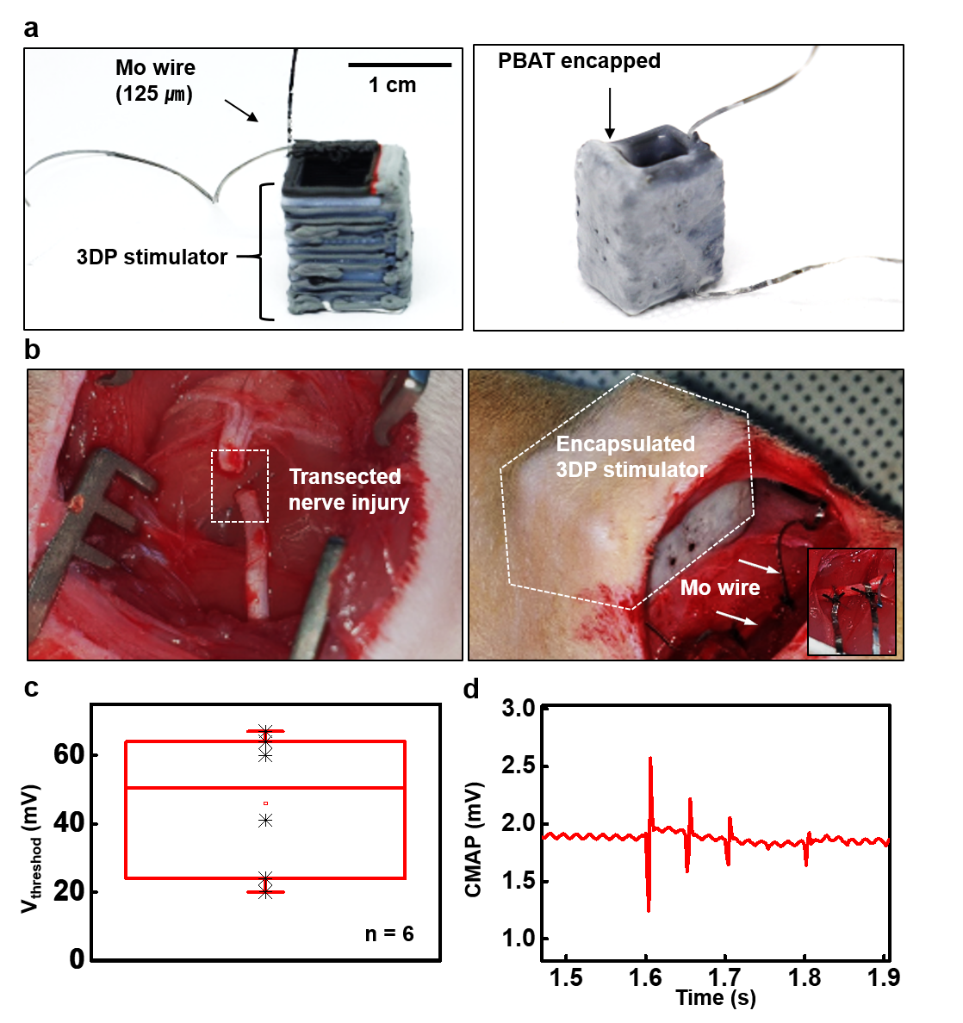

Supplementary Figure 38. Implantation surgical process of the 3D printed biodegradable stimulator in a canine model. (a) Surgical implantation process into the sciatic nerve. (b) X-ray image of the implanted 3D printed bioresorbable stimulator.
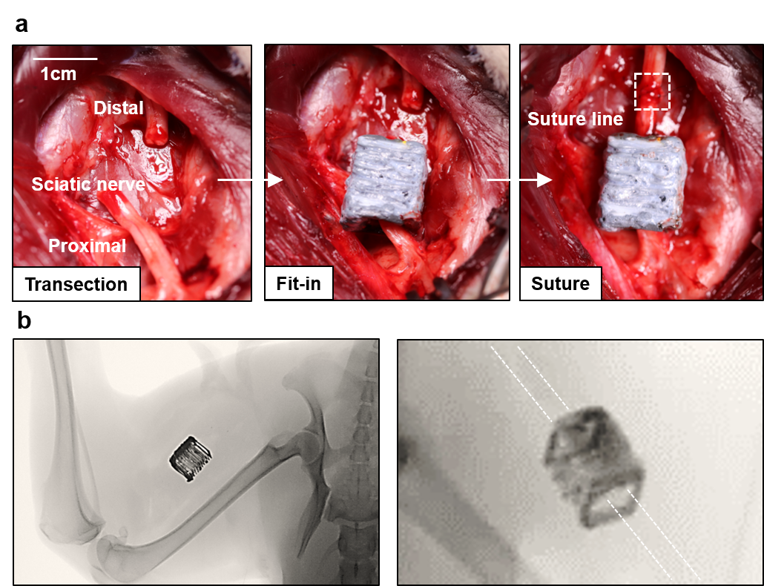

Supplementary Figure 39. CMAP measurements obtained from canine model in the presence of electrical stimulation by the 3D-printed biodegradable stimulator and function generator. Stimulation with direct connection to the function generator in burst mode: (a) 20 Hz, 200 μs, 0.6 Vpp, and (b) 20 Hz, 200 μs, 1.3 Vpp. (c) Stimulation with the wireless 3D printed biodegradable stimulator (d) Single CMAP signals which are generated by function generator (Left) and 3D-printed biodegradable stimulator (Right).
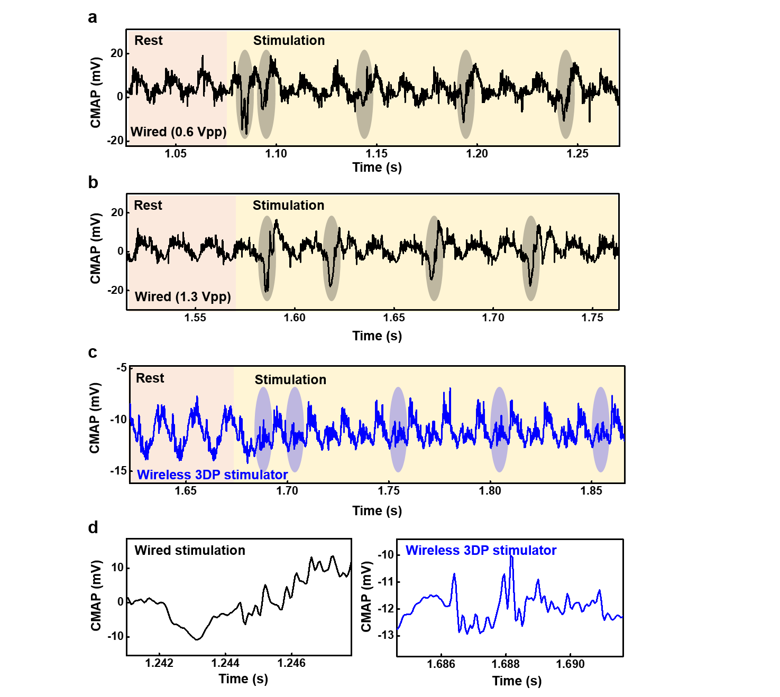

Supplementary Figure 40. Compound nerve action potential (CNAP) and CMAP measurement in canine model with standard stimulation. Illustration for measuring: (a) CMAP and (b) CNAP in the canine model. (c) CMAP and CNAP obtained from the canine model by electrical stimulation with the same condition (20 Hz, 200 μs, 0.8 Vpp). Stimulation electrodes were directly connected to function generator.

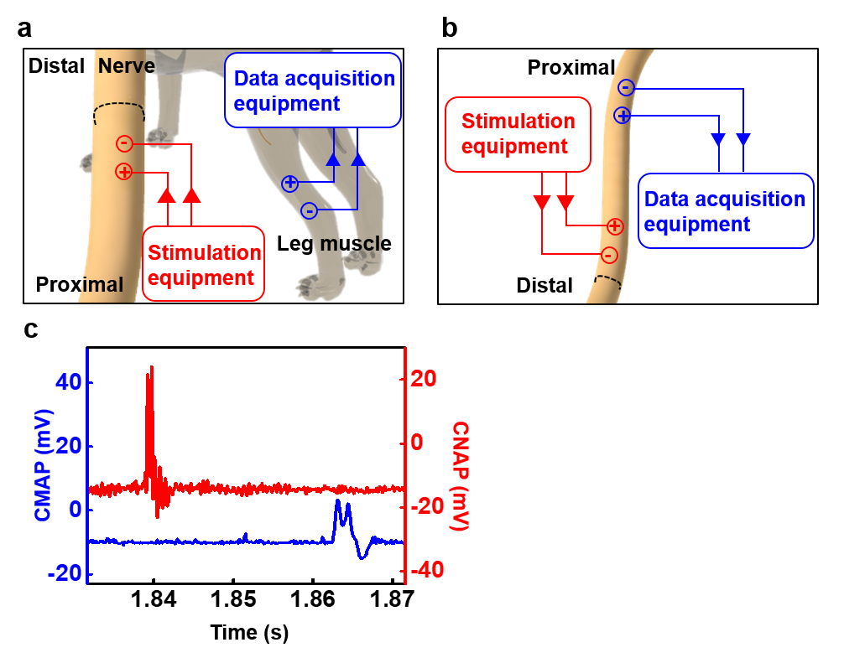

Supplementary Figure 41. CNAP measurement setup in canine model. (a) Schematic diagram of the setup and location of the 3D printed bioresorbable wireless stimulator for measurement. (b) Image of probes at the sciatic nerve. (c) Image of CNAP measurement with the wirelessly stimulating sciatic nerve using the 3D printed bioresorbable stimulator.
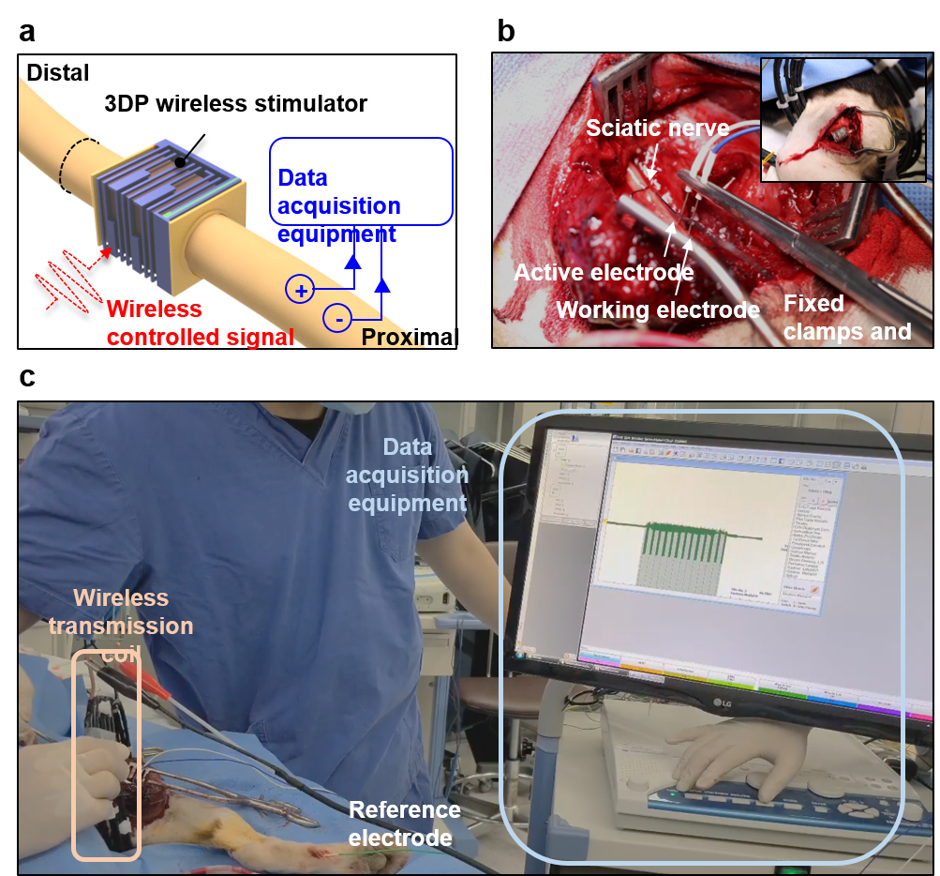

Supplementary Figure 42. Non-resorbable wireless electrical stimulator. (a) Cu/PI-based stimulator with Pt electrode encased in PDMS (~150 μm thick) for nerve interface. (b) Image of the surgical process for implantation of the non-resorbable wireless electrical stimulator in the sciatic nerve.

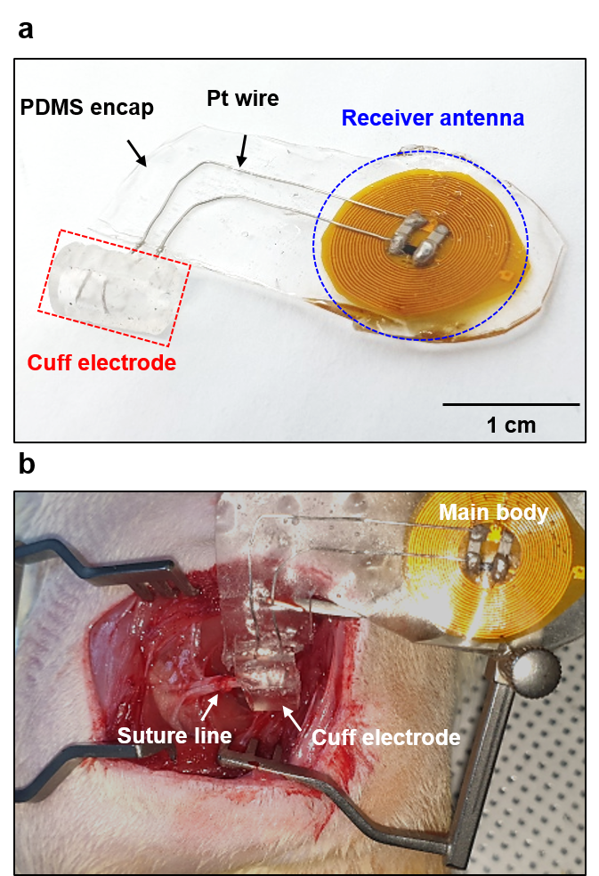

Supplementary Figure 43. Weekly assessed functional recovery by CMAP measurements of distal musculature among three groups (Transected; Transected + electrical stimulation 1 hour with 3D printed biodegradable stimulator; Transected + electrical stimulation 1 hour with non-resorbable stimulator). (a) CMAP for the three groups at 8-weeks. CMAP at 8-weeks for (b) Transected, (c) Transected + electrical stimulation 1 hour with 3D printed biodegradable stimulator, and (d) Transected + electrical stimulation 1 hour with Non-resorbable stimulator.
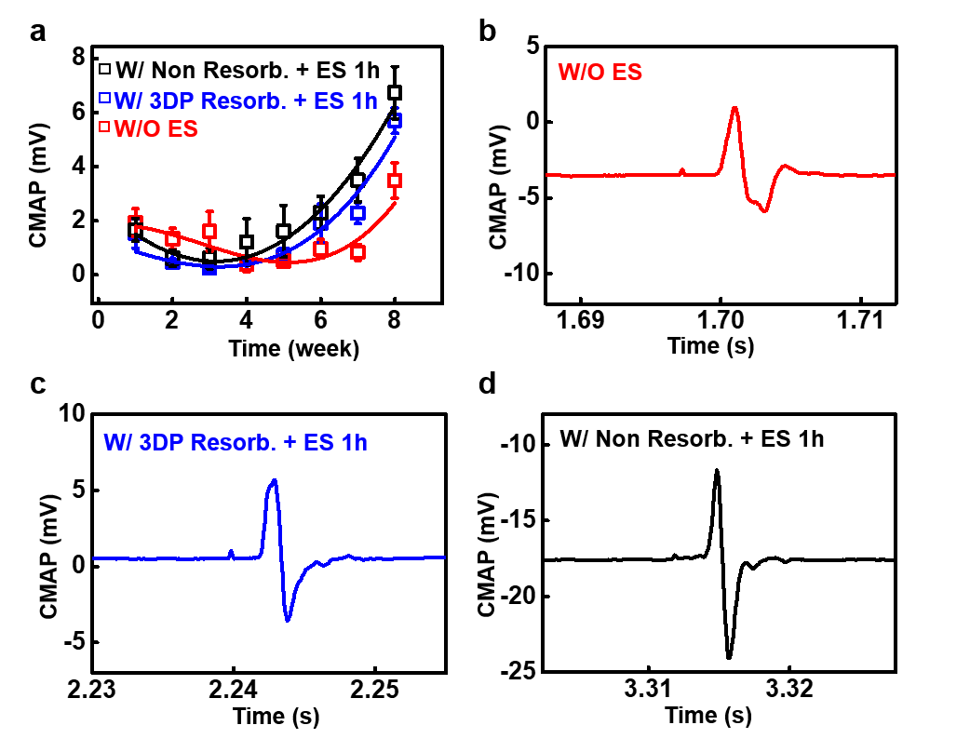

Supplementary Figure 44. Mass and fiber cross-section area of distal musculature at week 8 among three groups (Transected; Transected + electrical stimulation 1 hour with 3D printed biodegradable stimulator; Transected + electrical stimulation 1 hour with non-resorbable stimulator). (a) H&E stained GCM fiber cross-section. (b) Muscle mass and (c) cross-section area of muscle fiber in GCM (left) and TA (right) muscles. *p<0.05 by one-way ANOVA and Games-Howell post hoc tests.
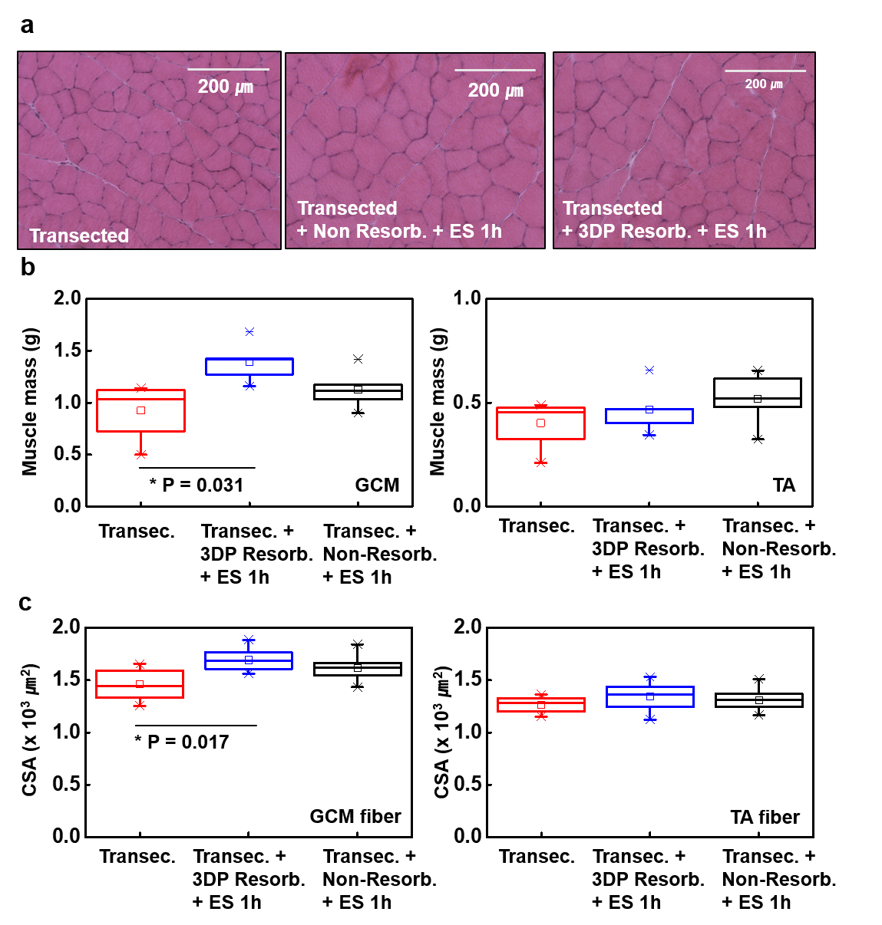

Supplementary Figure 45. Images and number of immunologically stained axons (TUJ1) in the sciatic nerve at week 8 among three groups. (a) Illustration of definition for the distance of the cross-sectional area. Positive is distal, and negative is proximal. Images of stained axons: (b) Transected, (c) Transected + electrical stimulation 1 hour with non-resorbable stimulator, (d) Transected + electrical stimulation 1 hour with 3D printed biodegradable stimulator, TUJ1 (green). Scale bar is 60 μm. (e) Box chart for axon numbers in the three groups. Break region: 1k - 24k. Symbols in the chart represent ‘–’ for max and min, ‘X’ for 99%, 1%, ‘□’ for mean, and the box for 75% to 25%. (f) Histogram of axon numbers in the three groups.
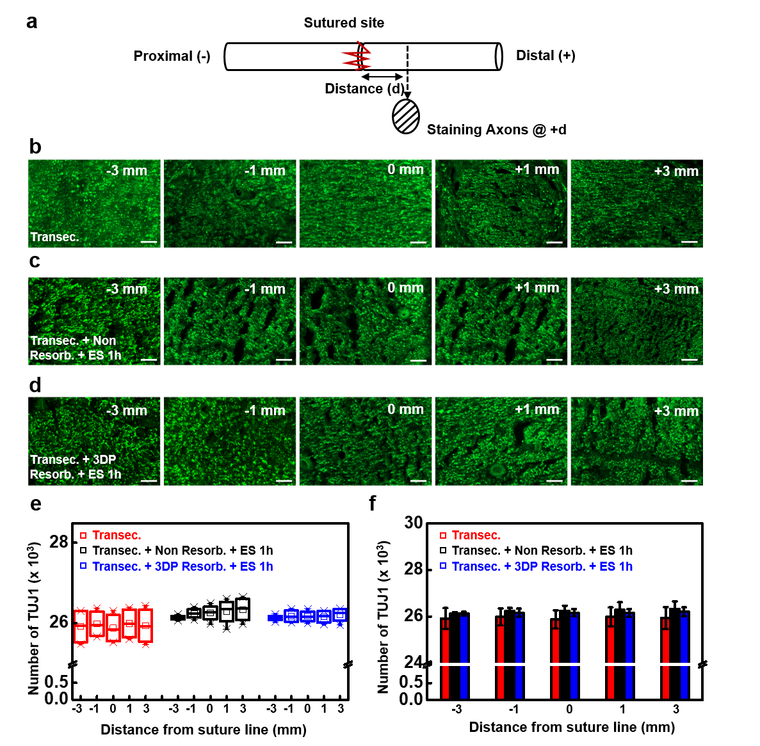

Supplementary Figure 46. Images and number of immunologically stained ED1-positive macrophages in the sciatic nerve at week 8 among three groups. (a) Illustration of definition for the distance of the cross-sectional area. Positive is distal, and negative is proximal. Images of stained axons: (b) Transected, (c) Transected + electrical stimulation 1 hour with non-resorbable stimulator, (d) Transected + electrical stimulation 1 hour with 3D printed biodegradable stimulator, ED1 (green). Scale bar is 60 μm. (e) Box chart for the total macrophage number in the three groups. Symbols in the chart represent ‘–’ for max and min, ‘X’ for 99%, 1%, ‘□’ for mean, and the box for 75% to 25%. (F) Histogram of ED1-positive macrophage numbers in the three groups. *p<0.05 by one-way ANOVA and Games-Howell post hoc tests.
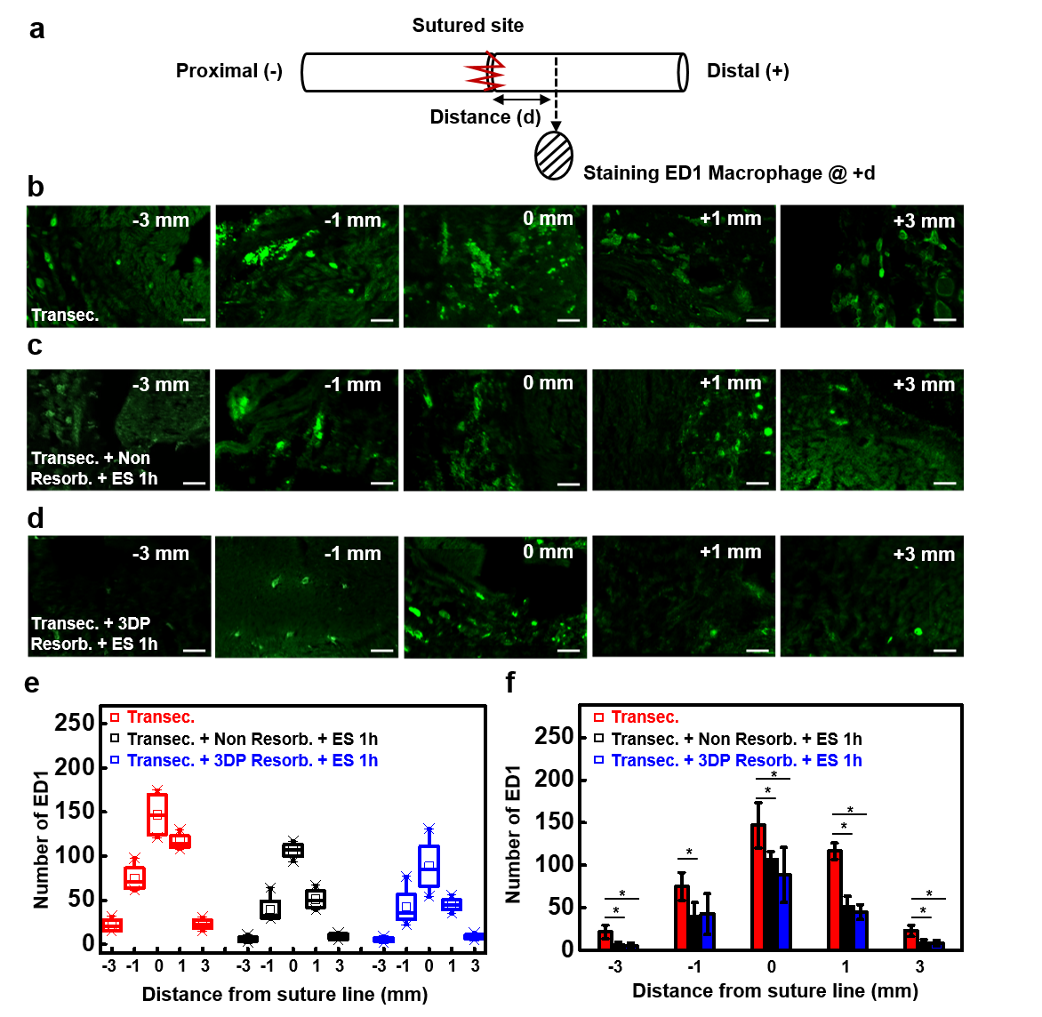

Supplementary Figure 47. Biocompatibility test of implanted 3d printed biodegradable stimulator on the sciatic nerve. (a) Serial images of the implanted stimulator (ID 3.2 mm) in the rat sciatic nerve for 8 weeks. (b) ED1 stained image within sagittal sectioning of the sciatic nerve after 8 weeks with the transected-only group and stimulator-implanted group.

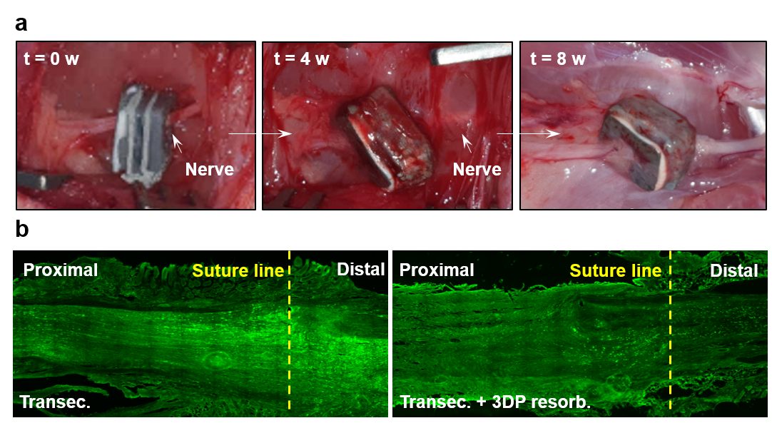

Supplementary Figure 48. Degradation behaviors of the 3D printed biodegradable stimulator in the acceleration test condition. (a) Serial degradation images of ID 5.6 mm stimulator in a Pasteur glass pipette in PBS at 45 °C with lipase. (b) Image of ID 8.8 mm stimulator in a PDMS hanger in mixed PBS/pH 10 standard solution at 70 °C. (c) Weekly mass ratio difference of ID 8.8 mm stimulator in different pH solutions (pH 4, 7, 10).

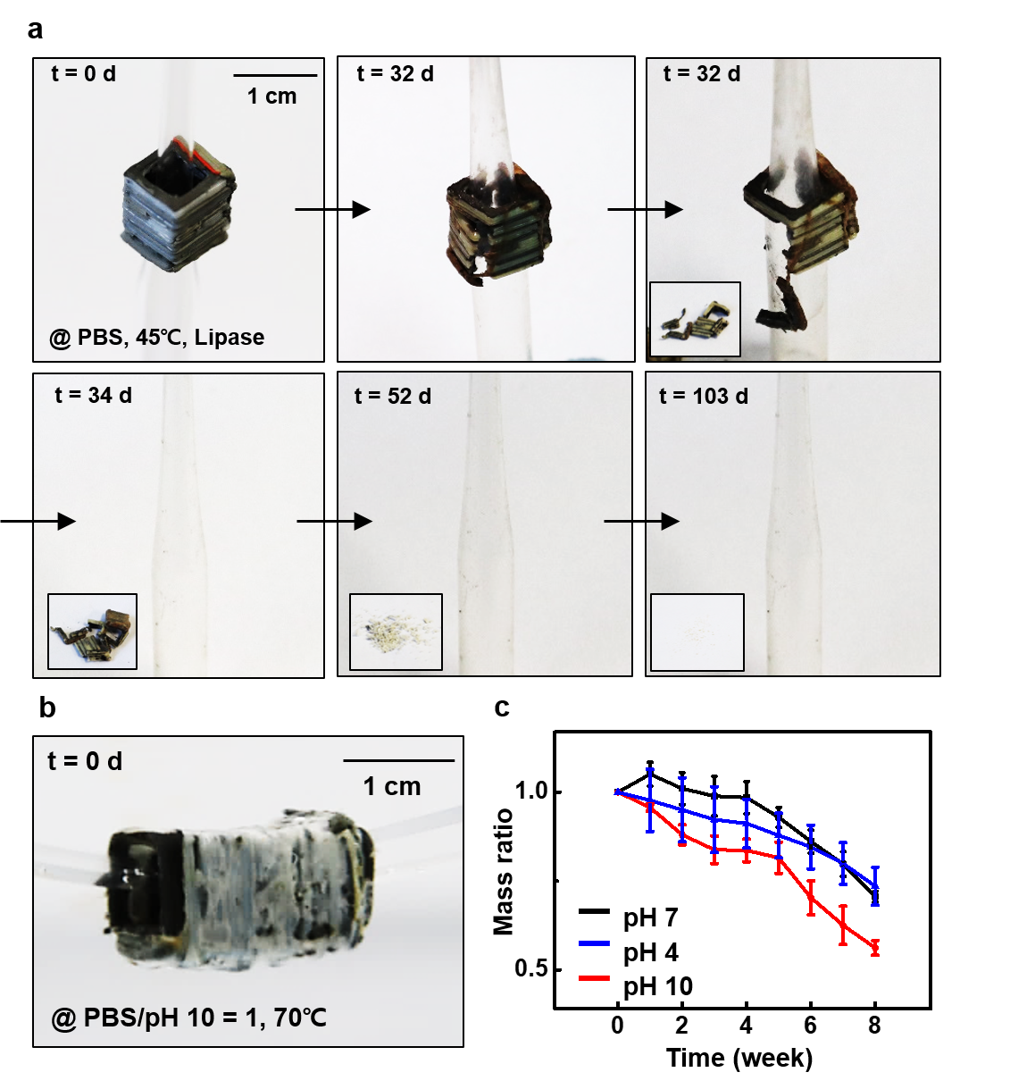

Supplementary Figure 49. In vivo degradation test of 3D printed biodegradable stimulator. (a) Serial images of the implantation of the stimulator at the dorsal subcutaneous region. (b) Serial X-ray images of the pristine stimulator in a rodent model for 18 weeks. (c) Illustration of treatment process for the acceleration of in vivo degradation. Gaseous chloroform was absorbed into the pristine sample for 15 minutes and immediately immersed in ethanol for 1 day and sterilized with a UV lamp. (d) Weight of a rat implanted with a pristine, and accelerated stimulator measured at two-week intervals.
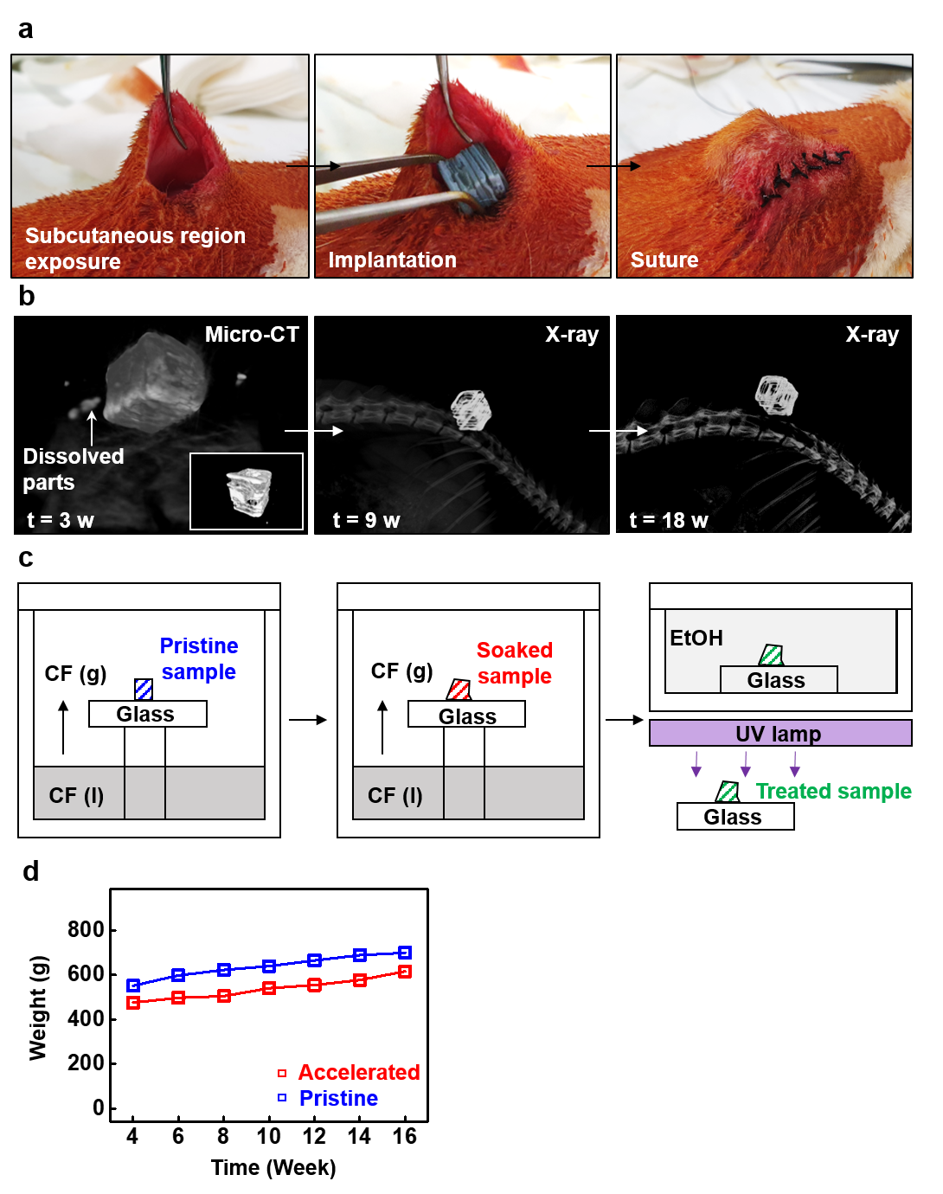
Supplementary Figure 50. Hematological analysis of a rat implanted with a 3D printed biodegradable stimulator. Acronyms at blood analysis followed as: WBC (White Blood Cell), RBC (Red Blood Cell), HGB (Hemoglobin), HCT (Hematocrit), PLT (Platelet), NEUT (Neutrophil), LYMPH (Lymphocyte), MONO (Monocyte), EOS (Eosinophil), BASO (Basophils), LUC (Large Unstained Cells); Ca (Calcium), IP (Inorganic Phosphorus), Glu (Glucose), BUN (Blood Urea Nitrogen), CHO (Cholesterol), TP (Total Protein), ALB (Albumin), TBIL (Total Bilirubin), ALP (Alkaline Phosphatase), AST (Aspartate Aminotransferase), and ALT (Alanine Aminotransferase).
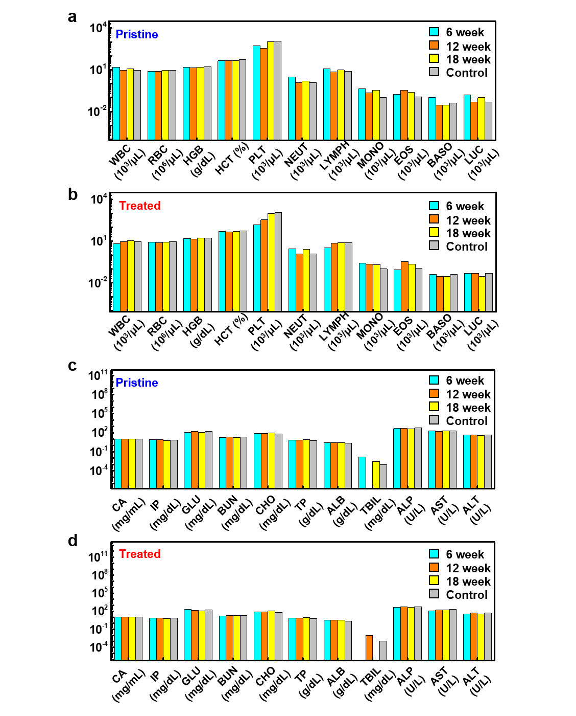
Supplementary Figure 51. Concept of 3D printed electronic nerve conduit for long nerve gap injury. (a) Illustration of electronic nerve conduit embedding guide channel and wireless stimulator for long nerve gap injury. (b) Exploded view of the electronic nerve conduit for long nerve gap defect. (c) Serial images of the simple surgical process for the implantation of the electronic nerve conduit to a long nerve gap injury.
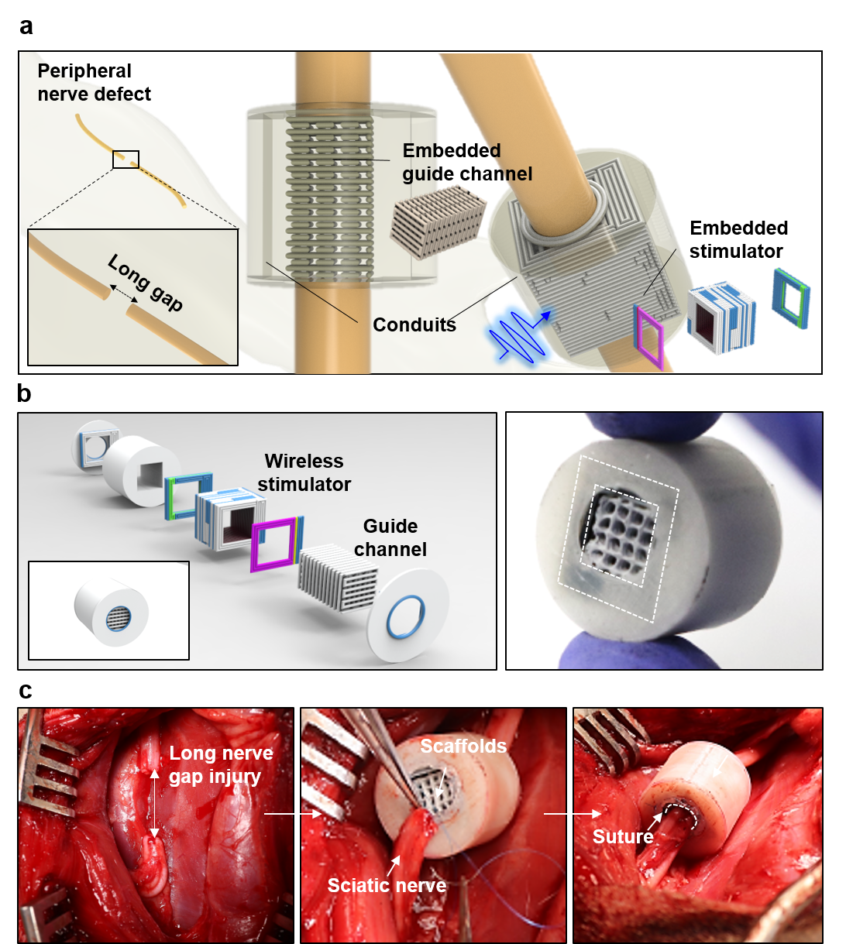

Supplementary Figure 52. Complex plane adaptive 3D printed temperature sensor array. (a) Image of a printed Zn-PCL resistor. (b) 2ⅹ2 temperature sensor on a stair-like slope structure with 4 wells (S1, S2, S3, S4). (c) Cu-wired 2ⅹ2 temperature sensor via silver epoxy. (d) IR image for temperature change at S3 by finger touch. (e) Resistance changes of Zn-PCL-based resistor at S3 where TCR = ΔR/Δ T ≈ 0.002/K.
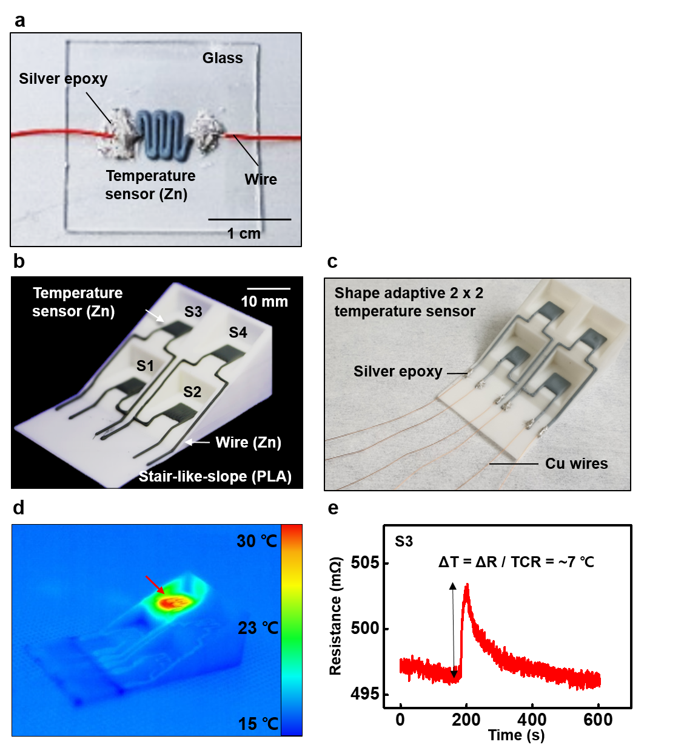

Supplementary Figure 53. 3D printed trench-structured capacitive-type pressure sensor. (a) Schematic illustration of the sensor. (b) Operation mechanism of the sensor (d₁ > d₂). (c) Designed dimensions of the sensor. (d) Serial images of the printing process of the sensor. (e) Image of the 3D printed pressure sensor. (f) Capacitance change due to repetitive external 1 MPa pressure applied to the sensor.
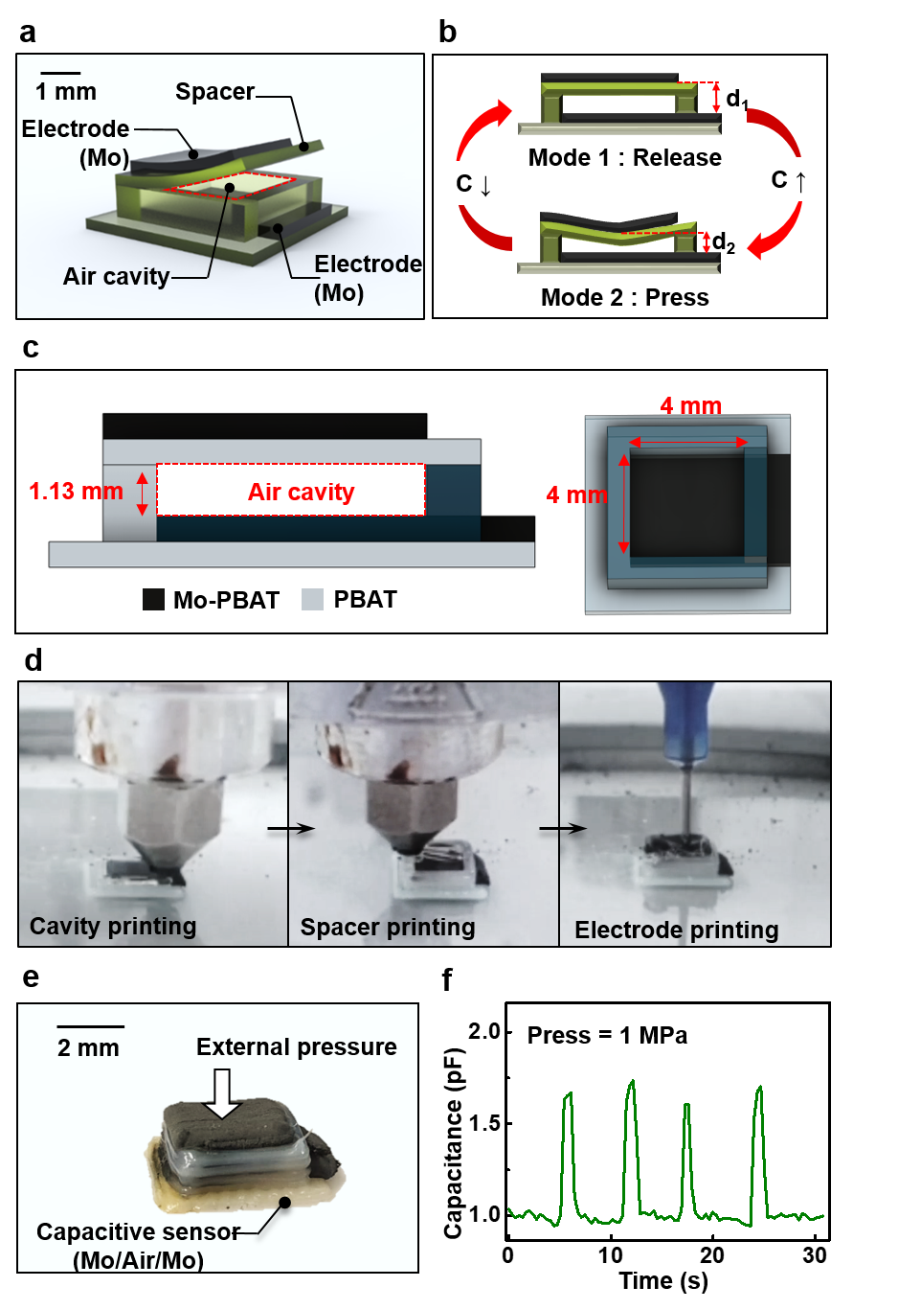
Supplementary Figure 54. 3D printed UV sensor. (a) Image of a 3D printed Mo / ZnO_{Al} / Mo UV sensor. (b) Resistance and conductance change of the UV sensor with a 15 W, 365 nm UV lamp at a 3.6 cm distance. Sensing area is 36.5 mm². (c) Conductance change in response to repetitive on/off UV stimulus.
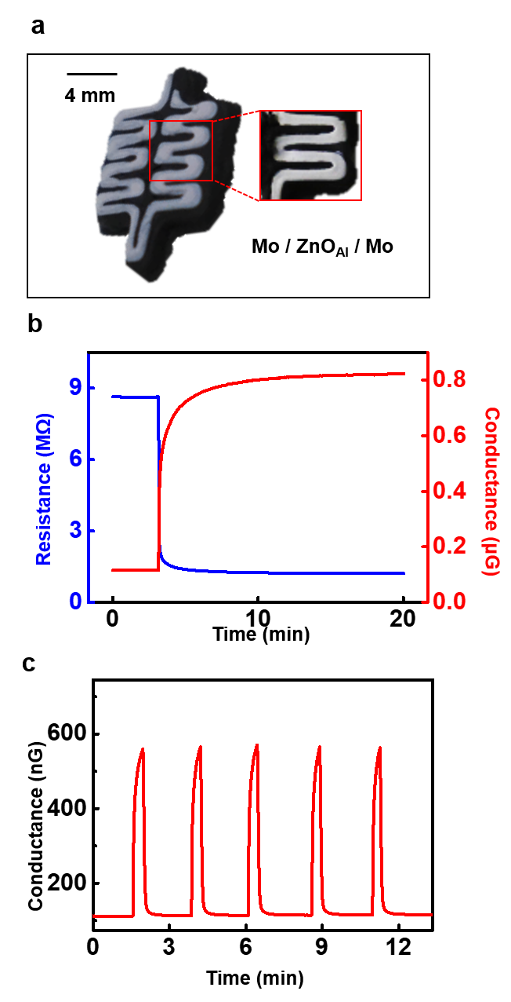

Supplementary Figure 55. 3D printed shape-shifting photodetector array. (a) Image of a 2ⅹ2 UV sensor array. (b) Serial images of the shape-shifting photodetector array with external heat delivered by a heat gun (~80 °C). (c) Image of a directly printed UV sensor unit on a shape-shifting PLA dome. (d) Resistance change of Mo-PBAT due to flexural deformation. Strain is determined by length change between jigs that hold the Mo-PBAT sample.
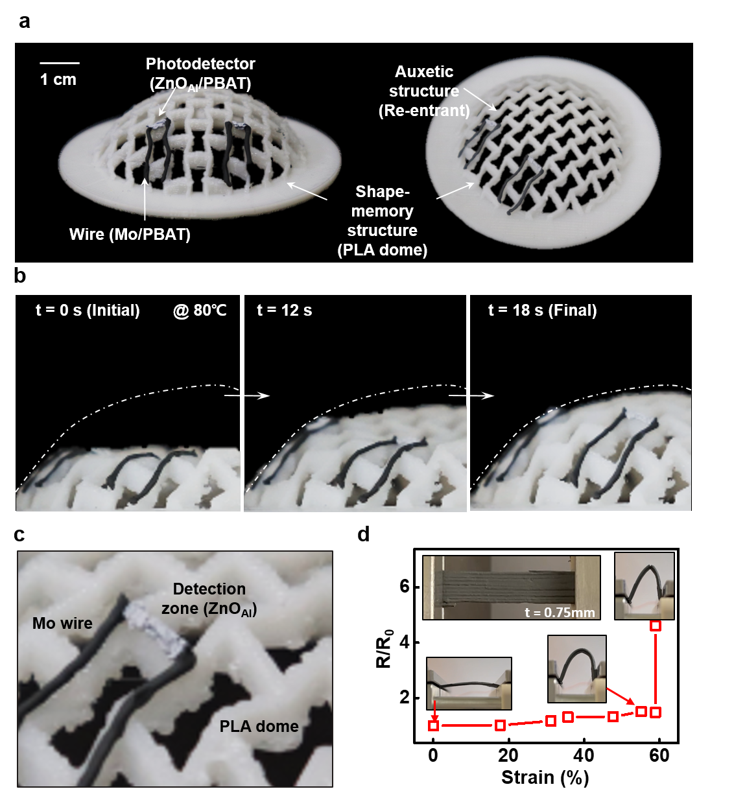

Supplementary Figure 56. 3D printed pH sensor. (a) Printed image of the pH sensor. (b) Image of the pH sensor measurement setup. (c) Schematic of a two-electrode system for measuring pH with the printed sensor. (d) Illustration of surface morphology change of ZnO at different pH. (e) Change of open circuit potential (OCP) of the pH sensor with different pH levels.
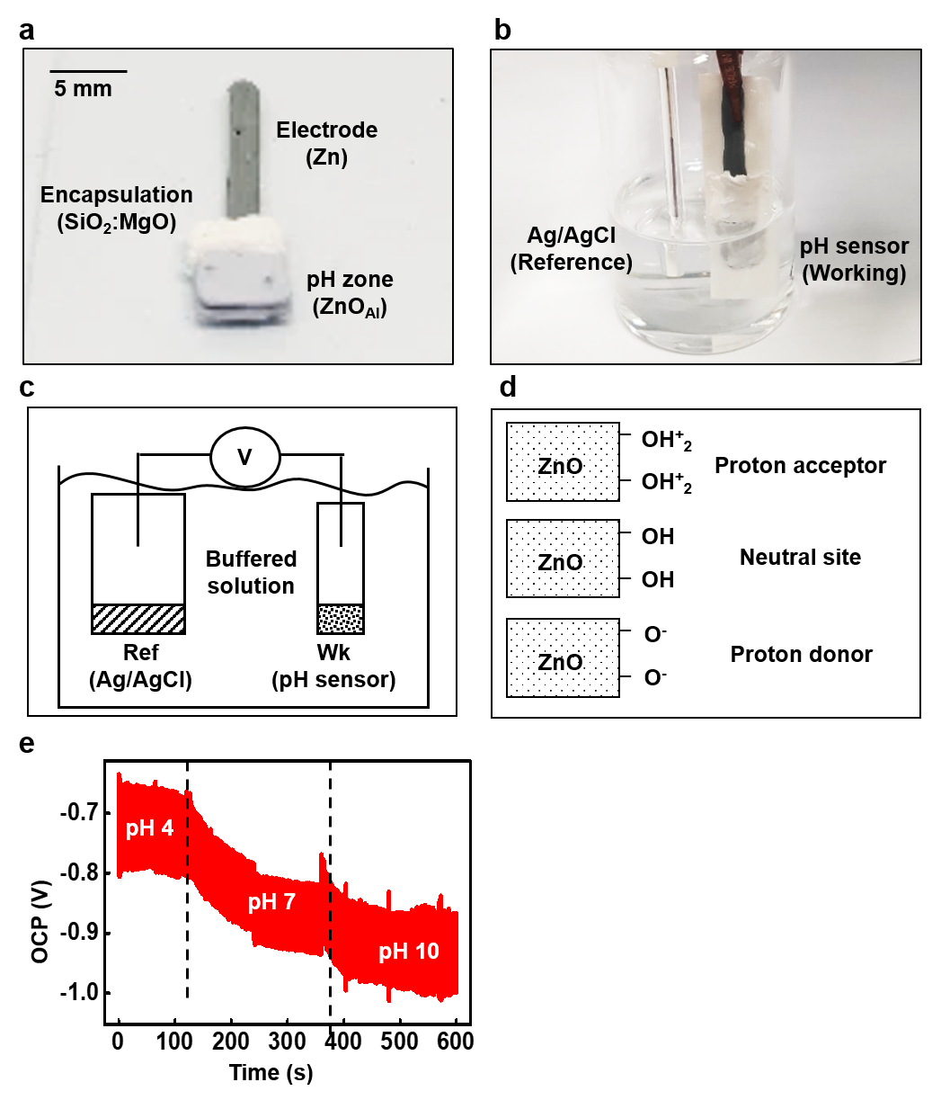

Supplementary Figure 57. 3D printed glucose sensor. (a) Fabrication process of the glucose sensor. FeCN is ferrocene and GOX is glucosidase. MoO₃ microparticles are used in this case. (b) Schematic of a three-electrode system for measuring glucose with the printed sensor. (c) Image of the glucose sensor measurement setup. (d) Change in response current of the glucose sensor with different glucose levels for a 300-second period each.
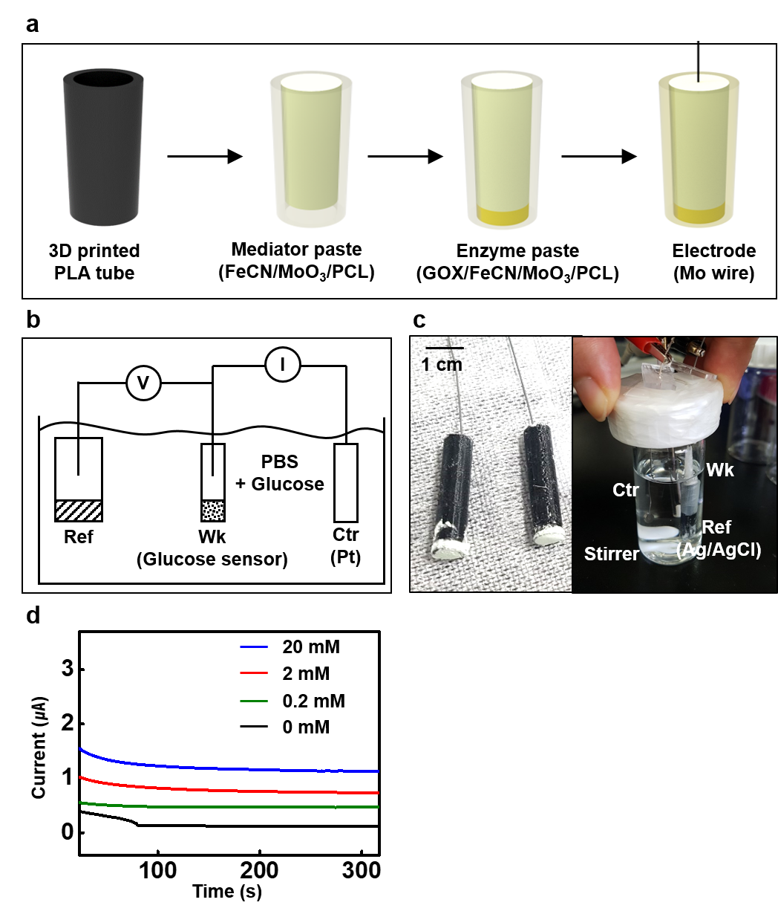

Supplementary Figure 58. Customized interface and biomedical applications for structural electronics. (a) Three types of customized contacts are illustrated based on the invasiveness of the target's location and deployment of the devices: surrounding interface (non-destructive), penetration interface (semi-destructive), and embedded interface (destructive). (b) Illustration of biomedical applications for the three types of customized contact: wireless electrical stimulator embracing peripheral nerve, localized transducer with EcoG sensor penetrating the skull bone, and wireless pressure sensor embedded in bone scaffolds.
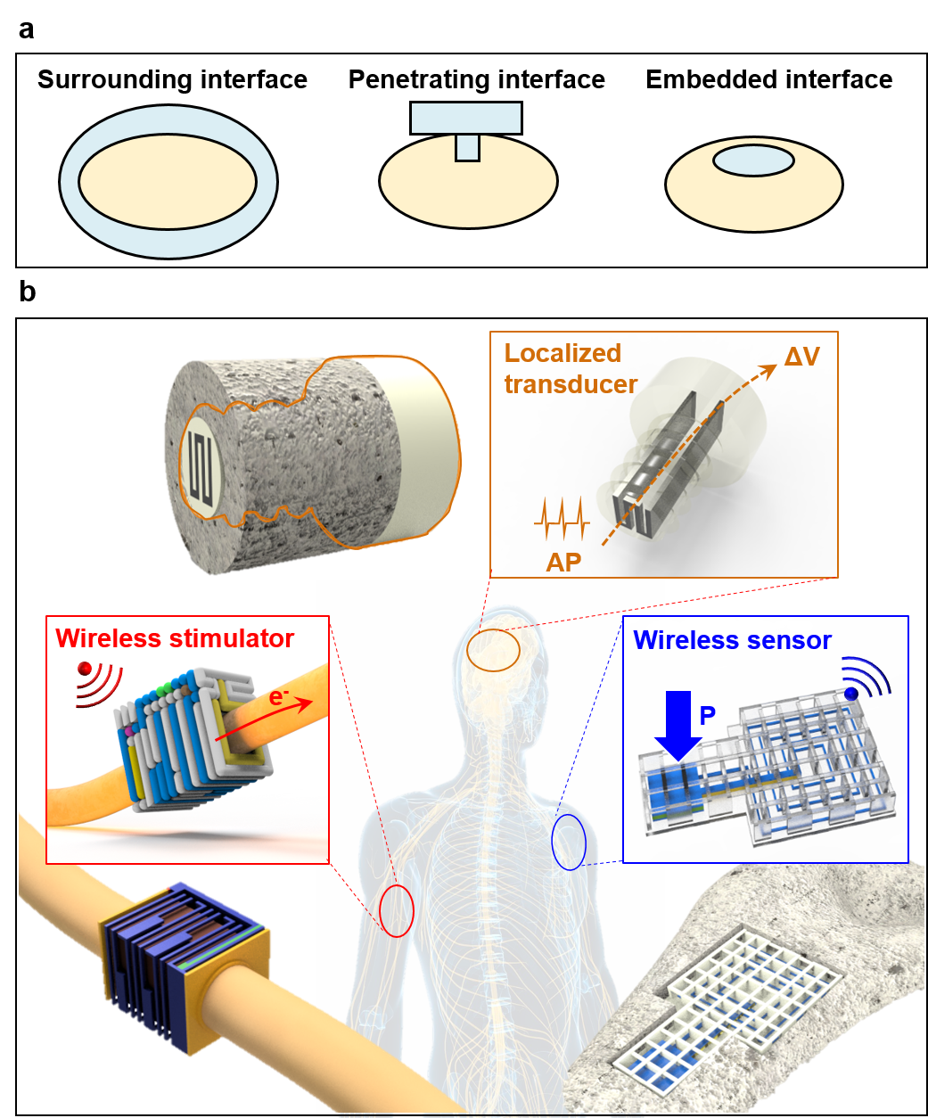

Supplementary Figure 59. Structure of 3D printed functional implants for wireless pressure monitoring. Concept and structure of a wireless bone sensor: (a) Illustration of a wireless bone sensor embedded with an inductor and capacitive pressure sensor in scaffolds for bone defects. (b) Serial images of printing sensors and inductors monolithically in scaffolds.
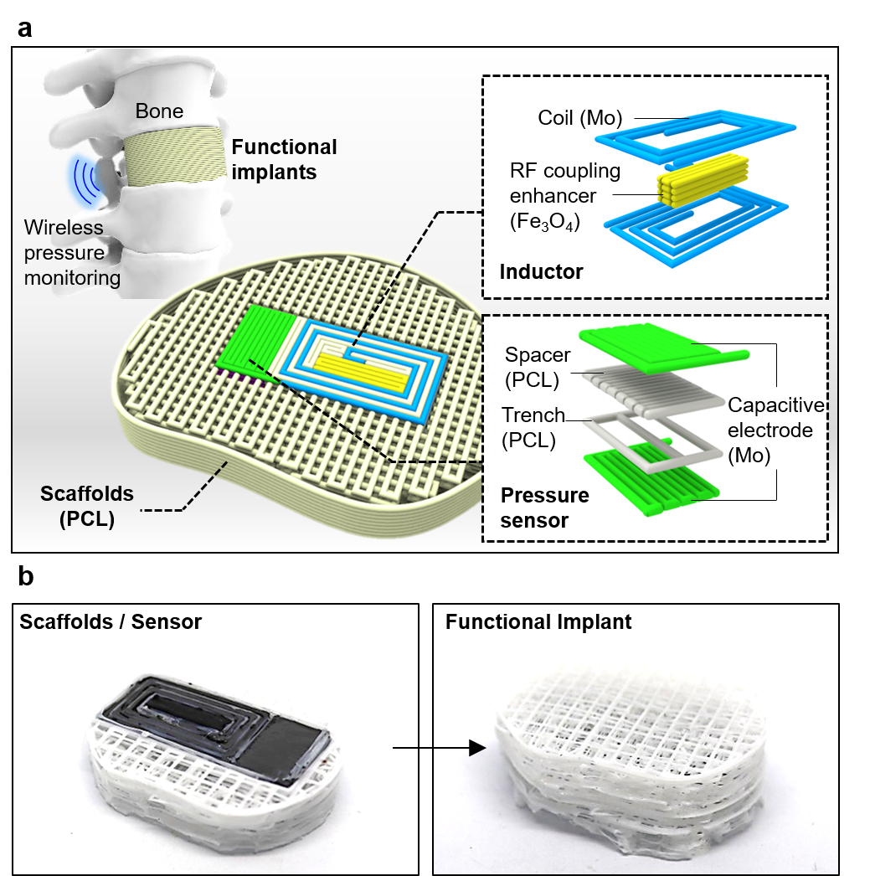

Supplementary Figure 60. Performances of 3D printed functional implants. (a) Circuit diagram of a wireless read-out system. (b) Image of a wireless read-out system with an external load. (c) Schematic differences in response to the same loads with bare sensors and embedded sensors. (d) Resonant frequency change due to weight applied to bare and embedded sensors. (e) S₁₁ change due to weight applied to a bare sensor. (f) S₁₁ change due to weight applied to an embedded sensor.
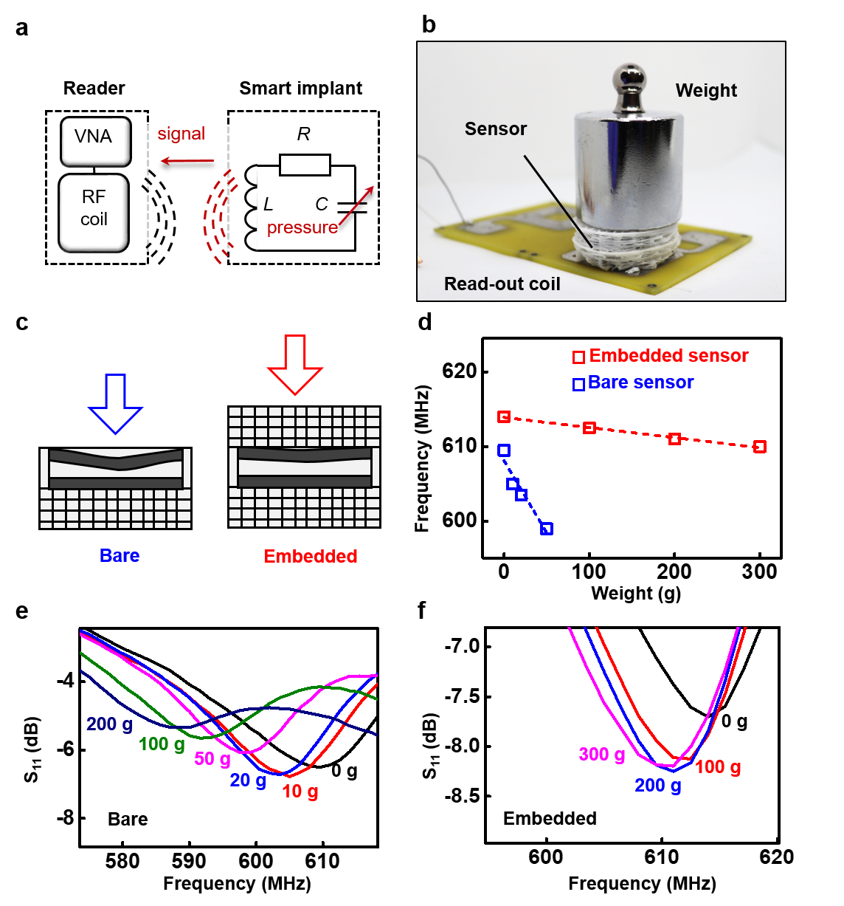

Supplementary Figure 61. Structure and in vivo experiments with plug-in type EcoG sensor. (a) Exploded view of a plug-in type EcoG sensor. (b) X-ray images of the sensor from a bottom view. Inset is a side view of the sensor. (c) Images of the surgical process of brain surface exposure (left) and stimulation process (right). (d) EcoG signals measured from two electrodes M1 and M2 on the motor cortex under a certain period of stimulation in real-time.
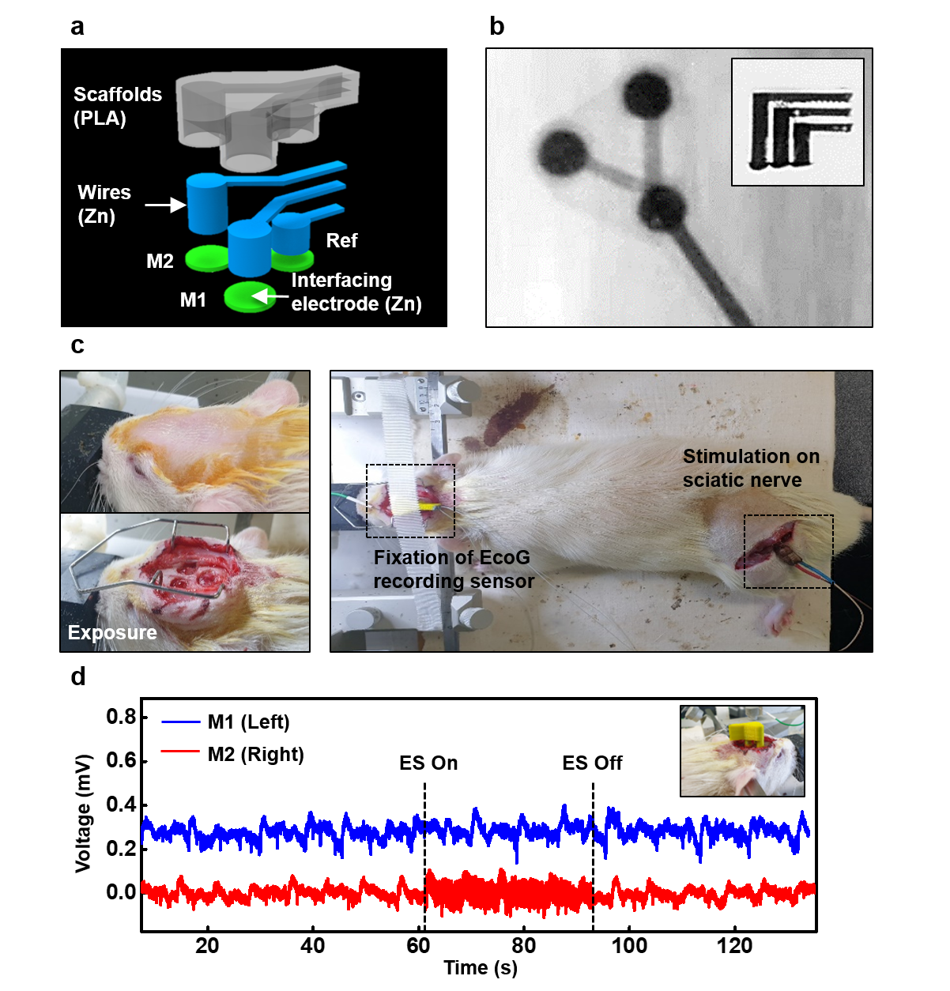

Supplementary Tables
Supplementary Table 1. Dissolution rate and chemistry of filler and binder materials^{3,16-19}
 | Dissolution rate | Dissolution chemistry
Zn | 70 ± 20 nm/h in DI  300 ± 200 nm/h in Hanks | Zn + 2H₂O → Zn(OH)₂ + H₂  Zn(OH)₂ → Zn²⁺ + 2OH⁻
Mo | - 1 ± 0.1 nm/h in DI 0.6 ± - 0.2 nm/h in Hanks pH 5 - 0.2 ± 0.03 nm/h in Hanks pH 7.4 - 8  - 0.7 ± 0.4 nm/h in Hanks pH 7.4 at 37 ℃ | 2Mo + 2H₂O + 3O₂ → 2H₂MoO₄
Fe | - 1 nm/h in DI  - 9 nm/h in Hanks pH 5  - 0.2 nm/h in Hanks pH 7.4 - 8  - 7 nm/h in Hanks pH 7.4 at 37 ℃ | Fe + H₂O + 1/2O₂ → Fe(OH)₂
W | - 0.7 ± 0.2 nm/h in DI  - 0.2 nm/h in Hanks pH 5  - 0.7 ± 0.2 nm/h in Hanks pH 7.4 - 8  - 2 nm/h in Hanks pH 7.4 at 37 ℃ | 2W +2H₂O + 3O₂ → 2H₂WO₄
Si | - 0.083 nm/h in PBS  - 0.167 nm/h in PBS at 37 ℃ | Si + 4H₂O → Si(OH)₄ + 2H₂
ZnO | 4.167 nm/h in PBS at 37 ℃ | ZnO + H₂O → Zn(OH)₂
SiO₂ | - tg-dry 4ⅹ10⁻⁴ nm/h  - tg-wet 1.2ⅹ10⁻⁴ nm/h  - PECVD 4ⅹ10⁻³ nm/h  - e-beam 0.4 nm/h  In PBS at 37 ℃ | SiO₂ + 2H₂O → Si(OH)₄
MgO | ~ 133 nm/h in DI | MgO + H₂O → Mg(OH)₂
Si₃N₄ | - LPCVD 6.7ⅹ10⁻³ nm/h  - PECVD 0.035 nm/h  in PBS at 37 ℃ | Si₃N₄ + 12H₂O → 3Si(OH)₄ + 4NH₃
PBAT | Remaining weight  0.8125 %/day in DI at 70 ℃ | Ester bond hydrolysis
PCL | Molecular weight degradation rate  0.001 /day in PBS at 37 ℃ | Ester bond hydrolysis

Supplementary Table 2. Biocompatibility of humectant and conjugated molecules²⁰⁻²⁴
 | LC50
Tetraglycol | Hematological analysis  RBC: 103 % viability  WBC: 74 % viability  PLT: 67 % viability  at 70 μl / 5 - 7 ml  after 30 days
Curcumin | NIH3T3 cell  35% cytotoxicity  40 nmol/ml after 24 h
Indigo | Keratinocytes  52.94% cell viability  at 500 μg/ml after 24 h
β-Carotene | HEK 293 cell  67% cell viability  at 80 μg/ml after 72 h
Indigo carmine | Human foreskin fibroblasts  55% cell viability  at 500 μg/ml after 24 h
Brilliant yellow | PC12 cell  > 90% cell viability  at 300 μM after 36h 37 ℃
Solvent Green 3 | MCTT HCETM model test by UPLC-UV  113.1 % cell viability  at 44.4 mg/ml after 24 h
Guanine | -

Supplementary Video Legends
Supplementary Video 1. Extrusion based multi-materials printing process of wireless stimulator.
Supplementary Video 2. Electrical stimulation with 3D-printed biodegradable wireless stimulator on rat model.
Supplementary Video 3. Resonance frequency variations in scaffolds embedding wireless pressure sensor.

References
1 Lee, Y. K. et al. Room temperature electrochemical sintering of Zn microparticles and its use in printable conducting inks for bioresorbable electronics. Advanced Materials 29, 1702665 (2017).
2 Farizhandi, A. A. K., Khalajabadi, S. Z., Krishnadoss, V. & Noshadi, I. Synthesized biocompatible and conductive ink for 3D printing of flexible electronics. Journal of the Mechanical Behavior of Biomedical Materials 110, 103960 (2020).
3 Hwang, S.-W. et al. A physically transient form of silicon electronics. Science 337, 1640-1644 (2012).
4 Maia, F. et al. Anhydrous crystals of DNA bases are wide gap semiconductors. The Journal of chemical physics 134 (2011).
5 Gamon, J., Giaume, D., Lefèvre, G., Le Mercier, T. & Barboux, P. The effect of organic additives on the intergranular conductivity of Al-doped ZnO. RSC advances 7, 38019-38027 (2017).
6 Benramache, S., Aoun, Y., Lakel, S. & Benhaoua, B. The effect of film thickness on the structural, optical and electrical properties of ZnO thin films deposited by ultrasonic spray deposition. Materials Research Express 6, 126418 (2019).
7 Bhattacharyya, A. et al. Schottky barrier height engineering in β-Ga 2 O 3 using SiO 2 interlayer dielectric. IEEE Journal of the Electron Devices Society 8, 286-294 (2020).
8 Chand, S. & Bala, S. Simulation studies of current transport in metal–insulator–semiconductor Schottky barrier diodes. Physica B: Condensed Matter 390, 179-184 (2007).
9 Çetin, H., Şahin, B., Ayyildiz, E. & Türüt, A. Ti/p-Si Schottky barrier diodes with interfacial layer prepared by thermal oxidation. Physica B: Condensed Matter 364, 133-141 (2005).
10 Todd, M. G. & Shi, F. G. Complex permittivity of composite systems: a comprehensive interphase approach. IEEE Transactions on Dielectrics and Electrical Insulation 12, 601-611 (2005).
11 Lay, M. et al. Interphase volume calculation of polyimide/TiO 2 nanofibers nanocomposite based on dielectric constant model and its effect on glass transition. Journal of Materials Science: Materials in Electronics 29, 20742-20749 (2018).
12 Alhabill, F. N., Ayoob, R., Andritsch, T. & Vaughan, A. S. Introducing particle interphase model for describing the electrical behaviour of nanodielectrics. Materials & Design 158, 62-73 (2018).
13 Ezzat, M., Sabiha, N. & Izzularab, M. Accurate model for computing dielectric constant of dielectric nanocomposites. Applied Nanoscience 4, 331-338 (2014).
14 Carvalho, J. T. et al. Fully printed zinc oxide electrolyte-gated transistors on paper. Nanomaterials 9, 169 (2019).
15 Khademi, M. & Barz, D. P. Structure of the electrical double layer revisited: Electrode capacitance in aqueous solutions. Langmuir 36, 4250-4260 (2020).
16 Yin, L. et al. Dissolvable metals for transient electronics. Advanced Functional Materials 24, 645-658 (2014).
17 Lu, D. et al. Transient Light‐Emitting Diodes Constructed from Semiconductors and Transparent Conductors that Biodegrade Under Physiological Conditions. Advanced Materials 31, 1902739 (2019).
18 Herrera, R., Franco, L., Rodríguez‐Galán, A. & Puiggalí, J. Characterization and degradation behavior of poly (butylene adipate‐co‐terephthalate) s. Journal of Polymer Science Part A: Polymer Chemistry 40, 4141-4157 (2002).
19 Fernández, J., Etxeberria, A. & Sarasua, J.-R. In vitro degradation studies and mechanical behavior of poly (ε-caprolactone-co-δ-valerolactone) and poly (ε-caprolactone-co-L-lactide) with random and semi-alternating chain microstructures. European Polymer Journal 71, 585-595 (2015).
20 Kunwar, A. et al. Quantitative cellular uptake, localization and cytotoxicity of curcumin in normal and tumor cells. Biochimica et Biophysica Acta (BBA)-General Subjects 1780, 673-679 (2008).
21 Lin, Y.-K. et al. Anti-psoriatic effects of indigo naturalis on the proliferation and differentiation of keratinocytes with indirubin as the active component. Journal of dermatological science 54, 168-174 (2009).
22 Yazdani, M. et al. Beta-carotene/cyclodextrin-based inclusion complex: Improved loading, solubility, stability, and cytotoxicity. Journal of inclusion phenomena and macrocyclic chemistry 102, 55-64 (2022).
23 Kehrl, J. et al. Vesicular glutamate transporter inhibitors: Structurally modified brilliant yellow analogs. Neurochemical Research 42, 1823-1832 (2017).
24 Joo, K.-M. et al. Development and validation of UPLC method for WST-1 cell viability assay and its application to MCTT HCE™ eye irritation test for colorful substances. Toxicology in Vitro 60, 412-419 (2019).

