Light-gated nano-porous polymersomes from stereoisomer-directed self-assemblies
Hui Chen,^{a,b} Yujiao Fan,^{b} Xia Yu,ª Vincent Semetey,^{b} Sylvain Trépout,^{c} and Min-Hui Li ^{b,*}
ª Beijing Advanced Innovation Center for Soft Matter Science and Engineering, Beijing University of Chemical Technology, 15 North Third Ring Road, Chaoyang District, 100029 Beijing, P. R. China.
^{b} Chimie ParisTech, PSL University Paris, CNRS, Institut de Recherche de Chimie Paris, UMR8247, 11 rue Pierre et Marie Curie, 75231 Paris Cedex 05, France.
^{c} Institut Curie, Inserm US43 and CNRS UMS2016, 91405 Orsay cedex, France.

Email: min-hui.li@chimieparistech.psl.eu

Content
1. Materials and methods 2
2. Instruments and measurements 2
3. Synthetic details of PEG550-TPE-Chol and trans- and cis-isomers 3
4. ¹H NMR, ¹³C NMR and HRMS spectra of intermediate products 7
5. Identification and characterization of stereoisomers during the synthesis 16
5. Thermo-stability of stereoisomers PEG550-TPE-Chol in solution 21
6. Photo-stability of stereoisomers PEG550-TPE-Chol in solution under weak UV light 22
7. Self-assembly of PEG550-TPE-Chol and its trans- and cis-isomers 23
8. AIE and photo-responsive properties of the self-assemblies 25
9. References 29

1. Materials and methods
4-Methoxybenzophenone (≥98%), Titanium tetrachloride (TiCl₄, >98%), Boron tribromide (BBr₃, >98%), 4-dimethylaminopyridine (DMAP, >99%), Zn Powder (2.5 cm, >99%), 1-(3-Dimethylaminopropyl)-3-ethylcarbodiimide hydrochloride (EDCI, >98%), Lithium hydroxide (LiOH, ≥98%), Cholesterol (Chol, >95%), Poly (ethylene glycol) methyl ether (MeO-PEG_{n}-OH, n = 12, M_{n} = 550 Da, M_{w}/M_{n} = 1.01) were purchased from Alfa Aesar. Tetrahydrofuran (THF) was distilled from sodium-benzophenone ketyl under argon. Dichloromethane (DCM) was distilled with calcium hydride under argon. Other chemical reagents were used as purchased without further purification.

2. Instruments and measurements
¹H NMR and ¹³C NMR spectra were measured on a Bruker AV 400 and Bruker AV 500 spectrometers. Chemical shifts δ are given in ppm and referenced to tetramethylsilane (TMS) in CDCl₃ (0 ppm). High-resolution mass spectra (HRMS) were recorded on a GCT premier CAB048 mass spectrometer operating in MALDI-TOF mode.
Number-average molecular weights (M_{n}) of polymers were calculated by ¹H NMR. Molecular weight distributions (M_{w}/M_{n}) of polymers were estimated by size exclusion chromatography (SEC) using THF as eluent at a flow rate of 1 mL/min.
UV spectra were measured on a Milton Ray Spectronic 3000 Array spectrophotometer. Photoluminescence (PL) spectra were recorded on a Horiba FluoroMax Spectrofluorometers. The sample solution in THF or acetone with concentrations of ~10⁻⁵ M was put in quartz cells with a pathlength of 1 cm.
UV (365 nm) intensities were measured with International Light ILT 1400-A Radiometer/Photometer equipped with SEL005 UV-Visible GaAsP detector.
Hydrodynamic diameters of self-assemblies and their distributions in pure water were measured at 25 °C by dynamic light scattering (DLS, Malvern zetasizer 3000HS, UK) with a 633 nm laser. A 90° scattering angle was used for all measurements.
Self-assembled morphologies were studied by cryo-electron microscopy (cryo-EM). Cryo-EM images were acquired on a JEOL 2200FS energy-filtered (20 eV slit) field emission gun electron microscope operating at 200 kV using a Gatan US1000 camera. For the sample preparation, a total of 5 μL of samples were deposited onto a 200-mesh holey copper grid (Ted Pella Inc., U.S.A.) and flash-frozen in liquid ethane cooled down at liquid nitrogen temperature using a Leica EM-CPC system.
Giant polymersomes were observed by epifluorescence microscopy using a Leica DMR upright microscope equipped with a Retiga Exi CCD camera (Teledyne Technologies​) and LED Lamp (λ=365 nm). Images were acquired with Image-Pro Plus (Media Cybernetics) and processed/analyzed using ImageJ. Samples (10 µL) were deposited between a glass slide and cover slip with spacers. The observations were performed with a 100x objective lens (N.A. 1.3).

3. Synthetic details of PEG550-TPE-Chol and trans- and cis-isomers
The amphiphilic polymers (PEG550-TPE-Chol) with tetraphenylethylene (TPE) at core were synthesized as shown in Scheme S1, without stereoisomers separation. Trans- and cis-isomers of PEG550-TPE-Chol were synthesized from trans- and cis-TPE-2COOMe according to Scheme S2.
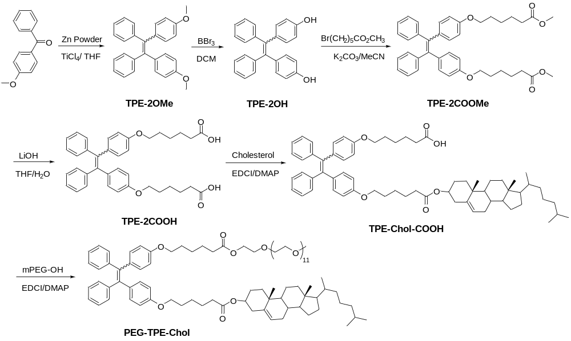
Scheme S1. Synthetic route to amphiphilic polymer PEG-TPE-Chol
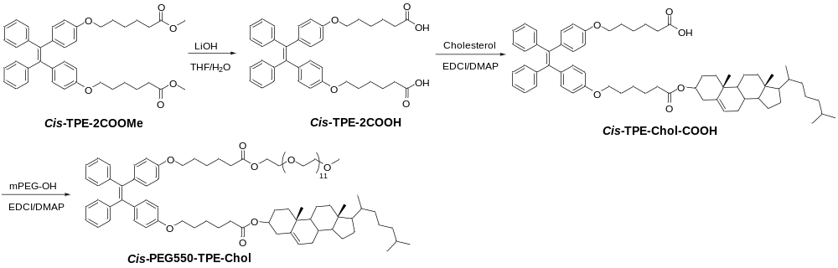Scheme S2. Synthetic route to cis-PEG550-TPE-Chol
Synthesis of TPE-2OMe:
A two-necked flask equipped with a magnetic stirrer was charged with p-methoxybenzophenone (8.07 g, 38.1 mmol), Zn powder (12.3 g, 190.0 mmol) and THF were stirred at 0 ºC under an argon atmosphere. Then TiCl₄ (29.20 g, 190.0 mmol) was dropped into the reaction mixture with rapidly stirring over 30 min. The mixture was heated to 80 ºC for 24 h. The reaction mixture was cooled to room temperature and then filtered. The filtrates were evaporated, and the crude product was purified by a silica gel column using hexane as eluent. The final product was white solid (6.27 g, 84%). ¹H NMR (CDCl₃, 400 MHz): δ = 7.15- 7.03 (m, 10H, ArH), 6.98- 6.93 (m, 4H, ArH), 6.68- 6.63 (m, 4H, ArH), 3.75 (m, 3H, OCH₃). ¹³C NMR (CDCl₃, 100 MHz): δ = 158.1, 144.4, 144.3, 139.8, 136.6, 136.5, 132.7, 131.5, 127.8, 127.7, 126.3, 113.2, 113.1, 55.2. HRMS (ESI) calcd. for ([M+H]⁺): C₂₈H₂₅O₂ 393.18491; Found: 393.18477.
Synthesis of TPE-2OH:
A two-necked flask containing compound TPE-2OMe (4.51 g, 11.5 mmol) and dried CH₂Cl₂ (50 mL) was cooled to -20 ºC, and 0.9 mL of BBr₃ (12.93 g, 51.6 mmol) was slowly added. The mixture was warmed to room temperature, allowed to stand for 4 h, and then poured into saturated aqueous sodium bicarbonate. The organic phase was dried over anhydrous MgSO4, and the crude product obtained in nearly quantitative yield. ¹H NMR (CDCl₃, 400 MHz): δ= 7.12- 7.00 (m, 10H, ArH), 6.91- 6.86 (m, 4H, ArH), 6.59- 6.54 (m, 4H, ArH). ¹³C NMR (CDCl₃, 100 MHz): δ= 154.0, 144.3, 144.2, 139.8, 136.8, 136.7, 132.9, 131.5, 127.8, 127.7, 126.4, 114.8, 114.7. HRMS (ESI) calcd. for ([M-H]⁻): C₂₆H₁₉O₂ 363.13905; Found: 363.13865.
The TPE-2OH trans/cis mixture with phenolic hydroxyl are difficult to separate to get stable trans- and cis- isomers since they can undergo easily trans-cis isomerization, in particular under acid conditions.¹ We supposed that the trans-cis conversion is due to keto–enol tautomerization for TPE-2OH (Scheme S3). The separation of trans- and cis-isomers was finally conducted for TPE-2COOMe derivative in the next step where two big and polar substituents methyl 6-bromohexanoate were connected to TPE-2OH by Williamson reaction.
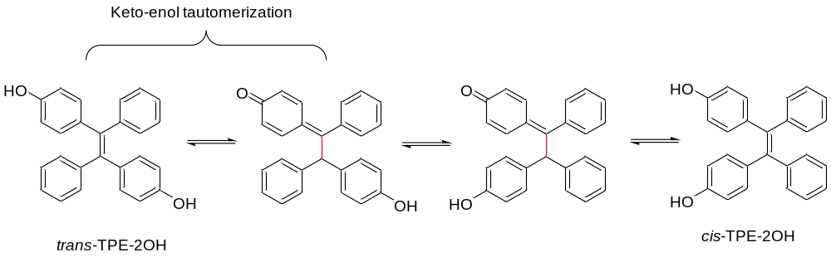
Scheme S3. Potential mechanism of transformation between trans- and cis-TPE-2OH

Synthesis of TPE-2COOMe:
The crude product TPE-2OH (2.18 g, 6.0 mmol) was dissolved in 50 mL of CH₃CN. K₂CO₃ (2.50 g, 18.0 mmol) and methyl 6-bromohexanoate (2.75, 13.2 mol) were added, and the mixture was refluxed for 4h before cooling and filtering. The filtrate was concentrated and purified by flash chromatography to obtain random TPE-2COOMe product (without stereoisomers separation) 1 g (81% yield).
If careful chromatography on a silica gel column with an eluent of PE and EA (10:1 v/v) was performed, trans-TPE-2COOMe and cis-TPE-2COOMe were separated. The trans-TPE-2COOMe was obtained as white solid and cis-TPE-2COOMe as pale-yellow liquid. Trans-TPE-2COOMe: ¹H NMR (CDCl₃, 400 MHz): δ = 7.10- 7.03 (m,10H, ArH), 6.89 (d, J = 8.0 Hz, 4H, ArH), 6.59 (d, J = 8.1 Hz, 4H, ArH), 3.87 (t, 4H, J= 6.2 Hz , ArOCH₂CH₂), 3.67 (s, 6H,OCH₃), 2.34 (t, J= 7.3 Hz, 4H, CH₂COOCH₃), 1.77- 1.65 (m, 8H, CH₂CH₂CH₂), 1.50- 1.47 (m, 4H, CH₂CH₂CH₂). ¹³C NMR (CDCl₃, 100 MHz): δ = 174.2, 157.5, 144.5, 139.8, 136.4, 132.7, 131.5, 127.8, 126.3, 113.6, 67.5, 51,7, 34.1, 29.1, 25.8, 24.9. HRMS (ESI) calcd. for ([M+Na] ⁺): C₄₀H₄₄O₆Na 643.30301; Found: 643.30295. Cis-TPE-2COOMe: ¹H NMR (CDCl₃, 400 MHz): δ = 7.06- 7.02 (m,10H, ArH), 6.93 (d, J = 7.8 Hz, 4H, ArH), 6.63 (d, J = 7.8 Hz, 4H, ArH), 3.89 (t, 4H, J= 6.1 Hz, ArOCH₂CH₂), 3.67 (s, 6H, OCH₃), 2.35 (t, J= 7.3 Hz, 4H, CH₂COOCH₃), 1.78- 1.68 (m, 8H, CH₂CH₂CH₂), 1.50- 1.47 (m, 4H, CH₂CH₂CH₂). ¹³C NMR (CDCl₃, 100 MHz): δ = 174.2, 157.5, 144.4, 139.7, 136.4, 132.6, 131.6, 127.7, 126.3, 113.7, 67.5, 51,6, 34.1, 29.1, 25.8, 24.9.
Synthesis of TPE-2COOH:
TPE-2COOMe (or its trans- or cis-isomer) (1.52 g, 2.5 mmol) was dissolved in 80mL of THF/H₂O (v/v = 7:1). LiOH (0.31 g, 12.5 mmol) was then slowly added, and the mixture was stirred overnight. THF was removed under reduced pressure and CH₂Cl₂ 100 mL added. The pH of the mixture was then adjusted to 1.0 with 1 M HCl before extracting 3 times with DCM. The organic phase was dried over anhydrous MgSO₄ and then concentrated to give compound TPE-2COOH (1.32 g, 91% yield) with flash chromatography. Trans-TPE-2COOH: ¹H NMR (CDCl₃, 400 MHz): δ= 7.12- 7.03 (m,10H, ArH), 6.89 (d, J = 8.5 Hz, 4H, ArH), 6.59 (d, J = 8.4 Hz, 4H, ArH), 3.87 (t, 4H, J= 6.3 Hz, ArOCH₂CH₂), 2.38 (t, J= 7.4 Hz, 4H, CH₂COOH), 1.79- 1.66 (m, 8H, CH₂CH₂CH₂), 1.54- 1.46 (m, 4H, CH₂CH₂CH₂). ¹³C NMR (CDCl₃, 100 MHz): δ= 179.3, 157.5, 144.5, 139.8, 136.4, 132.7, 131.5, 127.8, 126.3, 113.7, 67.5, 34.0, 29.1, 25.8, 24.6. HRMS (ESI) calcd. for ([M-H]⁻): C₃₈H₃₉O₆ 591.27521; Found: 591.27569. Cis-TPE-2COOH: ¹H NMR (CDCl₃, 400 MHz): δ= 7.08- 7.01 (m,10H, ArH), 6.91 (d, J = 8.1 Hz, 4H, ArH), 6.64 (d, J = 8.3 Hz, 4H, ArH), 3.89 (t, 4H, J= 6.1 Hz, ArOCH₂CH₂), 2.40 (t, J= 7.1 Hz, 4H, CH₂COOH), 1.80- 1.69 (m, 8H, -CH₂CH₂CH₂), 1.54- 1.50 (m, 4H, CH₂CH₂CH₂). ¹³C NMR (CDCl₃, 100 MHz): δ= 180.3, 157.6, 144.3, 139.9, 136.5, 132.6, 131.6, 127.7, 126.3, 113.8, 67.6, 34.1, 29.0, 25.7, 24.6.
Synthesis of TPE-Chol-COOH:
TPE-2COOH (or its trans- or cis-isomer) (2.50 g, 4.2 mmol), cholesterol (1.63 g, 4.2 mmol), EDCI (0.89 g, 4.6 mmol), DMAP (0.52 g, 4.2 mmol) and dried CH₂Cl₂ (100 mL) were introduced into a two-necked flask. The mixture was stirred overnight at room temperature. The organic layer was washed with saturated brine solution three times. The combined organic phase was dried over anhydrous Na₂SO₄. The filtrate was concentrated and purified on a silica gel column with an eluent of petroleum ether and ethyl acetate (10:1, v/v) to give white solid compound TPE-Chol-COOH (2.21 g, 54 % yield). Trans-TPE-Chol-COOH: ¹H NMR (CDCl₃, 400 MHz): δ= 7.11- 7.00 (m,10H, ArH), 6.89 (d, J = 8.0 Hz, 4H, ArH), 6.59 (d, J = 8.0 Hz, 4H, ArH), 5.37 (d, J = 4.0 Hz, 1H, C=CH), 4.65–4.57 (m, 4H, OCH), 2.40-2.30 (m, 6H, CH₂), 2.02-0.85 (m, 51H, CH, CH₂, CH₃), 0.68 (s, 3H, CH₃). ¹³C NMR (CDCl₃, 100 MHz): δ=178.6, 173.1, 157.4, 157.4, 144.3, 139.7, 139.6, 139.6, 136.3, 136.3, 132.5, 131.4, 127.6, 126.1, 122.6, 113.5, 77.3, 73.8, 67.4, 67.4, 56.7, 56.1, 50.0, 42.3, 39.8, 39.5, 38.2, 37.0, 36.6, 36.2, 35.8, 34.9, 33.7, 31.9, 31.9, 29.0, 28.3, 28.0, 27.8, 25.6, 24.8, 24.5, 24.3, 23.8, 22.8, 22.6, 21.0, 19.4, 18.7, 11.9. HRMS (ESI) calcd. for ([M-H]⁻): C₆₅H₈₃O₆ 959.61951; Found: 959.62004. Cis-TPE-Chol-COOH: ¹H NMR (CDCl₃, 400 MHz): δ= 7.09- 7.00 (m,10H, ArH), 6.93 (d, J = 8.0 Hz, 4H, ArH), 6.63 (d, J = 8.4 Hz, 4H, ArH), 5.38 (d, J = 4.0 Hz, 1H, C=CH), 4.67–4.59 (m, 4H, OCH), 3.87 (t, 4H, J= 6.3 Hz, ArOCH₂CH₂), 2.41-2.30 (m, 6H, CH₂), 2.05-0.87 (m, 51H, CH, CH₂, CH₃), 0.69 (s, 3H, CH₃). ¹³C NMR (CDCl₃, 100 MHz): δ= 179.1, 173.2, 157.4, 144.3, 139.7, 139.7, 139.6, 136.4, 136.3, 132.5, 131.4, 127.5, 126.1, 122.7, 113.6, 73.9, 67.4, 67.4, 56.7, 56.2, 50.0, 42.3, 39.8, 39.5, 38.2, 37.0, 36.6, 36.2, 35.8, 34.6, 33.9, 31.9, 31.9, 29.0, 28.3, 28.0, 27.8, 25.7, 24.8, 24.5, 24.3, 23.9, 22.9, 22.6, 21.1, 19.4, 18.8, 11.8.
Synthesis of PEG-TPE-Chol:
TPE-Chol-COOH (or its trans- or cis-isomer) (0.28 g, 0.30 mmol), mPEG-OH (M_{n} = 550 Da, 0.13 g, 0.23 mmol), EDCI (62.2 mg, 0.33 mmol), DMAP (39.7 mg, 0.33 mmol) and dried CH₂Cl₂ (50 mL) were introduced into two-necked flask. The mixture was stirred overnight at room temperature. The organic layer was washed with saturated brine solution 3 times. The combined organic phase was dried over anhydrous Na₂SO₄. The filtrate was concentrated and purified on a silica gel column with an eluent of dichloromethane and methanol (35:1, v/v) to give product PEG550-TPE-Chol (or trans-PEG550-TPE-Chol or cis-PEG550-TPE-Chol). ¹H NMR spectra of PEG550-TPE-Chol, trans-PEG550-TPE-Chol and cis-PEG550-TPE-Chol are shown in Fig. S3, S13-15 below.

4. ¹H NMR, ¹³C NMR and HRMS spectra of intermediate products
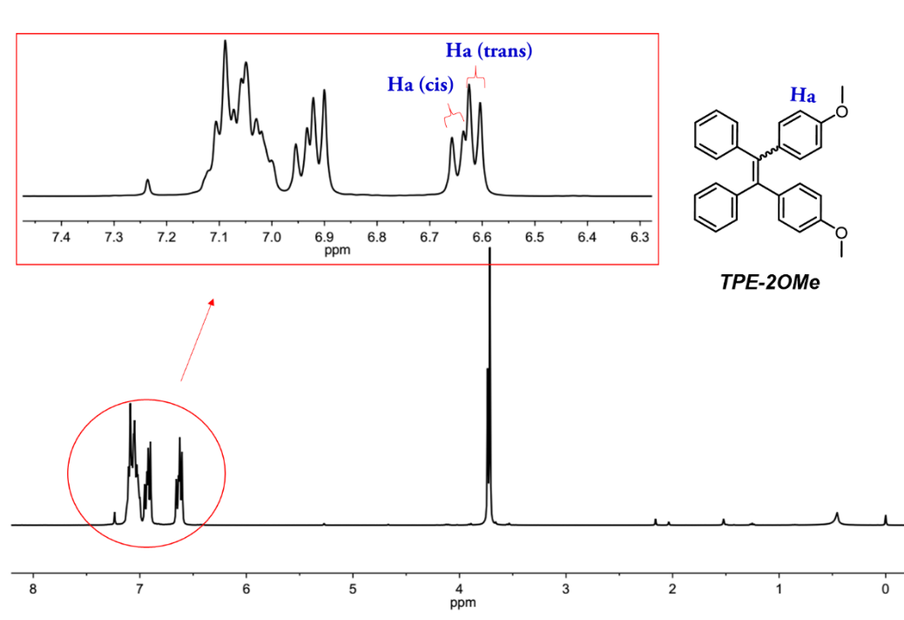
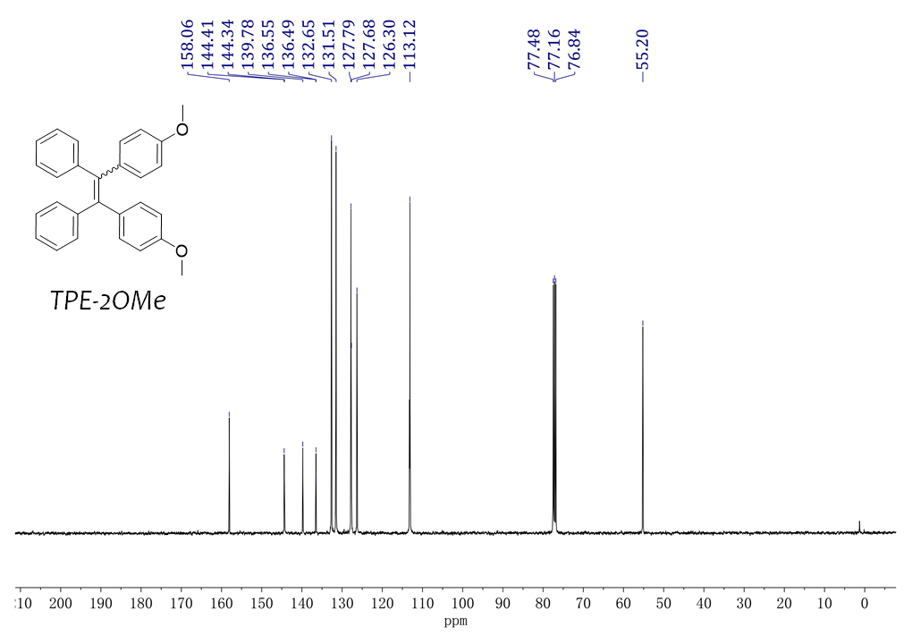
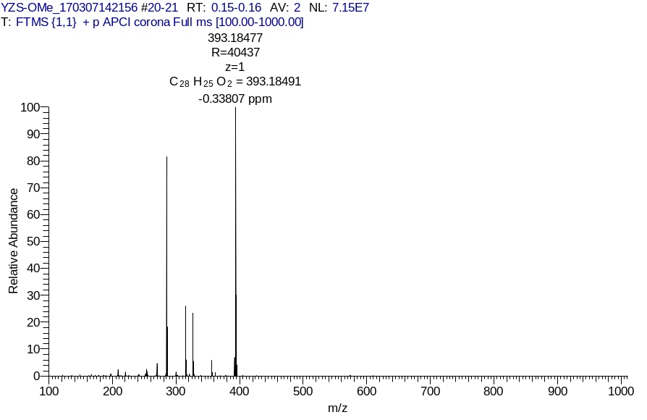
Fig. S1 ¹H NMR (400 MHz, CDCl₃), ¹³C NMR and HRMS spectra of TPE-2OMe.
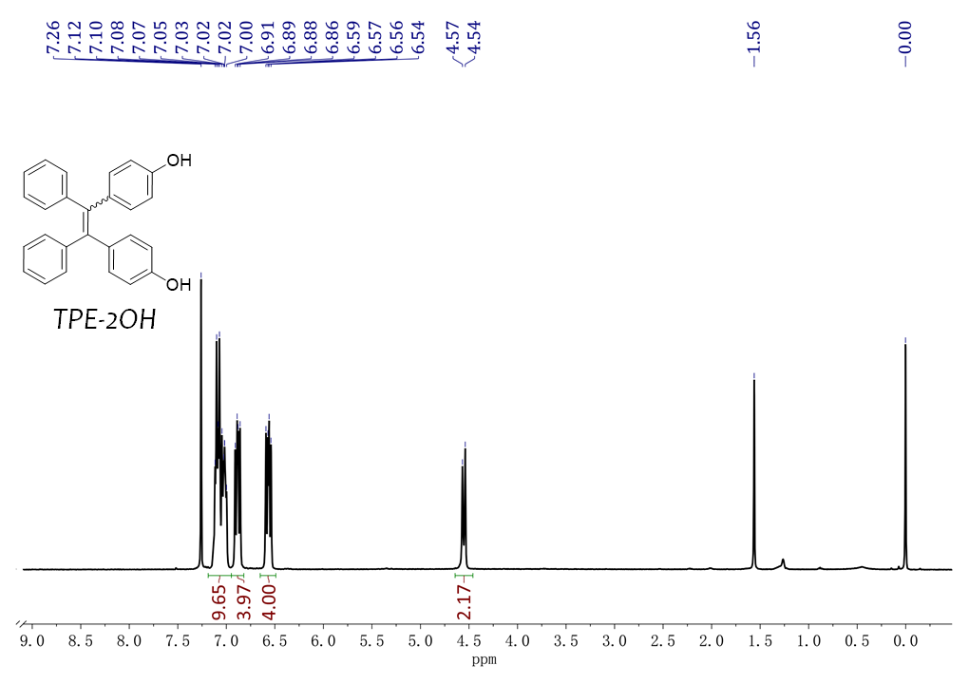
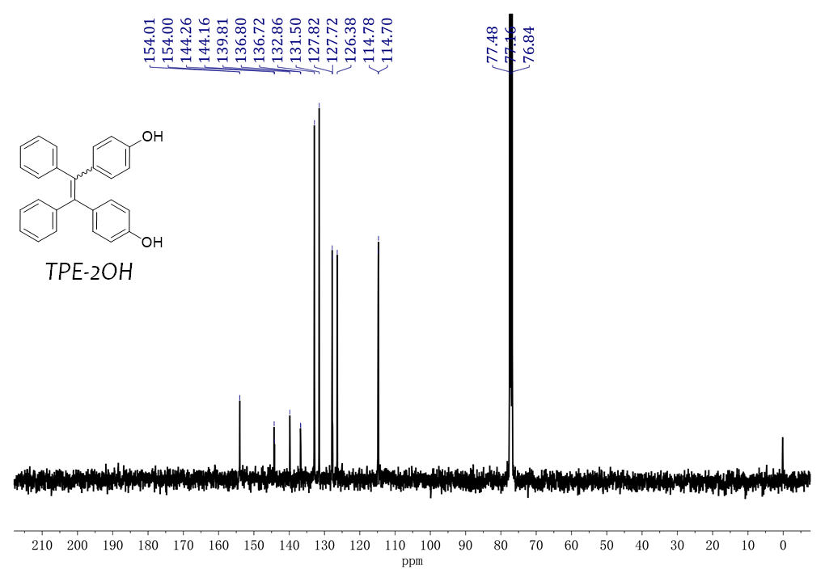
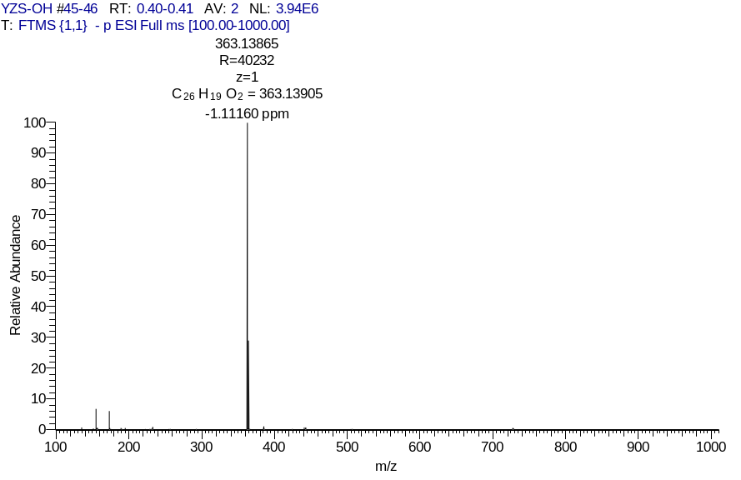
Fig. S2. ¹H NMR, ¹³C NMR and HRMS spectra of TPE-2OH.
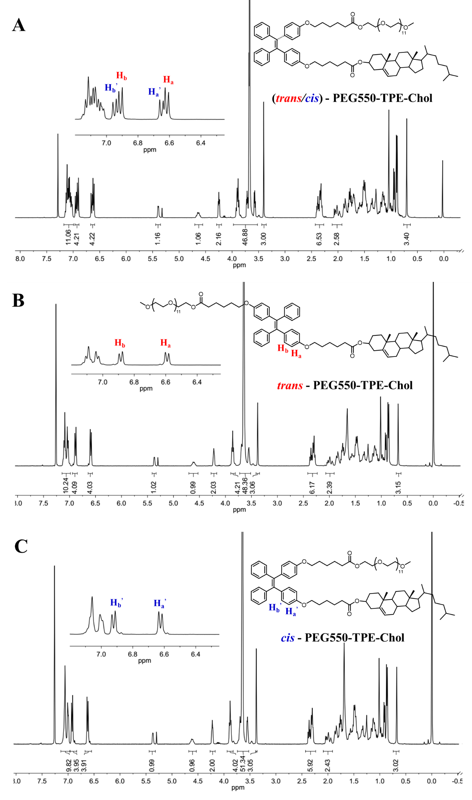
Fig. S3 ¹H NMR spectra of PEG550-TPE-Chol synthesized inherently without trans/cis stereoisomers separation (A), of trans-PEG550-TPE-Chol (B) and of cis-PEG550-TPE-Chol (C) (400 MHz, CDCl₃).
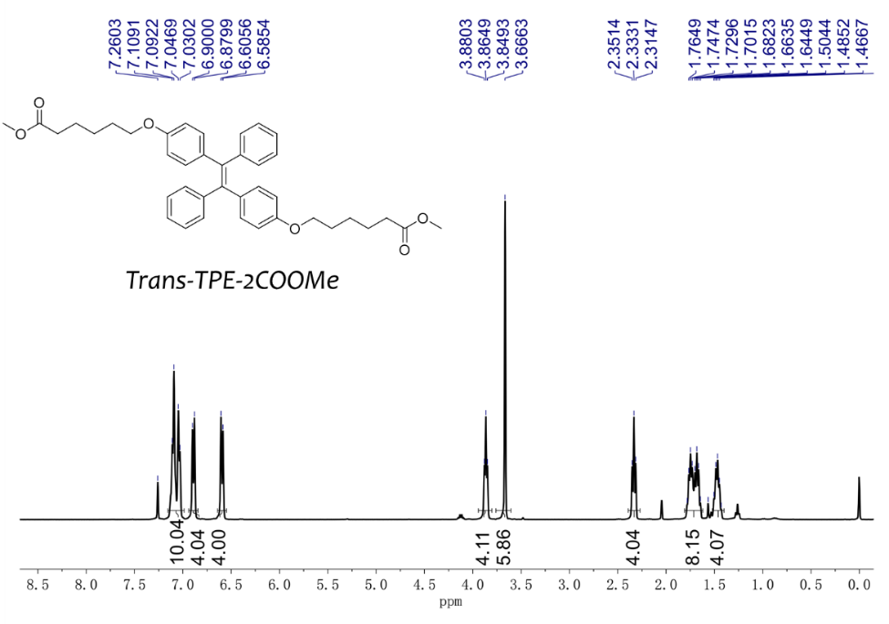
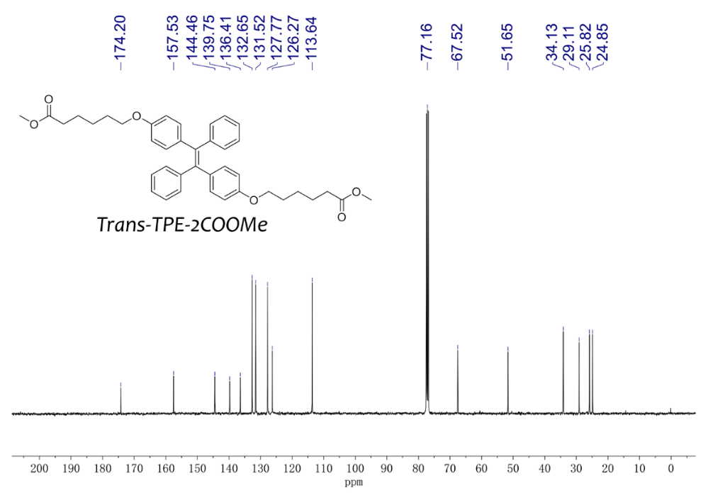
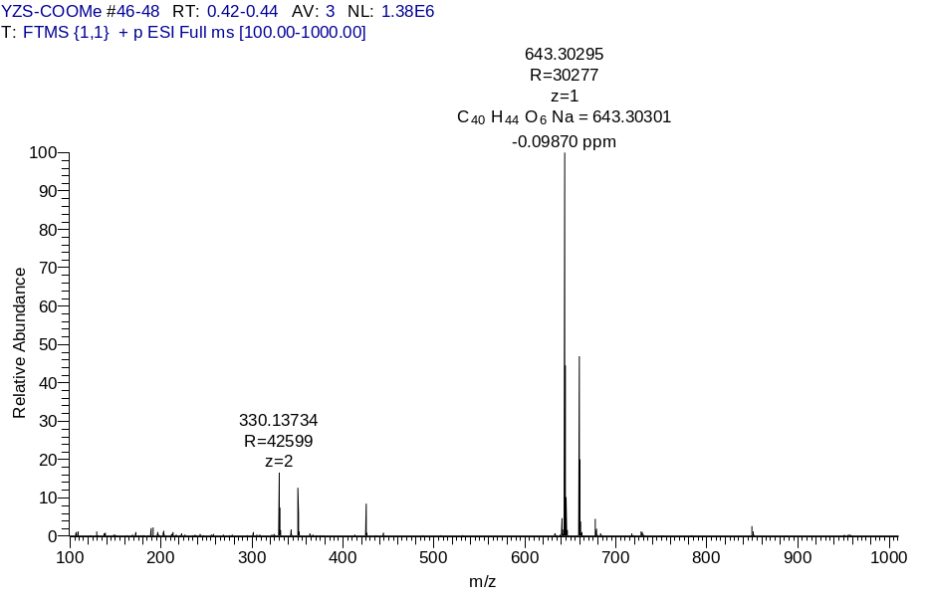
Fig. S4 ¹H NMR, ¹³C NMR and HRMS of trans-TPE-2COOMe.

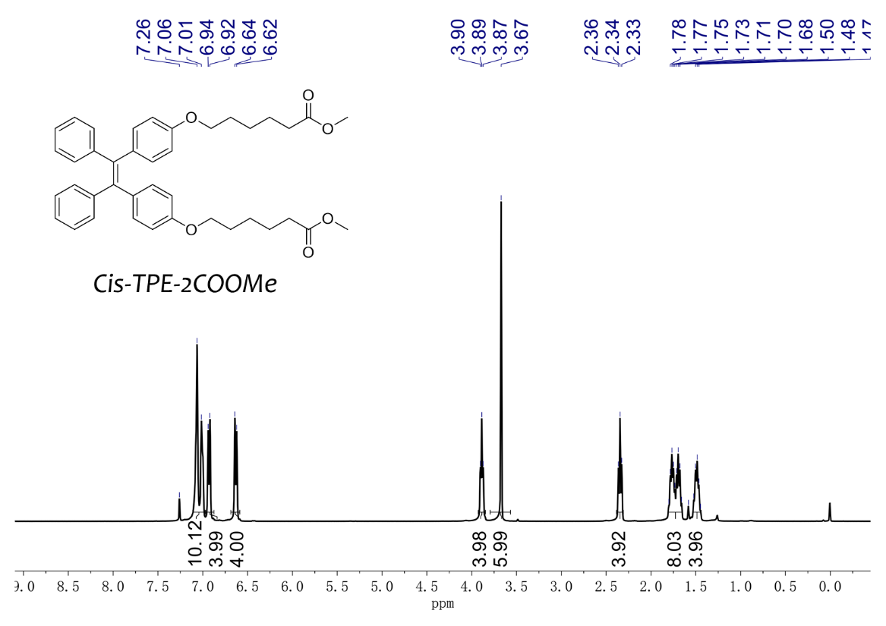
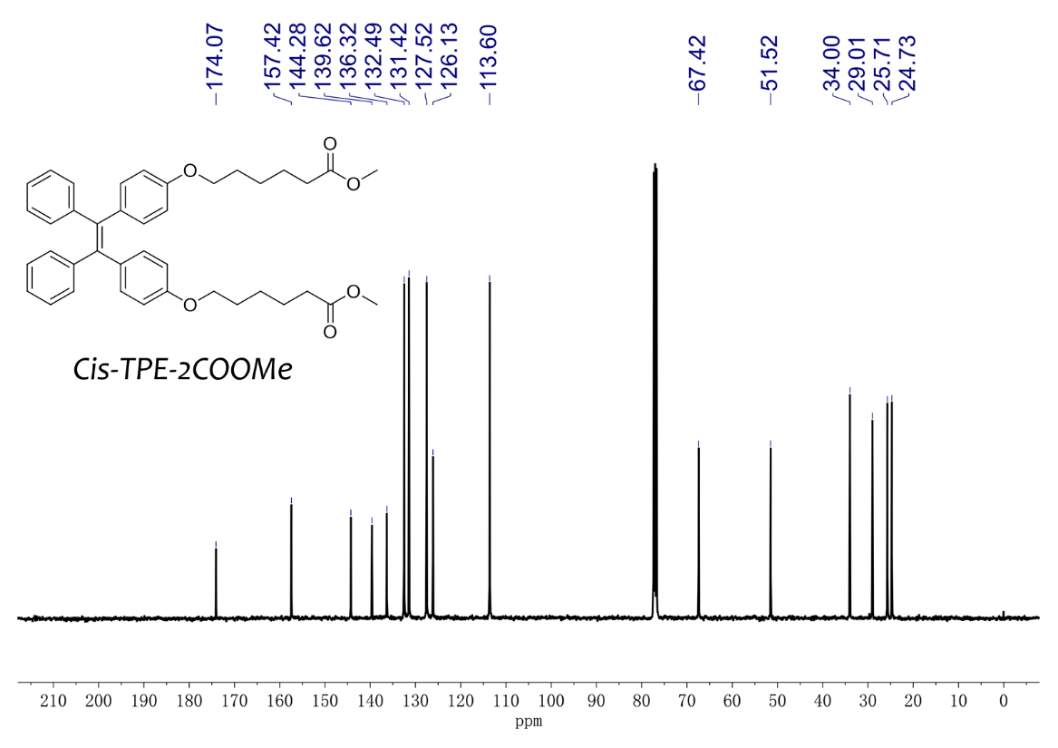
Fig. S5 ¹H NMR and ¹³C NMR of cis-TPE-2COOMe.

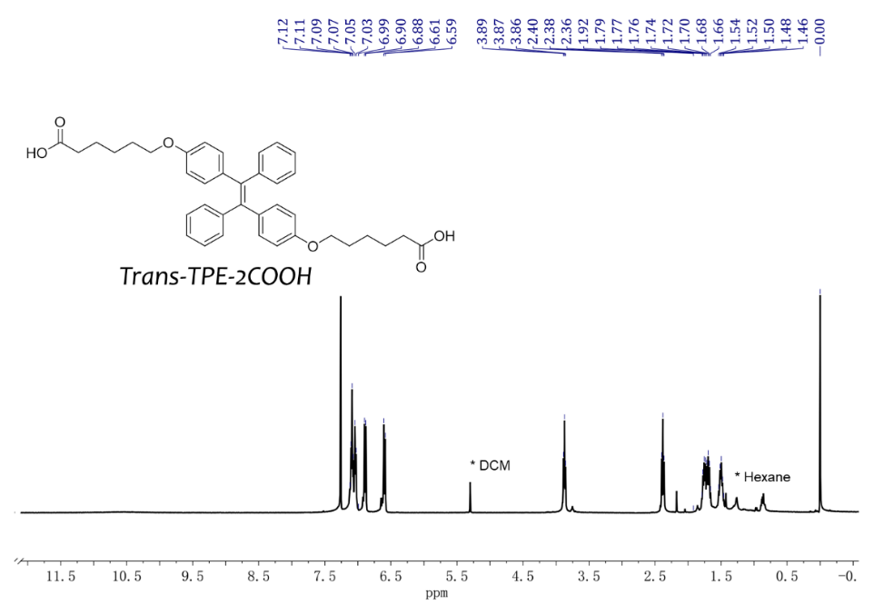
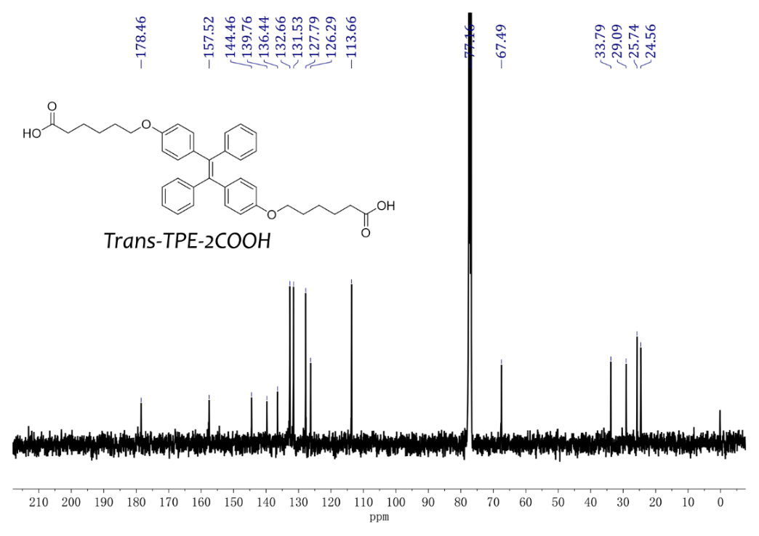
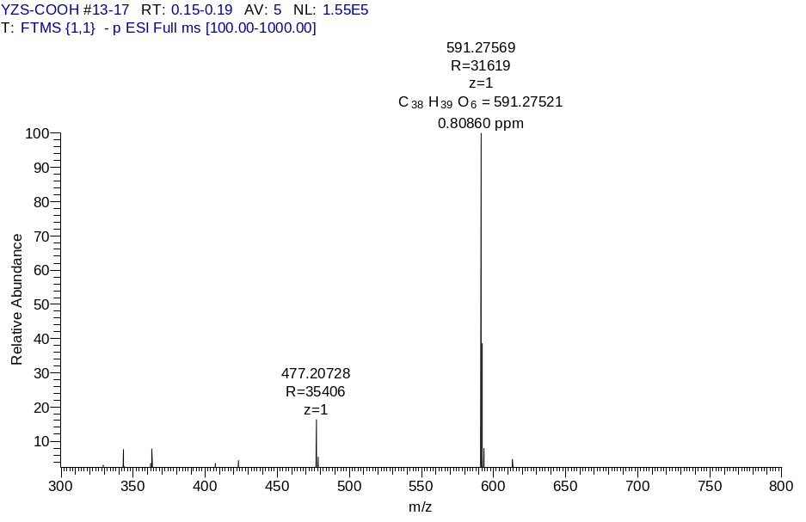
Fig. S6 ¹H NMR, ¹³C NMR and HRMS of trans-TPE-2COOH.

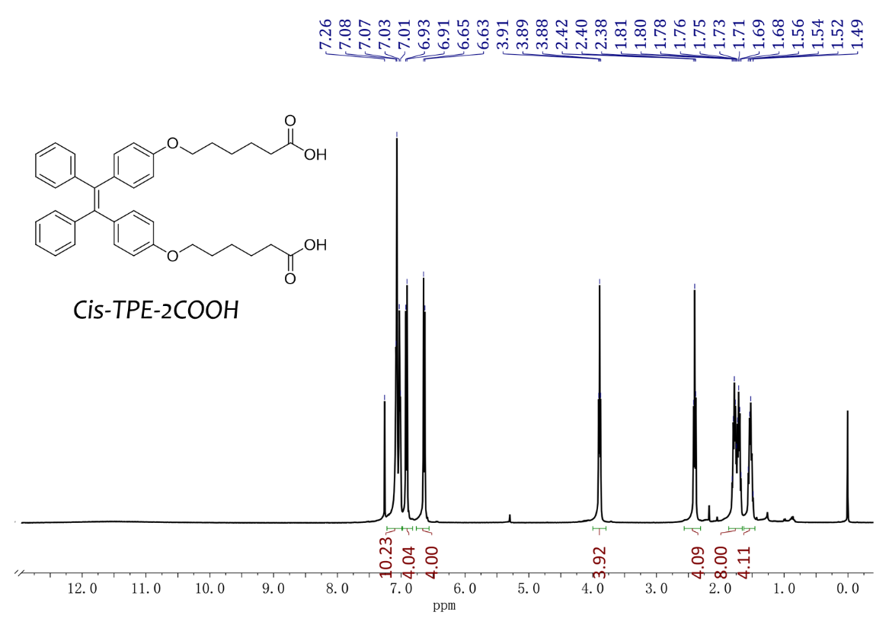
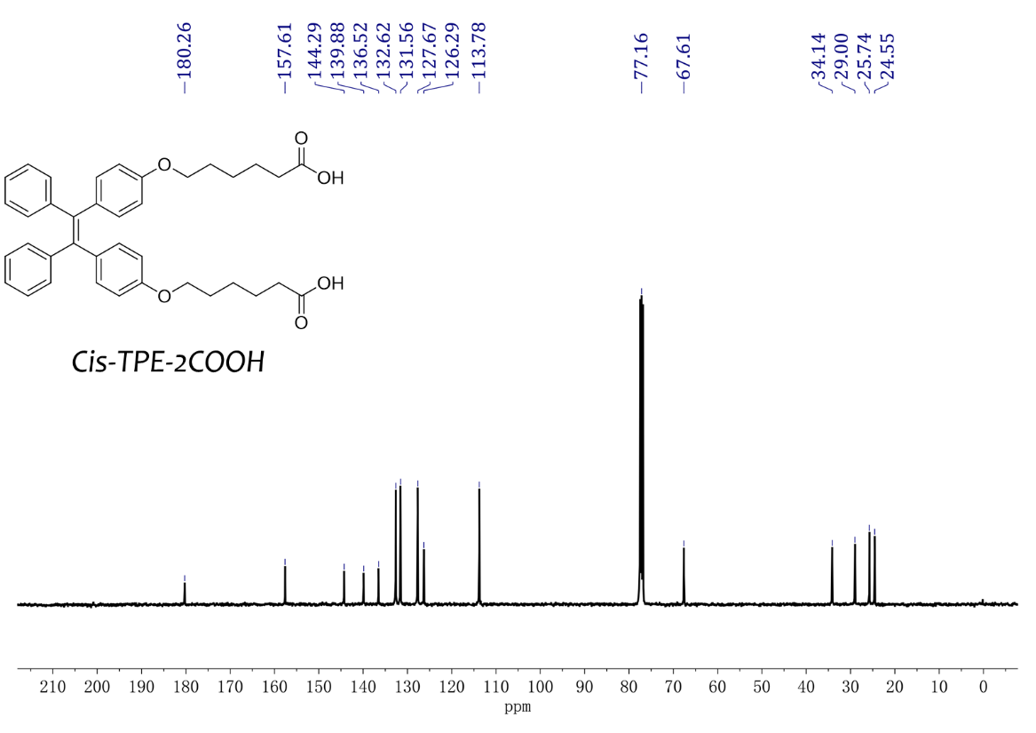
Fig. S7 ¹H NMR and ¹³C NMR of cis-TPE-2COOH.

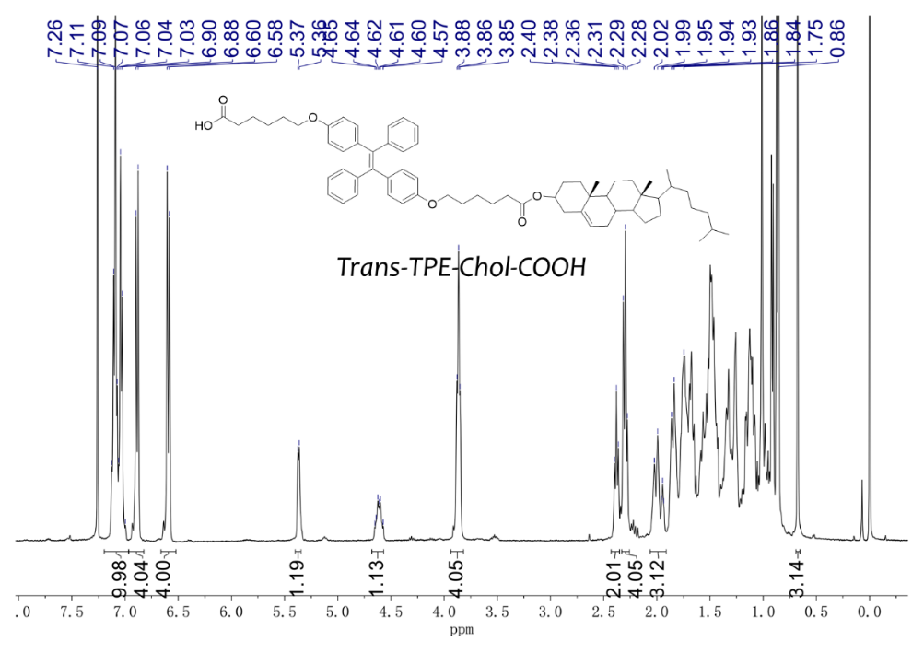
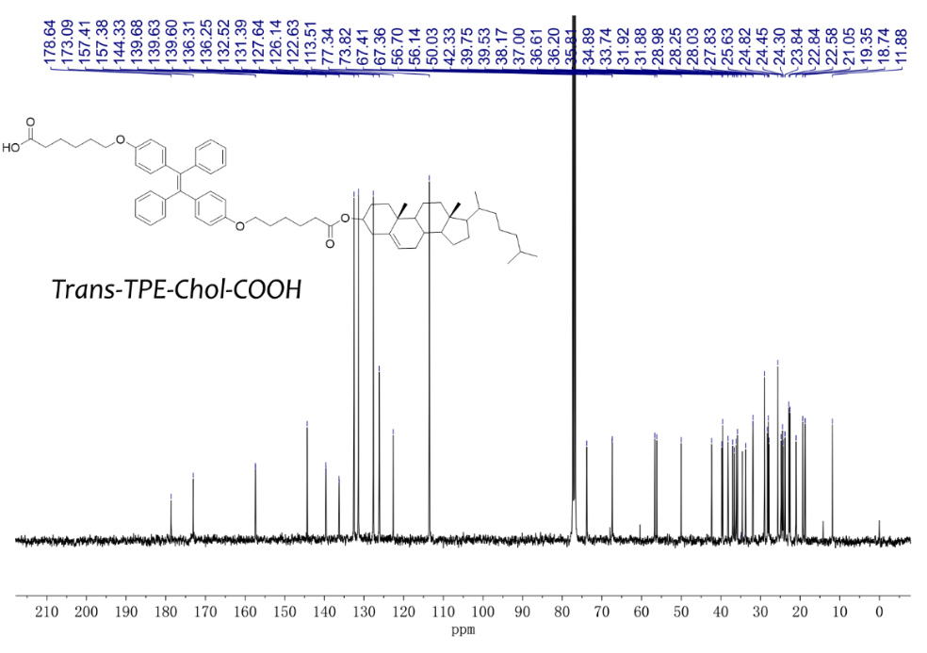
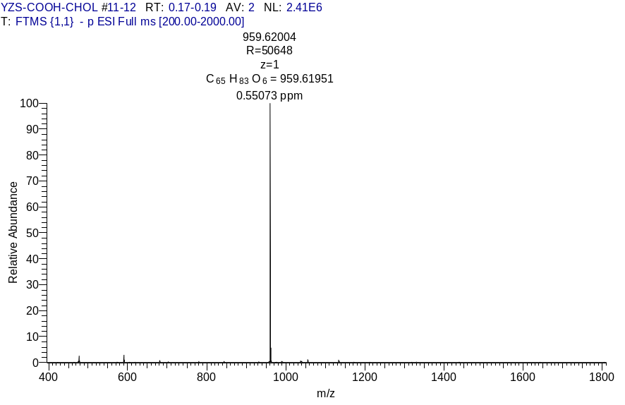
Fig. S8 ¹H NMR, ¹³C NMR and HRMS of trans-TPE-Chol-COOH.

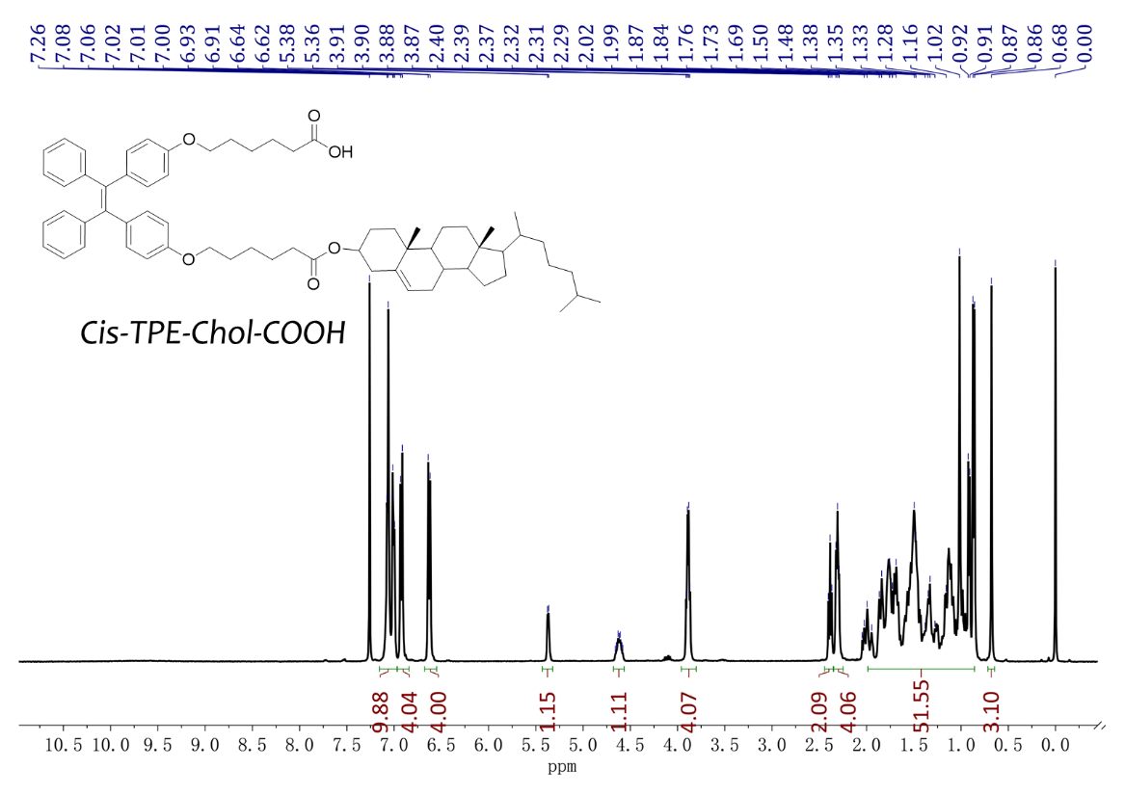
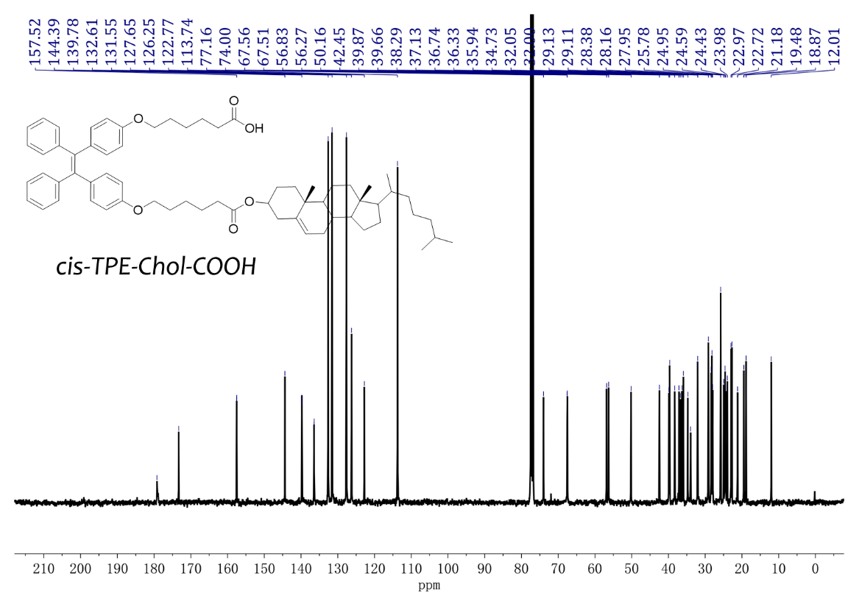
Fig. S9 ¹H NMR and ¹³C NMR of cis-TPE-Chol-COOH.

5. Identification and characterization of stereoisomers during the synthesis
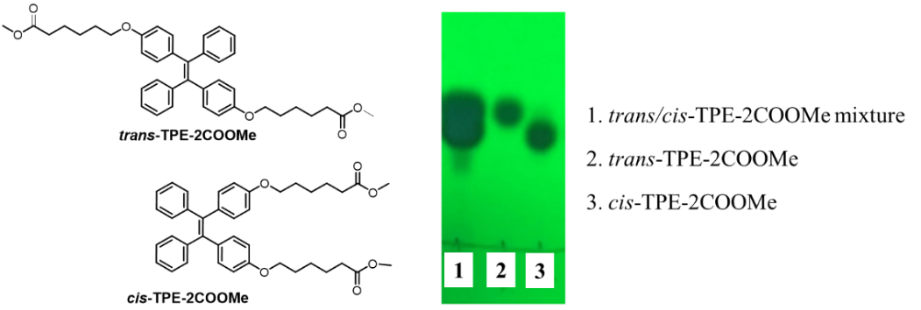
Fig. S10 TLC picture of trans/cis-TPE-2COOMe mixture and trans- and cis-TPE-2COOMe.
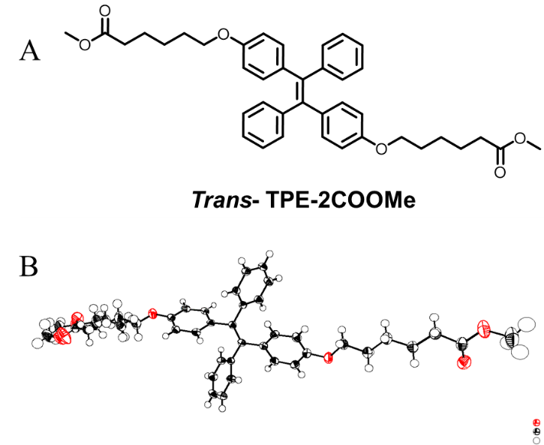
Fig. S11 The chemical structure (A) and the crystal structure of trans-TPE-2COOMe.
Table S1. Crystal data and structure refinement for trans-TPE-2COOMe
Identification code | exp_4495
Empirical formula | C₄₀H₄₄O₆
Formula weight | 620.75
Temperature / K | 169.9
Crystal system | triclinic
Space group | p-1
a / Å, b / Å, c / Å | 9.5549(4), 11.3703(5), 15.7162(6)
α/°, β/°, γ/° | 83.265(3), 87.056(3), 85.791(4)
Volume / Å³ | 1689.50(12)
Z | 2
ρ_{calc} / mg.mm⁻³ | 1.220
μ / mm^{‑1} | 0.081
F(000) | 664
Crystal size / mm³ | 0.40 × 0.25 × 0.08
2Θ range for data collection | 6 to 52°
Index ranges | -11 ≤ h ≤ 11, -11 ≤ k ≤ 14, -19 ≤ l ≤ 18
Reflections collected | 13246
Independent reflections | 6623[R(int) = 0.0244 (inf-0.9Å)]
Data/restraints/parameters | 6623/138/464
Goodness-of-fit on F² | 1.021
Final R indexes [I>2σ (I) i.e. F_{o}>4σ (F_{o})] | R₁ = 0.0572, wR₂ = 0.1249
Final R indexes [all data] | R₁ = 0.0818, wR₂ = 0.1413
Largest diff. peak/hole / e Å⁻³ | 0.387/-0.316
Flack Parameters | N
Completeness | 0.998
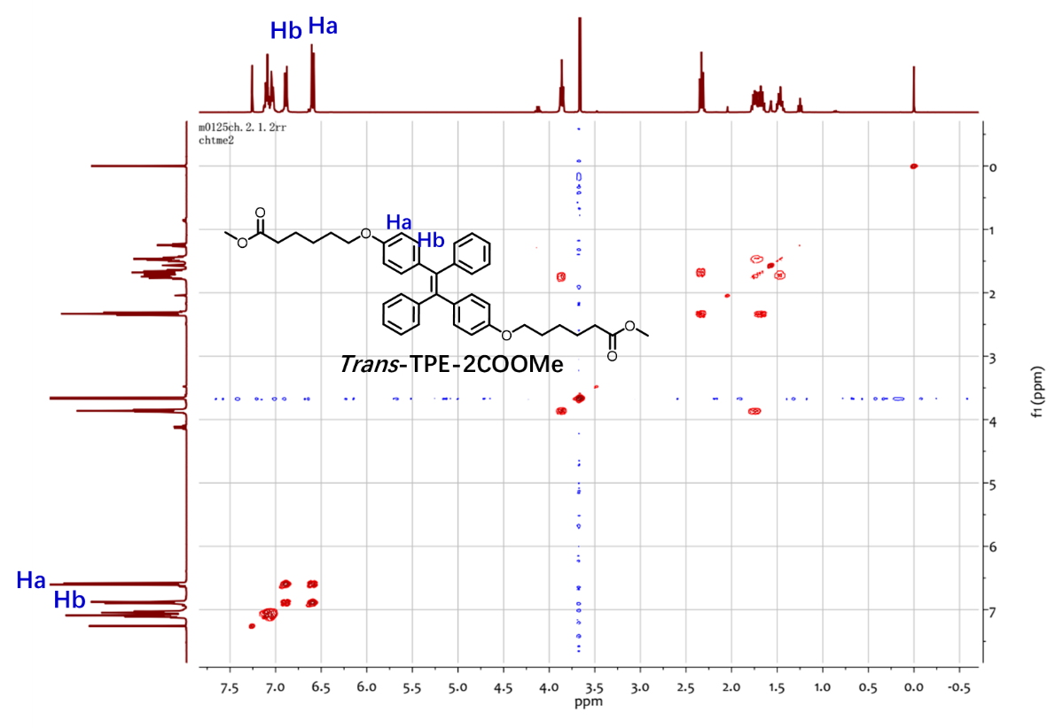
Fig. S12 COSY-NMR of trans-TPE-2COOMe (400 MHz, DMSO-D6). The double peaks at δ = 6.59 ppm correspond to H_{a} protons in trans-TPE-2COOMe due to the electron-donating property of the neighboring ester group. The double peaks at δ = 6.89 ppm ascribe to H_{b} because of their strong correlation with H_{a} in the COSY spectra. Similarly, for its cis counterpart, the resonances at δ = 6.63 are assigned to H_{a}, showing the downfield shift compared to those of its trans counterpart (Fig. 2A). Different resonances of the characteristic proton H_{a} and H_{a}’ allow us to use the NMR spectra to distinguish the trans and cis geometry of TPE molecules.

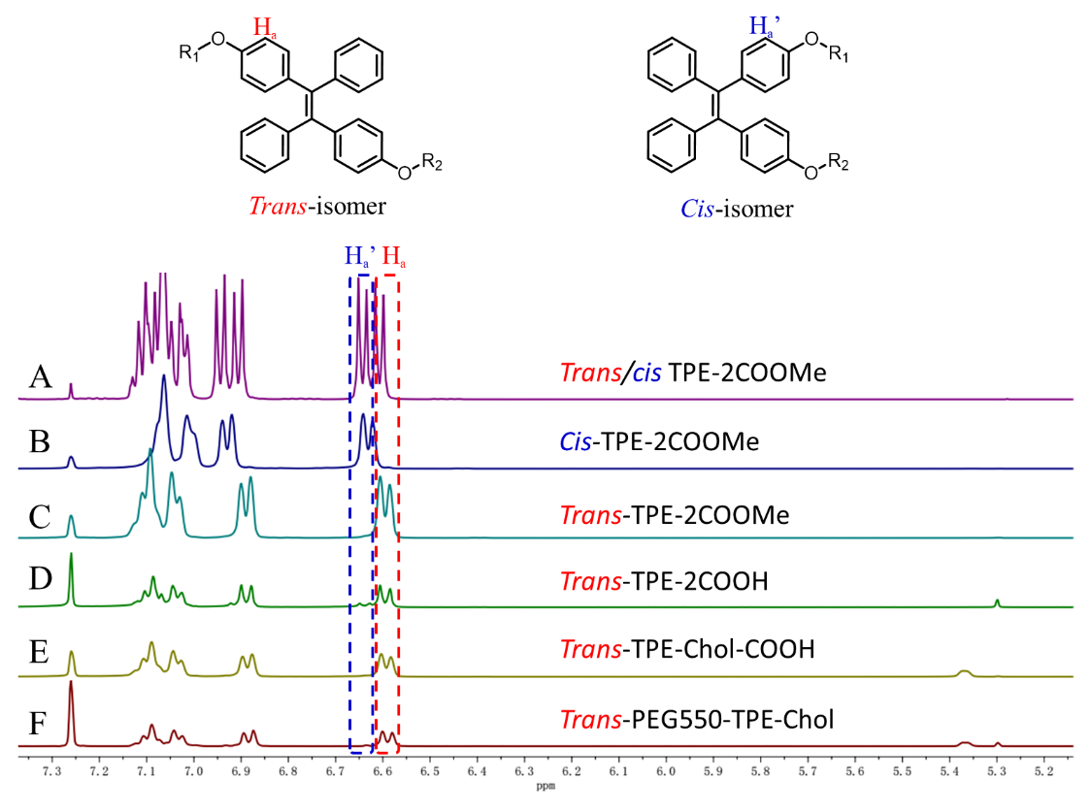
Fig. S13 Partial ¹H NMR spectra of synthesized products (400 MHz, CDCl₃). The characteristic proton H_{a} of trans-TPE-COOMe and other derivatives have the same chemical shift at δ = 6.59 ppm. The results indicated that the geometry of purified isomers would not be changed by the reactions.
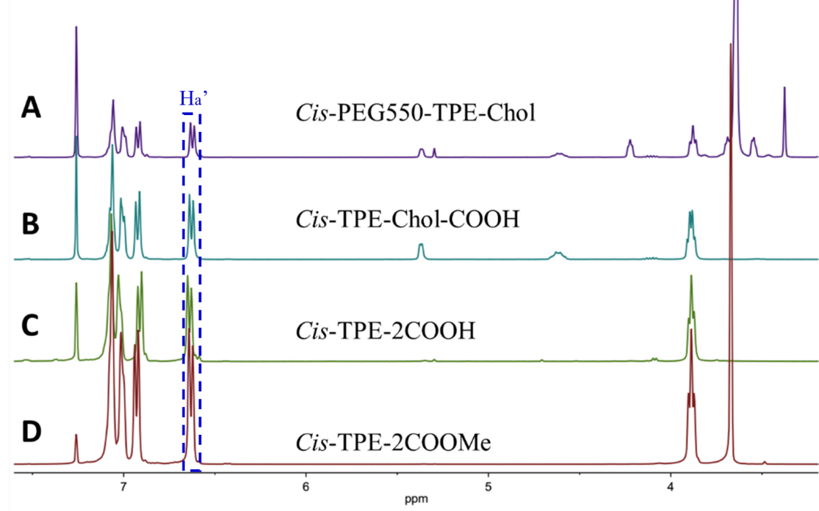
Fig. S14 Partial ¹H NMR spectra of synthesized cis-derivatives (400 MHz, CDCl₃). The protons Ha’ of cis-TPE-COOMe and other derivatives also gave the identical chemical shift at δ = 6.63 ppm. The results indicated that the geometry of purified isomers would not be changed by the reactions.
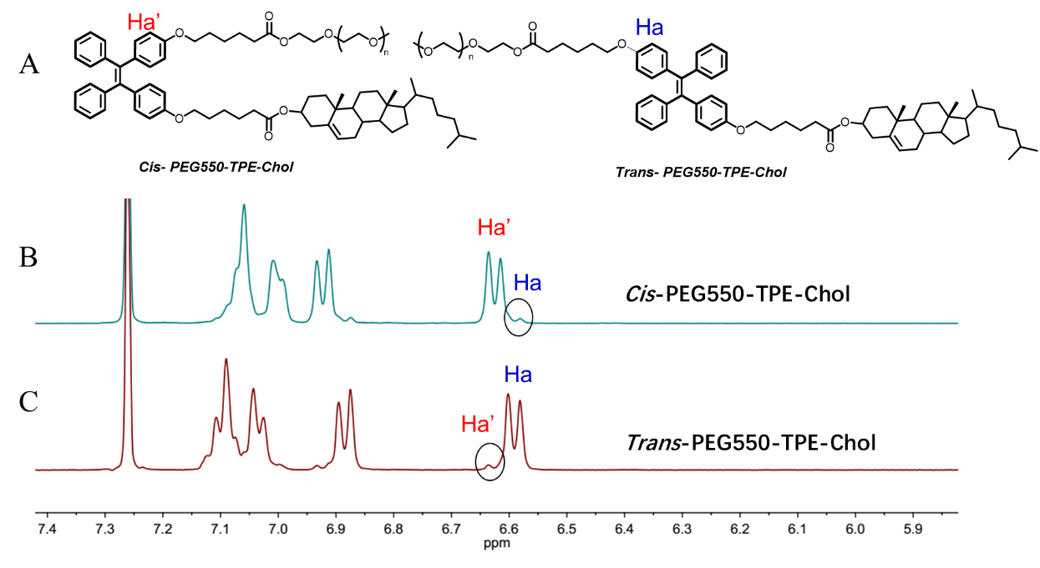
Fig. S15 Chemical structure (A) and partial ¹H NMR spectra of trans- and cis-PEG550-TPE-Chol (B and C) (400 MHz, CDCl₃).

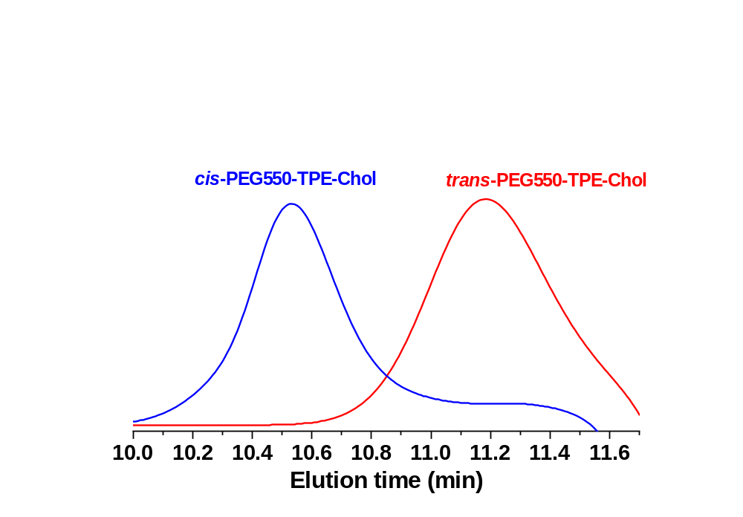
Fig. S16 SEC curves of trans- and cis-PEG550-TPE-Chol with THF eluent at rate of 1 mL/min (by refractometer).
Fig. S17 (A) UV−vis absorption spectra of trans- and cis-PEG550-TPE-Chol in acetone (concentration of polymer = 1 × 10⁻⁴ M). (B) Photoluminescence (PL) spectra of trans -PEG550-TPE-Chol in acetone/H₂O with different water fractions (concentration: 1 × 10⁻⁵ M; excitation wavelength: 352 nm). (C) Evolution of fluorescence intensity of trans- and cis-PEG550-TPE-Chol as a function of water content f_{w}. (D) PL spectra of trans -PEG550-TPE-Chol and cis-PEG550-TPE-Chol in acetone/H₂O with f_{w} = 99%.

5. Thermo-stability of stereoisomers PEG550-TPE-Chol in solution
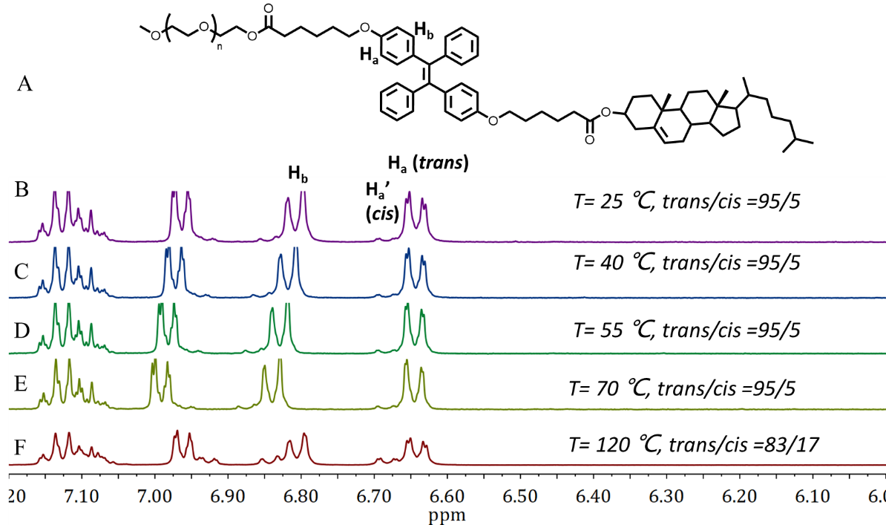
Fig. S18 Chemical structure (A) of trans-PEG550-TPE-Chol, and its partial ¹H NMR spectra of in DMSO-D6 recorded at different temperatures: (B) T= 25℃. (C) T= 40℃. (D) T= 55℃. (E) T= 70℃. (F) T= 120℃. (B-E) were recorded at temperature T after keeping at it for 30 min, while (F) was recorded at 25°C after heating at 120℃ for 24h and cooled down to room temperature.
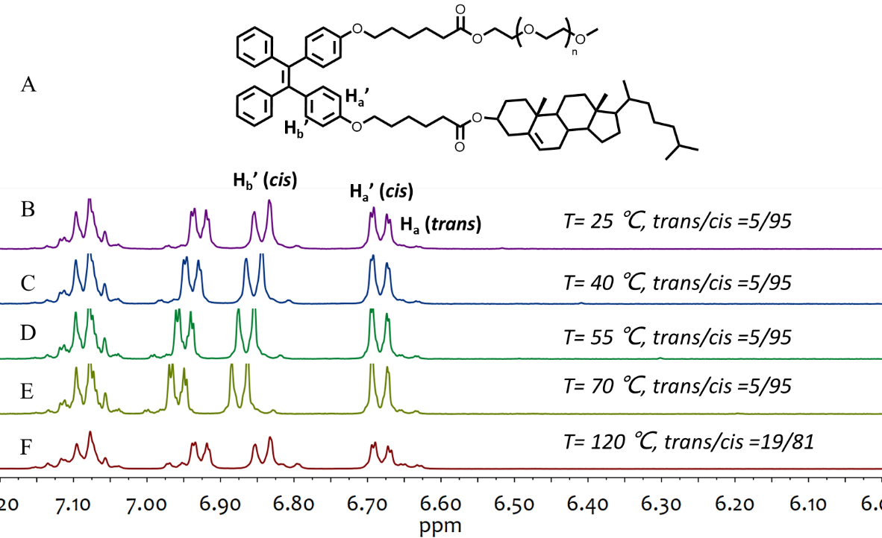
Fig. S19 Chemical structure of cis- PEG550-TPE-Chol (A), and its partial ¹H NMR spectra in DMSO-D6 recorded at different temperatures: (B) T= 25℃. (C) T= 40℃. (D) T= 55℃. (E) T= 70℃. (F) T= 120℃. (B-E) were recorded at temperature T after keeping at it for 30 min, while (F) was recorded at 25°C after heating at 120℃ for 24h and cooled down to room temperature.

6. Photo-stability of stereoisomers PEG550-TPE-Chol in solution under weak UV light
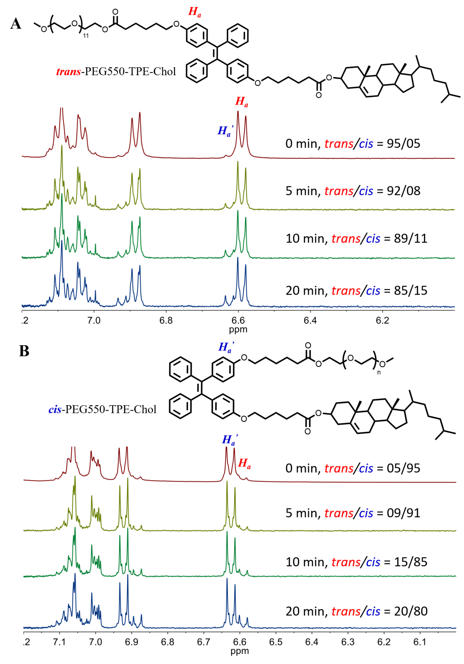
Fig. S20 (A) Partial ¹H NMR spectra of trans-PEG550-TPE-Chol in CDCl₃ upon weak UV light (365 nm, 0.5 mW/cm²) as a function of time. (B) Partial ¹H NMR spectra of cis-PEG550-TPE-Chol in CDCl₃ upon weak UV light (365 nm, 0.5 mW/cm²) as a function of time. T= 25℃. After 2 min of illumination, no photoisomerization can be detected. After 10 min of illumination, trans and cis-PEG550-TPE-Chol undergo 6% and 10% of isomerization, respectively.

7. Self-assembly of PEG550-TPE-Chol and its trans- and cis-isomers
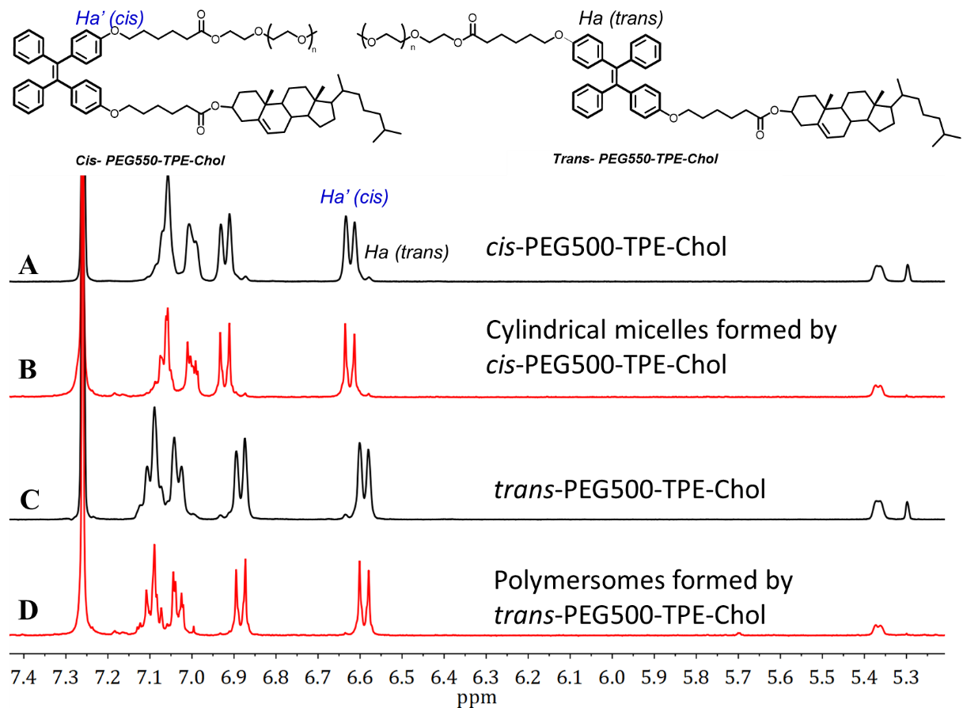
Fig. S21 Partial ¹H NMR spectra of trans- and cis-PEG550-TPE-Chol recovered from their self-assemblies, together with those of initial trans- and cis-PEG550-TPE-Chol polymers (400 MHz, CDCl₃). (A) cis-PEG550-TPE-Chol; (B) polymer recovered from cylindrical micelles formed by cis-PEG550-TPE-Chol; (C) trans-PEG550-TPE-Chol; (D) polymer recovered from polymersomes formed by trans-PEG550-TPE-Chol. The self-assemblies were prepared by film hydration method at 65℃ during 48h.
Fig. S22 Supplemental cryo-EM images of self-assemblies in water of PEG550-TPE-Chol synthesized without stereoisomer separation containing isomers at inherent ratio of trans/cis = 60/40.
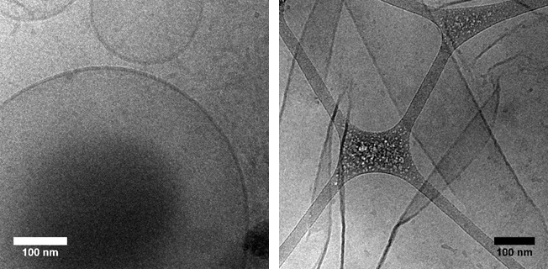
Fig. S23 Supplemental cryo-EM images of trans-PEG550-TPE-Chol self-assemblies in water.
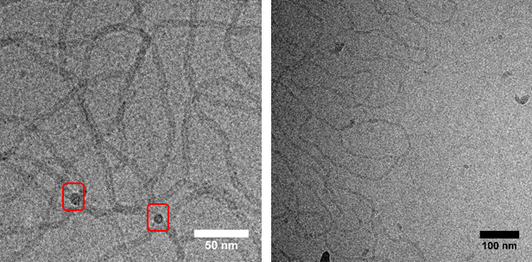
Fig. S24 Supplemental cryo-EM images of cis-PEG550-TPE-Chol self-assemblies in water. The squares indicate the round ends of the cylindrical micelles.
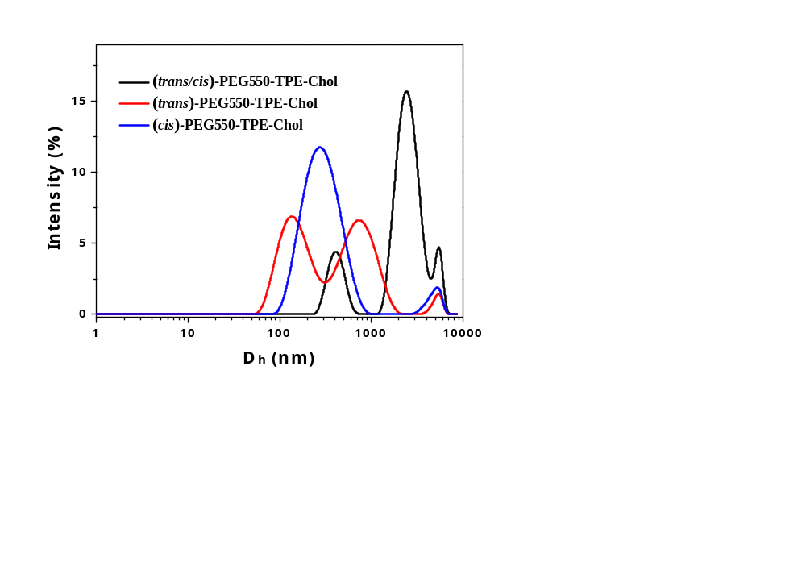
Fig. S25 Distributions of hydrodynamic diameters measured by DLS for self-assemblies formed by PEG550-TPE-Chol, trans-PEG550-TPE-Chol and cis-PEG550-TPE-Chol with film hydration method.
Fig. S26 The plausible molecular models of the hydrophobic part proposed for (A) trans-PEG-TPE-Chol and (B) cis-PEG-TPE-Chol in the bilayer membranes and cylindrical micelles. The red ellipsoid represents the cholesterol moiety, and the green trefoil the TPE group. The red line represents the aliphatic spacer C6, and the blue line the PEG550 chain. The lengths of hydrophobic parts were estimated by Chem3D.

8. AIE and photo-responsive properties of the self-assemblies
Quantum yield was measured by a relative method using the flowing equation:
$$∅_{2}=∅_{1}×\frac{n_{2}^{2}}{n_{1}^{2}}×\frac{F_{2}}{F_{1}}×\frac{A_{1}}{A_{2}}$$
$∅_{2}$ is the quantum yield of the fluorogen sample to be tested; $∅_{1}$ is the quantum yield of a standard fluorogen; n₁ and n₂ are the refractive indexes of the standard solution and the sample solution; F₁ and F₂ are the fluorescence integral areas of fluorescence spectra of standard and sample, which are measured at the same conditions; A₁ and A₂ are the absorbances of standard and sample, which are measured at the same conditions and at values lower than 0.05. The refractive index of ethanol was 1.366 at room temperature; the refractive index of water was 1.333 at room temperature. The selected standard fluorogen was 9,10-diphenylanthracene and its quantum yield was 0.96 in ethanol at room temperature (1 μg/mL; λ_{ex}=366 nm).
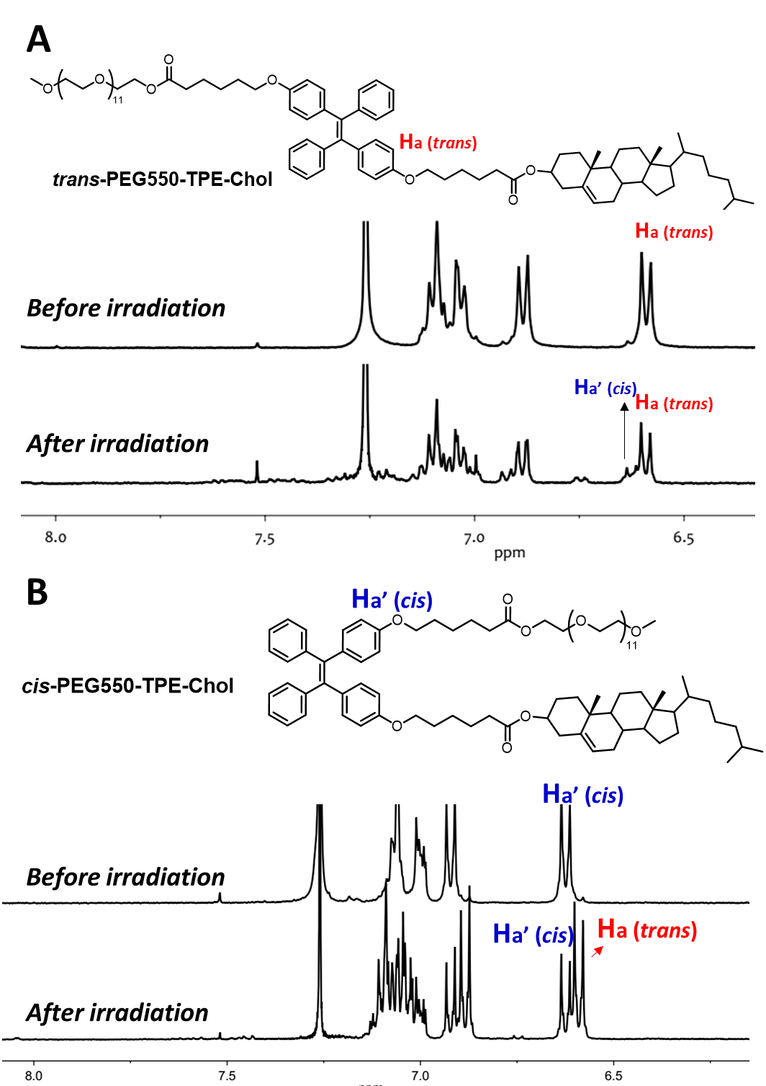
Fig. S27 ¹H NMR spectra of polymers recovered from polymersomes of trans-PEG-TPE-Chol (A) and from cylindrical micelles of cis-PEG-TPE-Chol (B) before and after irradiation under UV light (365 nm, 15 mW/cm²) for 30 min. The self-assemblies were freeze-dried and then solubilized in CDCl₃ to recover the polymers.

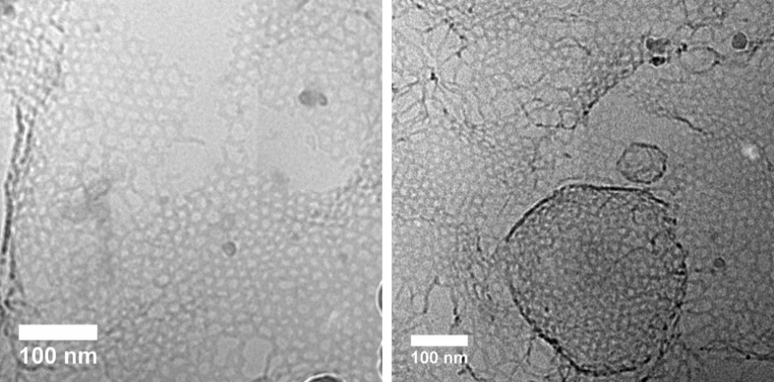
Fig. S28 Supplemental cryo-EM images of polymersomes of trans-PEG550-TPE-Chol after 30 min of irradiation by UV light (365 nm, 15 mW/cm²).

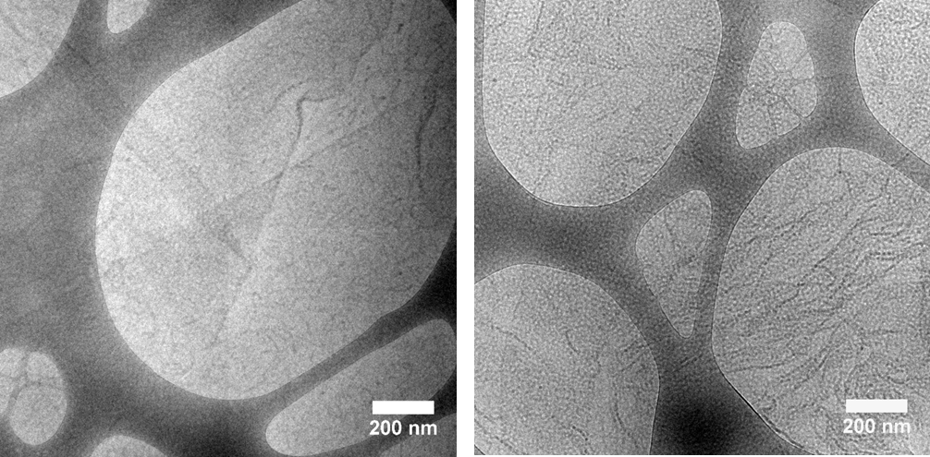
Fig. S29 Supplemental cryo-EM images of cylindrical micelles of cis-PEG550-TPE-Chol after 30 min of irradiation by UV light (365 nm, 15 mW/cm²).
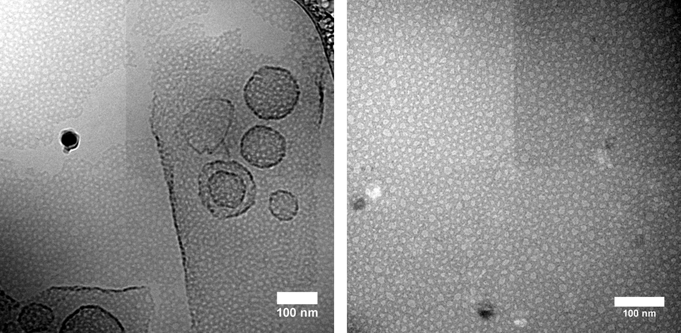
Fig. S30 Cryo-EM images of perforated vesicles and membranes of trans/cis mixture of PEG550-TPE-Chol (trans/cis = 50/50) after 30 min of irradiation by UV light (365 nm, 15 mW/cm²).
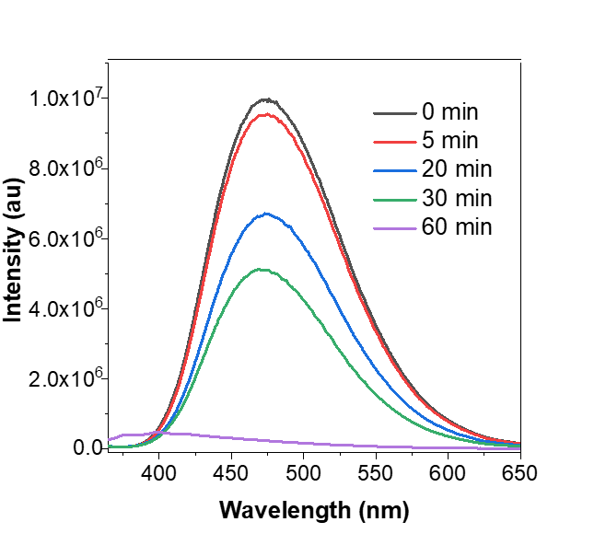
Fig. S31 Photoluminescence spectra of polymersomes of PEG550-TPE-Chol before (black line) and after irradiation under UV light (365 nm, 15 mW/cm²) for different time.

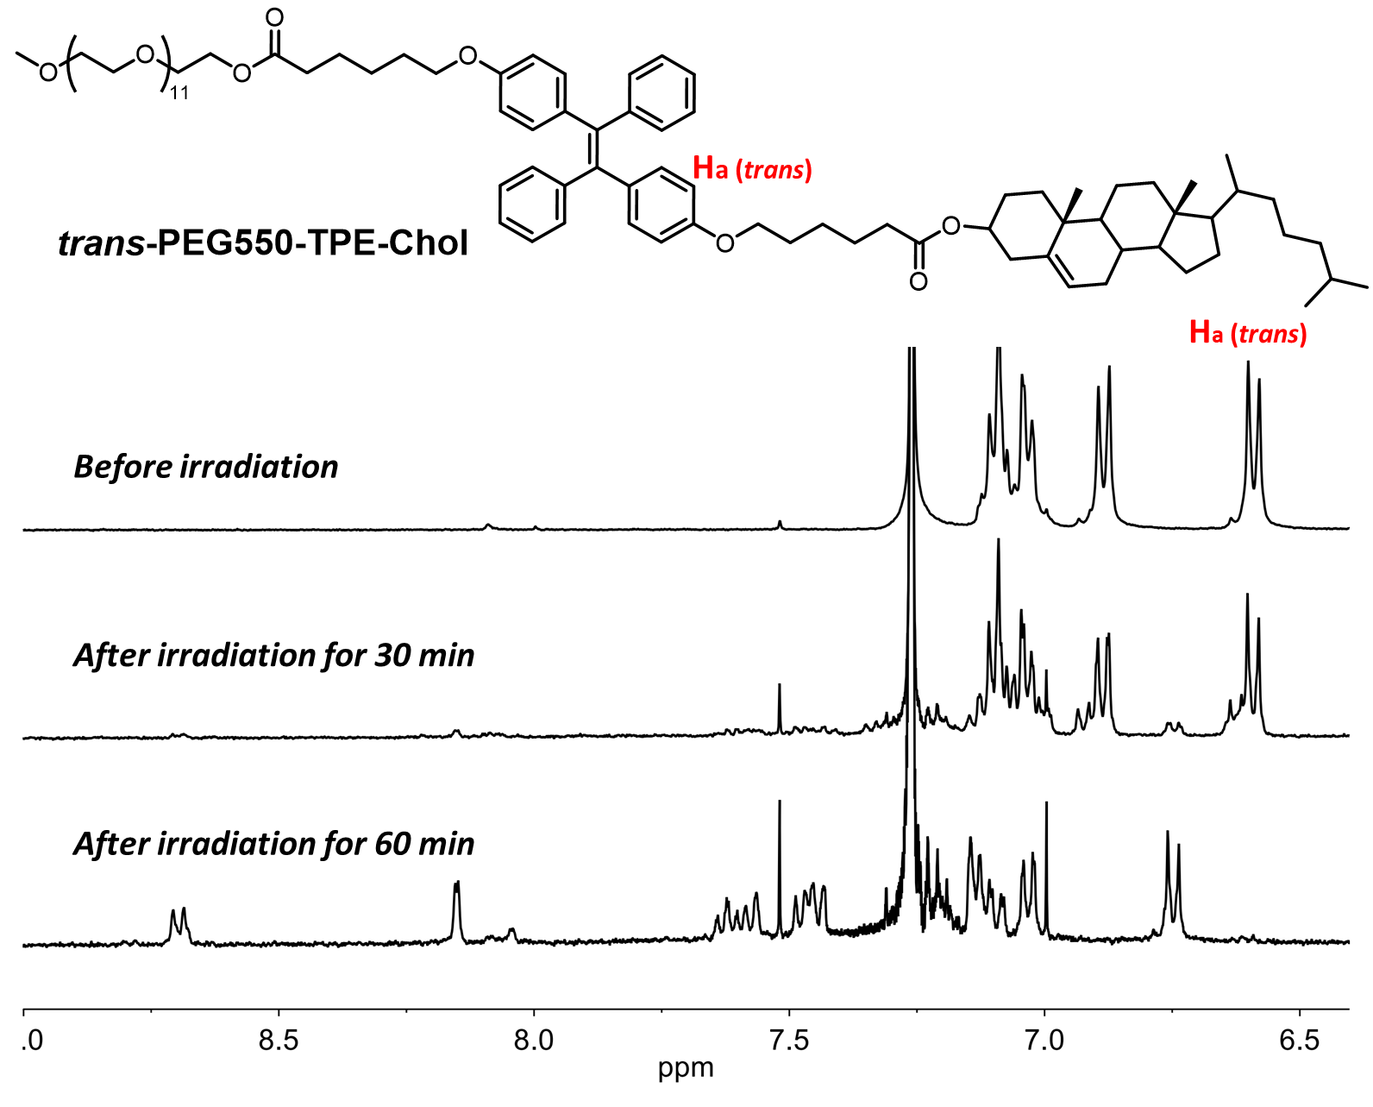
Fig. S32 ¹H NMR spectra of polymers recovered from polymersomes of trans-PEG-TPE-Chol before and after irradiation under UV light (365 nm, 15 mW/cm²) for 30 min and 60 min. The self-assemblies were freeze-dried and then solubilized in CDCl₃ to recover the polymers.

Supplementary Movie caption. Fluorescence images of giant polymersomes under continuous UV illumination recorded with an epifluorescence optical microscope. The first and the last images in the movie were taken at t = 0 and t = 60 sec of illumination, respectively. The exposure time of each picture was 300 µsec. Scale bar = 10 μm. LED-UV light (365 nm) was used with a focused intensity of 15 mW/cm² on the sample.

9. References
1. Zhang, C. J.; Feng, G.; Xu, S.; Zhu, Z.; Lu, X.; Wu, J.; Liu, B., Structure‐Dependent cis/trans Isomerization of Tetraphenylethene Derivatives: Consequences for Aggregation‐Induced Emission. Angewandte Chemie International Edition 2016, 55 (21), 6192-6196.

