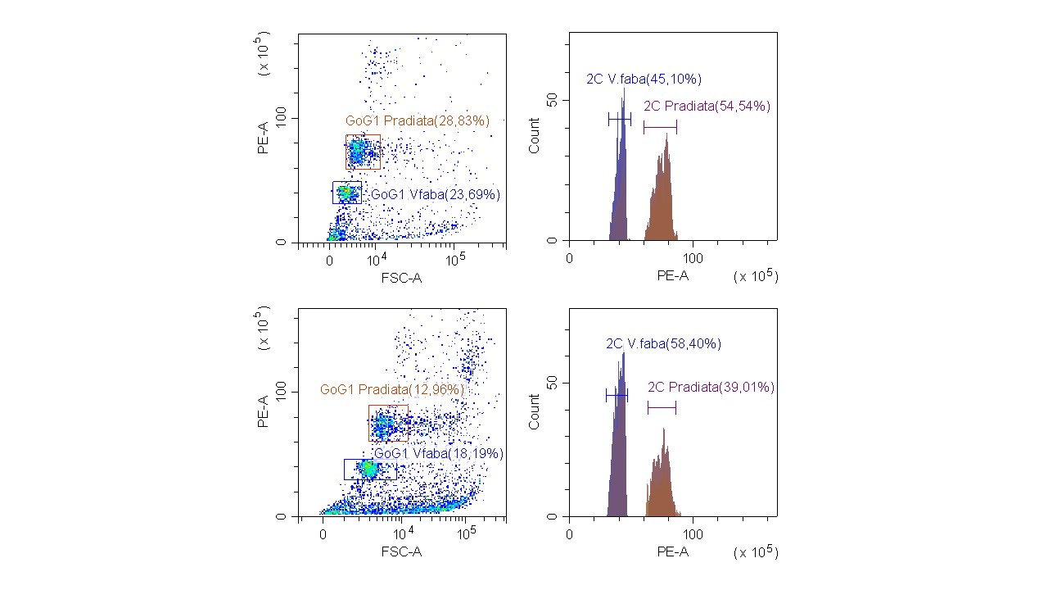

Figure S1. Graphic representations of flow cytometry analyses to evaluate the genetic stability among morphologically normal vs aberrant somatic embryos. The 2C nuclei populations at G0G1 corresponding to Pinus radiata and Vicia faba (internal standard) are shown in the forward scatter (FSC) vs. PE (fluorescence) cytogram and in the PE histogram. In the upper graphs normal embryos are shown and the lower graphics show aberrant embryos.

Table S1. Analysis of variance for the effect of storage at -80 ºC (fresh vs. frozen) in the DNA content, coefficient of variance (%) and DNA index in normal and aberrant somatic embryos of Pinus radiata.
Source |  | DNA content (pg/2C) |  | CV (%) |  | DNA index
Source |  | F-value | P-value | F-value | P-value | F-value | P-value
Storage (Normal somatic embryos) |  | 0.004 | 0.952 | 0.210 | 0.654 | 0.002 | 0.965
Storage (Aberrant somatic embryos) |  | 1.738 | 0.214 | 0.026 | 0.875 | 1.753 | 0.212

Table S2. Analysis of variance for the effect of the morphology and the maturation temperature in the DNA content and DNA index in somatic embryos of Pinus radiata.
Source |  | DNA content (pg/2C) |  | DNA index
Source |  | F-value | P-value | F-value | P-value
Morphology (M) |  | 12.168 | 0.001 | 12.059 | 0.001
Maturation temperature (T) |  | 0.456 | 0.715 | 0.450 | 0.718
M x T |  | 1.345 | 0.272 | 1.284 | 0.291

Table S3. Analysis of variance for the effect of the morphology in the DNA content and DNA index in somatic embryos of Pinus radiata. Each line correspond to a separate analysis carried out for each maturation temperature (MT).
Source |  | DNA content (pg/2C) |  | DNA index
Source |  | F-value | P-value | F-value | P-value
MT 23 ºC |  | 2.170 | 0.166 | 2.119 | 0.171
MT 40 ºC |  | 7.769 | 0.016 | 7.539 | 0.018
MT 50 ºC |  | 1.314 | 0.276 | 1.441 | 0.255
MT 60 ºC |  | 2.798 | 0.125 | 2.570 | 0.140

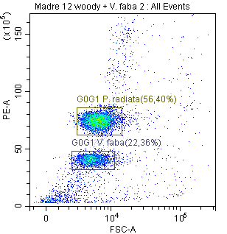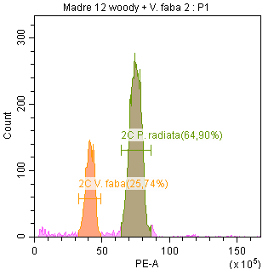
Figure S2. Graphic representations of flow cytometry analyses to evaluate the genetic stability of zygotic embryos. The 2C nuclei populations at G0G1 corresponding to Pinus radiata and Vicia faba (internal standard) are shown in the forward scatter (FSC) vs. PE (fluorescence) cytogram and in the PE histogram.

Table S4. Analysis of variance for the effect the embryo type (aberrant or normal somatic embryos and zygotic embryos) in the DNA content, and DNA index in embryos of Pinus radiata. The somatic embryos in this analysis were those from control maturation temperature.
Source |  | DNA content (pg/2C) |  | DNA index
Source |  | F-value | P-value | F-value | P-value
Embryo type |  | 1.616 | 0.228 | 1.639 | 0.223

Table S5. Analysis of variance for the effect of maturation temperature in the amount of free amino acids (µg/g FW) in somatic embryos of Pinus radiata D. Don.
Source: Temperature
 | F-value | P-value
Alanine | 0.291 | ≥0.05 ^{ns}
Arginine | 45.306 | <0.001 ***
Asparagine | 3.328 | ≥0.05 ^{ns}
Aspartate | 0.282 | ≥0.05 ^{ns}
Citrulline | 0.582 | ≥0.05 ^{ns}
GABA | 0.588 | ≥0.05 ^{ns}
Glutamine | 0.228 | ≥0.05 ^{ns}
Glutamate | 0.158 | ≥0.05 ^{ns}
Glycine | 13.471 | <0.01 **
Histidine | 0.912 | ≥0.05 ^{ns}
Isoleucine | 0.076 | ≥0.05 ^{ns}
Leucine | 0.381 | ≥0.05 ^{ns}
Lysine | 4.087 | <0.05 *
Methionine | 0.071 | ≥0.05 ^{ns}
Ornithine | 7.103 | <0.05 *
Phenylalanine | 0.980 | ≥0.05 ^{ns}
Serine | 0.015 | ≥0.05 ^{ns}
Tyrosine | 0.535 | ≥0.05 ^{ns}
Threonine | 0.101 | ≥0.05 ^{ns}
Tryptophan | 0.163 | ≥0.05 ^{ns}
Valine | 0.186 | ≥0.05 ^{ns}
*; **; *** Significant differences at p<0.05, p<0.01 or p<0.001, respectively; ^{ns} non-significant at p≥0.05.

Table S6. Analysis of variance for the maturation temperature and polyamine type (nmol/g FW) in somatic embryos of Pinus radiata D. Don.
Source | F-value | P-value
Temperature (T) | 3.656 | <0.05 *
Polyamine (PA) | 527.186 | <0.001 ***
T x PA | 1.902 | ≥0.05 ^{ns}
*; *** Significant differences at p<0.05 or p<0.001, respectively; ^{ns} non-significant at p≥0.05.

Table S7. Analysis of variance for the effect of maturation temperature different polyamine content (nmol/g FW) detected in somatic embryos of Pinus radiata D. Don.
Source: Temperature
 | F-value | P-value
Putrescine | 6.079 | <0.05 *
Spermidine | 0.770 | ≥0.05 ^{ns}
Spermine | 2.167 | ≥0.05 ^{ns}
Cadaverine | 0.216 | ≥0.05 ^{ns}
* Significant differences at p<0.05; ^{ns} non-significant at p≥0.05.

Table S8. Analysis of variance for the maturation temperature and embryogenic cell line (ECL) in morphological characteristics of somatic embryos of Pinus radiata D. Don.
Source | Dependent Variable |  | F-value | P-value
ECL | Length of the plantlets |  | 1.129 | ≥0.05 ^{ns}
 | Length of the aerial part |  | 3.852 | <0.01 **
 | Width of the needles |  | 2.061 | ≥0.05 ^{ns}
 | Number of needles |  | 4.510 | <0.01 **
 | Stem diameter |  | 6.553 | <0.001 ***
 | Root length |  | 0.888 | ≥0.05 ^{ns}
 | Number of roots |  | 10.499 | <0.001 ***
Temperature (T) | Length of the plantlets |  | 0.160 | ≥0.05 ^{ns}
 | Length of the aerial part |  | 0.183 | ≥0.05 ^{ns}
 | Width of the needles |  | 0.600 | ≥0.05 ^{ns}
 | Number of needles |  | 2.358 | ≥0.05 ^{ns}
 | Stem diameter |  | 0.117 | ≥0.05 ^{ns}
 | Root length |  | 0.350 | ≥0.05 ^{ns}
 | Number of roots |  | 0.752 | ≥0.05 ^{ns}
ECL x T | Length of the plantlets |  | 0.490 | ≥0.05 ^{ns}
 | Length of the aerial part |  | 1.546 | ≥0.05 ^{ns}
 | Width of the needles |  | 0.656 | ≥0.05 ^{ns}
 | Number of needles |  | 1.380 | ≥0.05 ^{ns}
 | Stem diameter |  | 0.938 | ≥0.05 ^{ns}
 | Root length |  | 0.468 | ≥0.05 ^{ns}
 | Number of roots |  | 1.963 | <0.05 *
*; **; *** Significant differences at p<0.05, p<0.01 or p<0.001, respectively; ^{ns} non-significant at p≥0.05.

Figure S3. Mean number of roots per embryogenic cell line and maturation temperature.

Table S9. Mean length somatic plantlets, width of needles and root length (mm) in different embryogenic cell lines maturated at different temperatures before ex vitro planting.
Embryogenic  Cell Lines | Lenght of the plantlets |  |  |  |  | Width of the needles |  |  |  |  | Root length
Embryogenic  Cell Lines | 23 ºC | 40 ºC | 50 ºC | 60 ºC |  | 23 ºC | 40 ºC | 50 ºC | 60 ºC |  | 23 ºC | 40 ºC | 50 ºC | 60 ºC
R130 | 64.95 | 54.10 | 71.67 | 62.64 |  | 0.36 | 0.35 | 0.32 | 0.33 |  | 34.88 | 30.50 | 45.22 | 38.54
R138 | 75.14 | 84.25 | 77.69 | 79.90 |  | 0.44 | 0.40 | 0.32 | 0.39 |  | 38.32 | 50.22 | 50.65 | 50.15
R16 | 84.61 | 86.58 | 54.92 | 69.38 |  | 0.44 | 0.37 | 0.51 | 0.36 |  | 50.08 | 47.66 | 30.81 | 31.53
R2 | 74.64 | 63.14 | 75.50 | 79.91 |  | 0.42 | 0.45 | 0.44 | 0.32 |  | 40.33 | 27.58 | 42.15 | 42.64
R49 | 79.22 | 72.48 | 90.35 | 68.92 |  | 0.30 | 0.32 | 0.26 | 0.23 |  | 47.99 | 35.70 | 46.48 | 34.97
R9 | 66.58 | 56.04 | 66.97 | 62.83 |  | 0.38 | 0.42 | 0.43 | 0.36 |  | 38.40 | 26.05 | 32.53 | 31.60
Mean | 74.19 | 69.43 | 72.85 | 70.60 |  | 0.39 | 0.39 | 0.38 | 0.33 |  | 41.67 | 36.29 | 41.31 | 38.24

