Supplementary section

Suppl. 1: Antibody information
Antibody | Barcode | clones that worked | vendor
CD69 | BX017 | EPR21814 | abcam
IgD | BX046 | EPR6146 | abcam
PAX5 | BX021 | D7H5X | CST
MUM1 | BX024 | EP5699 | abcam
CD19 | BX043 | LE-CD19 | BIORAD
CD22 | BX034 | EPR20061 | abcam
MPO | BX006 | EPR20257 | abcam
CD14 | BX030 | EPR3653 | abcam
Bcl-6 | BX023 | IG191E/A8 | Biolegend
CD223/LAG3 | BX027 | EPR4392 (2) | abcam
CD274/PDL1 | BX041 | CAL10 | ABCAM
PD1 | BX014 | D4W2J | CST
Foxp3 | BX020 | 236A/E7 | INVITROGEB
ICOS | BX042 | SP98 | abcam
IDO1 | BX025 | D5J4E | CST
CD4 | Bx003 | EPR6855 | Akoya
CD8 | Bx026 | C8/144B | Akoya
CD20 | BX007 | SP32 | abcam
CD21 | Bx032 | EP3093 | Akoya
CD68 | BX015 | KP1 | Akoya
CD3e | BX045 | EP449E | Akoya

Suppl table 2: Cell cycle data
Channel 1 | Exposure Time | Alexa 488 | Oligo Barcode | Clone | Antibody Dilution | Exposure Time | Atto 550 | Oligo Barcode | Clone | Antibody Dilution | Exposure Time | Alexa 647 | Oligo Barcode | Clone | Antibody Dilution | Exposure Time
Hoechst | 20 | Blank |  |  |  | 400 | Blank |  |  |  | 400 | Blank |  |  |  | 500
Hoechst | 20 | IgD | BX046 | EPR6146 | 1:25 | 400 | Bcl6 | BX023 | IG191E/A8 | 1:50 | 400 | CD3 | BX045 | EP449E | 1:50 | 500
Hoechst | 20 | CD19 | BX043 | LE-CD19 | 1:50 | 400 | CD20 | BX035 | SP32 | 1:50 | 400 | CD4 | BX003 | EPR6855 | 1:50 | 500
Hoechst | 20 | CD22 | BX034 | EPR20061 | 0.1111111 | 400 | CD21 | BX032 | EP3093 | 0.1805556 | 400 | CD14 | BX030 | EPR3653 | 1:50 | 500
Hoechst | 20 | IDO1 | BX025 | D5J4E | 1:50 | 400 | CD69 | BX017 | EPR21814 | 1:50 | 400 | CD68 | BX015 | KP1 | 1:50 | 500
Hoechst | 20 | Empty |  | - |  | 400 | Foxp3 | BX020 | 236A/E7 | 1:50 | 400 | ICOS | BX042 | SP98 | 1:50 | 500
Hoechst | 20 | Empty |  | - |  | 400 | PD1 | BX014 | D4W2J | 1:50 | 400 | LAG3 | BX027 | EPR4392 (2) | 1:50 | 500
Hoechst | 20 | Empty |  | - |  | 400 | PDL1 | BX041 | CAL10 | 1:25 | 400 | MPO | BX006 | EPR20257 | 0.11111 | 500
Hoechst | 20 | Empty |  | - |  | 400 | CD8 | BX026 | C8/144B | 1:50 | 400 | MUM1 | BX024 | EP5699 | 1:50 | 500
Hoechst | 20 | Empty |  | - |  | 400 | Empty | - |  |  | 400 | PAX5 | BX021 | D7H5X | 1:25 | 500
Hoechst | 20 | Blank |  |  |  | 400 | Blank |  |  |  | 400 | Blank |  |  |  | 500

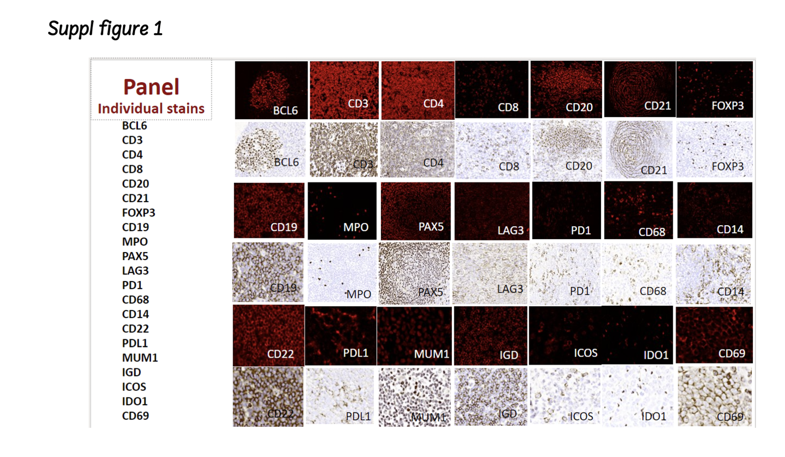

Sppl fig 2: Segmentation overlay using Mav software

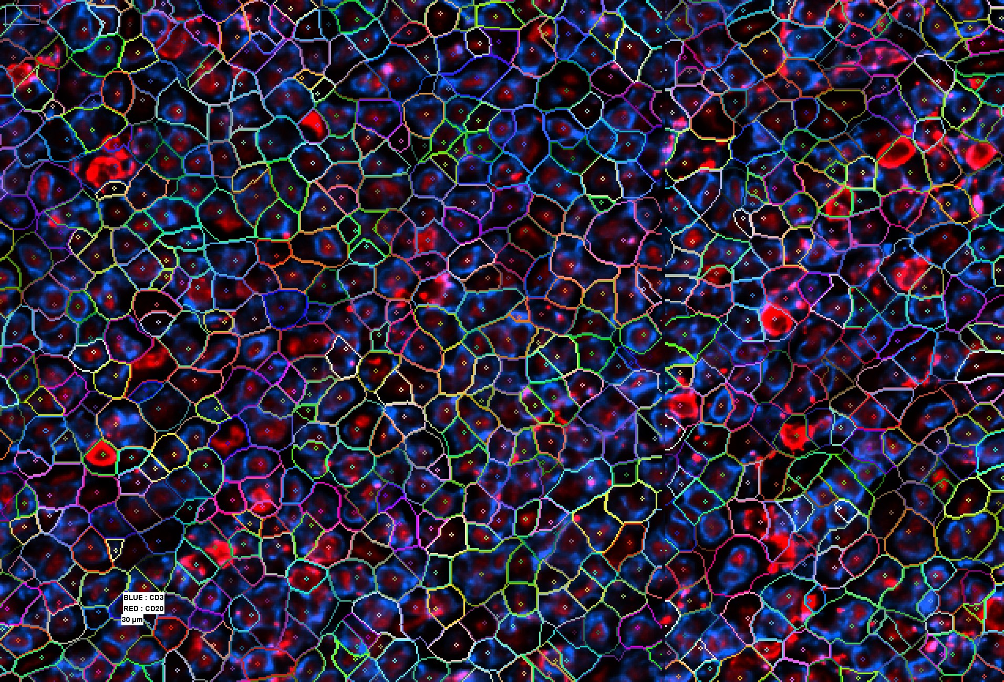

Suppl Fig 3: ROIs selected based on morphology from NLPHL and THRLBCL
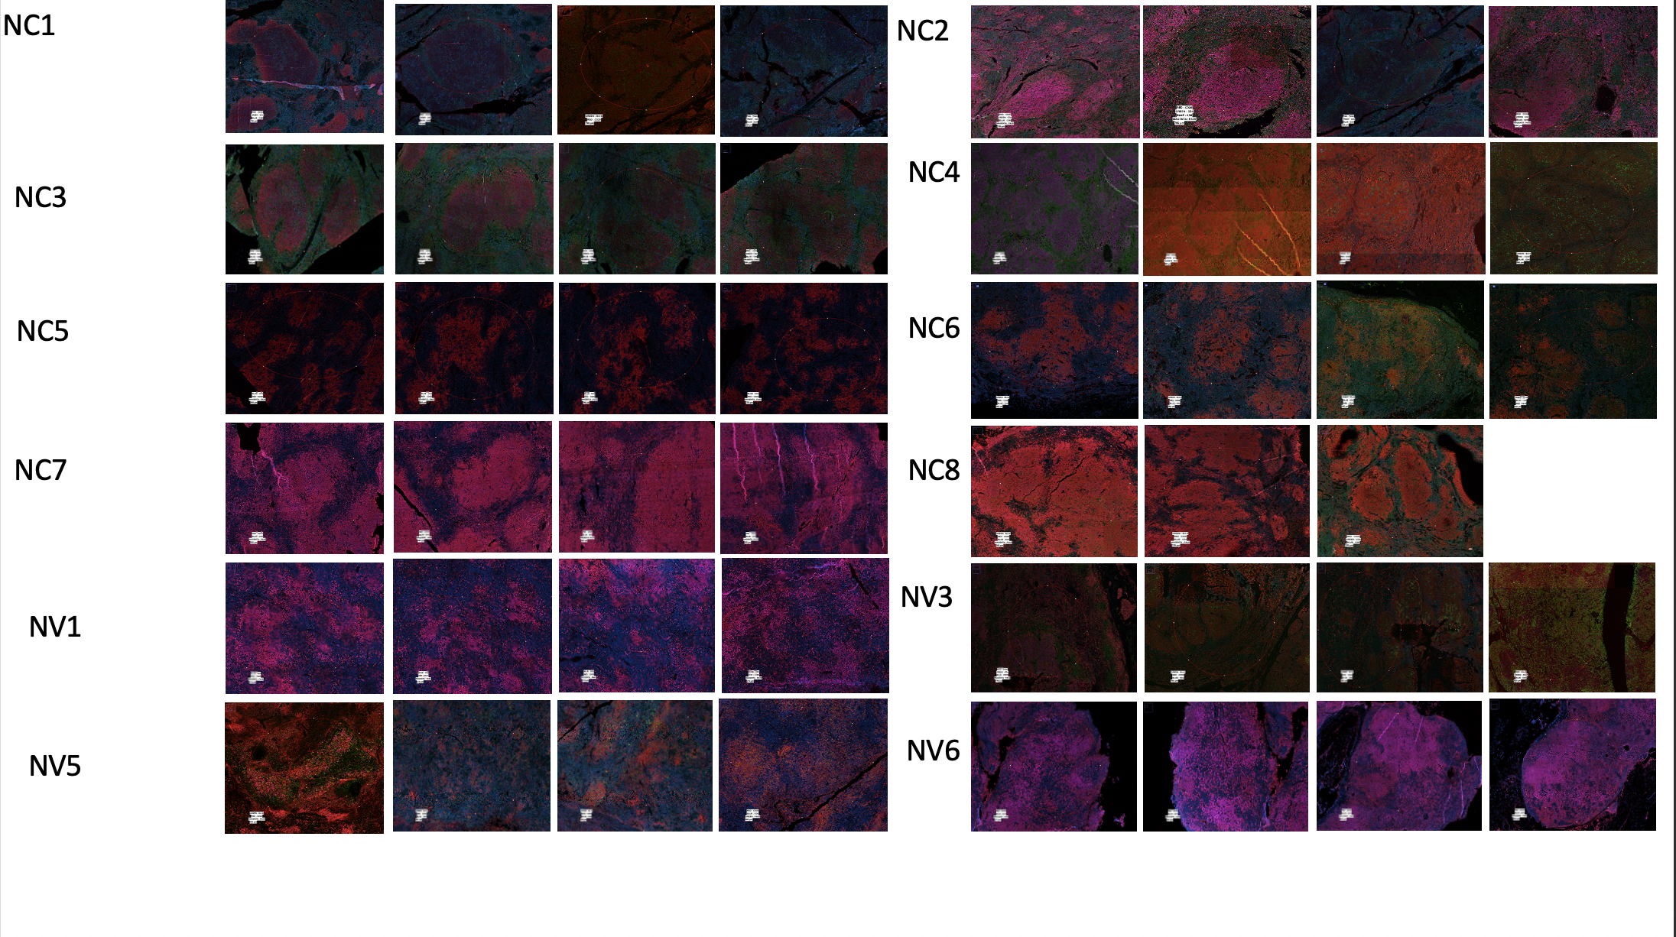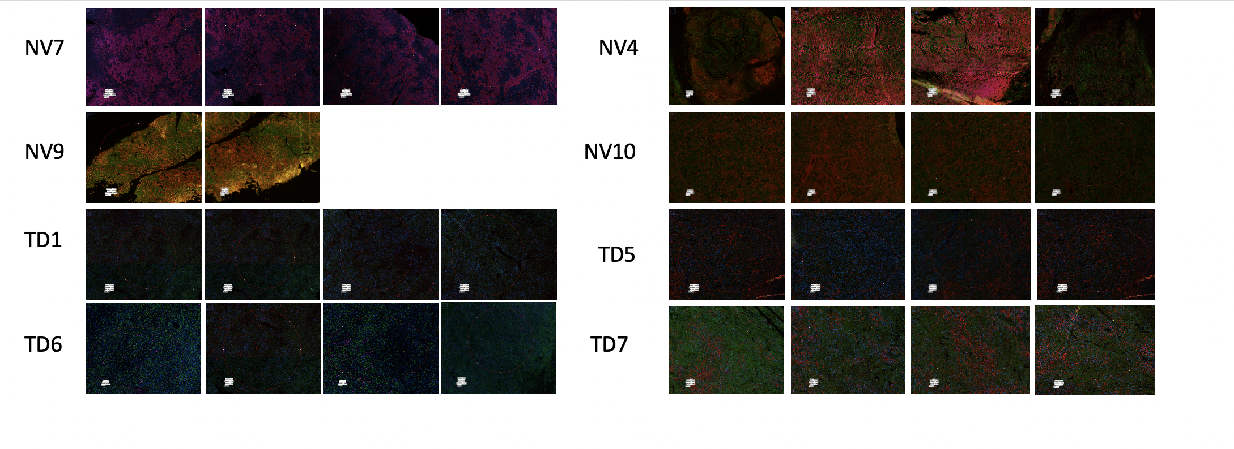

Suppl Figure 4: Frequencies of cellular populations in ROIs examined across NLPHL and THRLBCL cases

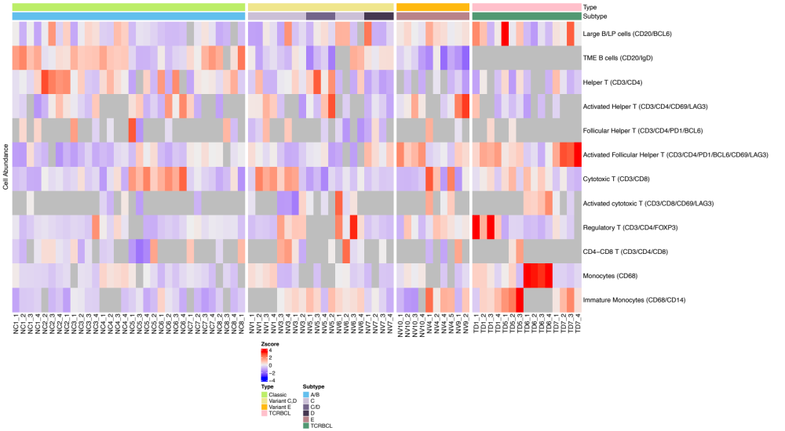

Suppl table 3: Z-scores by case

Z SCORES | NC1 | NC2 | NC3 | NC4 | NC5 | NC6 | NC7 | NV1 | NV10 | NC8 | NV3 | NV4 | NV5 | NV6 | NV7 | NV9 | TD1 | TD5 | TD6 | TD7
Large B/LP cells (CD20/BCL6) | -0.67 | 0.60 | -0.12 | 0.13 | -0.56 | -1.03 | -0.41 | -0.82 | 0.21 | -1.36 | -0.19 | 0.72 | -0.19 | -0.57 | -0.02 | 0.28 | 0.79 | 3.16 | -1.08 | 1.12
TME B cells (CD20/IgD) | 1.81 | 0.23 | 1.15 | 1.21 | -0.72 | -0.26 | 1.08 | -0.37 | -0.47 | 0.33 | -0.22 | -1.29 | -1.18 | 0.17 | 0.39 | -1.84 | NA | NA | NA | NA
Helper T (CD3/CD4) | 0.19 | 2.75 | 0.08 | 0.82 | -0.62 | 0.50 | 0.11 | -0.18 | -1.28 | 0.44 | 0.34 | -1.14 | 1.77 | -0.33 | -0.94 | -0.68 | -0.77 | 0.19 | -1.24 | -0.01
Activated Helper T (CD3/CD4/CD69/LAG3) | -0.57 | 0.46 | 0.26 | NA | 0.26 | 1.04 | -0.60 | 0.93 | 0.69 | -1.11 | -0.91 | -0.54 | 1.03 | -1.11 | -0.29 | 2.80 | -0.45 | -0.01 | -0.95 | -0.95
Follicular Helper T (CD3/CD4/PD1/BCL6) | 0.95 | NA | 1.19 | -1.02 | 1.23 | -1.33 | NA | 1.55 | NA | 0.68 | -0.60 | -0.12 | -1.21 | -1.01 | 0.55 | 0.55 | -0.62 | -0.80 | NA | NA
Activated Follicular Helper T (CD3/CD4/PD1/BCL6/CD69/LAG3) | -0.63 | -1.21 | -0.88 | -0.57 | 0.12 | -0.76 | 0.21 | 0.10 | 1.43 | -0.46 | -0.78 | -0.31 | -0.22 | -1.39 | 0.58 | 0.65 | 1.24 | 0.47 | -0.38 | 2.79
Cytotoxic T (CD3/CD8) | -0.99 | -0.24 | -0.23 | -0.69 | 1.69 | 2.09 | -0.42 | 1.40 | -0.93 | -0.96 | 0.93 | 1.27 | -1.23 | -0.41 | -0.62 | -0.95 | -0.02 | 0.38 | 0.56 | -0.64
Activated cytotoxic T (CD3/CD8/CD69/LAG3) | -0.65 | NA | NA | 0.21 | -1.13 | NA | -0.98 | -0.85 | NA | NA | -0.04 | 1.05 | -0.25 | 0.75 | NA | NA | NA | NA | 2.18 | -0.30
Regulatory T (CD3/CD4/FOXP3) | -0.49 | -0.37 | 0.13 | -0.02 | -1.16 | -0.57 | -0.04 | -0.70 | -0.17 | -0.32 | 1.01 | 0.43 | NA | 1.93 | -0.67 | 0.06 | 2.92 | -0.75 | -0.81 | -0.43
CD4-CD8 T (CD3/CD4/CD8) | -0.29 | 1.24 | 0.11 | -0.62 | -0.13 | NA | -1.10 | NA | NA | -0.08 | 1.91 | -1.06 | -1.24 | 0.76 | -1.16 | 1.09 | NA | 0.58 | NA | NA
Monocytes (CD68) | -0.13 | -0.31 | -0.36 | 0.57 | -0.10 | -0.42 | -0.25 | 0.55 | 0.17 | -0.58 | -0.62 | -0.69 | -0.72 | -0.18 | -0.62 | -0.40 | 0.46 | 0.07 | 3.90 | -0.34
Immature Monocytes (CD68/CD14) | -0.62 | NA | -0.21 | -1.22 | -0.59 | -0.22 | -1.10 | NA | -1.22 | -0.79 | 0.33 | 1.34 | 0.40 | 0.51 | -0.40 | -0.17 | 0.38 | 2.59 | NA | 0.99

Suppl Fig 5: Stacked bar charts of cellular populations in ROIs examined across NLPHL and THRLBCL

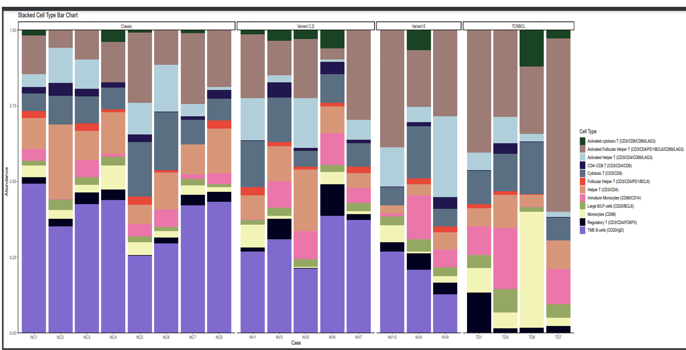

Suppl Fig 6: Qupath measurements data
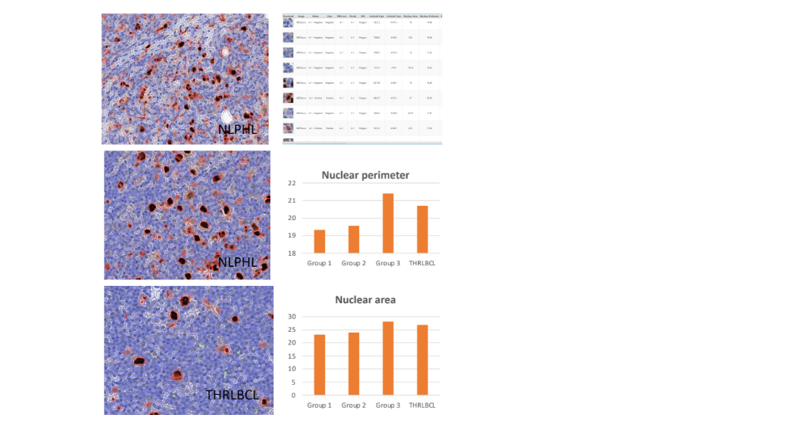

Suppl table 4: Interaction count between cell types in group-1 cases

GROUP 1 INTERACTIONS | TFH | REGULATORYTCELLS | LPCELLS | BCELLS | MONOCYTES | CD4CD8TCELLS | CYTOTOXICTCELLS | HELPERTCELLS
TFH | 0.485 | 0.038 | 0.094 | 0.264 | 0.091 | 0.045 | 0.136 | 0.158
REGULATORYTCELLS | 0.038 | 0.216 | 0.030 | 0.039 | 0.069 | 0.081 | 0.082 | 0.099
LPCELLS | 0.094 | 0.030 | 0.260 | 0.065 | 0.040 | 0.028 | 0.047 | 0.056
BCELLS | 0.264 | 0.039 | 0.065 | 1.029 | 0.100 | 0.043 | 0.161 | 0.294
MONOCYTES | 0.091 | 0.069 | 0.040 | 0.100 | 0.355 | 0.072 | 0.132 | 0.151
CD4CD8TCELLS | 0.045 | 0.081 | 0.028 | 0.043 | 0.072 | 0.210 | 0.147 | 0.141
CYTOTOXICTCELLS | 0.136 | 0.082 | 0.047 | 0.161 | 0.132 | 0.147 | 0.399 | 0.214
HELPERTCELLS | 0.158 | 0.099 | 0.056 | 0.294 | 0.151 | 0.141 | 0.214 | 0.580

Suppl table 5: Interaction count between cell types in group-2 cases

Group 2 interactions | REGULATORYTCELLS | LPCELLS | TFH | CYTOTOXICTCELLS | MONOCYTES | BCELLS | HELPERTCELLS | CD4CD8TCELLS
REGULATORYTCELLS | 0.233 | 0.030 | 0.067 | 0.107 | 0.063 | 0.091 | 0.063 | 0.109
LPCELLS | 0.030 | 0.241 | 0.058 | 0.035 | 0.023 | 0.062 | 0.045 | 0.034
TFH | 0.067 | 0.058 | 0.575 | 0.177 | 0.112 | 0.294 | 0.258 | 0.051
CYTOTOXICTCELLS | 0.107 | 0.035 | 0.177 | 0.355 | 0.111 | 0.189 | 0.193 | 0.126
MONOCYTES | 0.063 | 0.023 | 0.112 | 0.111 | 0.345 | 0.086 | 0.120 | 0.086
BCELLS | 0.091 | 0.062 | 0.294 | 0.189 | 0.086 | 0.807 | 0.210 | 0.066
HELPERTCELLS | 0.063 | 0.045 | 0.258 | 0.193 | 0.120 | 0.210 | 0.515 | 0.055
CD4CD8TCELLS | 0.109 | 0.034 | 0.051 | 0.126 | 0.086 | 0.066 | 0.055 | 0.258

Suppl table 6: Interaction count between cell types in group-3 cases

group 3 interactions | LPCELLS | REGULATORYTCELLS | BCELLS | CYTOTOXICTCELLS | TFH | MONOCYTES | HELPERTCELLS | CD4CD8TCELLS
LPCELLS | 0.292 | 0.029 | 0.048 | 0.044 | 0.079 | 0.040 | 0.047 | 0.034
REGULATORYTCELLS | 0.029 | 0.186 | 0.094 | 0.073 | 0.076 | 0.043 | 0.093 | 0.050
BCELLS | 0.048 | 0.094 | 0.657 | 0.175 | 0.262 | 0.070 | 0.223 | 0.042
CYTOTOXICTCELLS | 0.044 | 0.073 | 0.175 | 0.414 | 0.161 | 0.131 | 0.131 | 0.086
TFH | 0.079 | 0.076 | 0.262 | 0.161 | 0.583 | 0.116 | 0.253 | 0.064
MONOCYTES | 0.040 | 0.043 | 0.070 | 0.131 | 0.116 | 0.361 | 0.082 | 0.037
HELPERTCELLS | 0.047 | 0.093 | 0.223 | 0.131 | 0.253 | 0.082 | 0.367 | 0.080
CD4CD8TCELLS | 0.034 | 0.050 | 0.042 | 0.086 | 0.064 | 0.037 | 0.080 | 0.182

Suppl table 7: Interaction count between cell types in THRLBCL cases

THRLBCL interactions | LPCELLS | MONOCYTES | TFH | HELPERTCELLS | CYTOTOXICTCELLS | REGULATORYTCELLS
LPCELLS | 0.509 | 0.046 | 0.075 | 0.095 | 0.043 | 0.027
MONOCYTES | 0.046 | 0.423 | 0.224 | 0.182 | 0.165 | 0.048
TFH | 0.075 | 0.224 | 0.669 | 0.259 | 0.175 | 0.122
HELPERTCELLS | 0.095 | 0.182 | 0.259 | 0.420 | 0.145 | 0.070
CYTOTOXICTCELLS | 0.043 | 0.165 | 0.175 | 0.145 | 0.370 | 0.051
REGULATORYTCELLS | 0.027 | 0.048 | 0.122 | 0.070 | 0.051 | 0.247

Suppl table 8 : Summary data of population frequencies and unique spatial interactions

Population | Group 1 NLPHL |  | Group 2 |  | Group 3 |  | THRLBCL
 | Frequency | Unique spatial interactions | Frequency | Unique spatial interactions | Frequency | Unique spatial interactions | Frequency | Unique spatial interactions
LP/tumor cells ​ | low | TFH, TME B-cells | low | TME B-cells, TFH | high | TFH, TME B-cells | The highest | TFH, helper T-cells
TME B cells*​ | The highest number | LP cells, Helper T-cells and T-reg | More & close to LP​ | TFH, LP cells | lower | LP cells | Not detected
Helper T cells*​ | The highest number | TME B-cells, cytotoxic T-cells and monocytes | High​ | Cytotoxic T-cells | Lower |  | Lower | Monocytes, tumor cells
Activated Helper T cells*​ | High​ | TME B-cells, cytotoxic T-cells and monocytes | High​ | Cytotoxic T-cells | High​ |  | Low | Monocytes, tumor cells
TFH​ | High ​ | LP cells | High | LP cells, TME B-cells, and cytotoxic T-cells, T-reg | High | Cytotoxic, T-reg, LP cells | Low | monocytes, tumor cells, T-reg, Cytotoxic
Activated TFH*​ | The lowest number | LP cells | low | LP cells, TME B-cells, and cytotoxic T-cells, T-reg | high​ | Cytotoxic, T-reg, LP cells | High​ | monocytes, tumor cells, T-reg, Cytotoxic
Treg*​ | Low | TME B-cells, cytotoxic, monocytes, CD4-CD8 positive T-cells | High | cytotoxic T-cells, TFH | High | TFH | High​ | TFH
CD4-CD8 positive T-cells | Detected | Monocytes, T-reg, and cytotoxic T-cells | Detected |  | Detected
Cytotoxic T-cells | Low | Helper T-cells and CD4-CD8 positive T-cells, T-reg | low | Helper T-cells, TFH, and T-reg cels | low | TFH | High | Monocytes, TFH
Activated cytotoxic T cells | Low | Helper T-cells and CD4-CD8 positive T-cells, T-reg | low | Helper T-cells, TFH, and T-reg cels | low | TFH | High | Monocytes, TFH
Monocytes | Low | Helper T-cells and CD4-CD8 positive T-cells, T-reg | low |  | High |  | The highest | Helper T-cells, cytotoxic T-cells, TFH
Immature monocytes | Low | Helper T-cells and CD4-CD8 positive T-cells, T-reg | low |  | High |  | The highest | Helper T-cells, cytotoxic T-cells, TFH

Supplementary table 9: Nuclear area and perimeter measurements in NLPHL and THRLBCL

 | Group and Feature | Min. | 1st Qu. | Median | Mean | 3rd Qu. | Max. | SD | Cell Count
Nucleus: peimeter | Group 1 NLPHL | 10.8098 | 14.60155 | 17.5859 | 19.33311 | 22.13053 | 94.9054 | 6.926257384 | 7910
 | Group 2 NLPHL | 10.7871 | 15.0045 | 18.2311 | 19.56098 | 22.412 | 82.4607 | 6.37146433 | 8045
 | Group 3 NLPHL | 10.9251 | 16.14423 | 19.91675 | 21.39549 | 25.14718 | 72.0826 | 7.014452414 | 6492
 | THRLBCL | 10.8106 | 16.2968 | 19.6384 | 20.70375 | 24.10655 | 59.6871 | 6.026797576 | 4723
Nucleus: Area | Group 1 NLPHL | 8 | 13.75 | 18.75 | 23.13306 | 26.75 | 356.75 | 16.14327468 | 7910
 | Group 2 NLPHL | 7.75 | 15 | 20.5 | 23.97216 | 28.5 | 289.75 | 14.67151679 | 8045
 | Group 3 NLPHL | 8.25 | 16.75 | 24 | 28.13355 | 34.5 | 246.25 | 16.97008087 | 6492
 | THRLBCL | 7.75 | 17.5 | 24.25 | 26.87582 | 33.5 | 109 | 12.80267018 | 4723

