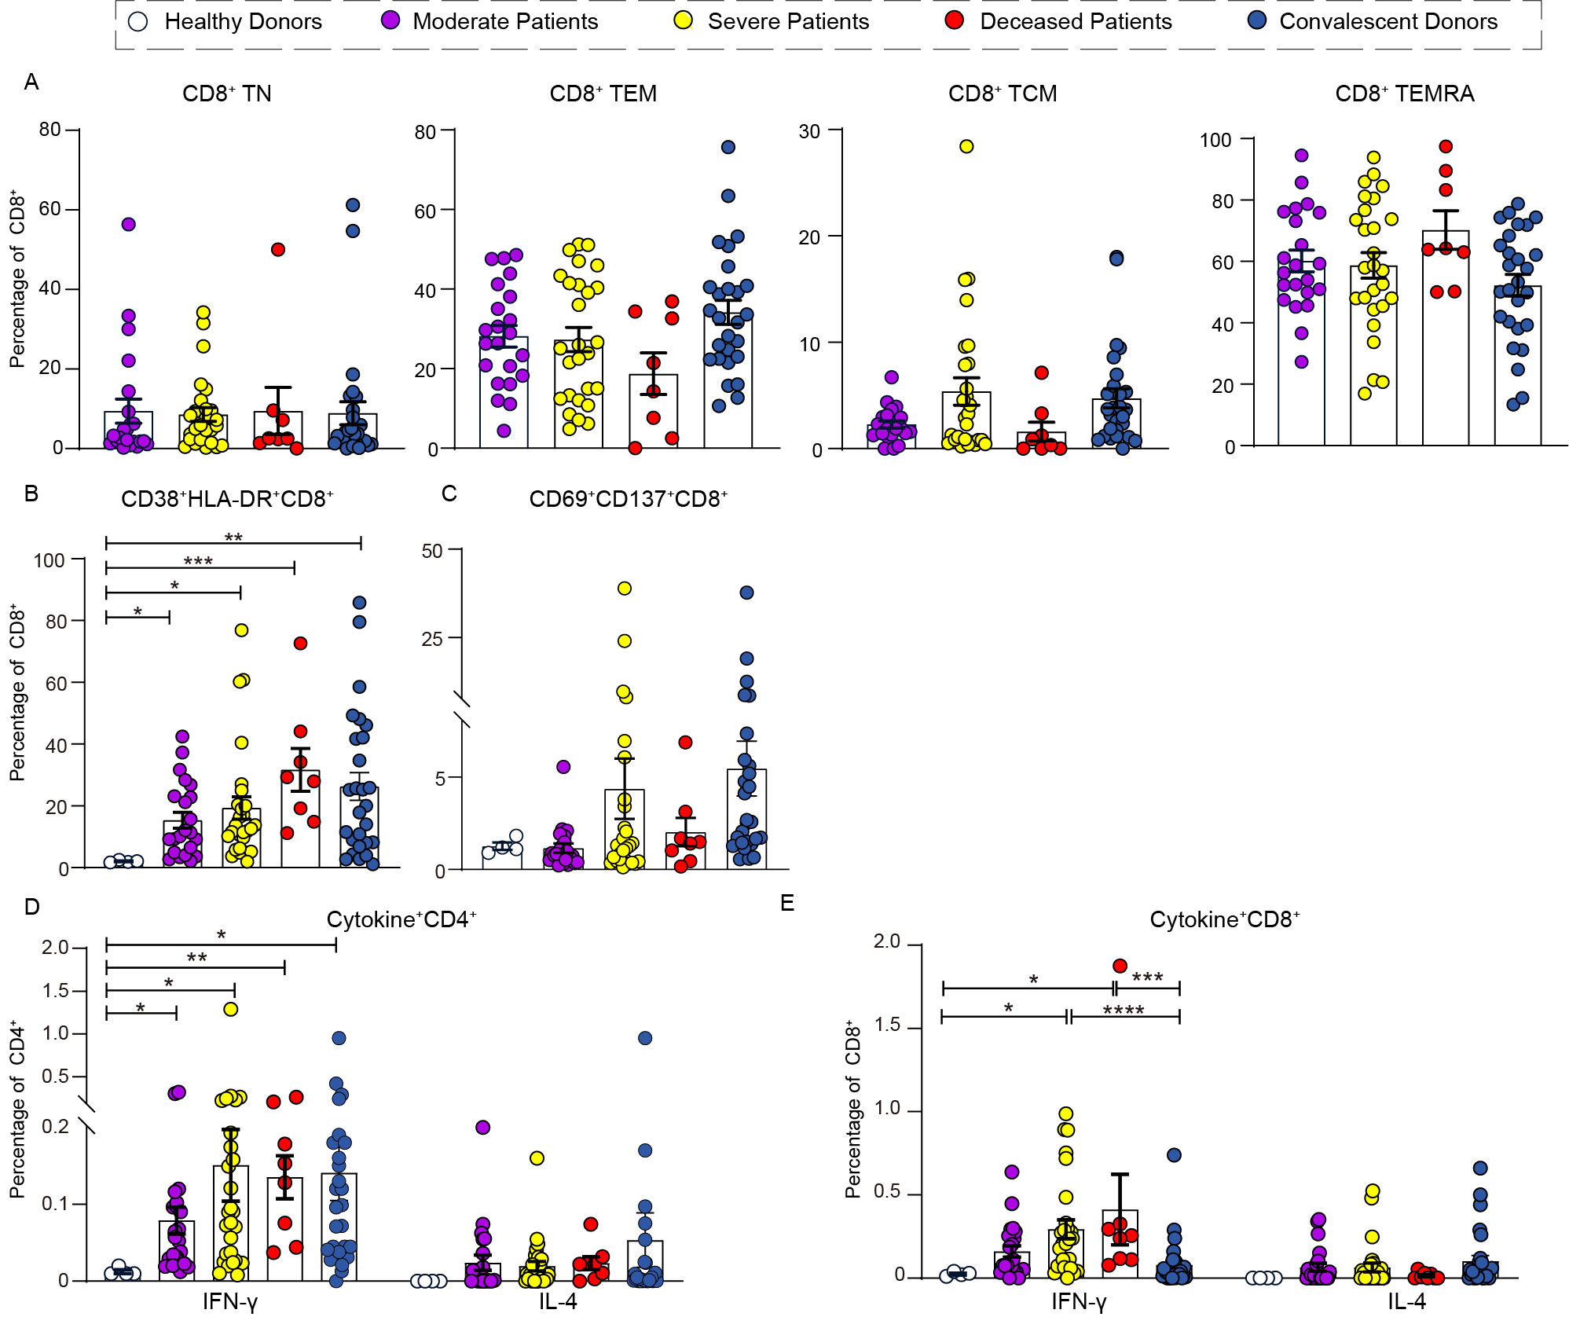
Supplementary Fig. 1. CD8⁺TM profile and activation signatures. (A) Percentages of CD8⁺ Naïve T (TN), effector memory T (TEM), central memory (TCM) and effector memory-expressing CD45RA (TEMRA). Percentages of (B) CD38⁺HLA-DR⁺CD8⁺ (C) CD69⁺CD137⁺CD8⁺ after peptide pool stimulation. Percentages of (D) IFN-γ⁺ and IL-4⁺ CD4⁺ (E) IFN-γ⁺ and IL-4⁺ CD8⁺ in HDs, MPs, SPs, DPs and CDs after peptide pool stimulation. Data were displayed as mean ± SEM and analyzed by One-way-ANOVA with Tukey correction or Kruskal-Wallis test according to data distribution.*p ≤ 0.05, **p ≤ 0.01, ***p ≤ 0.001, ****p ≤ 0.0001. MPs: Moderate patients; SPs: Severe patients; DPs: Deceased patients; CDs: Convalescent donors;
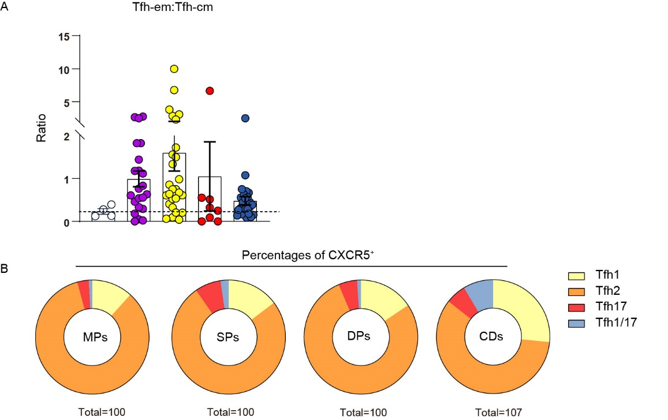
Supplementary Fig. 2. Deficiency of Tfh subsets. (A) Ratio of Tfh-em and Tfh-cm in HDs, MPs, SPs, DPs and CDs. Dotted line represented the mean baseline level. (B) Pie charts display the mean proportion of Tfh1, Tfh2, Tfh17 and Tfh1/17 in CXCR5⁺ cells in MPs, SPs, DPs and CDs.
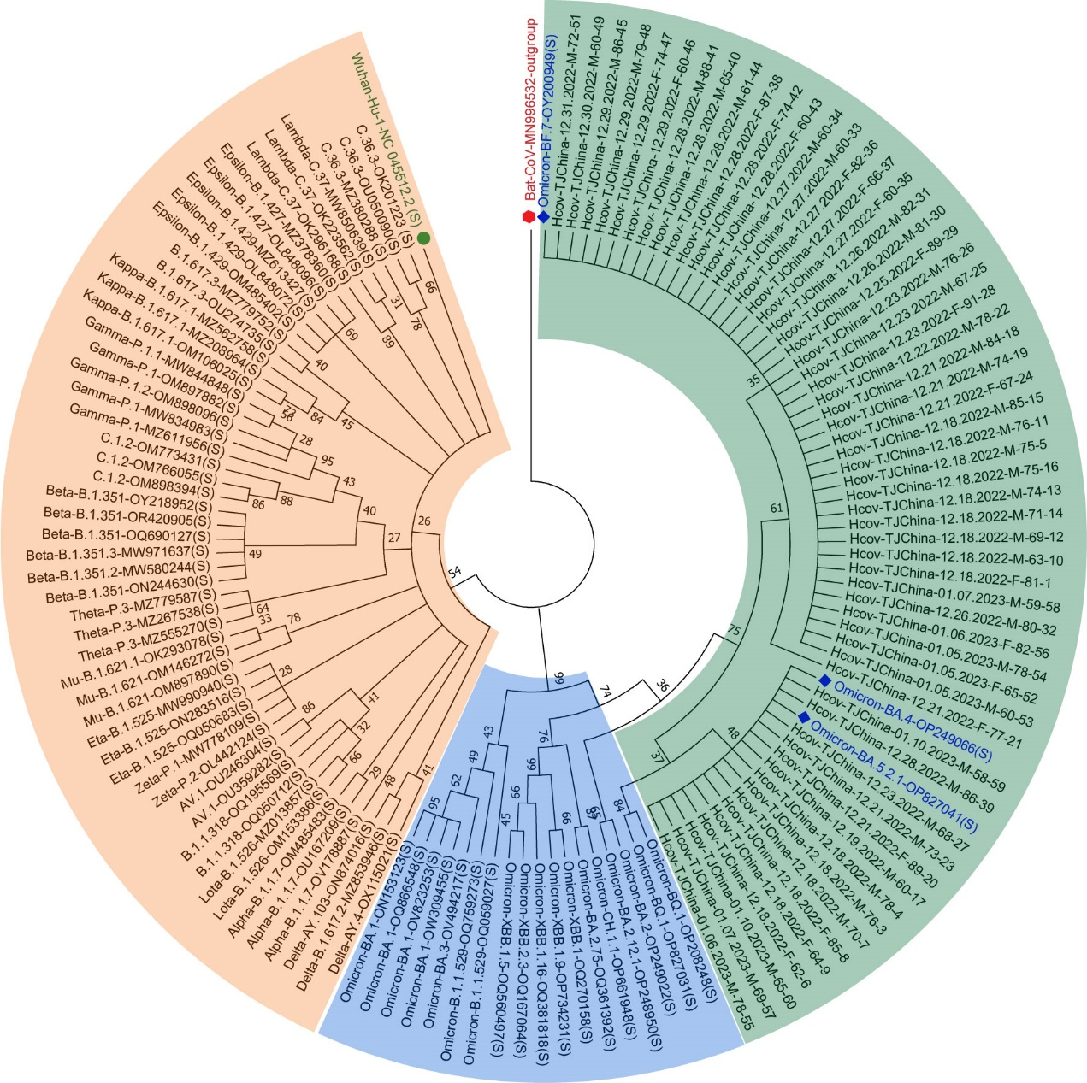
Supplementary Fig. 3. Phylogenetic analysis. Neighbor-joining (NJ) tree was generated using Tamura 3-parameter model with a bootstrap replication of 1,000 cycles. Throat swab sequences (n=58, throat swab of 56 out of 57 donors were available, 2 donors with age of 58 and 59, who were removed form the cohort in Table 1, were also included in the Phylogenetic analysis) were marked in light green, in which BA.5.2.1/ BF.7/BA.4 lineages were highlighted in blue. Retrieved sequences from NCBI were colored in orange and blue (Omicron lineages). Target sequences of our study were named as Hcov-TJChina- Sampling date-Sex-Age-Sample number. TJ: Tianjin; M: Male; F: Female.

Supplementary Fig. 4. Gating strategy for T cell subsets. PBMCs were pre-gated on singlets and live (DAPI⁻) population. Memory T (TM) profiles of CD4⁺ and CD8⁺ cells were gated via the expression of CD45RA and CCR7. Naive (TN: CD45RA⁺CCR7⁺), effector memory (TEM: CD45RA–CCR7–), central memory (TCM: CD45RA–CCR7⁺) and effector memory-expressing CD45RA (TEMRA: CD45RA⁺CCR7⁻). CD4⁺ cells were gated further and T helper cells were defined as follows: Treg (CD4⁺CD25⁺CD127⁻CD45RA⁻CD45RO⁺)， TFR (CD4⁺CD25⁺CD127⁻CXCR5⁺PD-1⁺), Tfh (CD4⁺CD25⁻CD45RA⁻CXCR5⁺PD-1⁺),
Tfh-cm (CD4⁺CD25⁻CD45RA⁻CXCR5⁺CCR7⁺PD-1⁻), Tfh-em (CD4⁺CD25⁻CD45RA⁻CXCR5⁺CCR7⁻PD-1⁺), Tfh1 (CD4⁺CD25⁻CD45RA⁻CXCR5⁺CXCR3⁺CCR6⁻), Tfh2 (CD4⁺CD25⁻CD45RA⁻CXCR5⁺CXCR3⁻CCR6⁻), Tfh17 (CD4⁺CD25⁻CD45RA⁻CXCR5⁺CXCR3⁻CCR6⁺), Tfh1/17 (CD4⁺CD25⁻CD45RA⁻CXCR5⁺CXCR3⁺CCR6⁺).

Supplementary Fig. 5. Gating strategy for T cell activation. Peptide pool stimulated PBMCs were pre-gated on singlets and live (DAPI⁻) population. Activated CD4⁺ and CD8⁺ cells were defined via the co-expression of CD69⁺CD137⁺, CD38⁺HLADR⁺, and cytokine secretion (IFN-γand IL-4). Cytotoxic CD4⁺ and CD8⁺ were measured via GZMB secretion.

