Fig.S1a. Parts of cotton dry stem
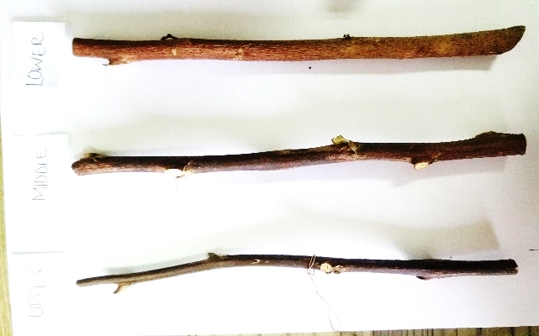
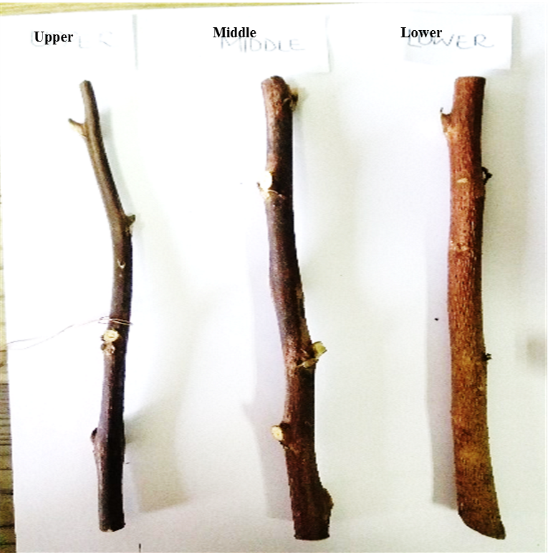
Lower

Fig.S1b. Plant stem strength meter
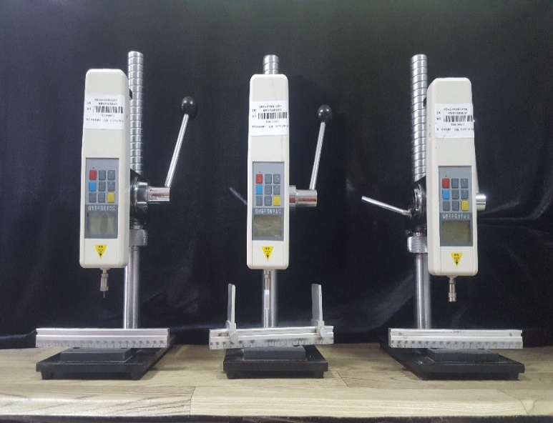

Figure S2: Frequency distribution of phenotypic variation of six stem hardness related traits BL: bending lower; AL: acupuncture lower; CL: compression lower; BU: bending upper; AU: acupuncture upper; CU; compression upper: and 7 fiber-related traits and correlation coefficients among the traits in 237 accessions. FS: fiber strength; FL: fiber length; MI: micronaire Index; E: elongation ratio; UP: Uniformity percentage: FE: fibre elongation; SCI: spinning consistency index; FD: days to flowering. ∗∗∗ Indicates extremely significant difference at P = 0.05 probability levels.

Figure S3: Frequency distribution of phenotypic variation of six-stem hardness related traits BL: bending lower; AL: acupuncture lower; CL: compression lower; BU: bending upper; AU: acupuncture upper; CU; compression upper: and seven yield-related traits and correlation coefficients among the traits in 237 accessions. PH: plant height; BW: boll weight; GP: growth period; LP: lint percentage; LI: lint index; SI: seed index index; FWPB: flower weight per boll. ∗∗∗ Indicates extremely significant difference at P = 0.05 probability levels.

