Additional Files supporting Manuscript “Intrabronchial Application of Extracellular Histones Shows no Proinflammatory Effects in Swine in a Translational Pilot Study”

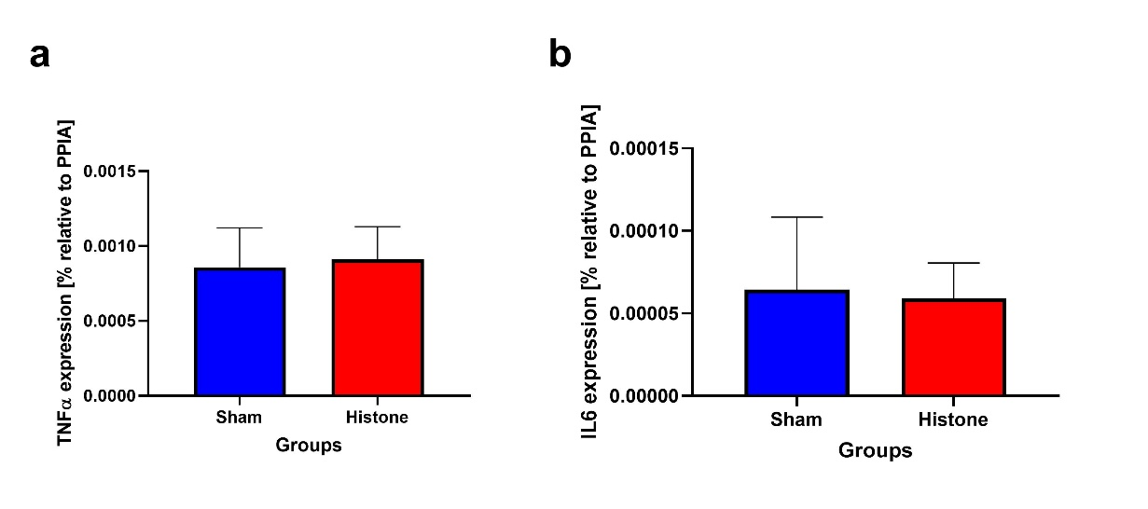

Figure S1: Inspiratory pressures over an 8 h monitoring period of sham and histone tracheal instillation groups. Peak inspiratory pressure (a) and mean airway pressure (b) were significantly increased (P<0.01) after instillation and remained elevated in both groups without showing relevant intergroup differences. The intravenously administered animals showed no changes to baseline and no other respiratory symptoms (data not shown).

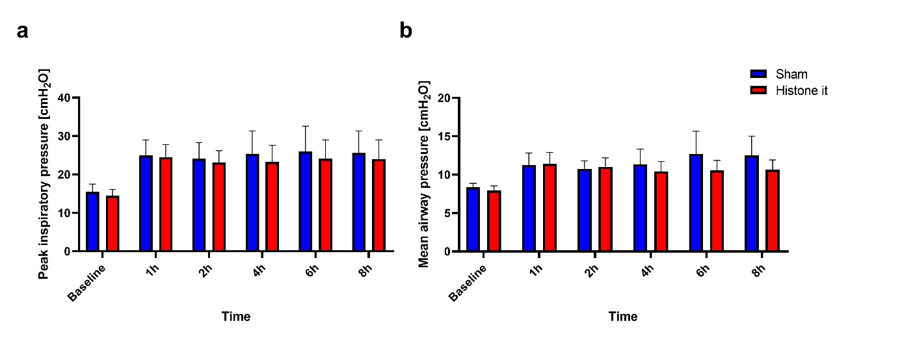
Figure S2: Inflammatory marker expression of TNF-alpha (a) and Interleukin-6 (b) in the lung tissues relative to Peptidylprolyisomerase A (PPIA) . No significant differences could be detected between the groups. Intravenous groups were not analyzed due to the lack of clinical indication for inflammation.

