SUPPLEMENTARY FIGURES

Figure 1. Generations of spheroid derived from primary cultures. The sample was captured using 10x magnifications.

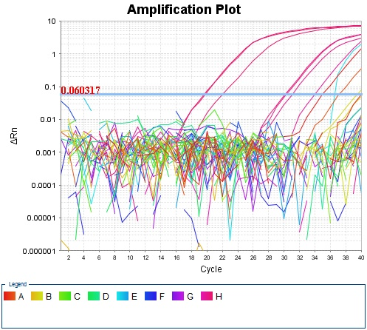
Figure 2. Amplifications plot of Human Cancer Pathway Finder. The genes were considered positively expressed if detected above background signal and detected between cycles 20-39 of 40 cycles.

