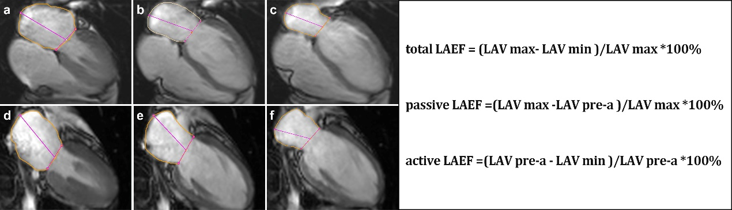
Additional fle. 1 Calculation of left atrial volume and function. The left atrial endocardial contour (orange curve) was delineated at the end of left ventricular systole (a,d), before left atrial systole (b,e) and end of left ventricular diastole (c,f) of the four-chamber long axis (a-c) and two-chamber long axis (d-f) images of CMR slices. The left atrial volume in three phases were automatically calculated, and the left atrial emptying fraction (LAEF) according to the formula

