Supplementary Information
Carbon farming in the Living Soils of the Americas
Carlos Eduardo Pellegrino Cerri^{1,*}, Federico Villarreal², Francisco Fujita de Castro Mello², João Marcos Villela¹, Jorge Luiz Locatelli¹, Martha Lustosa Carvalho¹, Maurício Roberto Cherubin¹, Rattan Lal³

¹Department of Soil Science, Luiz de Queiroz College of Agriculture, University of São Paulo, Piracicaba, São Paulo, Brazil; ²Directorate of Technical Cooperation, Inter-American Institute for Cooperation on Agriculture, San José, Costa Rica; ³CFAES Rattan Lal Center for Carbon Management and Sequestration, School of Environment and Natural Resources, The Ohio State University, Columbus, Ohio, USA
* cepcerri@usp.br

Table S1. The total number of studies returned by the search filtered C stock data for all depths, and 0 - 30 cm for the Americas and Caribbean.
Region/country | Number of studies presenting soil C stock data | Number of studies presenting soil C stock data up to 30 cm depth
Northern
Canada | 87 |  | 37
USA | 603 |  | 324
Mexico | 29 |  | 22
Central
Belize | 0 |  | 0
Costa Rica | 12 |  | 8
El Salvador | 0 |  | 0
Guatemala | 1 |  | 0
Honduras | 0 |  | 0
Nicaragua | 1 |  | 1
Panama | 2 |  | 0
Andean
Bolivia | 3 |  | 2
Colombia | 34 |  | 14
Ecuador | 21 |  | 10
Peru | 19 |  | 9
Venezuela | 6 |  | 3
Caribbean
Antigua e Barbuda | 0 |  | 0
Bahamas | 0 |  | 0
Barbados | 0 |  | 0
Dominica | 0 |  | 0
Grenada | 0 |  | 0
Guyana | 0 |  | 0
Haiti | 1 |  | 0
Jamaica | 0 |  | 0
Dominican Republic | 1 |  | 0
Saint Kitts and Nevis | 0 |  | 0
Saint Vincent and the Grenadines | 0 |  | 0
Saint Lucia | 0 |  | 0
Suriname | 0 |  | 0
Trinidad and Tobago | 1 |  | 0
Southern
Argentina | 58 |  | 15
Brazil | 271 |  | 134
Chile | 21 |  | 10
Paraguay | 5 |  | 4
Uruguay | 14 |  | 5
Total | 1190 |  | 598

Table S2. Keyword clusterning and frequency.
Clusters | Color | Total Keywords | Total Occurrence of keywords | Keyword
1 | Red | 30 | 3,974 | carbon sequestration (410), land-use change (392), soil carbon (306), carbon (254), soil (230), agroforestry (205), pasture (184), savanna (165), grazing (151), agriculture (138), biomass (124), nutrient cycling (118), ecosystem services (112), biodiversity (98), stable isotopes (87), soil nitrogen (87), brazil (82), restoration (80), fire (79), deforestation (78), carbon storage (75), disturbance (71), succession (64), soil nutrientes (64), amazon (62), modeling (56),tropical forest (53), global warming (51), biogeochemistry (51) and forest (47).
2 | Green | 26 | 5,028 | soil organic matter (671), no-tillage (661), soil organic carbon (629), tillage (345), soil quality (319), cover crops (274), microbial biomass (204), aggregate stability (180), soil fertility (163), crop rotation (149), soil management (143), soil health (132), conservation agriculture (120), soil properties (116), conventional tillage (113), soil structure (101), bulk density (99), soil compaction (81), organic agriculture (79), sustainable agriculture (78), microbial activity (65), cropping systems (65), soil degradation (64), earthworms (64), organic farming (57), reduced tillage (56)
3 | Blue | 16 | 1,158 | maize (161), decomposition (106), soybean (87), denitrification (74), rhizosphere (73), nitrification (68), fertilization (67), mineralization (65), nitrate (63), wheat (62), nitrogen mineralization (60), particulate organic matter (59), soil microbial biomass (56), roots (55), fungi (53) and bacteria (49)
4 | Yellow | 16 | 2,112 | climate change (369), carbon dioxide (256), grasslands (250), greenhouse gases (169), nitrous oxide (156), soil respiration (142), carbon cycle (98), soil moisture (96), eddy covariance (92), photosynthesis (89), methane (80), drought (79), evapotranspiration (70), global change (65), respiration (54) and carbon cycling (47)
5 | Violet | 12 | 1,483 | nitrogen (389), phosphorus (198), erosion (177), sustainability (129), nutrients (84), switchgrass (82), bioenergy (82), water quality (78), biochar (74), manure (72), runoff (65) and infiltration (53)

Table S3. Agricultural area, the estimated area with potential for agroecosystems’ improvements, average annual agricultural greenhouse gas (GHG) emissions, estimated soil carbon (C) sequestration potential, and estimated necessary area to mitigate GHG emissions from Americas and Caribbean countries’.
Country | Agricultural destinated area (Mha)¹ | Estimated area with potential for soil management improvements (Mha)² | Average annual CO₂eq emissions originated from agricultural activities (Mt CO₂eq year⁻¹)³ | Estimated soil C sequestration potential (Pg CO₂eq)⁴ | Estimated needed area to mitigate agricultural GHG emissions (Mha)⁵
Northern
Canada | 57.8 | 17.34 | 58.89 | 0.525 | 38.85
United States | 405.8 | 121.74 | 615.12 | 3.690 | 405.87
Mexico | 97.1 | 29.13 | 95.72 | 0.882 | 63.16
Central
Belize | 0.17 | 0.051 | 0.39 | 0.003 | 0.11
Costa Rica | 1.76 | 0.528 | 4.03 | 0.034 | 1.22
El Salvador | 1.2 | 0.36 | 2.47 | 0.023 | 0.75
Guatemala | 3.85 | 1.155 | 10.08 | 0.075 | 3.07
Honduras | 3.5 | 1.05 | 6.94 | 0.068 | 2.1
Nicaragua | 5.06 | 1.518 | 11.01 | 0.099 | 3.34
Panama | 2.2 | 0.66 | 3.51 | 0.043 | 1.06
Andean
Bolivia | 37.8 | 11.34 | 27.48 | 0.743 | 8.37
Colombia | 48.2 | 14.46 | 60.38 | 0.948 | 18.4
Ecuador | 5.4 | 1.62 | 12.63 | 0.106 | 3.85
Peru | 24.5 | 7.35 | 26.2 | 0.482 | 7.98
Venezuela | 21.5 | 6.45 | 38.91 | 0.423 | 11.85
Caribbean
Antigua and Barbuda | 0.009 | 0.0027 | 0.02 | 0.0001 | 0.006
Bahamas | 0.014 | 0.0042 | 0.03 | 0.0002 | 0.0097
Barbados | 0.01 | 0.003 | 0.06 | 0.0001 | 0.018
Dominica | 0.03 | 0.0075 | 0.04 | 0.0004 | 0.012
Dominican Republic | 2.42 | 0.726 | 9.07 | 0.047 | 2.76
Grenada | 0.008 | 0.0024 | 0.02 | 0.0001 | 0.006
Guyana | 1.20 | 0.36 | 2.29 | 0.023 | 0.69
Haiti | 1.84 | 0.552 | 4.52 | 0.036 | 1.37
Jamaica | 0.44 | 0.132 | 0.58 | 0.008 | 0.17
Saint Kitts and Nevis | 0.006 | 0.0018 | 0.01 | 0.0001 | 0.003
Saint Lucia | 0.009 | 0.0027 | 0.03 | 0.0001 | 0.0097
Saint Vincent and the Grenadines | 0.007 | 0.0021 | 0.01 | 0.0001 | 0.0054
Suriname | 0.08 | 0.0252 | 0.73 | 0.0016 | 0.22
Trinidad and Tobago | 0.05 | 0.0162 | 0.3 | 0.001 | 0.09
Southern
Argentina | 108.00 | 32.4 | 128.6 | 1.399 | 59.55
Brazil | 236.80 | 71.04 | 501.52 | 3.067 | 232.26
Chile | 15.70 | 4.71 | 10.46 | 0.203 | 4.84
Paraguay | 17.00 | 5.1 | 30.88 | 0.22 | 14.3
Uruguay | 14.00 | 4.2 | 26.76 | 0.181 | 12.39
¹World Bank (https://data.worldbank.org/indicator/AG.LND.AGRI.K2?name_desc=false); ²FAO. 2015 (https://www.fao.org/3/i5199e/i5199e.pdf); ³ClimateWatch (https://www.climatewatchdata.org/); ⁴Estimates based on soil C sequestrtion rates reported in the literature; ⁵Estimates calculated according to the average agricultural annual GHG emissions and soil C sequestration potential.

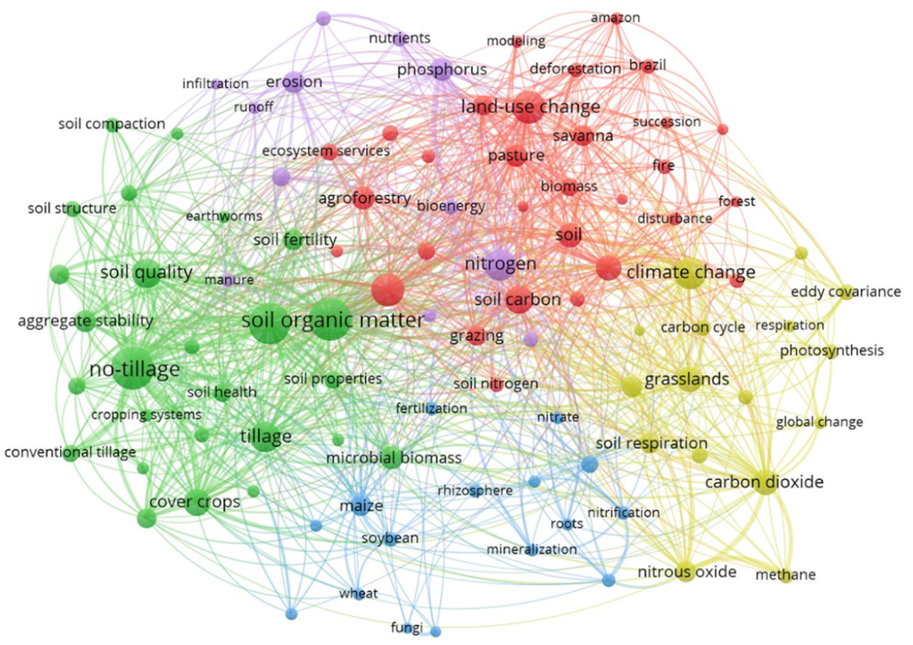

Figure S1. Map of co-occurrence of keywords from the publications retrieved during the 1985-2022 period for the Americas and Caribbean regions.

