Appendix
Table A1 Annual climate variables, including abbreviation and units, used to develop transfer functions to assess local adaptation in this analysis.
Variable abbreviation | Climate variable | Unit
AHM | Annual heat-moisture index | ℃ mm⁻¹
CMD | Hargreaves climatic moisture deficit | mm
DD_0 | Degree-days below 0 ℃ | ℃ days
DD5 | Degree-days above 5 ℃ | ℃ days
Eref | Hargreaves reference evaporation | mm
EMT | Extreme minimum temperature over 30 years | ℃
EXT | Extreme maximum temperature over 30 years | ℃
FFP | Frost-free period | day
NFFP | The number of frost-free days | days
bFFP | The day of the year on which FFP begins | day
eFFP | The day of the year on which FFP ends | day
MAP | Mean annual precipitation | mm
MAT | Mean annual temperature | ℃
MCMT | Mean coldest month temperature | ℃
MWMT | mean warmest month temperature | ℃
MAR | mean annual solar radiation | MJ m^{‐2} d^{‐1}
MSP | Mean summer precipitation | mm
CMI | Hogg’s climate moisture index | mm
PAS | Precipitation as snow | mm
RH | Mean annual relative humidity | %
SHM | Summer heat-moisture index | ℃ mm⁻¹
TD | Temperature difference (continentality; MWMT-MCMT) | ℃

Table A2 Parameter estimates of the selected Universal Response Functions (URFs) for lodgepole pine and white spruce
Variable | Parameter estimate | p_value | Partial R² |  | Variable | Parameter estimate | p_value | Partial R²
Lodgepole pine |  |  |  |  | White spruce
Intercept | -2.853000 | <0.001 |  |  | Intercept | -59.360000 | <0.001
MAT.p² | -0.005774 | <0.001 | 0.069 |  | AHM.p | -0.710200 | <0.001 | 0.039
TD.p | 0.048300 | <0.001 | 0.005 |  | AHM.p² | -0.001835 | <0.001 | 0.019
TD.p² | -0.002111 | <0.001 | 0.082 |  | NFFD.p | 0.025340 | <0.001 | 0.029
CMD.p² | -0.000003 | <0.001 | 0.025 |  | NFFD.p² | -0.000102 | <0.001 | 0.018
MCMT.s | -0.154400 | <0.001 | 0.069 |  | Eref.p | 0.091070 | <0.001 | 0.001
MCMT.s² | -0.008370 | <0.001 | 0.032 |  | Eref.p² | -0.000005 | <0.001 | 0.006
DD5.s | 0.004286 | <0.001 | 0.085 |  | MAP.s | 0.087060 | <0.001 | 0.232
DD5.s² | -0.000002 | <0.001 | 0.042 |  | MAP.s² | -0.000036 | <0.001 | 0.144
PAS.s | 0.002537 | <0.001 | 0.011 |  | SHM.s | 0.460300 | <0.001 | 0.046
PAS.s² | -0.000003 | <0.001 | 0.009 |  | SHM.s² | -0.001124 | <0.001 | 0.001
MCMT.s:MAT.p | 0.004568 | <0.001 | 0.001 |  | FFP.s | 0.103700 | <0.001 | 0.002
TD.p:MCMT.s | -0.003742 | <0.001 | 0.060 |  | FFP.s² | -0.000812 | <0.001 | 0.030
CMD.p:MCMT.s | 0.000169 | <0.001 | 0.023 |  | AHM.p:MAP.s | 0.001109 | <0.001 | 0.004
DD5.s:MAT.p | 0.000112 | <0.001 | 0.005 |  | AHM.p:SHM.s | 0.008649 | <0.001 | 0.010
TD.p:DD5.s | 0.000042 | <0.001 | 0.004 |  | AHM.p:FFP.s | -0.001704 | <0.001 | 0.003
CMD.p:DD5.s | -0.000001 | <0.001 | 0.003 |  | Eref.p:MAP.s | -0.000116 | <0.001 | 0.044
Note: p and s refer to provenance and site; full names of each climate variables are listed in Table A1

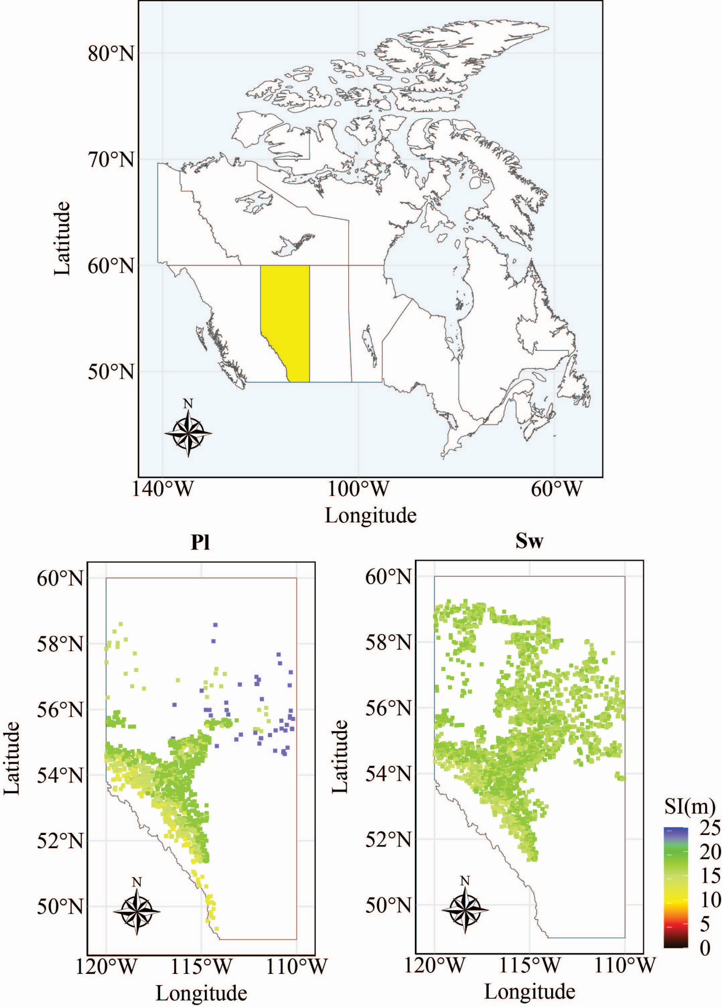
Fig. A1 Maps of Canada showing Alberta in yellow (top), and site index estimates (SI, m) for lodgepole pine (Pl, bottom left) and white spruce (Sw, bottom right) in Alberta based on Derived Ecological Phase (DEP, v2.0) digital map from Alberta government open data Derived Ecosite Phase v2.0 - Open Government (alberta.ca)
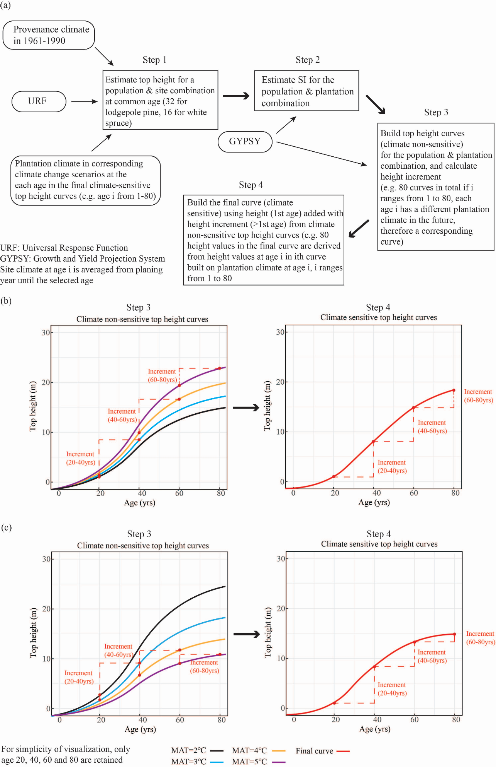
Fig. A2 Flow chart for building a climate-sensitive growth and yield model (a); climate-sensitive and non-sensitive top height curves in the case of increasing top height (b) and decreasing top height (c) under climate change scenarios

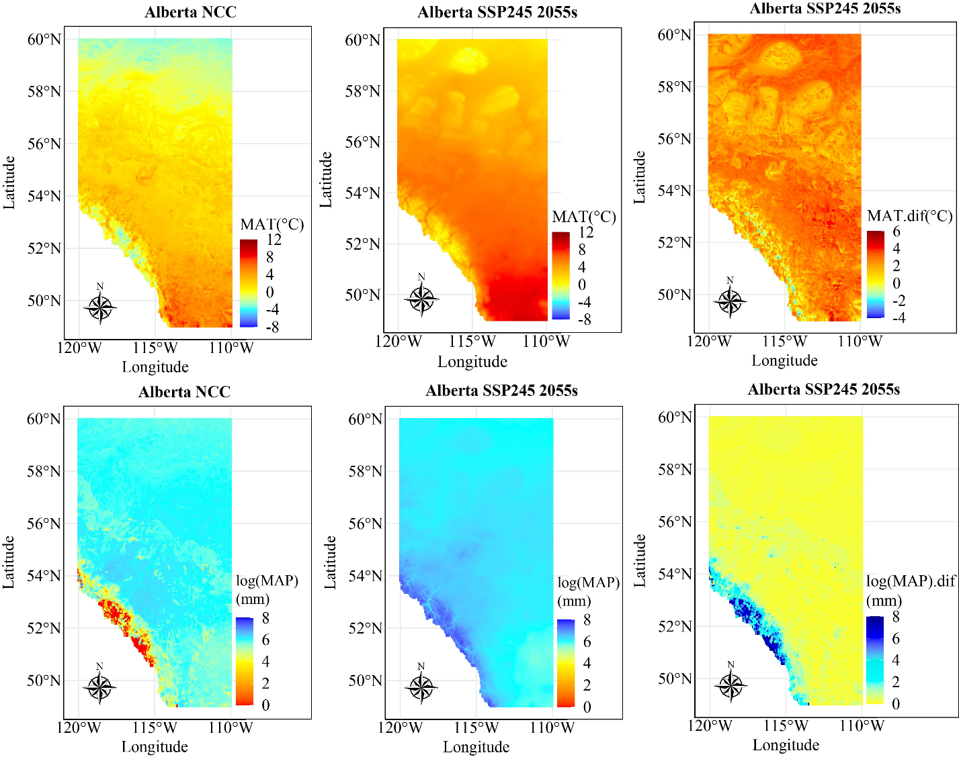
Fig. A3 Mean annual temperature (MAT), log mean annual precipitation (MAP) and their change (dif) in Alberta under no climate change (NCC) and under Shared Socioeconomic Pathway (SSP) 245 in the 2055s (averaged over 2041-2070)

