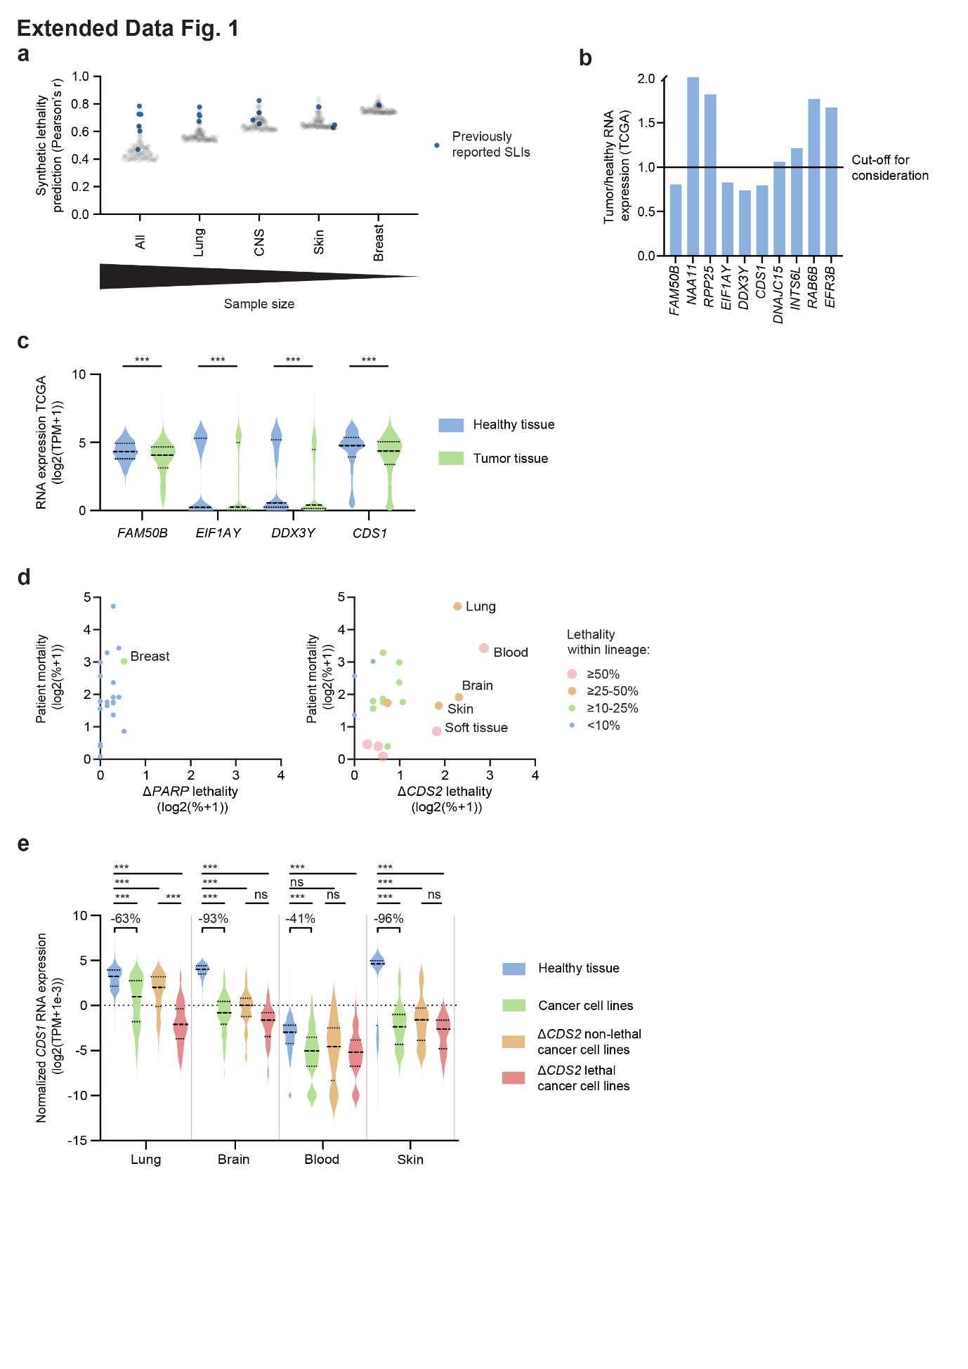
Extended Data Figure 1: Computational analyses identify CDS1-CDS2 as a common and cancer-associated SLI
a) The enrichment of the previously reported synthetic lethal interactions FAM50A-FAM50B, RPP25L-RPP25, EIF1AX-EIF1AY, DDX3X-DDX3Y, DNAJC19-DNAJC15, TTC7A-TTC7B and MCL1-BCL2L1 for different sample sizes. The correlation (Pearson’s r) between RNA and dependency data was calculated using all DepMap cancer cell lines or subsets corresponding to the indicated cancer types. The top 100 pairs were plotted and the data for the abovementioned synthetic lethal pairs is denoted in blue. n (cancer cell lines) = 913 (all), 122 (lung), 70 (CNS), 63 (skin) and 40 (breast).
b) The average fold-change in patient tumor samples compared to patient healthy samples (TCGA) for the anchor genes of the top ten predicted synthetic lethal pairs in Fig. 1c. Note that the y-axis was cut at 2.0. n = 10.005 patient samples (9264 tumor, 741 healthy).
c) The RNA expression in patient tumor samples and patient healthy samples for downregulated anchor genes in panel b (TCGA). The three dotted lines in each violin represent the quartile cut-offs. Kruskal-Wallis test followed up by Dunn’s test was used. n = 10.005 patient samples (9264 tumor, 741 healthy).
d) For each cancer type the relative cancer mortality (SEER) was plotted against the frequency of ΔCDS2 lethal cell lines (DepMap). The fraction of ΔCDS2 or ΔPARP lethal cell lines within each type is categorically depicted. The cut-off for lethality was CERES<-0.5. For each cell line, data for the most essential PARP gene (out of 13) was included in the analysis. n (cancer cell lines) = 906 (40 breast, 122 lung, 97 blood, 92 brain, 64 skin, 45 soft tissue).
e) For the top four lineages from panel d, the calibration gene normalized RNA expression in healthy tissue samples (GTEx), cancer cell lines (DepMap), ΔCDS2 lethal cancer cell lines (DepMap, CERES<-0.5) and ΔCDS2 non-lethal cancer cell lines (DepMap, CERES>-0.5) is presented in violin plots for the CDS1 gene. The percentual change in average TPM between the healthy tissue and cancer cell lines was indicated. The three dotted lines in each violin represent the quartile cut-offs. Kruskal-Wallis test followed up by Dunn’s test was used. n (healthy tissue samples) = 578 (lung), 2642 (brain), 929 (blood), 1809 (skin) and n (cancer cell lines) = 122 (lung, 87 ΔCDS2 non-lethal and 35 ΔCDS2 lethal), 75 (brain, 50 ΔCDS2 non-lethal and 25 ΔCDS2 lethal), 48 (blood, 13 ΔCDS2 non-lethal and 35 ΔCDS2 lethal), 63 (skin, 39 ΔCDS2 non-lethal and 24 ΔCDS2 lethal).

P-values were indicated by * (<0.05), ** (<0.01) and *** (<0.001).
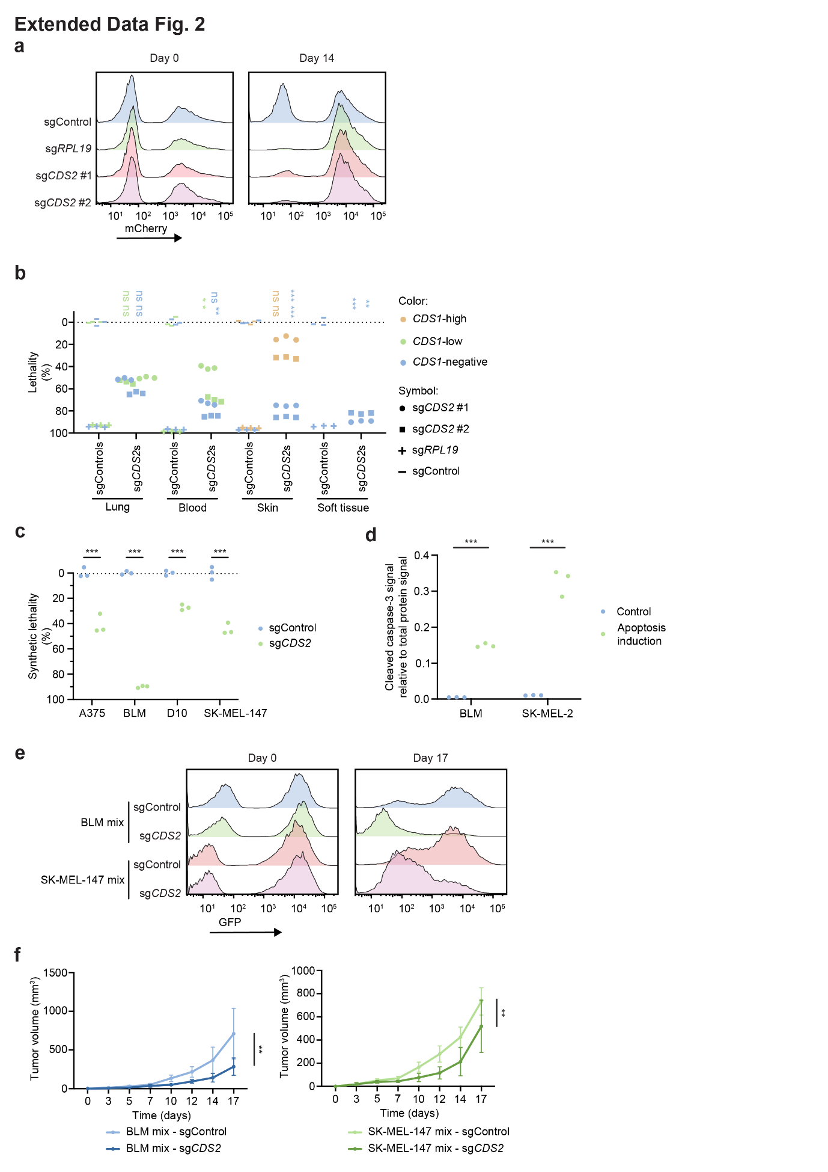

Extended Data Figure 2: CDS1 and CDS2 constitute a synthetic lethal gene pair across cancer types in vitro and in melanoma in vivo
a) As an example, representative histograms for the flow cytometry data used to calculate lethality for NCI-H2030 in Fig. 2d are presented.
b) The 8d results for the experiment in Fig. 2d. Two-way ANOVA followed up by Dunnett’s test was used. n = 3 replicates for 7 cancer cell lines with 2 CDS2 sgRNAs.
c) The 7d results for the experiment Fig. 2f. Two-way ANOVA followed up by Sidak’s test was used. n = 3 replicates for 4 cancer cell lines.
d) Graph depicting a snapshot of the total protein normalized level of cleaved caspase-3 in apoptotic or control samples of BLM and SK-MEL-2 cell lines, as determined by quantitative western blotting (Abby). Two-way ANOVA followed up by Sidak’s test was used. n = 3 replicates for 2 cancer cell lines.
e) Representative histograms for the flow cytometry data used to calculate synthetic lethality in Fig. 2h.
f) Growth curves for the experiment in Fig. 2h. Two-way ANOVA was used. Mean with SD is presented. n = 6 NOD-Scid IL2Rgnull mice per group for 2 cancer cell lines.

P-values were indicated by * (<0.05), ** (<0.01) and *** (<0.001).

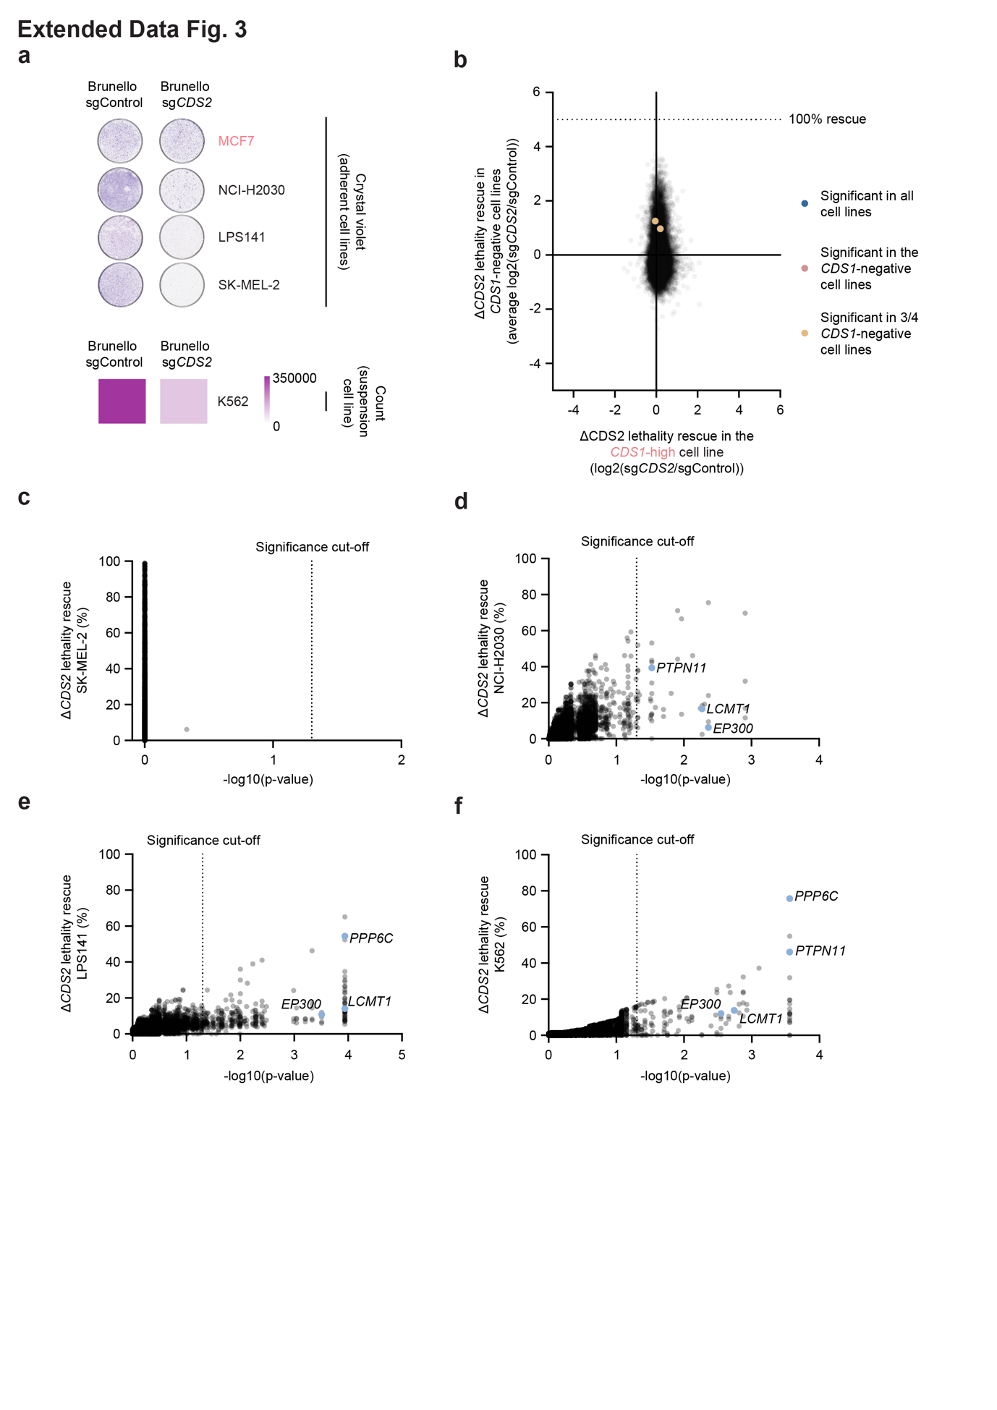

Extended Data Figure 3: No common escape mechanism for ΔCDS2 lethality
a) Top: Colony formation assays with adherent cell lines used for the screen. Crystal violet was used to visualize adherent cells while scans show the results. Bottom: Cell survival assay with the suspension screen cell line. Cell counts were used for quantification and heat maps present the result. n = 1 for 5 cancer cell lines, an independent experiment was performed for quantification (Fig. 3b).
b) The average ΔCDS2 changes for knockouts of each other gene in the four CDS1-negative cancer cell lines were plotted against the ΔCDS2 changes for knockouts of each other gene in the CDS1-high cell line. The second-best sgRNA out of four guides was used to calculate effect size. The dotted line corresponds to the ΔCDS2 change required to compensate for the average lethality quantified in Fig. 3b. n = 1 for 5 cancer cell lines at 200x coverage with 4 sgRNA per gene and 1000 sgControls in the CRISPR library.
c-f) Lethality rescue plotted against the Benjamini-Hochberg corrected p-values from MAGeCK for each gene in the separate screens. The rescue was calculated using average lethality quantified in Fig. 3b. The two genes significant in three cell lines (LCMT1 & EP300) and the two significant genes in two cell lines with the strongest rescue (PPP6C & PTPN11) were marked. Note that outliers above 100% were not plotted. n = 1 for 4 cancer cell lines at 200x coverage with 4 sgRNA per gene and 1000 sgControls in the CRISPR library.

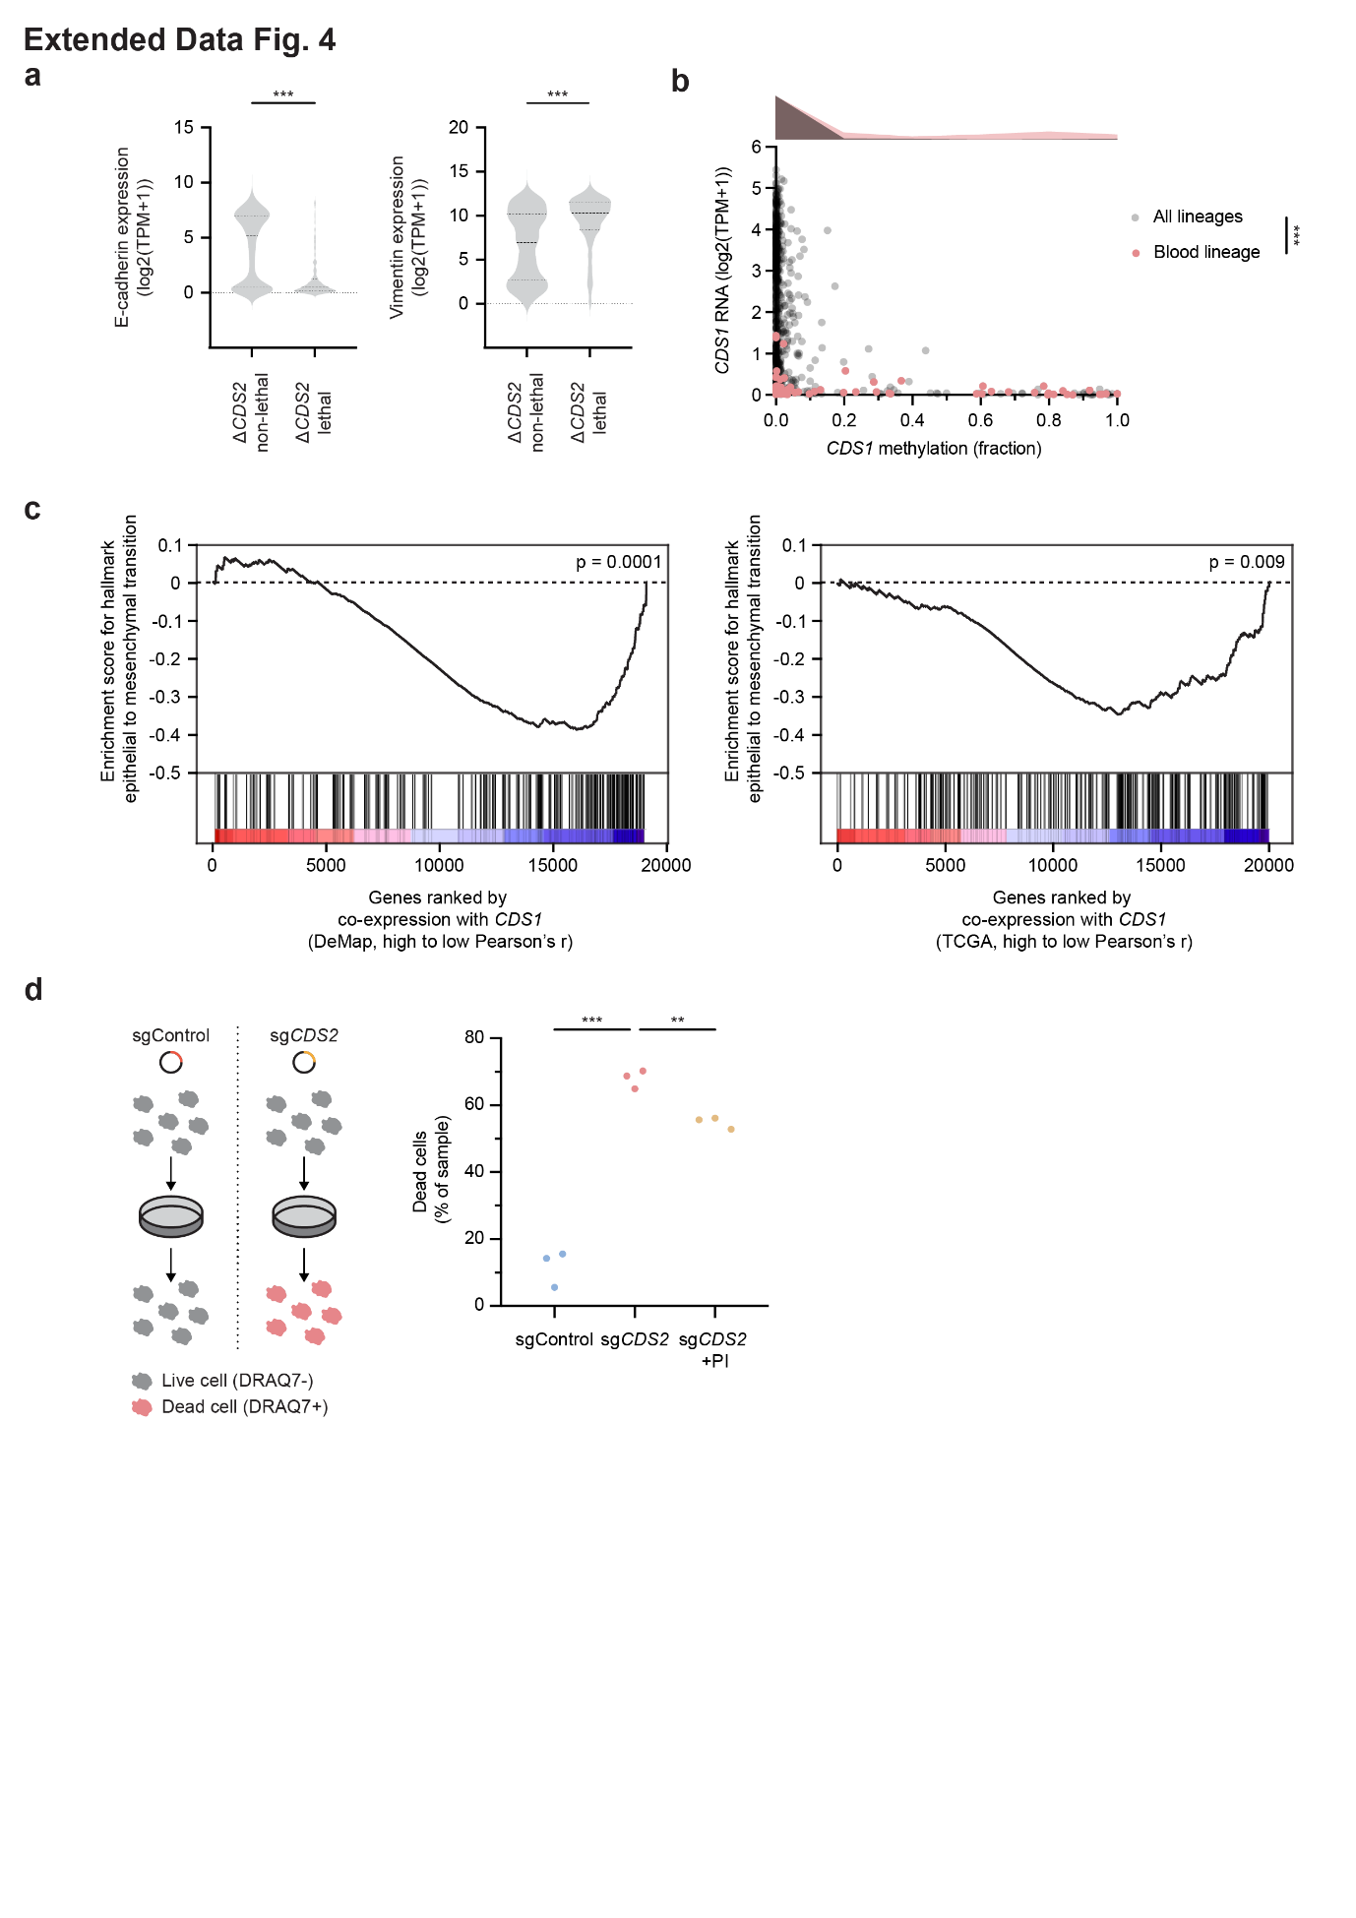

Extended Data Figure 4: Mesenchymal cancers depend on CDS2 for PI synthesis
a) E-cadherin and vimentin expression in ΔCDS2 lethal and ΔCDS2 non-lethal cancer cell lines (DepMap). Mann-Whitney test was used. n = 913 cancer cell lines (657 ΔCDS2 non-lethal and 256 ΔCDS2 lethal).
b) CDS1 promoter methylation in cancer cell lines and the subset of blood cancer cell lines (DepMap). Histograms were added to show the distribution of CDS1 promoter methylation. Mann-Whitney test was used. n = 792 cancer cell lines (72 blood cancer cell lines).
c) The gene set enrichment analysis (GSEA) results for Hallmark epithelial to mesenchymal transition. Results are from a full hallmark GSEA run on genome-wide CDS1 co-expression (Pearson’s r) utilizing DepMap and TCGA data. The Benjamini-Hochberg corrected GSEA associated p-values were used. n = 913 cancer cell lines and 11069 patient samples.
d) Left: diagram depicting method for quantifying the dead cell fraction using the DNA-intercalating dye DRAQ7. Right: rescue of ΔCDS2 cell death upon supplementation with phosphatidylinositol (PI) in cultured BLM cells. One-way ANOVA followed up by Sidak’s test was used. n = 3 replicates for 1 cancer cell line.

P-values were indicated by * (<0.05), ** (<0.01) and *** (<0.001).

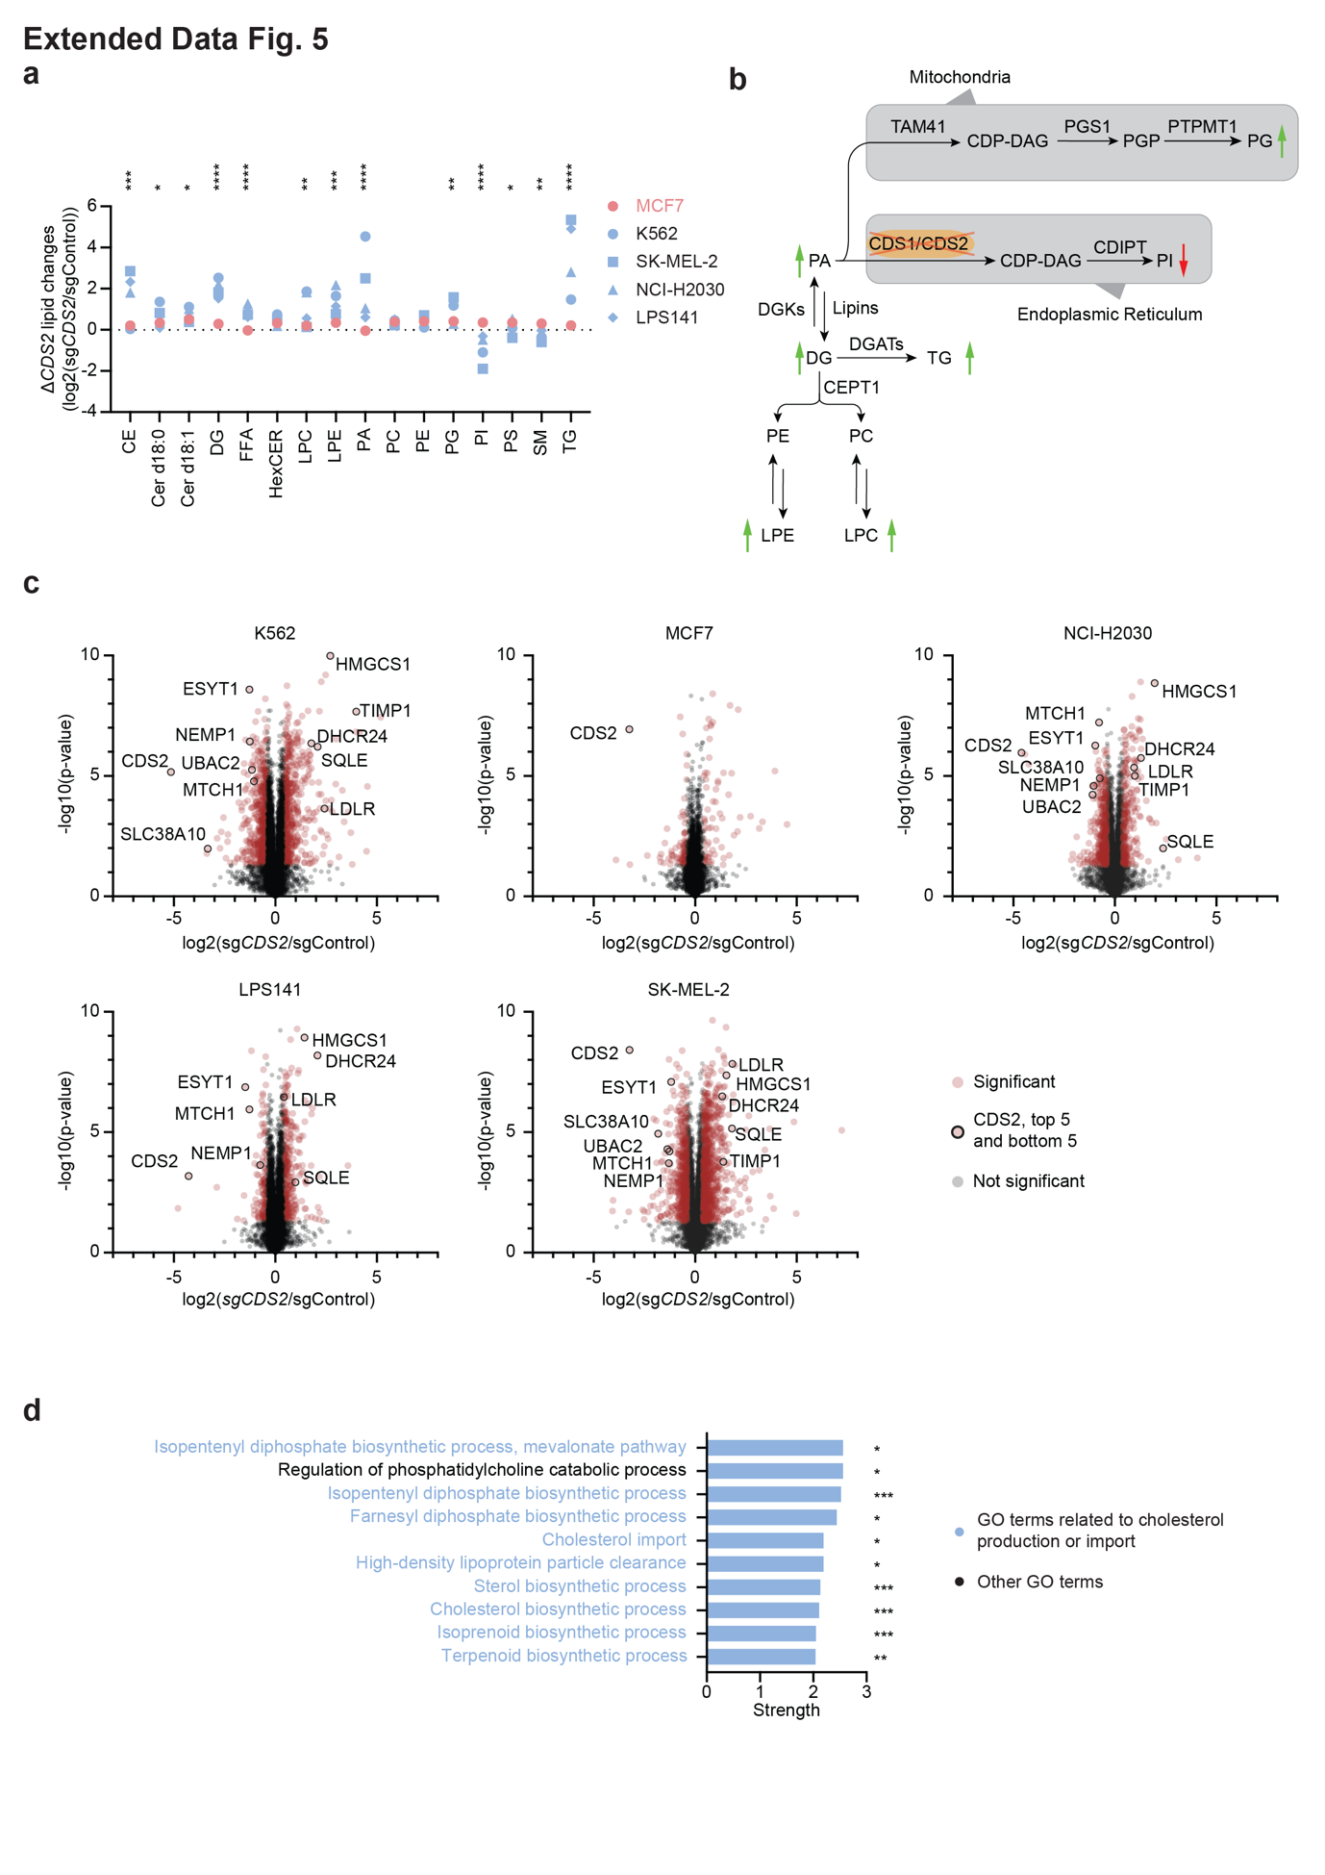

Extended Data Figure 5: Expression of either CDS1 or CDS2 is required for lipid homeostasis
a) ΔCDS2 lipid changes, presented in alphabetic order. Only lipid classes detected in all samples were plotted. Stars indicate number of CDS1-negative cancer cell lines with at least two-star significant lipid alterations compared to the CDS1-high cancer cell line. For abbreviations see bottom of figure description. Two-way ANOVA followed up by Sidak’s test was used. n = 4 replicates for 5 cancer cell lines.
b) CDS2 pathway with ΔCDS2-changed lipid classes in CDS1-negative cancer cell lines marked with arrows. For abbreviations see bottom of figure description. Included enzymes are annotated on UniProt.
c) Volcano plots presenting the ΔCDS2-induced protein changes in five cancer cell lines. In addition to CDS2, the top and bottom five proteins significant in at least 3/4 CDS1-negative cancer cell lines were marked. n = 4 replicates for 5 cancer cell lines.
d) The top ten significantly enriched GO-terms among ΔCDS2-changed proteins in the four CDS1-negative cancer cell lines. Benjamini-Hochberg p-values from Stringdb were used. n = 4 replicates for 4 cancer cell lines.

(b) Significance was indicated by one * for each cell line with p-value<0.01 (d) P-values were indicated by * (<0.05), ** (<0.01) and *** (<0.001).

Lipids: CE = cholesterol esters, Cerd18:0 = ceramide d18:0, Cerd18:1 = ceramide d18:1, DG = diacylglycerol, FFA = free fatty acids, HexCER = hexocylceramides, LPC = lysophosphatidylcholine, LPE = lysophosphatidylethanolamine, PA = phosphatidic acid, PC = phosphatidylcholine, PE = phosphatidylethanolamine, PG = phosphatidylglycerol, PI = phosphatidylinositol, PS = phosphatidylserine, SM = sphingomyelin, TG = triglycerides
Enzymes: PEMT = phosphatidylethanolamine n-methyltransferase, CEPT1 = choline/ethanolamine phosphotransferase 1, DGATs = diacylglycerol o-acyltransferases, DGKs = diacylglycerol kinases, CDS = cytidine diphosphate diacylglycerol synthase, TAM41 = mitochondrial phosphatidate cytidylyltransferase, CDIPT = cytidine diphosphate diacylglycerol synthase inositol-3-phosphatidyltransferase, PGS1 = phosphatidylglycerophosphate synthase 1, PTPMT1 = protein tyrosine phosphatase mitochondrial 1

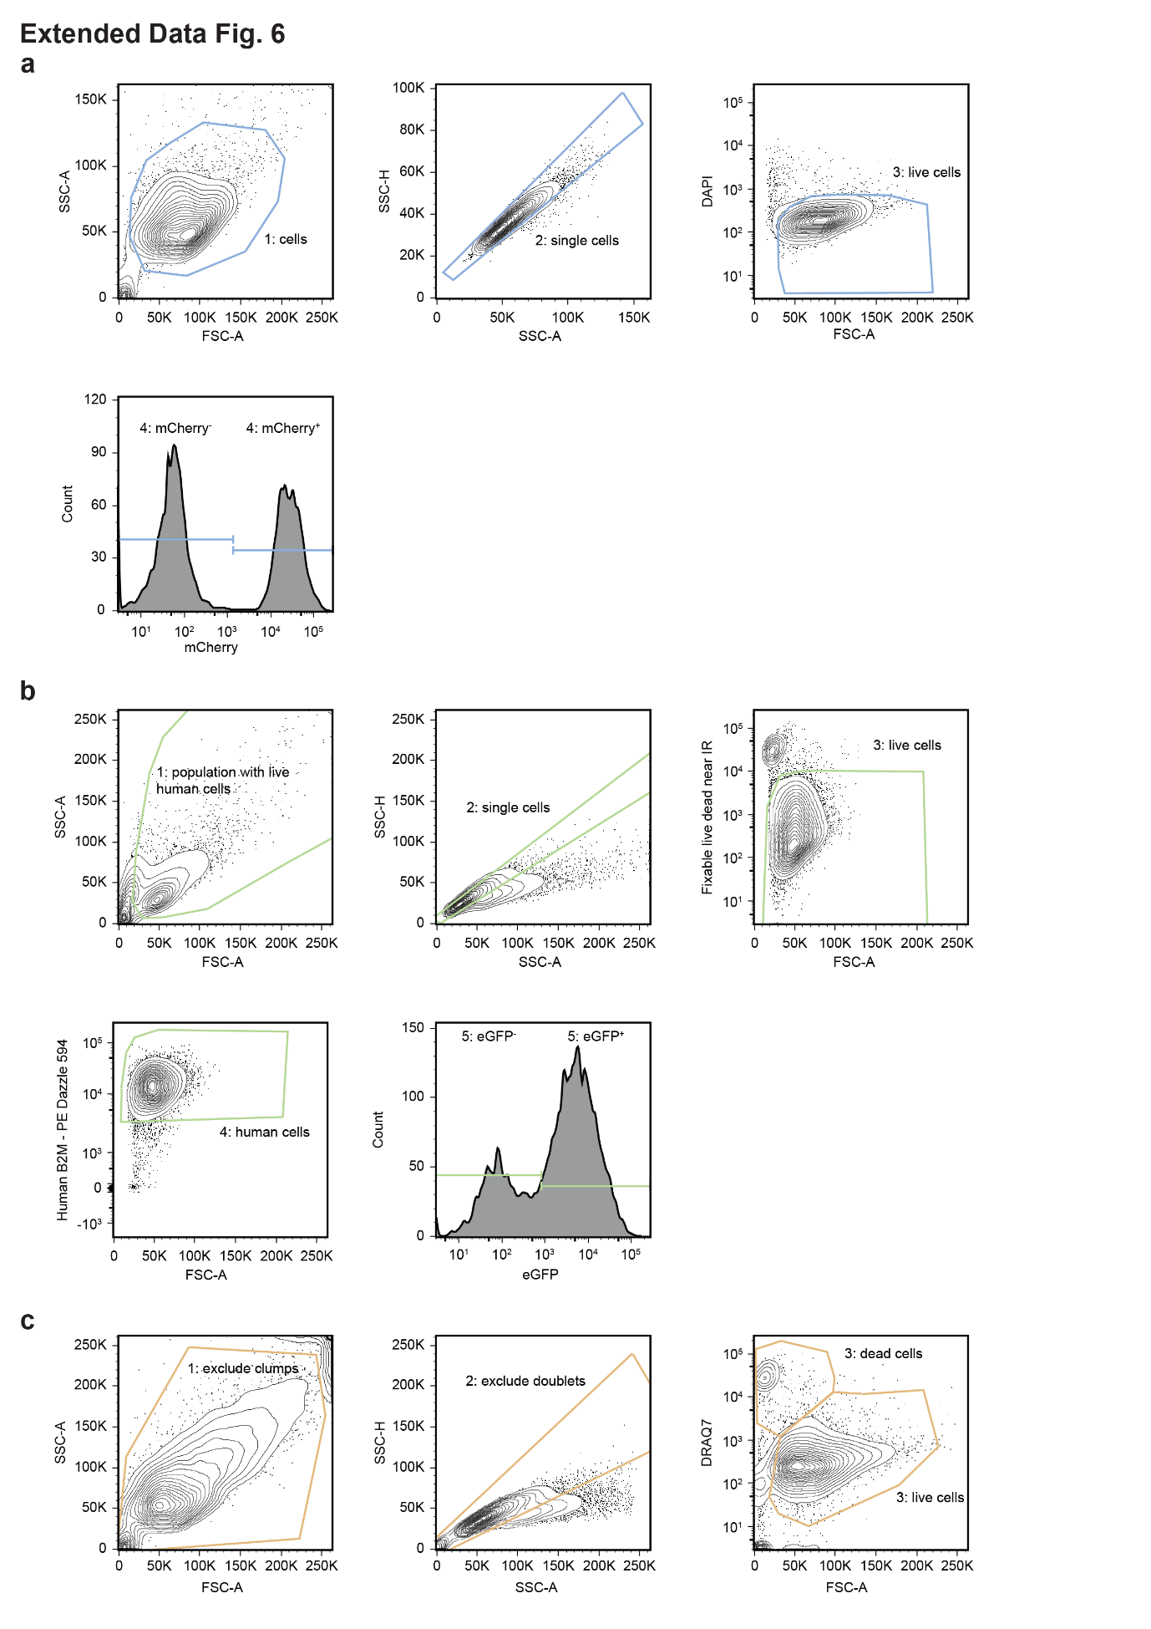

Extended Data Figure 6: Gating strategies
a) The gating strategy for in vitro GFP or mCherry mixing experiments.
b) The gating strategy for the in vivo mixing experiment.
c) The gating strategy for dead cell quantification.

