SUPPLEMENTARY MATERIAL

- Kaplan-Meier curve for the whole patient population

- Texture features summary

mean_0 | sd_0 | entropy_0 | mpp_0 | skewness_0 | kurtosis_0
Min. : 23.53 | Min. :12.82 | Min. :3.850 | Min. : 27.61 | Min. :-1.5700 | Min. :-0.5700
1st Qu.: 51.46 | 1st Qu.:20.55 | 1st Qu.:4.330 | 1st Qu.: 53.32 | 1st Qu.:-0.6475 | 1st Qu.: 0.1225
Median : 63.59 | Median :25.13 | Median :4.510 | Median : 65.69 | Median :-0.2750 | Median : 0.9300
Mean : 63.17 | Mean :24.94 | Mean :4.497 | Mean : 64.81 | Mean :-0.2917 | Mean : 1.1827
3rd Qu.: 72.59 | 3rd Qu.:27.99 | 3rd Qu.:4.665 | 3rd Qu.: 73.58 | 3rd Qu.: 0.0625 | 3rd Qu.: 1.8450
Max. :107.10 | Max. :51.48 | Max. :5.080 | Max. :107.22 | Max. : 0.8600 | Max. : 5.6400
mean_2 | sd_2 | entropy_2 | mpp_2 | skewness_2 | kurtosis_2
Min. :-5.320 | Min. : 34.05 | Min. :4.670 | Min. : 26.03 | Min. :-0.6600 | Min. :-0.6000
1st Qu.: 2.362 | 1st Qu.: 46.26 | 1st Qu.:5.130 | 1st Qu.: 37.93 | 1st Qu.:-0.0300 | 1st Qu.: 0.1700
Median : 4.385 | Median : 56.85 | Median :5.270 | Median : 47.80 | Median : 0.1150 | Median : 0.6350
Mean : 5.074 | Mean : 59.09 | Mean :5.287 | Mean : 48.83 | Mean : 0.1587 | Mean : 0.8436
3rd Qu.: 6.683 | 3rd Qu.: 68.50 | 3rd Qu.:5.440 | 3rd Qu.: 54.56 | 3rd Qu.: 0.3550 | 3rd Qu.: 1.3450
Max. :30.280 | Max. :118.70 | Max. :5.660 | Max. :102.42 | Max. : 1.4500 | Max. : 4.8900
mean_3 | sd_3 | entropy_3 | mpp_3 | skewness_3 | kurtosis_3
Min. :-6.750 | Min. : 31.46 | Min. :4.730 | Min. : 21.19 | Min. :-0.7800 | Min. :-0.9600
1st Qu.: 2.015 | 1st Qu.: 44.58 | 1st Qu.:5.082 | 1st Qu.: 35.66 | 1st Qu.:-0.1400 | 1st Qu.:-0.0700
Median : 5.365 | Median : 55.01 | Median :5.280 | Median : 44.93 | Median : 0.0600 | Median : 0.2550
Mean : 6.147 | Mean : 57.13 | Mean :5.251 | Mean : 47.68 | Mean : 0.1056 | Mean : 0.5541
3rd Qu.: 9.352 | 3rd Qu.: 65.34 | 3rd Qu.:5.400 | 3rd Qu.: 54.37 | 3rd Qu.: 0.3525 | 3rd Qu.: 0.9750
Max. :36.200 | Max. :117.74 | Max. :5.740 | Max. :109.24 | Max. : 1.6700 | Max. : 4.6000
mean_4 | sd_4 | entropy_4 | mpp_4 | skewness_4 | kurtosis_4
Min. : -8.520 | Min. : 30.32 | Min. :4.560 | Min. : 16.09 | Min. :-0.97000 | Min. :-1.0100
1st Qu.: 2.215 | 1st Qu.: 43.83 | 1st Qu.:5.032 | 1st Qu.: 35.53 | 1st Qu.:-0.21750 | 1st Qu.:-0.2700
Median : 5.395 | Median : 52.27 | Median :5.220 | Median : 43.78 | Median : 0.06000 | Median : 0.1900
Mean : 22.102 | Mean : 55.07 | Mean :5.219 | Mean : 46.06 | Mean : 0.05171 | Mean : 0.3654
3rd Qu.: 9.102 | 3rd Qu.: 62.84 | 3rd Qu.:5.367 | 3rd Qu.: 53.20 | 3rd Qu.: 0.25000 | 3rd Qu.: 0.6675
Max. :1121.000 | Max. :114.37 | Max. :5.760 | Max. :102.54 | Max. : 1.34000 | Max. : 3.8300
mean_6 | sd_6 | entropy_6 | mpp_6 | skewness_6 | kurtosis_6
Min. :-19.600 | Min. : 24.36 | Min. :4.330 | Min. :19.91 | Min. :-1.21000 | Min. :-1.050
1st Qu.: 1.110 | 1st Qu.: 42.09 | 1st Qu.:4.980 | 1st Qu.:33.55 | 1st Qu.:-0.28500 | 1st Qu.:-0.495
Median : 3.905 | Median : 49.56 | Median :5.125 | Median :42.54 | Median : 0.02000 | Median :-0.110
Mean : 5.605 | Mean : 50.82 | Mean :5.133 | Mean :43.44 | Mean : 0.02086 | Mean : 0.112
3rd Qu.: 9.215 | 3rd Qu.: 59.28 | 3rd Qu.:5.338 | 3rd Qu.:51.48 | 3rd Qu.: 0.33250 | 3rd Qu.: 0.465
Max. : 56.050 | Max. :110.61 | Max. :5.730 | Max. :94.65 | Max. : 1.46000 | Max. : 6.380
tumorburden
Min. : 201.2
1st Qu.: 793.5
Median :1258.7
Mean :1699.6
3rd Qu.:2519.1
Max. :6484.5

- LASSO model building

We built a Cox regression model via penalized maximum likelihood. The regularization path was computed using a LASSO penalty (alpha=1) and the regularization parameter lambda which minimizes the standard error was chosen using cross-validation (in our model lambda was fixed at 0.1548007). The plot shows the cross-validation curve, and upper and lower standard deviation curves, as a function of the lambda values used.
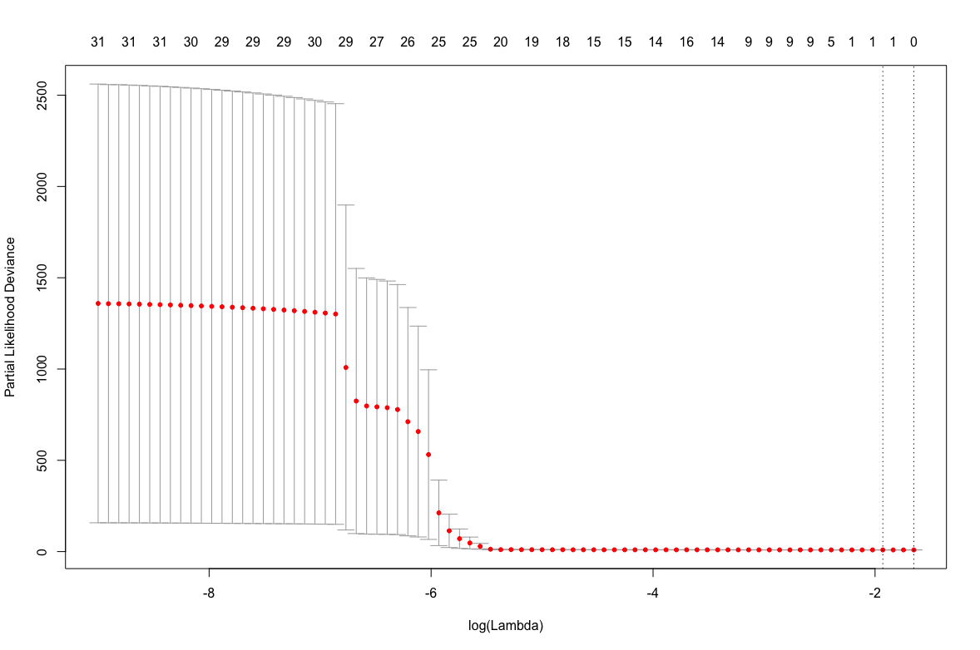

The plot below shows coefficient profile of the coefficient paths.

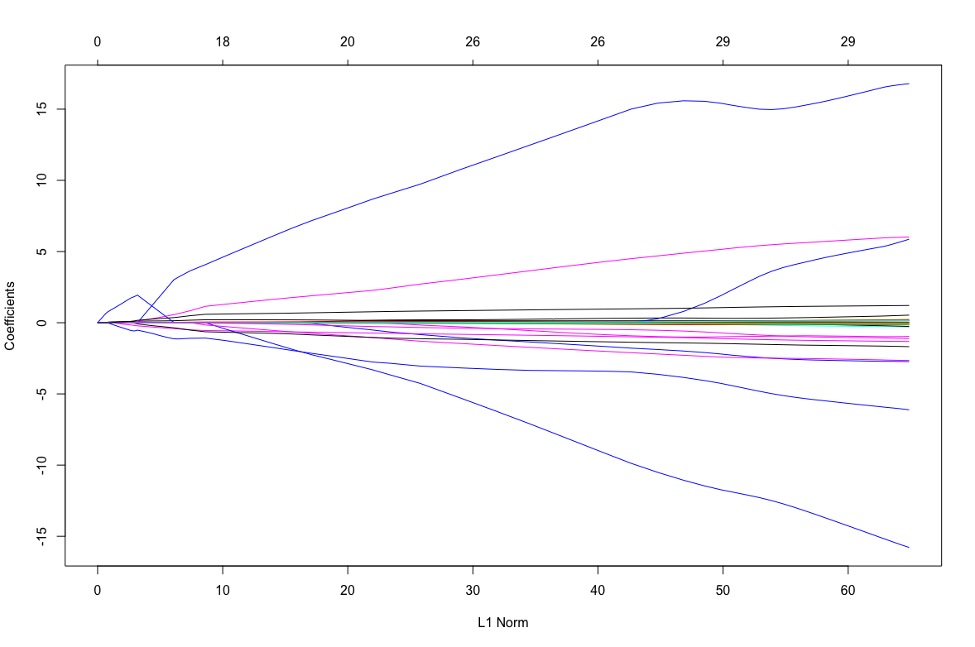
The following figures show the density distribution plot for the radiomic score and the cutoff used to split the population in two different groups.

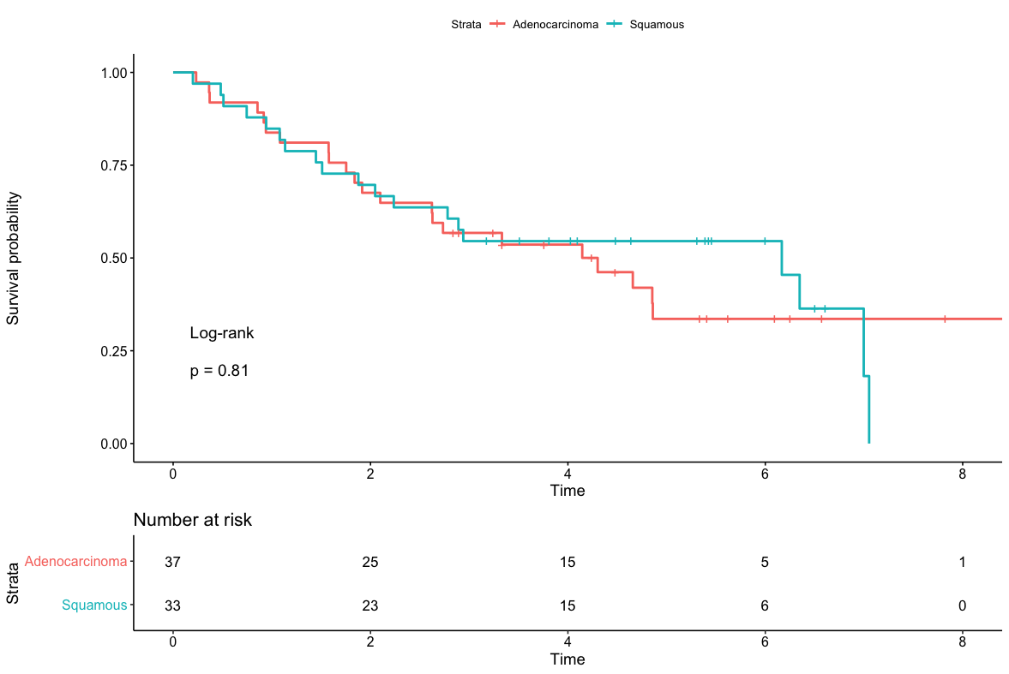

S1: Kaplan-Meier curves according to histotype. Time is expressed in months. The differences in survival between groups was not statistically significant.

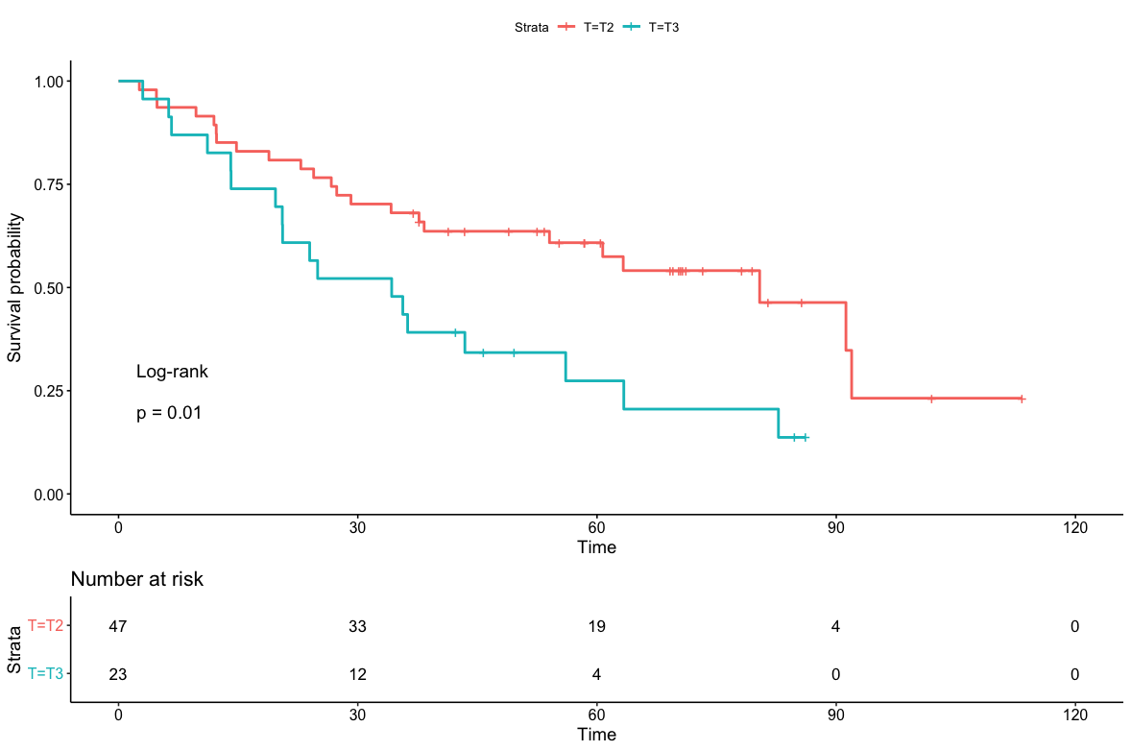
S2: Kaplan-Meier curves according to the T stage according to the 8th edition of the AJCC Cancer Staging Manual. Time is expressed in months. T2 tumors had a significantly longer survival compared to T3 tumors.

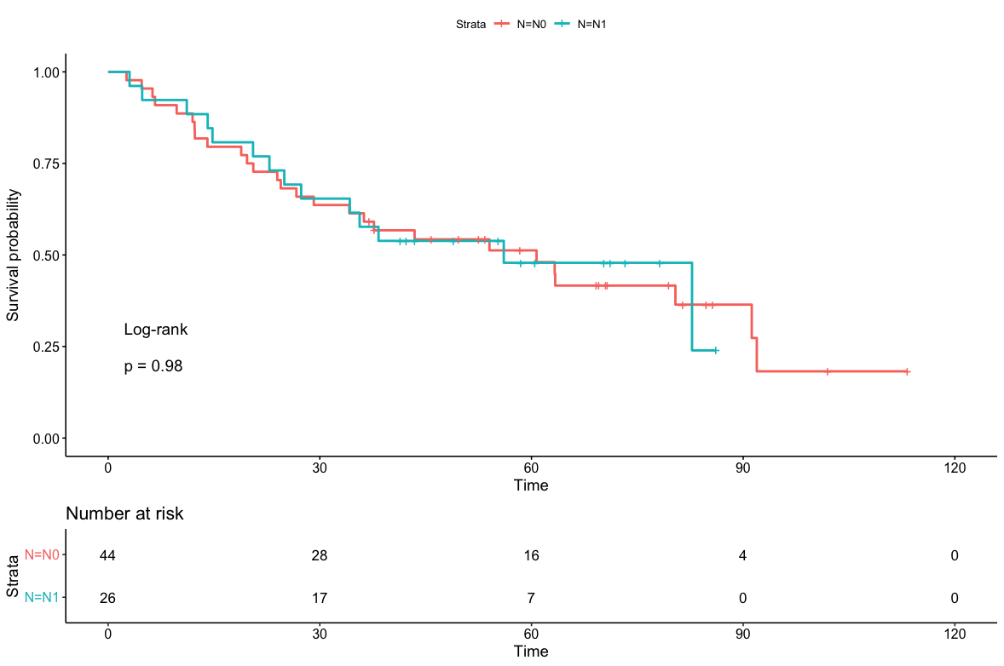
S3: Kaplan-Meier curves according to the N status. Time is expressed in months. The differences in survival between groups was not statistically significant.

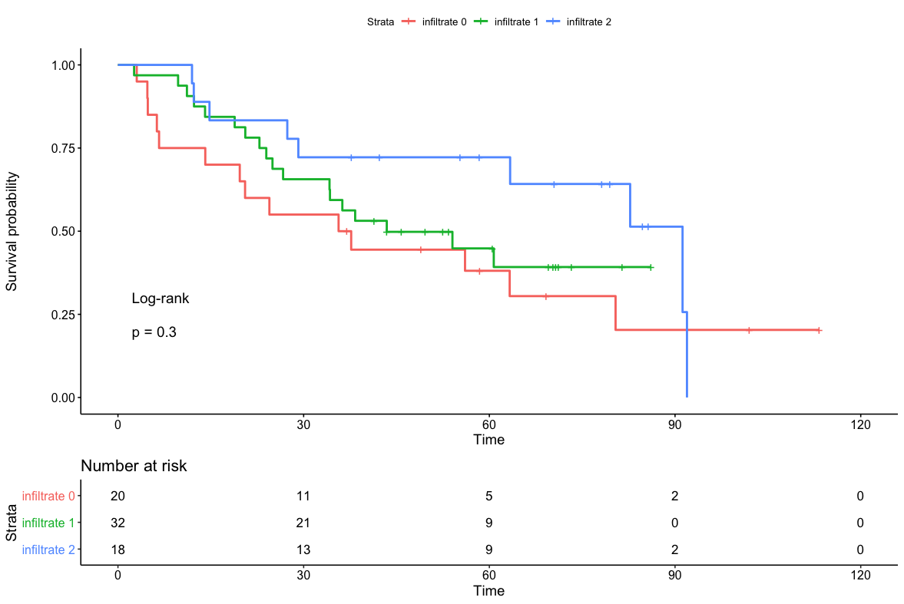
S4: Kaplan-Meier curves according to the degree of intra-tumoral lymphocyte infiltrate. Time is expressed in months. The differences in survival between groups was not statistically significant.

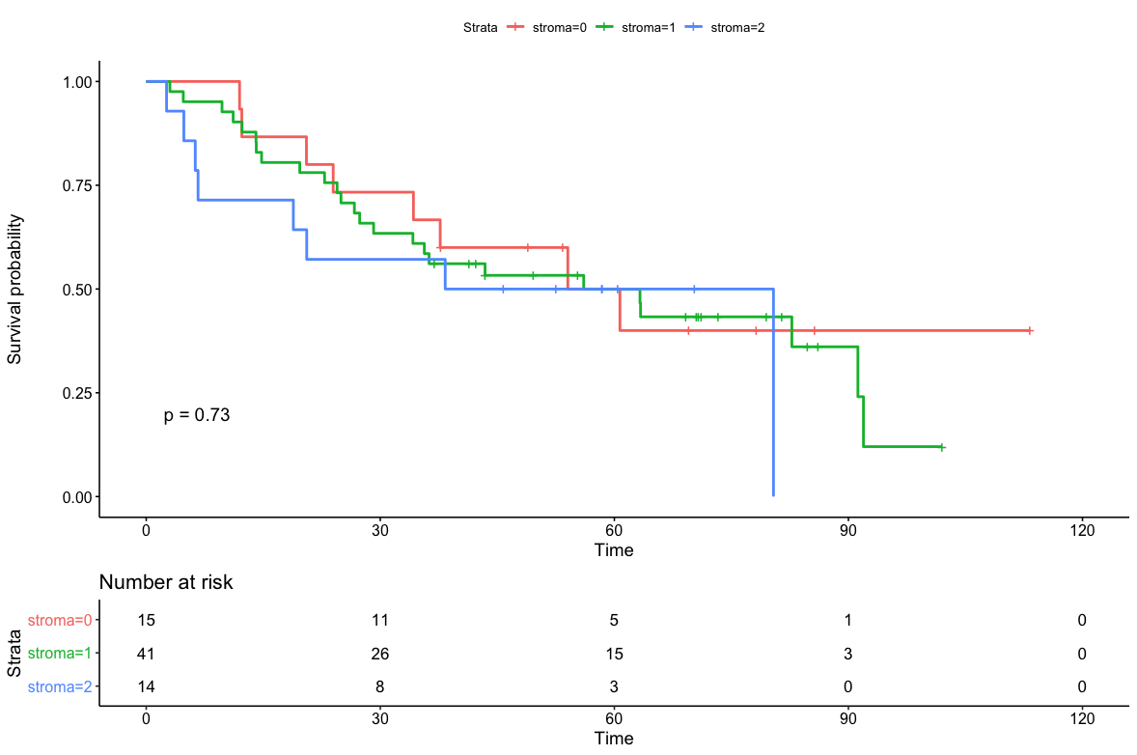
S5: Kaplan-Meier curves according to the degree of intra-tumoral strona. Time is expressed in months. The differences in survival between groups was not statistically significant.

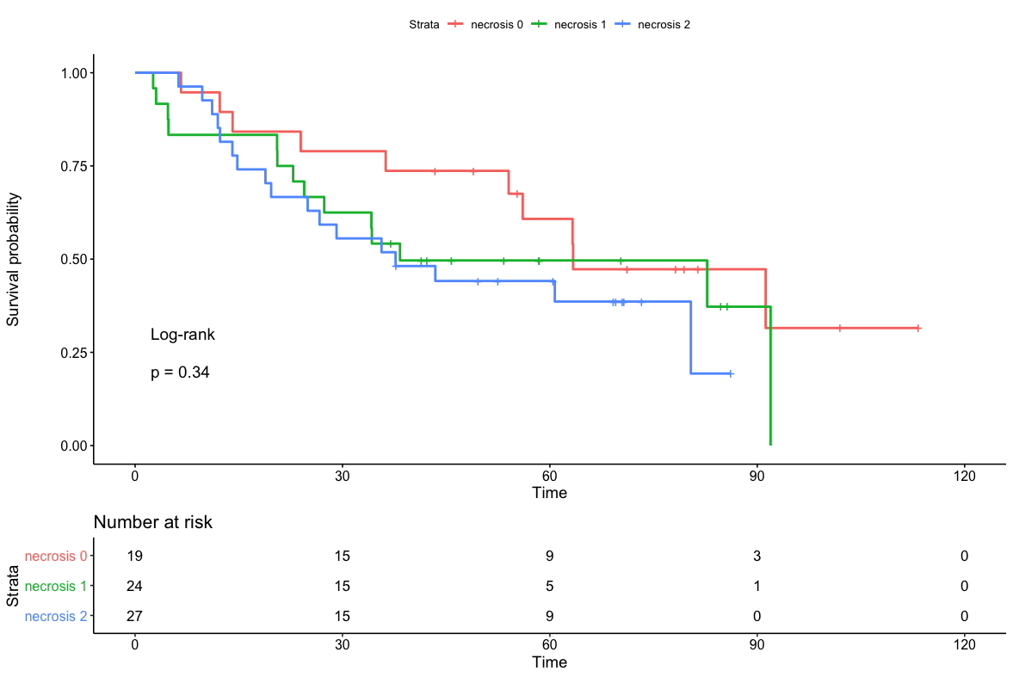
S6: Kaplan-Meier curves according to the degree of intra-tumoral necrosis. Time is expressed in months. The differences in survival between groups was not statistically significant.

