Supplementary Figures

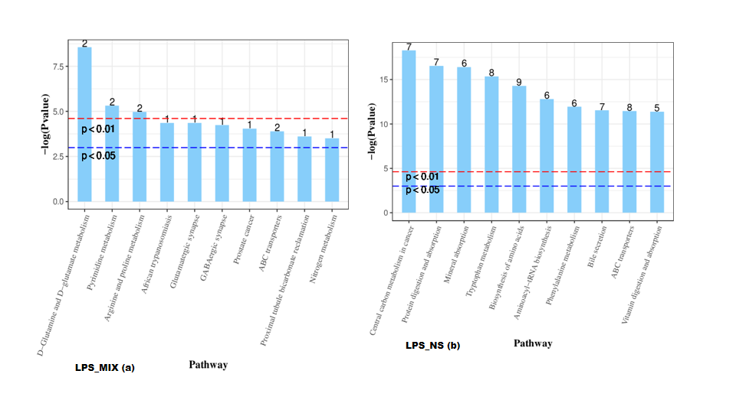
Figure S1(a, b). Pathway enrichment analysis bar chart.

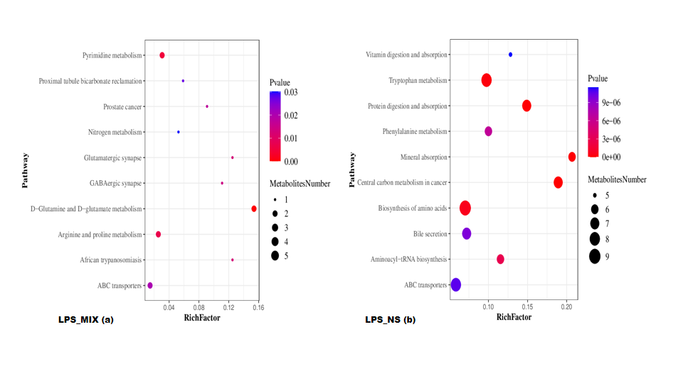
Figure S2(a, b). Metabolic pathway enrichment analysis bubble chart.

