Supplementary Material

Isolation of KH₂PO₄ from crude glycerol purified using Acromonia aculleata charcoal as adsorbent.
Milton de Souza Freitas¹, João Victor Godinho¹, David Lee Nelson¹, Alexandre P. Wentz¹, Claudio Roberto Neri², Lucas D. Zanatta², Fernando L. P. Pessoa³, Sandro L. Barbosa¹*

¹Department of Pharmacy, Universidade Federal dos Vales do Jequitinhonha e Mucuri-UFVJM, Campus JK, Rodovia MGT 367 - Km 583, nº 5.000, Alto da Jacuba, CEP 39100-000, Diamantina/MG, Brazil. e-mail: milton.freitas@ufvjm.edu.br (M.S.F.); sousa.joao@ufvjm.edu.br (J.V.S.); dleenelson@gmail.com (D.L.N.); wentzap@hotmail.com (A.P.W.); sandro.barbosa@ufvjm.edu (S.L.B.).
²Departamento de Química da Faculdade de Filosofia, Ciências e Letras de Ribeirão Preto da Universidade de São Paulo, Av. Bandeirantes 3900, Monte Alegre, CEP 14040-901, Ribeirão Preto/SP, Brazil. e-mail: crneri@usp.br (C.R.N.); lucaszanatta@alumni.usp.br (L.D.Z.).
³Centro Universitário SENAI-CIMATEC, Av. Orlando Gomes, 1845, Piatã, Salvador 41650-010, Brazil; fernando.pessoa@fieb.org.br (F.L.P.P.)

*Corresponding author. Tel.: +55-38-35321234; fax: +55-38-35321234; e-mail: sandro.barbosa@ufvjm.edu.br
_____________________________________________________________________________________
Abstract: Activated charcoal was prepared from Acrocomia aculeata (macaúba) endocarp by ZnCl₂ activation. The charcoal was used for the adsorptive purification of pretreated crude glycerol (CG) and potassium dihydrogen phosphate (KH₂PO₄ or KDP) was formed by the addition of H₃PO₄ to the crude glycerol containing KOH, which was used as catalyst in the production of biodiesel and glycerol. The KH₂PO₄ was isolated and purified by recrystallization from aqueous solution. The KH₂PO₄ was characterized by X-Ray diffraction (XRD), thermal analysis (TGA/DTA) and spectrophotometry in the infrared region – FTIR. From 216.0 m of crude glycerol, 20.1038 g of purified KH₂PO₄ was obtained.

Keywords: Environmentally friendly processes; potassium dihydrogen phosphate; waste management; crystallization process, glycerol, fatty acid methyl ester.
_____________________________________________________________________________________

Copies of EDXRF of the KH₂PO₄.
- Commercial standard KH₂PO₄
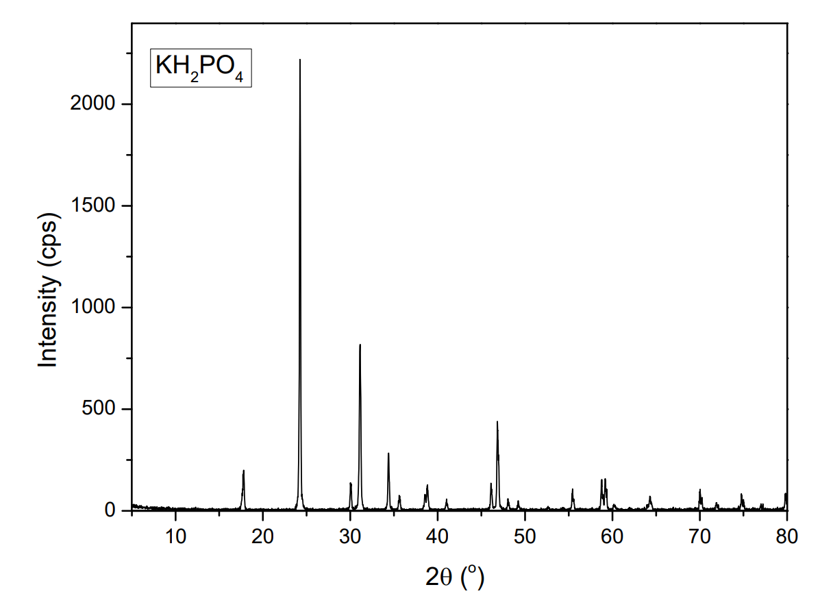
Figure S1. XRD patterns of commercial standard KH₂PO₄.

- Sample 1 KH₂PO₄
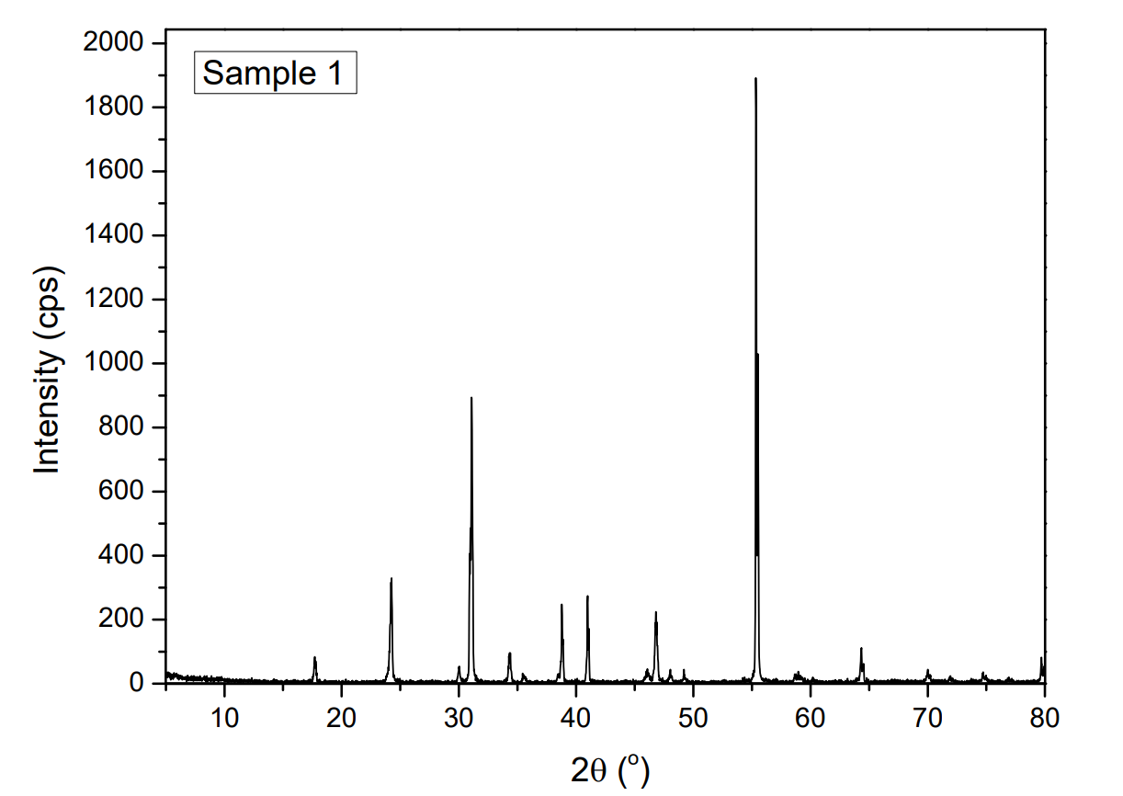
Figure S2. XRD patterns of KH₂PO₄ (prepared dry solid samples).

- Sample 2 KH₂PO₄
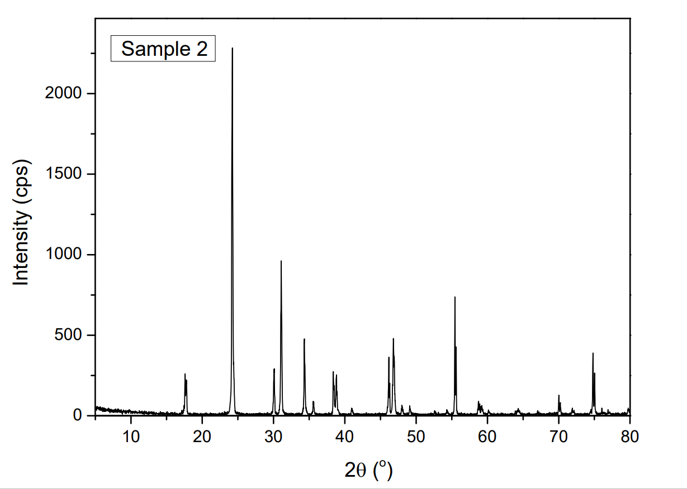
Figure S3. XRD patterns of KH₂PO₄ (prepared dry solid samples).

- Sample 3 KH₂PO₄
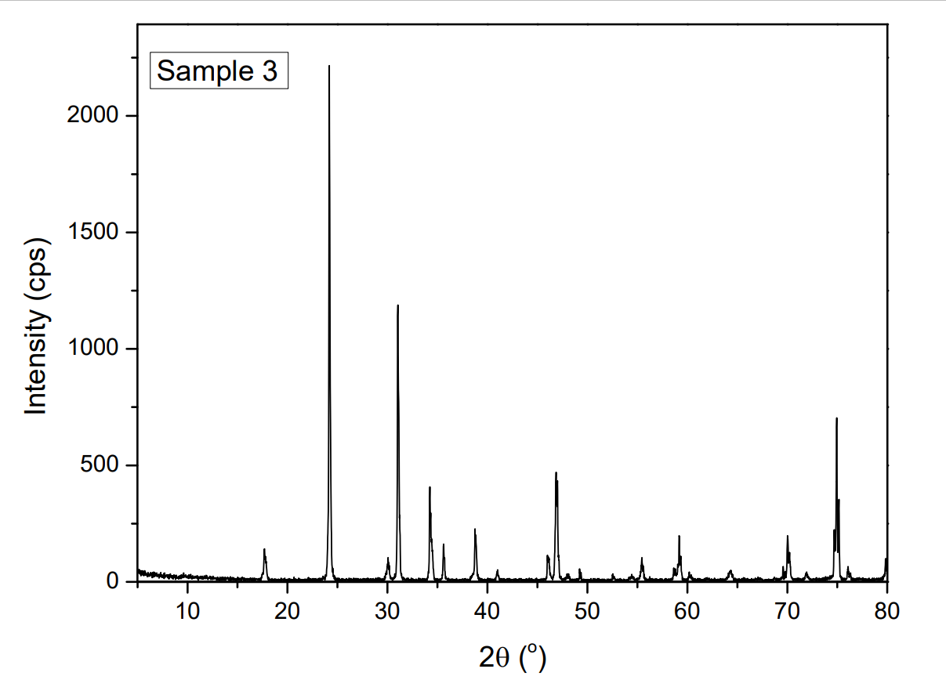
Figure S4. XRD patterns of KH₂PO₄ (prepared dry solid samples).

- Sample 4 of KH₂PO₄
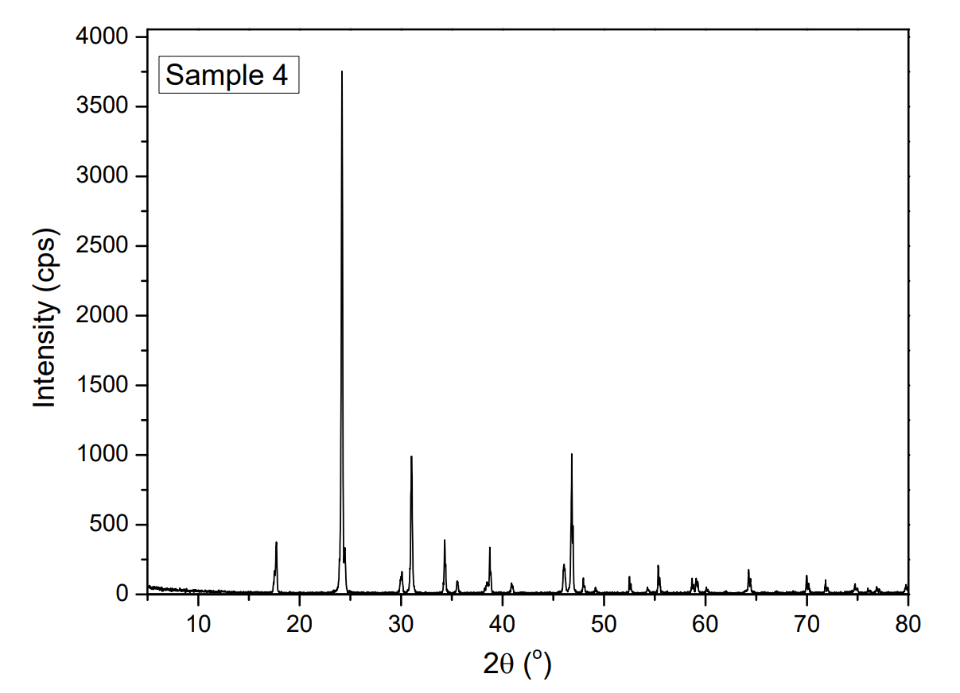
Figure S5. XRD patterns of KH₂PO₄ (prepared dry solid samples).

Copies of IV spectra for KH₂PO₄.
- Commercial standard KH₂PO₄.
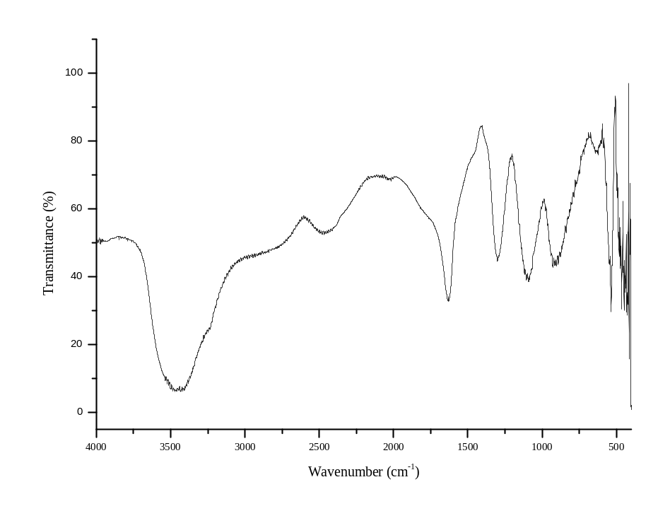
Figure S6. FTIR on KBr pellet of the commercial standard of KH₂PO₄.
- Sample 1 KH₂PO₄.
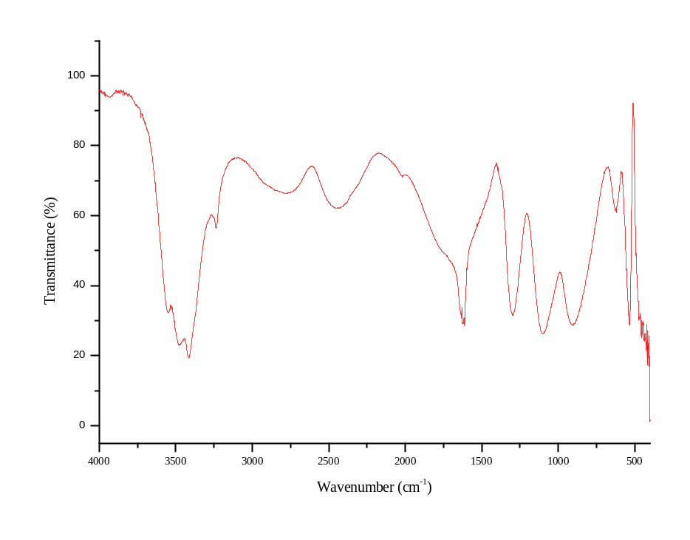
Figure S7. FTIR on KBr pellet of the samples 1 of KH₂PO₄.

- Sample 2 KH₂PO₄.
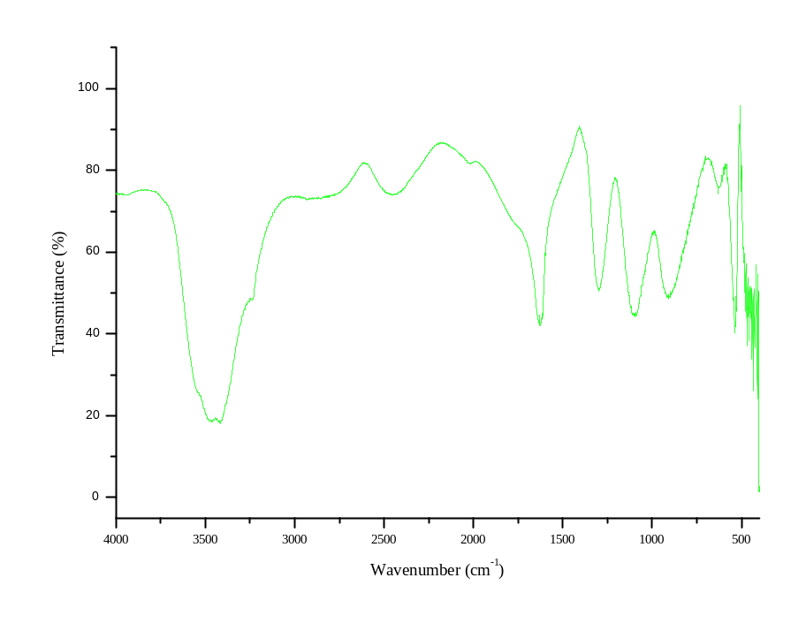
Figure S8. FTIR on KBr pellet of the samples 2 of KH₂PO₄.
- Sample 3 KH₂PO₄.
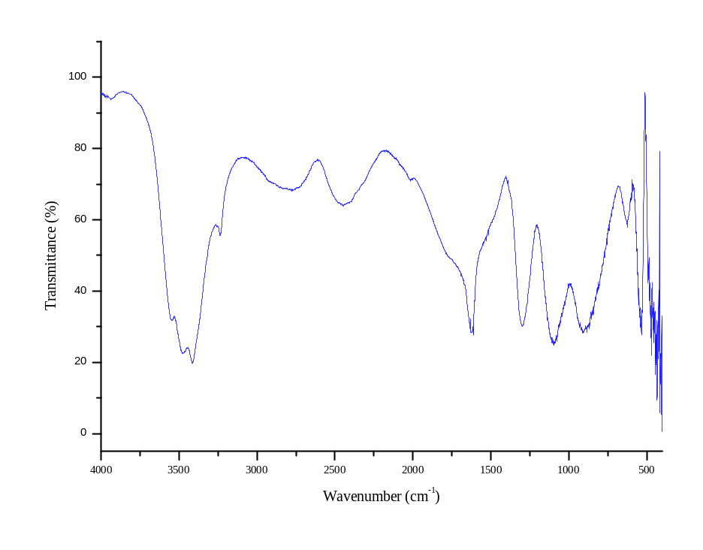
Figure S9. FTIR on KBr pellet of the sample 3 of KH₂PO₄.

- Sample 4 KH₂PO₄.
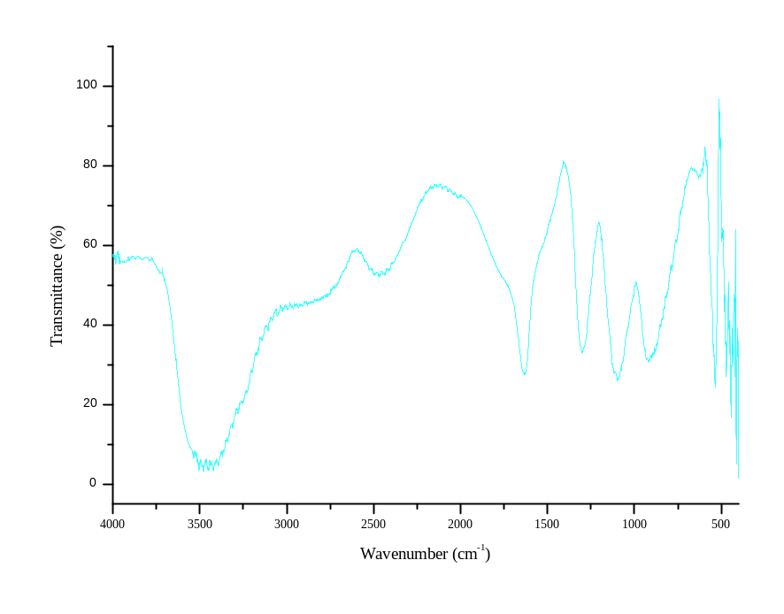
Figure S10. FTIR on KBr pellet of the sample 4 of KH₂PO₄.

