Setting the environmental performance threshold for diverting residual streams towards bioeconomy strategies
Supporting information document

U. Javourez¹, S.K. Karan^{1,2}, L. Hamelin^{1,*}

¹TBI, Université de Toulouse, CNRS, INRAE, INSA, Toulouse, France
² Department of Geomatics, Norwegian Institute of Bioeconomy Research, Ås, Norway
* Corresponding author: hamelin@insa-toulouse.fr

This document gathers additional information to support the analysis presented in the main manuscript. It is accompanied by a set of background calculation and modeling details available in a data repository and further described:
The dataset “Cambioscop RO1” is available at DOI: 10.17632/b9sx3h3584 and includes the following files:
- SI.1.Characterization: Description of the composition of the different residual streams.
- SI.2.Current_uses: Information on the current usage of residual biomasses in France.
- SI.3.Spatial_quantification: Generated amount and spatial quantification of the selected residual streams for France (include background data for Figure 3 of the main manuscript).
  - The document is accompanied by background data and calculation for each stream:
  - SI.3.Crop_residues
  - SI.3.Green_residues
  - SI.3.Household_biowaste
  - SI.3.Manure_generation
  - SI.3.Pruning_residues
  - SI.3.Sludge
  - SI.3.Potential_tot (background data for Table 1 of the main manuscript).
- SI.4.LCI: Details the life cycle inventories (LCI) of current residual biomass management pathways (including process flows diagrams, technological parameters, background processes selected, etc.) as well as the modeling of marginal suppliers of electricity, heat and fertilizing services for the French context.
  - The document is accompanied by the parametric LCI models (excel spreadsheets) for each pathway (gathered under umbrella categories).
  - SI.4.AD_module (anaerobic digestion LCI)
  - SI.4.Combust_module (open-air burning, incineration and domestic furnace LCIs)
  - SI.4.Compost module (industrial and open-air composting LCIs)
  - SI.4.Land_module (decay, spreading, aerobic treatment LCIs)
  - SI.4.Context_modeling (electricity, heat, fertilizing services marginal suppliers LCAs)
- SI.5.Unitary_LCA_results: Individual Monte Carlo simulations performed for each reported (pathway; feedstock) combination. Includes statistical analysis and background data for Table 2 and 3 of the main manuscript.
- SI.6.Scaled_LCA_model: Consolidated model to estimate the residual biomass baseline performance as well as its variance (use precalculated LCA results from previous sheets). Includes background data for the Figure 2 of the main manuscript.
- SI.6.Scaled_LCA_results: Monte Carlo simulations performed on the “Scaled_LCA_model”: background data for Figure 1 of the main manuscript

First, the attributes for direct quantification of selected residual resources are displayed in Table S1. Then, the current uses of residual streams in France are represented in different units (Figures S1-S3) to complement the Figure 2 of the main manuscript. Then, Figure S4-S6 illustrates the main variables used to establish the French residual biomass baseline (visual representation of SI.5.Unitary_LCA_results document). Then, the influence of crop residues accounting in agronomy practices on their environmental performances is quantified (Figure S7). Then, results are compared to two benchmarked of previous studies (Tables S2-S3). Finally, the estimation of household organic waste production stage impacts is elaborated.
Table S1 – Attributes for estimation or direct quantification of different residual resources.
Streams | Sub-Streams | Spatial Scale / Resolution | Data Sources and details | Additional Details
Primary Forestry Residues |  | 10 meters (Further aggregated to NUTS-1¹, and NUTS-3 scale). | Forest Inventory Statistics: (ADEME, 2019)  Forest area map (Raster data): (IGN, 2018)  Factor of basic wood density and biomass expansion factor: (IPCC, 2003) | Estimated. Detailed estimation methodology and uncertainty assessment available at: (Karan and Hamelin, 2020)
Agricultural Residues | Crop Residues | NUTS-3 and aggregated to NUTS-1, and the national level. | Data on crop production and surface area: Agreste Link (Agreste, 2020a)  Annual data on crop production and surface area available from 2000 to 2019. | Estimated. Additional details on estimation methods available at: (Karan and Hamelin, 2021)
Agricultural Residues | Pruning Residues | NUTS-3 and aggregated to NUTS-1, and the national level. | Data on production and surface area for orchards: Agreste Link (Agreste, 2020b)  Data on production and surface area for viticulture: Agreste Link (Agreste, 2020c) | Estimated. Data on surface area and production from orchards and viticulture is available at the NUTS-3 scale.  Annual data available from 2000 – 2019.
Agricultural Residues | Manure and slurry | NUTS-3 and aggregated to NUTS-1, and the national level except for the poultry category where data was only available at NUTS-1 level. | Data on number of heads of bovine and swine: Agreste Link (Agreste, 2020d)  Data on number of heads of poultry: Agreste Link (Agreste, 2020e) | Estimated. Data on number of heads of bovine and swine productions available from 2000 – 2019 at the NUTS-3 scale.  Data on number of heads of poultry available at the NUTS-1 scale.
Green/Garden Waste |  | NUTS-3 and aggregated to NUTS-1, and the national level. | Data on quantity of Green/Garden waste collection: SINOE Link (ADEME, 2023) | Quantified. As per SINOE, Green waste includes pruning waste and waste from the maintenance of parks and gardens.
Sewage Sludge |  | NUTS-3 and aggregated to NUTS-1, and the national level. | Data on quantity of sewage sludge generated: Link (Ministère de la Transition écologique et solidaire, 2023) | Quantified. Data on production of sewage sludge is at the NUTS-3 scale for the year 2016, which is the most recent, complete and comprehensive in terms of disposal routes.
Waste | Household Organic Waste | Commune (French administrative division), NUTS-3 and aggregated to NUTS-1, and the national level. | Data on quantity of Household bio waste collection: SINOE Link (ADEME, 2023)  Personal communication with regional waste observatories*
Waste | Agro-Industrial Waste | NUTS-3 and aggregated to NUTS-1, and the national level. | Data on quantity of industrial waste generated: Link (BRGM, 2020)  Personal communication with regional waste observatory⁺ | Quantified. Data from BRGM is available at the level of an industrial unit. The data used in the present study is from 2018, which is the most recent complete dataset.
¹ For France, NUTS-1 and NUTS-3 correspond to the Regional and Departmental administrative levels (Eurostat, 2020). * Raw data from some regions can’t be shared. ⁺ Locational details of the industries can’t be shared.

Figure S1 – Current uses of reported residual biomass streams in France, expressed in Mtonnes dry matter per year
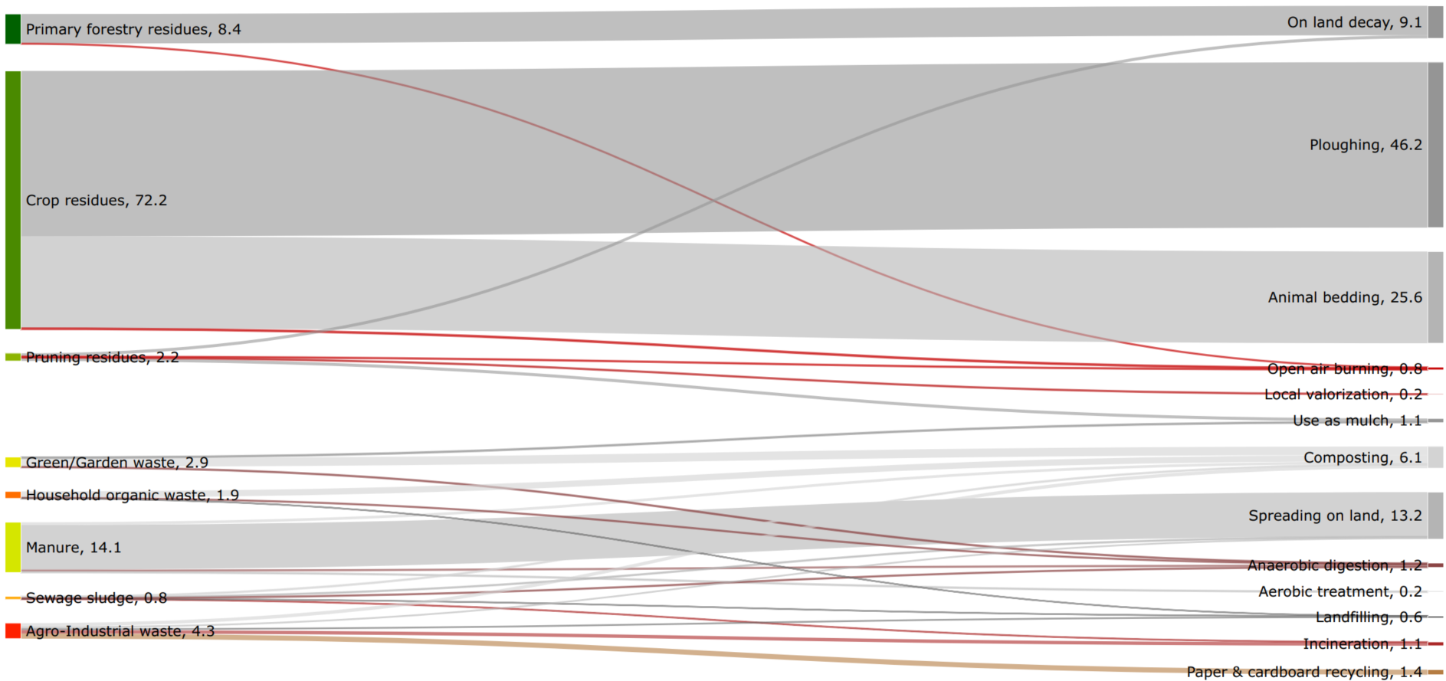

Figure S2 – Current uses of reported residual biomass streams in France, expressed in Mtonnes wet weight per year
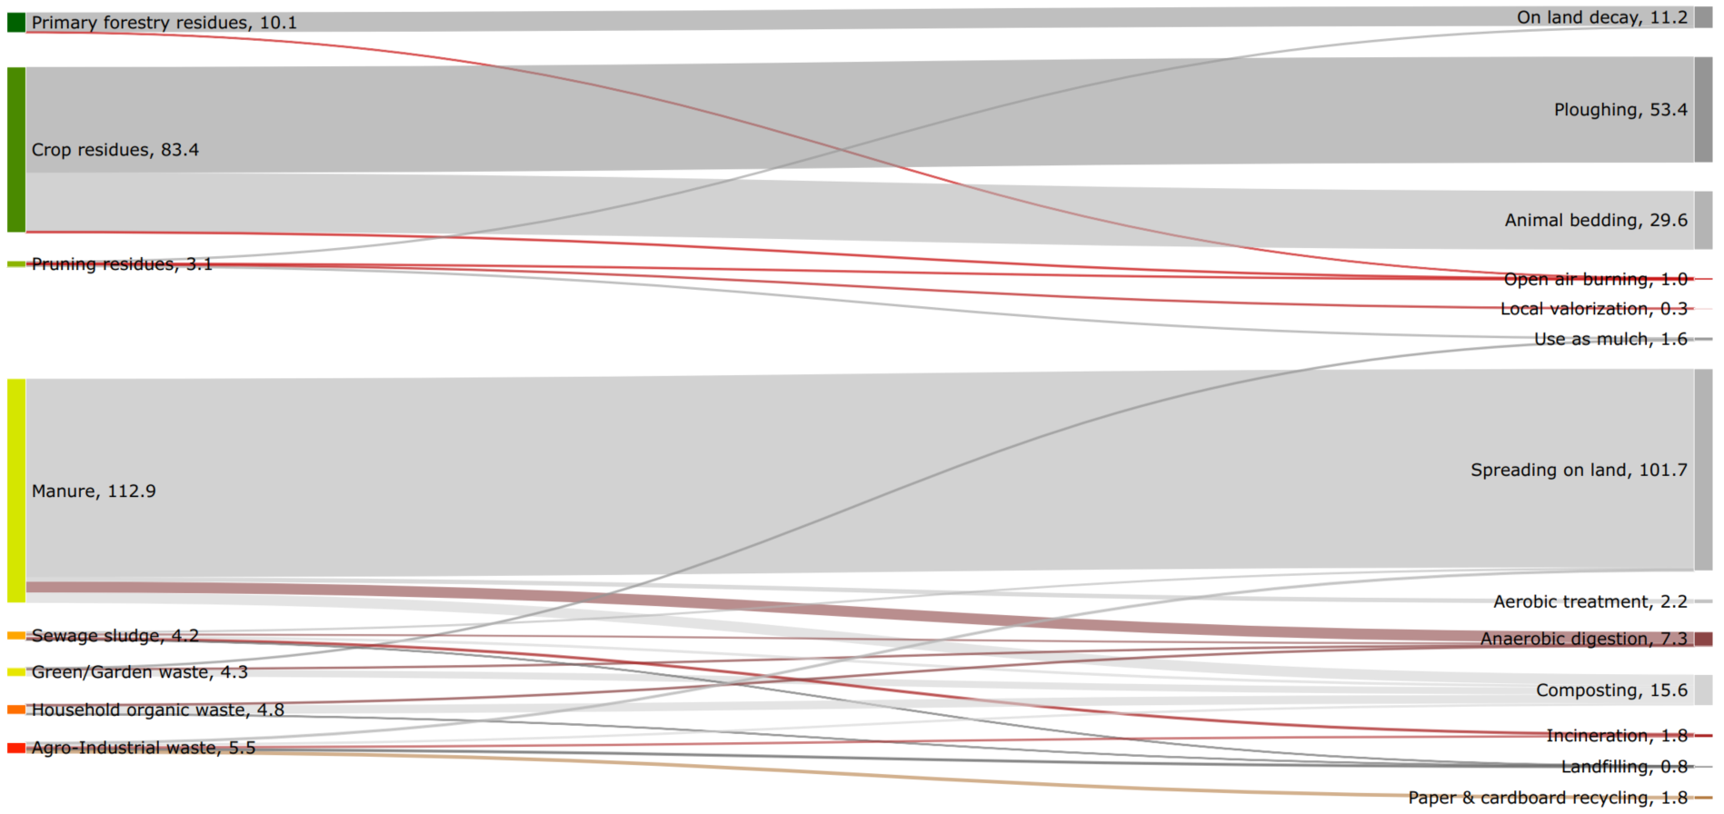

Figure S3 – Current uses of reported residual biomass streams in France, expressed in ktonnes nitrogen per year
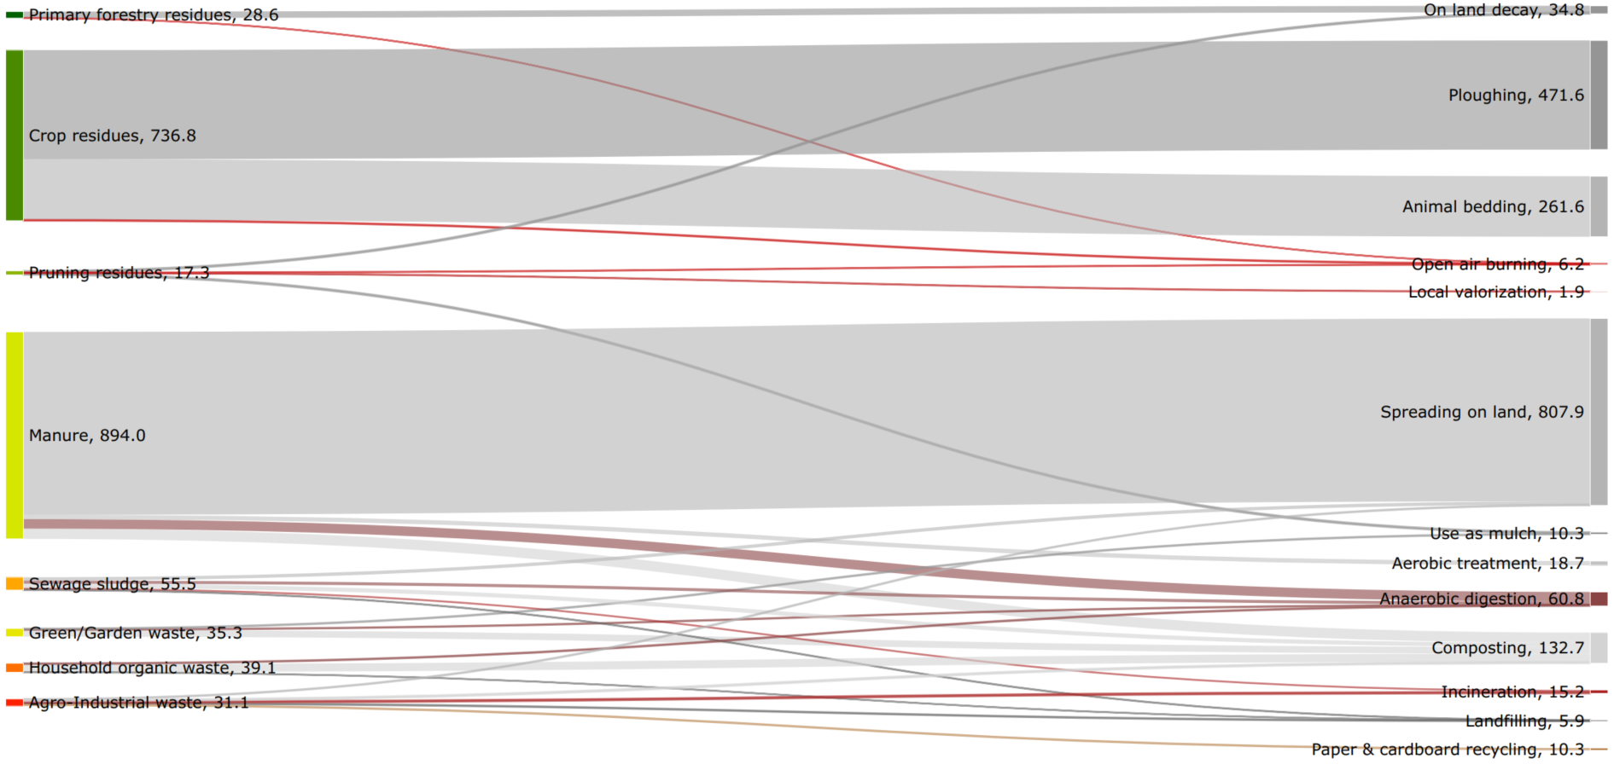
Background data for Figures S1 to S3 in the data repository (SI.6.Scaled_LCA_model spreadsheet).

Figure S4 – Independent variables to estimate French residual biomass baseline, with unitary impacts for climate change and marine eutrophication
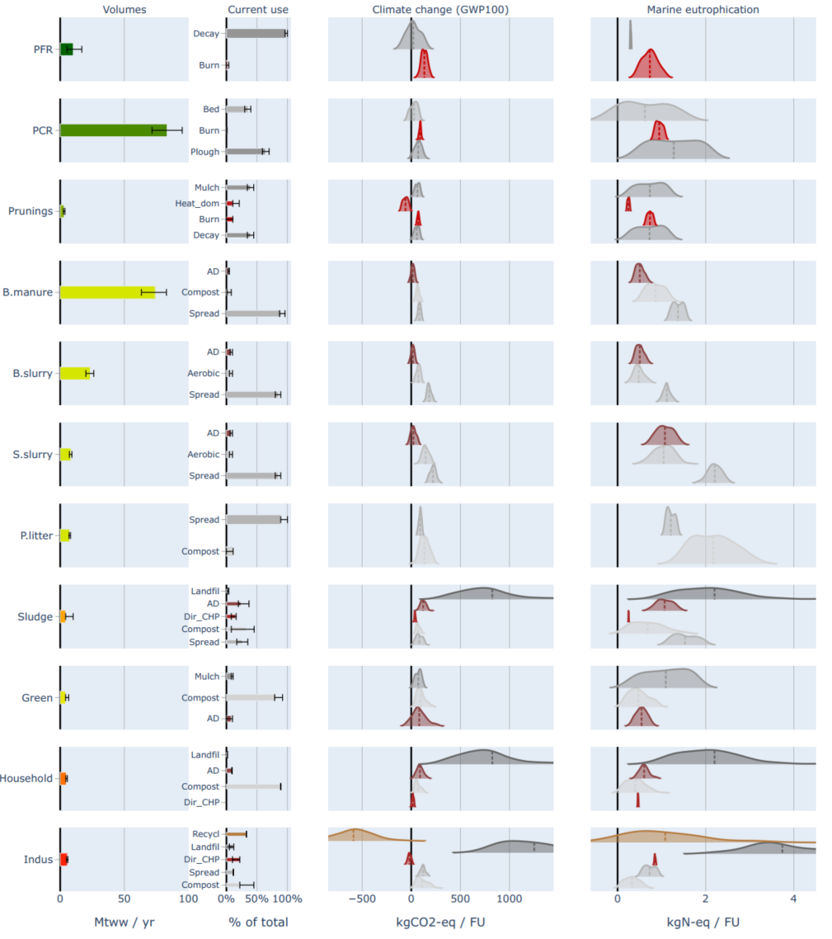

Figure S5 – Independent variables to estimate French residual biomass baseline, with unitary impacts for particulate matter formation and acidification
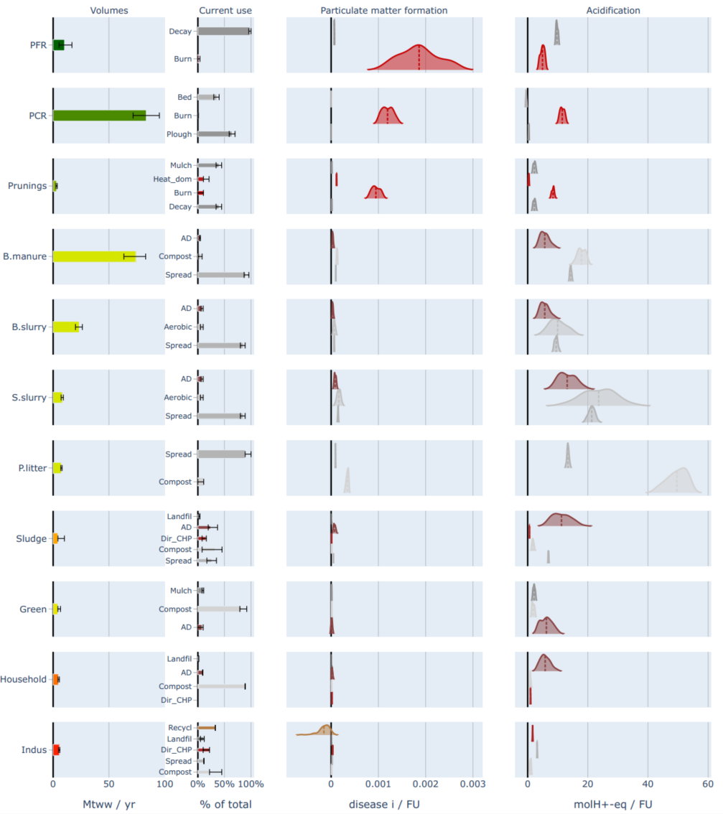

Figure S6 – Independent variables to estimate French residual biomass baseline, with unitary impacts for freshwater and terrestrial eutrophication
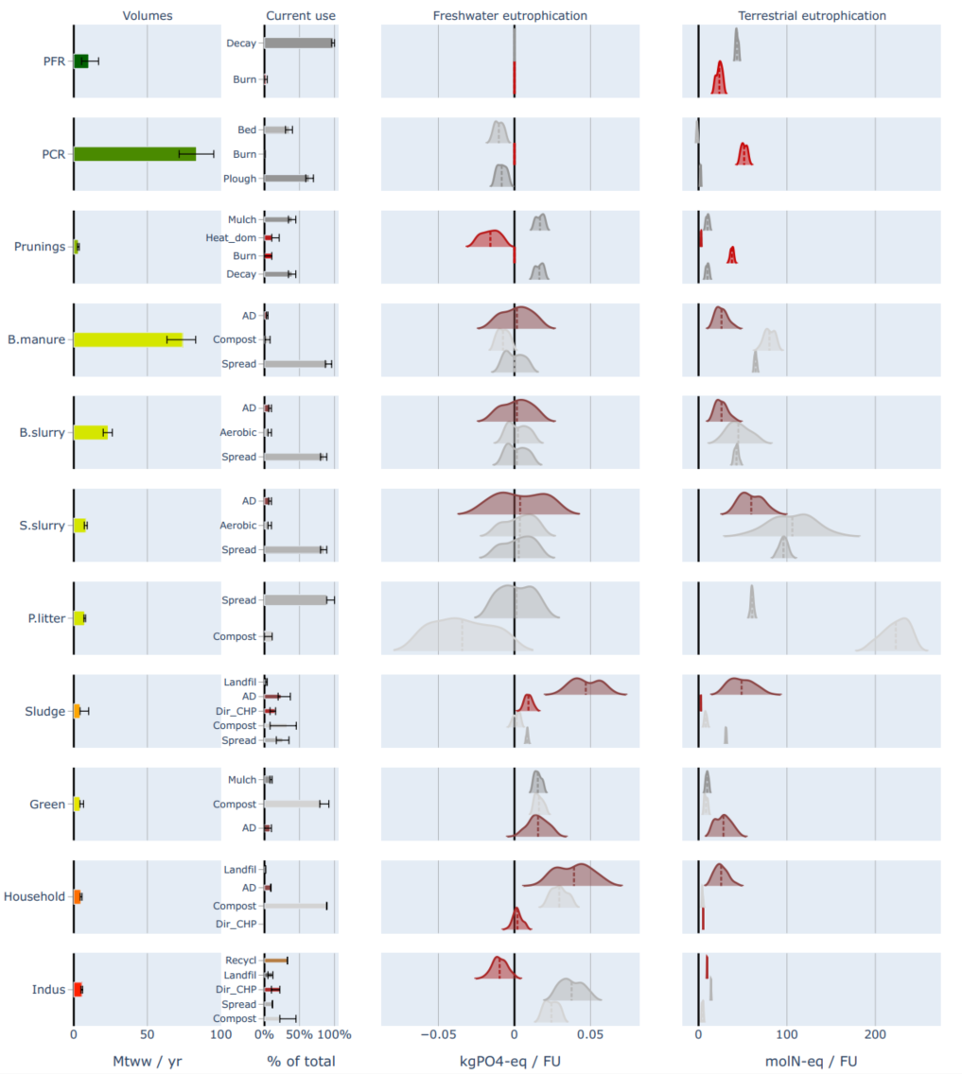
For figures S4 to S6, LCA scores in columns 3 and 4 (right-hand side) are expressed per unitary functional unit (FU), meaning that this FU is unique per stream (i.e. per rows). Ridgelines plots represent the dispersion of the net LCA scores for the corresponding (stream; pathway) combination depending on the technological performances. Uncertainties on current uses are generally reduced to a ±10% variation (see data repository, SI.1.Current_uses document). WW: Wet weight.

Figure S7 – Current environmental impacts of crop residues depend on how these influence agronomic practices
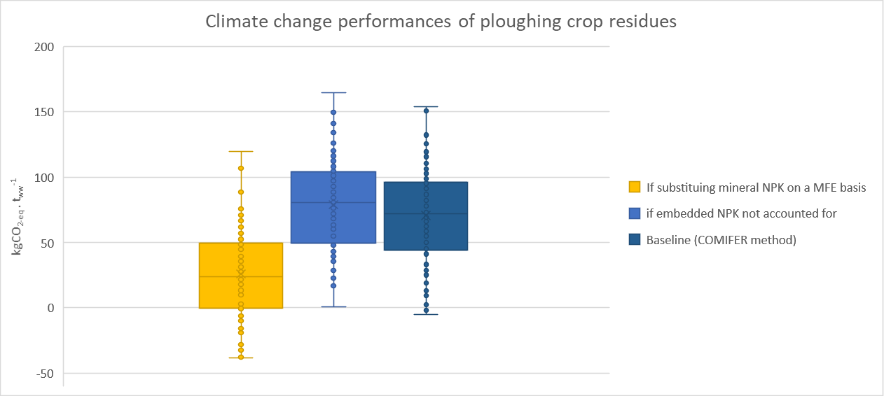
According to the COMIFER method, additional mineral N should be applied when crop residues are left on soils, while embedded P and K (in crop residues) should be accounted for in fertilizing practices. From a climate change perspective, these two effects seem to compensate (as the two blue tones distributions overlap). Yet, this is from a short-term perspective as ploughing crop residues helps maintaining soil N stocks, meaning that on the long term, this practice might lead to the avoidance of mineral N application. As the degree to which this long-term perspective is actually accounted for in practice remains unknown to our knowledge, here in yellow is displayed the best case, where ploughing crop residues fully substitutes mineral NPK application (accounting for corresponding MFE). This case (in yellow) is similar to the “animal bedding” pathway, as explained in the main manuscript. Accordingly, while we estimate that current crop residues management practices generate around 4.5 ± 2.2 MtCO_{2-eq}.y⁻¹, accounting for long-term effects of ploughing crop residues could lower this value down to 2.2 ± 2.2 MtCO_{2-eq}.y⁻¹. Distribution are based on 100 Monte Carlo simulations of the “decay on land” LCA model (excel spreadsheet available in the data repository) adapting the assumptions on the parameters related to the MFE to correspond to each of the 3 scenarios (see SI.4.LCI spreadsheet).

Table S2 – Benchmark of past studies estimating French manure and slurry potential
 | CITEPA | FAOSTATS | Loyon, 2017 | Loyon, 2018 | Harchaoui et al., 2023 | Malet et al., 2023** | This study
Reference year | 2020 | 2020 | 2008-2015 | 2008-2015 | 2020 | 2010 | 2018
 | Cow manure and slurry
Mheads.y⁻¹ | 17.7 | 17.8 |  |  |  |  | 18.5
Mt_{ww}.y⁻¹ |  |  | 86.9 | 86.9 |  |  | 97.3
Mt_{VS}.y⁻¹ | 5.3-7.9 |  |  |  |  | 17.5 | 9.1
ktN.y⁻¹ | 500 | 784 | 1326 | 530* |  |  | 652
 | Pig slurry
Mheads.y⁻¹ | 13.1 | 13.7 |  |  |  |  | 13.2
Mt_{ww}.y⁻¹ |  |  | 26.2 | 26.2 |  |  | 8.2
Mt_{VS}.y⁻¹ | 0.89 |  |  |  |  | 1.0 | 0.65
ktN.y⁻¹ | 124 | 157 | 143 | 130* |  |  | 112
 | Poultry manure
Mheads.y⁻¹ | 292 | 282 |  |  | 297 |  | 279
Mt_{ww}.y⁻¹ |  |  | 5.6 | 8.7 |  |  | 7.4
Mt_{VS}.y⁻¹ | 1.9 |  |  |  |  | 2.0 | 1.8
ktN.y⁻¹ | 128 | 147 | 127 | 140* | 138 |  | 133
Only accounting for share of manure generated during housing, in building (not on pasturelands). Here only baseline values (rounded) are provided without uncertainty ranges. *: author mentions the data is based on personal communication with CITEPA. **: Derived from the ELBA database, but already accounting for storage and handling losses (not ex-animal).

Table S3 – Benchmark of foreseen residual biomass mobilization in French prospective assessments
 |  | Afterres  (in 2050) * | Renewable gas mix in 2050 | Ademe, transition(s) (in 2050) * | Current NUTS-4 level potential
Forestry residues for energy | PJ | 22-155
Crop residues for energy | PJ | 0-25
Agro-industrial waste for energy | PJ | 65
Agro-industrial waste for biogas | PJ |  |  | 4-7
Agro-industrial waste for biogas | %_{mobilized} |  |  | 100% of rest
Municipal waste for biogas | PJ | 32 |  |  | 9**
Municipal waste for biogas | %_{mobilized}
Livestock effluents for biogas | PJ | 50-104 | 97 | 35-87 | 162
Livestock effluents for biogas | %_{mobilized} |  | 67% | 20-35%
Crop residues for biogas | PJ | 18-119 | 112 | 52-120 | 194
Crop residues for biogas | %_{mobilized} | 30% as baseline | 21% | 50%-100% | 60-76%
Municipal waste (total energy use) | PJ |  | 28
Municipal waste (total energy use) | %_{mobilized}
 |  | (Association Solagro, 2016) | (ADEME, 2018) | (ADEME, 2021) | (Malet et al., 2023)
*: range depending on prospective scenario rationale. Residual biomass potential depends on projected agricultural production, but most reviewed studies position such streams as key feedstocks to supply biomethane production. **: Only sewage sludge is considered here.

To quantifies the environmental impacts associated with the production stage of avoidable household organic waste, the following assumptions were considered. First, household organic waste was considered here to have the same composition as what is commonly referred to as the organic fraction of municipal solid waste (OFMSW). The share of green waste was removed from the potential (because assumed unavoidable), and the remaining part was considered as food losses (avoidable). To proxy the environmental impacts, two studies of similar goal, scope (geographically and temporally) and methodology (here, consequential LCA) were considered. The first one is Tonini et al., (2018) who estimated the impacts of food waste production in the UK accounting up to the associated land use change to produce the waste, the cooking stage and cold storage, as well as other losses in the supply chain. Notably, this study used the Environmental Footprint impact assessment method, which is consistent with the present work. The second one is Albizzati et al., (2021), who performed a similar exercise at the scale of Europe (that is, European average). They estimated the GWP₁₀₀ associated with the production of one tonne of food waste, and found respectively 2.9 tCO₂-eq.t_{ww}⁻¹ (ranging 2.1-3.7) and 4.2 tCO₂-eq.t_{ww}⁻¹ (ranging 3.9-4.5). These scores were considered as suitable proxies for France, and the production stage of household organic waste was assumed to uniformly range between 3 and 4 tCO₂-eq.t_{ww}⁻¹. This range was used in the sensitivity analysis discussed in the section 4.2. of the main manuscript.

References
ADEME, 2023. SINOE® - Accueil [WWW Document]. URL https://www.sinoe.org/ (accessed 5.16.23).
ADEME, 2021. Transition(s) 2050 - Choisir maintenant, Agir pour le climat - Rapport. ADEME Editions, Angers.
ADEME, 2019. L’outil aldo, pour une première estimation de la séquestration carbone dans les sols et la biomasse.
ADEME, 2018. Un mix de gaz 100% renouvelable en 2050 ? Etude de faisabilité technico-économique. Angers.
Agreste, 2020a. Cultures développées [WWW Document]. URL https://agreste.agriculture.gouv.fr/agreste-saiku/?plugin=true&query=query/open/SAANR_DEVELOPPE_2#query/open/SAANR_DEVELOPPE_2 (accessed 8.26.20).
Agreste, 2020b. Cultures fruitières [WWW Document]. URL https://agreste.agriculture.gouv.fr/agreste-web/disaron/SAANR_FRUITS/detail/ (accessed 8.26.20).
Agreste, 2020c. Production de raisin [WWW Document]. URL https://agreste.agriculture.gouv.fr/agreste-web/disaron/SAA_VIGNE/detail/ (accessed 8.26.20).
Agreste, 2020d. Production de bétail fini [WWW Document]. URL https://agreste.agriculture.gouv.fr/agreste-web/disaron/SAANR_9/detail/ (accessed 8.26.20).
Agreste, 2020e. Production de volailles et de lapins des exploitations agricoles [WWW Document]. URL https://agreste.agriculture.gouv.fr/agreste-web/disaron/SAANR_10/detail/ (accessed 8.26.20).
Albizzati, P.F., Tonini, D., Astrup, T.F., 2021. A Quantitative Sustainability Assessment of Food Waste Management in the European Union. Environ. Sci. Technol.
Association Solagro, 2016. Les scénarios Afterres2050, version 2016.
BRGM, 2020. Installations industrielles rejetant des polluants [WWW Document]. URL https://www.georisques.gouv.fr/donnees/bases-de-donnees/installations-industrielles-rejetant-des-polluants (accessed 8.26.20).
CITEPA, 2022. Rapport CCNUCC.
Eurostat, 2020. Statistical regions in the European Union and partner countries. NUTS and statistical regions 2021. https://doi.org/10.2785/850262
FAO, 2019. FAOSTAT [WWW Document]. URL http://www.fao.org/faostat/en/ (accessed 10.28.21).
Harchaoui, S., Blazy, V., Péchenart, E., Wilfart, A., 2023. Challenges and opportunities for improving circularity in the poultry meat and egg sector: The case of France. Resources, Conservation and Recycling 193, 106963. https://doi.org/10.1016/j.resconrec.2023.106963
IGN, 2018. BD Forêt® Version 2.0 - Descriptif de contenu.
IPCC, 2003. Good Practice Guidance for Land Use, Land-Use Change and Forestry.
Karan, S.K., Hamelin, L., 2021. Crop residues may be a key feedstock to bioeconomy but how reliable are current estimation methods? Resources, Conservation and Recycling 164, 105211. https://doi.org/10.1016/j.resconrec.2020.105211
Karan, S.K., Hamelin, L., 2020. Towards local bioeconomy: A stepwise framework for high-resolution spatial quantification of forestry residues. Renewable and Sustainable Energy Reviews 134, 110350. https://doi.org/10.1016/j.rser.2020.110350
Loyon, L., 2018. Overview of Animal Manure Management for Beef, Pig, and Poultry Farms in France. Frontiers in Sustainable Food Systems 2.
Loyon, L., 2017. Overview of manure treatment in France. Waste Management 61, 516–520. https://doi.org/10.1016/j.wasman.2016.11.040
Malet, N., Pellerin, S., Nesme, T., 2023. Agricultural biomethane production in France: A spatially-explicit estimate. Renewable and Sustainable Energy Reviews 185, 113603. https://doi.org/10.1016/j.rser.2023.113603
Ministère de la Transition écologique et solidaire, 2023. Portail assainissement collectif [WWW Document]. URL https://www.assainissement.developpement-durable.gouv.fr/PortailAC/tabSuivi (accessed 5.16.23).
Tonini, D., Albizzati, P.F., Astrup, T.F., 2018. Environmental impacts of food waste: Learnings and challenges from a case study on UK. Waste Manag. 76, 744–766. https://doi.org/10.1016/j.wasman.2018.03.032

