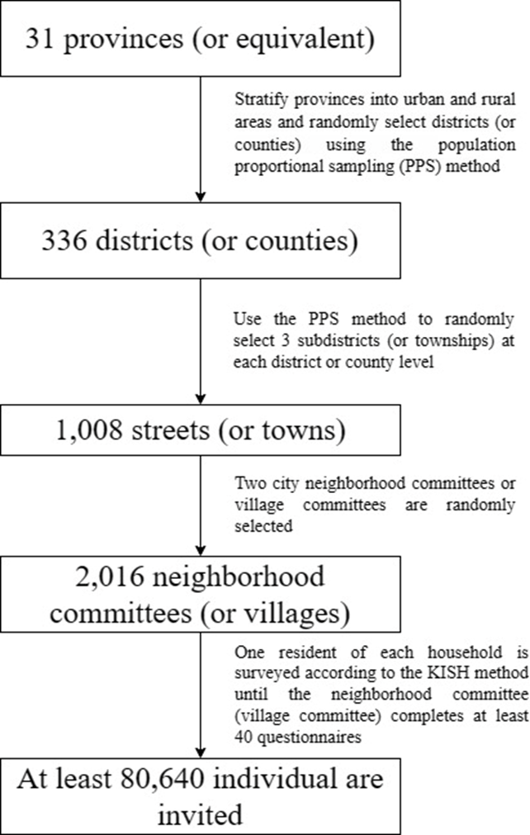
Appendix Figure 1. Flow diagram of study sampling procedure

