Extended Data Figures

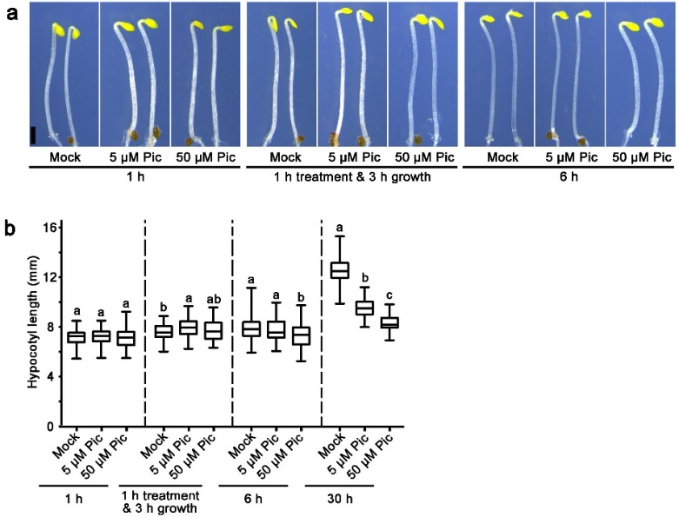

Extended Data Fig. 1 | Different dosages of auxin trigger opposite effects on the hypocotyl elongation of etiolated seedlings.
a, b, Phenotypes of dark-grown Col-0 plants treated with different concentrations of the auxin analogue picloram (Pic). Two-day-old dark-grown seedlings were treated with 100 μM yucasin for 6 h and then soaked in liquid MS buffer containing 5 μM Pic, 50 μM Pic, or equimolar DMSO (Mock) for 1 h, 6 h, or 30 h. One group of seedlings was treated with mock, 5 μM Pic, or 50 μM Pic for 1 h and then transferred to normal MS medium for 3 h (1 h of treatment & 3 h of growth). Statistical significance was assessed by one-way ANOVA along with Tukey’s multiple comparison.

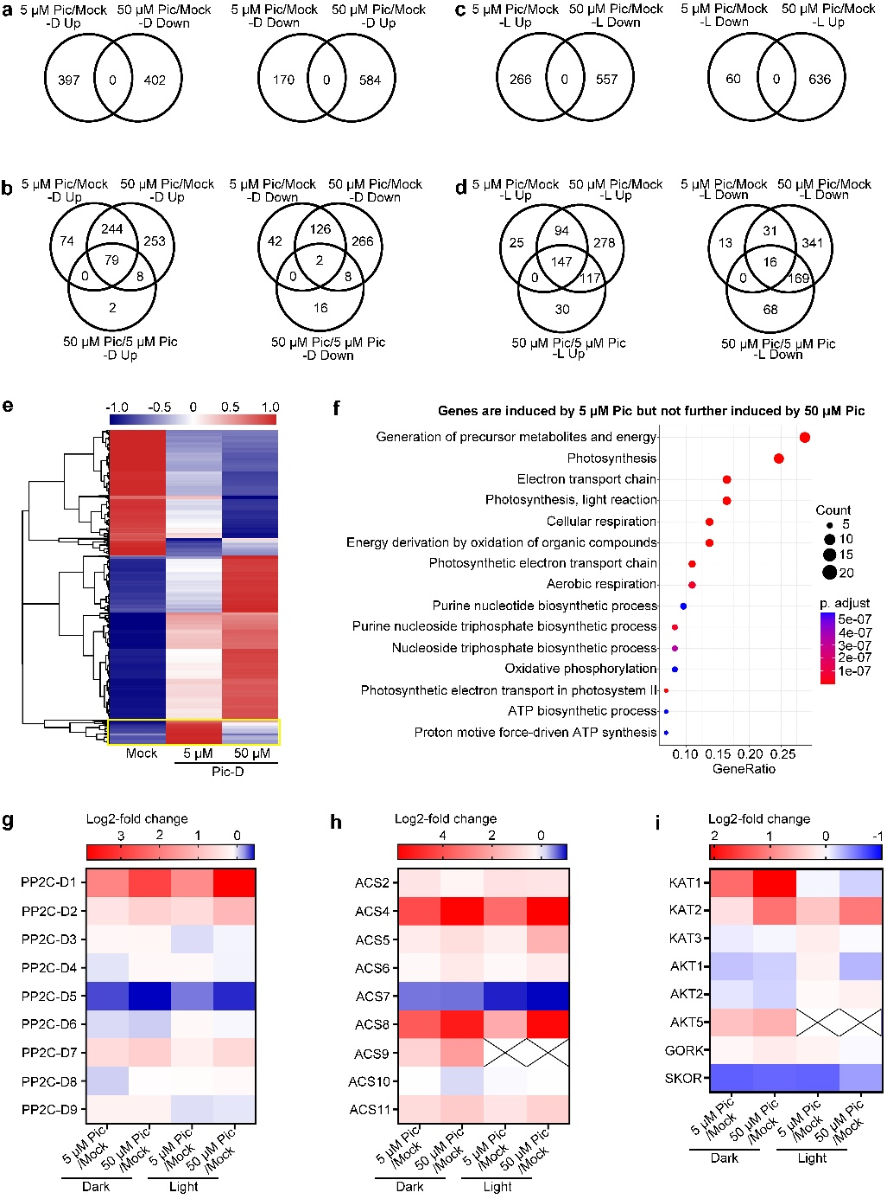
Extended Data Fig. 2 | Auxin-regulated genes in dark- and light-grown hypocotyls.
a-d, Venn diagrams showing the number of genes that were differentially regulated by different concentrations of Pic in dark- and light-grown wild-type hypocotyls. Please refer to Supplementary Table 2 for specific gene information. e, Hierarchical clustering analysis of differentially expressed genes in dark-grown hypocotyls in response to different concentrations of Pic. The yellow box indicates that the group of genes is induced by 5 μM but not further induced by 50 μM Pic. f, GO analysis of significantly enriched genes induced by 5 μM but not further induced by 50 μM Pic. This is the only group of genes induced by 5 μM but not further induced by 50 μM in etiolated hypocotyls was annotated to the GO term “photosynthesis-related and generation of precursor metabolites and energy”, which is unlikely to directly impact hypocotyl elongation in the dark. g, h, i, Heatmap of transcription levels of PP2C-D, ACS family genes, and K⁺ channel genes in dark- and light-grown wild-type hypocotyls treated with 5 μM Pic and 50 μM Pic.

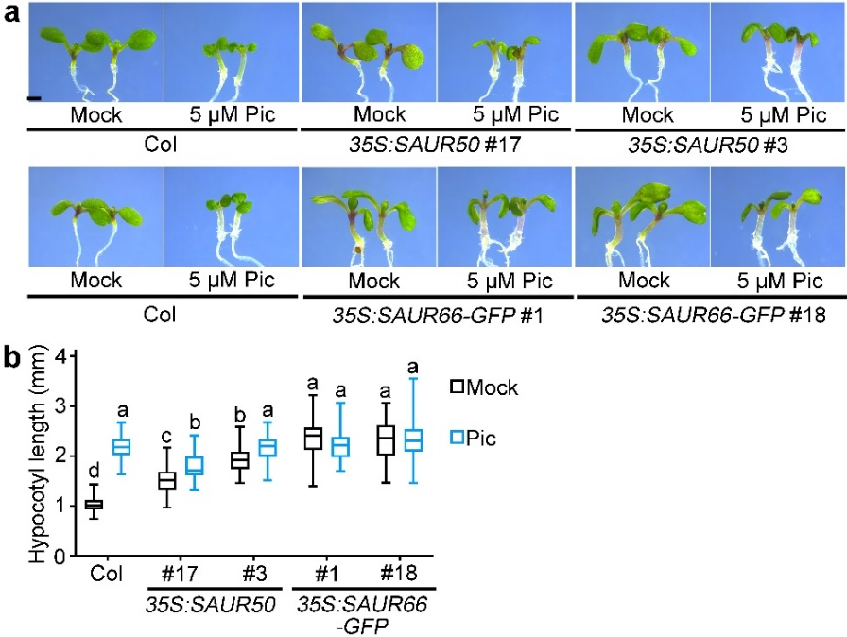

Extended Data Fig. 3| Over expression of SAUR50 and SAUR66 resulted in insensitivity to auxin in auxin-promoted hypocotyl elongation.
a, Representative seedlings were continuously treated with 5 μM picloram (5 μM Pic) or equimolar DMSO (Mock). Wild-type (Col-0), 35S:SAUR50, and 35S:SAUR66-GFP seedlings were grown in the light for 6 days. Bar = 1 mm. b, Hypocotyl length of light-grown seedlings treated with 5 μM Pic or mock. Statistical significance was assessed by two-way ANOVA and Tukey’s multiple comparison (P<0.01).

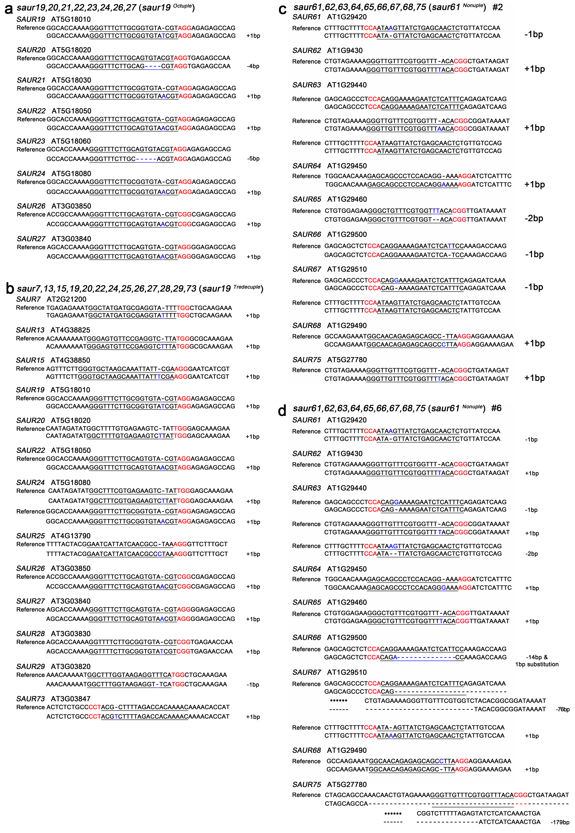
Extended Data Fig. 4 | Mutation sites in saur19 ^{Octuple}, saur19 ^{Tredecuple}, and saur61 ^{Nonuple} mutants.
saur19 ^{Octuple}, saur19 ^{Tredecuple}, and saur61 ^{Nonuple} mutants were generated by CRISPR/Cas9 gene editing. The schematic diagram shows the DNA sequences of these mutants. The PAM (protospacer adjacent motif) sequences are marked in red. The small-guide RNA sequences (20 bp) are underlined. “Plus” indicates insertion, and “minus” indicates deletion.

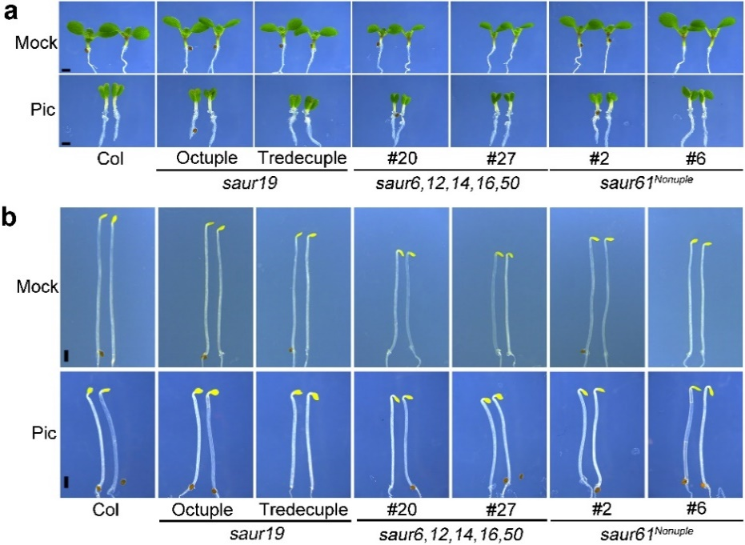
Extended Data Fig. 5 | High order mutants of SAUR genes exhibited deficient auxin-induced regulation of hypocotyl elongation.
a, Phenotypes of representative seedlings of the indicated genotypes under mock or Pic treatment. Col-0, saur19 saur20 saur21 saur22 saur23 saur24 saur26 saur27 (saur19^{Octuple}), saur7 saur13 saur15 saur19 saur20 saur22 saur24 saur25 saur26 saur27 saur28 saur29 saur73 (saur19^{Tredecuple}), saur6 saur12 saur14 saur16 saur50 (saur6,12,14,16,50), and saur61 saur62 saur63 saur64 saur65 saur66 saur67 saur68 saur75 (saur61^{Nonuple}) were grown on solid MS media containing 5 μM Pic or equimolar DMSO (mock) in the dark for 3 days. Bar = 1 mm. b, Phenotypes of light-grown Col-0, saur19^{Octuple}, saur19^{Tredecuple}, saur6,12,14,16,50, and saur61^{Nonuple} continuously treated with 5 μM picloram (Pic) or equimolar DMSO (mock). Bar = 1 mm.

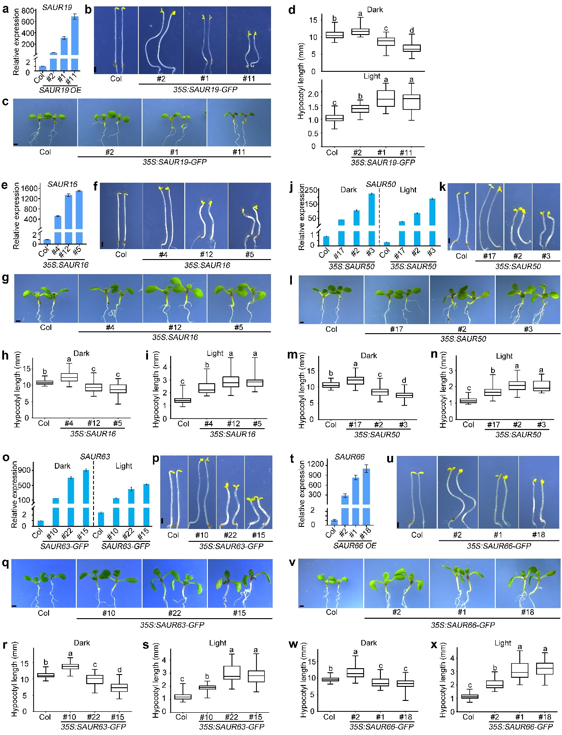
Extended Data Fig. 6 | Increasing levels of SAUR induced a biphasic response in hypocotyl elongation, similar to increasing auxin dosages.
a-x, Extreme overexpression of SAUR19, SAUR16, SAUR50, SAUR63, and SAUR66 inhibited hypocotyl elongation of etiolated seedlings, whereas moderate overexpression of SAURs promoted hypocotyl elongation in light or darkness. a, e, t, Expression levels of SAURs in 3-day-old dark-grown seedlings overexpressing SAUR. j, o, Expression levels of SAUR50 (j) and SAUR63 (o) in hypocotyls of transgenic lines of 35S:SAUR50 and 35S:SAUR63-GFP compared with wild-type Col-0, respectively. The seedlings were grown in the dark for 3 days (Dark) or grown under 0.8 μmol·m⁻²·s⁻¹ white fluorescent light for 4 days and then transferred to 80 μmol·m⁻²·s⁻¹ white fluorescent light for another 3 days (Light). Hypocotyls were dissected for the extraction of total RNA. a, e, j, o, t, The data shown are the means ± SDs of three biological replicates. PP2A was used as an internal control. b, c, f, g, k, l, p, q, u, v, Phenotypes of dark- and light-grown indicated SAURs. Seedlings were grown in the dark for 3-4 days or in the light for 5-7 days. Bar = 1 mm. d, h, i, m, n, r, s, w, x, Hypocotyl lengths of the indicated SAUR-overexpressing lines grown in the dark or light. Significant differences were assessed by one-way ANOVA and Bonferroni’s post-test (P<0.01).

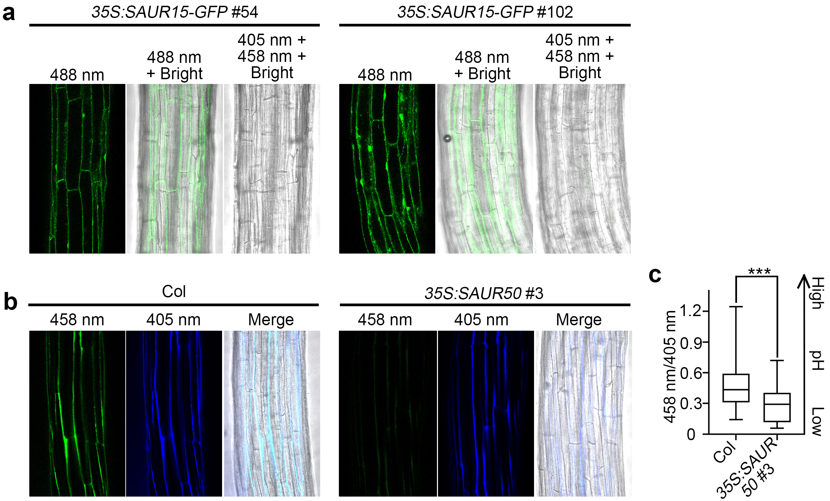

Extended Data Fig. 7 | HPTS staining shows that overexpressing SAUR lowers the apoplastic pH in hypocotyl epidermal cells.
a, The SAUR15-GFP signals, exhibiting a nucleus and cytoplasm localization pattern, did not interfere with observation results of HPTS dye. 3-day-old dark-grown hypocotyls of 35S:SAUR15-GFP (lines #54 and #102) was analyzed at excitation 488 nm for GFP or excitation 405nm and 458 nm for HPTS using a confocal microscope (Zeiss LSM880). b, c, SAUR50 overexpression lowered the apoplastic pH of hypocotyl epidermal cells. b, The apoplastic pH of 2-day-old dark-grown hypocotyls of Col-0 and 35S:SAUR50 #3 was determined by HPTS staining. c, Ratiometric (458 nm/405 nm) quantification of HPTS staining was used to indicate the relative apoplastic pH of Col-0 and 35S:SAUR50 hypocotyls. The significance was analysed by student t’test (***P<0.001, n≥24).

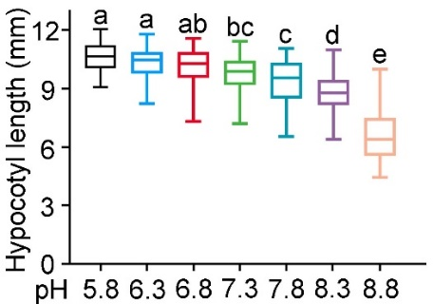
Extended Data Fig. 8 | High extracellular pH hinders hypocotyl elongation.
Dark-grown 2-day-old wild-type seedlings were submerged in liquid MS with the indicated pH for 24 h prior to measurement of the hypocotyl lengths. One-way ANOVA with Tukey’s post test (P < 0.05) was used to calculate statistical difference.

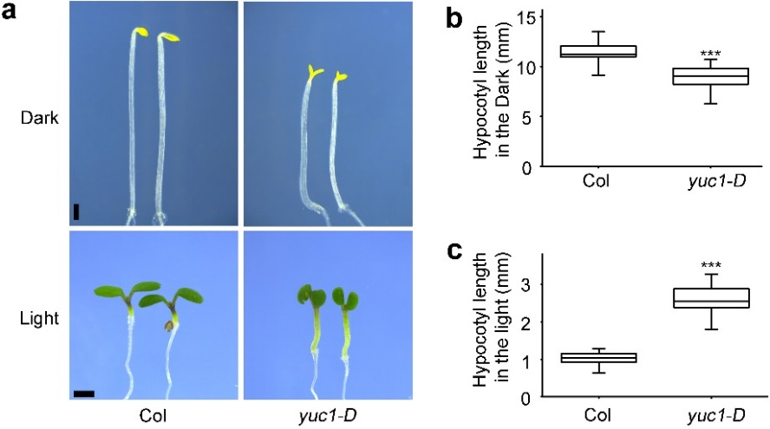
Extended Data Fig. 9 | Light modulates the effect of auxin on hypocotyl elongation.
a-c, Auxin-overproduction mutant yuc1-D seedlings have long hypocotyls when grown in light but display short hypocotyls when grown in darkness. a, Characteristic phenotypes of yuc1-D. The seedlings were grown in the dark for 3 days or in the light for 5 days. Bar = 1 mm. b, Hypocotyl length of dark-grown Col and yuc1D. c, Hypocotyl length of light-grown Col and yuc1-D. b, c, The statistical significance was assessed by Student’s t test. ***P<0.001.

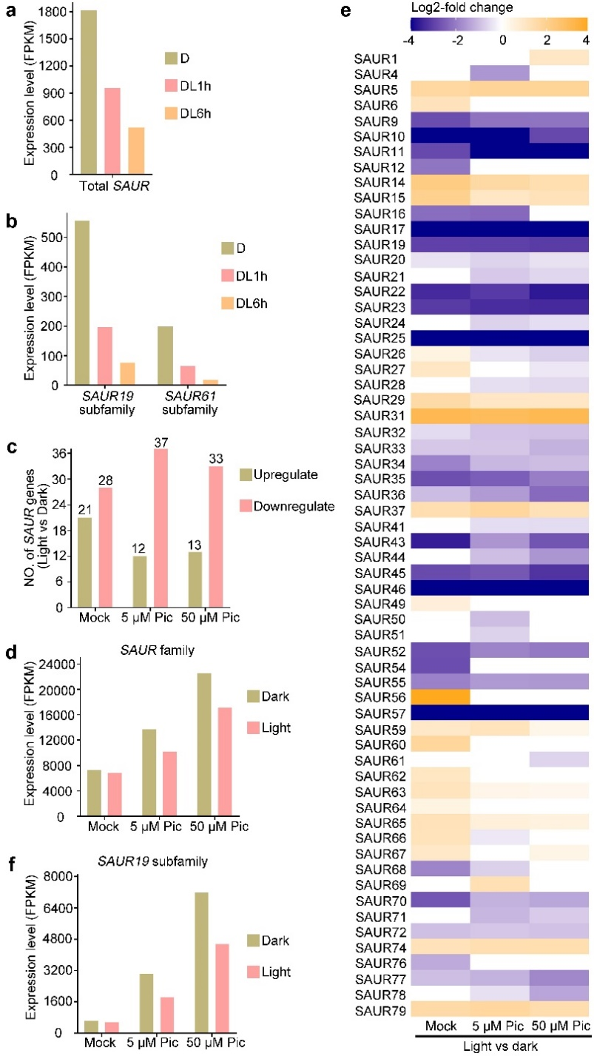
Extended Data Fig. 10 | Light attenuates collective levels of SAUR expression.
a, b, Expression levels of total SAUR family genes (a) and SAUR19 and SAUR61 subfamily genes (b) in hypocotyls during the dark-to-light transition (data are from Sun et al., 2016). c, Number of SAUR genes showing up- and downregulated expression in light vs dark-grown hypocotyls. d, f, Expression levels of total SAUR family genes (d) and SAUR19 subfamily genes (f) in dark- or light-grown hypocotyls treated with the indicated concentrations of Pic. e, Heatmap of transcripts of SAUR family genes in light-grown hypocotyls compared with dark-grown hypocotyls.

