Identification of the Campanian Ignimbrite in the Dead Sea and consequent time-transgressive hydroclimatic shifts in the Eastern Mediterranean

Rebecca Kearney¹, Markus Schwab¹, Daniel Redant¹, Ina Neugebauer¹, Oona Appelt¹, Cecile Blanchet¹ Jan Fietzke³, Christina Günter⁴, Daniela J.M. Müller^{1,2}, Rik Tjallingii¹, Achim Brauer^{1,4}

Supplementary information

Figures
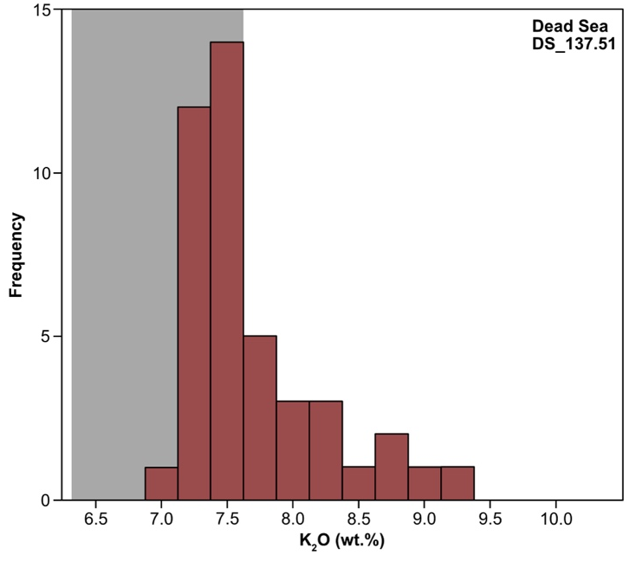

Fig. S1. Histogram of the K₂O glass composition of the DS_137.51 low-resolution Campanian Ignimbrite shards. Following Smith et al.^{[1]}, the grey shaded box shows the more evolved compositions of the early Plinian and Lower Flow deposit. The distribution of the K₂O from the Dead Sea shows the CI shards are from the fallout and the different PDC flows including the upper flow unit encompassing the full chemical composition of the CI eruption observed in other distal records.

Supplementary Discussion 1

The identification and correlation of volcanic shards that are not from Campi Flegrei
The following section focuses on presenting the other volcanic shards highlighted in the main paper but are not correlated to the Campanian Ignimbrite, Campi Flegrei. The subsequent geochemical composition of these “other” shards currently do not have a confident correlation to a known volcanic eruption from their proposed volcanic sources during this time period.

The 5cm sample of DS_137.81
The glass shards of DS_137.81 had a mixed morphology that varied from fluted shards with elongated bubbles within, to cuspate and bubble walled shards. The shard preservation at this depth are mainly altered and with some unaltered looking shards, typical of the tephra shards found throughout the Dead Sea record^{[2]}. A total of fourteen volcanic shards underwent geochemical analysis, revealing glasses that are heterogenous in chemical composition (Fig. S1a)
The dominant compositional group, Group 1 (n = 8) are rhyolitic with SiO₂ ranging from 79.26 to 72.03 wt.% and K₂O of 4.14 to 4.38 wt.% (Fig S1a). This group of shards are pantellerites with a distinctly high FeO (7.12-8.96 wt.%) and low Al₂O₃ (8.13-10.71 wt.%). Group 2 (n = 5) are also rhyolites (SiO₂ 71.60-73.01 wt.%) with a HKCA affinity (K₂O 4.41-4.74 wt.%) with a lower FeO (3.38-3.69 wt.%), higher Al₂O₃ (12.87-13.84 wt.%) and low CaO (0.50-0.70 wt.%). A single shard shows higher SiO₂ (76.51 wt.%), a HKCA affinity (4.48 wt.% K₂O) and slightly lower FeO (2.52 wt.%). Another single shard is a trachyte with lower SiO₂ (63.19 wt.%), higher K₂O (6.93 wt.%) and higher Na₂O (4.75 wt.%).
The dominant Group 1 with distinct composition of Fe-rich pantellerite shards can be correlated to an eruption originating from the volcanic island of Pantelleria (Sicily Channel). This volcano is known to produce distinct rhyolitic pantellerites, in addition to Nemrut from the Eastern Anatolian Volcanic Province (EAVP)^{[3,4]}. However, the FeO values of Group 1 are too high for a correlation to Nemrut^{[5]}(Fig. S2 c-d). The largest known eruption from this volcano produced the Pantelleria Green Tuff (PGT, in marine records termed the Y6 tephra), directly dated to 45.7 ± 1.0 yrs BP by ⁴⁰Ar/³⁹Ar^{[6]} (2σ). The tephra from this caldera-forming eruption has been found across the Mediterranean region^{[7–10]}. However, though the shards from Group 1 of DS_137.81 show close composition correlation to the PGT, a precise correlation to the PGT can be questioned.
Firstly, it can be proposed that Group 1 of DS_137.81 is younger than the ~45kya PGT. As this sample is within ~33cm of the first occurrence of the Campanian Ignimbrite, which itself is directly dated to 39.85 ± 0.14kya^{[11]} (⁴⁰Ar/³⁹Ar, 2σ), the long continuous sedimentation rate of the Dead Sea would not allow for ~5-6 kya within this short depth span^{[12]}, even with the presence of turbidites. In addition, there are slight variations in chemical composition for certain elements between Group 1 and the PGT. Group 1 shows slightly higher CaO (0.35 to 0.56 wt.%) and lower MgO (0-0.04 wt.%) compared to the PGT (Fig. S2 c-d).
Evidence for younger eruptions originating from Pantelleria post-PGT have been suggested. Proximal records of pyroclastic flows and lava flows on the Island have been investigated and date to being younger than the PGT ^{[13–15]}. Mahood and Hildreth^{[13]} have directly dated a trachyte lava from a vent at Mont Gibele on the island to 41-27kya (K/Ar), encompassing the possible age range of DS_137.81. In distal records, there are a limited number of records that contain post-PGT tephra layers in this time period. McGuire et al.^{[9]} has identified a potential post-PGT but pre-CI pantellerite tephra layer, IO8T_31.19. Comparisons of DS_137.81 Group 1 to IO8T_31.19 show some compositional overlap but may indicate different eruptions from Pantelleria. However, IO8T_31.19 has also been suggested as being reworked from the older PGT at Ioannina due to post-depositional processes^{[9]}. So far, only younger post-PGT tephra layers have been identified in records dating to the Holocene period^{[16,17]}. Nonetheless, Group 1 of DS_137.81 can be seen as a potential post-PGT eruption from Pantelleria, though no prominent proximal or distal eruption deposit has been identified so far in other records with similar chemical compositions, future investigations are needed.

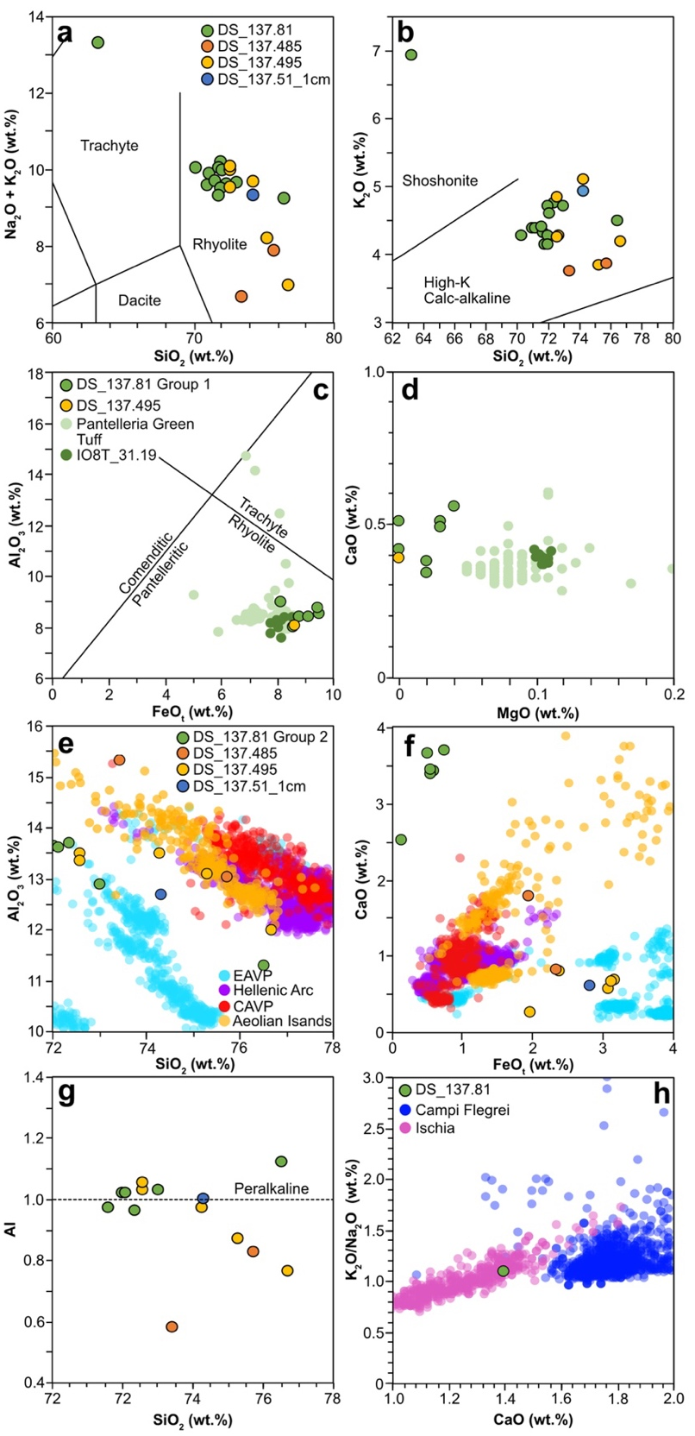

Fig. S2. Geochemical analyses of all glass shards from the samples investigated. a) total alkalis total Alkali Silica (TAS^{[18]}) plot of the individual glass shards from all the samples the Dead Sea discussed in the main paper; b) Major element bi-plot of these individual glasses; c-d) Comparisons of the Dead Sea samples with chemical composition similar to Pantelleria^{[8,9,19]}; e-f) Comparisons of high-SiO₂ rhyolitic shards from the Dead Sea to compared to similar high-SiO2 glass shards of Eastern Anatolian Volcanic Provence^{[5]}, Hellenic Arc^{[19–22]}, Central Anatolian Volcanic Provence^{[19,23–26]} and Aeolian Islands^{[27]}; g) Alkalinity Index of non-Pantellerite-type shards from all the Dead Sea shards discussed; h) Comparison of the trachyte shard from DS_137.81 to Campi Flegrei^{[19,28,29]} and Ischia^{[19,28–30]}
The five shards of Group 2 that have high SiO₂ content and the single rhyolitic shard shows potential correlations to the Hellenic Arc, Greece and EAVP, Turkey. Due to their rhyolitic shards with high SiO₂, Al₂O₃ and low CaO (Fig. S2e-f), a volcanic origin to the EAVP is most likely. However, DS_137.81 has a distinctly high FeO, higher than tephra layers that have been so far geochemically analysed in the Lake Van record as part of the TephroMed project^{[5]}. The Nemrut volcano from this provenance is known to have produced distinctly geochemically different tephras with each eruption^{[5]}. Currently, no direct correlation can be made to any tephra layers from this centre that have been currently investigated^{[5]}.
The single trachyte shard from DS_137.81 can be correlated to an eruption from Ischia, Italy. The low alkali ratio (K₂O /Na₂O) of 1.08 wt.% allows this shard to be distinguished from erupting from Ischia rather than Campi Flegrei^{[19,30]} (Fig. S2h). Several pre-CI eruptions from Ischia have been identified after the last largest know eruption from this volcano of Mount Epomeo Green Tuff, around 56kya^{[31]}. This includes several proximal eruptive units^{[32]} and tephra layers in distal records^{[9,28,30,32,33]}. Correlating this single shard to a particular pre-CI Ischia eruption is difficult, particularly as this is one shard and that the chemical compositions from these different pre-CI Ischia eruptions are similar in major, minor and trace element composition^{[30,32]}. Nonetheless, this shard in DS_137.81 is coming from an eruption of Ischia, not Campi Flegrei.

DS_137.51_1cm
Though six volcanic shards were counted and analysed, only two of these shards produced an analytical total of >92 wt.% that could be confidently used for correlation. The low analytical totals for the remaining four shards were due to the small shard area that was exposed for the beam for EPMA analysis without losing the whole shard in the sectioning process. Three of these shards show chemical compositions similar to the Campanian Ignimbrite but were not used in the correlation due to their low analytical totals.
The single shard that has an analytical total >92 wt.% and has not been correlated to the Campanian Ignimbrite have higher SiO₂ rhyolite (74.32 wt.%), with a HKCA affinity (4.93 wt.% K₂O), low FeO (2.82 wt.%) and very low CaO (0.60 wt.%). The peralkaline nature of this rhyolite (1.00 wt.% Alkalinity Index (AI), Fig. S2g) with very low CaO and higher FeO is indicative of originating from Nemrut in the EAVP (Fig. S2e-f). However, no current direct correlation to a V-layer from Lake Van or surrounding proximal record of the volcano can be made^{[5]}.

DS_137.495 (PT1779)
A total of eight volcanic glass shards underwent geochemical analysis. Of the shards that have not been correlated to the Campanian Ignimbrite, six are rhyolitic with high SiO₂ (76.69-72.56 wt.%). Within this group there is heterogeneity with all elements. Group 1 are two shards are chemically similar with SiO₂ (72.57-72.56 wt.%), low CaO (0.57-0.66 wt.%) and high FeO (3.14-3.08 wt.%). No know direct correlation to a tephra layer can be made, but due to their high AI (1.03-1.05 wt.%), this composition is similar to Nemrut from EAVP (Fig. S2e-f). A single shard with SiO₂ of 74.27 wt.% has low FeOt (1.98 wt.%) and very low CaO (0.26 wt.%). No corelation can be made to a volcanic centre or eruption currently. A rhyolitic single shard (SiO₂ 76.69 wt.%) is different with low Al₂O₃ of 11.98 wt.%, high FeO of 3.17 wt.% and low CaO of 0.67 wt.%. Currently no direct correlation can be made to a volcanic centre and/or eruption. An additional shard with SiO₂ of 75.30 wt.% is low in CaO (0.79 wt.%) and high FeO (2.39 wt.%) (Fig. S2e-f). These low values currently do not match any known volcanic centre or eruption. Though this chemical composition is similar to a shard in DS_137.485.
A single rhyolitic shard with high SiO₂ (72.71 wt.%) and distinctly high FeO (8.01 wt.%) with low Al₂O₃ (8.63 wt.%) indicates a pantellerite (Fig. S2c-d). This shard shows compositional overlap with the PGT of Pantelleria. Being a single shard, it is difficult to correlate to the potential post-PGT but to pre-CI of Group 1 in DS_137.81. This shard maybe re-worked from DS_137.81 deposit. However, with one shard, it is hard to ascertain if it is instead from a different eruption of Pantelleria.

DS_ 137.485 (PT1778)
The two shards that were identified and underwent geochemical analysis are rhyolitic with distinctly different chemical compositions. One shard has higher SiO₂ (75.73 wt.%) with a HKCA affinity (3.85 wt.% K₂O) and higher FeO (2.34 wt.%) and low CaO (0.81 wt.%). The second single shard has lower SiO₂ (73.42 wt.%) and a HKCA shard (3.76 wt.% K₂O) but with lower FeO (1.95 wt.%) and higher CaO (1.78 wt.%). These highly evolved rhyolitic shards show different volcanic origins. The rhyolitic shard with the lower FeO and higher CaO could potentially correlate to the Hellenic arch and is similar in composition to DS_137.485 shard with SiO₂ of 75.30 wt.%. While the second single shard of 73.42 wt.% currently has no correlation to a volcanic provenance.

References
1. Smith, V. C., Isaia, R., Engwell, S. L. & Albert, P. G. Tephra dispersal during the Campanian Ignimbrite (Italy) eruption: implications for ultra-distal ash transport during the large caldera-forming eruption. Bull Volcanol 78, (2016).
2. Neugebauer, I. et al. Cryptotephras in the Lateglacial ICDP Dead Sea sediment record and their implications for chronology. Boreas 50, 844–861 (2021).
3. Sumita, M. & Schmincke, H. U. Impact of volcanism on the evolution of Lake Van II: Temporal evolution of explosive volcanism of Nemrut Volcano (eastern Anatolia) during the past ca. 0.4Ma. Journal of Volcanology and Geothermal Research 253, 15–34 (2013).
4. Sumita, M. & Schmincke, H. U. Impact of volcanism on the evolution of Lake Van I: Evolution of explosive volcanism of Nemrut Volcano (eastern Anatolia) during the past >400,000 years. Bull Volcanol 75, 1–32 (2013).
5. Kearney, R. et al. The glass geochemistry of key visible tephra layers from Lake Van, eastern Anatolia 30-130kya. In preparation.
6. Scaillet, S., Vita-Scaillet, G. & Rotolo, S. G. Millennial-scale phase relationships between ice-core and Mediterranean marine records: insights from high-precision 40Ar/39Ar dating of the Green Tuff of Pantelleria, Sicily Strait. Quat Sci Rev 78, 141–154 (2013).
7. Paterne, M., Guichard, F. & Labeyrie, J. Explosive activity of the South Italian volcanoes during the past 80,000 years as determined by marine tephrochronology. Journal of Volcanology and Geothermal Research 34, 153–172 (1988).
8. Vogel, H., Zanchetta, G., Sulpizio, R., Wagner, B. & Nowaczyk, N. A tephrostratigraphic record for the last glacial-interglacial cycle from Lake Ohrid, Albania and Macedonia. J Quat Sci 25, 320–338 (2010).
9. McGuire, A. M., Lane, C. S., Roucoux, K. H., Albert, P. G. & Kearney, R. The dating and correlation of an eastern Mediterranean lake sediment sequence: a 46–4 ka tephrostratigraphy for Ioannina (NW Greece). J Quat Sci 37, 1313–1331 (2022).
10. Karkanas, P. et al. Tephra correlations and climatic events between the MIS6/5 transition and the beginning of MIS3 in Theopetra Cave, central Greece. Quat Sci Rev 118, 170–181 (2015).
11. Giaccio, B., Hajdas, I., Isaia, R., Deino, A. & Nomade, S. High-precision 14C and 40Ar/39 Ar dating of the Campanian Ignimbrite (Y-5) reconciles the time-scales of climatic-cultural processes at 40 ka. Sci Rep 7, (2017).
12. Kagan, E., Stein, M. & Marco, S. Integrated Paleoseismic Chronology of the Last Glacial Lake Lisan: From Lake Margin Seismites to Deep-Lake Mass Transport Deposits. J Geophys Res Solid Earth 123, 2806–2824 (2018).
13. Mahood, G. A. & Hildreth, W. Geology of the peralkaline volcano at Pantelleria, Strait of Sicily. Bull Volcanol 48, 143–172 (1986).
14. Civetta, L., Cornette, Y., Gillot, P. Y. & Orsi, G. The eruptive history of Pantelleria (Sicily channel) in the last 50 ka. Bull Volcanol 50, 47–57 (1988).
15. Speranza, F., Landi, P., D’Ajello Caracciolo, F. & Pignatelli, A. Paleomagnetic dating of the most recent silicic eruptive activity at Pantelleria (Strait of Sicily). Bull Volcanol 72, 847–858 (2010).
16. Magny, M. et al. Holocene hydrological changes in south-western Mediterranean as recorded by lake-level fluctuations at Lago Preola, a coastal lake in southern Sicily, Italy. Quat Sci Rev 30, 2459–2475 (2011).
17. Kearney, R. At an important tephrostratigraphic crossroads: a detailed Late Glacial to Early Holocene cryptotephra stratigraphy from two lake records in the Carpathian Mountains, Romania.
18. Le Bas, M. J., Le Maitre, R. W., Streckeisen, A. & Zanettin, B. A chemical classification of volcanic rocks based on the total alkali-silica diagram. Journal of Petrology 27, 745–750 (1986).
19. Tomlinson, E. L. et al. The major and trace element glass compositions of the productive Mediterranean volcanic sources: Tools for correlating distal tephra layers in and around Europe. Quat Sci Rev 118, 48–66 (2015).
20. Kutterolf, S. et al. The Medial Offshore Record of Explosive Volcanism Along the Central to Eastern Aegean Volcanic Arc: 2. Tephra Ages and Volumes, Eruption Magnitudes and Marine Sedimentation Rate Variations. Geochemistry, Geophysics, Geosystems 22, (2021).
21. Tomlinson, E. L. et al. The Upper and Lower Nisyros Pumices: Revisions to the Mediterranean tephrostratigraphic record based on micron-beam glass geochemistry. Journal of Volcanology and Geothermal Research 243–244, 69–80 (2012).
22. Margari, V., Pyle, D. M., Bryant, C. & Gibbard, P. L. Mediterranean tephra stratigraphy revisited: Results from a long terrestrial sequence on Lesvos Island, Greece. Journal of Volcanology and Geothermal Research 163, 34–54 (2007).
23. Kuzucuoğlu, C. et al. Geomorphology and tephrochronology review of the Hasandağ volcano (southern Cappadocia, Turkey). Mediterranean Geoscience Reviews 2, 185–215 (2020).
24. Develle, A. L., Williamson, D., Gasse, F. & Walter-Simonnet, A. V. Early Holocene volcanic ash fallout in the Yammoûneh lacustrine basin (Lebanon): Tephrochronological implications for the Near East. Journal of Volcanology and Geothermal Research 186, 416–425 (2009).
25. Tryon, C. A. et al. Building a tephrostratigraphic framework for the Paleolithic of Central Anatolia, Turkey. J Archaeol Sci 36, 637–652 (2009).
26. Cullen, V. L., Smith, V. C. & Arz, H. W. The detailed tephrostratigraphy of a core from the south-east Black Sea spanning the last ~60 ka. J Quat Sci 29, 675–690 (2014).
27. Albert, P. G. et al. Glass geochemistry of pyroclastic deposits from the Aeolian Islands in the last 50 ka: A proximal database for tephrochronology. Journal of Volcanology and Geothermal Research 336, 81–107 (2017).
28. Wutke, K. et al. Geochemical properties and environmental impacts of seven Campanian tephra layers deposited between 40 and 38 ka BP in the varved lake sediments of Lago Grande di Monticchio, southern Italy. Quat Sci Rev 118, 67–83 (2015).
29. Tomlinson, E. L. et al. Geochemistry of the Phlegraean Fields (Italy) proximal sources for major Mediterranean tephras: Implications for the dispersal of Plinian and co-ignimbritic components of explosive eruptions. Geochim Cosmochim Acta 93, 102–128 (2012).
30. Tomlinson, E. L. et al. Age and geochemistry of tephra layers from Ischia, Italy: Constraints from proximal-distal correlations with Lago Grande di Monticchio. Journal of Volcanology and Geothermal Research 287, 22–39 (2014).
31. Watts, W. Vegetation history and palaeoclimate of the last glacial period of Lago Grande di Monticchio, southern Italy. Quat Sci Rev 15, 133–153 (1996).
32. Vineberg, S. O., Isaia, R., Albert, P. G., Brown, R. J. & Smith, V. C. Insights into the explosive eruption history of the Campanian volcanoes prior to the Campanian Ignimbrite eruption. Journal of Volcanology and Geothermal Research 443, 107915 (2023).
33. Wulf, S. et al. The Marine Isotope Stage 1 to 5 cryptotephra record of Tenaghi Philippon, Greece: Towards a detailed tephrostratigraphic framework for the Eastern Mediterranean region. (2018) doi:https://doi.org/10.1016/j.quascirev.2018.03.011.

