Supplemental Digital Content

Association of preoperative NT-proBNP with postoperative inflammatory factors levels among children of unrestricted left-to-right shunts congenital heart disease

Wen-Juan Li ^{1#}, Wen-yuan Shang ^{1#}, Ya-nan Lu¹ and Ji-hong Huang¹*

S-Figure 1, Study flow chat
S-Figure 2, Correlation between pre NT-ProBNP and PASP in PAH-CHD patients

S-Figure 1, Study flow chat

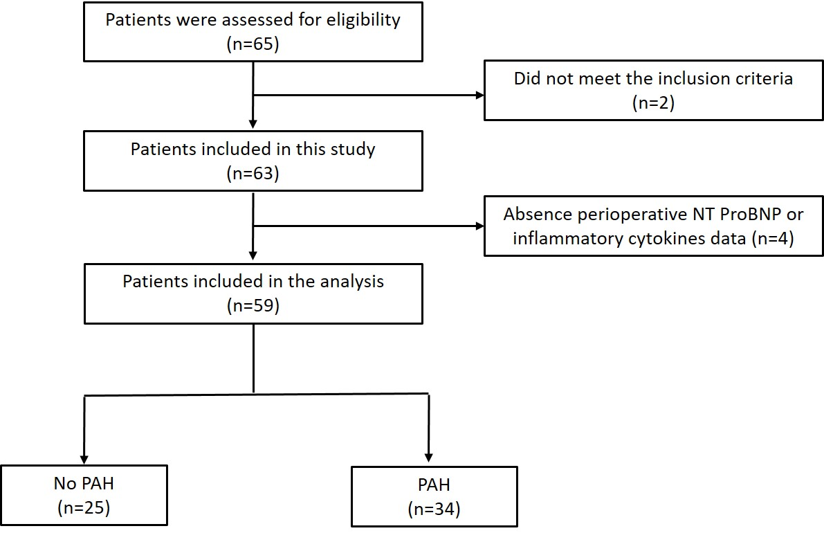

S-Figure 2, Correlation between pre NT-ProBNP and PASP in PAH-CHD patients

