Additional information:

Adjustments to reduce climbing of the corrals and/or escape from the apparatus
A common early issue in developing the Social versus Food Preference Test was that some animals would climb up the corrals and sit on the top. From the top of the corrals some animals were then able to jump out of their testing arena and escape completely or jump into the neighboring testing arena and disrupt the testing of other subjects. For rats, these issues were mitigated by placing corrals in the center of the back wall instead of in a corner (Fig 3A). To further reduce climbing and/or subsequent escape, the corrals were modified so that the tops were no longer flat. For the rat corrals this was achieved by adding a Plexiglas wedge to the lid of the corral (Fig 3A-B), and for the mouse corrals this was achieved by taping a weigh boat to the top of the corral (Fig 3C). These changes greatly decreased the frequency of climbing and escape, and in subsequent testing nearly all subjects spent the entire 10 min of each test exploring the apparatus and investigating the stimuli.
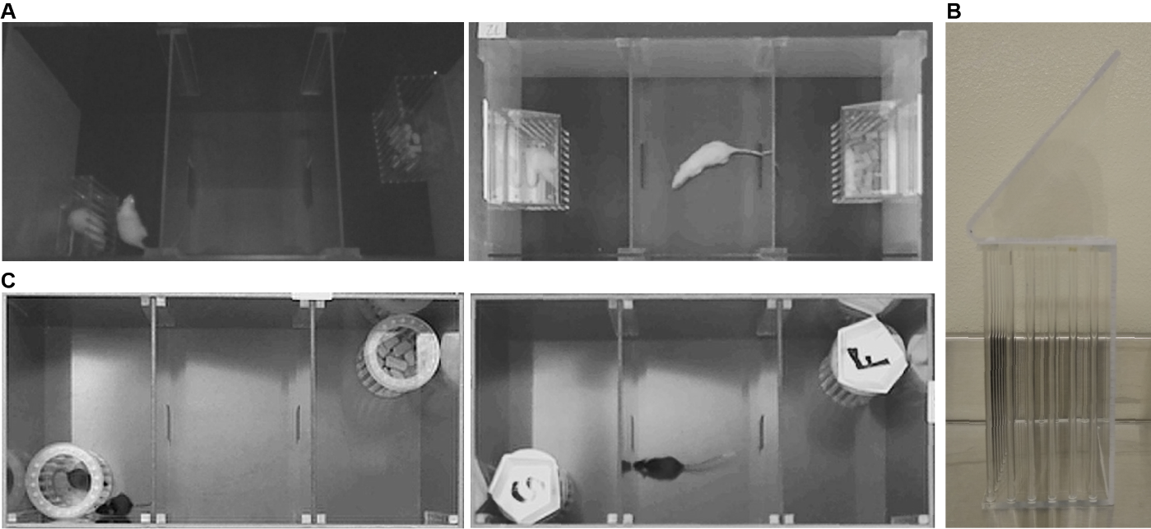
Fig 3. In initial testing, rats (A, left) and mice (C, left) would climb corrals and/or escape the apparatus. Altering corral placement and adding a wedge top to the corrals preventing climbing and escape in rats (A, right; B), and the addition of a weigh boat to the top of the corrals prevented climbing and escape in mice (C, right; marked to indicate stimulus inside).

Rats prefer a food stimulus over no stimulus
To determine if a food preference could be induced in rats, individually housed 9-10 week old male Wistar rats (n = 6) were first habituated to the apparatus and then tested the following day following acute (24 hr) food deprivation. During the test, subjects were placed into the center chamber and allowed to freely explore for 10 min. In one end chamber was a glass staining dish (107 x 87 x 70 mm) containing 3 chow pellets available for consumption, and the middle and opposing chambers were empty (i.e., did not contain corrals or dishes). Pellets were replaced, and the dish cleaned between subjects. Behavior was video-recorded, and later manually scored using Solomon Coder for the percent of time subjects spent in each chamber. A within-subjects ANOVA showed a significant effect of chamber (F_{(2, 10)} = 25.0, p < 0.001), and Bonferroni post hoc paired comparisons confirmed that rats spent a greater percent of time in the chamber containing the food compared to the percent of time spent in the opposing (p = 0.013) or middle chambers (p = 0.003; Fig 4A). The percent of time spent in the opposing and middle chambers was similar (p = 0.23). This suggests that in the absence of a social stimulus, rats can exhibit a preference for a food stimulus.

Mice prefer a social stimulus over no stimulus
To determine if a social preference could be induced in mice, pair-housed and ad lib fed 6-14 week old C57BL/6J mice (n =8 males, n = 8 males) were first habituated to the apparatus and then tested the following day [2]. During the test, subjects were placed into the center chamber and allowed to freely explore for 10 min. In one end chamber was a corral containing an unfamiliar age- and sex-matched conspecific, and in the other end chamber was an empty corral. Behavior was video recorded, and later manually scored using Solomon Coder for the amount time subjects spent investigating each corral. A paired samples t-Test showed that mice spent significantly more time investigating the corral containing the social stimulus compared to the empty corral (F_{(1,15)} = 3.88, p = 0.001; Fig 4B). This suggests that in the absence of a food stimulus, mice can exhibit a preference for a social stimulus.

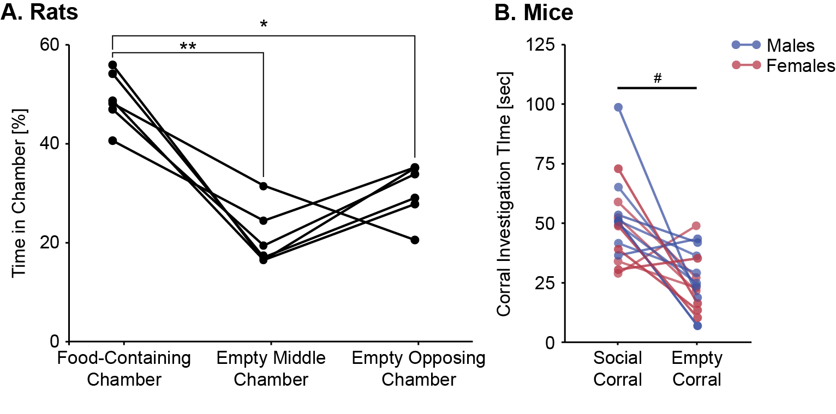
Fig 4. Male Wistar rats spent more time in the chamber containing food pellets compared to either other empty chamber (A). Male and female C57BL/6J mice spent more time investigating a corral containing a social stimulus compared to an empty corral (B); *p < 0.05, **p <0.001, Bonferroni post hoc paired comparisons; # p = 0.001, paired t-Test.

Using a freely-accessible food stimulus versus an inaccessible corralled food stimulus
In a two-chamber social interaction assay assessing the effects of hunger signals on social interest in mice, a food pellet was secured to the apparatus with adhesive putty which allowed for food consumption during the test [1]. In an initial pilot experiment, we examined whether stimulus investigation patterns would be similar when the food stimulus was freely-accessible (by placing food pellets in a glass staining dish; 107 x 87 x 70 mm) or inaccessible (by placing food pellets in corrals identical to those used for the social stimuli). Individually housed 5-6 week old male Wistar rats were first habituated to the testing apparatus and then exposed to the Social versus Food Preference Test on two occasions 48 hrs apart using a within-subjects counter-balanced design [sated x acutely food-deprived for 24 hrs]. For all subjects, the social stimulus was an unfamiliar age- and sex-matched conspecific, and the food stimulus was standard laboratory chow (Teklad Irradiated 22/5 Rodent Diet, 8940). For half of the subjects (n = 3) 3 chow pellets were placed into a rectangular glass staining dish allowing for consumption, and for the other half of the subjects (n = 4) 3 chow pellets were placed into a corral. Behavior was video recorded, and later manually scored using Solomon Coder for the amount of time subjects spent investigating each stimulus. All other methods were as described in Method details. This pilot was underpowered for statistical analyses, however, the average food deprivation-induced decrease in social over food preference was lower in subjects that had free-access to the food compared to subjects whose food was inaccessible (Fig 5A), and this was driven by average lower levels of food stimulus investigation in subjects that had free-access to the food compared to subjects whose food was inaccessible (Fig 5B). Additionally, one subject in the free-access condition carried a food pellet from the dish to the chamber with the social stimulus complicating the coding of behavior. Further, the expression of motivated behaviors is classically broken down into appetitive (i.e., initial, seeking) and consummatory (i.e, final, satisfaction of drive) behaviors [8], and corralling the food narrows the behavioral analyses to appetitive behaviors for both stimuli. For all these reasons, placing food in the corrals is recommended over free-access.
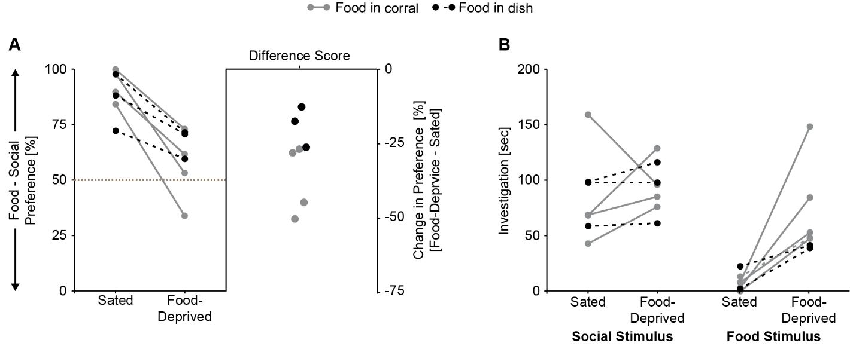
Fig 5. Male Wistar rats that were allowed free access to the food pellets showed less of a food deprivation-induced reduction in social over food preference (A) and spent less time investigating the food stimulus (B) than subjects for whom the food was inaccessible a corral.

Monitoring post-test food consumption for 30 min versus 1 hr
For experiments where subjects were food-deprived, we wanted to behaviorally assess hunger by examining food consumption in the homecage immediately following exposure to the Social versus Food Preference Test. Initial pilot tests were conducted to determine the length of time these post-test food consumption must be in order to observe differences in consumption between sated and food-deprived conditions. Specifically, individually housed male Wistar rats (n = 7, 5-6 weeks old) and female C57BL/6J mice (n = 4, 5-6 weeks old) were first habituated to the testing apparatus and then exposed to the Social versus Food Preference Test on two occasions 48 hrs apart using a within-subjects counter-balanced design [sated x acute food deprivation (rats: 24 hr, mice: 18 hr)]. For all subjects, the social stimulus was an unfamiliar age- and sex-matched conspecific, and the food stimulus was standard laboratory chow (Teklad Irradiated 22/5 Rodent Diet, 8940). Immediately following each test, subjects were weighed and body weight recorded. Subjects were then returned to their homecage where they were given a pre-weighed amount of food pellets which was replaced and weighed after 30 min and 60 min. All other methods were as described in Method details. Consumption was computed as percent of body weight [(grams consumed/body weight in grams)*100], and analyzed using two-way within-subjects ANOVAs [hunger (sated, food-deprived) X time point (30 min, 60 min)]. Bonferroni post hoc planned comparisons were used to assess the effect of hunger condition at each time point. In rats, there were main effects of both hunger (F_{(1,6)} = 199, p < 0.001) and time point (F_{(1,6)} = 42.6, p < 0.001); post hoc tests confirmed there was a difference between the sated and food-deprived conditions at both the 30 min and 60 min time points (p < 0.001, both; Fig 6A). In mice, there was a main effect of hunger (F_{(1,3)} = 35.1, p = 0.01) and a hunger by time point interaction (F_{(1,3)} = 10.8, p = 0.046); post hoc tests confirmed there was a difference between the sated and food-deprived conditions at both the 30 min (p = 0.02) and 60 min time points (p = 0.005; Fig 6B). Thus, monitoring post-test consumption for 30 min is sufficient to observe the effects of the acute food deprivation.

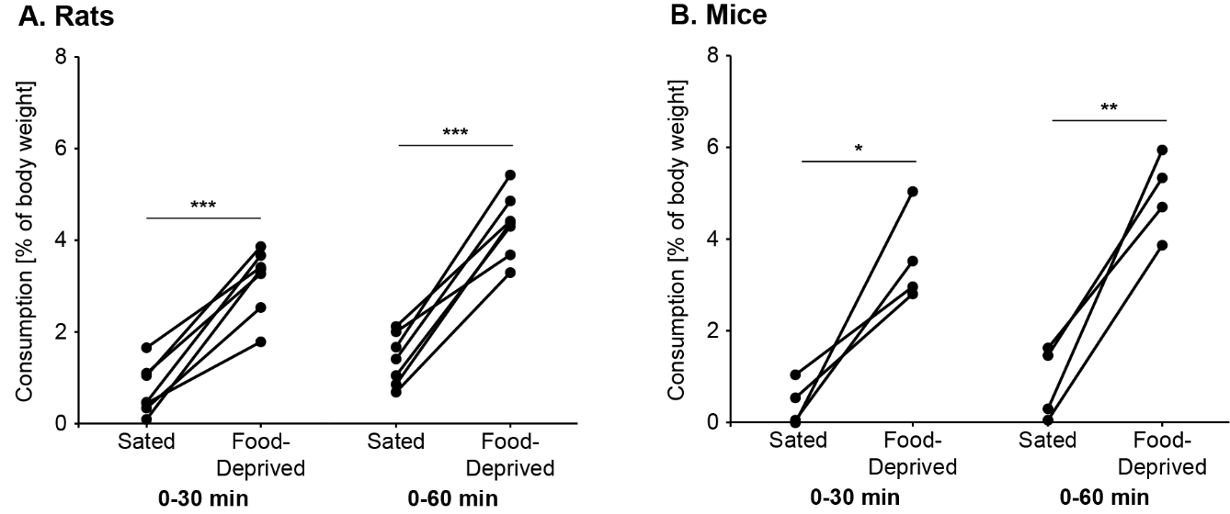
Fig 6. Monitoring post-test food consumption for 30 min is sufficient to observe differences between sated and food-deprived conditions in male Wistar rats (A) and female C57BL/6J mice (B); *p < 0.05, **p < 0.01, ***p < 0.001, Bonferroni post hoc paired comparisons.

Custom-construction allows for a modular design that can be utilized in additional behavioral assays.
While three-chamber testing apparatuses are commercially available, we had both our rat-sized and mouse-sized apparatuses custom-constructed at a much lower cost. For example, the cost for the custom-construction of our modular mouse-sized testing apparatus and the accompanying corrals by our campus Machine Shop (labor + materials) was 3-4 times cheaper than purchasing commercially available options. In addition to being budget-friendly, custom-construction allowed us to create a modular design which maximizes limited space and facilitates easy cleaning (Fig 7). The apparatus starts as a large, square arena which can be used for open-field tests to assess anxiety and general locomotor activity [9], for novel object recognition tests to assess learning and memory [10], or a variety of other behavioral tests. The insertion of an opaque partition divides the apparatus into two separate parts, and the insertion of transparent or opaque dividers can further divide the space to meet experimental needs. For the Social versus Food Preference Test we utilized two transparent dividers in each half of the apparatus in order to create two three-chamber testing arenas, and thus were able to run two subjects at the same time and record both from a single overhead camera. The apparatus could also be divided into a variety of smaller open-field arenas or two two-chamber arenas. With some removable Con-Tact paper, it would be possible to create a modified conditioned place preference setup [11] to assess learned place preferences as opposed to the real-time place preferences assessed in assays like the Social versus Food Preference Test. Cleaning is simple since all parts can be easily inserted and removed, including the main apparatus from the base, which also prevents the build-up of debris that can occur in edges/corners.

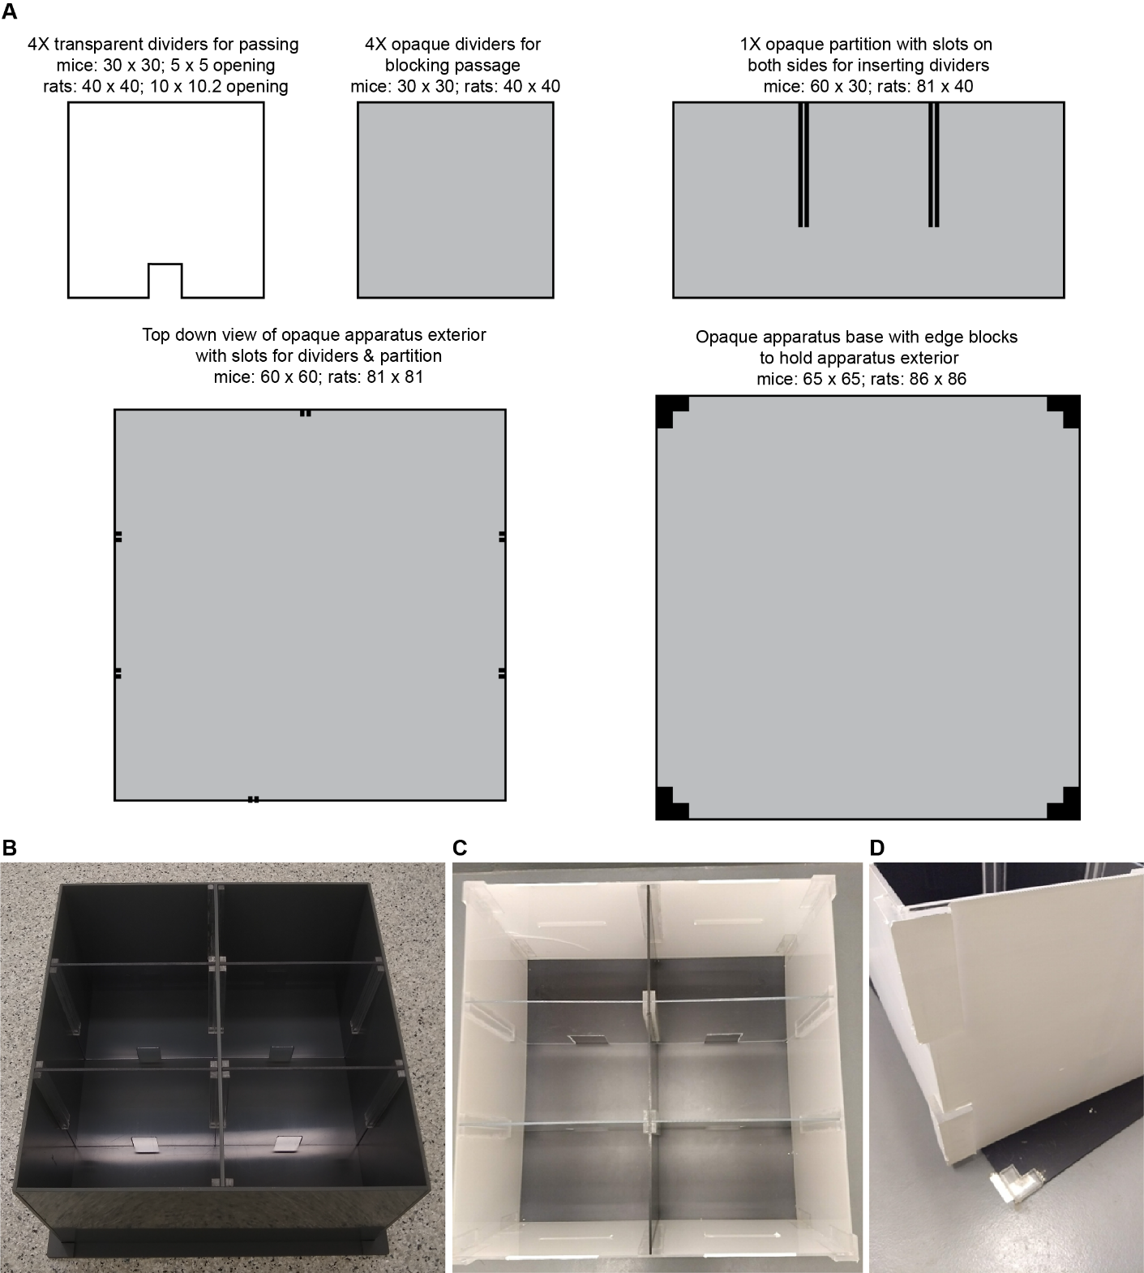
Fig 7. Dimensions, in cm, for the custom construction of a modular testing apparatus (A). A modular design allows for diverse uses: a single large open field arena, multiple smaller open field arenas of various sizes, or 2 two- or three-chamber arenas (mice: B, rats: C), and facilities easy cleaning of the dividers, partition, and base (D, exterior of apparatus lifted off base during cleaning).

