Alleviating coral thermal stress via inoculation with quorum quenching bacteria
Qingsong Yang^{1,2,3,4,#}; Bing Yang^{1,2,4,5,#}; Bin Yang^{1,2,3,4}; Wenqian Zhang^{1,2,4,5}; Xiaoyu Tang^{1,2,4}; Huiming Sun^{1,2,4}; Yanying Zhang ^{5,6}; Jie Li^{1,2,3,4}; Juan Ling ^{1,2,3,4,*}; Junde Dong ^{1,2,3,4,*}

¹ CAS Key Laboratory of Tropical Marine Bio-Resources and Ecology, Guangdong Provincial Key Laboratory of Applied Marine Biology, South China Sea Institute of Oceanology, Chinese Academy of Sciences, Guangzhou 510301, China
² Key Laboratory of Tropical Marine Biotechnology of Hainan Province, Sanya Institute of Ocean Eco-Environmental Engineering, Tropical Marine Biological Research Station in Hainan, Chinese Academy of Sciences, Sanya 572000, PR China
³ Guangdong Provincial Observation and Research Station for Coastal Upwelling Ecosystem, South China Sea Institute of Oceanology, Chinese Academy of Sciences, Shantou 515041, PR China
⁴ Innovation Academy of South China Sea Ecology and Environmental Engineering, Chinese Academy of Sciences, Guangzhou 511458, China
⁵ University of Chinese Academy of Sciences, Beijing, China;
⁶ Yantai University, Yantai 264003, China
# Qingsong Yang and Bing Yang contribute equally to this work.

*Correspondence: Juan Ling and Jun-de Dong
E-mail: lingjuan@scsio.ac.cn; dongjd@scsio.ac.cn

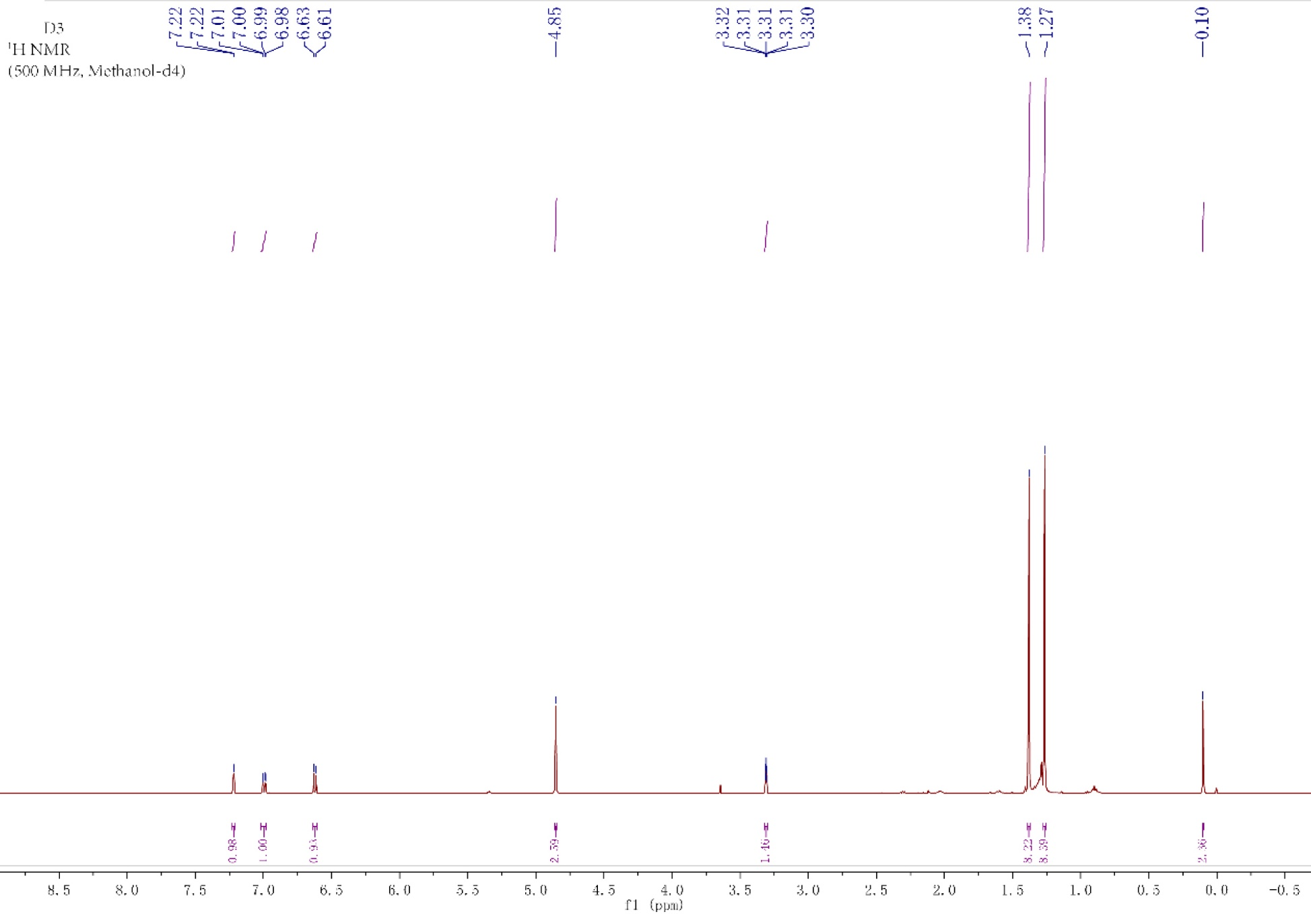
Fig. S1 1H-NMR spectrum of QSI compound (Methanol-d4) isolated from QQ bacteria SCSIO 43740. Two singlets at 1.27 ppm and 1.38 ppm. Another singlet around 4.85, 6.62 and 7.22 ppm.
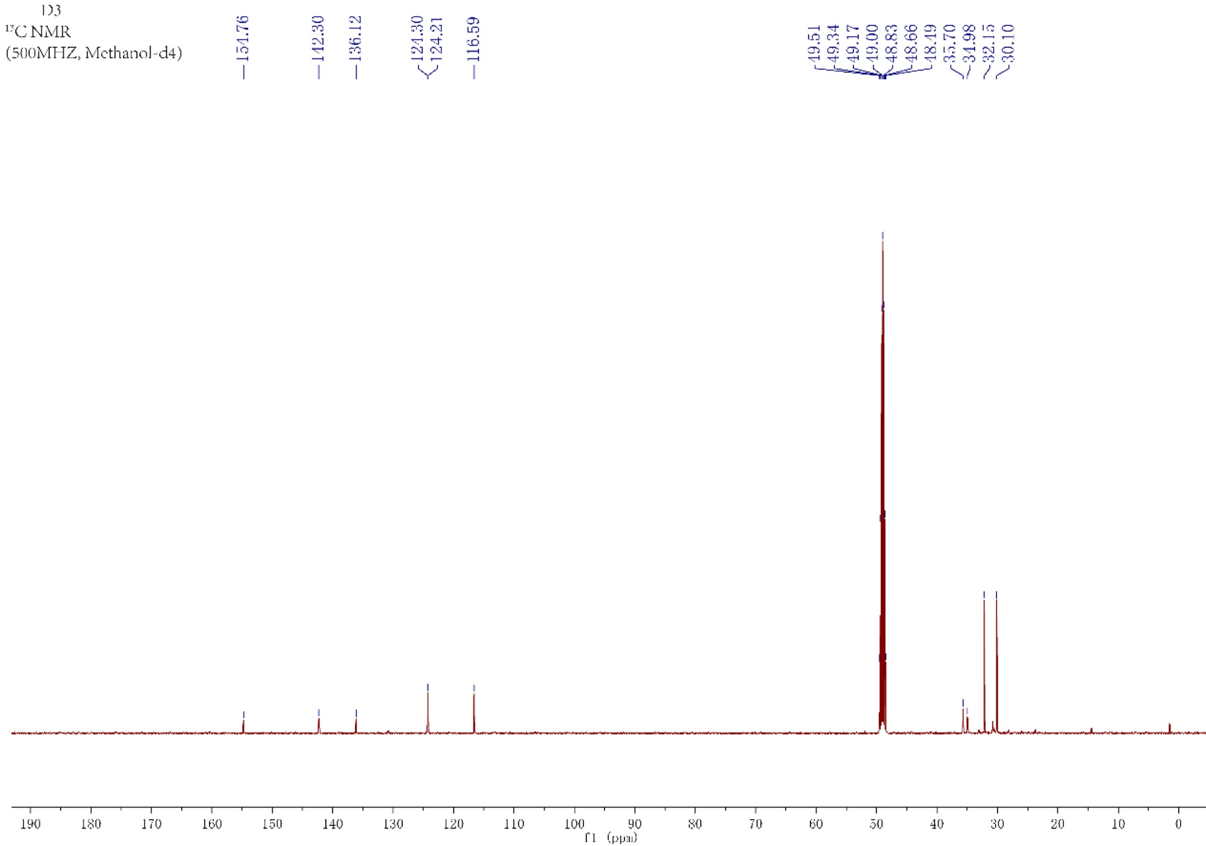
Fig. S2 13C-NMR spectrum of QSI compound (Methanol-d4) isolated from QQ bacteria SCSIO 43740. Carbon signals present in between 116.59 and 154.76 ppm. The upfield region in between 30.10 and 35.70 ppm. Three quaternary carbons at 154.76 ppm, 142.30 ppm, and 136.12 ppm. The presence of a phenolic OH group at quaternary carbon present at the most downfield region, i.e., 154.76 ppm Two were tertiary carbons at 35.7 ppm and 34.98 ppm while the rest of the two were methyl signals at 32.15 ppm and 30.10 ppm.

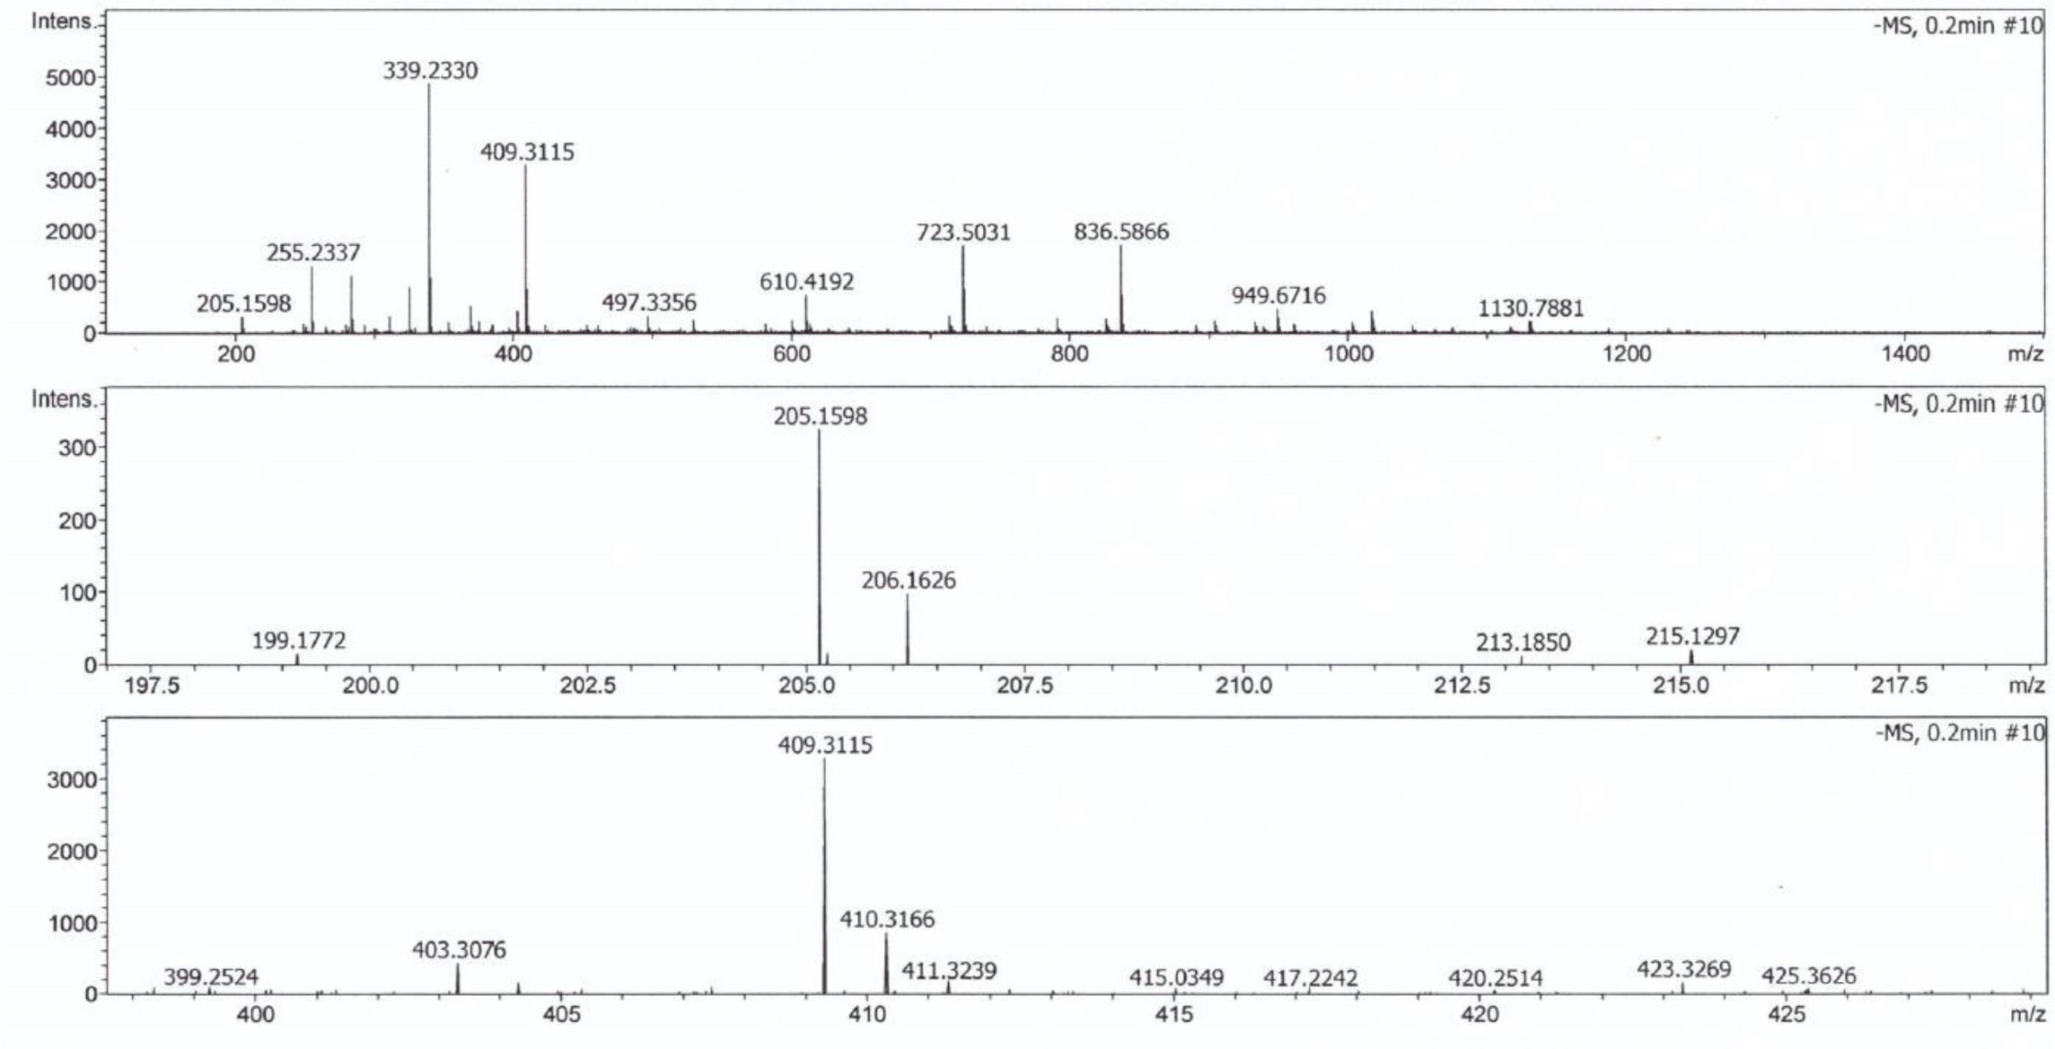
Fig. S3 High-resolution mass spectrometry of QSI compounds by Q-TOF (quadruple-time-of-flight). HRMS mass spectrometry with mass of [M + H] + at m/z 205.15, corresponding to the major peak, which gives the accurate mass of ≈206.17, in the positive ion mode.

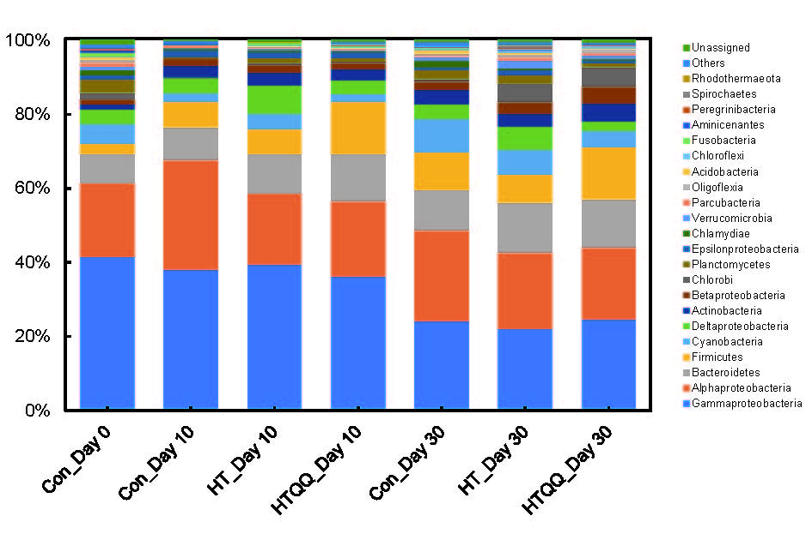
Fig. S4 Bacterial community compositions of coral samples in each treatment. Species composition is sorted taxonomically at the phylum level except for the Proteobacteria, which is presented at the class level.

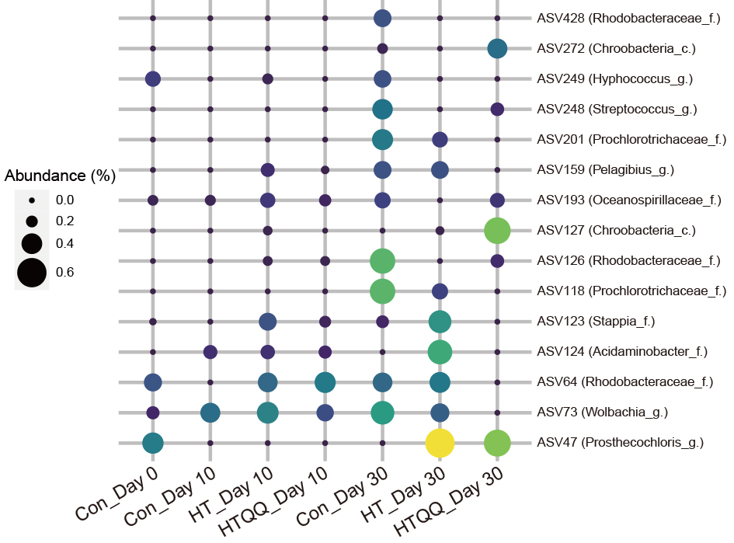
Fig. S5 Relative abundance distribution of ASVs used as bioindicators in the three treatments (Con, HT and HTQQ) at different time. The size and color of the circles represents the relative abundances. Class, family or genus of each ASVs are also shown in this figure.
Table S1. The alpha diversity of microbial communities in corals.
Expressed as mean±SE, multiple comparison conducted at the P<0.05 using LSD.
 | Faith's phylogenetic diversity | Pielou's evenness | Shannon’s Entropy
Con_Day0 | 61.61±1.77 a | 0.83±0.03 ab | 7.46±0.36 ab
Con_Day10 | 35.95±4.00 c | 0.80±0.02 b | 6.50±0.16 c
HT_Day10 | 38.28±2.33 c | 0.80±0.02 b | 6.78±0.27 bc
HTQQ_Day10 | 45.33±2.53 bc | 0.86±0.01 ab | 7.57±0.13 ab
Con_Day30 | 50.66±2.97 b | 0.89±0.03 a | 7.91±0.35 a
HT_Day30 | 45.34±5.20 bc | 0.86±0.02 ab | 7.47±0.36 ab
HTQQ_Day30 | 48.84±3.21 b | 0.85±0.02 ab | 7.05±0.30 bc

Table S2. The relative abundance of ASV252 which is most similar to the 16S rRNA of the inoculated QQ bacterial strain.
Treatment | Rep.1 | Rep.2 | Rep.3 | Rep.4 | Rep.5 | Mean±SE
Con_Day0 | 0.357% | 0.000% | 0.000% | 0.000% | 0.000% | 0.071%±0.071%
Con_Day10 | 0.000% | 0.000% | 0.000% | 0.000% | 0.000% | 0.000%±0.000%
Con_Day30 | 0.000% | 0.000% | 0.000% | 0.000% | 0.000% | 0.000%±0.000%
HT_Day10 | 0.000% | 0.000% | 0.000% | 0.000% | 0.000% | 0.000%±0.000%
HT_Day30 | 0.000% | 0.000% | 0.000% | 0.000% | 0.000% | 0.000%±0.000%
HTQQ_Day10 | 0.000% | 0.000% | 0.000% | 0.529% | 0.986% | 0.303%±0.199%
HTQQ_Day30 | 0.000% | 0.000% | 0.000% | 0.000% | 0.000% | 0.000%±0.000%

Table S3. Major topological features properties of co-occurrence networks.
 | Control | HT | HTQQ
Number of nodes | 81 | 84 | 87
Number of edges | 354 | 389 | 318
Positive (%) | 17.2 | 29.8 | 35.5
Negative (%) | 82.8 | 70.2 | 64.5
Average connectivity | 11.5 | 13.1 | 11.0
Average degree | 8.74 | 9.26 | 7.31
Betweenness Centrality | 0.021 | 0.017 | 0.022
Closeness Centrality | 0.382 | 0.434 | 0.358
Clustering coefficient | 0.153 | 0.266 | 0.264
Graph density | 0.109 | 0.112 | 0.085
Network diameter | 5.0 | 5.0 | 6.0

Table S4. Identity of the network hubs, module hubs and connectors as keystone microbes of co-occurrence networks.
 | ID | Class | Order | Family | Genus | Relative  abundance (‰)
1 | OTU193 | Deltaproteobacteria | Desulfuromonadales | Desulfuromonadaceae | Desulfuromonas | 0.55
2 | OTU5197 | Gammaproteobacteria | unclassified_Gammaproteobacteria | unclassified_Gammaproteobacteria | Sedimenticola | 0.02
3 | OTU203 | Deltaproteobacteria | Desulfobacterales | Desulfobacteraceae | Desulfatitalea | 0.52
4 | OTU96 | Alphaproteobacteria | Rhizobiales | Hyphomicrobiaceae | Hyphomicrobium | 1.19
5 | OTU200 | Deltaproteobacteria | Syntrophobacterales | Syntrophaceae | Desulfobacca | 0.53
6 | OTU76 | Deltaproteobacteria | Desulfuromonadales | Geobacteraceae | Geopsychrobacter | 1.50
7 | OTU170 | Alphaproteobacteria | Rhizobiales | Bradyrhizobiaceae | Bradyrhizobium | 0.62
8 | OTU82 | Clostridia | Clostridiales | Peptococcaceae |  | 1.42
9 | OTU36 | Deltaproteobacteria | Desulfuromonadales | Geobacteraceae | Geothermobacter | 3.76
10 | OTU95 | Betaproteobacteria | Burkholderiales | Burkholderiaceae | Paraburkholderia | 1.20
11 | OTU64 | Alphaproteobacteria | Oceanospirillales | Oceanospirillaceae | Marinobacterium | 1.76
12 | OTU157 | Deltaproteobacteria | Desulfuromonadales | Desulfuromonadaceae | Pelobacter | 0.68
13 | OTU175 | Alphaproteobacteria | Sphingomonadales | Sphingomonadaceae | Novosphingobium | 0.60
14 | OTU111 | Alphaproteobacteria | Sphingomonadales | Sphingomonadaceae | Novosphingobium | 1.01
15 | OTU158 | Alphaproteobacteria | Rhizobiales | Xanthobacteraceae | Xanthobacter | 0.65
16 | OTU168 | Deltaproteobacteria | Desulfobacterales | Desulfobacteraceae | Desulfatibacillum | 1.31
17 | OTU193 | Deltaproteobacteria | Desulfuromonadales | Desulfuromonadaceae | Desulfuromonas | 0.55
18 | OTU88 | Gammaproteobacteria | Pseudomonadales | Pseudomonadaceae | Azotobacter | 1.32
19 | OTU206 | Betaproteobacteria | Burkholderiales | Alcaligenaceae | Azohydromonas | 0.51
20 | OTU70 | Alphaproteobacteria | Desulfuromonadales | Desulfuromonadaceae | Desulfuromonas | 1.64

Table S5. QSI Isolated from Corals in previous reports
QSI | Coral species | QQ strain | Reporter strains | References
DL-homocysteine thiolactone | Pocillopora damicornis | Staphylococcus hominis | Chromobacterium violaceum ATCC 12472 | (Ma et al. 2018)
rhodamine isothiocyanate | Pocillopora damicornis | Vibrio alginolyticus | Chromobacterium violaceum ATCC 12472 | (Song et al. 2018)
2,4-di-tertbutylphenol | Pocillopora damicornis | Pseudoalteromonas piscicida SCSIO 43740 | Chromobacterium violaceum CV026 | This study

