Supplementary material

Municipality | Socioeconomic group classification
Vitacura | High-High
Las Condes | High-High
Ñuñoa | High-High
Lo Barnechea | High-High
Providencia | High-High
La Reina | High-High
Santiago | High-Middle
San Miguel | High-Middle
La Florida | High-Middle
Macul | High-Middle
La Cisterna | High-Middle
Huechuraba | Middle
Quilicura | Middle
Independencia | Middle
Puente Alto | Middle
Maipu | Middle
Estacion Central | Middle
El Bosque | Middle
Quinta Normal | Middle
Peñalolen | Low-middle
La Granja | Low-middle
San Ramon | Low-middle
Conchali | Low-middle
Renca | Low-middle
Pedro Aguirre Cerda | Low-middle
Pudahuel | Low-middle
Lo Prado | Low-middle
Cerrillos | Low-middle
San Bernardo | Low-middle
San Joaquin | Low-middle
Recoleta | Low-middle
La Pintana | Low
Lo Espejo | Low
Cerro Navia | Low

Figure S1: Hotspots of number of crashes per 10,000 registered vehicles

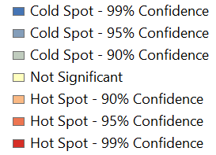
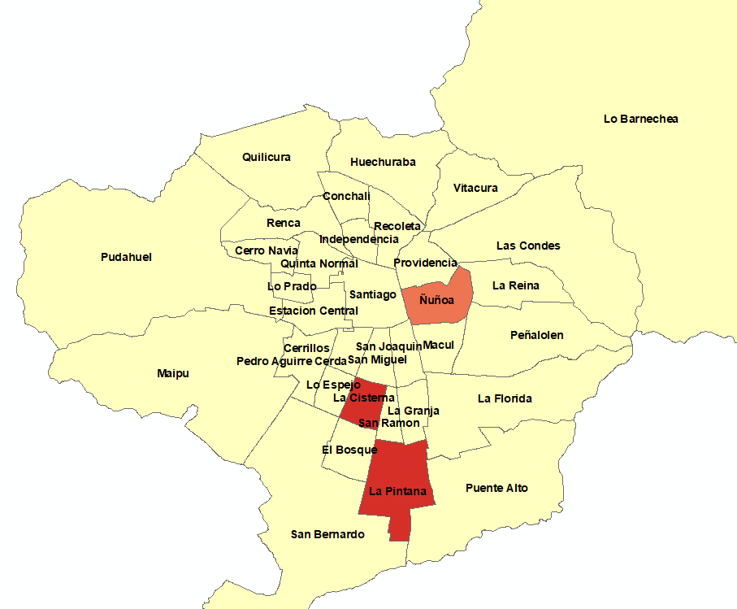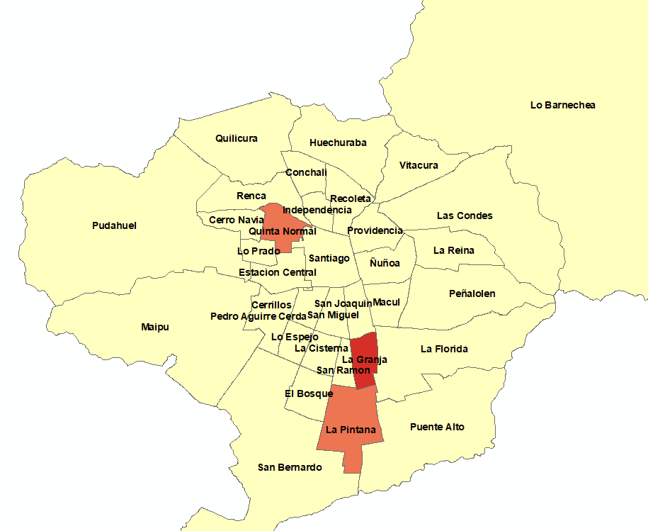
- Before Uber´s entry b) After Uber´s entry

Figure S2: Hotspots of number of KSI per 10,000 registered vehicles

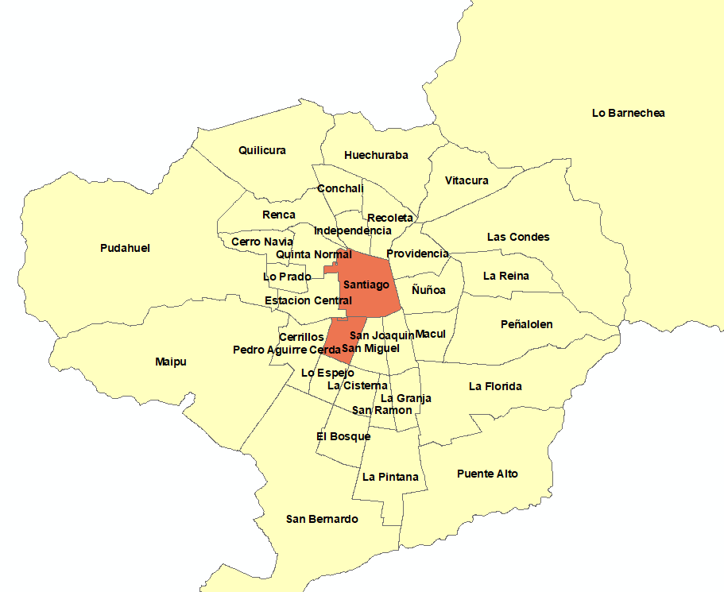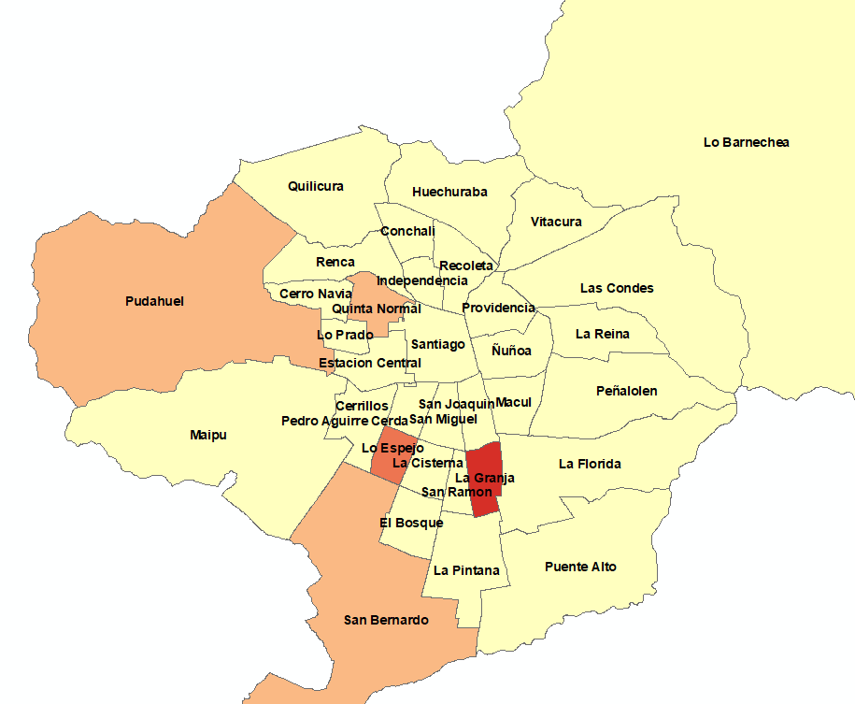
- Before Uber´s entry b) After Uber´s entry
Figure S.3 Bubble plot of alcohol-related crashes rate ratios with fitted meta regression line across municipality socio economic groups.
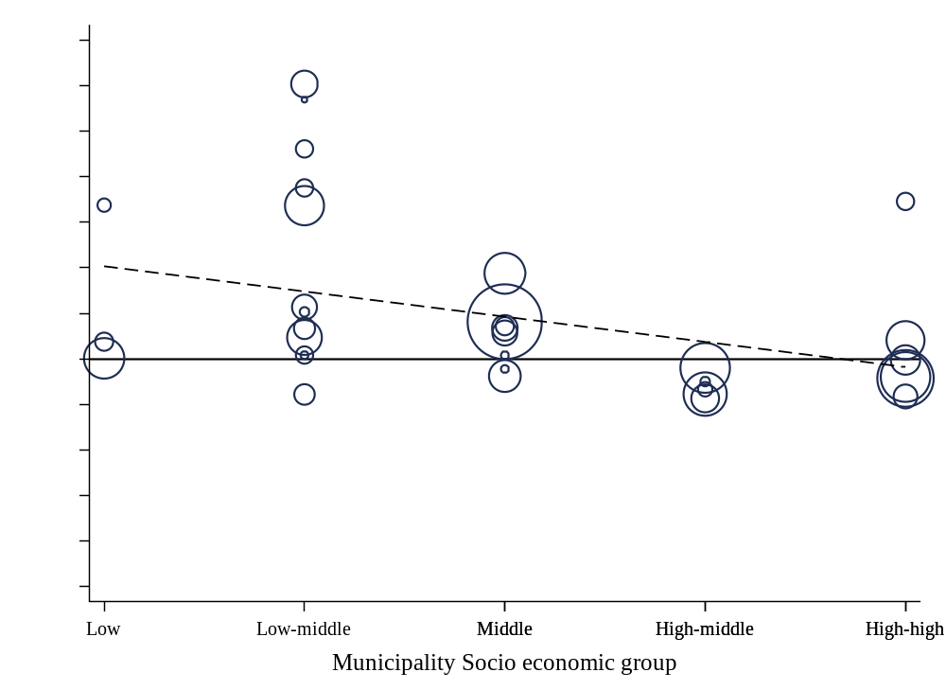
Figure S.4 Bubble plot of alcohol-related crashes KSI rate ratios with fitted meta regression line across municipality socio economic groups.